THE ARTISTS AND THEIR DESIGN
COCKATOO – Kym Krasa
EMU CHICK BY THE MURRAY RIVER –Laura Guest
EAGLE – Jason Marks
EEL TRAP – Diana Nikkelson
SNAKE IN SHELL – Sam Morrison
SHARK – Bianca Nikkelson
FISH – Joe Lee
BALLARAT PLATYPUS – Diana Nikkelson
TURTLES – Kelly Saylor
SWAN – Tim Karpany
MEAL TIME, GATHERING, COOKING– Greg Clark
WITH THANKS
Vice Chancellor David Battersby, Professor Terry Lloyd,
Deputy Vice Chancellor, Nikki Foy, Katrina Beer, Vivian
McDermott, Marley Smith, Clare Gervasoni, Paul Lambeth,
Paul Mason, Fred Cahir, Valda D’Angri, John Morris, Ben
Atkinson, Gwenda Freeman, Barbara Bennett, Professor
Peter Mathews, Head, Arts Academy, Val Shearer, Peter
at Creative Framing, Shelley Hinton.

Photographers
Paul Calistro, Ian Robinson, Fred Cahir, Clare Gervasoni, Nikki Foy.
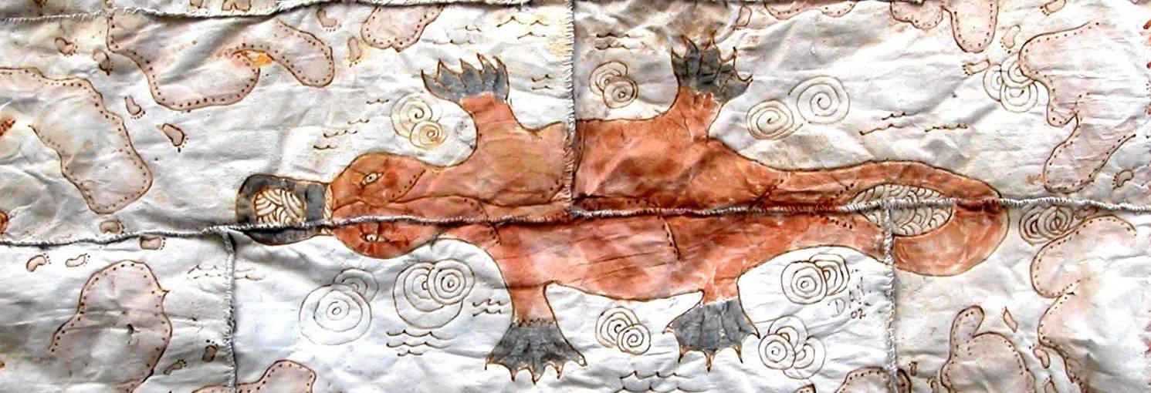
.

D Y I R R A N G A
‘A Long Journey’

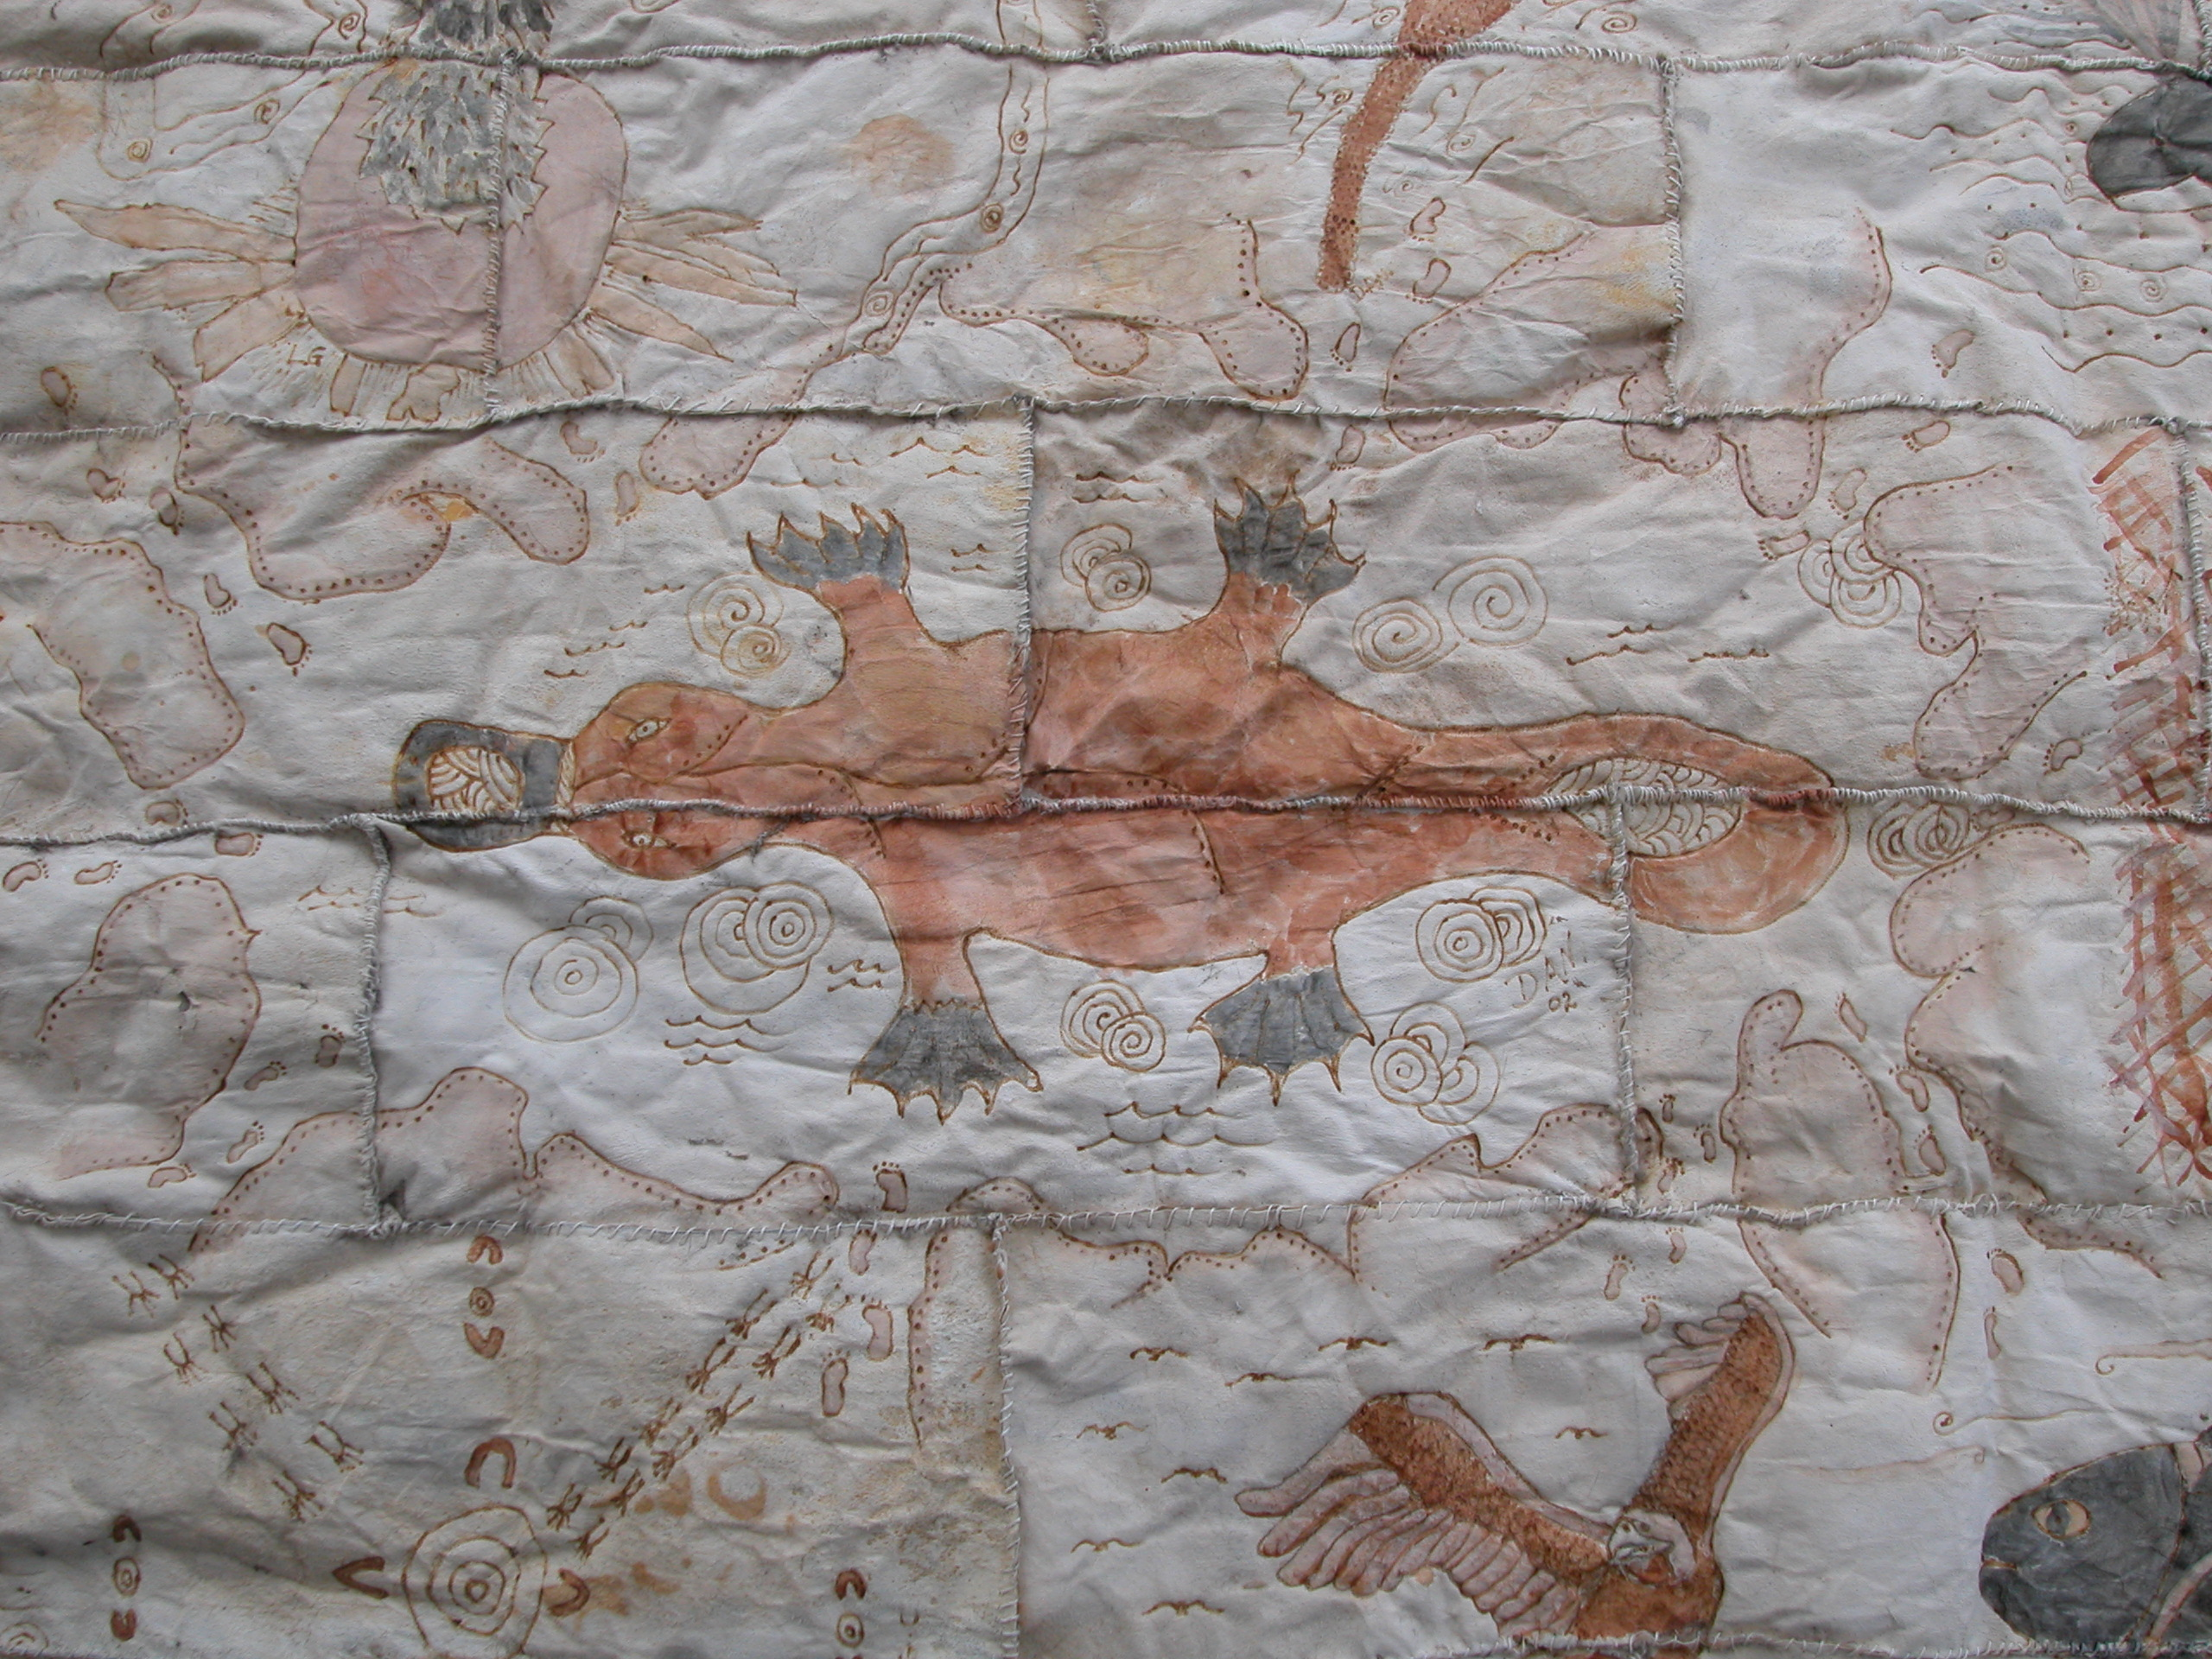

2008 NAIDOC Launch of ‘The Possum Skin Cloak’
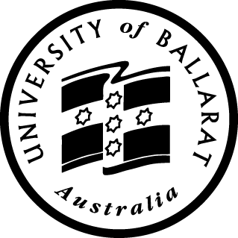
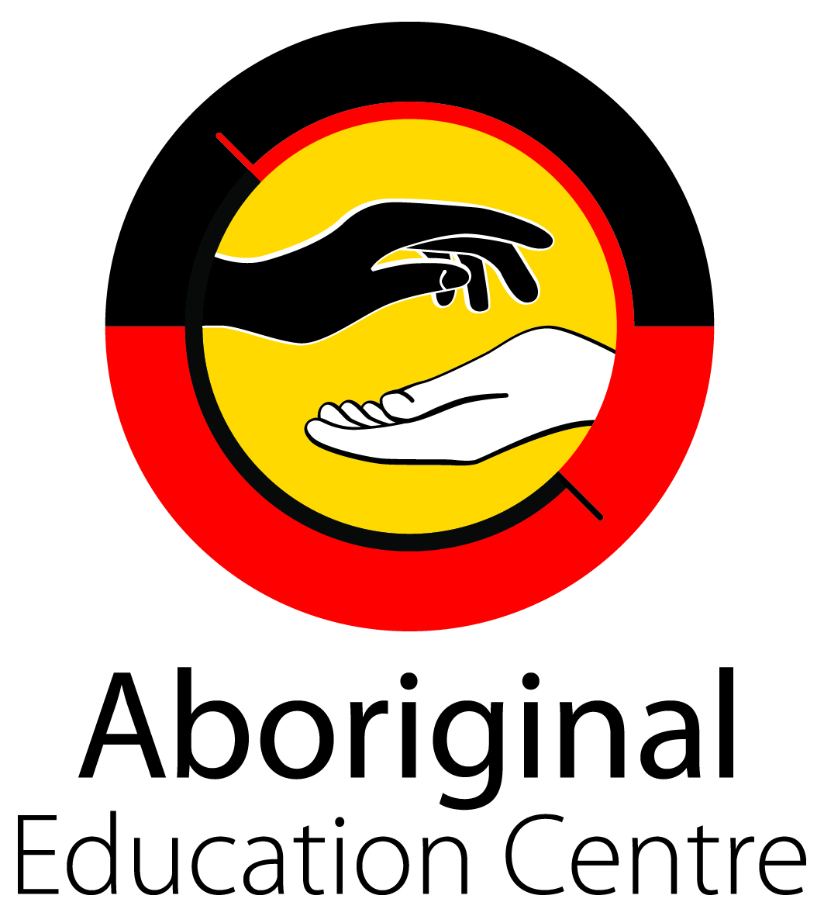
created by the students of the Advanced
Certificate Koori Art & Design
(1995 – 2002)
DYIRRANGA - (pronounced dji – rung – ga) is a word from the Wergaia language meaning “a long journey”.

The Journey
In 2002 a group of students from the Advanced Certificate in Koori Art and Design (1995-2002) undertook a project initiated by then teacher Fred Cahir. Fred had been inspired by an 1894 painting by artist Eugene Von Guerard entitled Barter, which depicted the exchange of possum skins between Indigenous peoples and white settlers in the early 1800’s. The students; Greg Clark, Laura Guest, Tim Karpany, Kym Krasa, Joe Lee, Jason Marks, Sam Morrision, Bianca Nikkelson, Diana Nikkelson and Kelly Saylor were each directed to research their own stories and totems which would then become the basis for the possum skin cloak design. Further discussions led to the central image and overall theme – the platypus. This swimming, egg laying marsupial, with its duck bill and webbed feet, aptly represented Ballarat with its many nations of people who had journeyed far to settle here, so too the artists who worked on the project , Indigenous people from different ‘nations’ around Victoria and Australia. Prior to starting the project, research was undertaken into how possum skin cloaks were traditionally made. Due to the fact that possums were, and still are, a protected species in Australia; twenty pelts were sourced from New Zealand. Textile teacher Valda D’Angri worked with students on sewing the pelts together with kangaroo gut, burning designs into the skins and creating a permanent resin for the ochres that had been collected from surrounding areas by the artists themselves.

The Journey Continues
Apart from the platypus, there are ten different designs adorning the cloak; the eel trap, whale, cockatoo, snake, turtles, fish, eagle, emu, swan and the gathering place. The Cloak is relatively smaller than traditional cloaks, which used anywhere between 60 -80 pelts. It measures around 1.00m x 1.5m (1.5m x1.8m framed) and was originally intended as a gift to welcome the birth of participating artist Bianca Nikkelson’s first born.
At the end of 2002 students’ works were exhibited, including the possum skin cloak. No-one knows what became of the cloak after that exhibition until 2007 when Katrina Beer and Nikki Foy of the Aboriginal Education Centre discovered it folded in a box in storage. Nikki was charged with the task of having the cloak’s condition assessed and enlisted the assistance of Head of Department, Arts Academy, Paul Lambeth and University Curator Clare Gervasoni. Paul, along with Nikki, was instrumental in securing funding for the restoration of the cloak through the Office of the Vice Chancellor. Clare also worked tirelessly with Nikki to have the cloak treated for moth egg infestation and later coordinated its framing.
Paul Mason painting teacher at the time commented on how the project “spilled over into other classes”. Paul Lambeth also noted how the ‘community embraced the course at that time’ and how the cloak was very much a “collaborative effort”. This collaborative effort has carried on through today where the efforts of past and present teachers and students have contributed to the re-emergence of ‘the possum skin project’ of 2002 to Dyirranga in NAIDOC 2008. After the NAIDOC Week 2008 launch, Dyirranga will find a permanent home at the University of Ballarat.

*Additional students of the Advanced Certificate in Koori Art & Design 1995-2002 not involved in the possum skin project include; Rubina Burgoyne, Paul Hollis, Ray Muir. Liaison Officer, Jasmine Morrison, Head, Arts Academy, Alister Heighway.

