FLUDE FAMILY PLOT

Ballaarat Old Cemetery

Photography: Roy Shrieke, August 2004

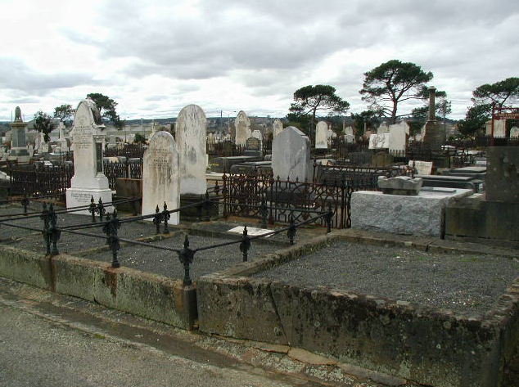

Joseph Flude (1825-1892)

Joseph Flude was one of the first members of the SMB teaching staff and member of the SMB Council 1871-1882.

