The celebrated clipper ship KENT Source: Arrival in Melbourne Malcolm Pascoe’s Family (tripod.com)
Her First Class accommodations are of a very superior character and include every requirement that can be demanded by families and single gentlemen. In second and third class the cabins are spacious, lofty and well ventilated; and the scale of diet comprises a liberal supply of the best provisions. Stewards have been engaged to wait upon second class passengers. Carries an experienced Surgeon.
The ‘Kent’ was the first of the Blackwall Frigates purpose built for the Melbourne trade. Writing in ‘The Age’ at a later date a Clarke Russel recalled her as "an Indiaman lying in the downs, her painted ports burnished like gold, her teak and brass burnished like gold flashing in the sun; the quarter and stern windows winking in the light and her great spread of rigging fix themselves in the memory of everyone who admires a ship.”
With the demise of the East India Company, those who ran the ships to India had to find an alternate trade. It was natural that some would turn to the migration of the 1850's to the Victorian gold rush. Some East India ships were built to simulate Her Majesty's Frigates as a subterfuge to deter attacks by pirates and privateers. The ‘Kent’ was one of these ships.
She was built in 1852 of oak by the Money Wigram's company at Blackwall, and measured 186 feet, with a beam of 33 feet and a draught of 20 feet and displaced 927 tons of water. She had a full bow with no sheer and carried over the side two wide channels. Her main mast was 130 feet and the yards were banded at every three feet. She carried sails over the royals with four reef points and included a flying outstretched jib boom. She sported quarter galleries and stern windows. Painted black on top and white under with a stumpy appearance which contributed to the Navy appearance.
The ‘Kent’ had a crew of about sixty and ten midshipmen. Everything was done in the finest manner and to proper discipline. On hoisting the topsail passengers would join with the crew in tailing to the halyards. Whilst she brought migrants out she carried gold home which was concealed in a caulked vault under the master's cabin, and on one voyage carried over half a million pounds worth. She was described as "the armed clipper ship, ’Kent’." She was armed with three guns; one long gun and two carronades.
A cabin passage cost 80 guineas. Usually the fare would vary, depending on how the ship filled up, but the ‘Kent’ was so popular that the prices kept high. Passengers provided their own bedding, linen and soap. Drinks were free, champagne on Thursday and Sunday when dinner would finish with plum duff with plenty of brandy.
The ‘KENT’ sounds too good to be true. Sailing in the 1800's and before was not for the light hearted. "What were the thoughts of the 228 passengers on board the immigrant ship Argyle as it sailed up Port Phillip Bay on 12th April 1841? After more than five months at sea, in a ship of 650 tons which had left Liverpool in wintry November, the uppermost feeling was surely relief that the voyage had come to an end, mixed with hopes and fears of the new life ahead." (IRISH FORTUNES by Gladys Clarke)
What made these and others travel such a huge distance between England and Melbourne, Australia. Bad weather or fine, the passengers suffered the indignity of cramped quarters in vessels approximately 120ft long by 35ft wide (Kent 186 by 33ft). A quite distinct difference seems to exist between the Irish settlers of the Clarke's and of the Pascoe's. The Irish lived in the midst of poverty and sickness, whilst mining in Cornwall's west saw some security. During the early journeys to a new home many perished. The expectancy of a new beginning must have been severely tempered by the losses of family and friends. The sailing ship ‘Southern Ocean’ also played a part in transporting the Pascoe family members to Melbourne. Sarah (Sally) Pascoe (nee Kinsman) arrived in Melbourne in 1868. She followed her husband Martin Prist who made the journey on the ‘Kent’ the previous year.

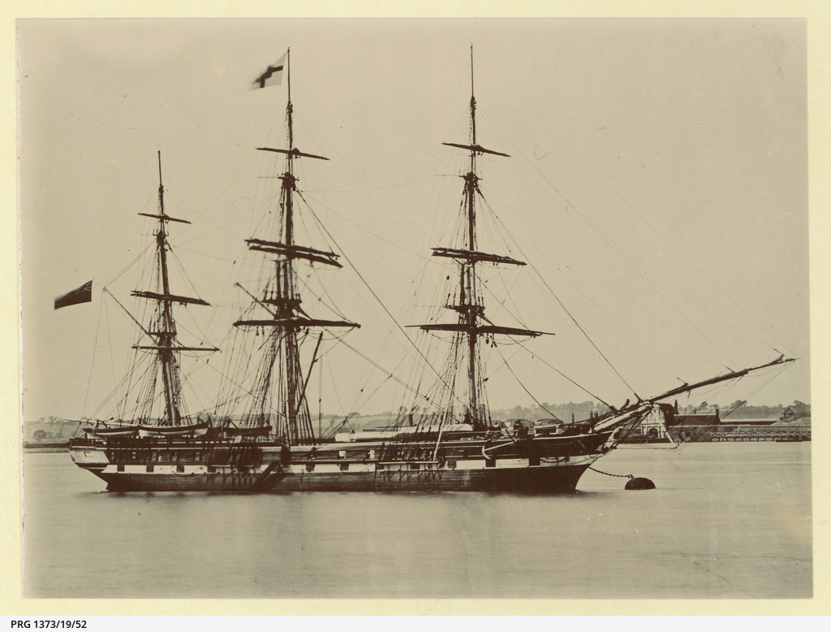
Source: The 'Kent' moored at Gravesend, U.K. • Photograph • State Library of South Australia (slsa.sa.gov.au)
THE BLACKWALL LINER KENT.

This clipper ship will take her departure for England on the 10th instant. Since January, 1853, the Kent has made four and a half runs round the world under the same experienced commander, George Coleman Esq, and will complete the fifth when she lands in England the correspondence and papers now preparing for her. Much interest is attached to the runs of this vessel, as the champion of the London fleet, both on account of the regularity with which they have been performed, and as experiments, the results of which tell against the necessity of making high southern latitudes with their certain discomforts and possible dangers, in order to secure a quick voyage. We therefore subjoin a short digest of these trips, which, with the single exception of the first run home, exhibit a regularity very remarkable for a sailing vessel. With that exception, however, the average time occupied in the transmission of the mails has been only eighty days; omitting it from the calculations, the average has been a little over seventy-seven days.

First Voyage. Sailed from Isle of Wight, 28th January, 1853; Lizard Point, 29th January; off King's Island 16th April; arrived in Hobson’s Bay 20th April; number of days from land to land, 79; days out to landing mails, 82 Sailed from Hobson's Bay, 5th June, 1853; off Cape Otway, 6th June; Start Point, 10th September; Downs, 11th September; number of days from land to land. 96: days out to landing malls, 98.

Second Voyage. Sailed from Spithead, October, 1853; off C Ward L Point, 28th October; off Cape Otway, 12th January ;arrived Hobson's Bay, 12th January ; number of days from land to land, 76 days out to landing mail, 78, Sailed from Hobson's Bay, 28th February, 1854; off Cape Otway, 2nd March; off Start Point, 23rd May; arrived at Plymouth. 23rd May; number of days from land to land -2 days out to landing mail, 84.

Third Voyage. Sailed from Plymouth, 2nd August, 1854; off Lizard Point, 2nd August; off Cape Otway, l1th October ; arrived Hobson's Bay, 18th October; number of days from land to land, 77 ; days out to landing mails, 77, Sailed from Hobson's Bay, 3rd December, 1C54; off Kent's Group, 5th December ; off Start Point, 25th February, 1855; arrived at Hastings, 27th February number of days from land to land, 82; days out to landing mail, 86

Fourth Voyage. Sailed from Plymouth, 13th May, 1855; off Lizard Point, 14th May; off Cape Otway, 21st July; arrived Port Phillip, 23rd July; number of days from land to land, 68; days out to landing mails, 71. Sailed from Hobson’s Bay, 13th September, 1855; off Cape Otway, 14th September; off Land's End, 25th November; arrived at Penzance, 26th November; number of days from land to land, 72 ; days out to landing mails, 74.

Fifth Voyage. Sailed from Plymouth 16th July, 1856; off Lizard Point, 16th February off Cape Otway, 6th April; arrived at Port Phillip, 27th April ; number of days from land to land,70'; days out to landing mail, 71.

These trips give the Kent a high position as regards reputation for regularity, when it is remembered that the average of the passages of the last five mail ships that have arrived is eighty-nine days, and of the last five of whose arrival in England we are advised, ninety-one days. The well sustained character of both the vessel and her commander has secured a full passenger-list for the homeward voyage; and the engagements for gold are likely to be very heavy, notwithstanding that the Royal Charter sailed with seven tons and a quarter some nine days since. Messrs. W. White and Co., the agents of the Blackwall line, have advertised the True Briton as the ship to succeed the Kent.

The Shipping Gazette and Sydney General Trade List (NSW 1844 – 1860), Mon 23 June 1856, Page 127
The Blackwall Liner Kent
Source TROVE

