McGowan family formerly of Bendigo
Daniel Andrew McGowan. Buried Bendigo Cemetey 15.12. 1918 MON I5
Married in 1869 to
Josephine Anderson. Ada Josephine McGowan (nee Anderson)
Buried Bendigo Cemetery 17.11.1881 MON I5

Children
1871 Annie Josephine
1879 Ada Elizabeth Buried 17.11 1881 MON I5
1884 Letitia Margaret (Margaret?) Buried 9.7 1938 MON I6
1876 Herbert William Buried 7.11 1952 MON I6
Ada Annie Elizabeth Buried 2.2.1874 MON B2
Henry McGowan Buried 31.7.1979 MON I6
Margaret Mary Buried 24.8.1922 MON I6

Family Notices
Bendigonian (Bendigo, Vic. : 1914 - 1918) Thursday 18 April 1918 p 7 Family Notices

McGOWAN—McMAHON.—On Saturday, 6th April, at St. Augustine's Church, Myer's Flat, by the Rev. Father Rooney, Bert, second eldest son of Mr. and Mrs. D. McGowan, Hargreaves-street, Bendigo, to Margaret, third daughter of Mrs. and the late John McMahon, Myer's Flat.

OBITUARY.
Bendigonian (Bendigo, Vic. : 1914 - 1918) Thursday 19 December 1918 p 4 Article

McGOWAN. — The death occurred on Saturday of a well-known citizen, Mr. D. A. McGowan, at his residence, "Lanark," Hargreaves-street. He was born in Glasgow, Scotland, 76 years ago and came to Australia with his parents at the age of nine years. The family settled in Melbourne, later on going to Ballarat, where Mr. McGowan was married to Miss Anderson-Harper. He came to Bendigo in the early eighties. Though he took no active part in public matters, in business circles he was highly esteemed and honored for his high principles and broadmindedness and was highly respected by a wide circle of friends. The deceased leaves a widow and family of three daughters and four sons. The eldest son holds a Government appointment in China. The funeral on Sunday was largely attended, including many members of the Bendigo District Farriers' Association, of which he was a member. A large collection of floral tributes were received. The pall-bearers were Messrs. D. Wild, J. Leslie, J. Moher, B. Dyett, S. Leggo and W. Kinsella, and the coffin-bearers Messrs. S. Eathorne, W. Gardner,
R. Murdoch and J. Mead. The Rev. Father Brady officiated at the grave. Messrs. Fizelle and Mulqueen carried out the funeral arrangements.
OBITUARY.
Bendigo Advertiser (Vic. : 1855 - 1918) Monday 16 December 1918 p 5 Article

Family Notices
Bendigonian (Bendigo, Vic. : 1914 - 1918) Thursday 19 December 1918 p 3 Family Notices

McGOWAN.—On the 14th December, 1918, at his residence, "Lanark," Hargreaves street, Bendigo, Daniel Andrew McGowan, beloved husband of Josephine McGowan. Aged 76 years.

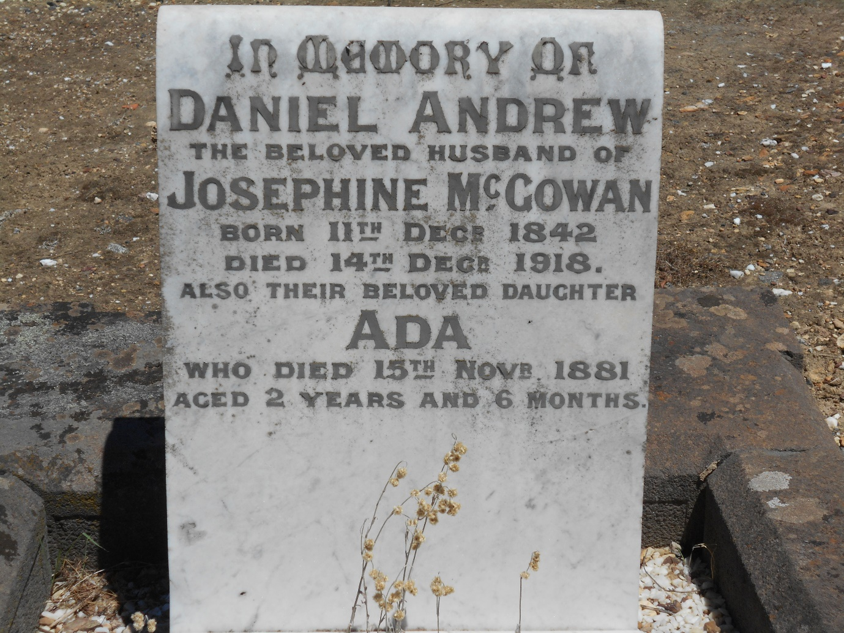

“Lanark” 466 Hargreaves Street Bendigo
Corner of Wattle Street.
