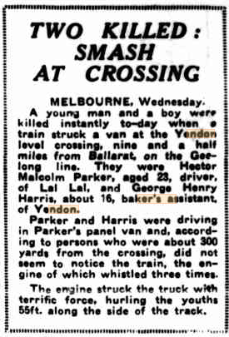Examiner (Launceston) Thur. 29 Sept. 1938 p 11

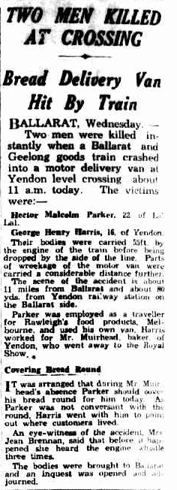 Sun-News Pictorial (Melbourne) Thur. 29 Sept. 1938 p 36