Wal Jack Death reports – Divisional Diary September 1964
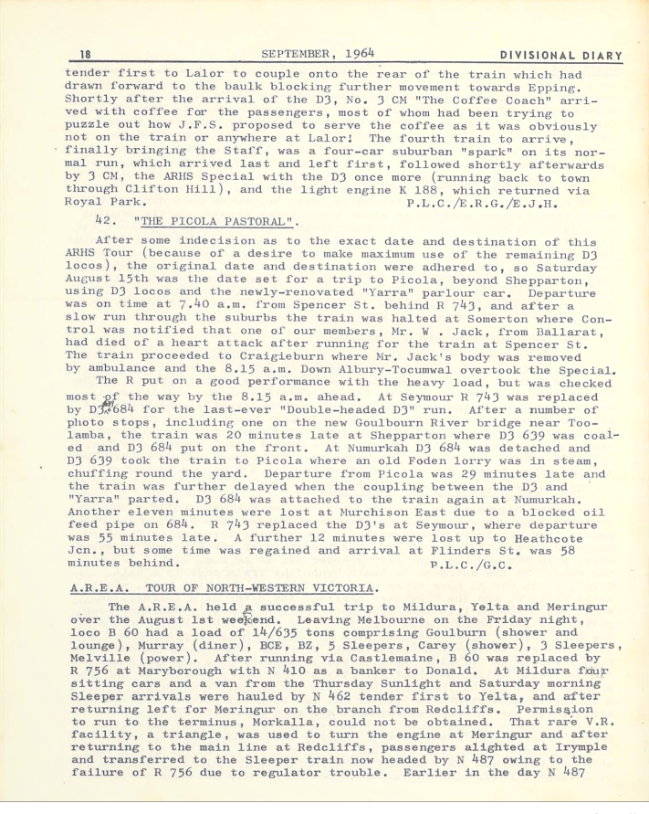

Divisional Diary - Oct. 1964

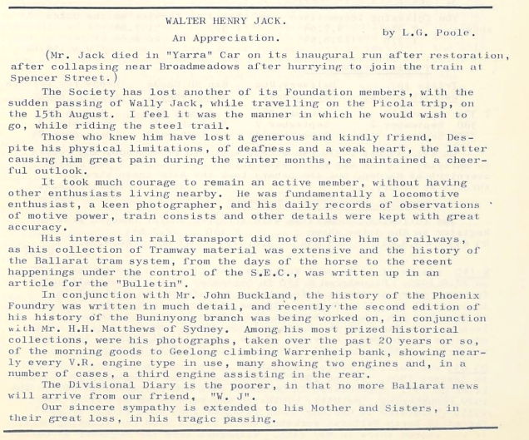

Electric Traction – September 1964
