*Brent Gerstle went to Tiblisi in 2012 where he obtained the Birth Certificate of Bernhard which dates his birth year as 1922.*

*All official documents from the Australian National Archives have 1921 as his date of birth\**

Bernhard Hermann GERSTLE, Tiflis Russia *09/02/1921-13/08/1978 Sydney Australia[1]

Mother: Rosalie PLOOM 1889 - Riga, Estonia

Died Spain 16/04/1982

Father: Hermann GERSTLE 1883 - Russia

Died 1/04/1941 Stuttgart, Germany

Johanna (1912), Edgard (1914), Gertrude (1916), Renee (1918), Bernhard (1921), Willi (1923), Flori (1925), Luise (1929). Johanna, Willi, Flori, Luise died from various diseases

Hermann Gerstle was born in Russia in 1883 to ancestors who had migrated from Stuttgart in the south of Germany. He married Rosalie Ploom born in Riga in 1889 with Estonian nationality. German nationality had been retained by Hermann’s father and Rosalie had to learn German to teach their children as Hermann insisted the children speak the language at home. Bernie had an accent which was probably Russian. Retaining the German nationality had punitive outcomes: Rosalie and Hermann with their children were interned in Siberia during WWI where their first born Johanna died and their removal from Persia and severe disruption to their lives in WWII.

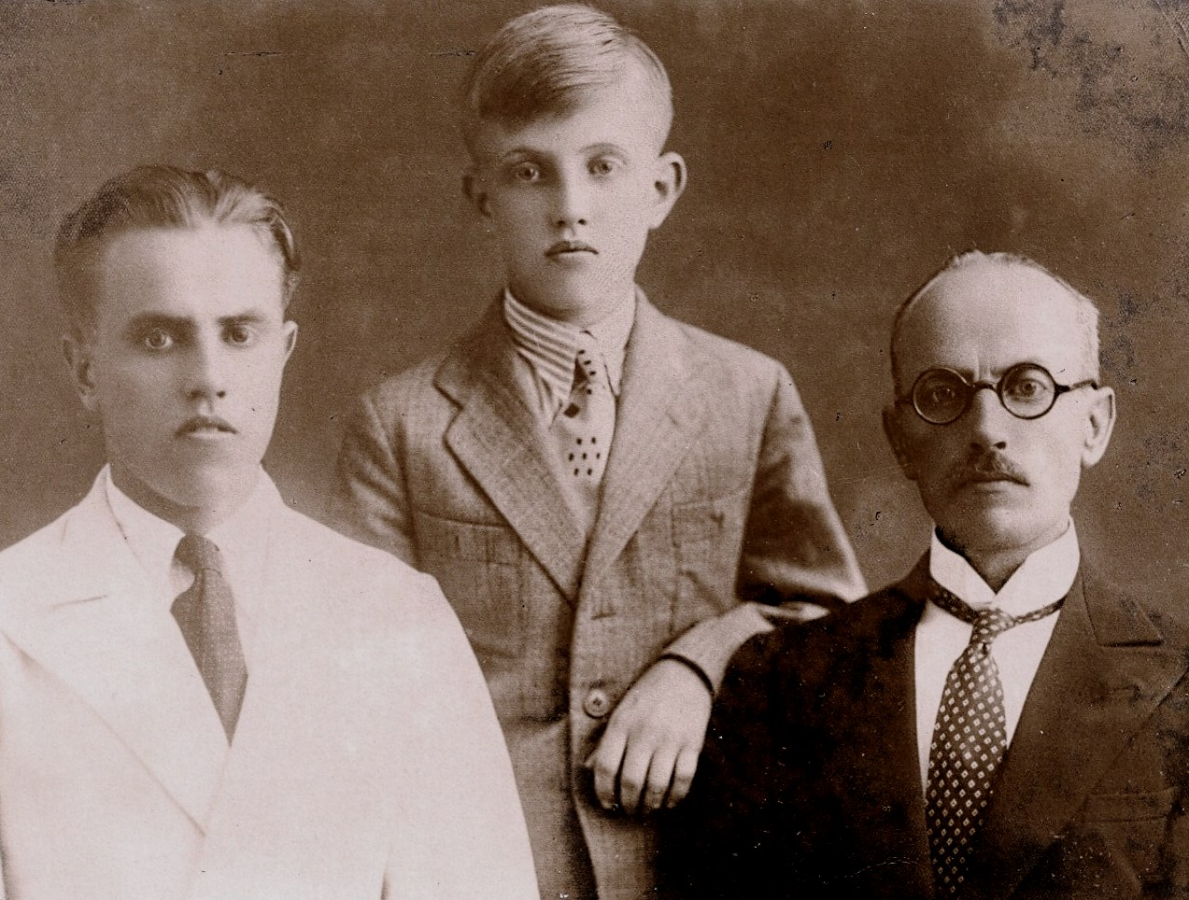

**Russia - Tiflis, Georgia:**

The family lived in Tiflis (Tiblisi), the capital of Georgia in the Caucasus notorious for being the birth place of Joseph Stalin, where Bernie was born on the 9th of February 1922[2]. The communist government’s collectivization of farms and other edicts resulted in extreme famine and the death of countless millions. Bernie can attest to this as he had a deep scar on his foot caused by a coal from the oven which burned deeply into his flesh which he was unable to remove as he would have had to drop the precious bread.

**Iran -** Rosalie and Hermann escaped to Tehran via a circuitous route in 1927/28 with Edgard, Gertrude, Renee and Bernhard and possibly Willi and Flori[3]. All of the eight children suffered from devastating diseases including diphtheria, typhoid, smallpox and cholera which caused the death of the three youngest: Willi, Flori and Luise,

*1940: mountain climbing. Bernie second from right*

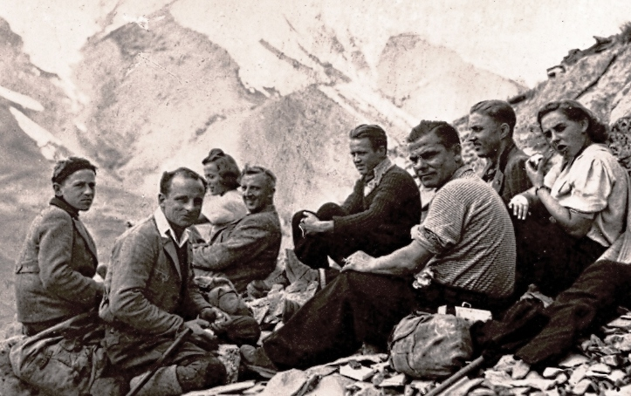

The Gerstle children went to the International school attended mainly by expatriates. Most international firms’ nationals held all the executive positions and were paid many times more than the locals. They were treated with deference with the German Club exclusively for their community.

Bernie talked of a great social life including sports such as skiing and rock climbing and shooting in the surrounds of Tehran with his friends.

Hermann was a chemist whom the family credited with devising a method to prevent bitumen from melting on the roads in Iran‘s hot summers. He suffered from poor health and prior to the British/Russian invasion of Iran was hospitalized in Stuttgart where he died on 1st April 1941.

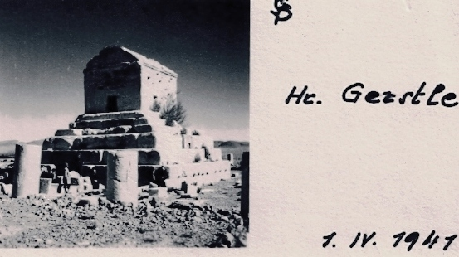

The surviving children told me of his dictatorial attitudes regarding behavior, manners, and respect for elders and of his demands for unquestioning obedience to his authority with excessive punishments meted out for offences. If any of the children ate with outstretched elbows all meals for the following week would be eaten with a heavy book under each arm. Edgar was slapped on the face by an irate father for coming home later than the set time resulting in him leaving home and going to Germany where he enlisted in the army.

Rosalie had a dry-cleaning business in which Gertrude and Renee worked. A western woman running a business in Iran in the thirties must have been extraordinary much more so than for me in the fifties in emancipated Australia. I came to know in the late fifties when Erik Burmeister[4], Commer-cial Attaché with the German Embassy, asked Bernie to provide details of this business as the German government was compensating overseas nationals for property losses. *Gertrude and Renee Gerstle*

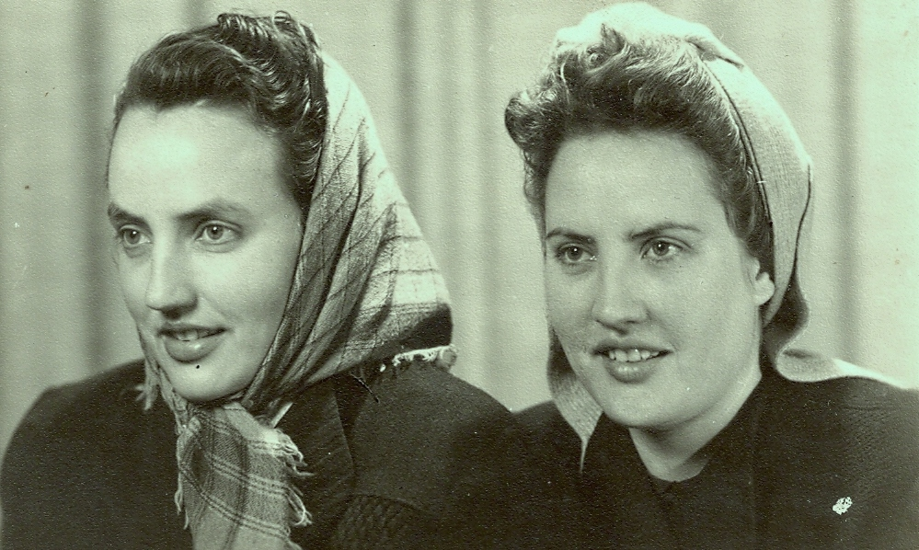

Bernie was a leader in the German Youth movement in Tehran and, with the exception of his father, a Baha’i and a pacifist; all the family believed that Hitler would restore Germany to its former glory. After the start of the war Bernie’s command of Farsi, German and Russian enabled him to translate the news bulletins for the German Consulate. His full time work was as assistant merchant employed by Siemens which was then and again today the largest turbine engineering and electrical manufacturing and installation business in the world. He told me that to do business bribing was mandatory and had personally called on government officials to present them with the keys to a Mercedes Benz with the compliments of his company.

**Invasion of Persia**: (aka Iran *preferred by the British to differentiate it from Iraq[5]*)

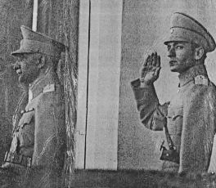

After Germany’s attack on the Soviet Union in June 1941, the British and Russian forces opened up a new front in the Middle East to guarantee supply lines and access to the essential oil supplies of the neutral Iran. Soviet and British[6] troops entered Iran in August 1941[7] and Tehran on September 17[8]. They forced the abdication of the aged Reza Pahlavi who was considered to be pro-German and his son, Mohammad Reza Shah Pahlavi, ascended the Peacock throne on 16th September 1941. *Reza Pahlavi, Mohammad Resa Shah Pahlavi*

The British/Russian forces considered that the German nationals were a threat to security and ordered their removal. After the German Ambassador, Erwin Ettel, witnessed ‘Iranian military taking up positions with machine guns trained on the gates’[9] heprovided communal accommodation at the summer residence at Schimran for the 783 Germans including 260 women living in Tehran[10] As a safeguard Ettel destroyed all secret material and left the 40 watt radio transmitter and the cash of the Embassy in the care of the friendly Japanese for safe keeping[11].

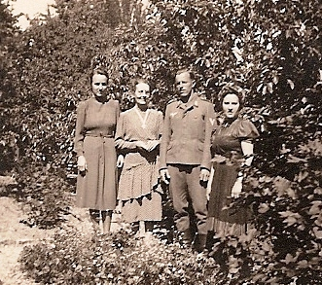

*Gertrude, Rosalie, Edgard, Renee Gerstle*

Rosalie, Gertrude and Renee with the other women and children, accompanied by the Ambassador, the Swedish Consul and five officials of the Iranian Foreign Office, were transported under Russian guard to the Turkish border.[12] Although Ettel had diplomatic immunity he refused to carry small parcels of valuables for the women. At the border they were robbed by the Russians of all belongings leaving them with only the clothes they wore. They were trans-ported by trucks through Turkey to Istanbul where they were accommodated for a week in a pre-war German cruise liner then trained to Berlin[13] then to Stuttgart from where the Gerstle family ancestors originated.

The men in the German Embassy were handed over to the British on the 15th September 1941: Bernie’s official document records 19th September as the date of capture and the date of Internment by the British Authority.[14] The Russians listed only a few men whom they wanted to take for interrogation with the remainder were left with the British Authorities. Franz Koerfgen, joint- managing director of the Persian branch of Siemens, was listed as a person of prominence whom the Russians wanted. Fortunately his name translated into Farsi script was unrecognizable so that he was taken with the other German male civilians by the British Authority.

The males and families, not being repatriated to Germany, were put on a British ship, SS Rona, which sailed from Basra via the Persian Gulf onto Bombay.[15] A famine in India forced a change of plan for the British Authorities who requested the Australian government provide internment facilities for their captives the costs of which they would reimburse.

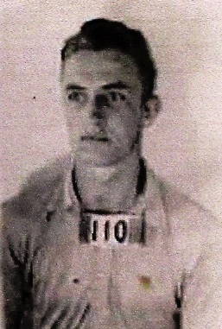

From Bombay they were marched in to the SS Rangitiki, a New Zealand ship via a gang plank placed between the two vessels. Cabins were assigned to the families while nearly 500 men were crowded together.[16] The crossing from India via Colombo to Singapore and from there to Australia had a Scottish Military Garrison with an armed warship steaming in front and two others following behind. They arrived at the Outer Harbour SA on 19th November 1941 and on the 21st November the single men were marched *(Bernie recalled that the soldiers were over six foot)* to Loveday Internment Camp, Barmera, South Australia.

Bernie was accommodated in **Camp 10** where he remained until the Mess Hut was burnt down late in the war and then moved to 14A for a month prior to being transferred to Tatura in Victoria.

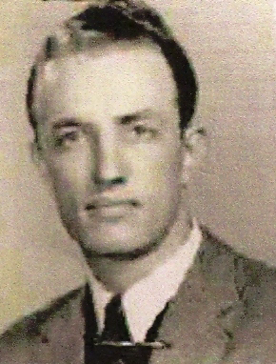

From then onwards, even after release under the Aliens Control Regulations, Bernie was designated as R.36479 and sometimes 66205*.[17]*

*Photos on form - Application for Registration with finger prints of both hands[18]*

**Loveday Internment camp:**

The *Military History, the 4th Military District, Internment in South Australia*, outlines reasons for the construction of the camps at Loveday, South Australia. After the outbreak of war in September 1939 Germans, considered dangerous to the security of Australia, were held in custody. After the fall of France in 1940 and Italy’s entry large numbers of Italians and prisoners of war from the Middle East were detained. The first camps to be constructed were 9 and **10**, each consisting of a camp HQ of forty buildings and a compound rectangular in shape with thirty-nine buildings and a hospital inside each.

**Security:** There were fifteen foot guard towers at each corner of the compound manned by sentries with machine guns, rifles, bayonets and fifty rounds each of SAA with ground patrols operating between the towers.[19] On occasions it was considered necessary to double-staff all posts and patrols.[20] This security seems at odds with the fact that up to one hundred internees at a time were allowed excursions outside guarded by only two sentries who took them to the Murray River for swimming and the surrounds for outdoor activities. Bernie spoke of the size of the Murray cod that he caught and it is probable his love of fishing came from this although his later catches were less impressive.

Internees worked on projects outside compounds and one group working on stone restoration of a church arrived back at the camp after dusk. As no one had been missing at the roll call taken earlier the sentry initially refused entry suggesting that they were at the wrong camp![21] There were no successful attempts of mass escapes and only one foiled attempt after construction of a tunnel at Camp **10** when nearly at the two perimeter fence**.** Only ten men, half being German internees from Camp **10,** ever escaped from Loveday Internment Group**.** No internee from Loveday was at large longer than three days with early apprehension due to the efforts of the late Jimmy James, well-known black-tracker, who lived in the River Murray District.[22]

**Surveillance**: Initially the task of collating information on the political activities, associates and general conduct of internees was entrusted to camp officers but later an Intelligence Officer was posted to Group HQ plus a Staff Sergeant to each camp. The dossier on each internee amassed a great deal of information concerning individuals, political groups and factions.[23] It must have been from this that the *Internee - Service and Casualty Forms* were compiled as the one on Franz Koerfgen noted detention for not answering “Here Sir”. There was nothing noted on Bernie but his advice to his sons “keep your nose clean” was probably learned from experience.

**Nationalities**: “*Each of the three main nationalities held …required special study and a different method of handling and treatment. “The Germans: Arrogant, appreciated strict discipline and firm control. “The Italians: Naturally temperamental, needed firm handling, but once shown who was in control had to be led like a schoolboy. “The Japanese: Subservient, were model prisoners. Their fanatical desire to maintain ’face’ made them easy to handle in their eagerness to obey all orders and instructions to the letter. “For these reasons, it is suggested that where possible people of different races be segregated“[24]* This segregation enabled different rations to be arranged for each major nationality: the Germans were given Australian Armed Forces diet; the Italians wanted more bread and spaghetti and the Japanese smaller quantities with less meat but more rice.[25]

**Hospitals**: Compounds 9 and **10** each had a twenty-bed hospital which was not adequate for anything more than minor ailments. Late in 1941 “*Hitler’s Tourists’ arrived from Iran and brought with them much Malaria and Amoebic Dysentery. This latter disease necessitated ‘dramatic action’ to safeguard the residents of the district from infection and contamination of the water supply.”[26]* Fly-proofing of kitchens, meat huts, hospital and latrines resulted in the incidence of sickness being low throughout the internment at Loveday.[27]

**Work**: Under the Geneva Convention a civilian internee need not work, unlike Prisoners of War who must if ordered, but those who wished to work were paid one shilling per day. Authorities claimed that, apart from being a big saving to the taxpayer, the cheap labour materially assisted the smooth running, administration and health of the internees and that employed men were healthier and happier and less inclined to complain of their internment.[28]

The German and Japanese Governments made available pocket money for their indigent nationals which were received through the agency of the Protecting Power. Each German was given ‘*Three pounds per quarter on signing to be true to the Reich and their request for repatriation to no other country than Germany“[29].*  The Authorities were of the view that receipt of this money was the reason that many did not accept work as this was sufficient for personal necessities such as tobacco.The first employment was camp sanitation and removal of faeces previously done by the Barmera District Council[30] which was probably a greater disincentive as when more jobs such as working in the hospital became available they were sought after.  *Loveday - Camp 10 Hospital*

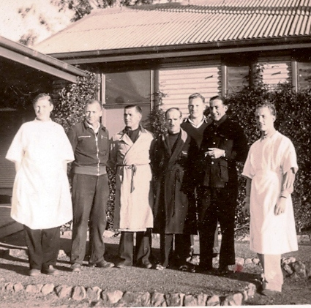

A German internee - *far left* had privilege to select internees as hospital orderlies and Bernie *(far right)* became one of them. Several internees were doctors and an Italian, Dr Tessie from the Iranian group rendered valuable assistance throughout his three years with his knowledge of some of the rarer tropical diseases.[31] The *Military History* states that after the influx of internees sent by the UK to Camp **10**, when overseas events were in favour of the Axis, that “… *medical work was impeded. An entire lack of co-operation was evident. Subtle forms of sabotage as well as actual destruction of equipment were practiced.”[32]*

**Projects**: A wide range of vegetables, pyrethrum for insecticides, opium poppies for morphine, Mexican guayule shrub for production of rubber was grown. The Vegetable Seed Committee grew varieties and quantities of unprocurable and urgently needed seeds for army and civilian use. The piggery and poultry undertakings provided quantities of meat and eggs. Listed are the quantities and production values: the largest produce was about 38% for vegetables, seed and research crops and a similar percentage for firewood, posts and sawn wood, pigs (9%) and poultry and eggs (4%). Ordnance projects such as repairs to tents, blankets; horse rugs, etc. were given a value but boot repair and the considerable work in the hospitals, canteens, repair of machinery, construction and outside work was not quantified.

**Currency**: Printed paper coupons were issued when money was withdrawn from the Camp Paymaster but coupons were discontinued in July 1943 when specially minted metal money consisting of 5/- 2/-, 1/-, 3d and 1d was issued.[33] This token money was used in canteens, staffed by internees under supervision of Australian Army Canteen Services, which were stocked with fresh fruits in season as well as normal canteen items. A percentage of the profits, upwards of 100 pounds per camp per month, were made available for sports materials and amenities, and to pay internees doing work in the camp which was not covered by the Department of the Army.[34]

**Recreation**: In each compound a recreation hut was used for hobbies, for billiards and table tennis and there were areas for football, cricket, baseball, hockey and bowls. Internee labour constructed tennis courts and a distillery at Moorook was salvaged, transported and built into a Recreation hall. This opened on 20 October 1943 where fortnightly dances were held with music by the camp orchestra and monthly entertainment was provided by Army Amenities Concert parties from Adelaide.[35]

**Camp 10:** Bernie arrived at Camp **10** in Loveday, South Australia on 21/11/41 when he was eighteen years of age and remained there until 24/01/45.[36] The difference in the lives of his sons, Gary and Brent, at a similar age bore no comparison but he comforted himself by appreciating that his life had been far preferable to that of his mother and siblings. He had a community, referred to as ‘college’, where he made many friends, was well fed, educated by professors, played chess, soccer and hockey. His mother and sisters had been sent to a foreign country with only limited command of the language where they had to work wherever ordered in a bombed, war torn Germany with little food and no support. Edgard, in the German army, was captured fighting at Stalingrad, and endured five year’s incarceration in a Prisoner of War camp fearful that his captors would summarily shoot him as a traitor should he give any indication that he had been born in Russia. When released more than a year after the capitulation of Germany he weighed less than six stone although he was 6 ft tall.

By 1 March 1942 the total of six internment camps held 3961 internees[37] with camp **10** holding 764 men.[38] By 15 May 1943, after more camps had been built to accommodate the Japanese, camp numbers had increased to 5382, but Camp **10** had declined to 619 persons.[39]

The accommodation of the sleeping huts in camp **10** were 60 ft x 18 ft with bunks down the centre which were subsequently replaced by beds made by internee labour.[40] This compound housed United Kingdom Germans and Italians, local Germans, Germans and Italians from Persia and Palestine, Russians, Finns, etc. Many were engineers whose skills were used to construct a tunnel, the only attempted mass escape recorded, which was already at the two perimeter fence when discovered and a mass breakout prevented.

On 7th December 1944 a large Mess hut in No **10** compound was razed by fire.[41] The authorities were of the opinion that “*This compound had, in all probability, been one of the most difficult and dangerous in Australia as its inmates were overseas Germans - most of whom were ardent Nazis*“.[42] The remaining internees, 608 Germans and Italians, were transferred to 14A compound which housed local Italians[43] where Bernie was assigned to hut 61with hut leader Karl Haegole. In January 1945 all internees at Loveday were sent to Tatura Internment Camp in Victoria.

By VE Day, 8 May 1945, only Japanese internees were held in Loveday camps and the effect of the surrender of the German Armies was not materially noticeable.[44] There were 115 internees, 7 of whom were German, who died whilst detained at Loveday Internment Group and are buried in the Barmera War Cemetery - Internee Section.[45] The South Australian Internment camps were closed on 28 February 1946 when only two German internees, inmates of mental hospitals, and one undergoing civil detention remained.

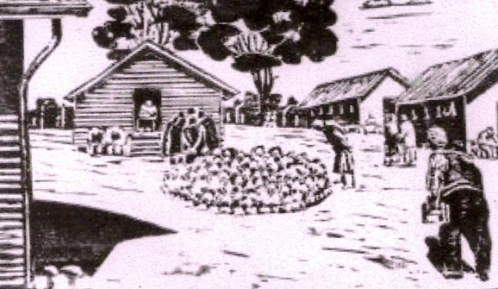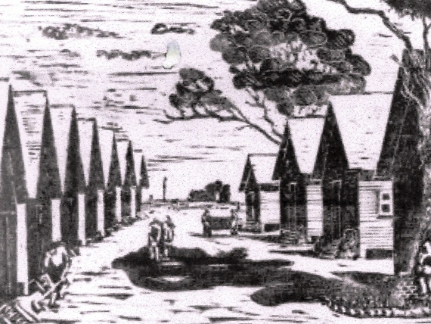

**Tatura Internment Camp:** (*-*

After arrival at Tatura on 26th January 1945, Bernie was housed in Bcompound, camp 1, hut 3, hut leader Dr Gottfried Eissfeldt, Manager AEG Electricity captured 13th September 1941 at Alwaz.[46]

*16 March 1945. German internees in B Compound, No 1 Camp Tatura Internment Group. Back row left to right: R36479- Bernhard Gerstle,unidentified, R36853 Dr Wilhelm Eilers last men unidentified. Front row: unidentified; R36454 Hermann Exeler, N1114 Dr Gerhard E.W. Neumann, two men unidentified.*

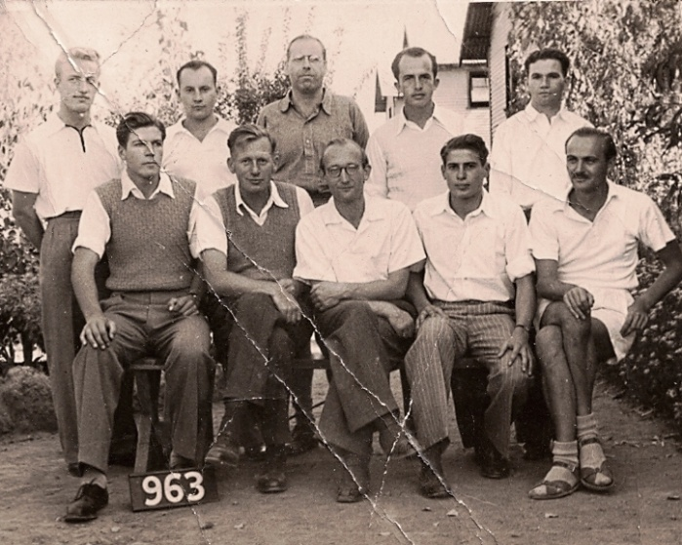

(*Prefix* ***R*** *indicates apprehended by the British Forces in* ***Iran*** *Prefix* ***N*** *indicates apprehended in NSW*)

The camp was in a hollow on six hectares of land, surrounded by two high fences of spiked wire with coils of barbed wire between them. Four gates in the carriageway gave entry to four diamond shaped compounds: A, B, C and D where Jewish people were housed and was shut off from the others.[47]

The arrival of the internees at Tatura at the beginning of 1945 was at a very different time from when they entered Loveday more than three years earlier. In November 1941 Germany and the Axis were winning the war and the USA, while providing armaments, only declared war after the bombing of Pearl Harbour on 8th December 1941. Now the war was virtually over with German armies defeated and the country in ruins. A few months later with the German unconditional surrenderon 8th May 1945 the European conflict came to an end. The internees were demoralized and contemplating very uncertain futures.

Each internee was examined for their political status before a Committee of Inquiry presided over by Justice Simpson, a judge from Tasmania, examined possible deportations for Nazi die-hards, those who wanted repatriation and those wishing to remain in Australia.[48] Any with contentious claims were released later after investigation by Judge Hutchins. Bernie was released on 29th August 1946 fifteen months after the European war ended at the same time as many of those removed from Iran.

The majority of internees who stayed in Australia settled in Melbourne but Bernie went to Sydney. The Commonwealth of Australia, National Security (Aliens Control) Regulations forms *Notice of Change of Abode* states that on 30th August 1946 he was living at 32 Nithsdale Street Sydney, two months later he was at 72 Stanley Street, East Sydney and on the 11th December 1946 relocated to the Hotel Lapstone.[49]

Bernie’s first job was washing up at Dungowan, a large Italian restaurant in the basement in Martin Place. He was elevated to food waiter and although tipping was not customary in this restaurant he often received *shrapnel*[50]. This he utilised in a clenched fist to good effect late one night when attacked near his residence in east Sydney, a notorious area inhabited by sellers of sly grog, prostitutes and under-world characters. He relocated to the Hotel Lapstone working as a waiter but stayed only seven months before moving back to Stanley Street.

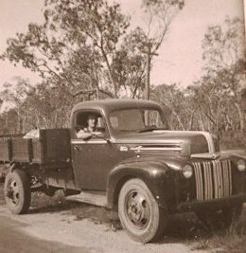

**Exploring & Mining in Northern Territory:** Bernie travelled with an Italian *college friend* who had lived in northern Queensland before intern-ment. An old prospector guided them to an area in the Northern Territory where he claimed was a lode of tin just there for the taking.

They travelled through rugged country for months and spent several weeks sluicing for tin. The isolated mine, while a memorable experience, could not be commercialized but he never gave up the idea that there was money to be made from mining and thought of Australia as a huge mine and had the illusion that he would find his Eldorado. He took sand from beaches, including Killcare, and had it analysed for rutile and other minerals. His interest in the stock market sparked mine but his only dabbles were in mining stocks and held one or two small parcels of *penny dreadful* when he died. A much appreciated Christmas present on the tree was script of a few hundred Santos shares.



After his long confinement Bernie made good use of his freedom and, whilst he didn’t kiss and tell evidence is not needed to assume that he made up for lost time. *Franz Koerfgen and Bernie Gerstle with dates*

After returning from the Northern Territory Bernie was re-employed as Maitre d’/Assistant Manager in charge of staff at the Hotel Lapstone. He enjoyed working there and told stories of the United Nations convention held in 1948 when his command of English, German, Russian and enough Italian to be understood was utilised. He had no opportunity of using Farsi except for the early get-togethers with one or two Iranians who stayed in Australia after internment.

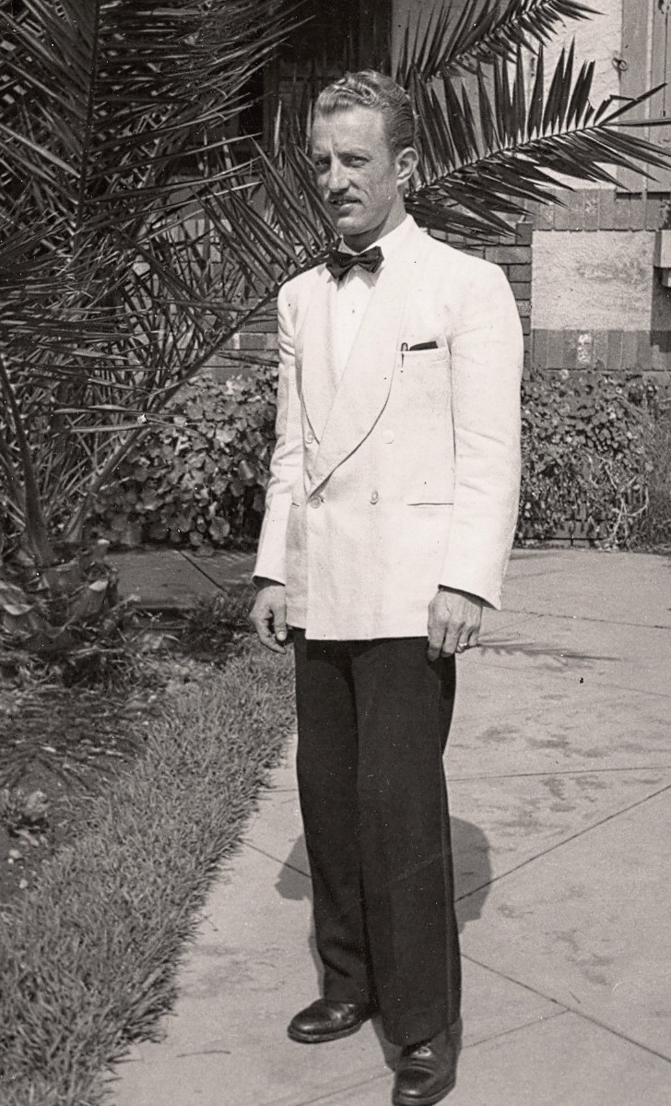

On 15th March 1952 Bernhard Gerstle and Mary Henderson married at 9.30 a.m. at the Sydney Registry Office. After a champagne toast and sandwiches the guests joined the cavalcade to the Quay where we boarded the Lloyd Triestino’s *Oceania* which sailed for Europe at 12 noon.

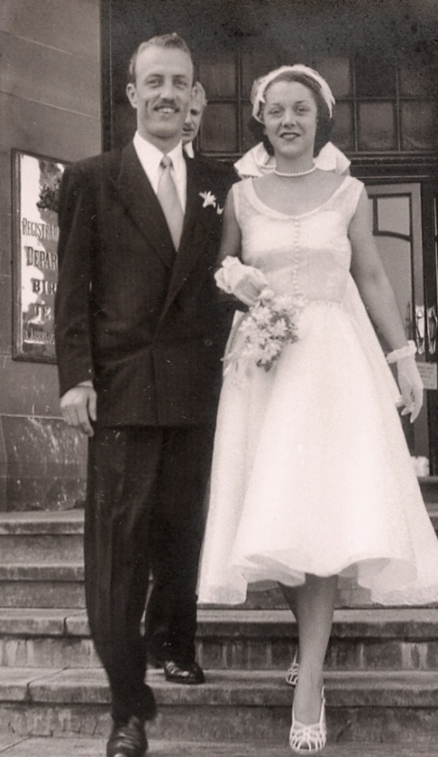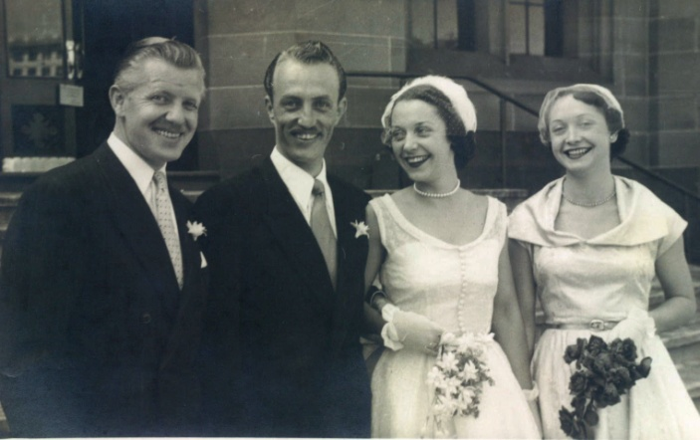

We spent six months in Europe: Italy, Switzerland, Germany, where we stayed with the Gerstles in Stuttgart.

Franz Koerfgen[51], a month after being best man at our wedding in Sydney, travelled to Germany to rejoin the phoenix of Siemens, his former company of which he had been joint managing director in Iran. Already given a prominent position, he tried to persuade Bernie to rejoin the old firm. Bernie spent considerable time at their head office in nearby Erlangen where management promised that his internment would count as service/seniority and that he would be given a good position in a rapidly expanding company.

I was happy to stay in Germany as, apart from my small business, neither of us had commitments in Australia. This was a good offer to which Bernie gave consideration but decided that there were better opportunities in a young country with a shortage of skilled people. He preferred the egalitarian attitude in Australia where family, education or connections were of less importance than they were in Europe. He felt more alien in Germany than in Australia even though here he had been classified as an enemy alien during and many years after the war.

After a stay of over six weeks in Germany, and Bernie declining the offer from his old firm, we continued our journey and toured Italy, Germany, Switzerland and France. In Scotland I visited my mother’s family (Beattie) in the Inverness region and my father’s family (Henderson) property ‘Newark’ near Dumfries in the south.

After our return to Australia Bernie did many different types of work and in 1956 joined Wyeth Pharmaceuticals as a medical representative effective 1st January 1959 By the end of 1960 Bernie was confident that there were career opportunities in working for Wyeth shown by his 1961 New Year resolution which I wrote down in my old Trip book: *“Bernie’s 10 year plan: GOAL - Managing Director Wyeth” with t*he following listed*: “1. Spelling & Correspondence 2. Social activities, Clubs etc 3. Sales Management course”*. When I demurred, pointing out that there were many more qualified than he and questioned how this could be achieved, he assured me that that was merely detail having the goal was vital, a strategy would follow.

In July 1962 he became Assistant to the General Manager, 1st April 1963 Aus/Asian Sales Manager, and on 1st January 1967 Managing Director. Only eleven years with Wyeth, starting at the lowest rung of the ladder, Bernie achieved the goal he had set himself in a little more than half the time!

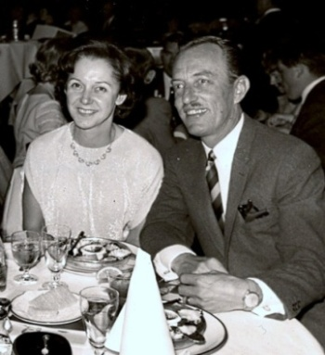

*1967: Celebrating Bernie’s promotion to Managing Director*

When Bernie became M.D. he was an active participant in industry Associations which was part of his strategy outlined in his *Ten year* plan*.*  He was a member of APMA Public Relations Committee from August 1971 to July 1977, and its Convener and Chairman from August 1974 to July 1977, and a member of the Councl of the APMA from July 1974 to July 1977.

October1975 Bernie made his annual trip to head office and as usual broke his trip in San Francisco. After checking into the *Top of the Mark* hotel he felt unwell and took a bath. Realising that he was having a heart attack he crawled out and phoned reception.

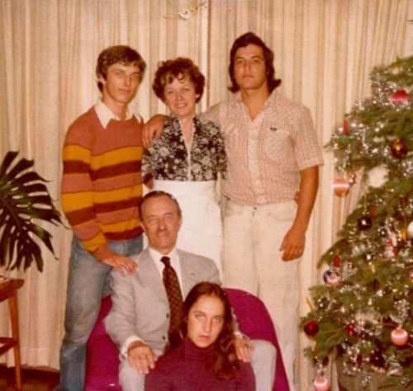

I flew to be with him fearing that he would not recover but after six weeks hospitalisation brought him home to Killara. Christmas that year shows Bernie frail, thinner but in good spirits and all of us pleased that he was home.

*Gerstle family: M Brent,, Mary, Gary, Bernhard, Tanya*

Bernie resumed work and tried to maintain his work load including chairing the APMA Public Relations Committee which required frequent trips to Canberra.

Eighteen month’s later he had another coronary. In 1978 Gary drew my attention to the fact that his father had ticked off the last item on his list of things to do that he had been been working through. That Sunday around 9.00 p.m Bernie had his third coronary while we were watching “*the Godfather*” on TV.

Gary gave his father mouth to mouth resuscitation until the ambulance arrived and the medics took over and drove to the Hornsby hospital. Gary drove me to the hospital but Bernie never regained consciousness - his death certificate states DOA. Tanya and Brent were located by Giselle and Megan and were able to see their father but none of us had been able to say our goodbyes.

The funeral was arranged for the 16th August at the Northern Suburbs Crematorium for 10.10 a.m. Reverend Walther, Presbyterian minister, read the Eulogy which spoke of his youth and the Gerstle family in Germany, growing up in difficult times, his journey through life and his children. Gary Berhard Gerstle, Martyn Brent Gerstle and Tanya Peggy Gerstle. I wrote the Eulogy and asked the children to amend or add to it if they wished, and Tanya asked that I include mention of his personal discipline.

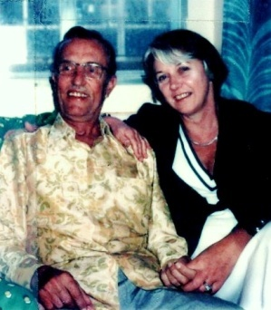

The written Eulogy has not survived, but a controversy over whether a naturalised citizen is equal to an Australian born here and should be treated the same prompted me on 2nd February 2011 to send in the following to the Sydney Morning Herald ‘*Letters*’:

*“ ....... Bernhard Gerstle was born in Russia, his father was born in Russia but had retained German nationality, his mother was Estonian who had to learn German to teach her eight children. During WW2, Bernie was removed from Iran where he grew up because of his nationality and interned in Australia for five years. He stayed here, became naturalised and was a great supporter of the Australian way of life and willingness of the people to share their great country with those seeking freedom and equality. The eulogy stated “Bernie was brought here against his will, but he became a proud Australian and taught many of us who took much for granted, to appreciate our good fortune.”*

The funeral was attended by many executives of Wyeth from here and overseas, heads of pharmaceutical companies, as well as members of parliament and of the various committees on which chaired or sat. Many friends attended the funeral with over one hundred signing the Memorial book and many more *were noted.* After the ceremony several came to Killara for refreshments.

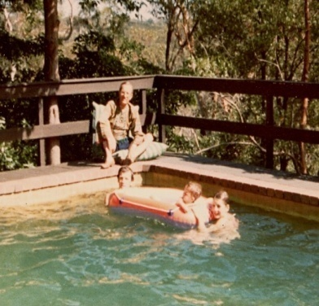

The countless flowers sent to our home and those at the Crematorium were forwarded to the Hornsby & Ku-ring-gai Hospital, while several people donated to the Heart Foundation.

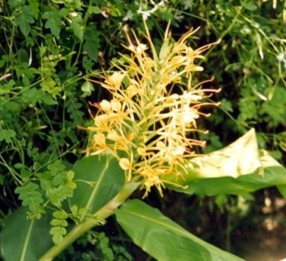

Bernie’s ashes were scattered on a ginger plant under the deck of his favourite spot where he frequently sat.

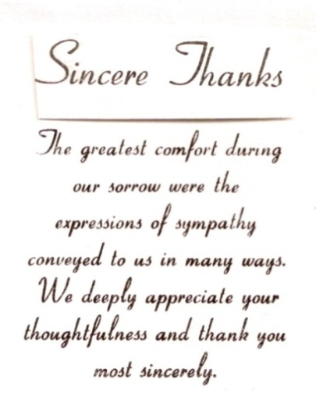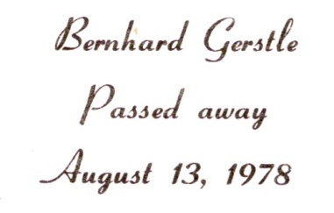

Gary, Brent, Tanya or I signed and wrote a personal thank you on inscribed cards.

1. All these dates are doubtful
2. Birth certificate obtained by Brent from Tiblisi

   gives 1922. All other documents give 1921.
3. Bernie’s hand written note has these ages, but

   they differ from Gaby’s
4. Erik Burmeister was from Hamburg and headed up a company in Tehran and spent the war years in Loveday and Tatura camps. His wife and son migrated to Australia after the war. Erik was overseas when Bernie died. As his father lived till over one hundred he may still be alive.
5. H.S.Northcote’s Biography “*The Linkup: Anglo-Soviet Invasion of Persia*” p642
6. P W Fabry P3 The attack on Persia’s sovereign rights “Churchill appears to have had no scruples” despite that is was “a direct breach of the principles on which England had declared war on Hitler”
7. Philipp W Fabry ‘Decision in Persia’ p2
8. ’The Linkup” p643
9. Ibid
10. Decisions on Persia p8 p4 he states that in **1939** there were **750** including **369** women and children
11. Ibid p7
12. ‘Decision in Persia’ Phillip W Fabry p13
13. Ibid p13
14. Australian Military Forces, Report on Prisoner of War
15. ‘Sing Me That Lovely Song Again’ Helga Griffin p76
16. Ibid p77-78
17. Ibid *(R indicated captured in Iran)*
18. National Archives of Australia
19. Military History p21
20. Ibid p19
21. Edgard Meinke as told to his son Albert Meinke with whom I had a long conversation.
22. Tatura & District Historical Society p13
23. Ibid p13 *Loveday - Camp 10 Hospital* 
24. Ibid p10
25. Ibid p15
26. Addendum letter from SMO Aus Camp Hospital
27. Ibid p14
28. Military History p16
29. Ibid p17
30. Ibid
31. Addendum letter from SMO Aus Camp Hospital
32. Ibid p1
33. Ibid p14
34. Ibid p12
35. Ibid
36. Australian Military Forces ‘*Internee - Service and Casualty Form’*
37. Military History pp6-7
38. Ibid p1
39. Ibid p7
40. Ibid p11
41. Ibid p8
42. Ibid p8
43. Ibid p15
44. Ibid p9
45. Ibid p13
46. Tatura Museum records provided by volunteer historians Lurline & Arthur Knee
47. ‘*Sing Me That Lovely Song Again’ p86*
48. ‘*Sing Me That Lovely Song Again* 150
49. Commonwealth of Aus, National Security (Aliens Control) Regulations
50. ‘Shrapnel’ slang for coins as they made holes in your pocket. A Globite case

    with slot was used for storage and when counted were a considerable amount.
51. Franz Koerfgen, born in Strasburg, Elsass on 4/04/1907, was taken captive in Tehran. He was listed by the Russians as a person of prominence whom they wanted to interrogate. Translated into Farsi script his name was unrecognisable with the fortunate result that he was taken with the other German male civilians to be interned in Australia – firstly at Loveday and near the end of the war at Tatura. Franz subsequently headed up Siemens once again in Iran and lived there with his wife he met in Germany after the war and their son.