Nancy Yvonne Bolch

(Her own life story)

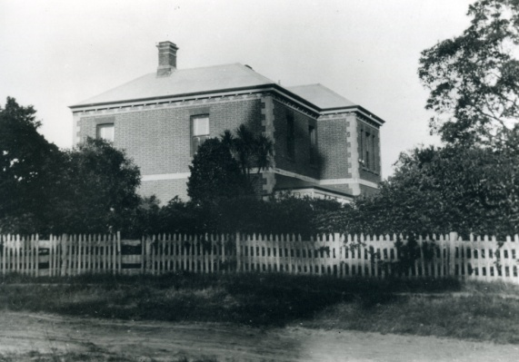

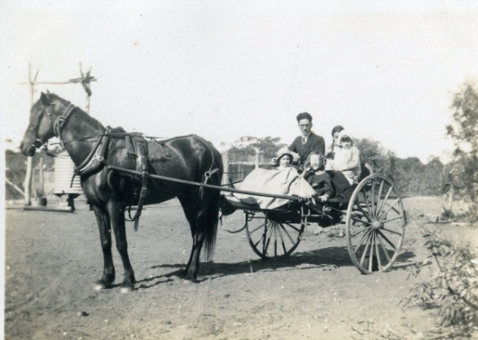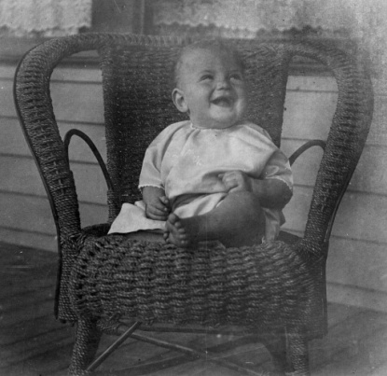 I was born on May 1st 1926 at Merlin Private Hospital Langhorne Street, Dandenong to Len and Melva Bolch (nee Thompson). My father was a carpenter and built our home at 34 Hammond Road Dandenong. At six weeks of age I developed an extreme case of eczema and my parents decided against having any more children who might also get eczema. Mum took me to the Children’s Hospital by train twice a week for over a year.

Dad had a motor-bike and sidecar in those early years. When I was about 4 years old he bought a Willys Knight car. The first trip I can remember was up to Nurrung in the Mallee to visit friends. There were children older than me and one day they took me to school with them. The teacher boarded with them and drove a horse and jinker to school. I remember wanting to go back to Mum but they kept me happy with crayons and paper.

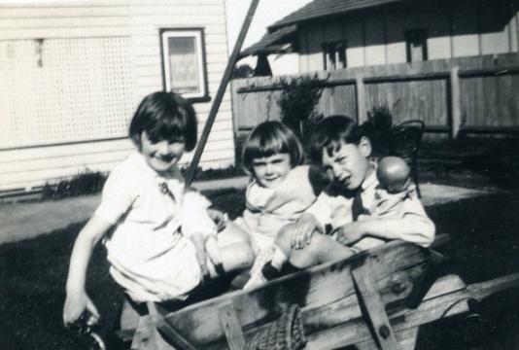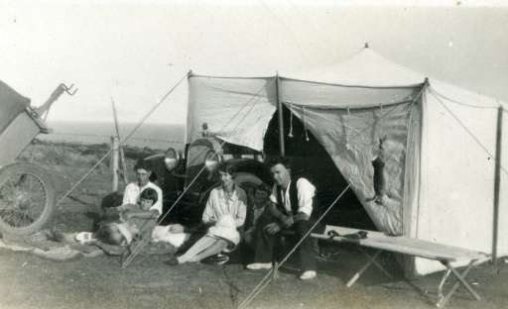 My parents sewed a heavy duty canvas tent on an ordinary sewing machine and Dad made wooden tent poles and we had many happy camping experiences. The tent was still perfectly good 30 years later.

Although an only child I was lucky to have my two cousins, Noel and Joan Dunn living two doors from us. Noel was 6 months older than me and Joan was 18 months younger. We were constant playmates until they moved to Dandenong North in about 1937.

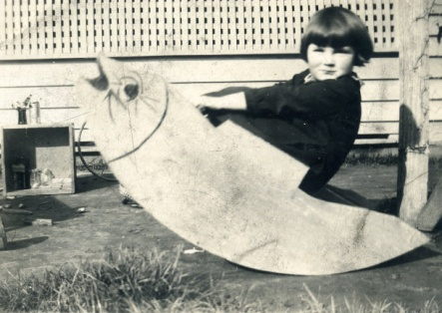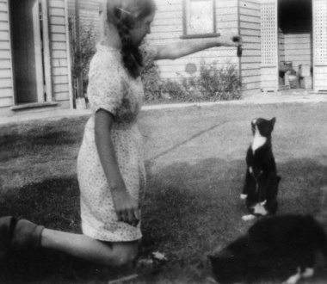 My father was always making things for me and I remember a very large leather schoolbag which never wore out. In later times it carried our fishing tackle. He made a lounge suite for my dolls, upholstered with car upholstery. He also made one for Joan. He made me a yoyo, a spinning top and a hopscotch taw. Also a rocker painted like a fish for me to rock in. There were open paddocks at the back of our home and Dad made kites for me. One was huge, taller than me. I used to fly it and tie it to the back fence when I went in to lunch and it would still be flying when I went out again. He also made a large box kite. Did he have as much fun as me? Dad also built a very nice bird cage and I had canaries for many years. My other pets were two black and white cats, Topsy and her son Rastus. Dad gave Rastus to an orchardist at Narre Warren North but Rastus walked home again so we kept him. I taught Topsy to do some tricks like jumping through my arms.

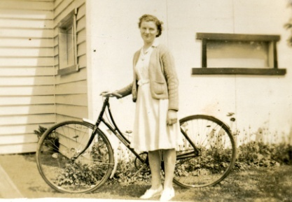 I remember my first day at Dandenong East Primary School No.1403. I thought the cloak room looked a bit like a milking shed. This was because I had spent a lot of time at Willow Vale, my mother's, uncle's and aunt 's farm at Lysterfield and I was used to being in the milking shed. I loved school and remember my 2nd grade report stating that I was "Doing very well scholastically but Nancy could never be described as being as quiet as a mouse." The teachers said I could be a school teacher, not my desire at all. However I did the professional course at Dandenong High School, but in year 4 my parents could see that I only wanted to work in an office and allowed me to go to Reed's Business College in Melbourne for 6 months.

I had piano lessons, first with a lady just across from the school and then at the local convent. I passed playing exams and also Theory & Perception.

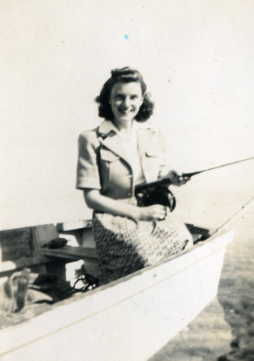 Dad taught me to drive our 1926 Dodge sedan when I was 16 and at 17 I passed my driving test. Before then I used to tow our trailer with a wooden boat on it down to Sunnyside (near Mt Eliza) and we used to go fishing, catching many a bag of flathead and other fish. I have driven many makes of cars and 4WDs since then but I still fondly remember the dear old Dodge.

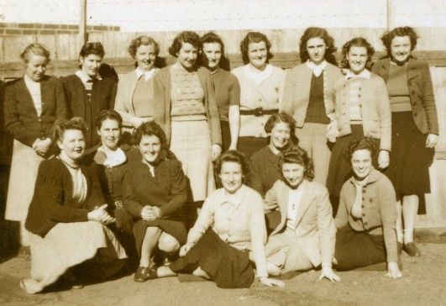 Having finished business college, I put in for a job in the office at the Dandenong Bacon Company. Luckily I did not get the job, but started work at the State Electricity Commission office in Lonsdale Street Dandenong. I was 16 years old when I started work and World War 2 had been on for 3 years and most of the young men were in the services. There were more girls working in the office as the men went off to war. We were to lose several of the men while serving. I worked at the SEC for 6 years.

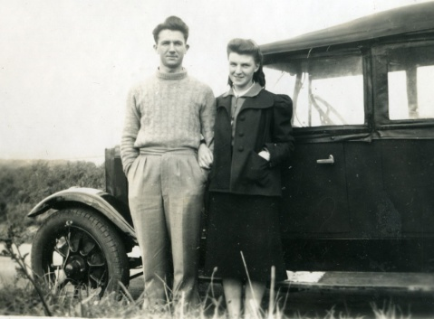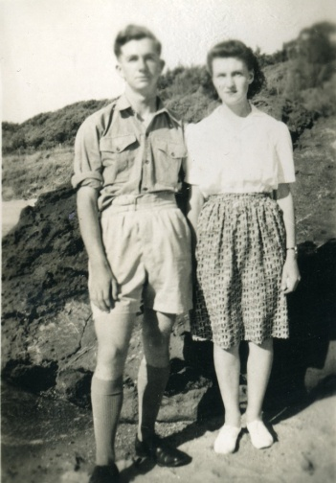 I had not been at the SEC very long when we had a first aid demonstration and I was a “patient” that day. A young man from the meter and test room, Bill Brooke, decided I would make a nice girlfriend and the rest is history. Our first date was to Luna Park on my 17th birthday and a week later Bill turned 18 and joined the Royal Australian Air Force. He was stationed in various areas of Australia for a couple of years, working as a flight mechanic. Whenever he had leave we spent time together and then he was posted to the Pacific area and then Labuan Island off Borneo. The war was almost over but there was a lot of cleaning up to do and Bill was discharged in 1946 after a year away. I joined the Volunteer Air Observers Corps during the war and, after some training, was given 2 hours a week off from work to climb the tower built behind the Dandenong Fire Brigade station to identify any aircraft flying in the area and ring the appropriate officials in Melbourne.

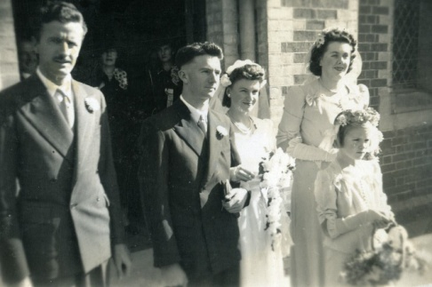 During the war Mum and I knitted for the Australian Comforts Fund. We knitted socks, balaclavas, etc for the soldiers. We sat with our feet in the open door of the wood-fired oven in the winter. We could each knit half a sock each night. We also both did a lot of embroidery for my “box”.

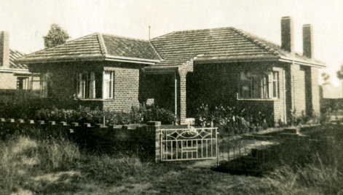 Bill returned to work at the SEC and we continued to enjoy life. Saturday night dances at the "local trot" at Dandenong Town Hall were one of our great enjoyments as were the "flicks" at the old Boomerang Theatre. Bill bought a Morris Cowley car and we had some great trips with that, although petrol was still rationed. Life for us was wonderful. We became engaged and on May 1st 1948, my 22nd birthday, were married at Scots Church in Dandenong.

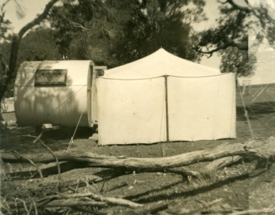 Bill had bought a building block on the black market, in Ann Street Dandenong not long before we were married and our small house was nearly finished when we came home from our honeymoon in Adelaide. It was a hard time to build. Building supplies were in short supply after the war and you were only allowed to build 12 squares. However it was our first home and we loved it. We soon had a garden on the go with flowers and vegetables.

Then came our children, Annette in 1949, Susan in 1951and Sheryl in 1953. What a thrill each one was for us. During this time we changed from our Morris Cowley to Bill's parents 1937 Chev and our caravan trips began. At first we had to hire vans, then Dad bought a van and we borrowed that. 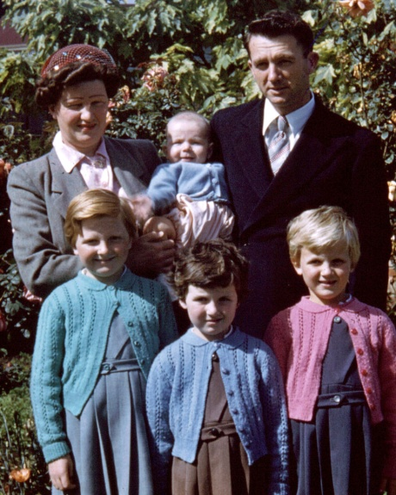Bill and his father added a big playroom onto the back of our house in 1952. As the girls grew we decided we needed a bigger home and we bought a block in Jones Road Dandenong West and built a 3 bedroom home there, only a few doors from Dandenong West Primary School. In 1957 we had our 4th child, a son Rick. It was wonderful for all of us. The girls had a little brother and our family was complete.

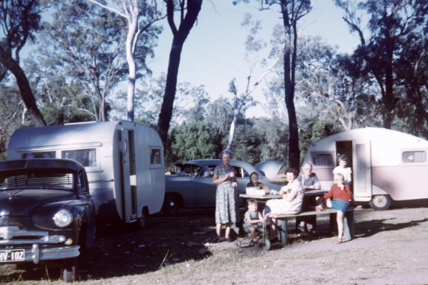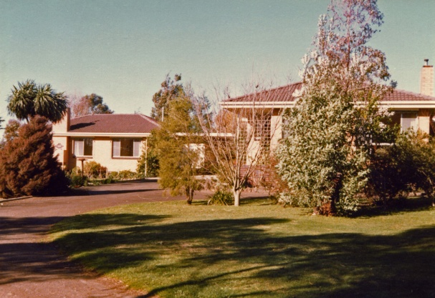 During the years we lived there we had many great caravan holidays, always quite hectic with 4 children. Then in 1961 Bill took 10 weeks long service leave and we hired a van. With my parents in their Vanguard car and towing their caravan we headed for Queensland. We took the girls out of school with the headmaster's permission and off we went. We managed a caravan trip every year and that was not easy with 4 children. Every time I would say "never again" but in 12 months I was ready to take off again. Sometimes we went to Mallacoota twice in the year. They were the easy trips as once settled in it was all good.

We were at Jones Road until 1968, when we again moved and built a larger home on 5 acres at Hampton Park. My parents were going to live on the block also and their home was well on the way when Dad suddenly passed away on 29th August 1969, a day before his 69th birthday. We took Mum from Hammond Road after 45 years there and we shared a shed and two caravans until both homes were finished.

During the children’ school years life was very busy. I was in mothers' clubs, did canteen duties etc. The girls all learnt dancing and every year there were costumes to be made for the end of the year concert. I made three of some costumes and there were quite a number of items. Sue also did gymnastics. Annette learnt to play the piano accordion and Sue the guitar. We joined Rick up in the Cubs but he hated it and did not go into Scouts. Bill took the children to Sunday School doing three trips every Sunday.

As the children grew older we began travelling without them, around the western half of Australia in 1972, New Zealand in 1973 and in 1974 Bill and I went to Singapore and Kuala Lumpur then Sabah in Borneo, Brunei and Labuan Island where Bill had spent most of his overseas time with the Air Force during World War 2. We were treated as VIPs as the Australian services are remembered and highly thought of by the locals there. Bill found where they had camped on Labuan and it was now an orchid nursery.

In 1976 we did our big overseas trip. Four months this time, our dream for many years. We flew to San Francisco, spent time in Reno with friends, visited Disneyland, trained it through the Rocky Mountains from Denver to Salt Lake City, saw the Grand Canyon and up into Canada. We went part of the way by train across Canada stopping at my pen pal's home on the way, then on to Toronto and down to Niagara Falls, Washington and New York. From there we went to London and hired a car for 2 weeks. After a bus trip through Scotland and a few days in London we were exhausted and very ready to fly home. We came home with hundreds of colour slides. We decided it was definitely not a holiday but a most wonderful trip.

While staying with Bill's cousin, Betty and her husband Vern in Pocatello, Idaho, we had a very lucky escape. They took us out for the day up to see the Teton Mountains in Montana. We were to stop in Sugar City for lunch but when we arrived there it was still early so Vern decided we would go on up to the next town. While having lunch in a cafe the Sheriff's car went rushing past with siren sounding and we heard that the Teton Dam had burst its earthen walls and had washed most of Sugar City away. There were many deaths and the Snake River flooded. A picnic table by the river in Pocatello where we had a picnic the day before was well under water later that day. However we did see the beautiful snow covered mountains.

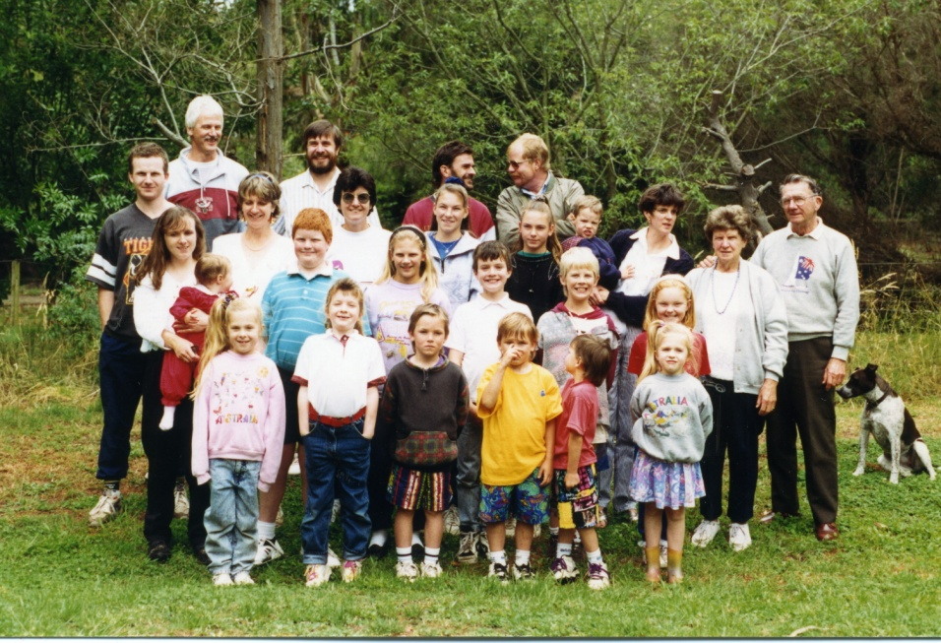 In 1974 the first of our 14 grandchildren was born. What a thrill. A new stage of our life had begun. Bill and I welcomed them all with love and pride and over the years they gave us much love, pleasure and fun.

We continued our travels around Australia, often with Margaret and Rob (Bill’s brother), friends Irene and Arthur Rice or my Uncle Gordon Thompson and Vera.

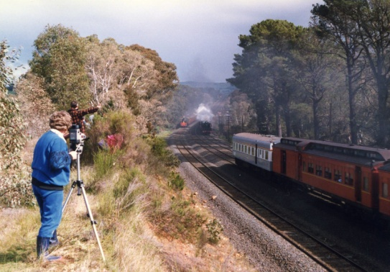 In 1981 Bill retired and we had the time to do these longer travels. We sold Hampton Park and bought a bush property at Tonimbuk, another adventure. We loved Tonimbuk. We loved the bush and the many beautiful birds, kangaroos etc. Ash Wednesday fires gave us a fright but we were lucky, although the hot ashes were falling around us.

I had bought a video camera in 1986 and we had taken many videos of our trips, especially trains. In 1988 we spent 2 weeks at Seymour during the Bicentenary Aus Steam train celebrations. Many happy hours were spent by railway lines

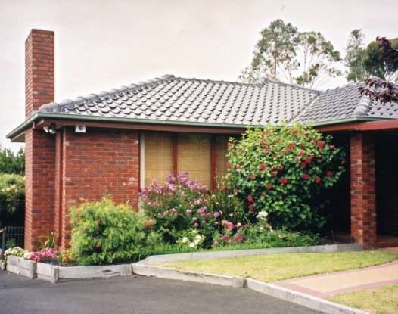 Two weeks after coming home from a Birdsville trip in 1991 Bill had a stroke. He had a month in hospital and then came home with some problems. He did not drive for 6 months, but after attending Warragul Hospital for therapy, he was again able to drive and we had more trips. We continued to go to Mallacoota and Emerald Beach near Coffs Harbour. We had always shared the driving and continued to do so.

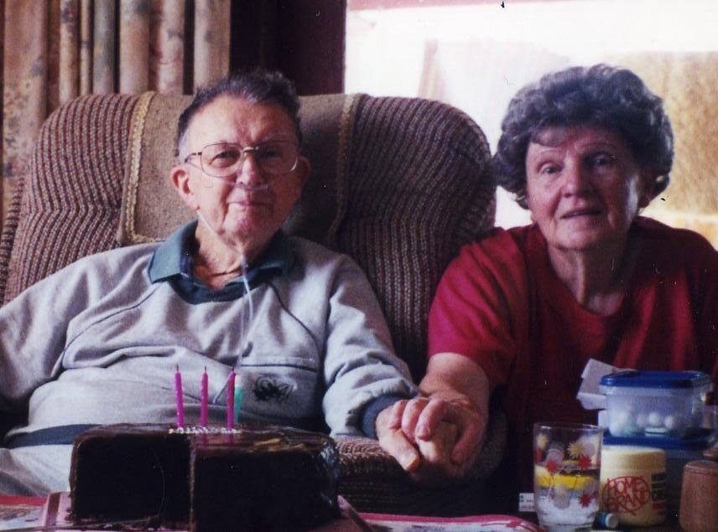 In 1991 we moved to Pakenham to be nearer doctors and family. Bill had always had a small model railway and it now became a passion, not only for Bill, but his brother Rob and son Rick. The railway just grew and grew taking up half of the garage.

Bill started to feel unwell and in the next couple of years he got worse. In 2001 he was diagnosed with prostate cancer. After a lot of treatment at the Alfred Hospital no more could be done for him and the cancer had got into his bones. I looked after him at home most of the time for the last 3 months with help from the family and he passed away on February 7th 2002. We had almost 54 years of a very happy marriage.

So began a new stage in my life, this time without my soul-mate Bill. I was very sad but with the help of my loving family I was able to get on fairly well. Later that year my daughter Annette suggested I needed a holiday and I went on a tour to Norfolk Island. I enjoyed this so much that it became a passion to travel again but this time on organised tours, especially with " Young at Heart" where I made some good friends with the staff. As well as bus tours I flew in a DC3 aircraft known as "Air Nostalgia". This was very nostalgic as Bill and I had flown to Adelaide in a DC3 for our honeymoon. Other travels were to China, train tours of Tasmania and New Zealand, 2 cruises on the Murray River, Darwin and the Ghan train and Lord Howe Island.

Two years after Bill went I had a break-down and had panic attacks, very frightening. Again my family came to the rescue. Not long after that Rick was able to move the model railway to his home in Cranbourne and I was able to sell my home. I was lucky to buy a new unit in Meadowvale Village in Pakenham. I love it here and have made some nice new friends.

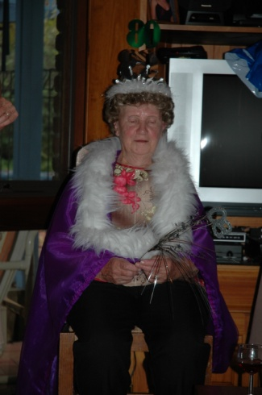 Sue and her partner Brian have a 54 acre property at Woodside. Many weekends they take me with them to Woodside and I enjoy helping in the garden and having great bonfires with fallen gum branches. The time spent with Sue and Brian is often hilarious and does me so much good. They built "me" a veranda out from my bedroom and then Sue gave me the garden in front of the veranda which I planted with native shrubs.

I also did some trips to Mallacoota, twice alone and also with the family. I would stay in a flat and then spend the day with my cousin Joan. How I missed her when she passed away. We had put Bill's ashes in the lake at Sou West Arm at Mallacoota and I have been there several times on our wedding anniversary. Mallacoota is my favourite place and one day I will rest there with Bill.

One thing that has made me very sad is that Bill only met one of our 8 great grandchildren. He would have loved them.

Over the years I have had many hobbies. Gardening began when I was very young and I still love it very much. With Bill’s help I have had some wonderful gardens at each home we had. Reading has also been a great pleasure to me. My Dad and I went to the first meeting in Dandenong to try to get a library started. That was in the 1960’s and from that meeting developed what is now a huge library system. My children, grandchildren and I have benefited from it. In 1998 at the age of 72 I bought a computer and have done several courses in computing. I love using my iPad to keep in touch with my friends and family. Now in the winter I love to do jigsaw puzzles. I have always enjoyed travelling and caravanning around Australia we saw so much of our beautiful country.

I thank all my family for the love and help they have given me and I love and have great pride in every one of you. I feel I have had a life filled with love and happiness as a child, as a wife and mother and although I have missed Bill so much in the last 9 years you have all helped me to find peace and happiness again.

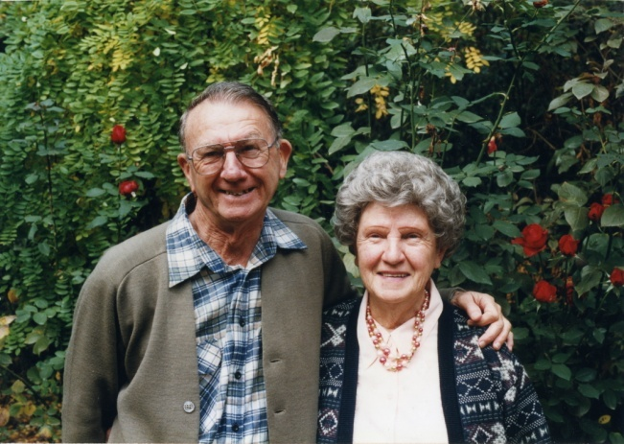

Annette’s note:

This is Mum’s story as she told it to me in 2011.

Mum had a wonderful life and had not had a major illness until the last 3 or 4 months when she gradually became more unwell. In Dandenong Hospital in October this year she was diagnosed with cancer. She was moved to McCulloch House at Monash Clayton where she passed away peacefully with her family by her side on October 24th. As per her wishes her ashes were scattered in the lake at Mallacoota and she is once more with her beloved Bill.