Tram Rails Dandenong to Rowville -1913-1917.
Discussion at Endeavour Hills Men’s Shed with Maurice Canterbury.
Dandenong Police Paddocks Reserve is a peaceful 499 Hectare area that has been developed into a place of spiritual and historic importance.
The main purpose of this discussion is to see if any of the members of the EHMS has any additional knowledge from your friends or relatives from
The First World War era , such as documents or photos which would help me create a sketch of the operations such as the horses pulling the empty skips back up to be reloaded with the crushed road metal rock from the quarry.

- Please raise your hand if you have walked through the Police Paddocks or Churchill National Park recently.
- The Dandenong shire Tramway was planned to be three kilometres long to the quarry but truncated at the Stud Road /Brady Road extension corner.
- The Dandenong quarry was just inside the northern boundary of the Police paddocks now Churchill National Park.
Many activities , Such as Aboriginal Police Force , Native Police Headquarters Aerial surveys, Gun emplacements., Cemetries, Accidental worker deaths , Dandenong Council quarrels, Disgruntled contractors , Scout camps , horse liberators, Knox have been issues over
Historic Markers , sports grounds ,Horse Equestrian Archery and horse whispering which is operating on the Brady Road extension and is going to
Move to the Pakenham Livery Stables at December 2026.
And the introduction of motorised trucks. , Friends of the Police Paddocks Management , Division the control of land , Council and Government and political money to improve the park , to name only a few.
Some of the detail that I would like to clarify and any others you perceive :

1.
Booklet by Ray Peace of the Knox Historical Society in Ferntree Gully gives clues.
- How many horses pulled the quarry skip unloaded back up the slope
- My thoughts , 3 in a straight line between the muddy tracks ?
- And what distance (From Dandenong or from rail loop ?.
- What breed of horse ,Draught. ,Retired police horses .pit ponies /
- How did the loaded trucks down the slope to Stud Road , corner of Brady Road extension ?
- Do you know any past member of The “Friends Of The Police Paddocks ?

UNTIL YOU KNOW SOME OF THE HISTORY OF THE PLACE YOU
LIVE IN YOU CAN NOT REALLY FEEL PART OF IT .
CONTENTS:--
- Historic Proof and past citizens.
- Gathering information.
- Overview contact with area
- Location Dandenong Police Paddocks, Churchill National Park.
- Lysterfield Park and Governance of Areas.
- Industrial, social and sporting activities.
- Future plans to revitalize the area
- Dandenong Quarry 1920’s
- Sketches
- Historical societies
- Painting. - Dandenong Quarry and treatment plant.
- Museums
- Prominent People and street naming.

2.

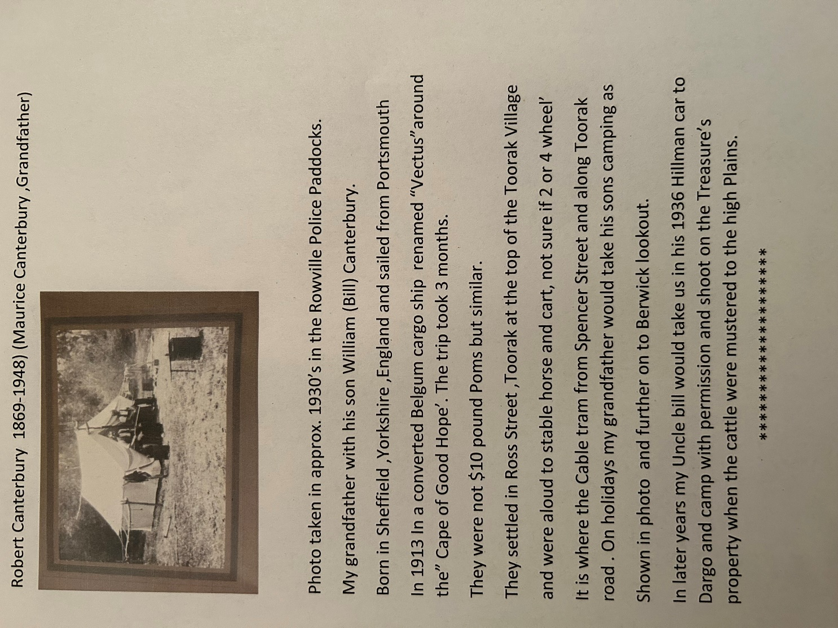

3.

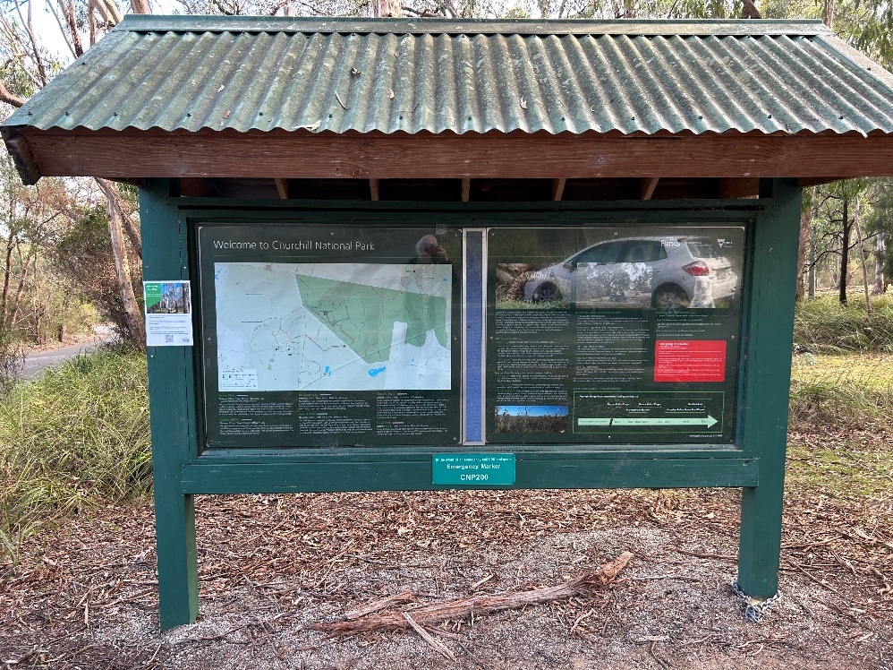
Notice Board at Picnic areat at Churchill National Park.
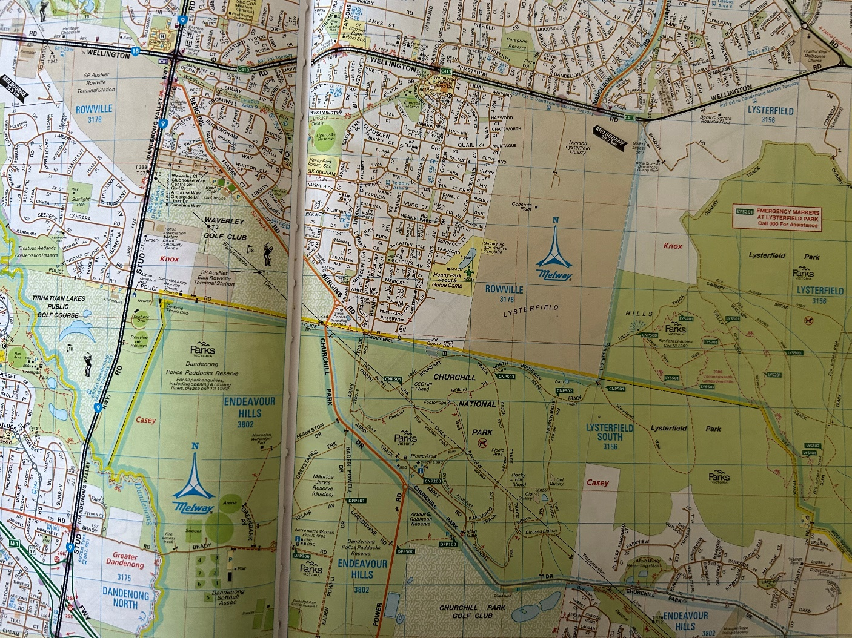
Map of area and Park areas.
5.
.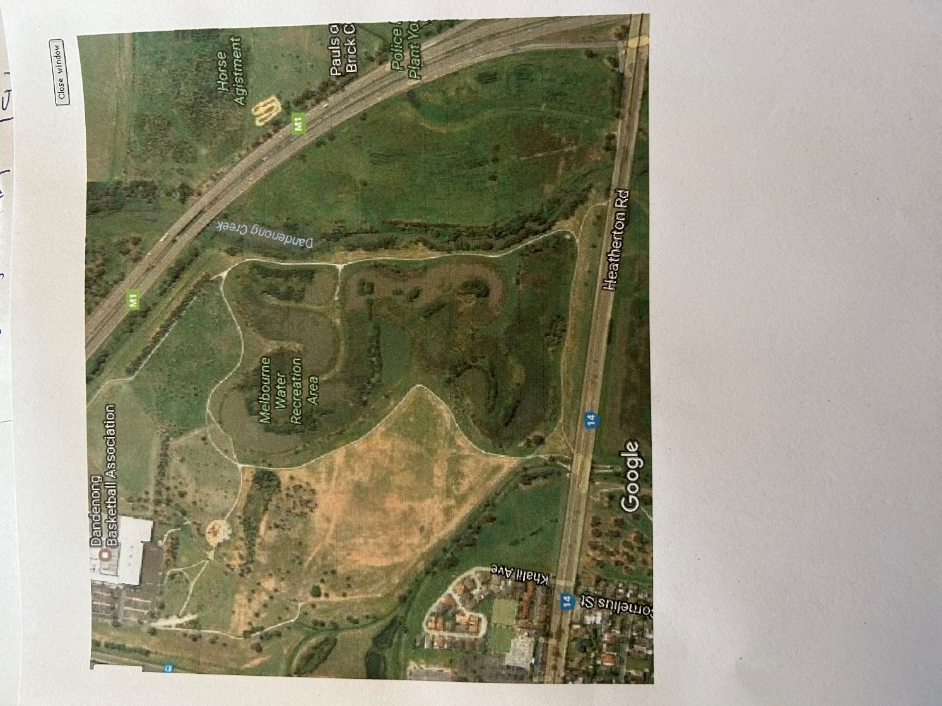
Heatherton road ,Wetlands historic arial Photo. 2017.

6.

Park public Facilities
. Dandenong Soccer Ground
. Droneit . Drone operation classes.
. 3 Golf courses with Club house and dining facilities
. CNP Walking Tours
. Trail Bike riding paths Trail Bike Association, Commonwealth Games 2006.
Shed at Commonwealth Games mountain bike
. Softball Park with night lighting
. Archery and Equestrian Centre
Brady Road extension
. Knox City Reserve : Cricket , football, Tennis.
. Rubbish Tip.
. Water supply .
. Electricity Towers and lines.

Sydney Pargeter Reserve
Endeavour Hills Mens shed.
Endeavour Hills Cricket club
Berwick miners Grid Iron Football
Wierd Entertainmer & Petanque Club
Eagle Heights Sports Club

7.
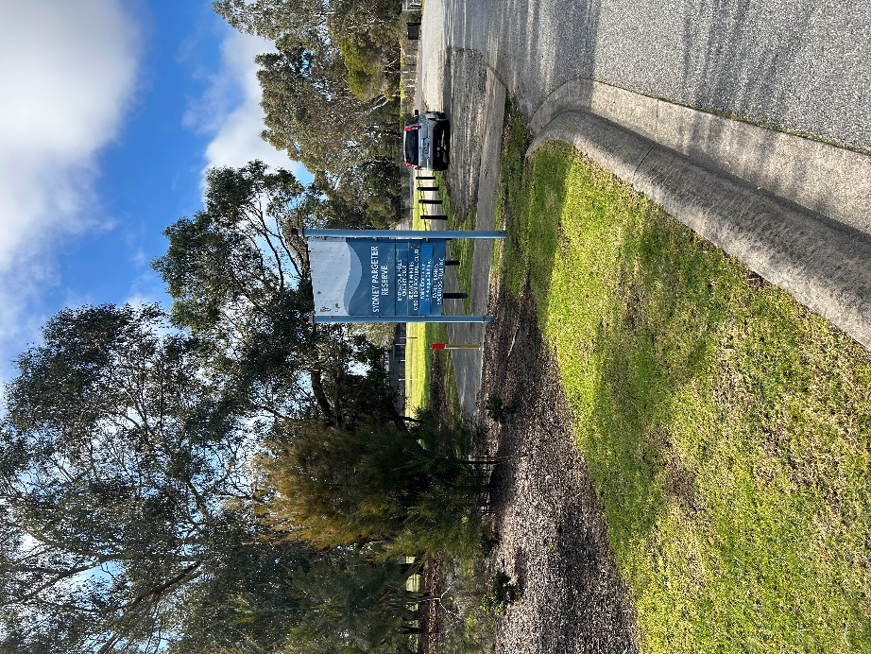
Sydney Pargeter Reserve including EHMS.

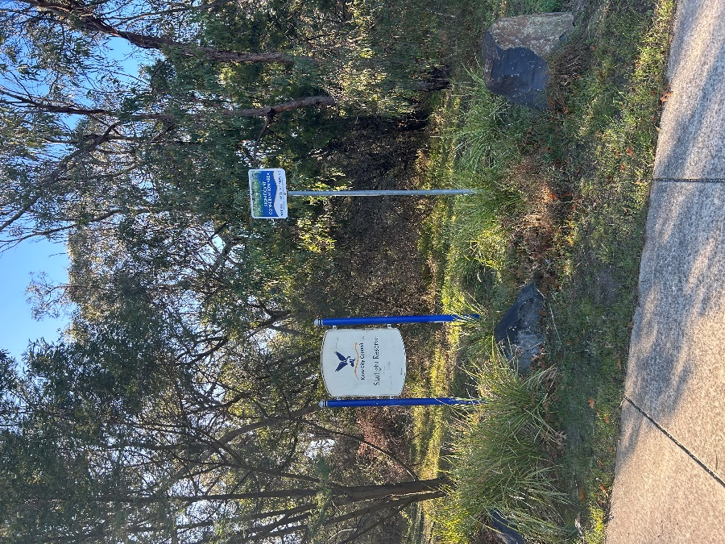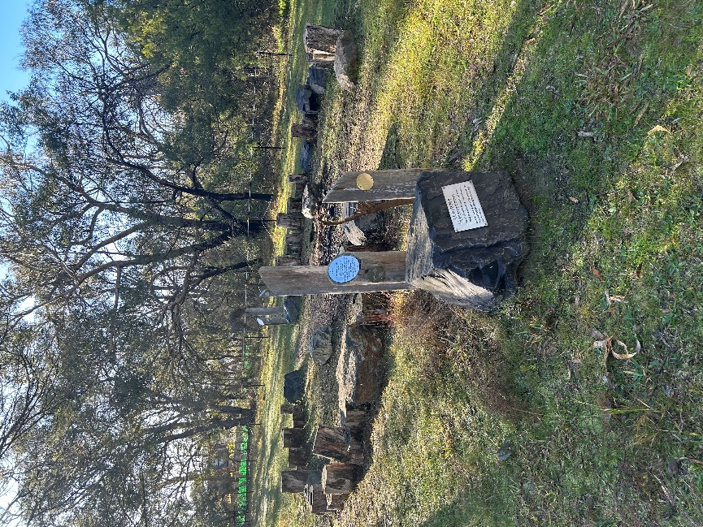
Starlight Reserve 8. Aboriginal walkaround..

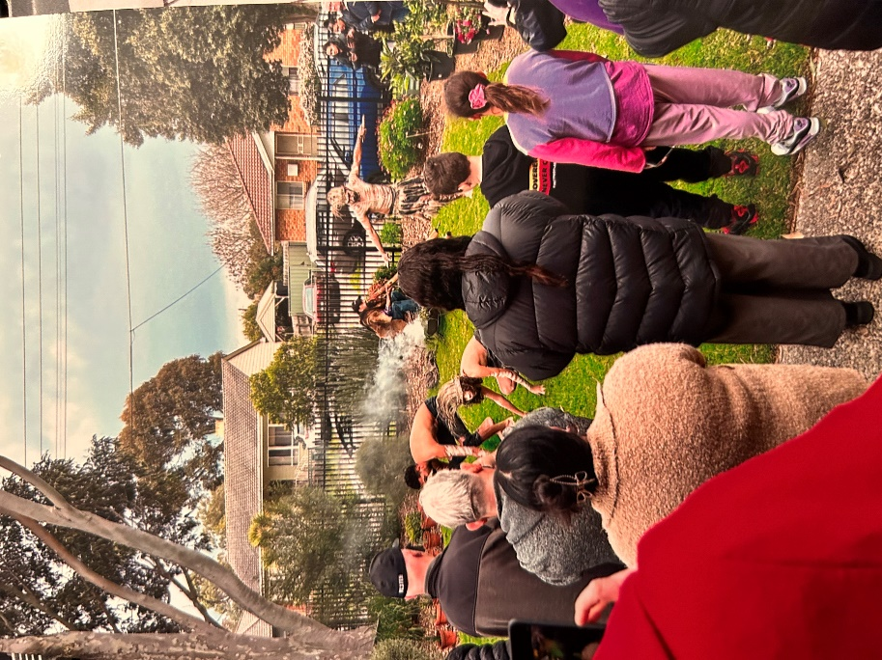
Linden Place Doveton ,first Nation Ceremony July 2024
,Elder Uncle Charlie Presiding.

9.
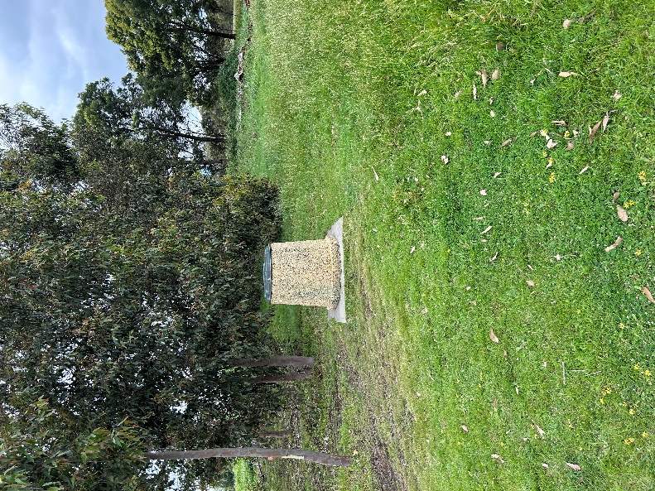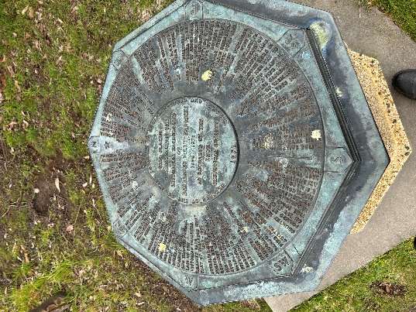i

Historic plaque erected on ceremony 1971 , Knox Council and Berwick and
Dandenong Police Paddocks 1856 -1971.
As recorded by the Knox Historic Society.

9.

Historic Marker erected 1972 by Knox Historic Society and 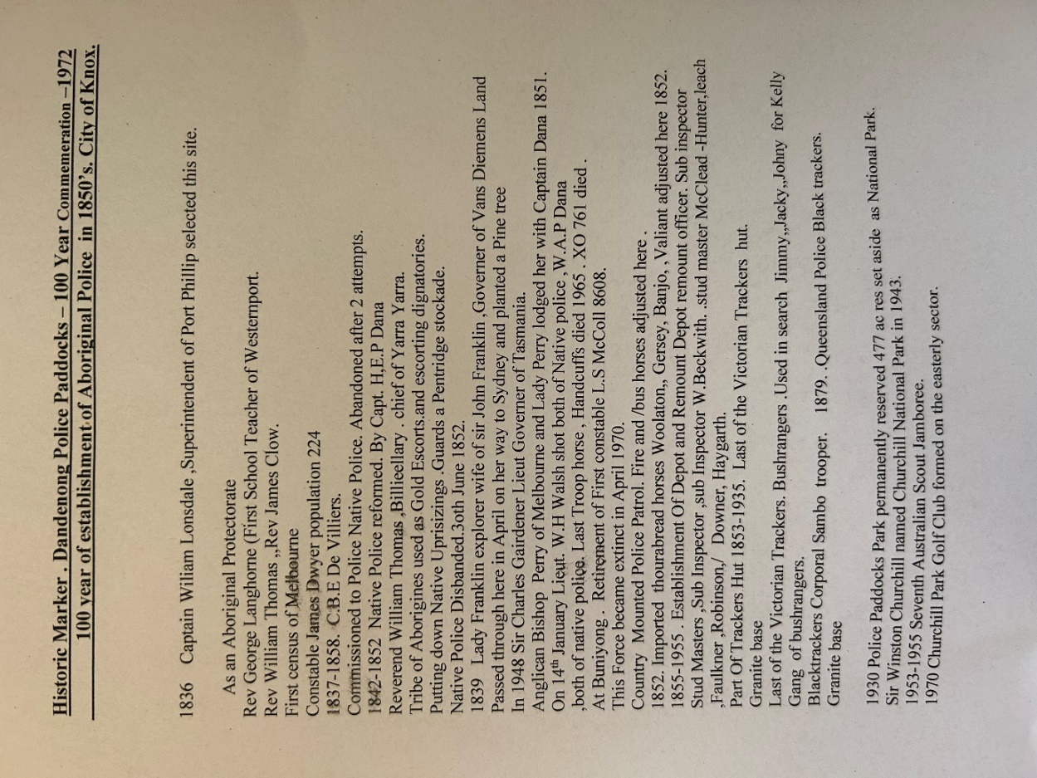

10.
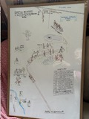

White board sketch to convey Historic activities to artist to create painting..
Photo board to convey detail to artist

11.
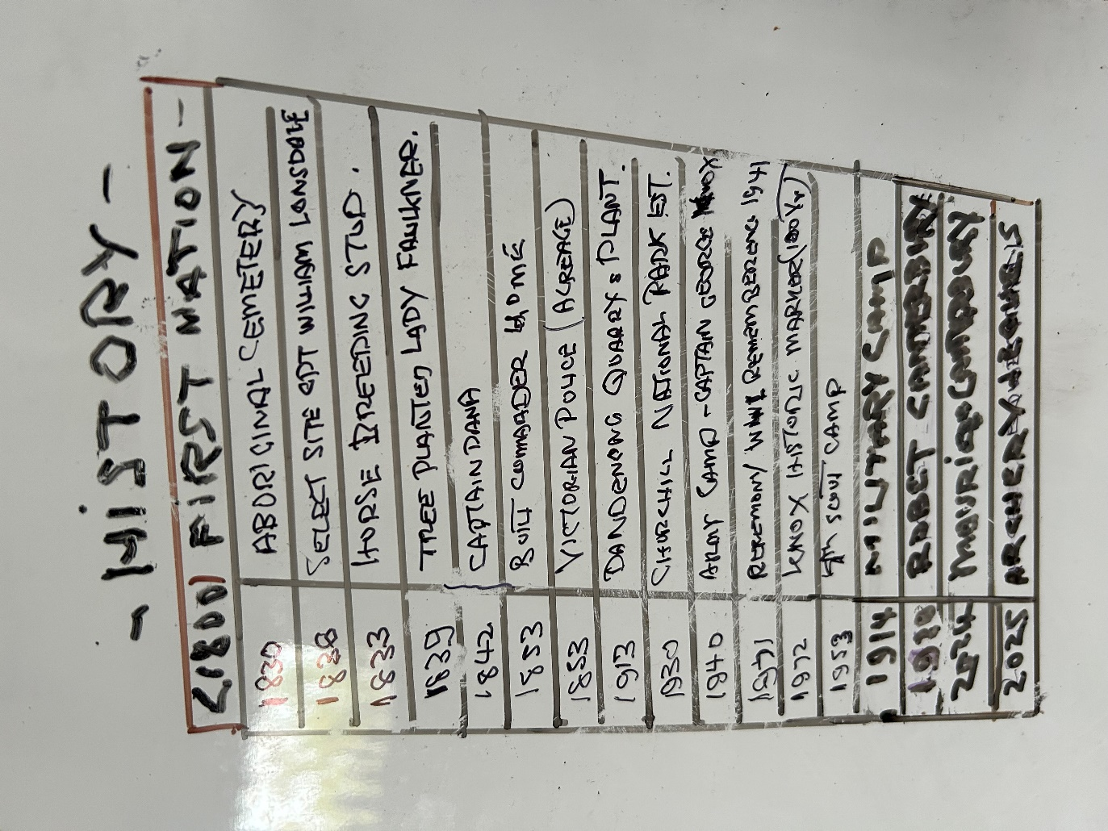
White board historical events by date identification.

12.

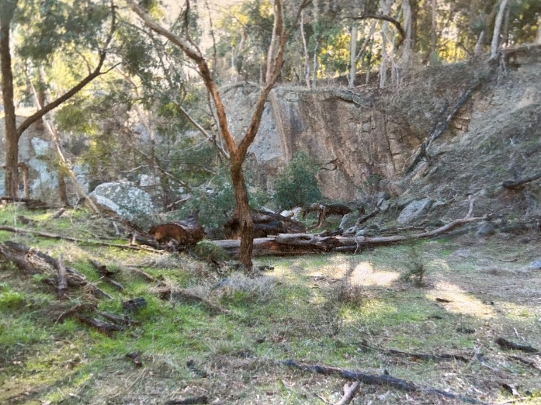Dandenong quarry Wall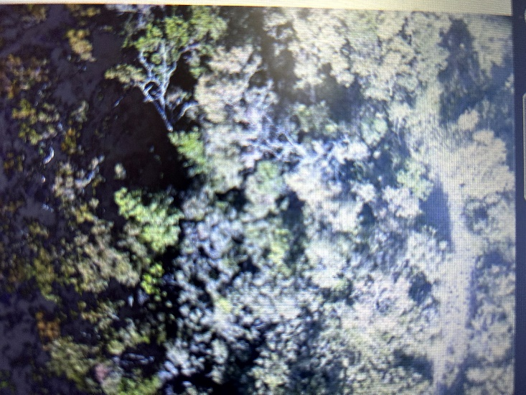
Drone photo in 2025.
The Quarry is at the top of the slope S37.56-40.05,140 ASL .From north and West side due west 260 degrees. And gradually curves around to the south west. The tramway making a slight kink to the south.
A small stone cutting in the south-West end of the ridge measuring 10 x 11 metres. Part of the ridge has been cut away to a depth of 1.5 metres. Leaving a semi circular stone face exposed beneath the surface soil. Trail bikes run Through and around it.The stone was unsuitable for building material as it a soft sedimentary rock. It does not appear to be related to prehistoric /contact.
13.
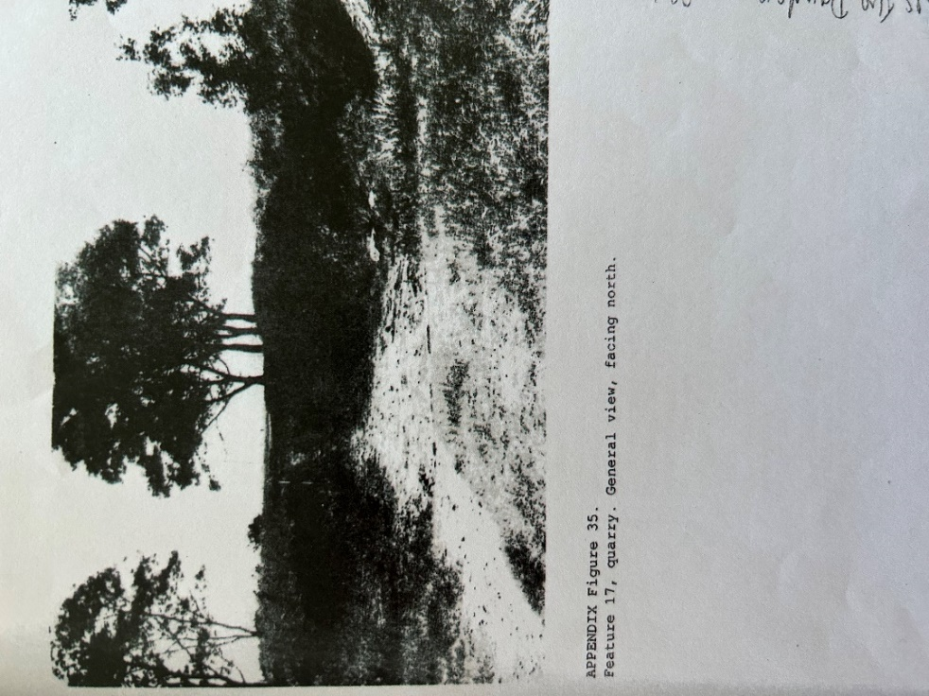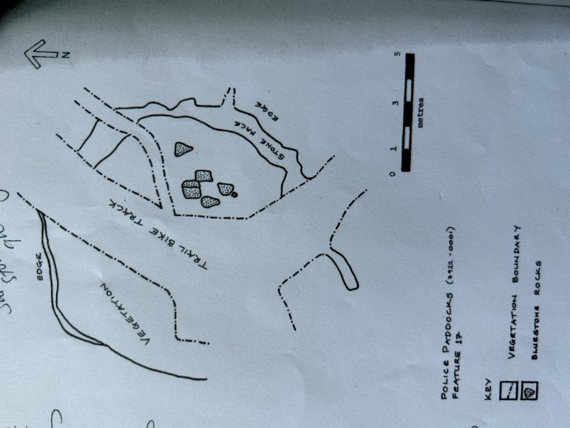 .
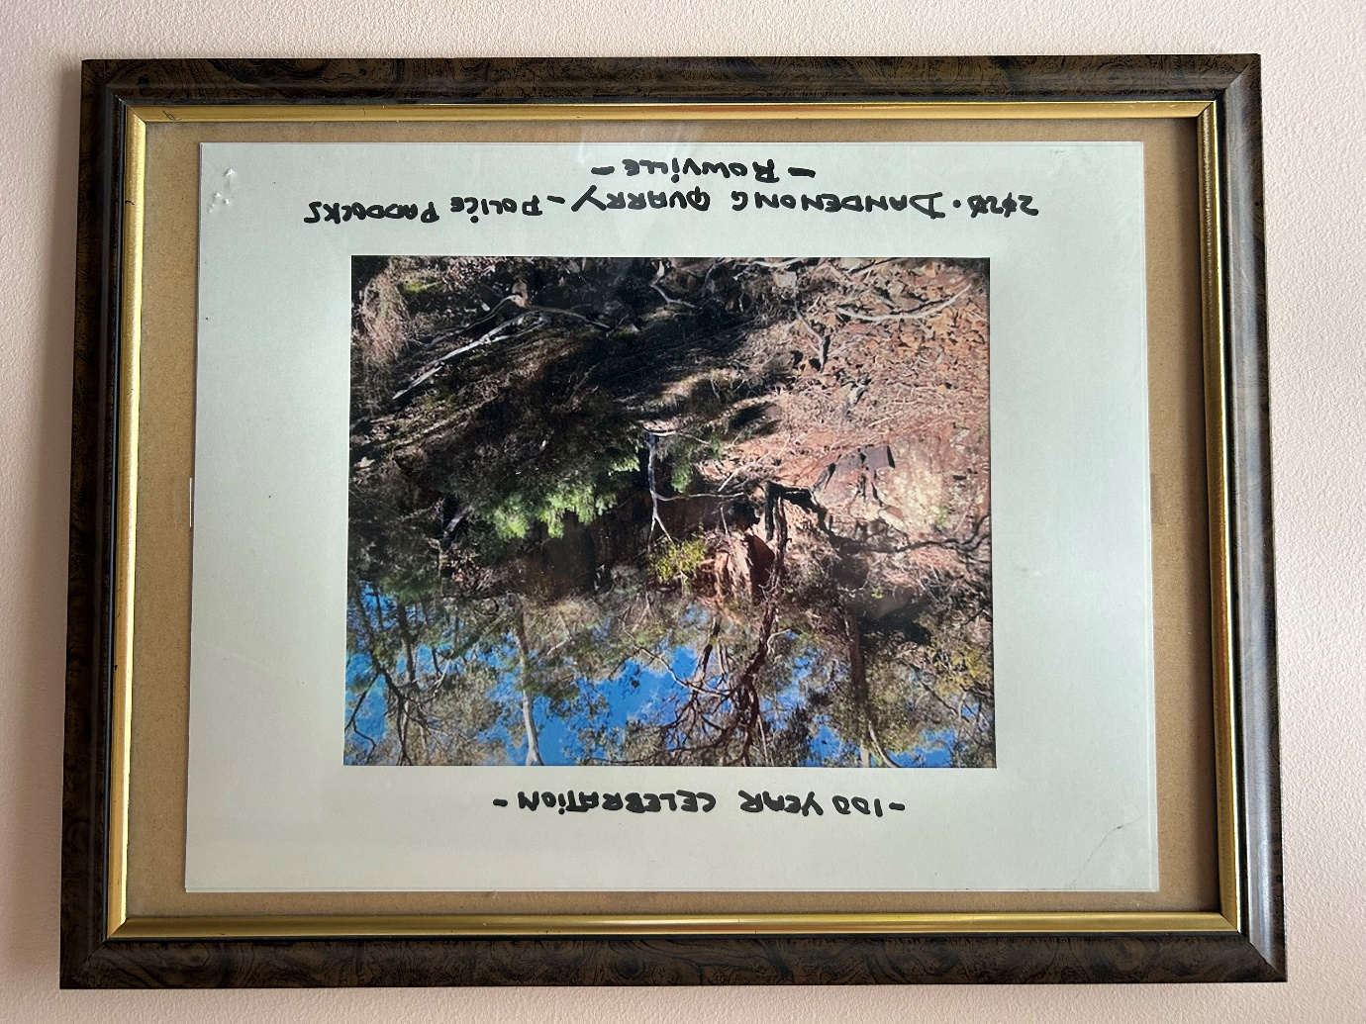 14.
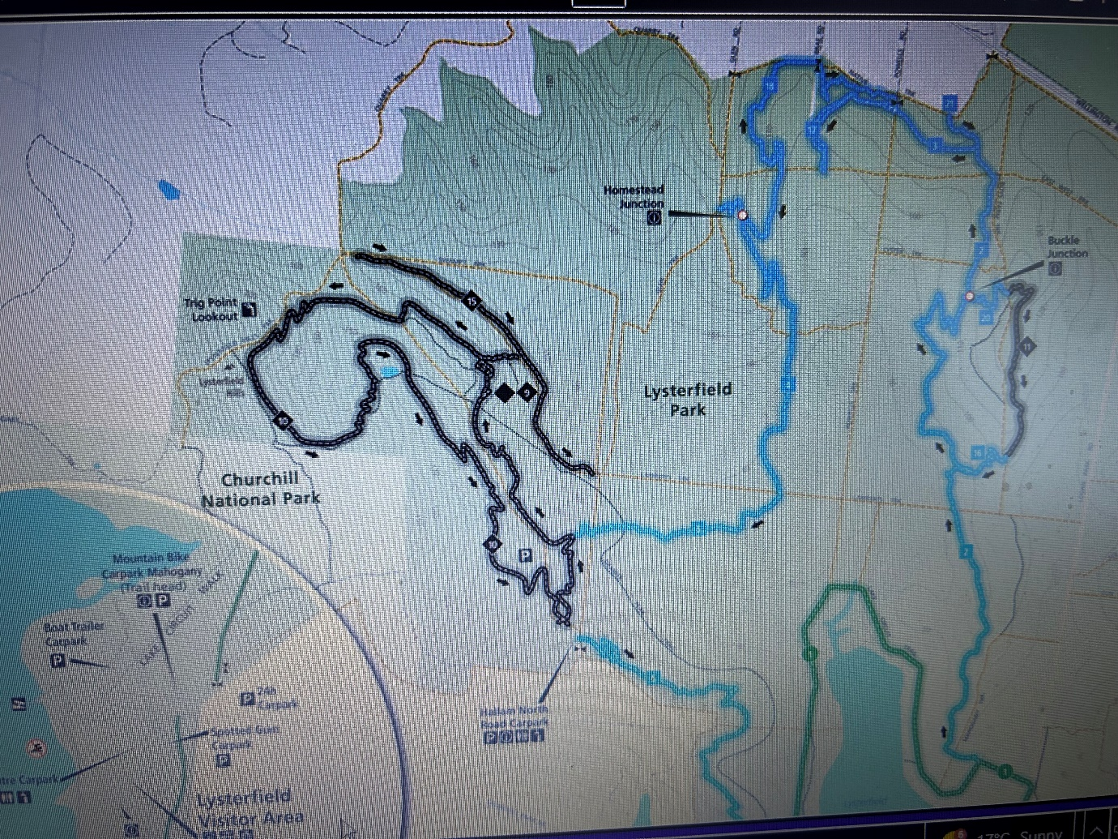
Trail Bike Paths.
Main Clubhouse Shed and notice Board at end of Forest Hill Grove where the
Commonwealth Games Mountain Bike Games we held in 19XX

15.

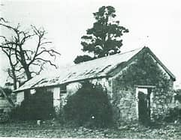 Captain Dana ,Superintendants house
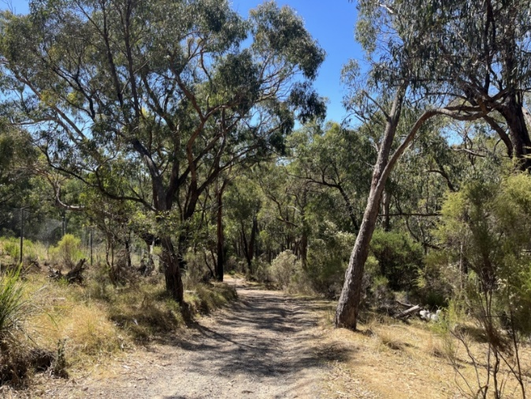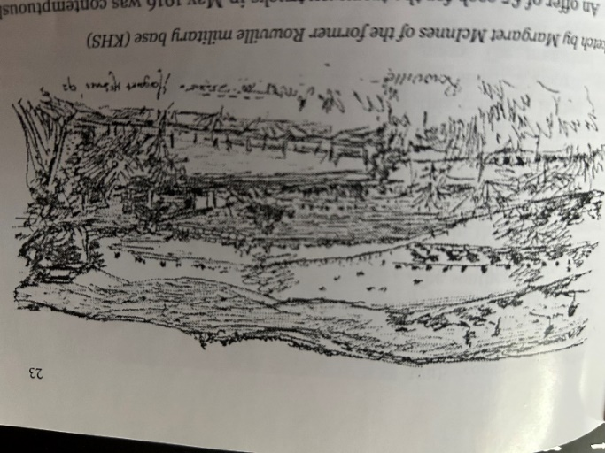

Sketch by Margaret McInnes from memory when in Army Barracks in 1922..

15.
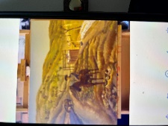
Initial sketch of Dandenong Quarry by Asad Ali
16.

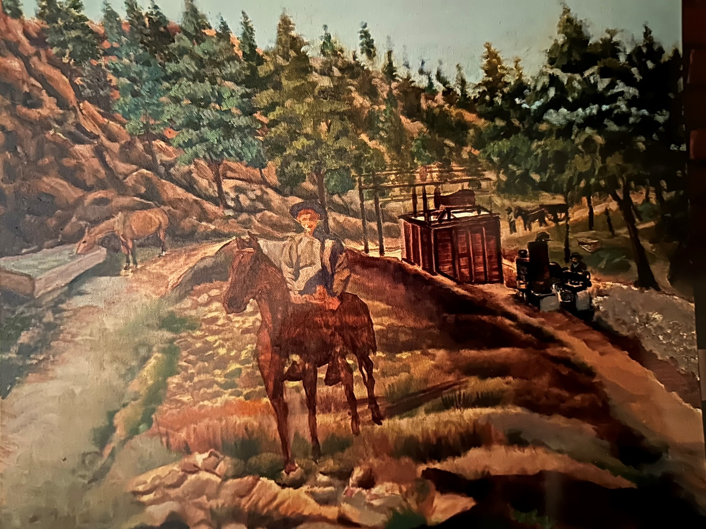

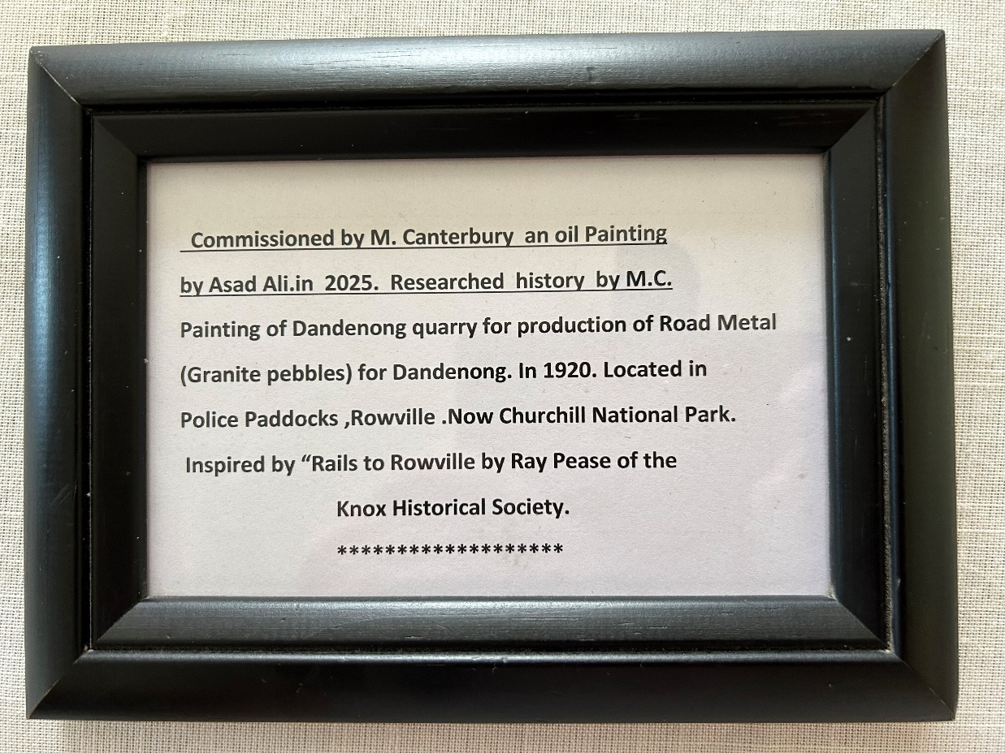

1957 Berwick ,Ferntree Gully & Dandenong Council
City of Berwick 1959 , 144 Hectares
City of Dandenong 271 Hectares
City of Knox 1961 83 hectares.

11/1/1851 Quarry Hill Mr W.A Thomas permit to have 600 cubic metres of quarry stone in 1918. Paying one shilling per 2 tonnes permission by Victorian Police. Located North of Scout Camp.

First Memorial in Dandenong with granite supplied by Mr W A Thomas
First memorial in Dandenong of granite supplied by R W. A Thomas ,monumental mason of the Granite Quarry Industry .Engineer Woodcock.
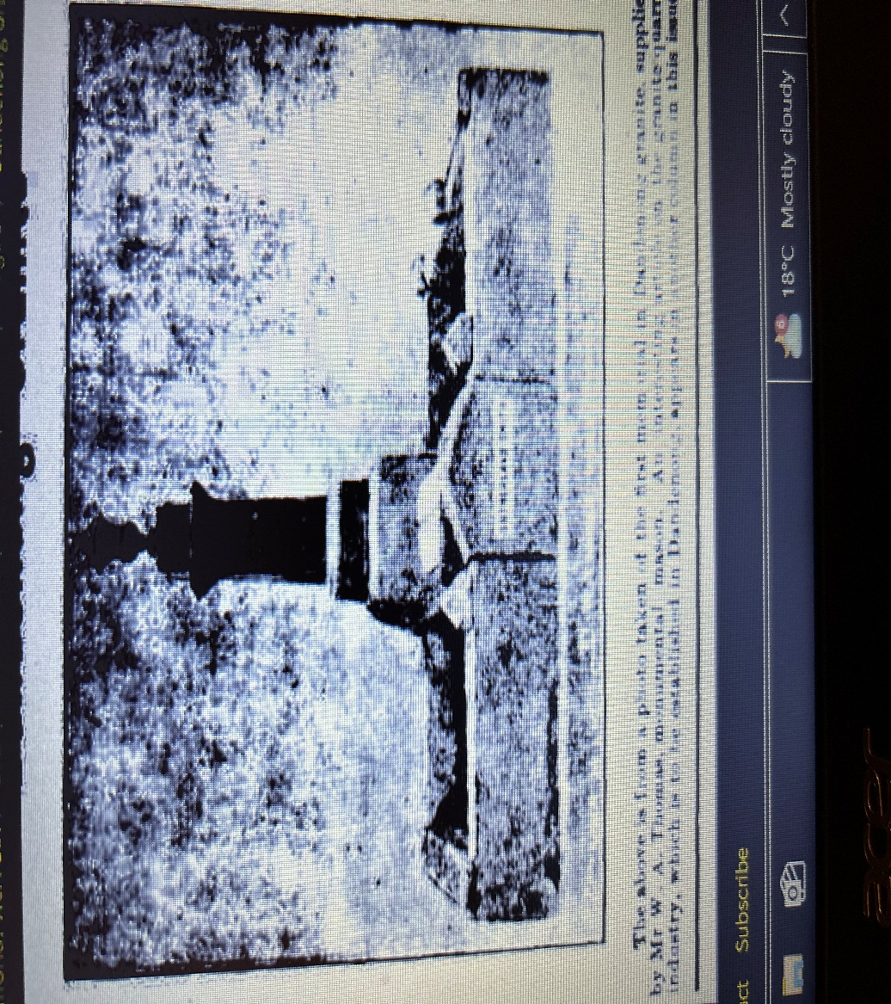

17.
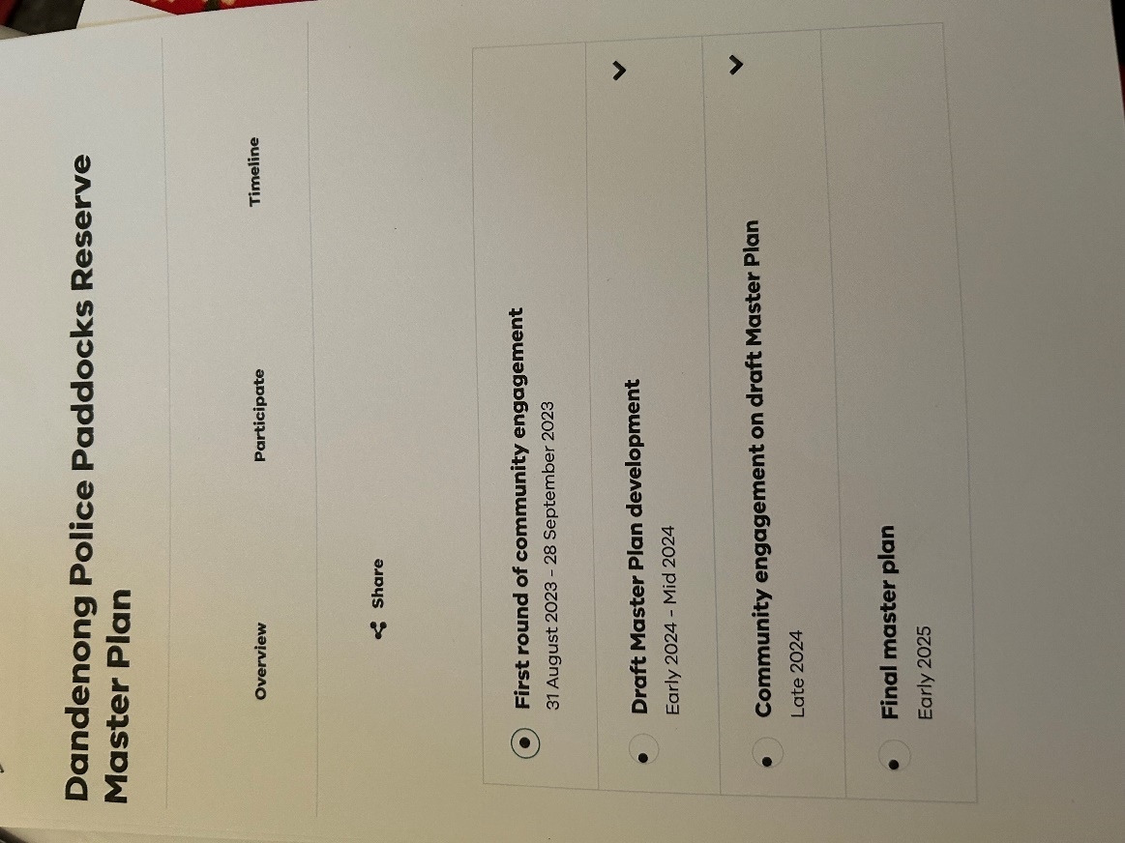

19.
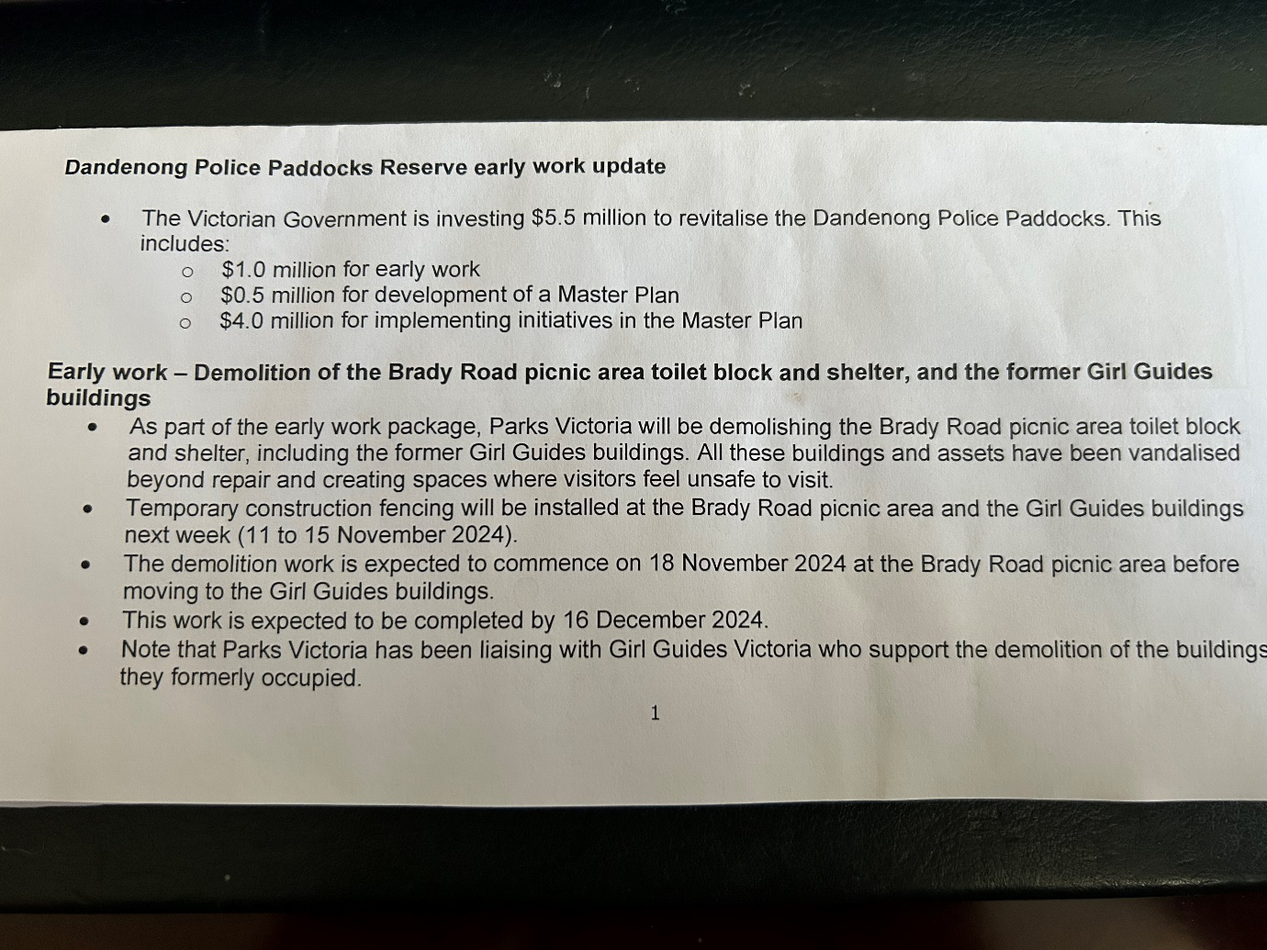
Belinda Wilson MP comments on Revitalization

19..
References:
Historic Police Paddocks ,Rowville ,Bob Padula
Dandenong Police Paddocks and Churchill National Park
-Pictorial Heritage 1837-2017.
Parks Victoria , 535 Bourke Street , Melbourne
Healthy Parks Walks : Anthea Dee.
Native Police Headquarters Dandenong An Archaeological Survey1989.
By David Rhodes
- The Dandenong Police Paddocks Volume 3
An Archaeological survey 1990.
- The Dandenong Police Paddocks :early use a
- s police headquarters
And aboriginal protectorate station 1837-1853. By Marie Hansen Fels.
Land History and use 1851-1988.
- The Dandenong Police Paddocks :land history and use 1851-1988.
- Dandenong Police Paddocks reserve proposed management Plan.
- Friends of the Police Paddocks ,Rowville ,Victoria Australia 2021.
B. Padula
A local committee of conservationists. taken over by Parks Victoria..
- An archaeological Surveying ,Victora ,-Dandenong .
- Melbourne Street Life , Andrew Brown May. ISBN 10-1925984613
- Casey Cardinia -Links To Our life
Call Back Yesterday, Eumemmering Parish.
Doveton A Brief History. ,Maria Harding.
Old Australia ,The People , The Past times ,The Pioneering Spirit.
Chronicles Of Dandenong. Niall Brennan.
The City Past and Present. By eMelbourne 20.
Published by School of Historical and philosophical studies ,
University Of Melbourne. 2008
Dandenong and Surrounds. Odd Australian History.
The History of Dandenong , Trove 1930
Discover Dandenong History ,Michael Tonta.
When the Clock Strikes . Jack Johnston.
Growing Up On The Rural Market Town Of Dandenong.
Lysterfield Park , and Churchill National Park . Visitors Guide.
By Parks Victoria.
Gippsland Gate by Langford
Dandenong and District Historical Society ISBN 1321-5035 182

Addendum

The Dandenong market has operated for 135 years.
The markets for livestock and produce started in 1866.-1926
The Livestock section was made
separate and moved to Cleeland Street in 1958.

23.

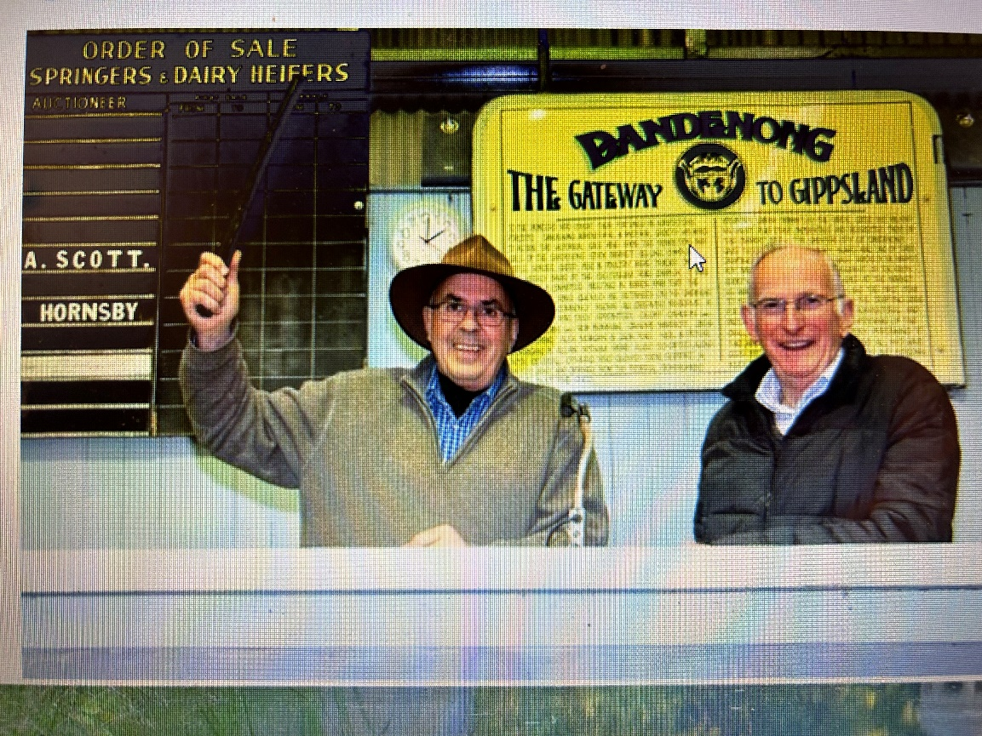

Dandenong Cattle Yards operated for 135 years.

22

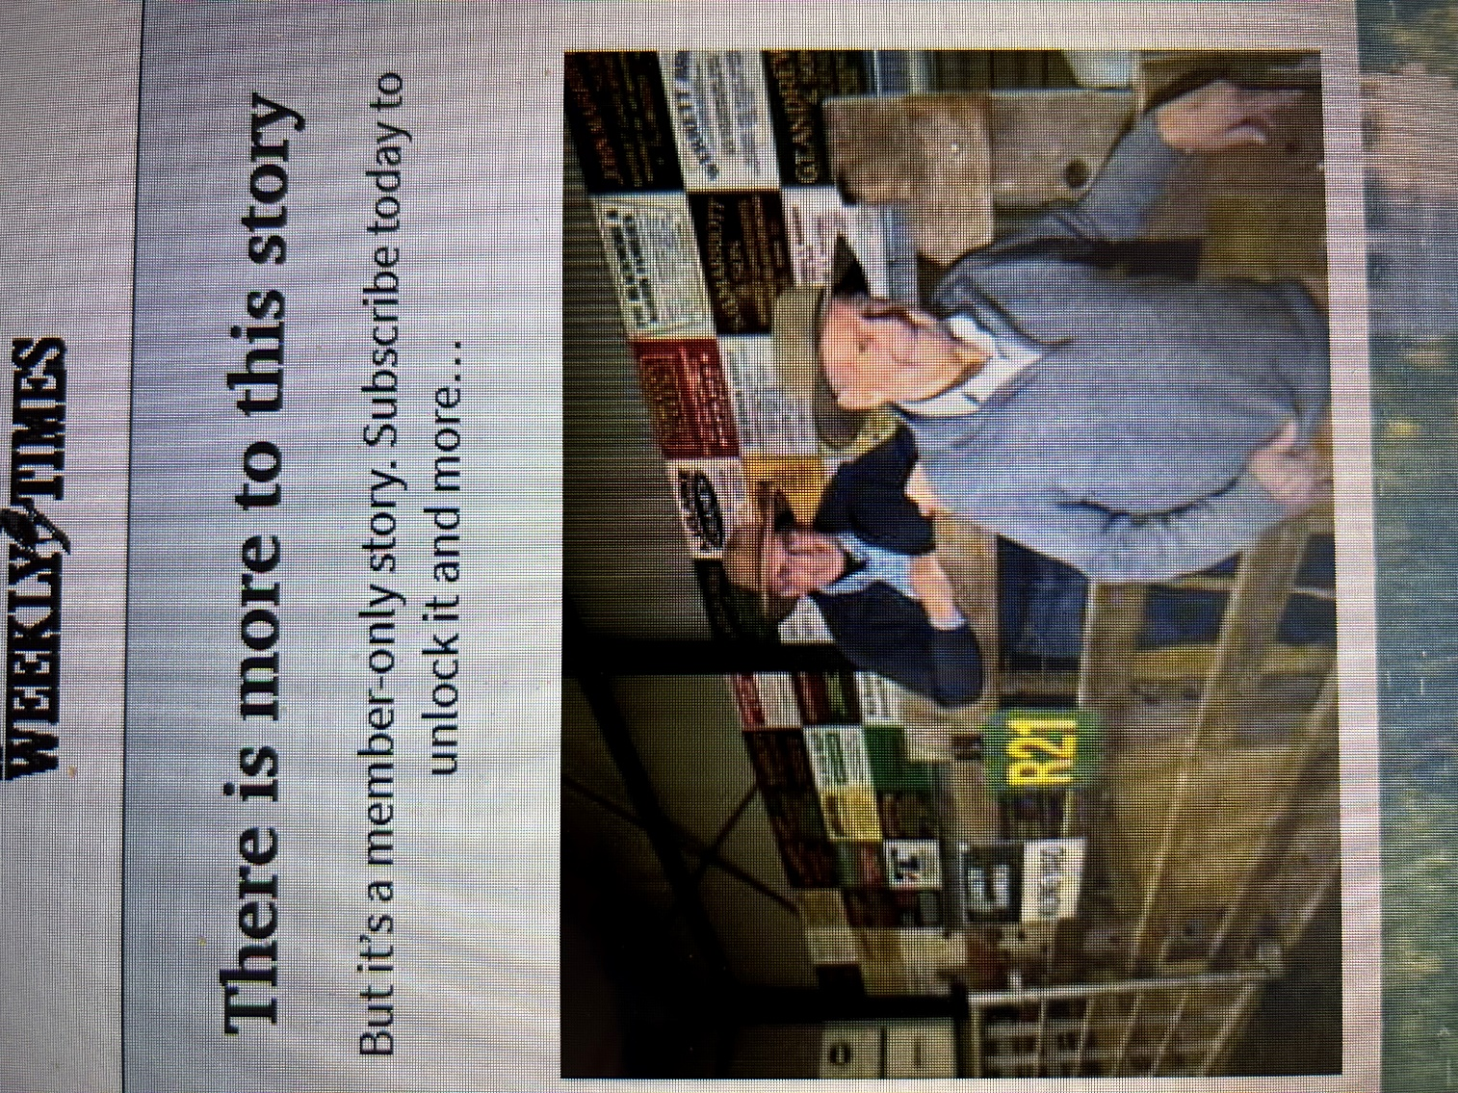

Cattle Yards Operated for 135 Years
23.
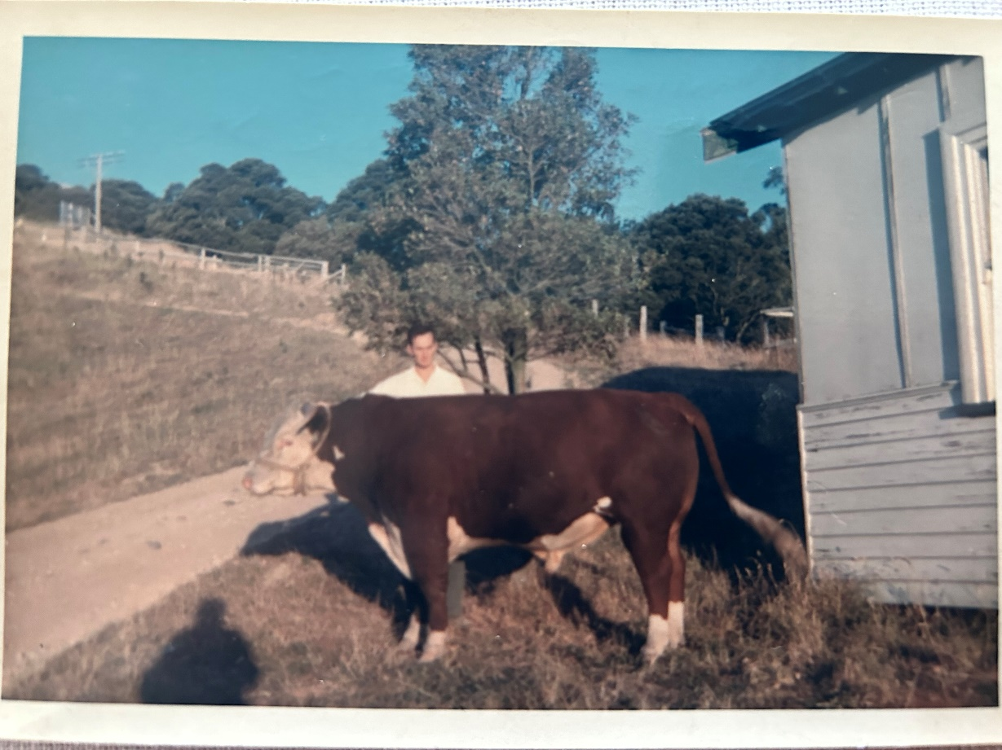
Canterbury Hereford Stud , Pedigree Bull “Dungog” ,Mid 1950’s
Strzelecki Ranges South of Yarragon past Warragul. Gippsland.
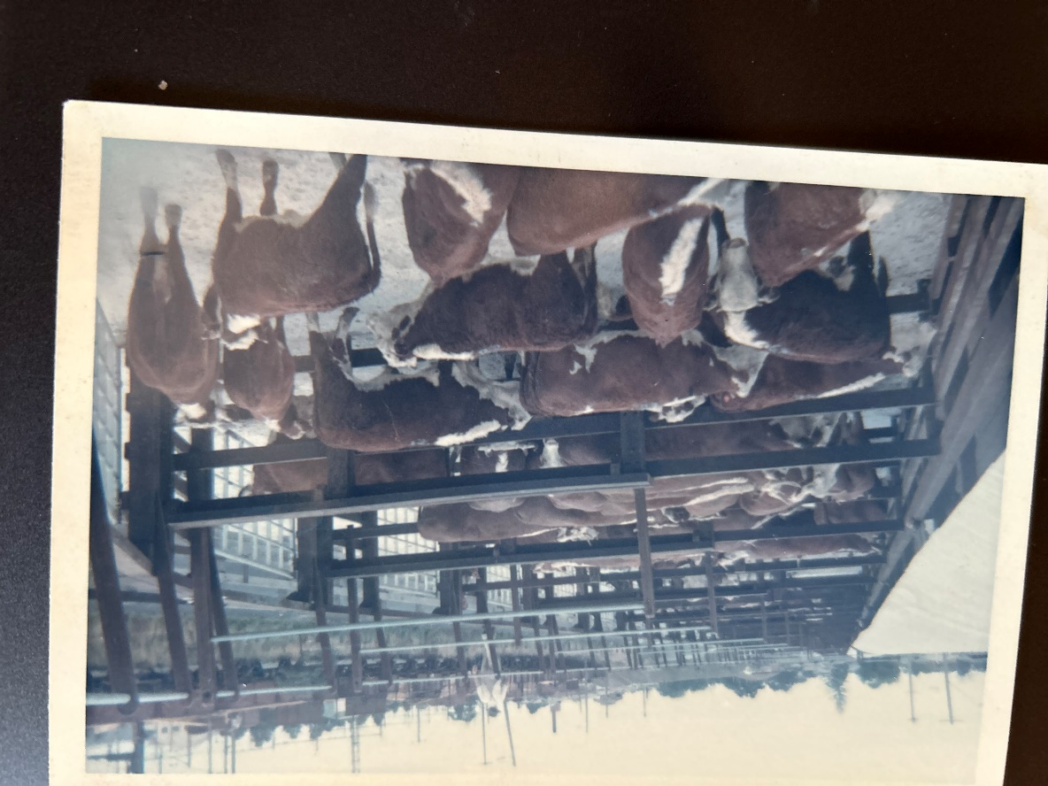 Canterbury Hereford Stud Vealers Dandenong Market Cattle Yards ,1955
.
How did they do it . ? Recognize and relatives. ??
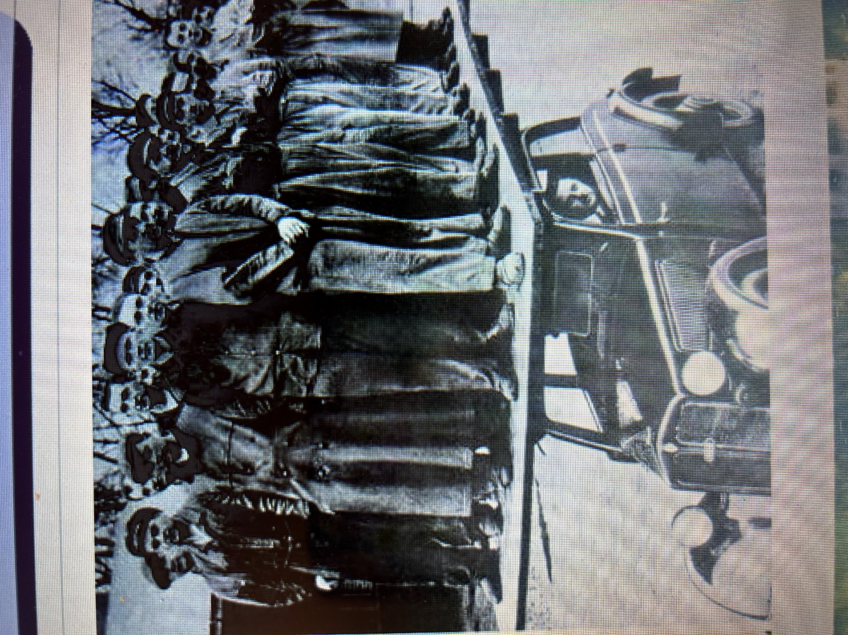

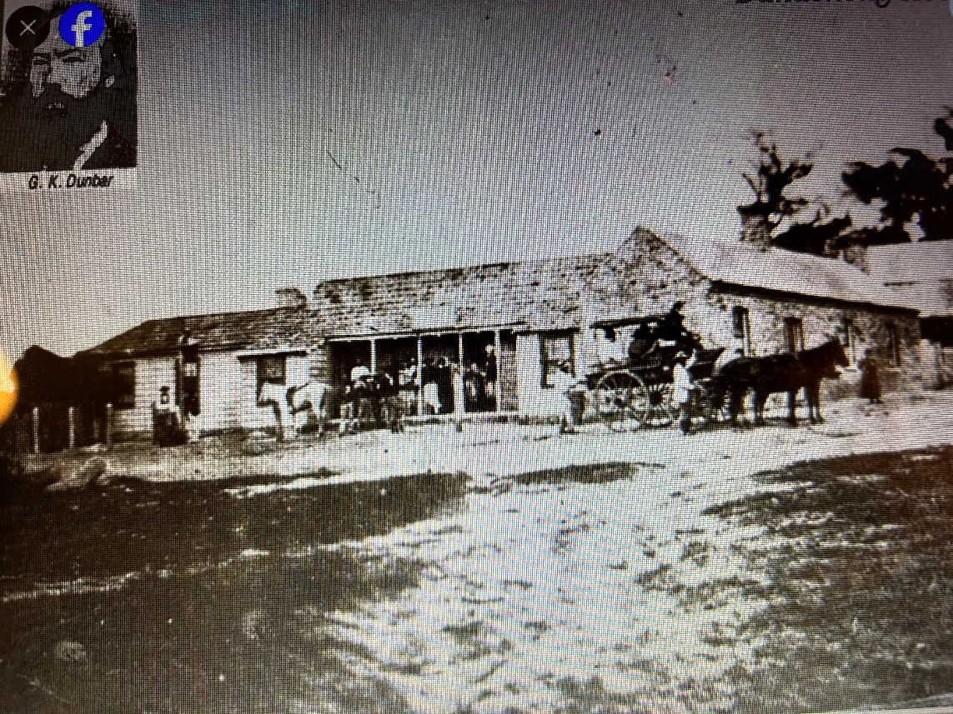

Dunbar Hotel . Dandenong main Street, Clow Street 1890
Stage Coach ready to leave.

25.

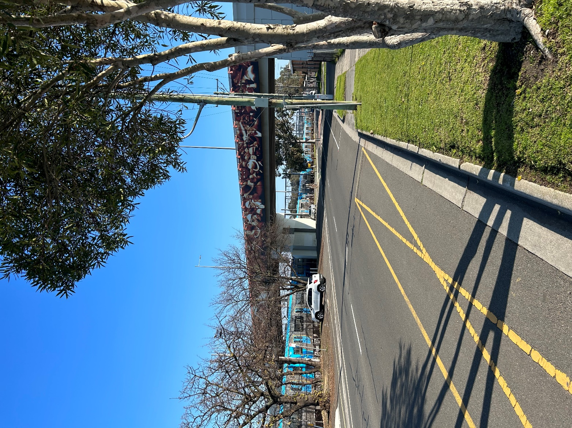
Overpass Mural as a reminder of the Stock yards at the Dandenong
Station overpass bridge as at 2025. Yards operated for 135 years as
The gateway to Gippsland livestock.

26.

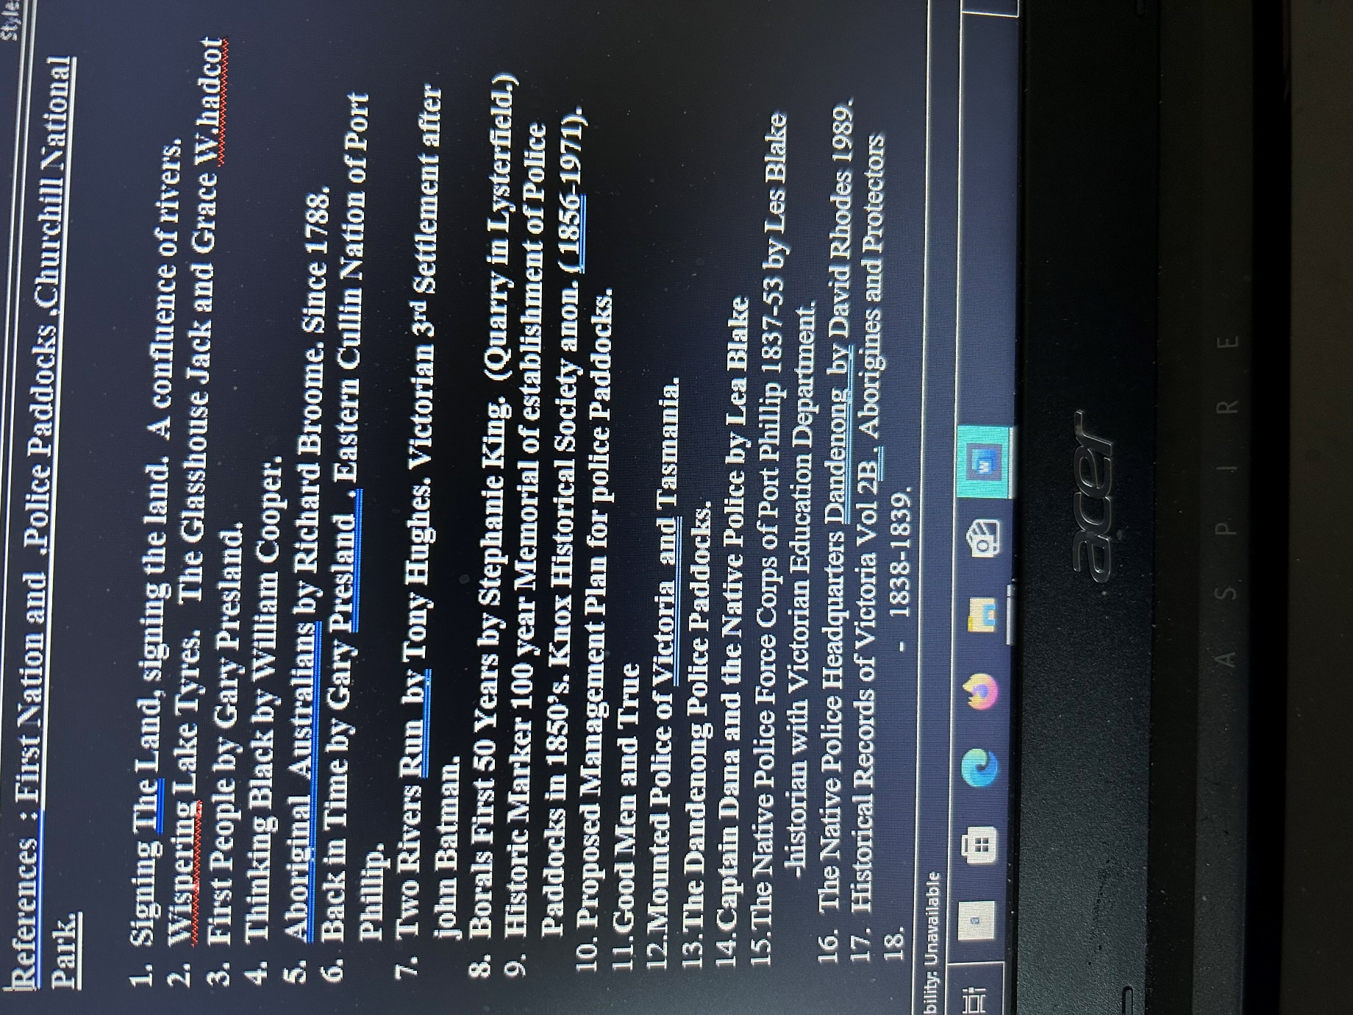
27.
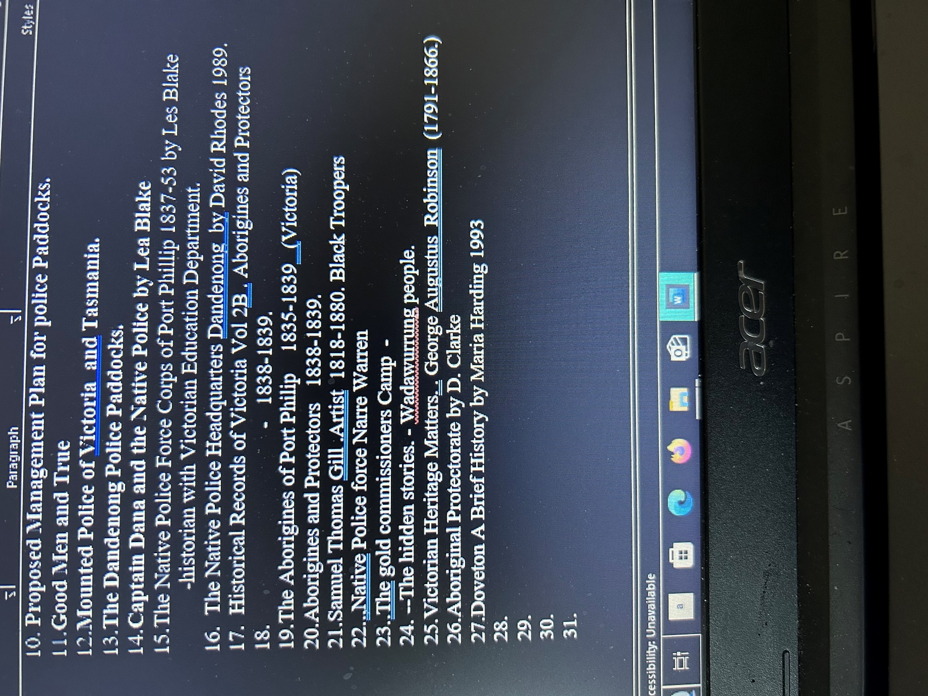

28.

Historical Societies:
Knox Historical Society
Ambelside , 1-3Olivebank Road , Ferntree Gully., Ray Peace.
- Dandenong and District Historical Society INC
39 Clow Street,Dandenong ,Gwenda D Jones
State Library Of Victoria ,Swanston Street, Melbourne.
Historic Monash ,3 Atherton Road ,Oakleigh.
- Narre Warren and District historical society
The Casy Complex. , Eileen Durdin.
Victorian Police Historical Society
Street and Park naming after prominent people;
Churchill National Park : Sir Winston Churchill. CNP ,Park renamed 1949.
Knox City: Sir George Knox 1885-1960.
Speaker of the Legislative Assembly , Soldier.
Stud Road: Police Horse Breeding stud ,1853
Franklin Street: Lady Franklin ,wife of Premier of Tasmania.
Brady Road :
Power Road :
Doveton: Mr and Mrs Doveton 1894
Bergins Road:
Clow Street:
Heatherton Road :
Casey: Lord Casey
Lysterfield :
Keys
Sydney Pargeter donated land for Pargeter Reserve 29.
Mc Crae Dr Farquar McCrae 1839
Scott Alex Scott
Marriot Graeme .Market Gardeners and draught horse breeding in Bentleigh.
Weightman Margaret.
Cerrol Tommy
Hemmings Sir John Hemmings (wheel wright business.)
Dana Captain 1838 First Aboriginal Police Superintendant
Shugg Bill Shug
Standish Captain ,First Police Commissioner.
Halinan , James 1913.
Hutton . Colonel
Heatherton road possibly named from ‘Heath Plant” on Wetlands.
Endeavour Hills Shopping Centre ;Gazetted 4/7/71 Acquired 1924.
Dandenong Stock Market ,Sale of horses ,cattle and sheep. At Dandenong
Station 1900’s
Aldrich Peter Dandenong Cattle Market Auctioneer .
Rae Jack .OAM Pavillion.
Dandenong Produce Market , Established 1917.
Cadles Mr William The Grange House : ,
Warren Park ,Apple Orchard.
Autumn Place 4 shops acquired 1959
Myuana Farm established 1982.
Three Oaks Dairy Farm (Where Bellbird Filmed).
Mosgiel Park.
Shugg Bill , Rifle Range on Hallam Road.
Chalcot Lodge (Last working farm in locality.) 30

The Pines Farm (Now Endeavour Hills Shopping Centre ,Gazetted 14/7
City of Berwick ,Gazetted and proclaimed by State Governer.
Endeavour Hills secondary College 1992.
Museums:
Heritage Hill Museum ( Benga)
66 McCrae Street ,Dandenong. Rhonda Tilley
Dandenong Museum/Historical Society
39 Clow Street ,Dandenonog.
Victorian Police Museum
313 Spencer Street Docklands , Melbourne Victoria.
Knox Historical Society 3 Olivebank Road , Ferntree Gully.
Berwick Museum. ,Princess Hwy, Pakenham.
Springvale and District Historical Society.
5 Hill Crest Grove, Springvale. Robyn Robie.
Knox Historical Society .
1/3 Olivebank Road ,Fern Tree Gully , -Ray Peace. (Historian)
Andrew Ross Museum
Main Road ,Kangaroo ground,

**************************************************
31
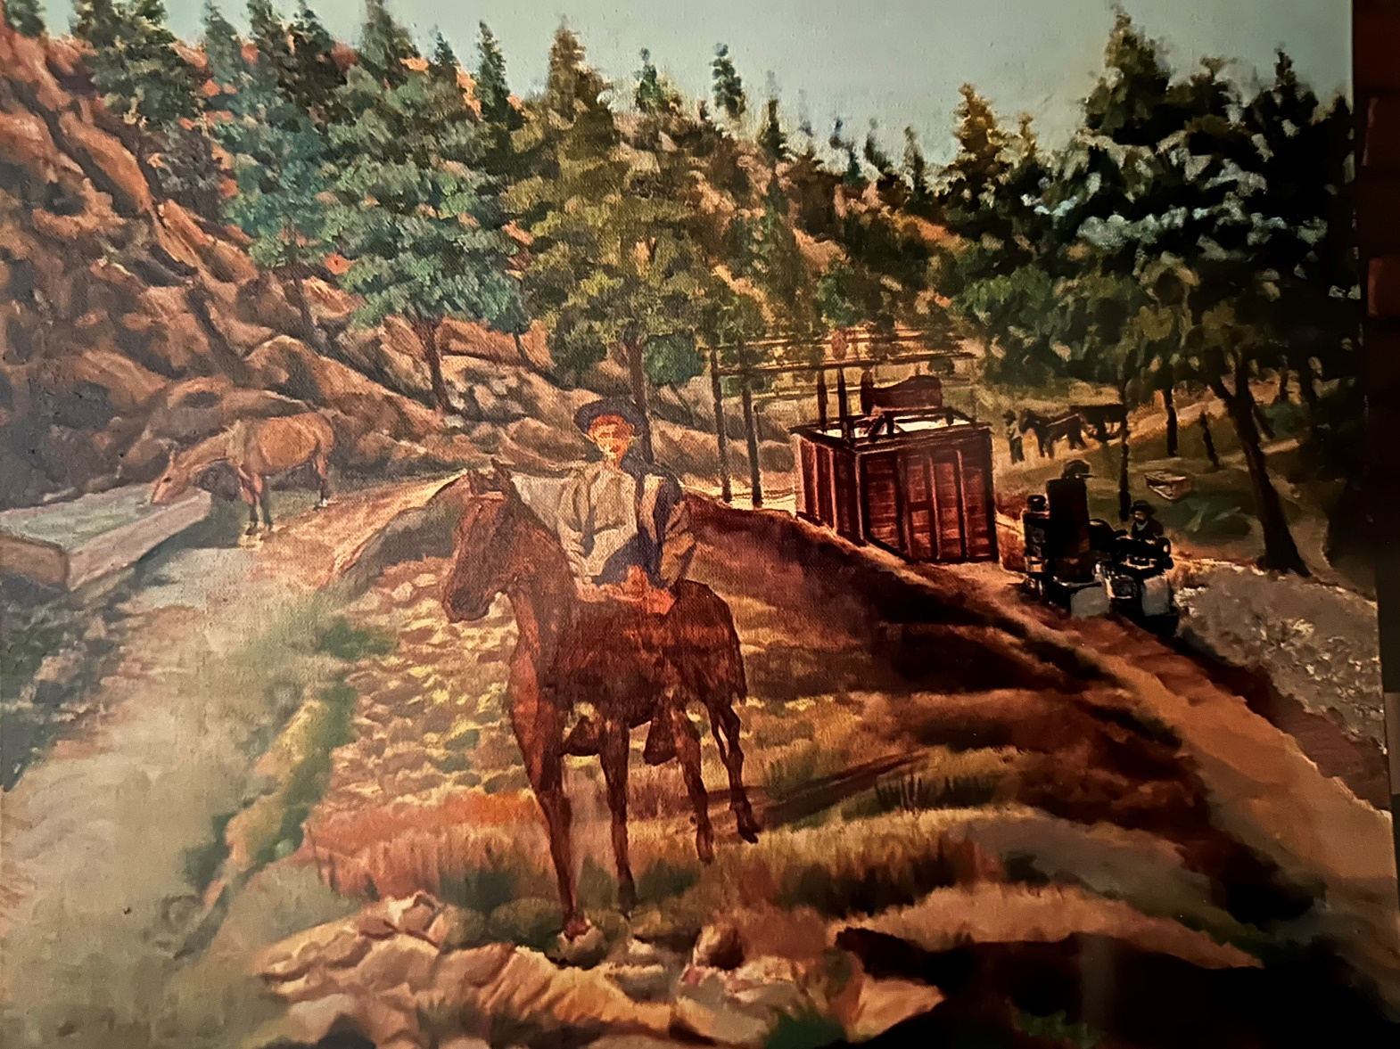
Dandenong Quarry and quarry plant platform and wooden skip tram rails with horse pulling uphill for reloading of road metal.
Directed by Maurice Canterbury,Reconstruction painting by Asad Ali. 2025.
  32.

