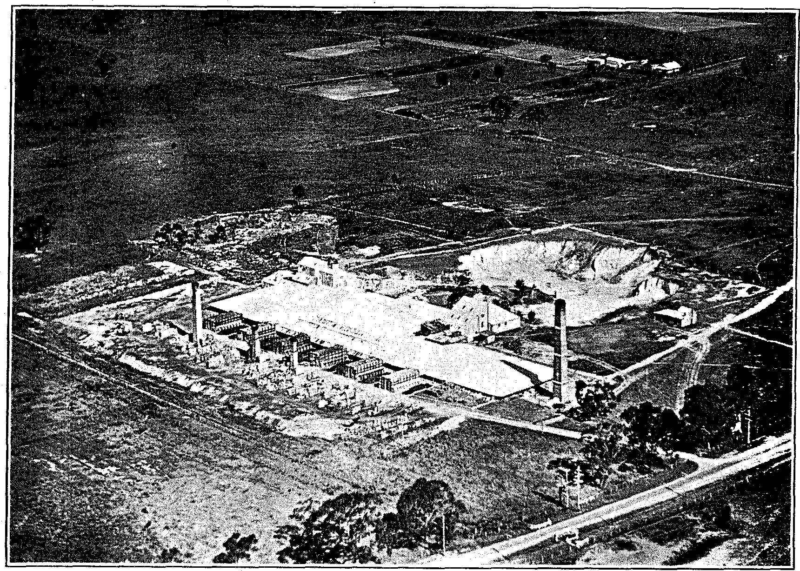
ORDISH BRICK COMPANY
This article was lifted from a booklet created for the Dandenong Jubilee Celebrations 1873-1933.
Visitors to Dandenong who have been absent for the past thirty years or so will find many new industries established, but none of these has been of greater benefit to the town than one with which they were familiar in those distant days as Ordish Brick Works, established by the late W. P. Ordish and carried on by him successfully for many years.
The business was afterwards acquired by the Ordish Fire Brick Co. Pty. Ltd., and under the new management into one of our largest industries, giving employment in normal times to thirty men and sending its products to every State of the Commonwealth and New Zealand.
Possessing the largest known deposit of fireclay in the world, covering some twenty acres, the company has spent large sums in building up-to-date kilns and modernising its works, and those who are under the impression that a brick is just a brick would speedily be disillusioned by a visit to the works of the company on Stud road, where a thousand different shapes are produced to meet the widely different purposes for which fire bricks are required.
The motto of the company, "Ordish fire bricks are known by the customers they keep," is borne out by their list of customers, which includes the Railway Departments of almost every State, the State Electricity Commission, Melbourne and Metropolitan Board of Works, and many of the leading manufacturers throughout the Commonwealth.
A gratifying feature from a town point of view is that the whole of the employees, including the Manager, Mr. R. W. Allen, are residents of Dandenong, some of them having been in the employ of the company from its inception.
It is difficult to fully estimate the benefits that have accrued to the district from this splendid industry, which has advertised Dandenong far and wide by the quality of the fifty thousand bricks which it produces in an average week.
With the return to better times which we all look forward to, this fine industry should have an even greater future before it, and old residents and new wish it an ever-increasing prosperity.

