This information has been lifted from a souvenir booklet created for the Dandenong Jubilee Celebrations 1873-1933
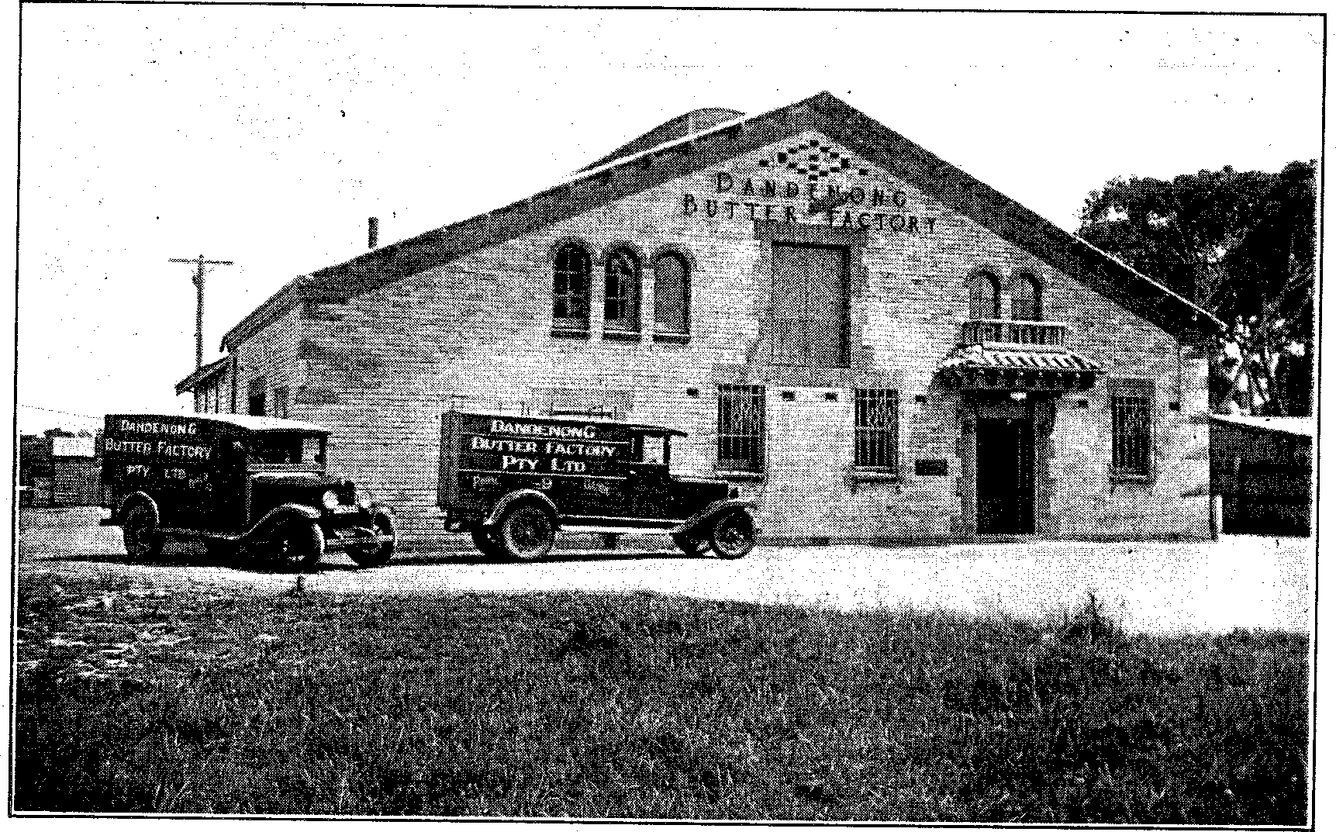
DANDENONG BUTTER FACTORY PTY. LTD.
ONE of the first essentials of a dairying district such as Dandenong is an up-to-date butter factory, and this is provided by the Dandenong Butter Factory Pty. Ltd., with its fine, modern building on Stud road. The business, which was acquired by the company some years ago, has grown steadily, until its production for last year reached 800 tons, valued at £120,000. Cream is collected over a wide area, and prices paid are similar to that paid to Western District suppliers. A feature of the company's business is the large proportion of butter produced which is disposed of in the neighbouring seaside districts and in the eastern suburbs, while naturally a considerable quantity finds its way into Dandenong homes.
The growth of the company's business necessitated rebuilding, and last year a fine modern factory, of which an illustration appears in this publication, was erected, and, as will be seen, successful effort has been made to combine beauty and utility.
The building is one of which the proprietors have reason to be proud, and is in keeping with the general improvement in construction which has been a feature of recent additions to shops and factories in Dandenong.
With a return to better times and higher prices, a successful future should be assured for the enterprising proprietors of the factory, and correspondingly better times for its suppliers, on whose fortunes the future progress of Dandenong must to a large extent depend.

