Vision Queensland, QBIC and the Queensland Industrial Institution for the Blind
A History 1883 - 1999
Vision Queensland, QBIC and the Queensland Industrial Institution for the Blind
A History 1883 - 1999
By Basil Shaw
Vision Queensland PO Box 6091 Fairfield Gardens Qld 4103
Dedicated to all the blind and vision impaired people who have worked at the Kent and Cornwall Streets site at Woolloongabba, and their families and carers.
Contents
Foreword..................................................................................................p 3 Preface..................................................................................................... p 5
Chapter 1
QBIC and Vision Queensland, 1995 to 1999................................... p 7
Chapter 2
The Welfare of the Blind and Vision Impaired, 1883 to 1983 - a Tradition Established............................................... p 23
Chapter 3
The Queensland Blind Industrial Centre, 1984 - 1988 .............................................................................................p 38
Chapter 4
QBIC and the Annerley Campus of the Yeronga College of TAFE, 1989 - 1994 .................................................p 43
Appendix 1
Vision Queensland Subscribers at the Inception of the Company, 1996..................................................................... p 61
Appendix 2
Vision Queensland Board of Directors, 1999 ...........................................................................................................p 62
Reference List ........................................................................................ p 63
Index..........................................................................................................p 65
Foreword
As a former employee of the Queensland Blind Industrial Centre (QBIC), as secretary of the Blind Workers Union of Employees for many years, and more recently as a Director of Vision Queensland, I was pleased to accept the invitation to write the foreword to this history.
The industrial workshop of QBIC Industries, now a division of Vision Queensland, is the oldest facility of any kind providing support to blind people in this state. For the last 116 years on the present site, which used to also encompass an area extending through to Cornwall Street, generations of people with legal blindness worked for all, or part of their lives, and others showed their commitment to people with a disability by providing support to them. Most people who have had an attachment to the QBIC workshop can sense the history in the place and can appreciate the value of the facility to blind people.
The first history of QBIC, written after 100 years in 1983, has now been revised, updated and presented in new form in a most able fashion by Dr Basil Shaw. We are all indebted to Dr Shaw for his painstaking research and his presentation of this history in a most readable manner. We would also like to acknowledge a grant from the Brisbane City Council which helped in the publication of the history.
The recent history of QBIC, presented by Dr Shaw for the first time, covers the most tumultuous years in the experience of blind workshop employees. This history clearly shows the failure of policy makers to understand that people should be given choice in relation to their employment options and that employment in open industry is not for everyone. The result of policy makers' agendas, which nearly resulted in the demise of QBIC in the first half of the 1990s, is a lesson to blind people that eternal vigilance must be maintained so that supported employment will always be an available option.
Finally, I should pay tribute to the foresight of Vision Queensland management in initiating and facilitating the writing of this history after only two years of the company's acceptance of responsibility for QBIC. It was indeed most important that the history of the 1980s and 1990s be written before people pass on and records become lost, and on behalf of the blind community I thank the company for this initiative.
Kevin O'Mahoney OAM
Preface
Community organisations such as Rotary have always worked with disabled people and it was through the Rotary Club of Brisbane that I was asked to write the history of Vision Queensland.
Des Knight and John Puttick, the Deputy Chairman and Chairman respectively of Vision Queensland, are both members of the Rotary Club of Brisbane and Rotary friends of some long standing.
Their original request was to write a history of Vision Queensland, but as I worked my way into the project it seemed to me that while Vision Queensland might be the main focus of the story, a knowledge of the organisations that had preceded Vision Queensland was also important.
This research brought me an awareness of the Queensland Industrial Institution for the Blind which had occupied the Kent Street Woolloongabba site, the location ofVision Queensland, since 1883. A History of the Queensland Industrial Institution for the Blind, 1883-1983 by Rhonda Forrest was published to commemorate the centenary of the organisation which had been concerned with the education of, and the provision of work for, blind and vision impaired people at the Kent Street site.
This publication is out of print so I felt it necessary to provide some of the information contained in it and as well, to include some of the material available in the archives of Education Queensland on the education of blind children.
The decision in 1989 to transfer the Queensland Blind Industrial Centre (as the Queensland Industrial Institution for the Blind was later renamed) to theYeronga College of TAPE brought me into contact with the Director and staff of the College. They helped me to understand the reasons behind the decision by the Commonwealth Government to relocate blind and vision impaired workers into vocational education courses, and the attempts that were made by the College to help blind and visually impaired workers.
Chapter 1 describes Vision Queensland and the Queensland Blind Industrial Centre (QBIC) from late 1994 - early 1995 to 1999. At that time QBIC was transferred from the control of the Yeronga College of TAFE to the QBIC Management Advisory Board.
Chapter 2 covers the earliest days of community concern for the welfare of blind and vision impaired people and reviews Forrest's history of the Queensland
Industrial Institution for the Blind (QIIB). The chapter includes material on the education of blind children and covers the period from 1883 to 1983.
Chapter 3 continues the history of QIIB and the organisation that replaced it, QBIC. This chapter covers the period from 1984 to 1988 and is quite brief
Chapter 4 deals with the period from the end of 1988 to late 1994. During this period the management of QBIC was transferred to the Yeronga College of TAPE. This period was difficult for both the workers at QBIC and the staff of the College who sought to provide them with training and education which would fit them for work in the private sector. The chapter also describes the intervention of the Minister, the Hon Matt Foley, which resulted in the production of the Tregillis Report and looks forward to the establishment of Vision Queensland.
An issue which caused me concern was the terminology associated with blindness. I came across terms such as blind, legally blind, partially blind, partially sighted, visually impaired and vision impaired. Trying to work out when the language changed and why, I finally decided, was outside my terms of reference, so I have used the term that seemed to be current at the time. I have tried to be consistent.
Two appendixes list the founding subscribers and the current directors of Vision Queensland and a Reference List records material referred to and the names of people who kindly allowed me to interview them. During the interviews Sam McCord and Merv Matthews helped me identify workers in the photographs used to illustrate the text.
Peter Lynam and Margaret Ford from Vision Queensland have assisted me with the archive housed at Vision Queensland, Peter in particular, also reading the typescript to make it as accurate as possible. I was also helped by staff, both current and past, as well as the workers at Vision Queensland. The Director of the ^eronga Institute of TAPE, Brian Hutchison, and a former staff member of the Institute, Bob Faulconbridge, read parts of the typescript. The author of the report which finally resulted in the establishment of Vision Queensland, Brian Tregillis, also provided comment. To all these people go my grateful thanks.
I would also like to thank my wife, Beth, who once again edited material that I have written, and in the process helped me produce a more readable account than might have otherwise resulted.
Brisbane, 1999.
Chapter 1
QBIC and Vision Queensland 199 5 to 1999

The Situation Today -a Private Organisation Once Again
In the second half of 1999 Vision Queensland is in its third year of operation as a private company limited by guarantee. It is a registered charity in Queensland. Vision Queensland can trace its history back to the Queensland Blind and Deaf and Dumb Institution which was founded in 1883. It was also a private charitable organisation but in January 1918 it was declared a public institution under the control of the Government of the State of Queensland. For almost eighty years the welfare of the blind and visually impaired people who worked at the industrial workshops in Kent Street, Woolloongabba was managed by various Public Service Departments.
.Vision Queensland therefore revisits past traditions by serving blind and vision impaired people in the private sector. The Mission Statement of Vision Queensland clarifies the nature of this service.

To encourage, foster and facilitate blind and vision impaired people to achieve their potential through employment, education and training and participate and have access to the amenities of life enjoyed by all Australian Citizens.
To achieve its mission the Company has established three core services. Firstly, there is the Division of QBIC Industries, a supported business service which provides employment and training in industrial manufacturing, assembly and packaging. The former Queensland Blind Industrial Centre (QBIC) now trades under the name of QBIC Industries. Employed by QBIC Industries are long-term blind and vision impaired employees and a small number of trainees employed for twelve months while undertaking training and employment leading to a Certificate in Industrial Manufacturing or a Statement of Attainment of skills acquired.
The second core service is provided by the Division of Client Services. This division provides an employment job search and placement support service. Also provided are an information and

referral service to clients who register with the Division.
The third core service of Vision Queensland is the development arm, which has responsibility for public relations, community awareness, corporate sponsorship, access to charitable grant funding and fund raising among the general public.
This chapter examines Vision Queensland as it is operating currently and the core services it provides.
QBIC becomes part of Vision Queensland
The offices of Vision Queensland are located at a property occupied for over 100 years by QBIC, or those earlier organisations dedicated to the welfare of blind and vision impaired people, in Kent Street, Woolloongabba. From 1989 to 1994 the Kent Street property was known as the Annerley Campus of theYeronga College of TAPE.
In late 1994 the responsible Minister, the Hon Matt Foley, asked the Director-General of the Department of Training and Industrial Relations, Bob Marshman, to take a personal interest in QBIC which had been experiencing major difficulties. At this time the Director-General transferred control of QBIC from the Yeronga College of TAFE to the Training Division of the Department. He appointed Peter

Lynam as Interim General Manager. Early in 1995 Marshman established the QBIC Management Advisory Board, which he subsequently chaired, to determine strategic matters which were related to the future of QBIC. The Advisory Board met monthly from 18 July 1995 until Vision Queensland was incorporated on 8 October 1996 as a public non-profit company limited by guarantee.
During 1995-96 there were substantial negotiations carried out by the General Manager to transfer QBIC from government control and to prepare for its transformation into a non-profit company. At the time QBIC was running at a substantial loss of $1.07 million per year. Lynam's brief included restructuring QBIC and reducing the loss the Company had been making.
The negotiations with the Department of Crown Law, the Department of Public Works and Housing, and the controlling Department took many months. They were delayed by a change in Government early in 1995. A report addressing the future of QBIC, and previously accepted by the Labor Government, had to be resubmitted to the new Minister, the Hon Santo Santoro, in the Coalition Government. He approved the privatisation of QBIC in March 1996. It was heartening that both the Labor and Coalition governments had treated the Report in an apolitical manner.
The results of the various negotiations to remove QBIC from Government control were successful and QBIC Industries emerged as a privately incorporated company with a long-term lease on the Kent Street site at a peppercorn rental. The State Government agreed to provide site maintenance funding for ten years as well as general funding to support the restructuring of QBIC Industries. During this period the General Manager was to establish Vision Queensland, the parent company, as a viable commercial enterprise.
Following incorporation, the first formal meeting of its subscribers occurred on 22 October of that year. (See Appendix 1 for the list of initial subscribers). The subscribers comprised the former members of the Management Advisory Committee who became directors of the new company. Vision Queensland accepted responsibility for the former Queensland Blind Industrial Centre on 1 November 1996.
The Board of Directors of Vision Queensland and Early Initiatives
The Constitution of Vision Queensland provides for a chairman and a deputy chairman together with a number of directors from the professions, business, industry and the blind community as well as service organisations such as Rotary and Lions.

There are currently eleven Board members in all, but the Constitution allows for a number between nine and twelve.
The Constitution is quite specific about community and professional representation, the framers of the document wanting a mix of sighted and vision impaired representatives as well as directors with legal, accounting, marketing and business experience relative to Vision Queensland's mission. There are two representatives of organisations representing blind and vision impaired people on the Board and a representative of the Director-General of the State Government Department of Employment, Training and Industrial Relations, which department is responsible for the interim funding of Vision Queensland. This director remains on the Board for as long as the State Government remains responsible for the funding of Vision Queensland.
In addition, the Chief Executive Officer of the Company may be appointed a director. This has occurred with the present CEO and the title Managing Director is used for formal
correspondence.
\
John Puttick, the Managing Director of Global Banking and Securities Transactions, a computing software firm in Brisbane, was the inaugural chairman and currently still holds that office. The deputy chairman is Des Knight, a Director of Priority

Maintenance Services. Both Puttick and Knight are prominent businessmen and members of the Brisbane Rotary Club. The current directors are listed in the second appendix to the history, of whom Geoffrey Melvin, a solicitor with Melvin and Company, is the Company Secretary.
In his Chairman's Report to the 1998 Annual General Meeting Puttick was able to record his satisfaction at an upturn in sales by QBIC Industries of

just under half a million dollars which was an increase of 45% on the previous year's figure. This growth in turnover was achieved through the introduction of a computerised brushmaking machine, improved presentation of products and growth of markets. The adoption of the QBIC Industries registered trade mark, the 'frog' logo, improved packaging and the introduction of bar-coding have helped to improve the marketing of QBIC Industries products.

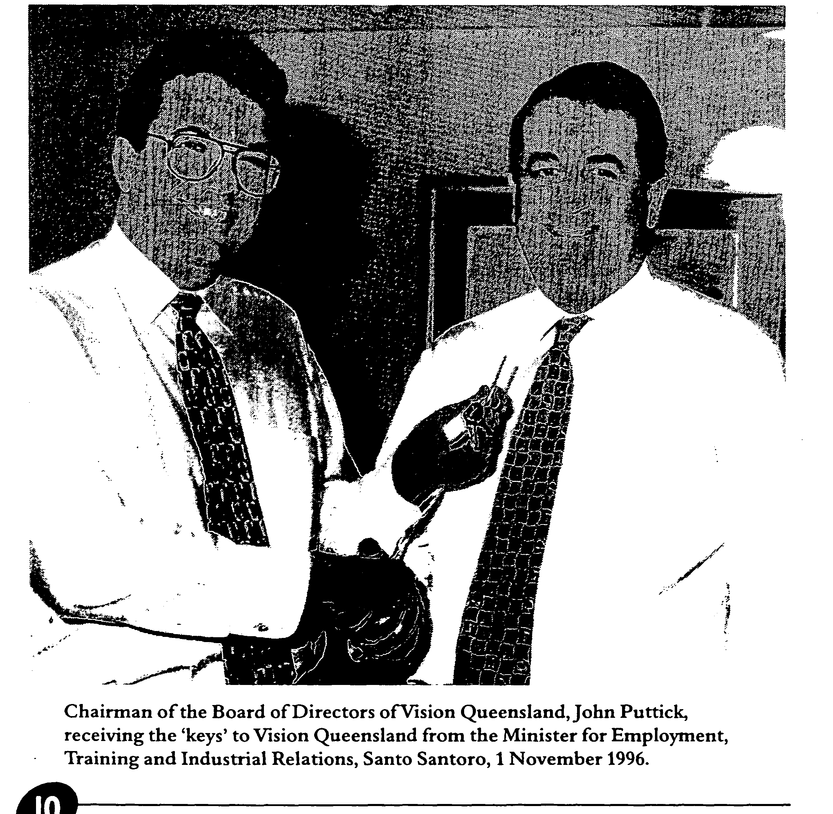

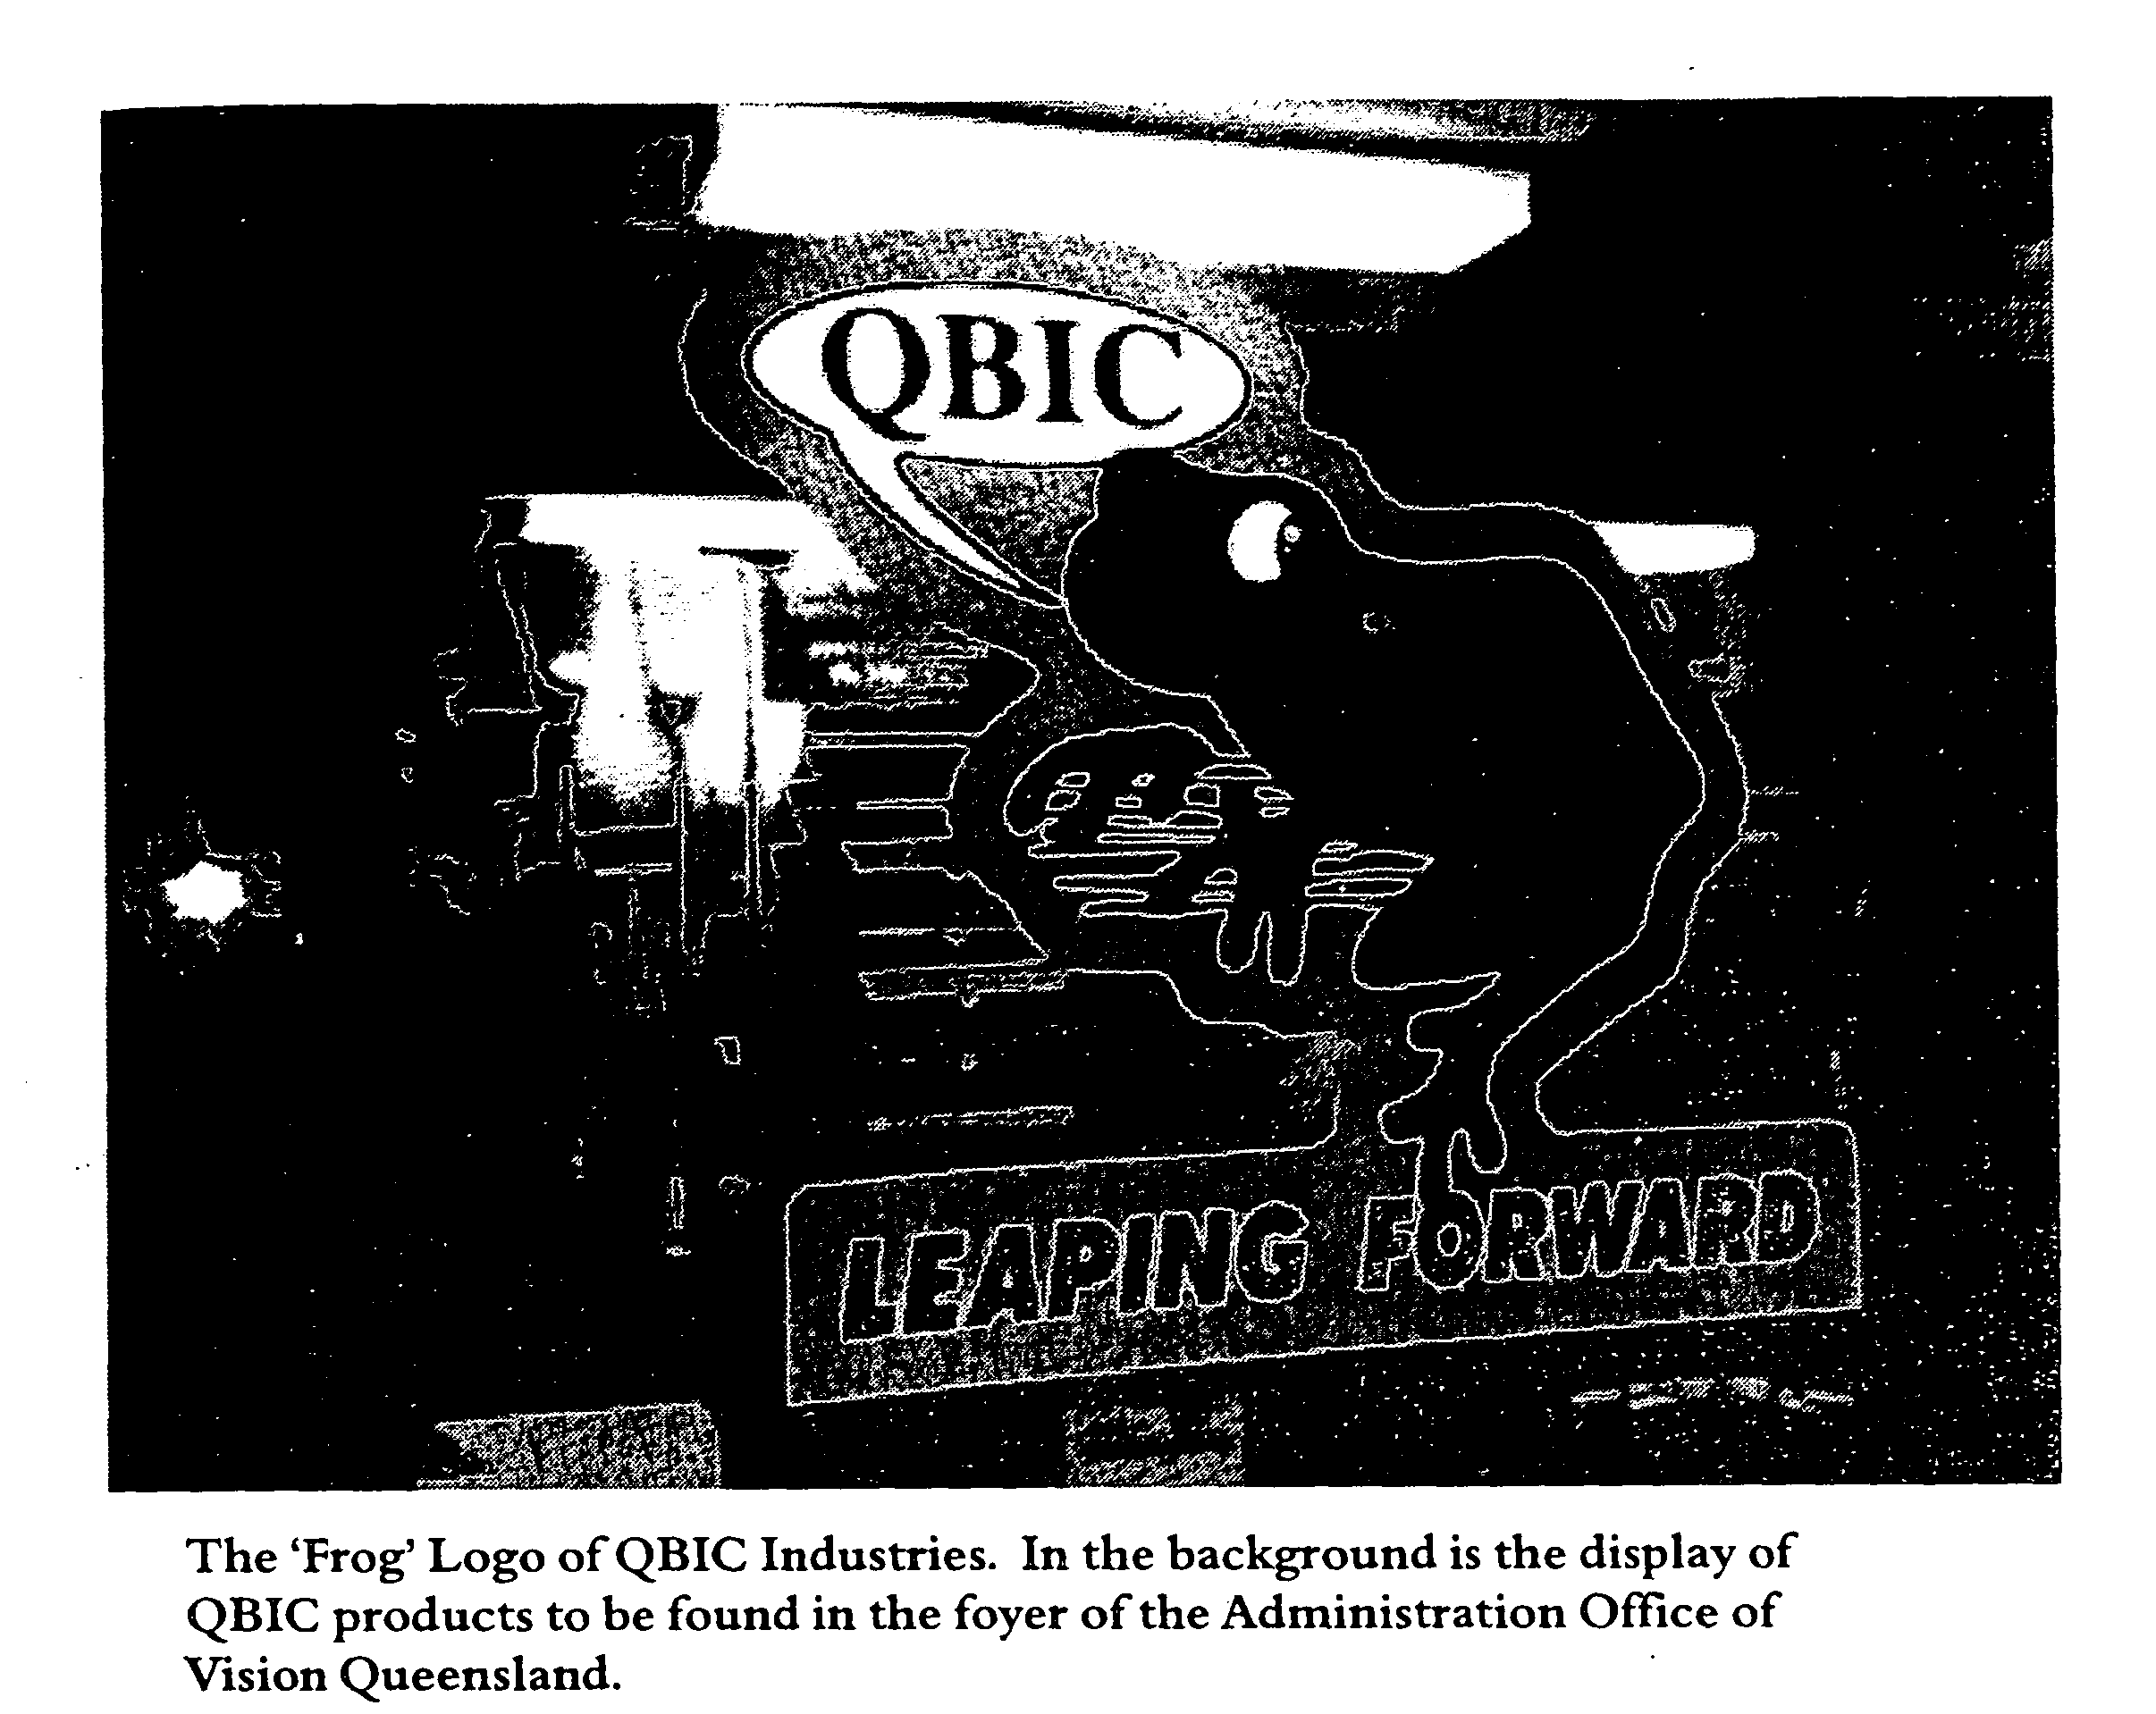

Puttick in the previous year's report acknowledged that Vision Queensland is indebted to Brian Tregillis, who was the guest speaker at the 1997 AGM. Tregillis played an important part in the history of Vision Queensland and QBIC Industries because a report he presented to the Queensland Government in 1995 had already brought about changes to the status and welfare of blind and vision impaired people associated with QBIC. (A fuller account of the Tregillis Report and its recommendations is to be found in Chapter 4 of this history.)
In 1997 Tregillis urged the company to concentrate on two significant matters:

Firstly, to maintain its focus on the provision a/employment and training services for people with vision impairment.
Secondly, to pursue closer working arrangements and amalgamation with the numerous vision impairment support organisations in Queensland.
While the first of these matters is in hand and the Directors have provided opportunities for both training services and employment placement, there has been little real progress in relation to the second objective. It is evident that the many organisations concerned with the welfare of blind and vision impaired people in Queensland remain

fragmented and often apprehensive of one another. However, Vision Queensland remains committed to the goal of creating an umbrella organisation, which could lobby Government and other supporting organisations with a united voice.
Another of the major achievements of the Board has been the adoption of a Strategic Directions document which covers the period from 1997-98 to 2001-02. This position paper, together with an Annual Business Plan, provides targets for all of the service areas managed by Vision Queensland. It should be noted that QBIC Industries is commonly referred to as QBIC and that should be taken into account in what follows.
Strategic Directions
This strategic position paper includes a statement of the Company's values; its role and functions and a series of objectives under the headings of
• Research, Policy Development and Advice Strategies
• Technology Brokerage and Support Strategies
<
• Employment Education and
Training Support, and
• Financial Earnings and Disbursement Program

In introducing these strategic directions the Board noted,
By mid 1997 sales of QBIC products were increasing, new employees had been engaged for the first time in ten years, and a significant progress towards restoring QBIC as a supported business had been made. However, the facility is in need of more capital investment in machinery, there is a need to identify a greater variety of manufacturing options for the employment of blind and vision impaired people whose skills and abilities vary considerably, and generally QBIC needs more work so it can employ a larger number of vision impaired people who are currently seeking supported employment (p.4).
In relation to research, policy development and advice Vision Queensland sees itself as promoting an awareness of the range of services available to the blind and vision impaired in Queensland generally rather than solely in Brisbane. This raising of awareness will involve advocacy of the rights of blind workers both privately and with the State and Federal Governments. Vision Queensland accepts that it may not be the appropriate organisation to help all blind and vision impaired clients and hopes to be able to refer those it cannot help to other organisations.
Improved information technology provides both opportunities and challenges to the blind community and
Vision Queensland is committed to providing access to the latest developments in services, such as the Internet, to allow its consumers (as the company describes its blind and vision impaired clientele, their families and carers) to improve their employment prospects, vocational education and training. In this regard the Company has entered into an agreement with the Yeronga Institute of TAFE to establish a joint venture, The New Vision Adaptive Technology Resource Centre.
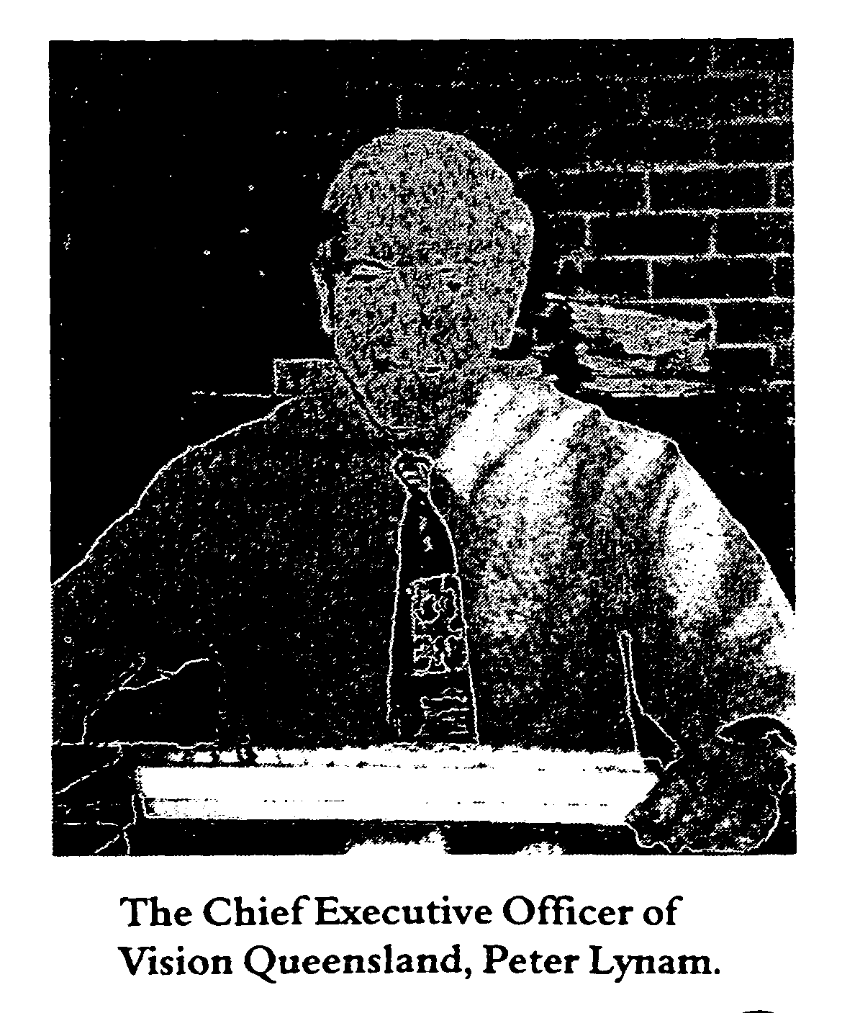
Vision Queensland has an employment register and is committed to helping its consumers access the employment market. It will also investigate ways of helping its consumers raise 'seed funding' where they provide evidence of being able to start a small business. An important part of employment services is the provision of adequate training and the Company refers potential employees to training providers such as the Yeronga College of TAFE with whom it has had a long relationship.
Finally, Vision Queensland intends to access all sources of funding. This includes support provided by both State and Federal Governments, as well as charitable and benevolent trusts and funding provided by private industry. It will also work towards maximising the earnings of QBIC Industries and it is committed to 'ensuring that funding ... is professionally managed, accounted for and disbursed for the

benefit of consumers in accordance with the objects of the Company' (p.3).
Management Structure and Workforce
The Chief Executive of Vision Queensland is Peter Lynam who has been responsible for QBIC and Vision Queensland since 4 November 1994. Lynam, a former senior Commonwealth public servant, had worked on aspects of the investigation Tregillis conducted into QBIC as it operated on the Annerley Campus of the Yeronga College of TAFE. His public service work experience involved corporate management, employment, training and industrial relations and he was the Director of Industrial Training on ceasing with the Commonwealth. He subsequently worked on various
projects for the Queensland Department of Employment, Training and Industrial Relations.
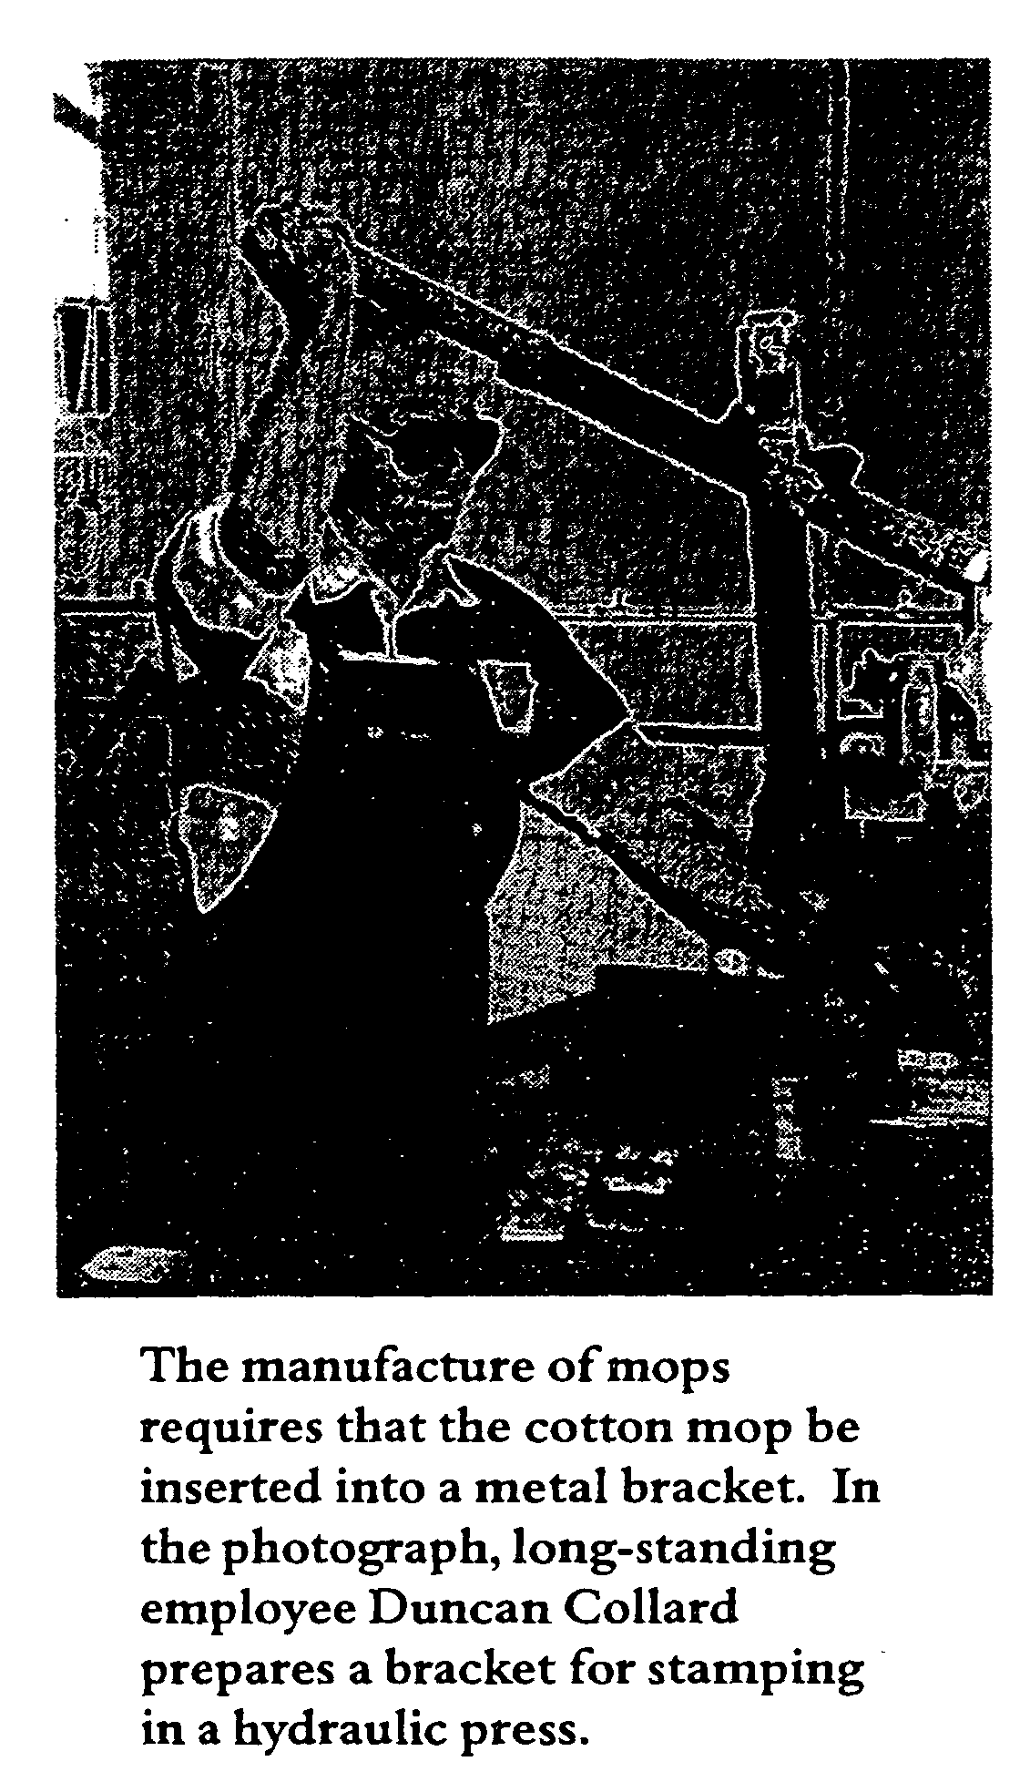
The Chief Executive is supported by the Manager of QBIC Industries, Henry Cichowski, who is also the Marketing Manager. Cichowski is responsible for production and training in the workshops, managed by Keith Smith. Margaret Ford is responsible for Finance and Administration.
Reporting directly to the Chief Executive also are the Development Manager, David McKenzie, and the Employment Services Manager, Nigel Irwin. McKenzie is the organisation's fund raiser and is responsible for public relations for Vision Queensland, while Irwin interviews blind and vision impaired people seeking employment, arranges training where necessary and helps them find employment.
The staff establishment consists of six other full-time sighted staff who provide supervision of the workforce, administrative assistance, and stores and maintenance services. The canteen is let out to private contract and is staffed by two part-time workers. The blind and vision impaired workforce consists of twenty-five workers, a number of whom have multiple disabilities. In addition there are currently two trainees preparing for the Certificate in Industrial Manufacturing.
After many years of effort by the Blind Workers Union to obtain industrial

coverage, blind and vision impaired workers are currently employed under the Vision Queensland Award -State with the responding unions being the Blind Workers Union of Employees and the State Public Service Federation Queensland. Workplace health and safety is a major concern in workshops such as those operating at Kent Street and a safety committee, a safety officer and a rehabilitation officer are responsible for compliance with the workplace, health and safety act.
Because of the space it has available, Vision Queensland could double the number of workers it presently

employs if additional suitable work could be found for them and Vision Queensland will continue to actively seek suitable businesses to increase its workforce. In its heyday prior to WW II the Centre supported over 100 workers. Today it has underutilised space. Another reason for the small workforce at QBIC is that the incidence of blindness has decreased in more recent times as rubella vaccinations have become commonplace.

Production
An illustrated four colour catalogue published by QBIC Industries lists its current products. There are more than fifty different types of brooms, with both wooden and plastic stocks, some for use in heavy duty applications such as sand mining and road sweeping. QBIC also produces a wide variety of brush ware, mops and squeegees. The production manager is able to manufacture small runs of specialised products such as rollers for the mining and fruit industries as well as strip and polishing brushes.

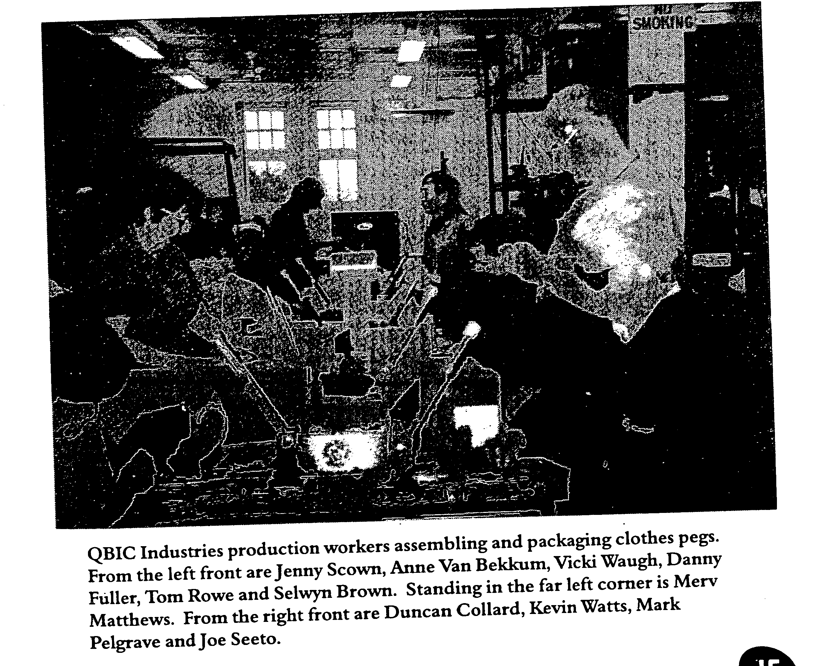

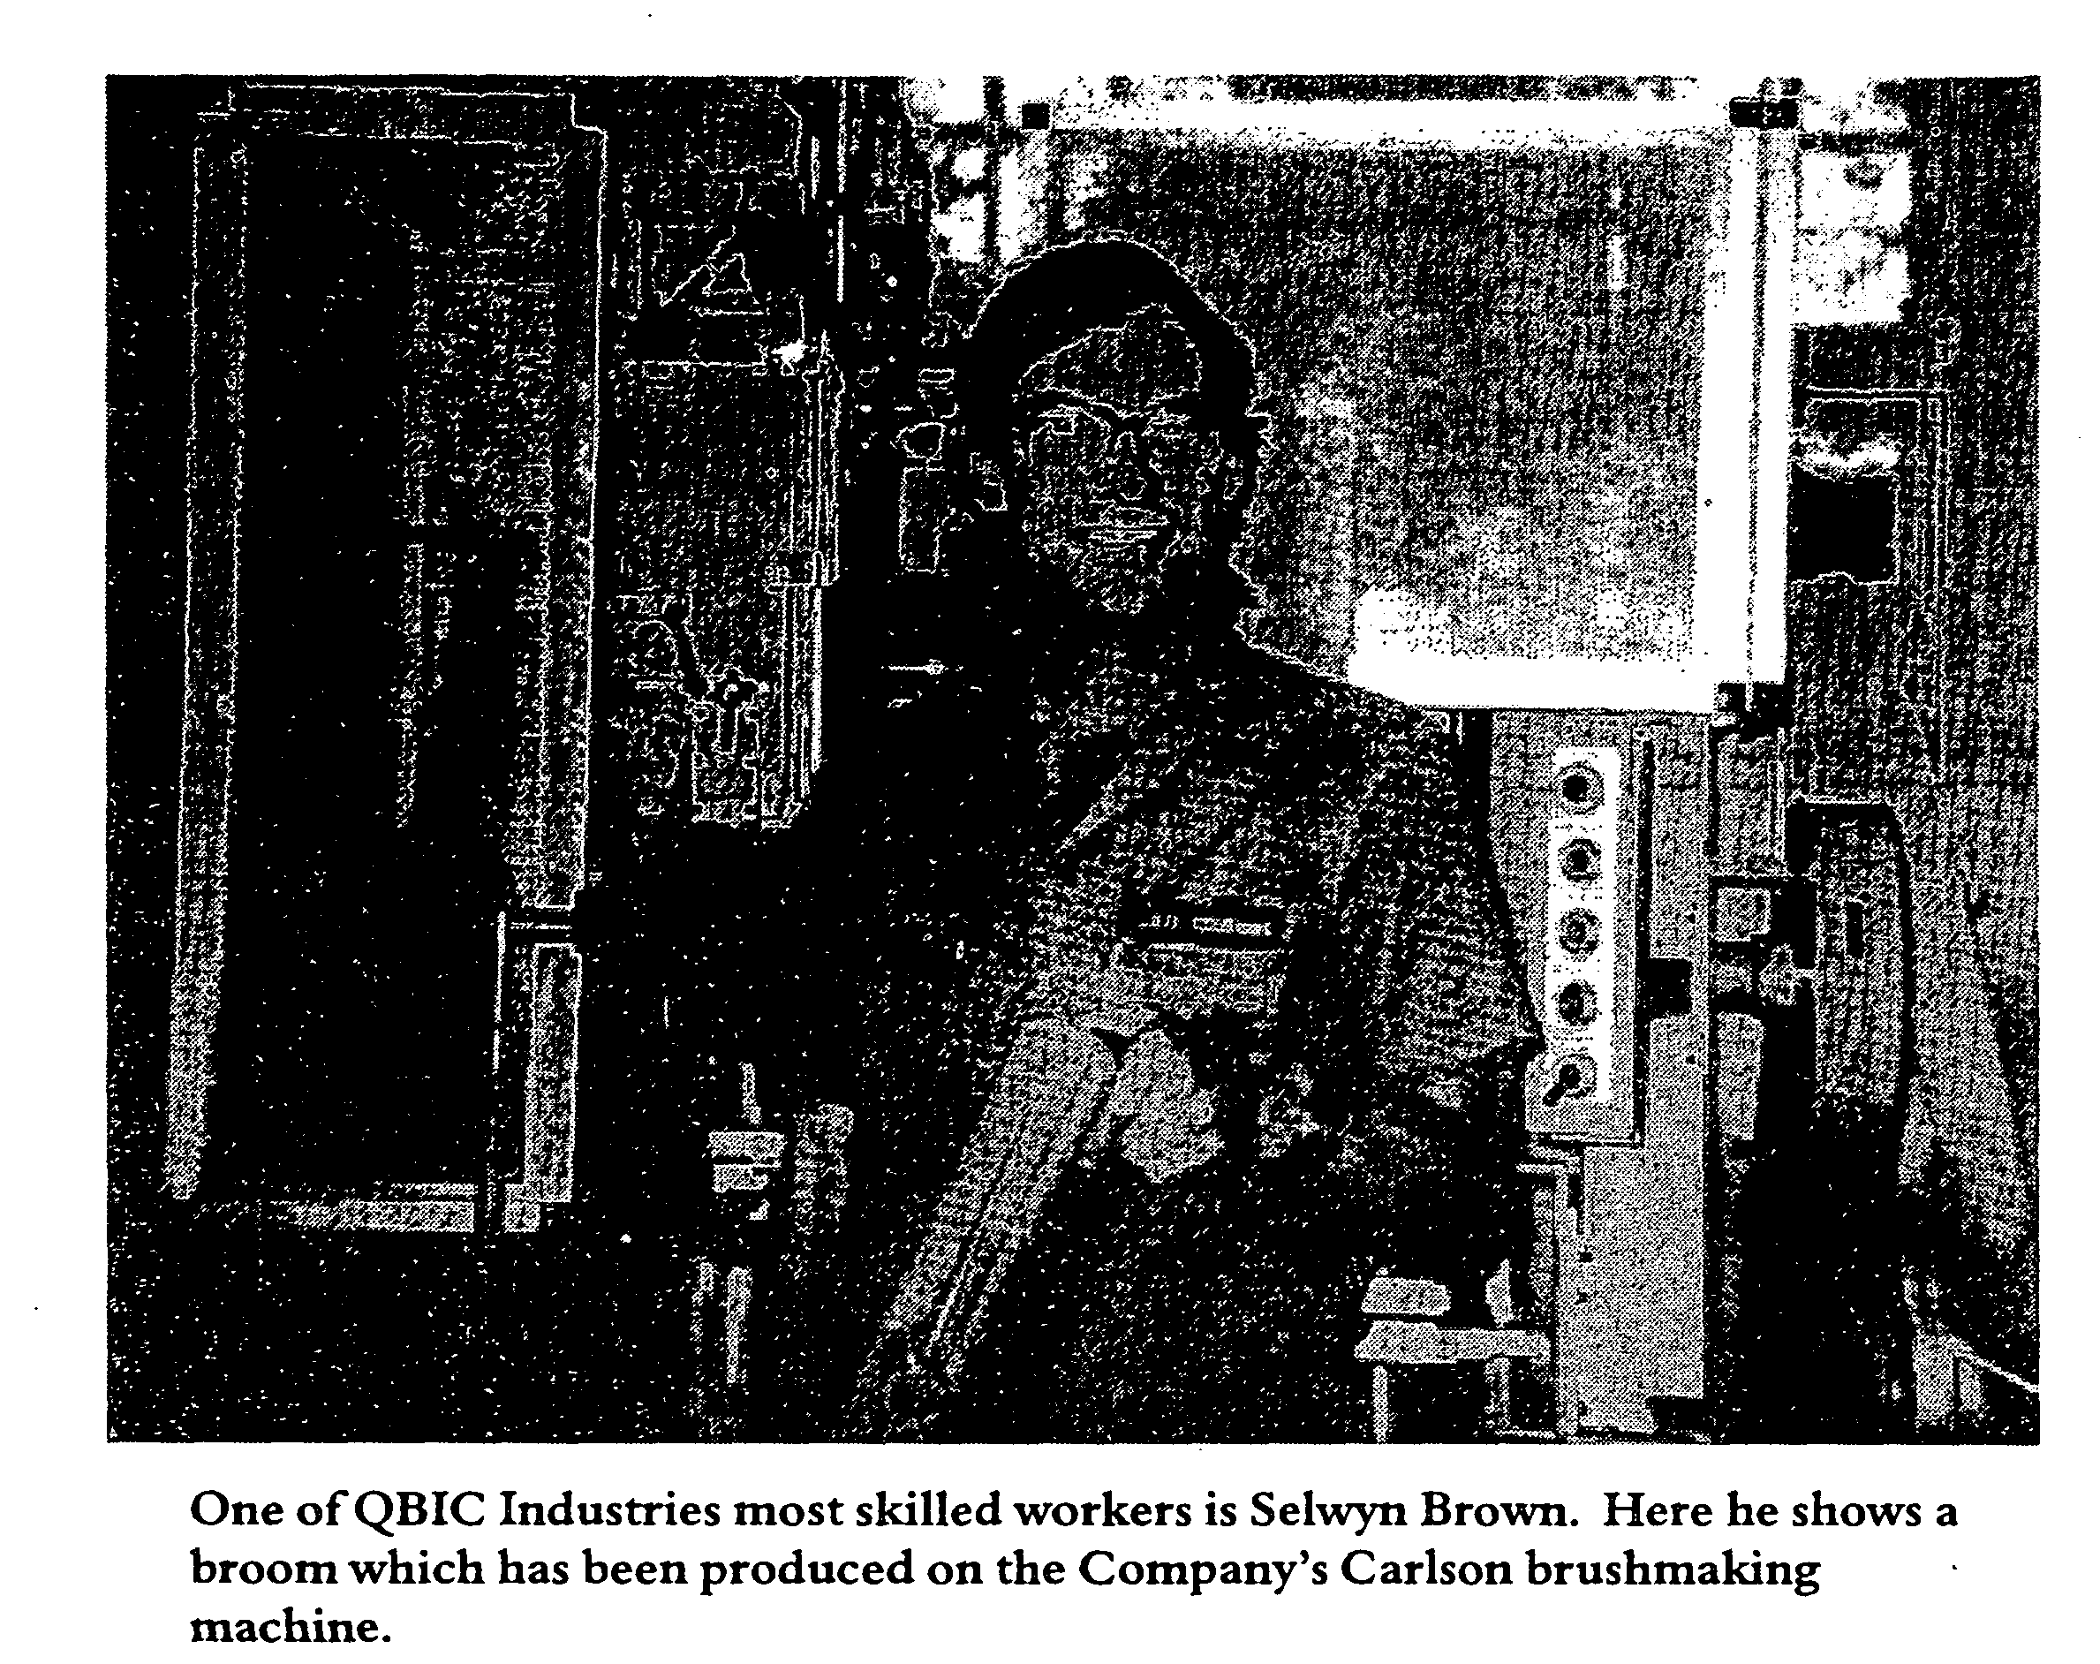

Plastic clothes pegs are also assembled and packed as are clothes hangers. A large contract in mid-1999 with REVA Plastics has meant that many workers were redeployed, packaging plastic pegs. A semi-automated clothes peg assembly machine has been constructed as a joint venture with REVA Plastics. This machine is currently undergoing more development work. The machine is used when the demand for pegs is great.
QBIC formerly produced cane basket < ware and shark netting and these products are still manufactured when there is demand for them. Education Queensland is an important customer for caneware wastepaper baskets. All of

Queensland's shark netting is woven at QBIC and is purchased by the Department of Primary Industries when nets need replacement.
In 1998 the Company purchased a panel saw which allowed it to fill a contract by Beach Collections for the supply of timber products. All machinery operated by blind and vision impaired people must undergo safety evaluation by officers from the Division ofWorkplace, Health and Safety. In the case of the saw a special jig had to be made to allow the machine to be operated safely and to produce goods to the standard required. Most machinery operated at Kent Street makes use of similar safety jigs.

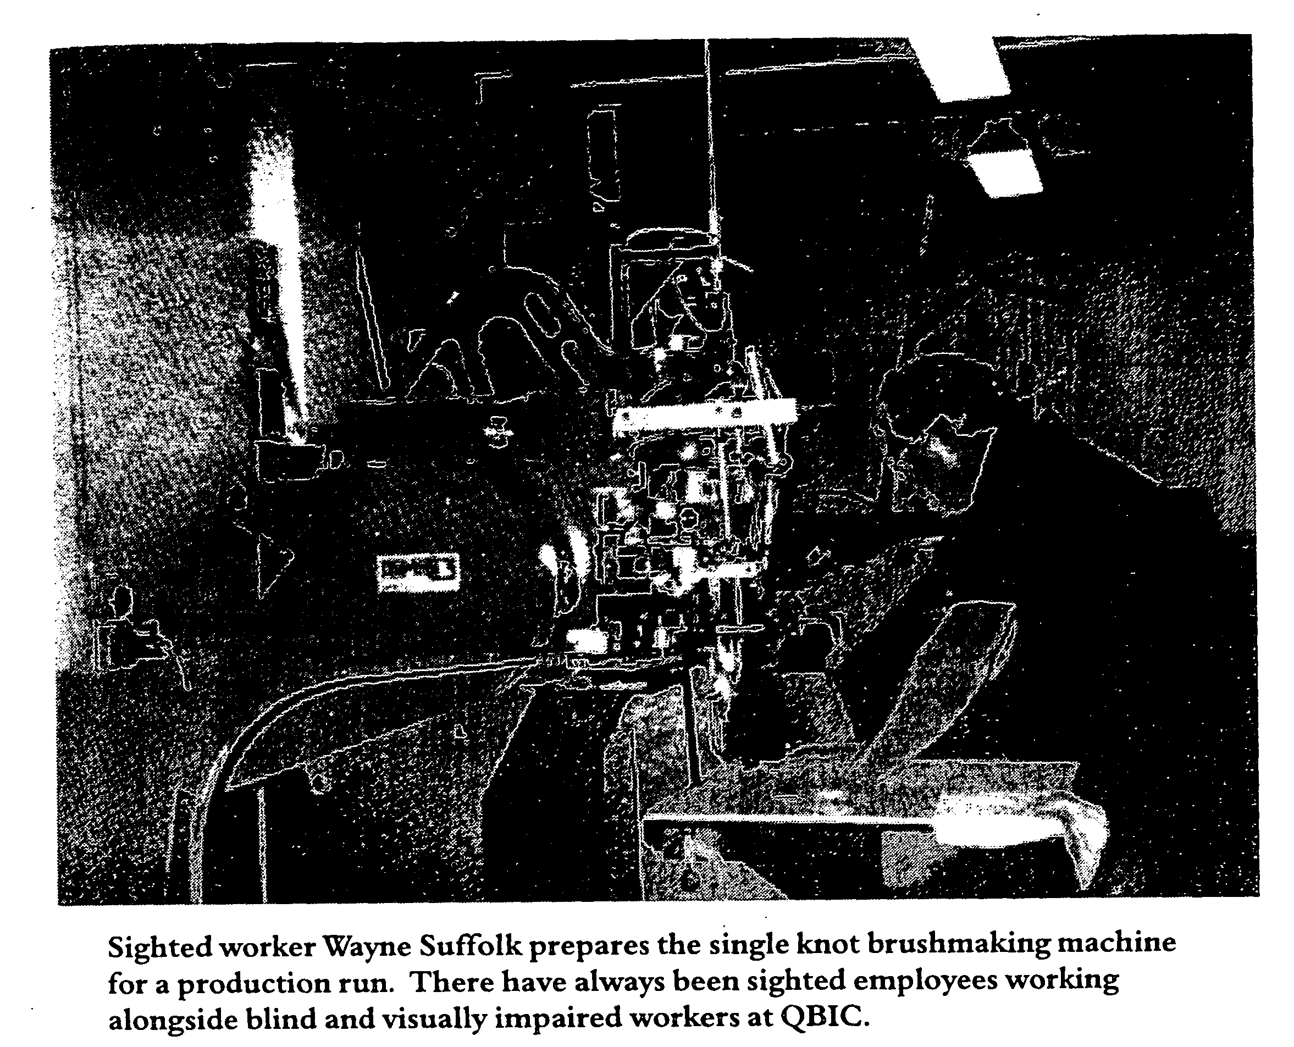

Improved production of brushware, which remains the company's major source of income, has resulted from the introduction of a computerised brush-making machine, the CNC Carlson, which can produce both wooden and plastic-stocked brooms and brushes. In addition the older mechanical brush makers, the ESTO and RUNO machines, have been renovated, although they produce wooden-stocked products only. New wood working machinery to produce cottage craft timber products was purchased with a grant from the AMP Foundation.
Also recently installed is a single-knot brush machine, which was imported

from Italy. The March 1999 issue of Insights, the regular newsletter produced by Vision Queensland, reported that the machine 'will help Vision Queensland make specialist brushes for the many industries we service, enable us to repair brushes that currently would need to be replaced with expensive new ones, create further employment in our workshop, enable us to gain new clients and enhance the service we offer existing clients' (p.l). Purchase of the machine was made at a cost of $77,683, of which $30,000 came from the Jupiters Casino Community Benefit Fund.

New markets have been developed following the appointment of agents in North Queensland, New South Wales and Victoria and the first consignment of products was exported to Vanuatu in 1999. Further expansion is under consideration in relation to the other Australian states. A major consideration in this expansion is the perception among customers that QBIC now produces quality products and, equally importantly, is a reliable supplier.

Financial Matters
Vision Queensland operates under a five-year funding agreement with the Queensland Department of Employment, Training and Industrial Relations. The current arrangement will operate until June 2001 when it is expected that the major subsidies paid to the company will become the responsibility of the Commonwealth Government under the Commonwealth/State Disability Agreement of 1991. The Disability Agreement provides for financial support by the Commonwealth Government for business services. Currently the

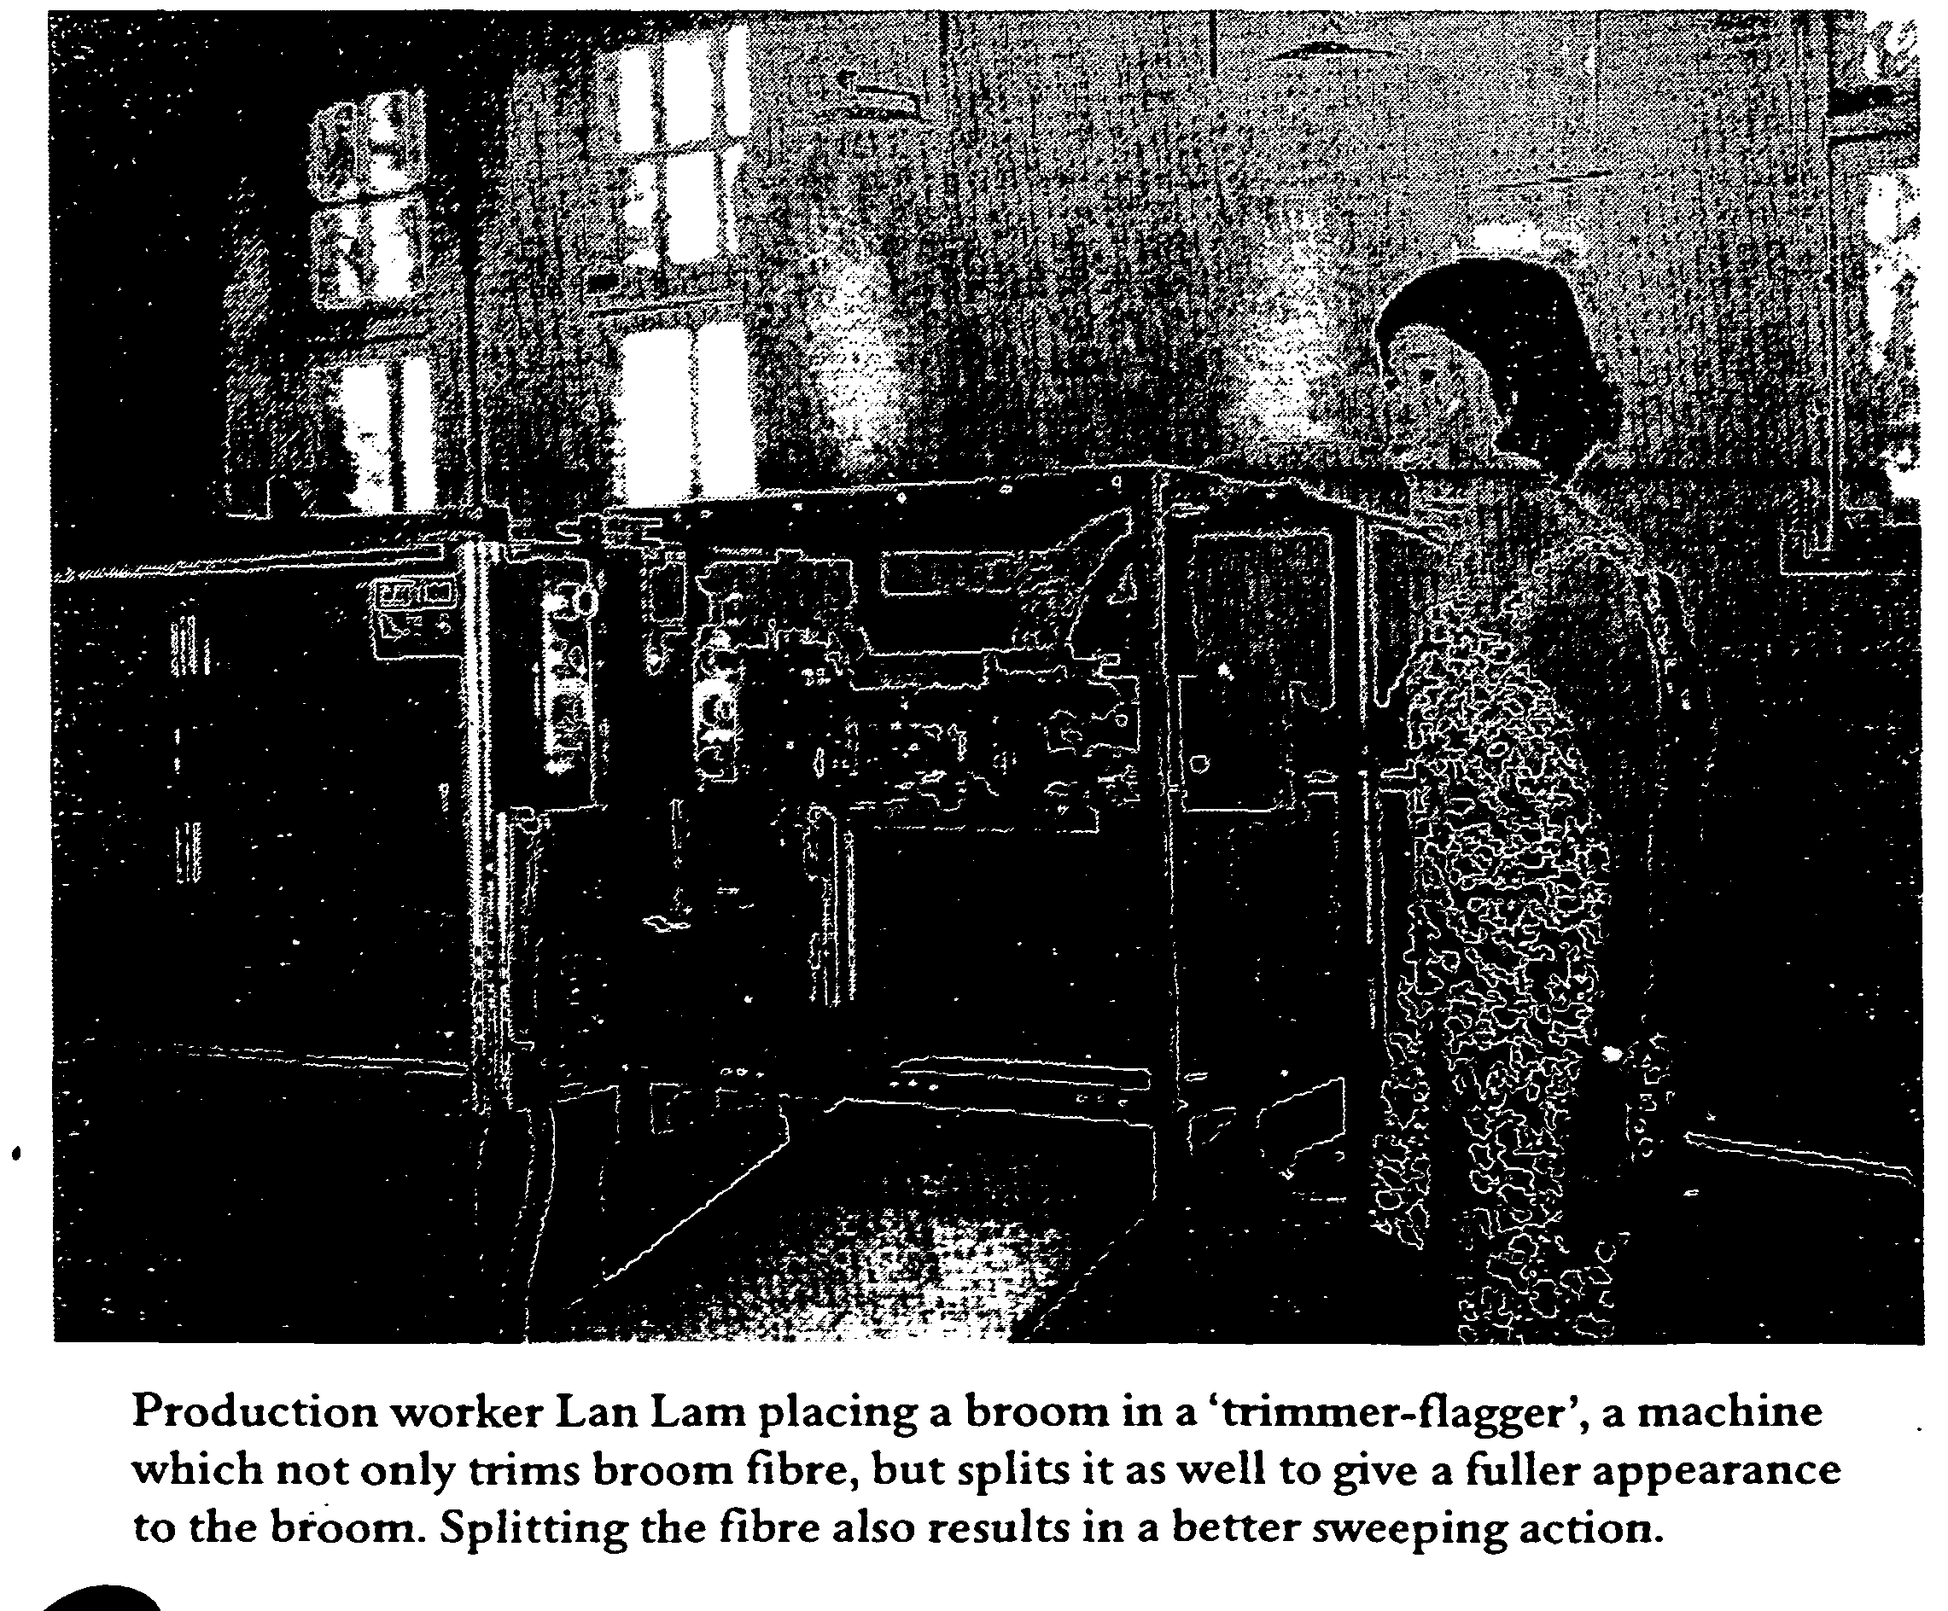

agreement provides State funding of just over one million dollars per annum to the company, the funding reducing as restructuring reduces running costs.
The Company has been building up a reserve over the last three years against the day when it will have to be self-sufficient. The reserve is for capital outlay such as the recent purchase for just under $100,000 of a rug manufacturing enterprise, its first new business acquisition. By the 30 June 1999 the operating loss for QBIC Industries, before Government grants, had been reduced to $659,561. At the same date sales had increased by 23.33% from $466,312 to $575,239.
The canteen operates at an annual loss of just over $3,000, the loss being subsidised by income from the Legacy

Trust Fund. Other income from the Trust Fund is being used to subsidise the QBIC traineeship scheme. The Legacy Trust Fund, originally the Legacy Fund, dates back to the 1930s and is briefly discussed in subsequent chapters.
The Company does not pay income tax;
it does not pay a dividend and the Directors receive no remuneration for their services.
Reporting
Vision Queensland produces an Annual Report and Financial Statement which is presented and adopted by the Annual General Meeting which is usually held towards the end of the calendar year. The 1997-98 Report included reports from the Chairman, the

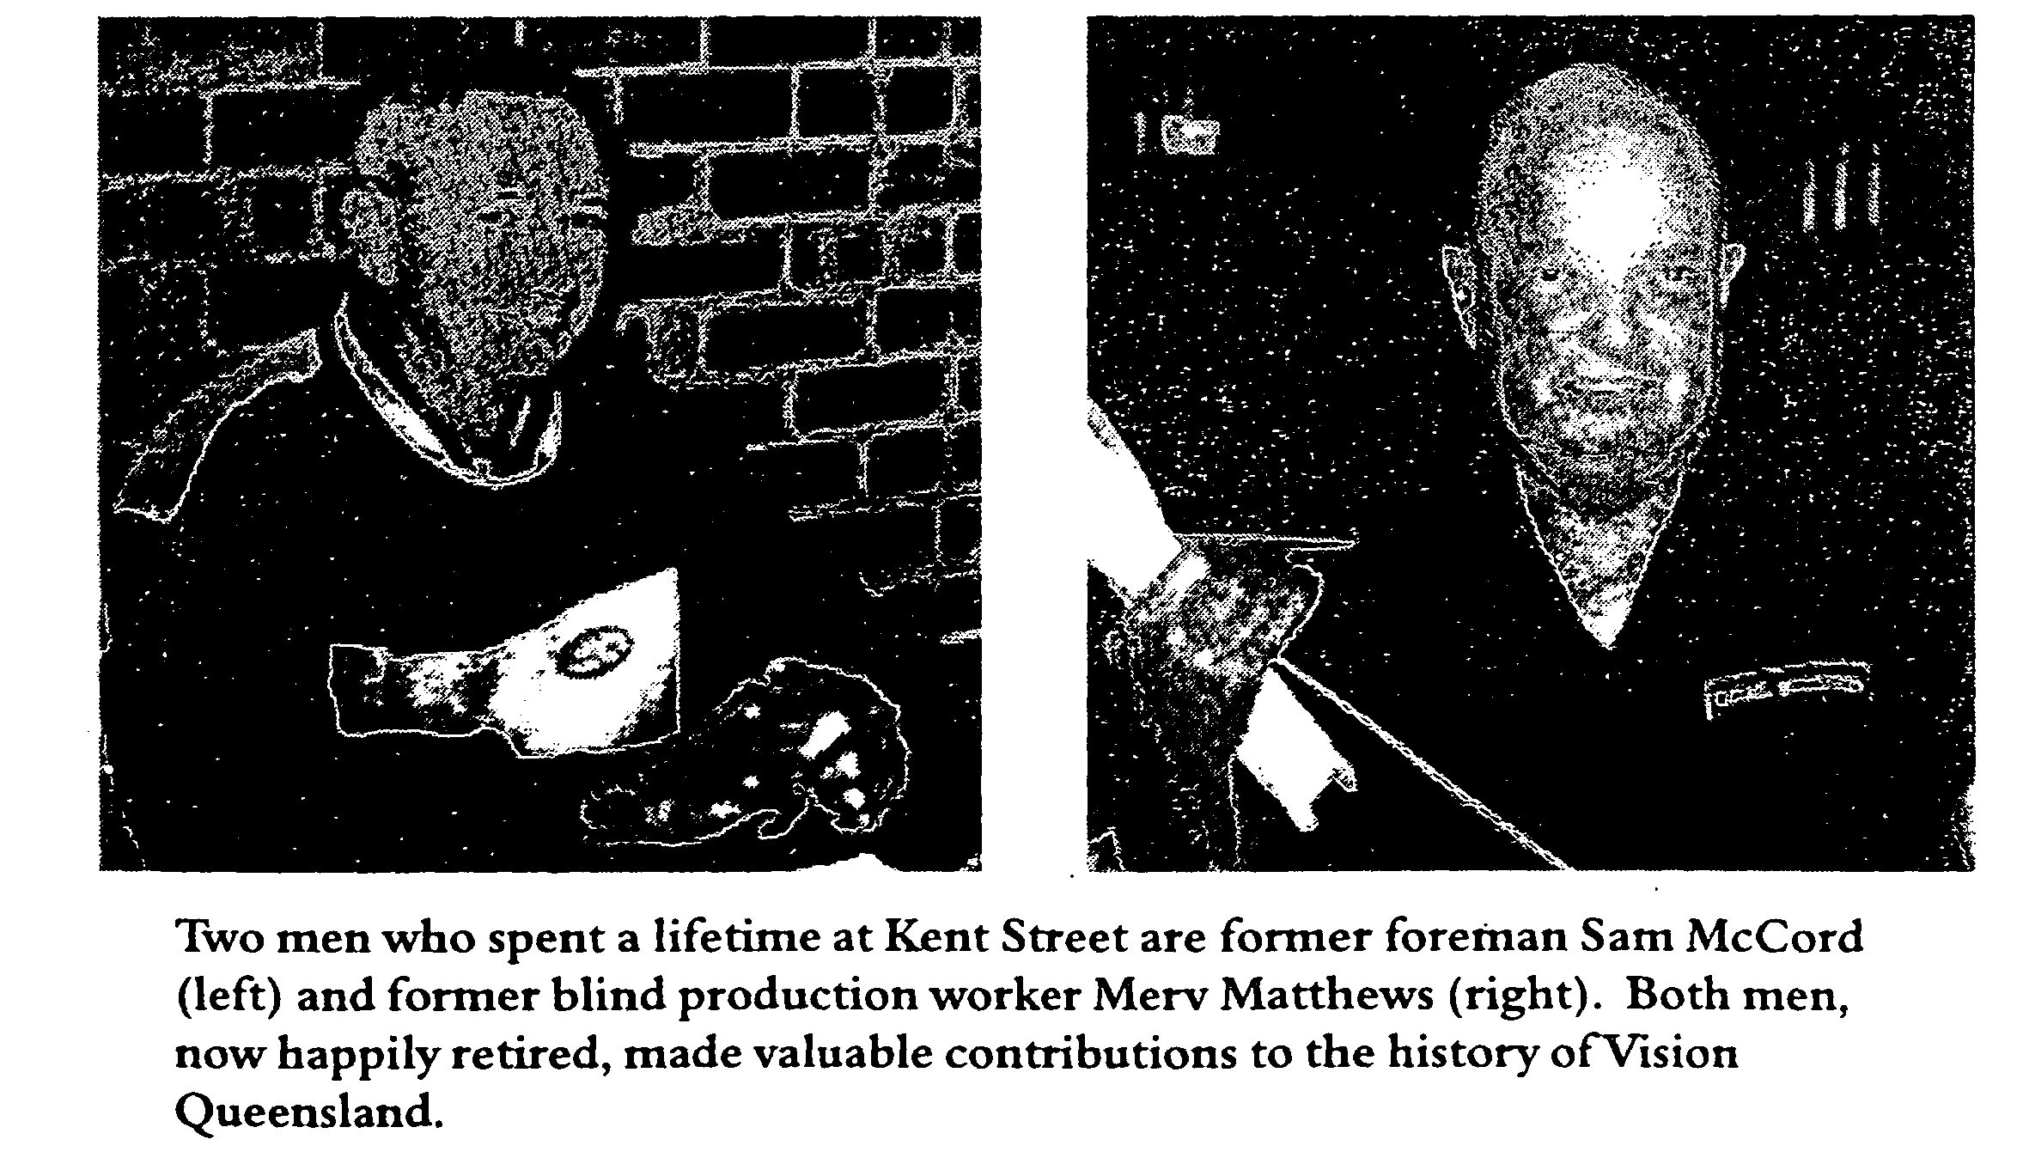

Chief Executive and the Directors, and an attachment setting out the Directors' employment affiliation, formal qualifications and an attendance summary.
The Financial Statement includes the Balance Sheet for the Company, a Profit and Loss Account Statement and a Statement of Cash Flows. The Company is currently in the healthy position of having a balance of $1.235 million in reserve funds as at 30 June 1999, up from $837,000 at the same time in 1998.
The newsletter, Insights, is the official means of communication with members and supporters of the organisation. It comes out three times a year and contains a feature story, a report from the Managing Director, staff and employee news, news of initiatives and a feature from the Development Office. The lead story from volume 1 number 3, November 1997, was entitled 'Learning New Skills' and reported on the traineeship program adopted by Vision Queensland, the details of which follow.
The Training Service - Provided by Vision Queensland
The Commonwealth Department of Employment, Education, Training and Youth Affairs provided a grant which

allowed the Program to be developed with the assistance of Industry Training Advisory bodies. It was the first accredited traineeship designed for blind and vision impaired people in Australia. The objectives are as follows:
Vision Queensland's traineeship program is designed to provide blind and vision impaired people with one year of paid employment and skills development to assist their job search prospects in the open labour market - the program is not part of normal entry arrangements to the supported workshops ofQBIC Industries. At the conclusion of the traineeship period the trainee is assisted by our open employment service to look for suitable work (p.l).
The curriculum of the traineeship program provides a core of training including an awareness of workplace health and safety and elective subjects such as general light assembly, packaging and industrial sewing. QBIC Industries provides on-the-job work experience for the trainees, who receive a Certificate of Industrial Manufacturing or a Statement of Attainment at the completion of the course. Two trainees finished the course in 1998 and a further two are currently enrolled.
The Client Services Division: Employment Placement
The March 1999 issue of Insights reported that eighteen vision impaired people had been placed in employment, of whom thirteen had been employed since July 1998 when the first full-time Employment Services Officer was appointed. Most of the employment was found in the public sector although five employees have been placed in private industry.
In early 1999 there were eighty people with experience and training in administration, teaching, factory work, customer work, information technology and personal caring on Vision Queensland's books seeking employment. Insights went on to record that 'the role ofVision Queensland does not end on placement but includes on-the-job support, organising workplace modifications and many other support roles' (p.3).
Other Developments
The Board recently approved the establishment of a Visionary Club for people in the community who wish to support the work of the organisation. Annual donations at levels of $5,000, $1,000 and $250 entitle the donors to gold, silver and bronze levels of recognition. Members of the Club

receive Insights and are invited to regular events which show-case the work of Vision Queensland. The registration of Vision Queensland as a charity has made donations to this fund tax deductible. »
The amalgamation of Queensland's blind and vision impaired organisations, which number in the twenties, is constantly under review and in Insights volume 2 number 3, November 1998, the Managing Director reported that
We have put the objective of cooperation into practice in a number of ways including encouraging co-location on the Vision Queensland site by the Queensland Foundation for Blind People, and more recently by Blind Citizens Australia. We have produced a Compendium of Vision Impairment Services in Queensland on behalf of all blindness agencies. We have established the Queensland Blindness Trust with two other support agency partners and we have offered participation in this Trust to other organisations (p.2).
A new 1800 telephone service was introduced for people who are blind and vision impaired. Listed under the heading of Vision Impairment Info Line, the service provides information about diagnostic or support services to both metropolitan and country people who are experiencing vision impairment for the first time.
Quo Vadis
It is clear from what has been described above that much has been achieved by the Board and staff of Vision Queensland in a comparatively short time but much still remains to be done. In reviewing the progress of the organisation in a report to the Director-General of the Department of Employment, Training and Industrial Relations in March 1999, Peter Lynam, the Managing Director of Vision Queensland, had the following to say in relation to the smaller services other than the Guide Dogs Organisations. It is reported in detail because services to the blind and vision impaired in Queensland remain fragmented and unmet in many parts of the State.
Services to blind people in Queensland are delivered by a plethora of small, mostly marginally viable organisations lacking the scale to provide services to any extent outside the southern suburbs of Brisbane. There is no office or full time service in any regional location and in view of the ageing population and retirees locating to parts of regional Queensland from other states there exists considerable unmet need and also a notable inequity to regional Oueenslanders with vision impairment. (Author's underlining).... There remains in Queensland a waste of resources by the duplication of management overheads in separate organisations in receipt of both State and Commonwealth Government funding.

Vision Queensland has been required to develop business planning and to reorganise its operations to compete in the increasingly privatised Australian business world at the end of the twentieth century. Vision Queensland offers one kind of successful model for the other 'marginally viable organisations' mentioned above in Mr Lynam's report.
This brief history of Vision Queensland's first years supports the case that welfare organisations providing work for the blind and vision impaired have to change as social and commercial imperatives change. To ignore these changes, or to misunderstand them, as will be described in the history of QBIC that follows, may threaten the life of an organisation. In this regard Vision Queensland can be seen as a testament to the people who work at Kent Street and their carers and supporters who confronted change and in the end prevailed.
Chapter 2
The Welfare of the Blind and Vision Impaired^ 1883 to 1983 - a Tradition Established

By Way of Introduction
This chapter covers the period from 1883 to 1983. Much of the material comes from accounts dealing with the employment and education of blind and partially sighted people which are no longer readily available.
Vision Queensland, which includes the Queensland Blind Industrial Centre (QBIC), occupies an enclosed block of land facing Kent Street, Woolloongabba. The land was once part of a much larger block of some four hectares on the corner of Kent and Cornwall Streets which was vested in the Trustees of the Blind and Deaf and Dumb Institution in 1886. However, the oldest building on the site is dated 1883 and that is the date usually associated with the introduction of welfare services to the blind and vision impaired people of Queensland.
Since that year, when blind children and adult workers first came to this part of suburban Brisbane, the Princess Alexandra (PA) Hospital and the Education Department and its

precursor, the Department of Public Instruction, have acquired various parcels of the original land, reducing the site to about one hectare.
Dutton Park Railway Station on the Brisbane suburban rail line to the Gold Coast is a short walking distance west from QBIC. The railway is the boundary between the suburbs of Dutton Park and Woolloongabba and earlier residents of Brisbane would have been uncertain whether the present QBIC site was in Dutton Park, Annerley, Woolloongabba or South Brisbane. The state school which fronted Cornwall Street was at one time known as the Queensland School for the Deaf and Blind at Woolloongabba and in earlier days these suburbs were all part of South Brisbane. The postal address of the Queensland Industrial Institute for the Blind provided with the 1965 Annual Report of Activities was Cornwall Street, Annerley S3.
To the east is the rapidly expanding PA Hospital, the facilities of which include a helicopter pad some fifty metres from the QBIC boundary. It is a bustling and noisy part of Brisbane, but it wasn't like

that when the Blind and Deaf and Dumb Institution first took up the site in the eighties. Then it was on the outskirts of the city. Two histories dealing with the education and welfare of blind people at this location have been published covering the period to 1983. These accounts are by Lamond (1913) and Forrest (1983). Neither is readily available so a brief summary will provide the main details of what for much of this period was the Queensland Industrial Institution for the Blind. This summary also includes information from several typescripts, believed to be by former School for the Blind Head Teacher, E B Searle, from the Education Department Archives on the education of blind children.
The Welfare of the Blind in the Nineteenth Century
It was generally assumed in the last decades of the nineteenth century that the welfare of the disabled and the destitute was the responsibility of families or voluntary charitable institutions such as the Friendly Societies. Where, these forms of support were not available the state government provided accommodation and limited opportunity for work at Dunwich Asylum on Stradbroke Island. This is where many adult blind people lived in thel870s.
The histories suggest that there was a social stigma associated with being

blind in earlier times, a judgement, perhaps, by God, and that families sequestered their blind members away from the general public to avoid embarrassment. Searle notes that blind children 'were left to grow up in ignorance and idleness, entirely dependent for a living upon the alms of the benevolent and often subject to the persecutions of the ignorant and vicious elements of the community' (p.l). This was a situation which prominent community leaders in Brisbane at the end of the nineteenth century felt had to be challenged.
In 1873 Forrest records that MrJB Driscoll petitioned the government for aid on behalf of fourteen prudent families who had sent their children to the Sydney Blind Deaf and Dumb Institution because there was no such facility in Brisbane. By 1883 the Institution in Brisbane, under the control of a Management Committee, had been established and three years later the land fronting Cornwall Street had been provided by the government, under the Hospitals Act 1847 -1891. In 1887 a manager's residence, an office and a workshop were built from public donations and the first six workers (four totally blind and two partially sighted) commenced the production of halters, mats, mattresses and baskets. In 1889, in a significant move, the government started to subsidise charitable funds raised for the welfare of blind people.
Mr Isaac Dickinson was appointed the first manager of the Institution in 1888
and devoted his life to the welfare of blind people. He was the first of a number of people who have served the blind community in Brisbane and other parts of Queensland, with affection and dedication. Another dedicated worker for the blind was Miss Sharp who was the first head teacher of the Blind School.
By 1890 there were approaches to the government to provide for blind, deaf and dumb children and in 1893 a home and a school were completed. This facility was staffed by Mr Dickinson, who supervised the blind workshop, Miss Sharp and a matron. Resources included a library of Braille and Moon books which were lent to blind people throughout the colony. Forrest records that the 1891 census in Queensland identified 210 blind people and 154 who were deaf and dumb. In 1893 there were eighteen children in the home and twenty-two totally or partially sighted workers producing, in addition to the previously mentioned goods, brooms and brushes.
As Federation approached and the Australian states moved out of the depression of the 1890s, additions to the buildings were made and the government doubled its rate of subsidy. Blind children and deaf and dumb children were separated for some parts of their schooling and the Institution came to public notice through its displays at the annual RNA Show at the Brisbane Exhibition Grounds. At the end of the century there were forty-four

adults and fifty-three children attending the South Brisbane site.
By the early 1900s it was recognised that the educational and industrial functions of the Institution should be separated and a system of payment by results and a uniform minimum wage was instituted for blind workers. At this time the Institution was funded through a mix of charitable donations, government subsidy and returns from goods sold to the public.
The New Century
Brisbane expanded rapidly in the nineties and at the turn of the century blind workers could take a tram to the Dutton Park terminus or a train to the Dutton Park Railway Station. Signs on the roads and footpaths near the Institution warned motorists that blind people used the crossings. Recognising that blind children should be covered by the 1875 Education Act, the government provided funds for additions to what was effectively a boarding school.
With the growth of unionism in Australia blind workers moved for improved working conditions and better wages and an enquiry in 1918 recommended that the State Department of Health and Home Affairs become responsible for the Institution. That year the Queensland Blind and Deaf and Dumb Institution
became a charitable institution under the Charitable Institutions Management Act 1855 (Qld). Forrest notes, 'it was to provide a home and institution for the blind, and the deaf and dumb, and to assist in their maintenance. The Department was also to conduct an Industrial Department in the interests of the blind' (p.7). The Government had finally accepted responsibility for those blind people who could be accommodated in Brisbane, although Brisbane's charitable bodies still made major contributions to the welfare of blind people.
It is proposed to deal with the educational and industrial branches of the Institution separately in the remainder of this chapter which covers the period to 1983.
The Education of Blind Children, 1918-1983
In the early part of the century groups associated with the Institution agitated for the education of blind children to be compulsory and this was finally acceded to in 1924 with the passing of the Blind, Deaf and Dumb Children Instruction Act (Qld). The typescript from the Education Department , Archives at the Dutton Park State School notes, 'Thus the State refused to allow false conceptions of kindness and affection on the part of parents to stand in the way of the child's intellectual development' (p.3).

In 1931 further changes were made to the administration of the Institution with the industrial branch being placed under the auspices of the Home Secretary's Department while the school and residential branch was controlled by the Department of Public Instruction.
Following the entry of Japan into the war in the summer of 1941-42 the school was requisitioned, as were many schools in Queensland, for use as a hospital. By 1943 the threat of invasion had passed and normal schooling was resumed.
In 1963 the Government finally recognised the need which had been expressed over many years and established a separate school for blind children at the Buranda Infants School, later known as Narbethong (an Aboriginal word meaning 'cheerful place'). As the school expanded it took over parts of the adjacent Buranda Boys and Girls Schools. Deaf children, however, continued to be educated at Cornwall Street although some of the blind children still lived in the residence.
Inl956 blind students were accepted into the secondary school system, firstly at Cavendish Road High School and later at Kelvin Grove High School where there were specialist teachers and educational facilities that recognised their particular needs. At some time in the sixties, in one of the early attempts at political correctness, blind people
were described as visually impaired, either totally or partially.
Partially sighted children need books with large print, magnification lenses, larger than normal blackboards, desks which tilt from the front so that their work can be brought closer to them, adjustable chairs for postural needs and individual reading lamps. Braille is also taught to most blind students and Braille shorthand machines, portable typewriters and other technological aids make it possible for blind students to progress to higher education. Many blind and vision impaired people prefer to use talking books for information and entertainment. Searle devotes a page in his history to the work of Mr R F Tunley who gave over fifty years of volunteer service to blind and partially sighted people. Mr Tunley made Braille maps and globes and provided models and toys so that these children could conceptualise their environment.
Many blind people wanted to move into the workforce as soon as they were suitably trained and in this regard the Queensland Training and Placement Centre for the Blind in Gowrie Street should be mentioned. Often simply called Gowrie Street by those people associated with the Centre, it was located at the Junction Park State Primary School, where it operated until it was transferred to what is now the Yeronga Institute of TAPE. Its main function, as the name suggests, was to train blind people for the workforce and to help them find employment. Searle

records the contribution of Mr Harold Dickinson, another dedicated worker for the blind, as the first full-time Director of the Centre. His wife, Mercy Griffin, is another person whose contribution to the welfare of blind and vision impaired workers has be.en considerable.
This is a very brief outline of the education of blind children in Brisbane and is included because the Vision Queensland property at Kent and Cornwall Streets was once the site of their school. In addition many of the people who worked at QBIC went to the Narbethong School and its precursor, and found employment through the Queensland Training and Placement Centre. Education of the blind, as Searle notes, is essential for young people with this form of disability, in order that they might become useful, integrated members of society (p. 14).
The Queensland Industrial Institution for the Blind (Q11B)
Forrest's history of the Institution divides the period from 1883 tol983 into ten-year periods. That approach is not followed in this account which examines a number of topics and issues, and highlights the changing nature of the Institution as it coped with the rapid changes associated with the twentieth century, particularly the post-World War II period.

The topics and issues identified are:
• buildings and plant on the site;
• the size and nature of the workforce;
• production and product range;
• management and
administration of the QIIB and
• the welfare of workers, and industrial conditions at the Institute.

Buildings and Plant at Kent and Cornwall Streets
Forrest records that the early work at the Institution was conducted in a number of discrete workshops on the site. During the period 1904-09 the telephone was connected to the office with extensions to the various workshops. The library was completed and a small brickworks was added. A knitting machine was provided for blind women in the hope that this would bring in more contract work.

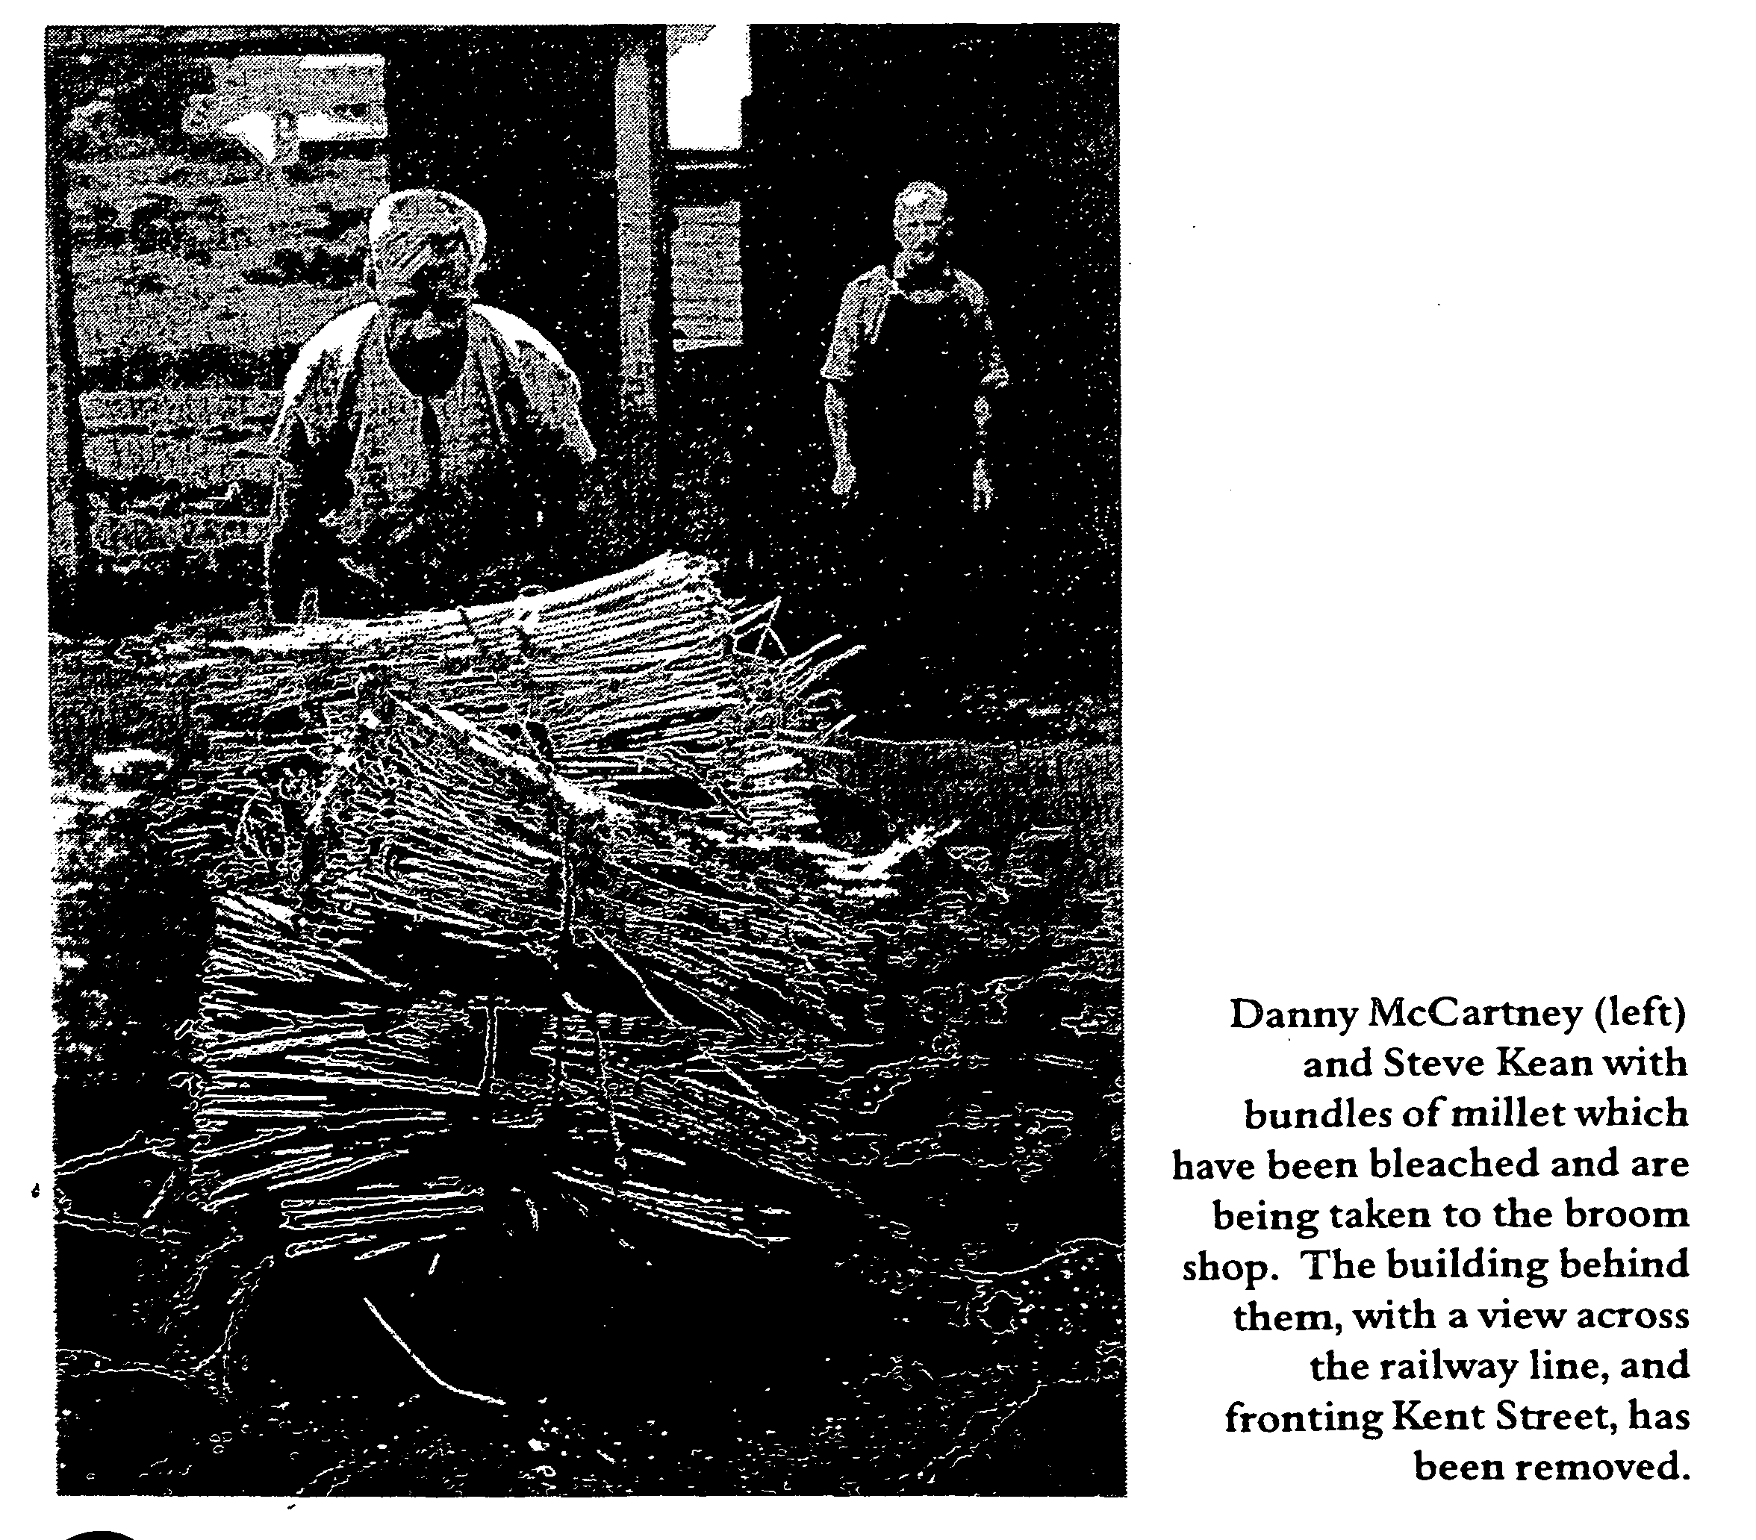

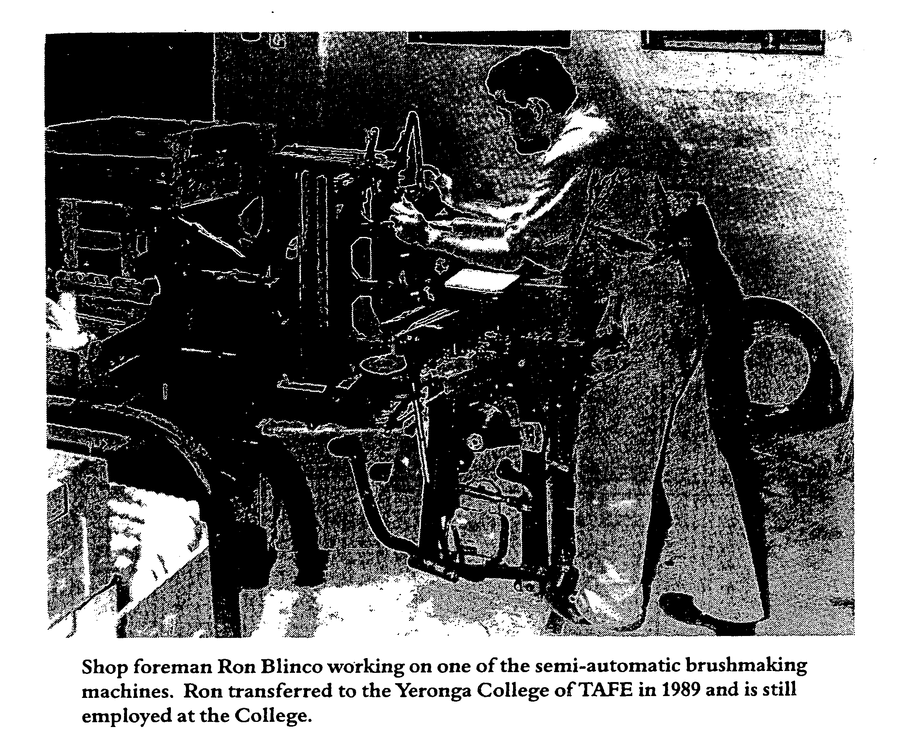

A fire in 1932 destroyed part of the plant and in 1939 additions to the site included an additional brick wing to the residence, a dining hall, a goods warehouse, a workshop office and storeroom facilities. Hot water was finally provided in the accommodation block. Just prior to the outbreak of World War II the library was sending out books and magazines to blind people throughout the State.
In the fifties a canteen was added, fire destroyed the bedding workshop and the library acquired talking books and talking book machines. In this last development the Apex Clubs of

Queensland agreed to provide tapes and equipment, commencing a long-lasting association of service clubs with the Institution. The recreational areas of the site were contracting so in 1954 the Brisbane City Council set aside part of Yeronga Park for blind cricketers.
In 1972 a sheltered workshop was added to the plant to provide work for people who were intellectually disabled as well as being blind. At this time the Institution was organised as a series of workshops each controlled by a foreman. The Annual Report for 1972 submitted by manager, J E Holland, records a bed shop, a basket shop, a

brush shop, a chair shop, a furniture shop, a mat shop, a millet shop and the sheltered workshop. Messrs Barnes, Blinco, Chawner, Goring and McCord were the foremen and Mrs Hal-wood was the seamstress. They were among a staff of sixteen, all of whom were sighted. There was a total of fifty-seven blind and partially sighted workers employed in the various shops.
By 1978 the site looked much as it does currently with the completion of the two-storey administration building opened by the Minister for Welfare, Mr Sam Doumany. Today the lower floor of this building is occupied by Vision Queensland with the upper floor leased out to the Queensland Foundation for Blind People. The additional space available following these additions allowed students from Narbethong to undertake work experience at the Institution.
The Size and Nature of the Workforce
The Annual Reports of QIIB to Parliament show the workforce to be at its largest just prior to the onset of World War II with approximately 100 workers. The number of
4
administration staff increased in the following decades as the Institution established itself as part of the Public Service. For example, in 1975 there were twenty sighted administration staff, six in the office and fourteen

employed as foremen, carters, storemen and cleaners.
The Dickinson family has already been mentioned in connection with the education of blind children and another group of dedicated supporters were the Rafton and Faulconbridge families. They became associated with the Institution in the early 1900s when Walter Rafton Sr worked as a foreman-instructor at Kent Street. In 1913 Jack Faulconbridge, later to become Walter's son-in-law, joined the workforce at QIIB and went on to become a foreman instructor.
After WW II Walter Rafton Jr worked as a sighted foreman in the basket weaving shop and his son, Allan Rafton, also worked at the Queensland Industrial Institution for the Blind. Jack's son, Bob, a lecturer in the building trades at theYeronga Institute ofTAFE, supervised courses for young blind people in the mid-eighties when the Training and Placement Centre for Blind People was in transition from the Junction Park State Primary School to the Yeronga College.
By 1983, the end of the period under consideration, there were approximately sixty people working at QIIB, some one-third sighted with the remainder partially sighted or totally blind. Nine of the workers, six men and three women, were employed in the sheltered workshop, which seems to have been a constant worry to the respective managers during the eighties.
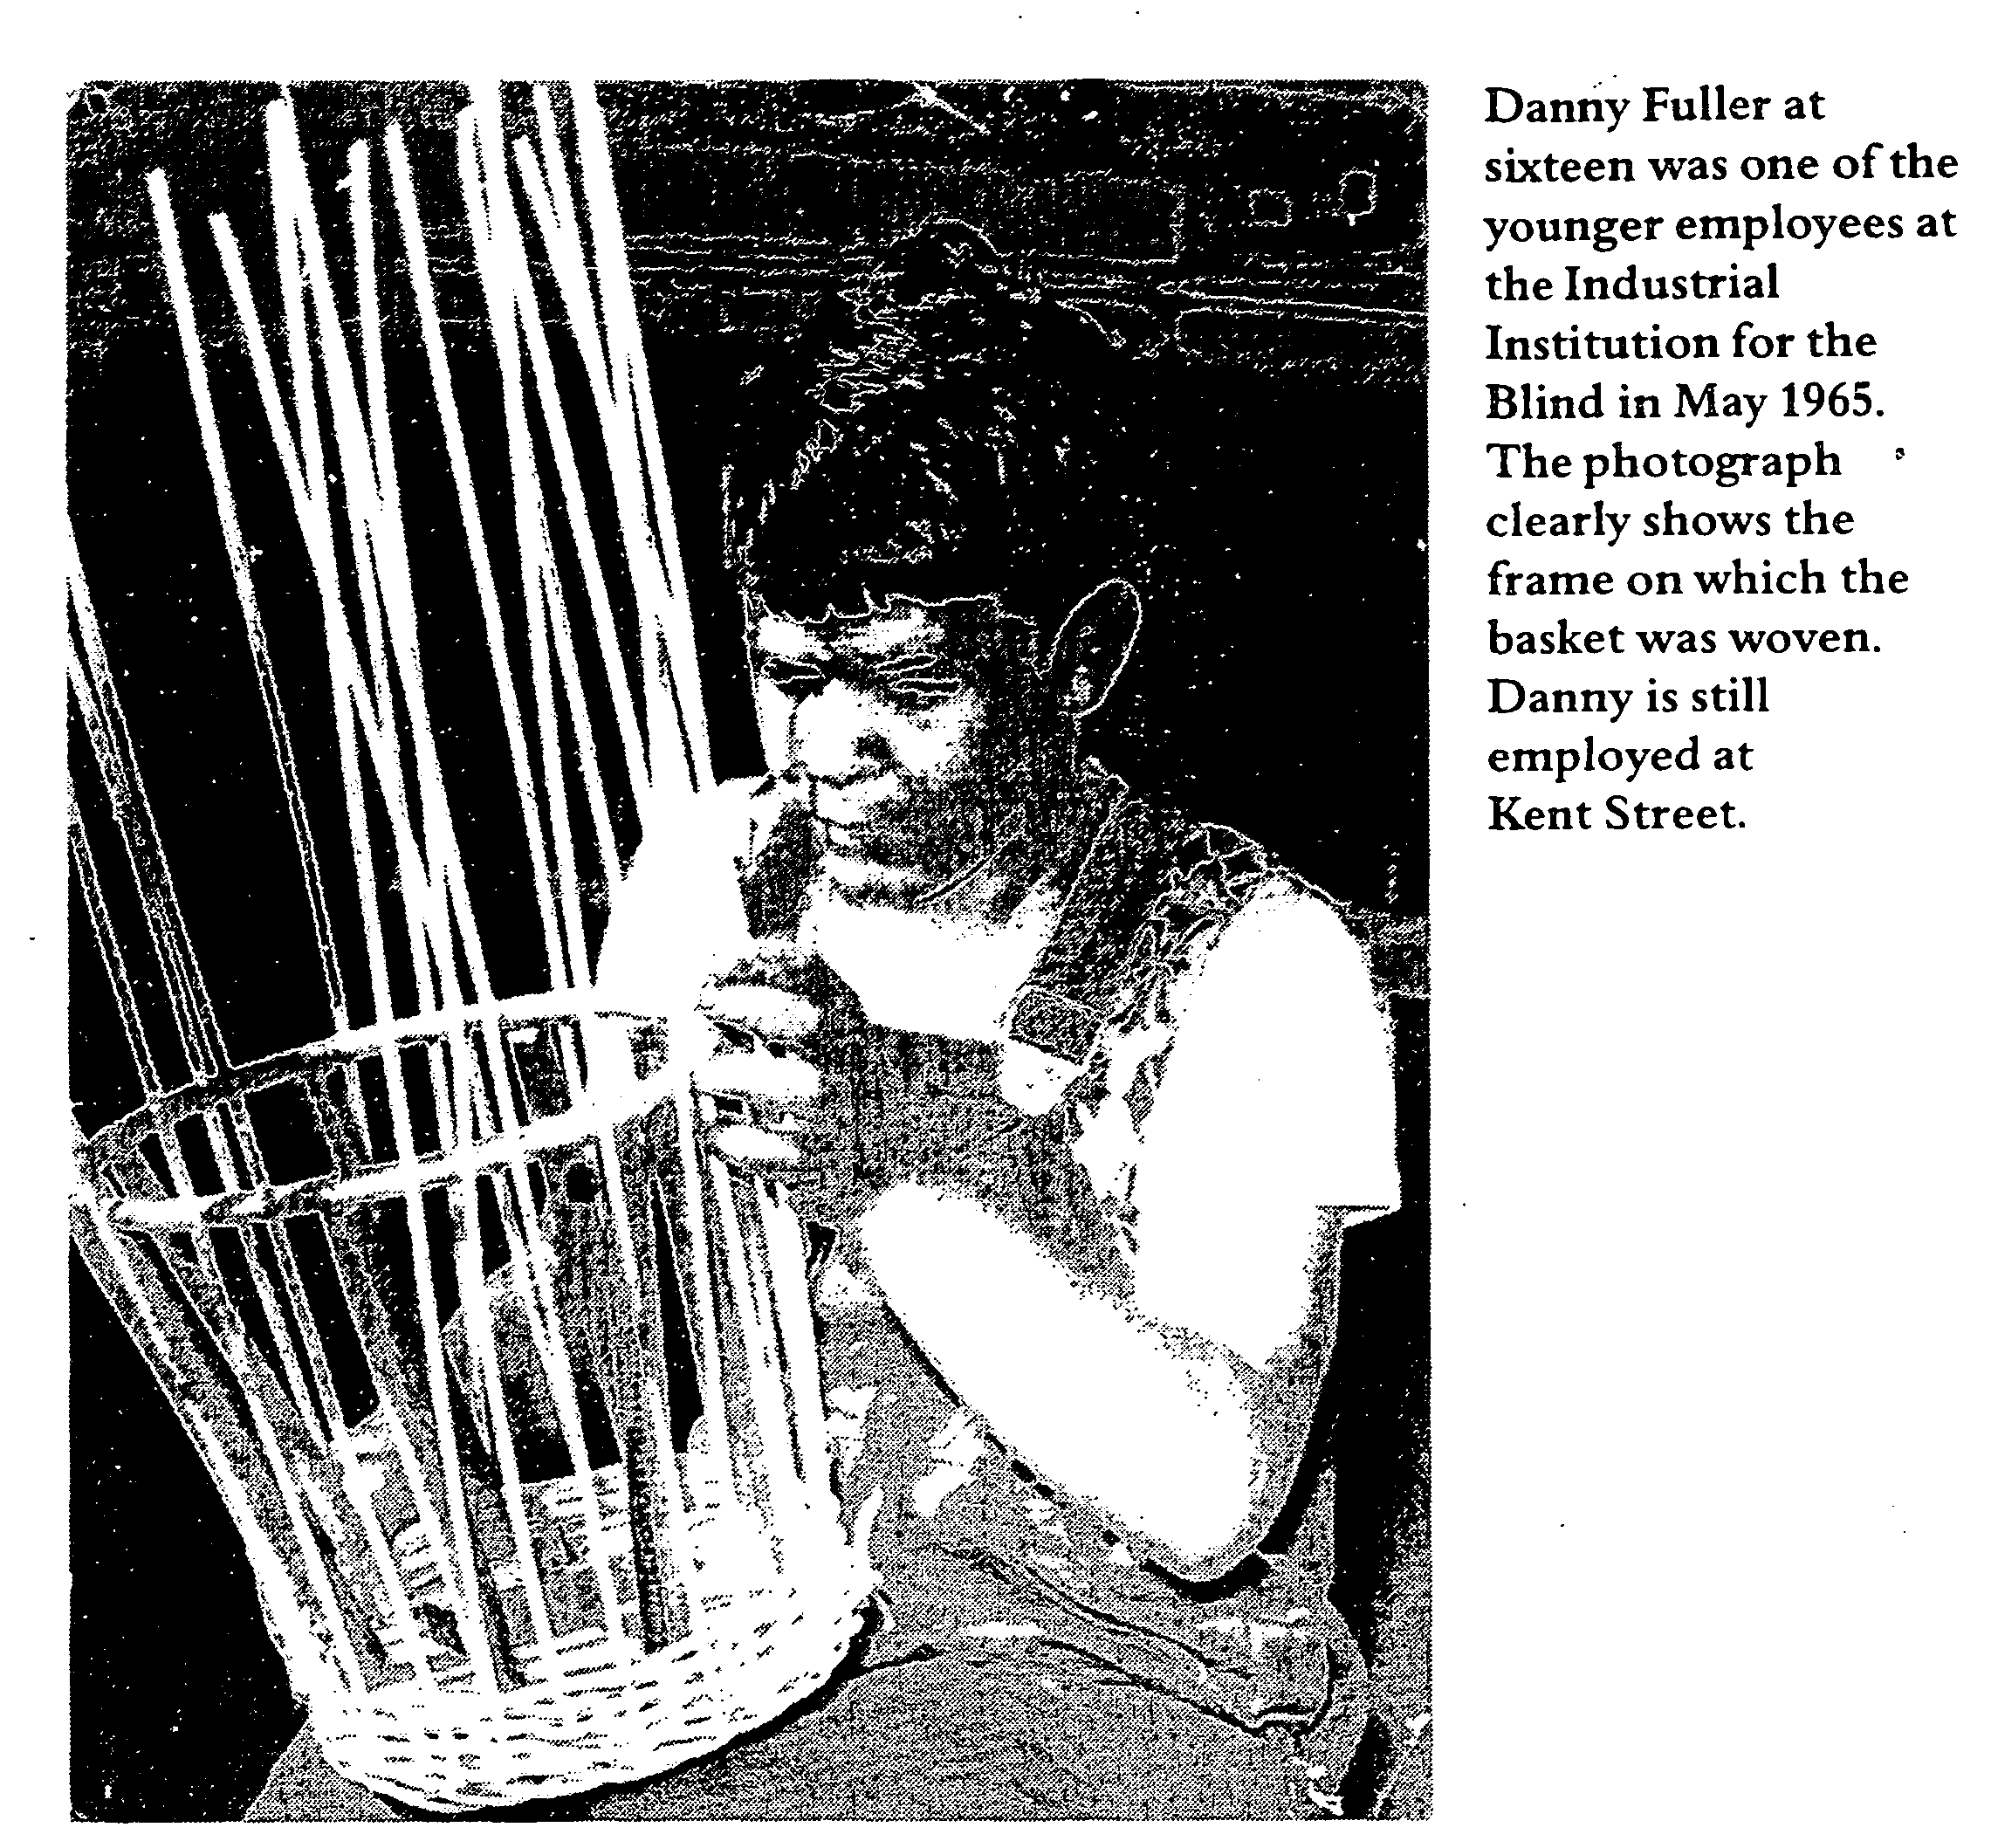

For example, the 1980 Annual Report has this to say,
Because the majority of people now being admitted to this shop have additional handicaps to blindness, production is much lower than that of workers in the Industrial Section. Also because of their limited capabilities it has been necessary to accept certain classes of contract work which are not profitable. As the numbers of workers in this shop increase, the loss to the shops could increase (Appendix A, p.l).

The inference to be drawn from this statement is that the increasing cost of the Institution "was a mounting concern to the State Government as more and more people, who were both intellectually disabled and blind, moved into institutions such as QIIB.
Production and Product Range
An examination of production issues in Forrest's account gives the impression that no sooner had the Institution found a product that could

be manufactured economically (and a market developed for it) than factors such as undercutting suppliers (often from S E Asia), improved technology and the advent of extruded plastics eroded the markets developed by QIIB. Other factors which reduced QIIB competitiveness were the increasing cost of raw materials such as millet and cane, and the imposition of sales tax on some of the QIIB product range.
One advantage which the Institution enjoyed in the face of this challenge to production - and this lasted into the seventies - was the promotion of QIIB products by the Government. Many products were purchased through the

Queensland State Stores Board and the Annual Reports record thanks to organisations such as State and Commonwealth Departments (particularly the Defence Forces), Schools and Hospital Boards.
The product range was promoted in catalogues, one such catalogue from the seventies listing bass and fibre brushes and brooms, millet brooms, pillows and cushions, the caning of Austrian bent-wood chairs, coir matting and door mats, mattresses and mattress covers, cane furniture and cane hoops (used in physical education classes in schools), dolls prams, coat hangers, baskets, blackboard dusters and shark netting.

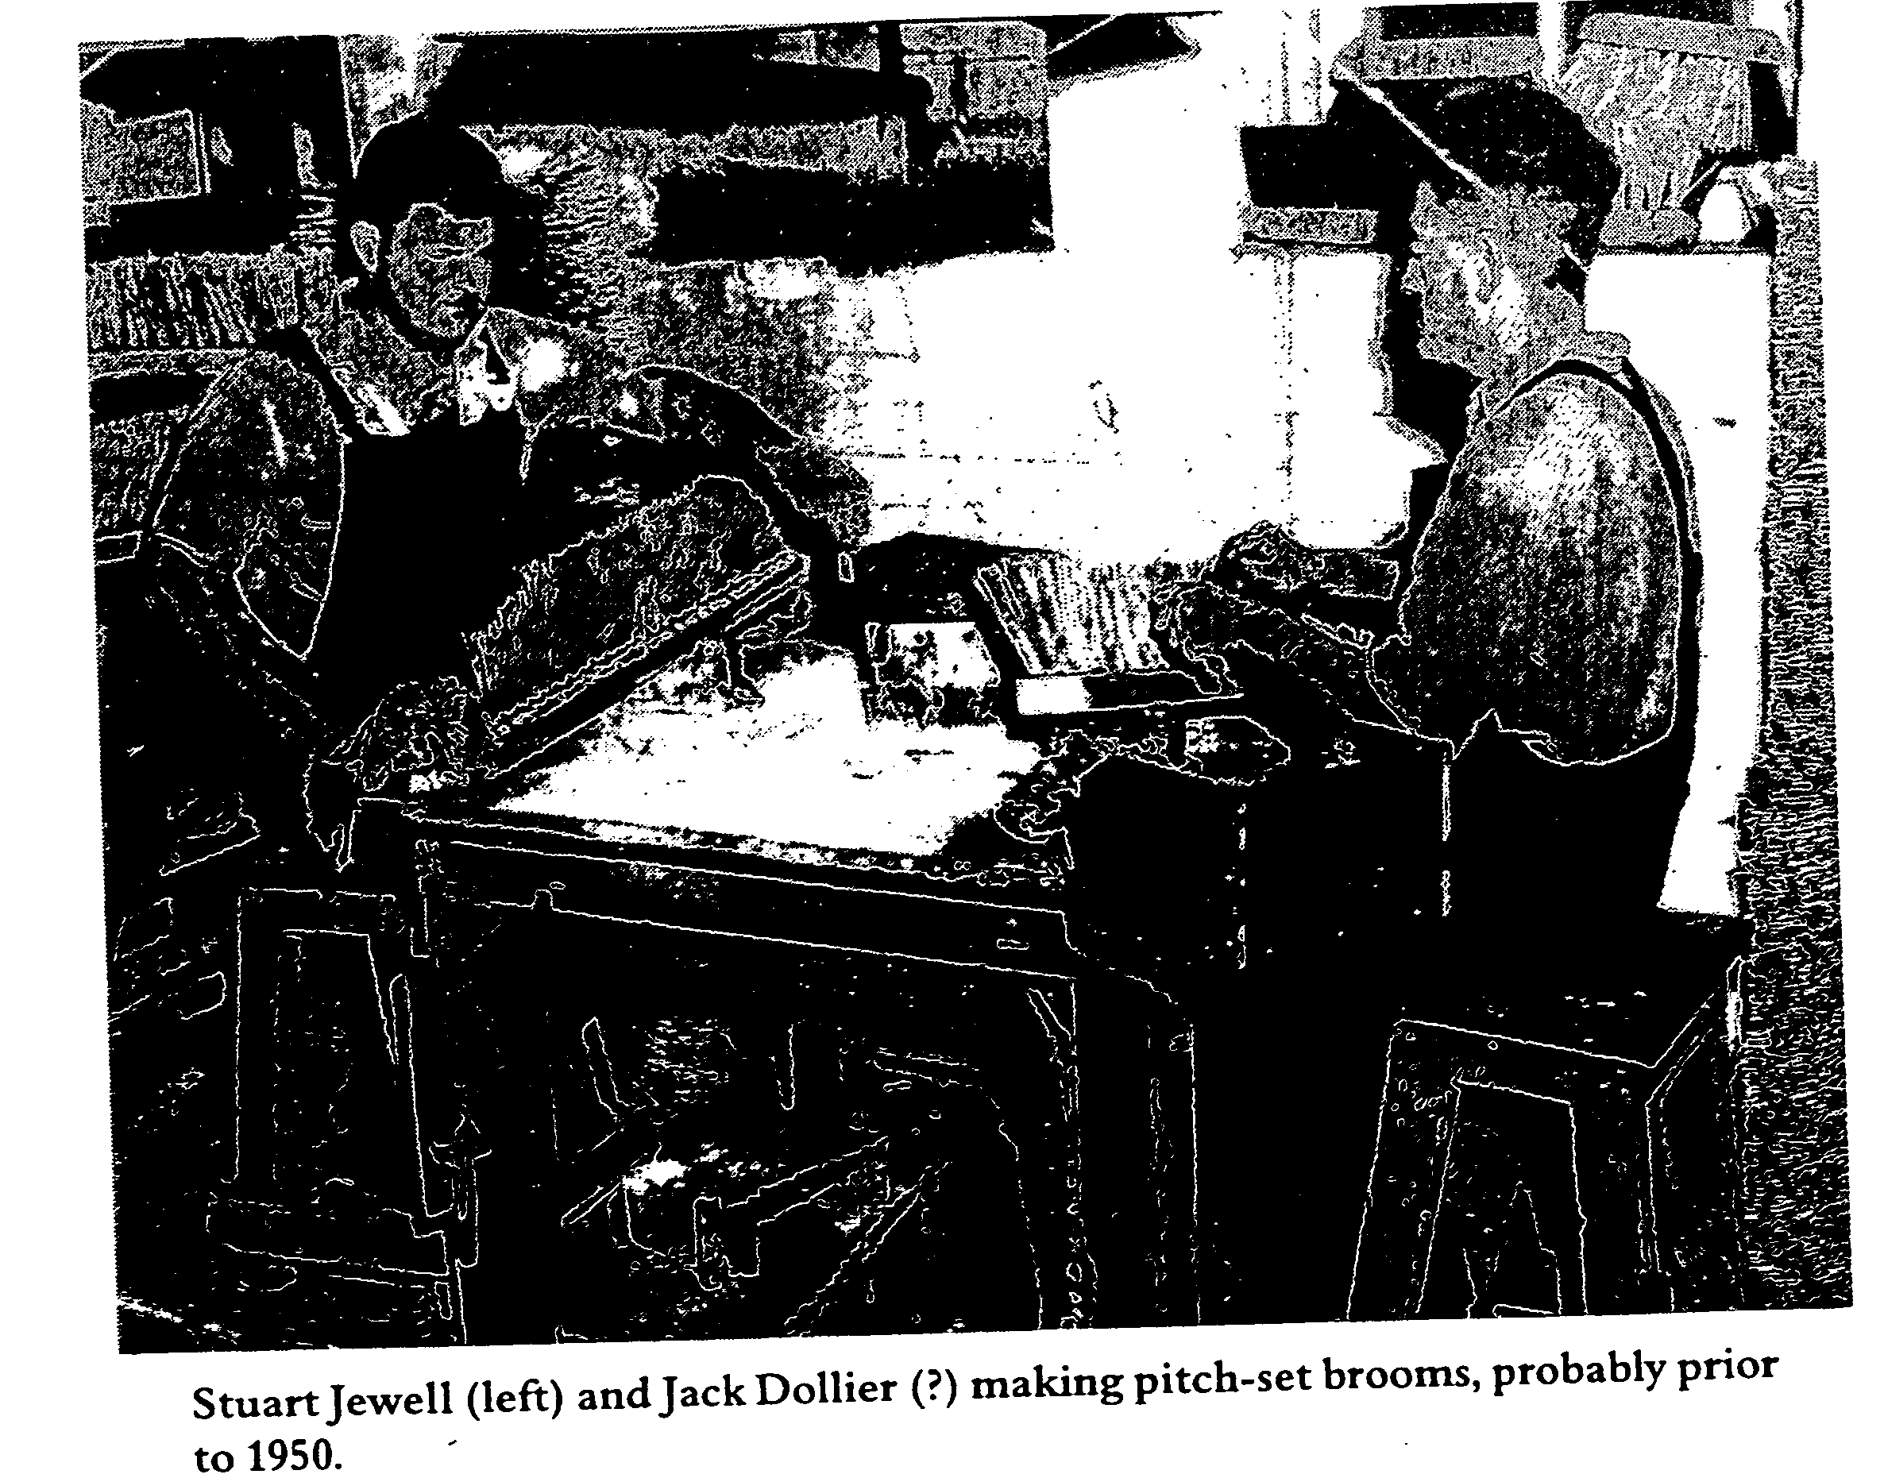

Most of these products were painstakingly made with the blind workers finding considerable satisfaction in the quality of their products and Forrest records a number of testimonials from satisfied customers. The writer can support this viewpoint having had a bent-wood chair handsomely recaned at QIIB in the seventies.
The financial statements are an important part of the Annual Reports. They include a workshop account (arranged in such a way that the productivity of the various shops can

be compared), a Profit and Loss Account and a statement of Assets and Liabilities. The 1979-80 Report shows that the Institution ran at a loss of just over $100,000 that year on sales of $410,000. The brush shop was most profitable that year offsetting losses in the chair, furniture, mat and millet shops. Just over $400,000 worth of 'Stock on Hand' indicated a large inventory of unsold merchandise, two-thirds of it being brushes and brooms.
This is fairly typical of the Annual Reports, which although showing steady srowth in production and sales,

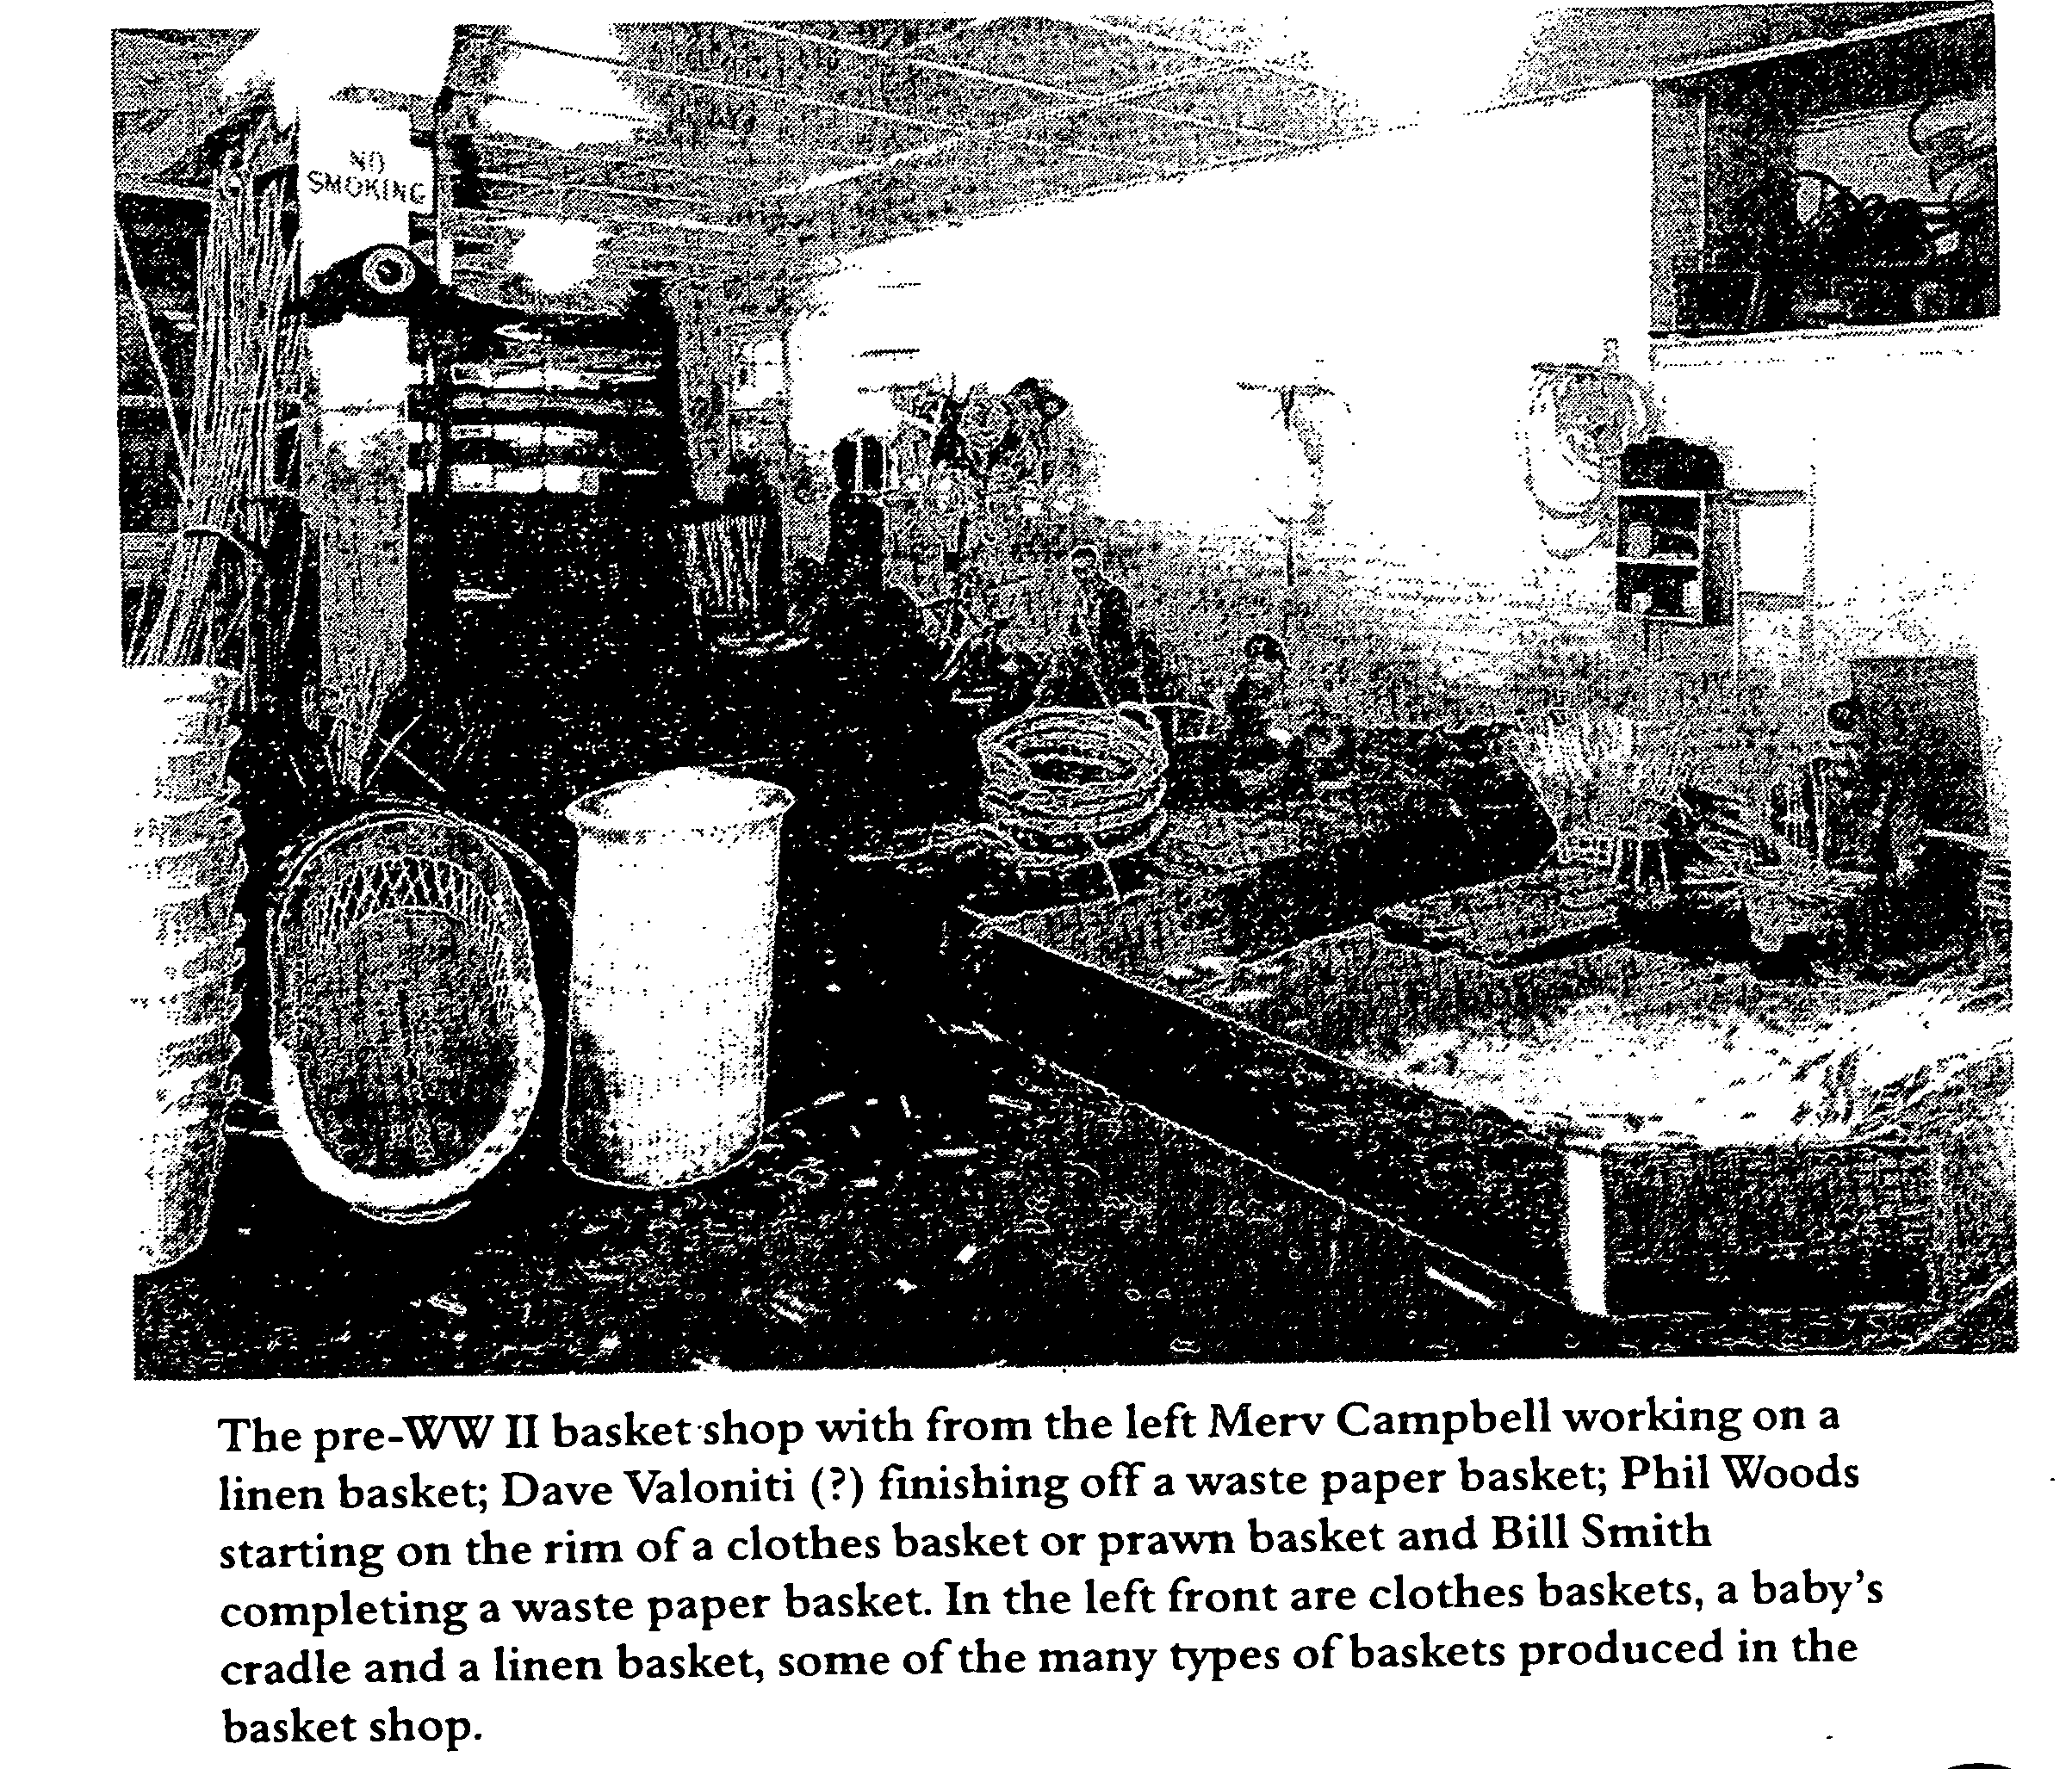

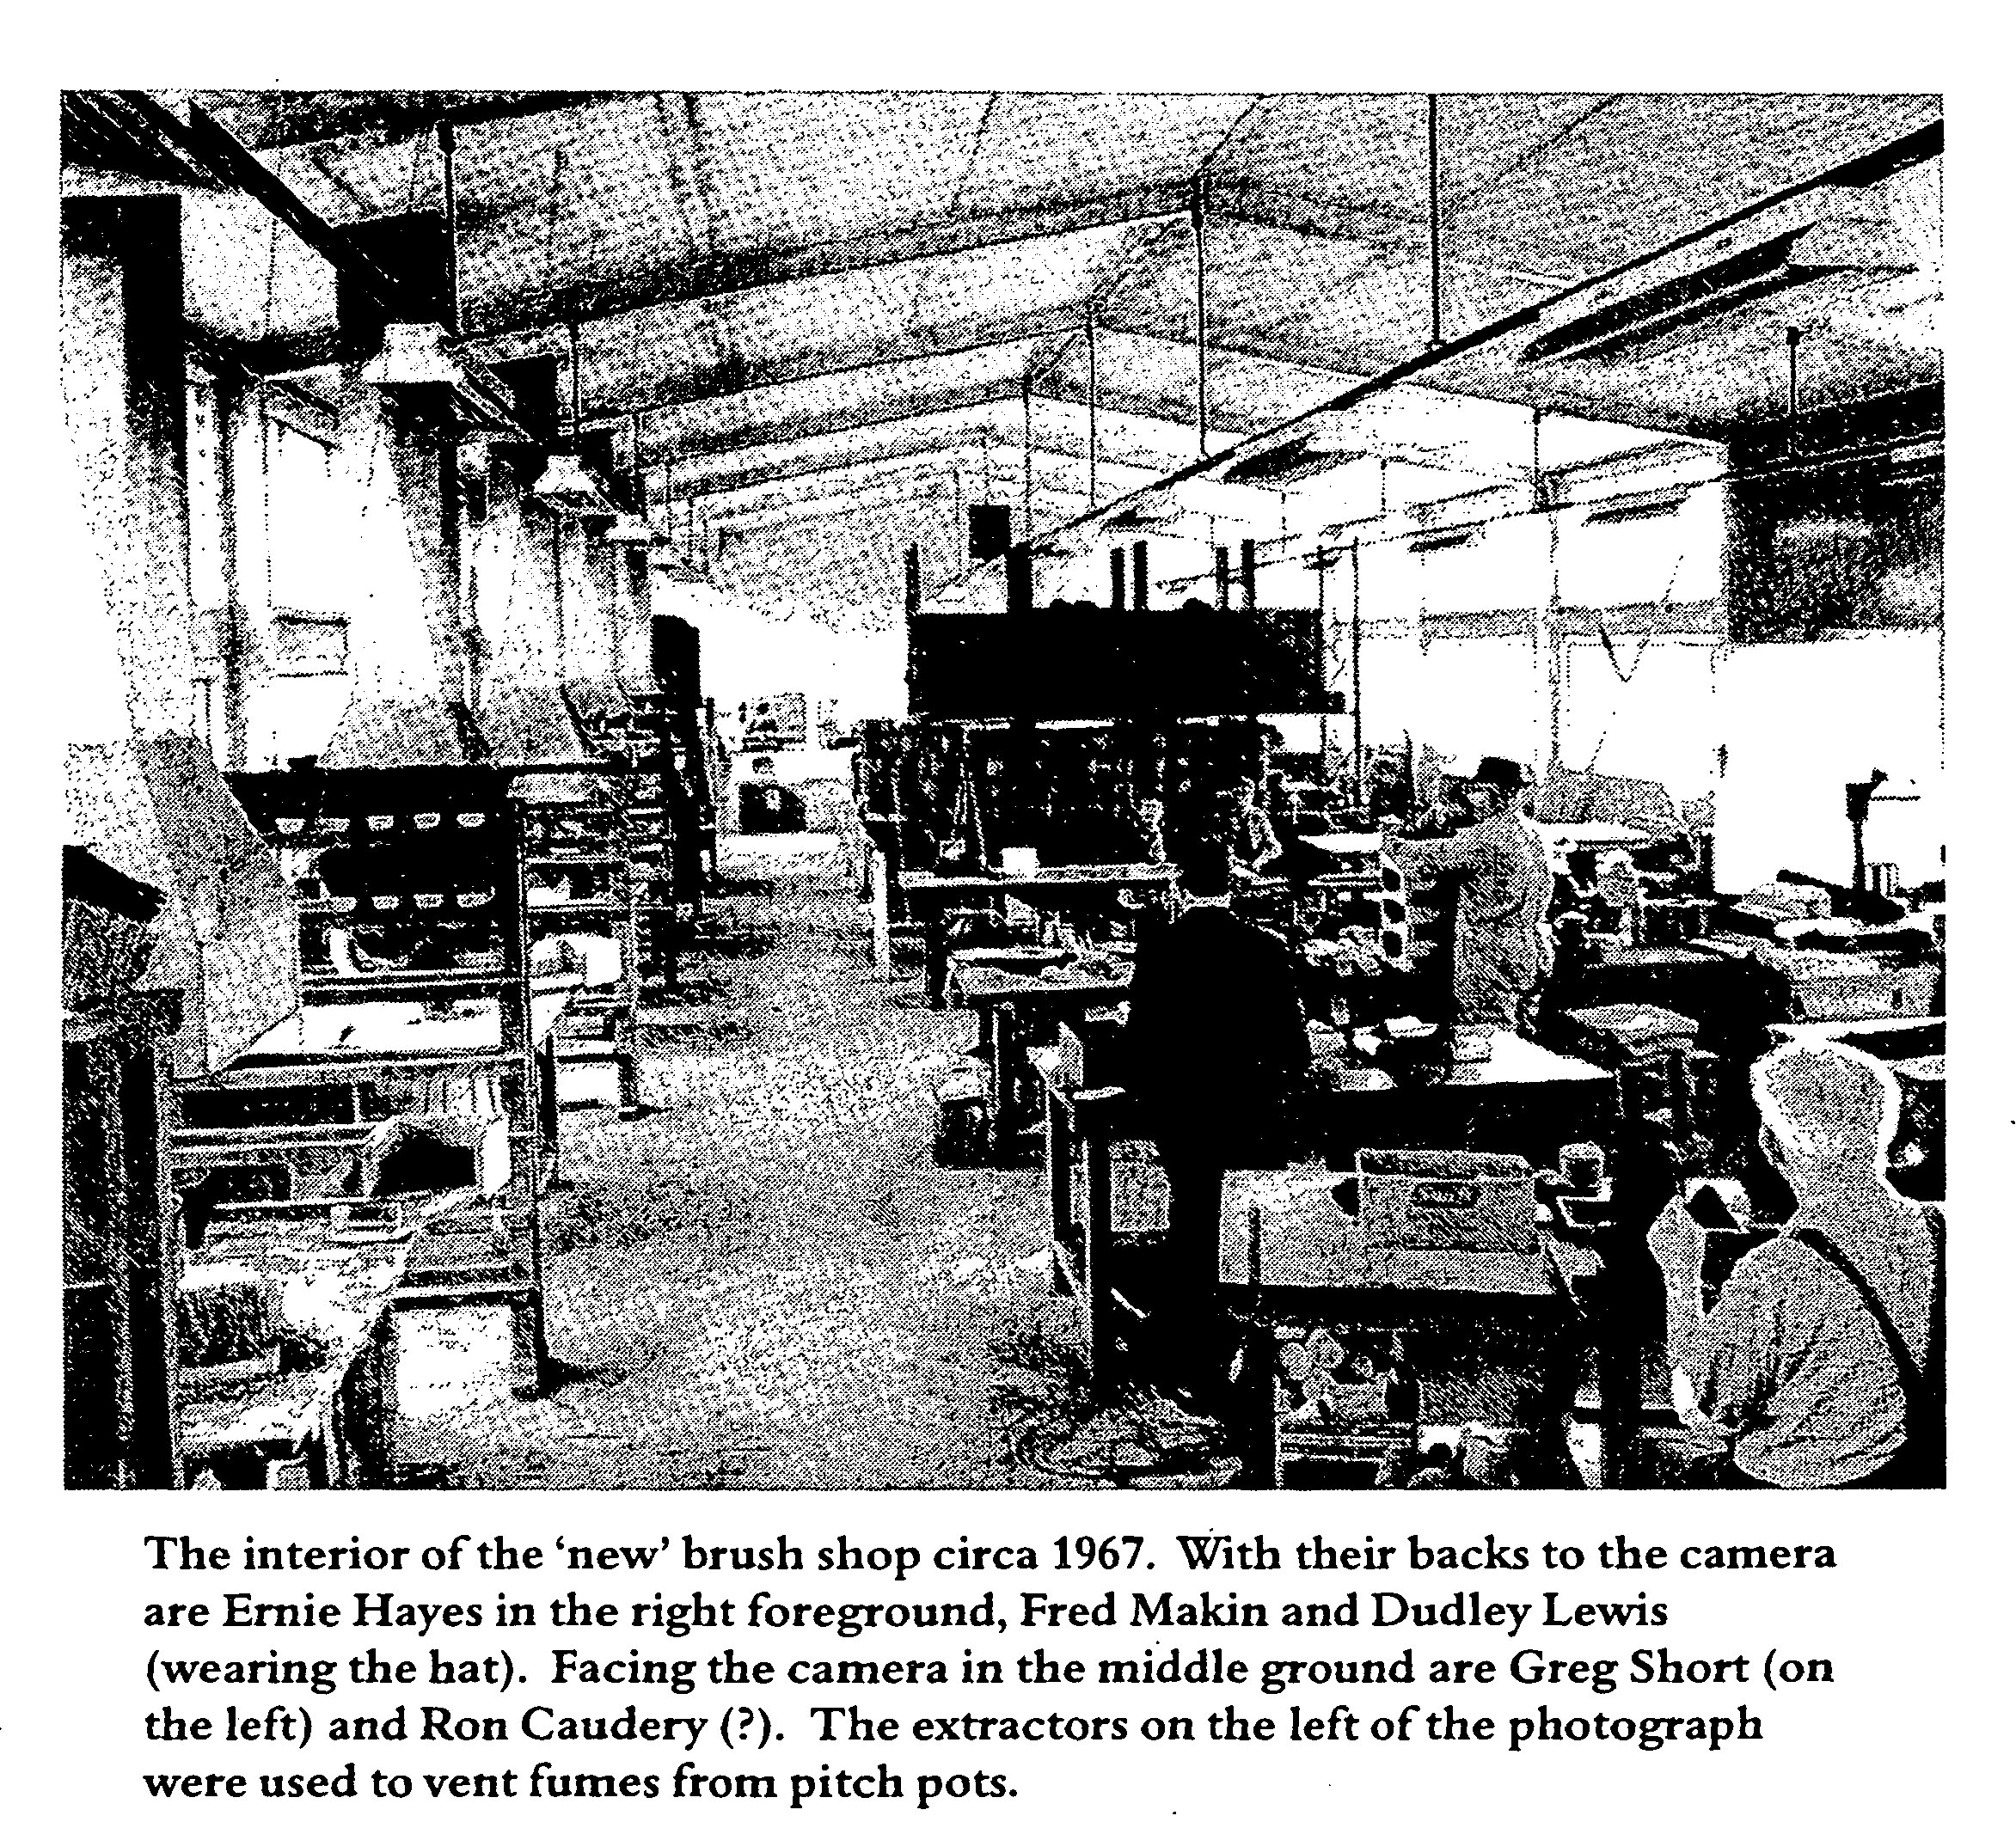

also show a concern at an increase in costs and a burgeoning unsold inventory.
The Welfare of Workers and Industrial Conditions at QIIB
Forrest's account provides evidence of a steady improvement in wages and working conditions at the Institution. In the period before the First World War the wage for a married blind worker was increased to one pound, a reasonable

wage at the time, and the Home Secretary provided free rail season tickets for those able to live at home and travel to Dutton Park. Forrest notes,
By January 1940, the Department of Health and Home Affairs had instituted improvements including a definite policy governing admissions and conditions of employment, including an apprenticeship scheme covering adults and juniors, ensuring sound training..., a wage increase of six shillings per week was paid to married employees..., sick leave provisions were brought into line with those of the

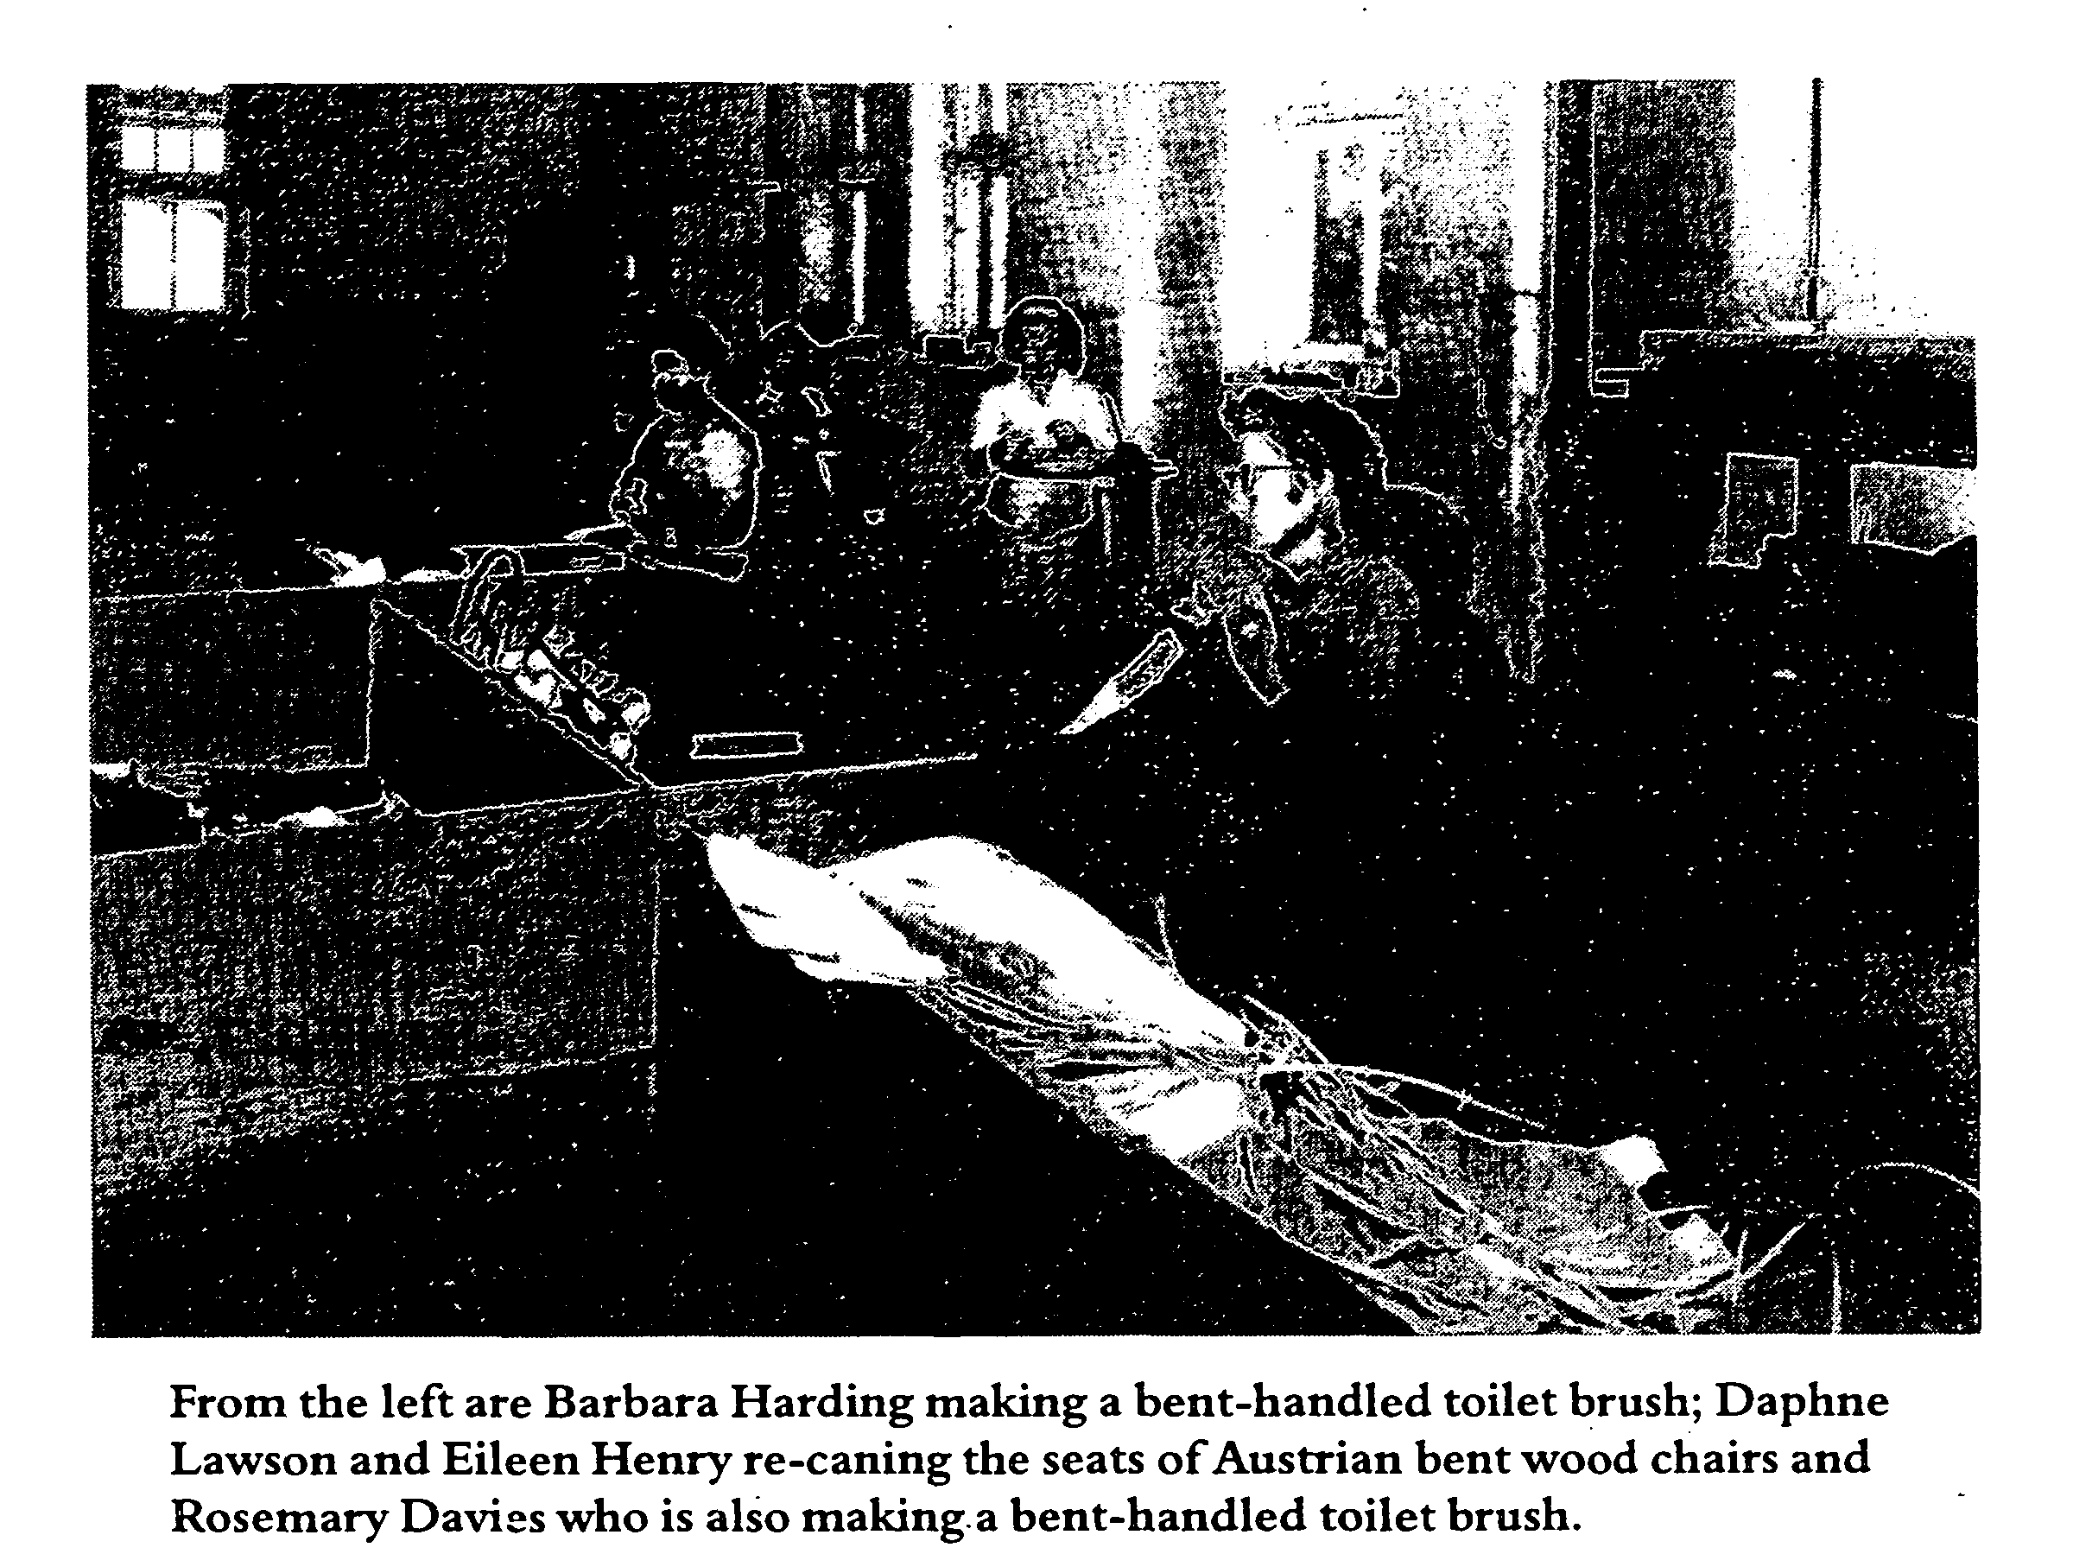

Public Service...together with pensions and other concessions [these changes] made for a more satisfactory standard of living for blind workers (p. 15).
The 1944 Disabled Persons Employment Act (Qld) allowed many more blind workers to be employed in outside industry and Forrest records blind workers obtaining work in the sugar industry and in a timber mill. Others were employed in dictaphone typing and switchboard operating. Some worked for Kodak in developing and printing film (p.16). Implicit in Forrest's record is the fact that some blind workers preferred to work in the security of the workshops while others relished the opportunity to move outside the Institution. That choice has

always been important to blind people and is as important today as it was in the 1940s.
During the 1970s, on the initiative of the union, female workers were finally granted equal pay with male workers and an incentive scheme rewarding those achieving increased production brought wages close to those being paid in private industry.
In other welfare initiatives the formation of the 1952 Australian National Council of and for the Blind aimed at improving conditions for blind workers throughout Australia on a uniform basis. For the first time a national organisation was able to lobby on behalf of the various state agencies

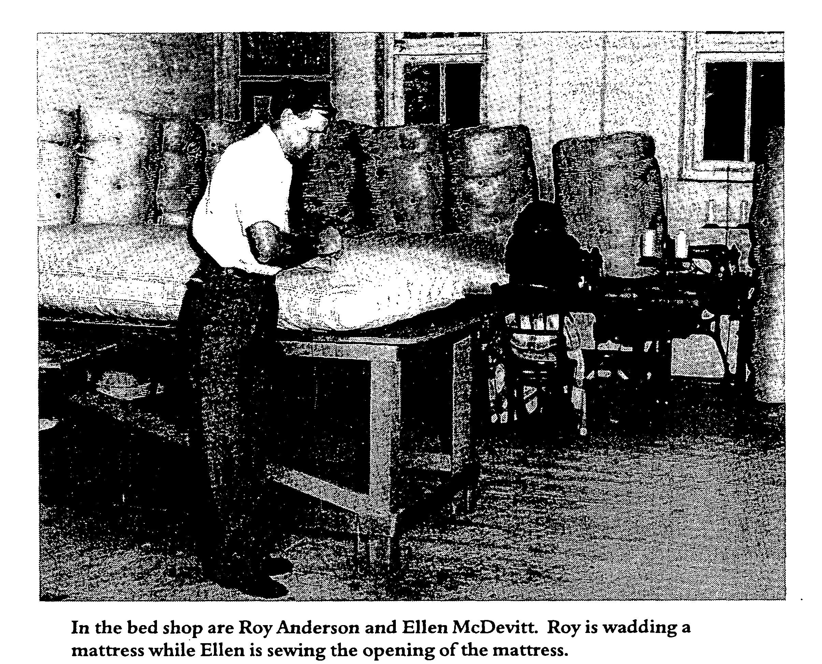

and charities which supported blind and vision impaired workers.
The Legacy Trust Fund also helped in improving the welfare of blind "workers. Administered by the QIIB Management it is mentioned several times by Forrest and is still in existence. It was a fund set up to hold unsolicited donations, bequests and legacies and was used to provide amenities for blind workers. Improvements to the canteen, and the supply of radios, talking book machines and Braille and Moon books have,been achieved through funds provided by the Legacy Fund.
The provision of guide dogs for the blind is first mentioned in the 1963

Annual Report. Three blind workers travelled to Melbourne to receive training in the use and care of the dogs, the report noting that 'special Brisbane City Council and Railway Department ordinances allow the dogs to be taken on public transport' (p.3). Blind workers accompanied by their dogs became part of the scene at Annerley.
Forrest's account of QIIB concludes in 1983. The Annual Report for that year is incorporated into the much larger report of the Department of Welfare Services. In a very brief appendix F, the manager advised that, because of increased wages and difficult trading, QIIB had suffered a net loss of

$210,713 on reduced sales of $476,756. This was a drop of just under $13,000 on the previous year. As early as 1970 an Advisory Committee for the Blind had been set up to report to the Minister on the future direction of services to the blind and vision impaired. At the time of the publication of the 1983 Annual Report the Committee was being reconstituted and its terms of reference revised.
It is clear in reading the Annual Reports for the period 1980 -1983 that the

future of the Queensland Industrial Institution for the Blind was in the balance. The Department of Welfare Services had, in May 1982, established a Disabled Persons Service which had a number of different remits such as Volcare (relief for families caringTor the disabled), the Visually Impaired People's Program (services for the partially blind) and Low Vision Care Centre (assessment of the needs of partially sighted people).
The Department seemed to be intent

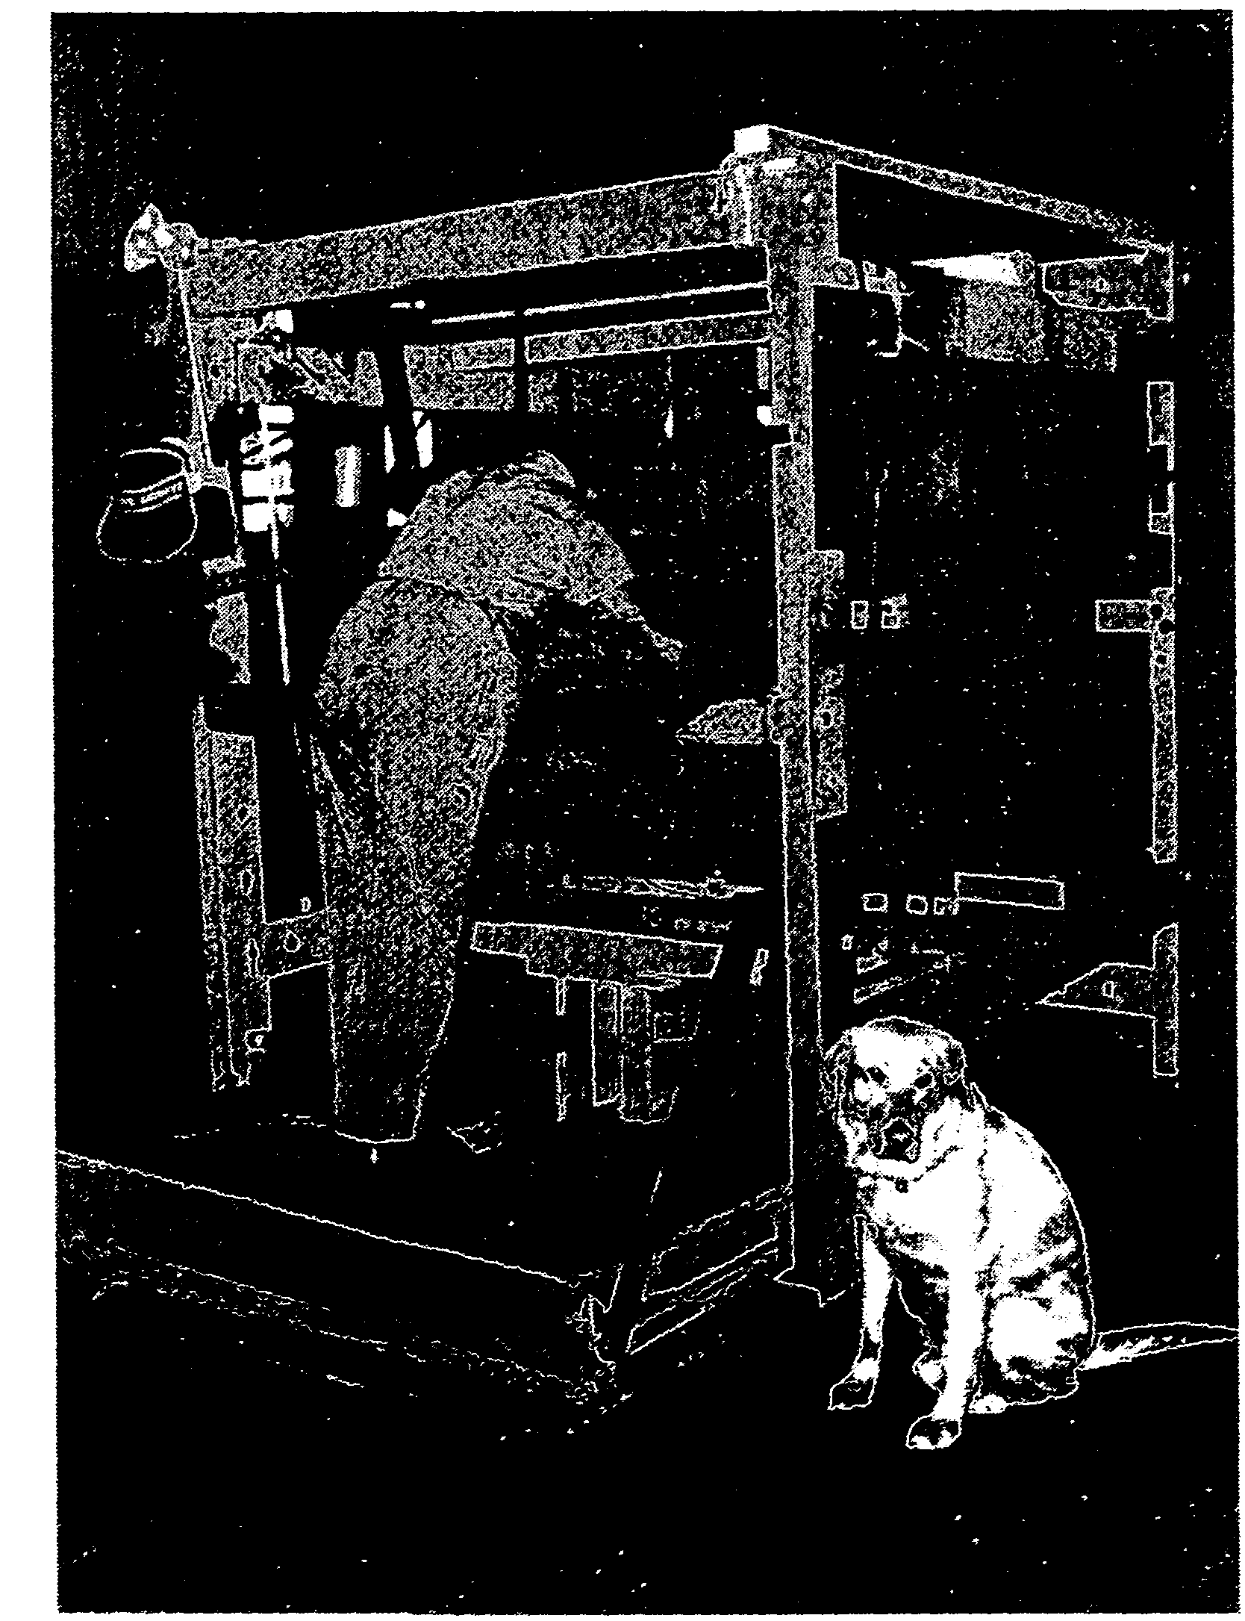
on widening the provision of services to the visually impaired and those interested in the welfare of blind and vision impaired people were left with the question of where QIIB would fit into the structure of welfare services for the disabled, which the Department was developing for the State of Queensland.

Chapter 3
The Queensland Blind
-^^
Industrial Centre, 1984 to 1988

A Change of Name
Forrest's history was published by the Disabled Persons Service of the Department of Welfare Services to acknowledge the first one hundred years of service to blind people by the Queensland Industrial Institution for the Blind which was celebrated in October of 1983. For much of this period the Institution had been supported by grants from the Queensland Government and managed by officers from the State Government Public Service.
In 1984 the Minister for Welfare Services announced that the Queensland Institution for the Blind was to be renamed. Its new name, the Queensland Blind Industrial Centre (QBIC), was intended to reflect the new directions the former institution would take to address 'contemporary employment problems of blind people' (Annual Report, p.5). A renaming ceremony by the Minister was performed in March 1985. In the 1984-85 year BillJohnston had been appointed Manager of

QBIC to replace Jack Sullivan who had been the Manager of QIIB for nine years.
The change of name was important. An 'Institution' is both an organisation, or society, as well as the buildings associated with that organisation. The word dates from the eighteenth century and has overtones of a social or public service, often of a charitable or religious nature. The former name clearly was inappropriate in the 1980s. The focus was on the word 'Centre', the intention being that QBIC would establish itself as a workplace, where work preparation and job training and, most importantly, employment could be provided for blind and visually impaired people.
The word 'normalisation' appears in the record of this* period. Writing to the Director of Marketing and Publicity, Department of Welfare Services on 5 September 1988, the Manager of QBIC, Bill Johnston, described the process of normalisation as occurring when work was valued of itself and produced in a valued environment.

The implications inJohnston's remarks were that workers at QBIC would be working productively under industrial awards, in a workplace where the safeguards of health and safety regulations provided them with congenial, efficient workspace. This was necessary if they were to compete in the open market. Workers' initiatives were encouraged and should be rewarded, particularly when this lead to increased production.
The 1984 Annual Report indicates that a marketing officer had been appointed, 'resulting in the

development of new product lines, additional markets and an effective network of contacts' (p.5). Sales figures for the year improved to just under $600,000, a record figure at that time, at a net cost to the government of $384,579. In the same report the Director-General of Welfare Services reported that he had reconstituted the Advisory Committee for the Blind, one among the additional terms of reference being the devising of 'methods of developing a better understanding in the community of Government Policy and services to the blind' (p.6).

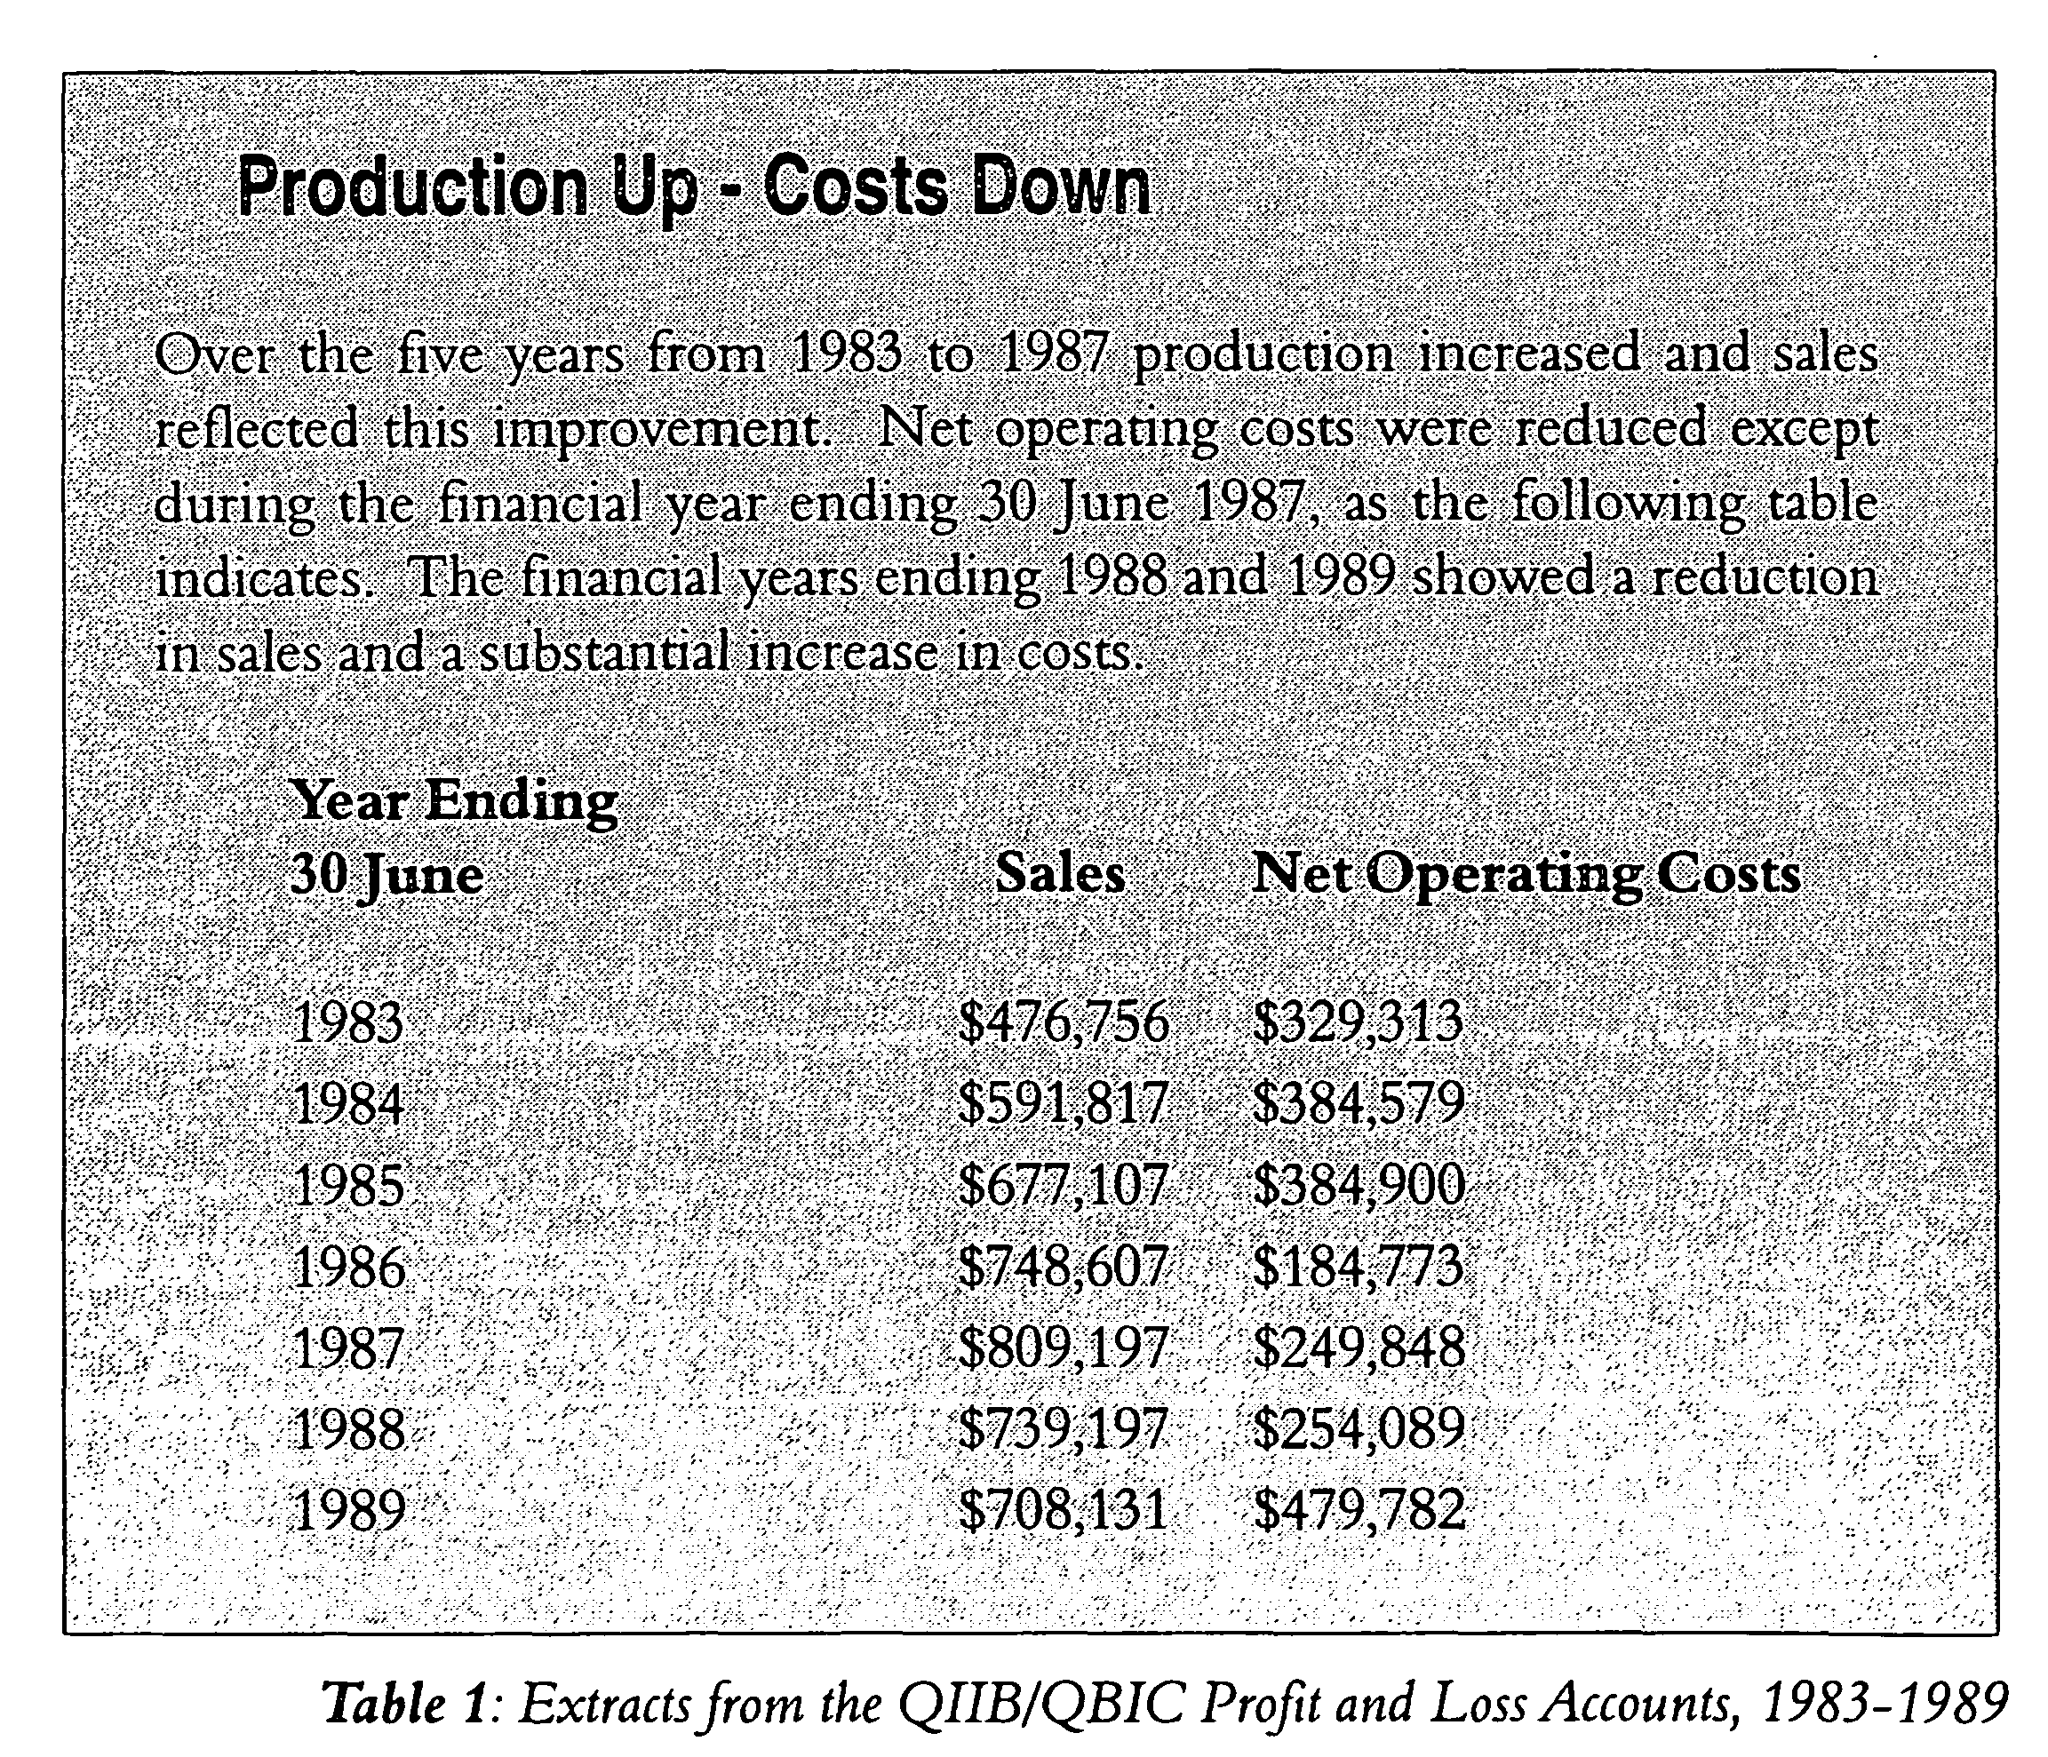

The reasons for the increased productivity until 1987 were the replacement of old, out-dated equipment and the introduction of new lines, particularly household mops which met with great demand. As well, QBIC was at this time the only manufacturer of millet brooms in Queensland. The trade name QBIC with its attractive logo was also thought to be responsible for a higher profile for the products of the Centre. There was also an increased penetration of existing markets, especially in Government Departments, which had been long-standing customers.
It is informative to look in more detail at one of these years, for example 1984-85. Of the seven shops producing materials (bed, brush, basket, chair, furniture, mat and millet) the brush shop, which produced bass and fibre brushes and brooms, contributed almost one-half of the total sales of $677,107 and sufficient profit, $126,687, to cover the losses of the other shops with the exception of the bed shop which made a small profit. The sheltered workshop that year, as in all years, made a small loss. As with many small businesses, the performance of slow-performing lines. had to be balanced against well-performing lines for a variety or reasons, not the least of which was the need to satisfy existing customers for these lines and to keep workers employed. The private enterprise option of reducing the workforce did not exist at QBIC.

Other Initiatives
An audit of the Centre entitled 'Future Search', conducted by the Management Services Branch of the Department of Welfare Services in August 1984, involved workers, administration staff and personnel from other related industries and organisations. Their recommendations developed policy proposals and set in train a new direction for the Centre.
One of these initiatives, noted in the 1985 Annual Report, was the establishment of a joint Department of Education - Department of Welfare Services committee to plan the provision of education courses to be offered by the Yeronga College of TAFE, a harbinger of events to come! These courses would be run by the VIVA Unit of the College.
The 1985-86 Report, at this time presented to the Minister by a new, and greatly enlarged, Department of Family and Youth Services, noted that 'a sheetmetal work section was established on the [QBIC] premises which will allow for increased cooperation in the training and employment of sight-disabled people' (p.16). A further educational initiative was the offering of regular seminars to nurses on the psychological impact of blindness, a seminar which the Department of Welfare Services intended to develop for the other caring professions in future years.
The Final Years of QBIC
By the time of the 1986 Report QBIC seems to have been swallowed up in a massive bureaucracy comprising elements of Children's Services, Youth, Ethnic Affairs, Family Services, the Recreation Council and Disabled Persons Services. As a consequence the annual report was confined to a fairly cursory statement at the conclusion of the DFS report.
Among snippets in the report was the announcement of the construction of dog kennels for the seeing-eye dogs. Also noted in the Report was a visit by the Governor, Sir Walter Campbell and Lady Campbell 'who have shown a keen interest in the Centre and the valuable contribution blind workers are making to the community' (p. 16).
The calendar year 1988 was the final year of operation of the original QBIC and the 1987-88 Annual Report comprised some 200 "words, which was incorporated into the Report of the Department of Disability Services (p.22). QBIC, by this time, had formally added the provision of vocational education to its charter, becoming 'an employment, training and education Centre for blind people.' It employed thirty-five workers in the industrial workshops and a further seven in the sheltered workshop. As Table 1 shows there was a downturn in sales and an increase in

costs brought about by decreased demand for QBIC products.
In the Report there is no information about staff numbers nor a comparative table of products manufactured;
nor is there any reference to the future of QBIC. The usual reference to the Legacy Trust Fund is brief in the extreme with a statistical summary recording that there were over 6500 cassettes sent out monthly to 900 readers covering 1,250 titles. No details were provided of the financial position of the Trust. This deficiency was addressed in the 1989 Annual Report which showed a total of $382,981 in the Fund, the administration of which was to be retained by the Department of Family Services.
It is hard not to assume from the cursory nature of the 1987-88 Report that decisions had been made about the future of the Centre, but readers of the Report would not have known that Commonwealth and State Government officers had other plans for QBIC based on the provisions of the Commonwealth Disabilities Services Act 1986.
The Act asserted the rights of people with disabilities and provided a schedule of services to meet these rights. In the Interim Report of The Strategic Review of the Disability Services Program, the authors, Baume and Kay summarise the intended outcome of the Act,
The new policy changed the focus from funding segregated facilities for people with a disability to meeting the support. needs of people with a disability and achieving positive outcomes for them. The intention was to de-institutionalise segregated services, increase the range of community options and include people with a disability into wider community life (p.l5).
QBIC was a segregated facility and the intention was to de-institutionalise segregated services, such as the industrial workshops and the sheltered workshop, and to include blind and visually impaired people, as well as those with intellectual disabilities, into wider community life. How this was to happen at QBIC and what was to happen to the workers, both blind and sighted, will be covered in chapter 4.
A final word, however. QBIC, and QIIB before it, had been integral parts of the life of the blind community in Brisbane for a long time. Both organisations aroused strong defensive emotions in those families who worked in and for them. There was also a great deal of sympathy for blind people, particularly among state and local politicians, who were used to approaches for help from blind and vision impaired people and their families and carers. Any changes at QBIC would need to be carefully managed.
Chapter 4
QBIC and the Annerley Campus of the Teronga College of TAFE 19 89 to 1994

A Difficult Time
For the workers at QBIC and for the Director and staff at what is now the Yeronga Institute of TAFE who were involved in the transfer of QBIC operations to Yeronga the years 1989 to 1994 were stressful and frustrating. Emotions ran high at the time as both groups of people wrestled with the future of QBIC. Ten years later the people involved still find the events of these years difficult to discuss and the available record is incomplete. The whole story is yet to be told. The following account provides an outline of events and a starting point for discussion and understanding.
New Directions
The implementation in 1988 of the Commomvealth Disability Services Act 1986 caused radical changes to the operation of the Queensland Blind Industrial Centre at Kent Street. In December 1988 the responsibility for managing QBIC passed from the

Queensland Department of Family Services (DFS) to the Queensland Department of Employment, Vocational Education and Training (DEVET). All the operations of QBIC, with the exception of the Legacy Trust Account and Talking Book Library, were to be transferred. These two operations would be retained by DFS.
In February 1989 the responsibility for managing QBIC was vested in the Director of the Yeronga College of TAFE, a Division of DEVET, with the Kent Street site eventually becoming the Annerley Campus of the College and the former employees of QBIC becoming either 'paid students', in the case of the blind and visually impaired, or TAFE employees, in the case of the sighted supervisors and administrative staff.
The term 'paid students' was a controversial one which caused concern among blind people who still considered themselves 'workers' or 'employees' because they continued to receive their wages and service increments as previously. In retrospect the use of the term seems to have been

an unhappy choice. As well, the use of the term 'paid student' instead of 'employee' blurred the industrial relationship between employee and employer and one is left to wonder about their status in matters of arbitration.
QBIC remained under the control of the Yeronga College of TAFE until December 1994 when the responsible Minister, the Hon Matt Foley, implemented some of the recommendations of a report which he had commissioned into the future of QBIC. The report, prepared by consultant Brian Tregillis, recommended, in brief, that QBIC should revert to being a supported industrial workshop and that the blind and partially sighted paid students should revert to being employees. Tregillis further recommended that QBIC should become a 'business service' operating in the private sector and that appropriate management structures should be set up, prior to the organisation being handed over to the Commonwealth for financial support.
This chapter examines QBIC during the period 1989 to 1994 under the following headings:
• The Commonwealth Disability Services Act 1986 and its implications for QBIC.
«• QBIC and the Annerley
Campus of the Yeronga College ofTAFE.

® The status and activities of the paid students during this period.
⁹ The Transition Project and associated reports, 1991-1993.
⁸ The Tregillis Report of 1994 and its outcomes.
⁹ Events leading to the establishment of Vision Queensland.
The Commonwealth Disability Services Act 1986(DSA)andits implications for QBIC
In 1971 the United Nations adopted the Declaration of Rights of Disabled Persons which was the catalyst for increased concern for, and legislation involving, disabled people in Australia. In 1974 the Handicapped Persons Assistance Act was passed and subsequently reviewed in 1983. 1981 was the UN International Year of Disabled Persons.
In 1985 an Office of Disability was established by the Commonwealth Government and this was followed by the Disability Service Act (DSA) in 1986. Over the next five years there was a flurry of activity. Introduced in quick succession were a Disability Services Program (DSP) - 1987; a
Social Security review of income support for disabled people (1988) and a States and Commonwealth Disability Agreement (1991) which 'narrowed the focus of services funded directly by the Commonwealth to the area of employment and to areas including advocacy and research in which responsibilities were shared' (Baume and Kay, p.16). Accommodation support, training for independent living, information services, recreation services and respite care for blind and vision impaired people were all to remain a responsibility of the State Government.
As part of the changed administrative arrangements between State and Commonwealth, employment services were accepted as a Commonwealth responsibility. Employment services throughout Australia were identified for transfer to the Commonwealth Government. QBIC was one of these services.
QBIC is the last remaining employment service in Australia which has not yet been transferred to Commonwealth responsibility and it should be asked why this is so. The answer to this question is conjecture, but many of the stake-holders of QBIC believe that the Commonwealth Government did not want to maintain QBIC as a long-term place of employment for vision impaired people. There is a viewpoint that while a few blind and vision impaired workers might find work in open employment,

the remainder would be left without work as QBIC would eventually be closed.
This concern by QBIC employees, and in many cases by their parents and carers, helps explain, and is to some extent a consequence of, the dissatisfaction felt at the lack of success by Yeronga TAFE staff to place employees in the open labour market.
In 1992 the Commonwealth Disability Services Act was amended to allow for longer periods of compliance to gain Commonwealth support for service providers. In the same year the Commonwealth Disability Discrimination Act was passed. In 1993 the UN adopted Draft Standard Rules on the Equalisation of Opportunity for People "with Disabilities and the following year the Australian Industrial Relations Commission agreed to insert a model clause into awards which provide pro-rata payments for people with disabilities based upon assessed skills.
Out of this labyrinthine maze of enactments, schedules and agreements came an increasing focus on the rights of blind people: on improved training;
on their access to services and accommodation in the wider community; on their participation in decisions that affected their lives; on grievance and dispute resolution and on access to social and work-related opportunities that the rest of the population took for granted. In addition, if disabled people could not
address these issues on their own behalf, then provision was to be made for advocacy, that is, for someone - an advocate - to represent their interests.
To address these issues the Queensland Government decided that the future of QBIC employees could best be addressed by reducing .the time employees spent in the industrial and sheltered workshops operating at Kent Street and by increasing the time blind and vision impaired people spent on vocational education, work-related skills training and personal development. Because Visually Impaired Vocational Assistance (VIVA) courses were already being run by Yeronga TAPE teachers it was logical that the future of QBIC employees could best be provided for by linking the supported facility of QBIC with a provider of vocational education such as Yeronga TAFE, and this was effected by Order in Council on 8 December 1988.
Anecdotal evidence from former QBIC employees suggests that this decision wasn't fully explained to QBIC blind and vision impaired workers who believed that QBIC would eventually be phased out and the workshops closed down. Some thought that the reason for the closure was to save money, a view later supported by Tregillis who commented in his draft report,

I have not been able to find any papers setting out the reasons/or the then Government's decision to transfer QBIC to the Yeronga College of TAFE and to change their status from employee to paid student but in my view a plausible explanation is that it was simply a device to avoid an award being made which might have had repercussive effects on other institutions for disabled persons which produced goods for sale (p. 11).
For some employees who had spent most of their adult lives at Kent Street the decision was devastating. They understood that providing them with training, no matter how tailored it was to their individual needs, gave them no guarantee of work in the open labour market.
A report in the Sunday Sun of 20 August 1989 quoted Merv Wendt, a blind QBIC worker, as saying, "The moves don't impress me. I would like to stay here. This place represents security and at my age another job would be very hard to get." Security in all of its senses would become one of the key issues for the blind and vision impaired workers, their families and carers as QBIC was absorbed into the Yeronga College of TAFE.
QBIC and the Annerley Campus of the Yeronga College of TAPE
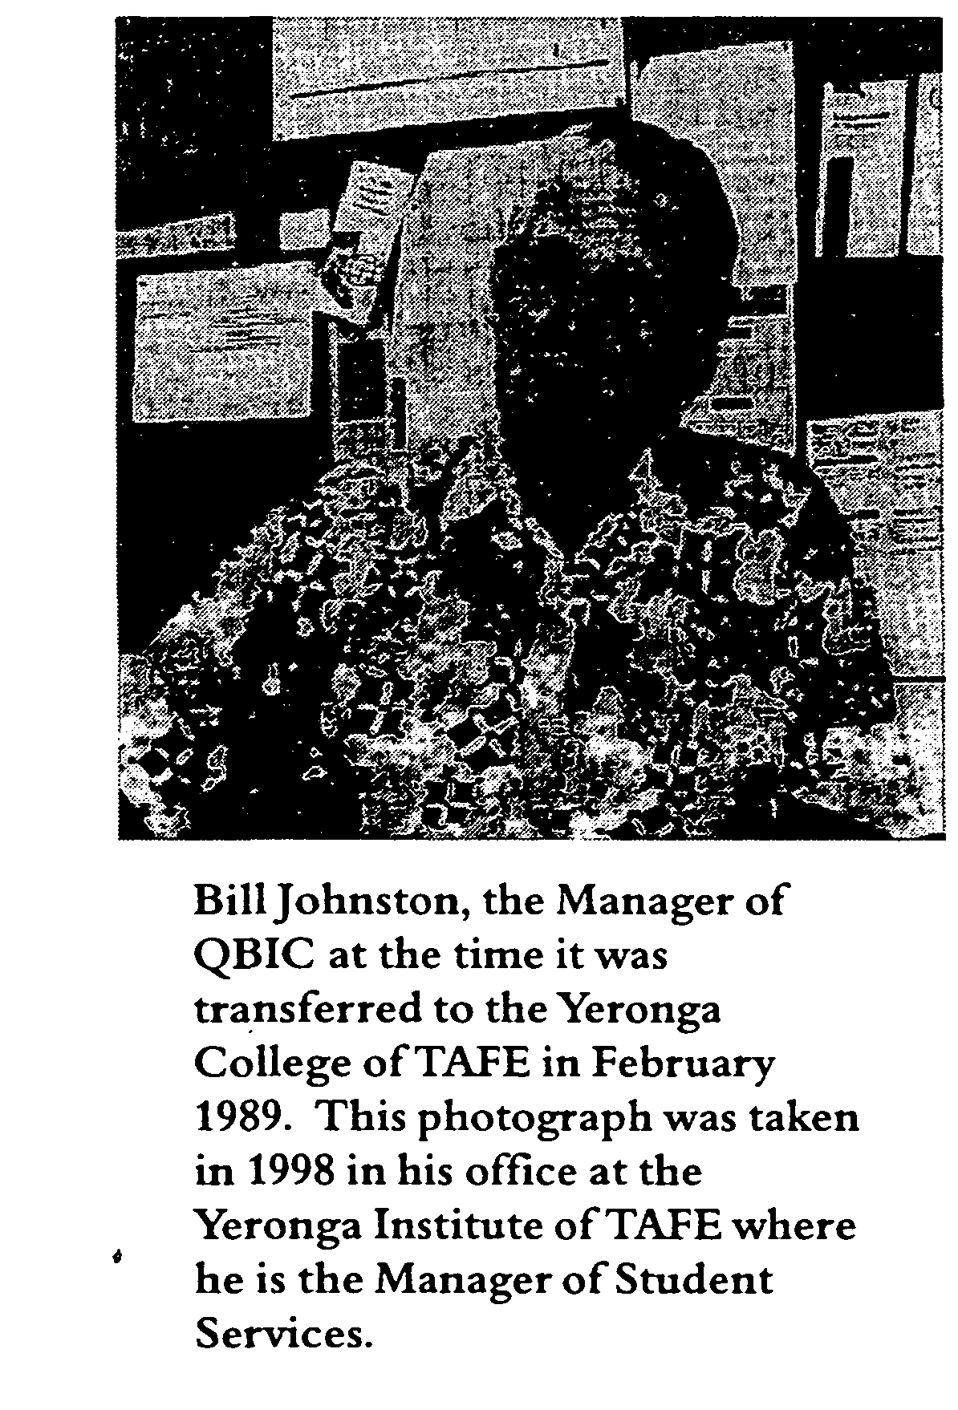
Over the six years that QBIC was located on the Annerley Campus of the Yeronga College of TAPE most of the administrative staff were reassigned to positions at the Yeronga Campus. For example, the QBIC Manager, Bill Johnston, eventually became the Manager of Student Services and the Assistant Manager, Nev Abell, became Head of the Human Resources Unit at the College. One of the shop supervisors, Ron Blinco, was placed at the College, as were some of the visually impaired workers such as David Brown, who joined the grounds staff

and David Dale who became a cleaner.
Of the other supervisors Sam McCord and Tom Chawner remained at Kent Street during these years overseeing production. Both have now retired but Sam McCord spent forty-five years at QIIB/QBIC. He and his father, who was also a supervisor at the Queensland Industrial Institute for the Blind, had been associated with Kent Street for more than half of the life of the institution.
An undated staff profile from the Vision Queensland Archives for this period shows that there were two administrative staff employed full time at Annerley and that six other Yeronga staff including the Director and the Head of the then Community Education Faculty, Shahid Khan, spent small amounts of time on Annerley Campus matters. It is an inescapable conclusion, both from production figures and from supervision of the QBIC operation, that the production aspect of QBIC operations was being run down as Yeronga TAFE staff addressed vocational training and personal development needs to improve the prospects of blind and vision impaired workers being placed in outside employment.
It has not been possible to find detailed production figures for some of these years, but Tregillis noted that takings were down to $302,000 in 1993-94 and that supply of traditional products was no longer guaranteed to regular
customers who subsequently lost faith in QBIC to supply their needs. The income for 1994-95 decreased to just over $200,000. As blind workers retired no new employees were taken on, thus compounding the loss of production. Some blind workers were distressed with their inability to meet orders;
others were concerned about being idle. Being in work and keeping up orders were important articles of faith with many of them.
The status and activities of the students
Former VIVA teachers from the Department of Community Education, such as Cherrill Tulip and Shirley McCormick, came onto the campus to offer courses such as typing and word processing. During this period independent living modules were provided, including three fully equipped kitchens on the second floor of the administration building at Kent Street for the use of the students, although the courses were not restricted to the vision impaired. Mixing of sighted and blind students in classes was encouraged as a prelude to their moving into the wider community.
At the same time other main-stream TAFE courses, unrelated to the VIVA unit, were transferred to Kent Street. A shop for motor mechanics was bmit by the staff and apprentices and

the necessary equipment installed and a floor-cover laying studio established over the industrial workshops. Kent Street was changing from a special-purpose production facility, which also happened to house industrial workshops, the production from which was diminishing, to an educational campus with a mix of students, including the blind and vision impaired.
Yeronga TAFE Staff interviewed in relation to this section of the history are all adamant that the resources provided during this period of transition were generous and the staff-student ratio was ample so that the students, who usually attended classes for an average of three hours per week, were given individual attention. The archival material referred to above indicated that just over half of the thirty-two blind and visually-impaired workers attended classes, most averaging three hours per week. For the remainder of the time they continued to work in the industrial workshops. However, the record shows that sales were declining and that the costs of running the facility were increasing.
During this period there was on-going TAFE curriculum development which introduced subjects in which evolving technologies were made available to blind people. For example, during the late eighties word processors started to replace manual and electric typewriters in the workplace and courses had to be developed by staff members, such as
Cherrill Tulip, Genevieve Head and Shirley McCormick for the accreditation that all TAPE courses undergo.
The Transition Project and Associated Reports, 1990-1993
By October 1990 the College had established a working party to investigate ways in which blind workers and those with vision impairment could be provided with vocational education courses and training which would allow them to find employment opportunities in the wider community. The working party saw its role as bringing about evolutionary change over a five-year period. The name given to this investigation was The Annerley Campus Transition Project.
In summary the project proposed three objectives: the development of an employment strategy; a strategy to 'mainstream' blind and vision-impaired students into appropriate vocational education courses; and the development of a management plan for the Annerley Campus to allow the first two objectives to proceed. The working party, which comprised representatives from the Yeronga TAFE, the relevant government departments, blind and vision impaired workers and union representatives presented its report on 18Junel991.

The first part of the transition period would run from May 1991 to April 1992 under the control of a steering group. The outcomes of the project were related to setting up the necessary infrastructure (the provision of suitable resources and curriculum development), recruitment, retraining and redeployment of staff and the establishment of support services such as an employment service. Total projected cost of implementing the three phases of the plan was of the order of half a million dollars.
The report includes a paragraph on the 'Perceptions of the Blind Community', which frankly admits that 'various undertakings have been given [to blind and vision-impaired students] to improve training and therefore employment options. These have only been partially met, and have resulted in a jaundiced perception of the TAFE system and the Yeronga College of TAFE.' This comment was a harbinger of the frustration ahead.
By October 1991 a report on phase 1 of the Transition Project had been prepared which identified the complexities associated with disability, equity, productivity-based wages, union representation, equal opportunity, workplace health and safety and workers compensation to name just some of the many issues which are of great importance to blind and vision impaired people.
It is clear that bureaucratic systems which the College had to set up to consider the implications of the manifold and varied issues of the Transition Project were slowly identifying all the issues that had to be resolved. A corollary of this consultative process was that these procedures were irritating and frustrating to the QBIC employees who had seen a whole year pass with little resolution of their difficulties.
Report by Management Consultants KPMG Peat Marwick
The Consultants' Report, Queensland Blind Industrial Centre - Review of Financial and Operating Information was presented on 15 June 1992. In a caveat to the report the consultants advised that 'much of the information necessary to completely address the original issues was not readily available', a situation with which this writer expresses some sympathy.
The Consultants were engaged to examine the financial operations of QBIC from 1989 to 1992 and to 'identify and assess the value of assets and liabilities of QBIC which will pass across to the Commonwealth upon handover, and those not specifically required for future operations.'

KPMG Peat Marwick concluded that 'QBIC cannot continue to operate indefinitely as it has done in recent years, producing a significant financial loss.' This loss was caused by 'a lack of experienced business management' involving 'a lack of pro-active marketing, production of stock irrespective of market requirements and a lack of product costing information necessary to make production and pricing decisions.' QBIC urgently needed to dispose of its inventory of stock and to have a management structure instituted whereby administration personnel on a part-time basis would be replaced by as few as possible full-time QBIC staff.
The consultants produced figures to show QBIC, on average, was costing the government annually just under a half a million dollars over the period 1988-89 to 1991-92. In effect this was to provide employment for some thirty blind and vision impaired workers and the administration staff at QBIC. By 1994 when Tregillis presented his report the figure had increased to $600,000, made up of operating costs of some $900,000 less income from sales which amounted to just over $300,000. When DEVETIR fully assessed the costs of running QBIC in early 1995, they agreed to fund QBIC, and later Vision Queensland, with a base grant of $1.07 million. Tregillis commented in 1994 that little had been done to address the concerns outlined in the KPMG Peat Marwick Report during the period 1992-1994.
A Framework of Action for Vision Impaired and Blinds Consumers of Annerley Campus,
Yeronga College of TAFE and Associated Reports
By September of 1992 there was a new state government administration in Queensland following the successful return of the Goss Labor Government. The new Minister, the Hon Matt Foley, was soon lobbied on behalf of the students, as had been his predecessor. At the same time the TAFE -TEQ and College administrations were stepping up their evaluation and development activities in response to student criticisms. A search of archival material turned up no fewer than twelve reports which were presented to the Yeronga College of TAFE or to TAFE - TEQ during 1993. This is an indication of the seriousness with which the College viewed the concerns of the paid students. Some brief analysis of these reports follows to substantiate this viewpoint.
The initial report, the full title of which is ' Framework of Action for Vision Impaired and Blind Consumers of Annerley Campus, Yeronga College of TAFE - a Report to the Minister,

the Honourable Matt Foley MLA will be called A Framework of Action in what follows. The report which is undated, but was probably presented in March 1993, concluded that
DEVETIR must demonstrate its commitment to the reforms occurring in disability services at a state and national level. As a result there is a requirement for significant redirection of service provision at Annerley Campus... It is critical that stakeholders are involved in consultations to prepare a case for and against the maintenance of Annerley Campus as a place of employment for people who are blind or vision impaired (p.25).
The final paragraph of the Report concluded that 'there is a strong basis for the change processes [to be] linked to a reduction of Annerley Campus activities.' It is possible to conclude from the phrase 'a reduction of Annerley Campus activities' that a decision to wind down the production activities of QBIC had already been taken by DEVETIR. If this were so, then making a case for or against the retention of QBIC as a place of employment would have been a pointless exercise.
Whatever interpretation is put on this part of the conclusion to a Framework of Action, on 18 March 1993 the Minister endorsed the recommendations that
1. A comprehensive consultation process be undertaken with all stakeholders to provide a case for and against the maintenance of employment activity at Annerley Campus.
2. The'Framework of Action'and transition arrangements be completed by December 1993.
Outcomes of the Consultation Process
By 27 May 1993 two documents had been prepared in response to the resolution -which the Minister had adopted on 18 March 1993. These documents were (i) Explanatory Notes on Draft Confirmation of Consultancy and (ii) Confirmation of Consultancy on the Case For and Against the Maintenance of Employment Related Activity at Annerley Campus, Yeronga College of TAFE. These documents will be called the Explanatory Notes and the Confirmation in what follows.
The Explanatory Notes outline the process followed in the building of the case Tor' and 'against' the maintenance of employment-related activities on the Annerley Campus. It is evident that the arguments of the Electrical Trades Union advocate and the views of a number of blind organisations influenced this stage of

the activity because the project co-ordinator subsequently went to Melbourne to visit the Royal Victorian Institute for the Blind and Worknet Victoria whose operations may have been able to provide models for retaining the QBIC operation.
The Confirmation document summarised and ratified the opinions of more than seventy individuals and organisations. In summary the case 'for' argued the right of QBIC workers to stay at Annerley; it found a well-established recognition by the community that blind people had decreased work options and therefore the Government had a responsibility to keep the campus open; that the provision of a 'safety net' was necessary for those who might try, but not succeed in, moving to outside employment, and a number of factors which related to social dislocation, loss of friendships and hardship for both workers and their parents and carers.
The case 'against' was largely based on the cost of keeping the campus open;
the argument that the annual costs of running QBIC could be more usefully converted to real dollars (some $20,000 per worker, per annum) to help them find other work; and the benefits to be gained by blind people moving into the mainstream community.
The case 'for' and 'against' the Maintenance of Employment Activities at Annerley Campus
Anyone with a social conscience reading the arguments and listening to the blind people put their point of view would have been swayed by the case 'for' and this appeared to be the situation when the case was put to the Minister in late 1993 in a report called The Case 'for' and 'against' the Maintenance of Employment Activities at Annerley Campus.
In summary the recommendations proposed that the Annerley Campus maintain its employment-related activities and that the QBIC operation be returned to profitability by rationalising the product inventory, seeking new products and customers and by re-establishing QBIC management under the control of a new auspicing body. Vocational education and training would still be available to blind and vision impaired workers. The working party was to report to the Minister on these objectives by October 1994.
There are also a number of other documents in the archives which show the direction the curriculum development process was taking. One of these documents related to work experience, which was an important part of helping the QBIC paid students experience what working in the wider ^community would be like.

Report on Framework of Action Work Experience Project 27 September -
J 0
15 December 1993
To help the paid students prepare for open employment, counselling and advocacy services were eventually provided in late 1993 and QBIC employees were given access to supported work experience. 'Supported' meant that individual employees would be accompanied by a support officer during the extent of the work experience. One of the major goals was to provide information to the curriculum development team on incorporating a work experience segment into the program for people with disabilities. This information was essential if the College were to fulfil its charter for the QBIC employees.
Details of this project, which was run by the Access, Equity and Foundation Studies Branch of TAFE, are to be found in the report, Framework of Action - Work Experience Project, 27 September- 15 December 1993. The contact officer was Lyn Moorfoot, the project coordinator. Twenty-six students participated in three-day work experience placements with eighteen different firms identified by consultants Comepass. The students were interviewed on completion of the placements and it is clear from their comments that a degree of stress from
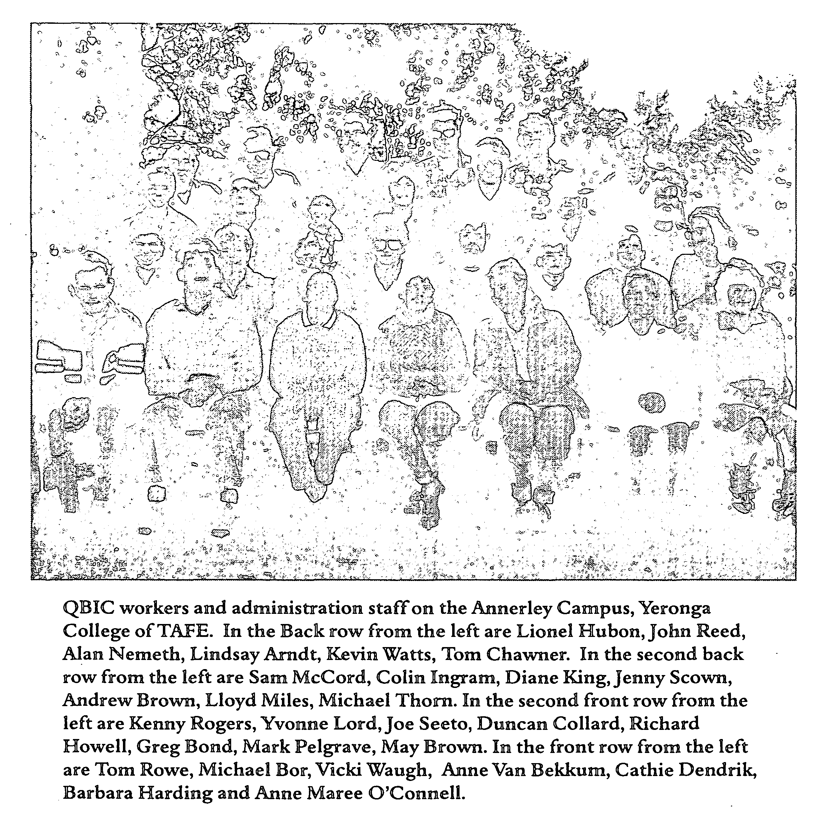

a number of sources was associated with moving from a familiar environment to an unfamiliar one. The evaluation notes
Paid students expressed a high degree of anxiety on commencement of the program. Issues raised included the purpose of the project, timing, working with sighted people for the first time, working outside QBIC for the first time and commitment to production of orders at QBIC.

Advocacy support was critical in the early stages of the program to respond to these anxieties.
One of the former students commented that they had never been interviewed and counselled so much in their lives before and it is clear from comments made by both interviewers and interviewees that participants on both sides of the project were clearly frustrated although they were learning from their experiences.

Another investigation of a completely different nature which was proceeding in mid-year 1993 involved the question of discrimination which was raised with the Director-General ofDEVETIR in relation to the employment of a small number of former workers from the QBIC sheltered workshop who were at this time working alongside the workers from the industrial workshop.
The Queensland Blind Industrial Centre - The Question of Discrimination on the Grounds of Impairment
This question was considered by Peter Rutkin, an Industrial Relations consultant with the TAFE Human Resource Planning and Development Branch, who investigated the relationship between the wages and conditions of employment of the former industrial workshop employees and the former sheltered workshop employees.
Rutkin established that different workers at QBIC were paid different "wages comprising a base rate plus a bonus based upon productivity together with a service increment. The disparity between take home pay for the highest paid industrial workshop employee and the majority of former sheltered workshop

employees was of the order of $500 per fortnight. The former sheltered workshop employees felt they were doing the same work as the other workers and took their grievance to the Federal Industrial Court on the question of breach of the antidiscrimination legislation. The issue was settled out of court.
While the issue was resolved by a productivity-based reassessment of wages for all workers, which had not been reviewed for many years, the case indicates the sort of dispute which disrupted the College's attempt to fulfil its obligations to the former QBIC employees. Some generalisations about this sort of dispute are made in the following report.
Report on Individual
0
Futures Plans -Annerley Campus
The final report to be considered in this section of the history of QBIC on the Annerley Campus of the Yeronga College of TAFE is a report presented by Workscope Incorporated, a private consultancy firm which was given the task of investigating the individual future aspirations of the QBIC students. The report confirms much of what was reported in the work experience program which was being run at the same time, so there is little point in repeating the conclusions.
What is interesting are some of the blunt and colourful comments made inter alia by the author, the Manager of Workscope, David Craven.
The IFF [Individual Futures Plans] process struggled against a -background of anxiety, anger, personal assassination, disharmony, distrust and misunderstanding whose roots lay in past frustrations. This historical baggage placed an enormous load on the IF P process (p.4).
Further,
For an IFP to have maximum effect, it needs to take place on a background of co-operation, harmony, trust and vision. Clearly the protracted negotiations between the numerous stakeholders regarding the future of QBIC and its resultant effect upon the students, impinged upon the conduct of the IFP process (p.4) .
The Minister was thinking the same way. Consultation and negotiation among such a diverse group of interested parties with so much 'historical baggage' had become counter productive. He needed an authoritative solution by an outsider and he chose Brian Tregillis, former National Director of the Commonwealth Government Employment Service. Tregillis had had experience in industry training and the apprenticeship system. The Minister asked him to report as soon as possible in 1994. Briefly, his terms of reference firstly were to identify, evaluate and recommend

employment options for the former QBIC students which would lead to their living as independently as possible. Secondly, he was to establish how QBIC could be transferred from State to Commonwealth financial support and finally, to consider whether QBIC could develop into a viable commercial business.
The Tregillis Report of 1994 and its Outcomes
The report by Brian Tregillis is a pivotal document which appears to exist only in draft form. It is in places, contentious, and some of its contents are still challenged by the Director and staff of the Yeronga Institute of TAFE who feel that they were given only limited opportunities to respond to the document before it was presented to the Minister in October 1994 when it was endorsed immediately. They believe the Tregillis Report fails to acknowledge the difficulties associated with implementing the provisions of the Commonwealth DSA, the Director pointing out to the Director-General of DEVET in a letter dated 6 December 1994 that
In this time [1989-1994] the operation of QBIC was conducted in an environment of uncertainty, one in which many reports into its operation were undertaken to provide information for the development of government policy.
The Director appears to be saying that government policy in relation to QBIC was being formulated after its transfer to DEVET, a situation which had inherent difficulties. One of the contentious issues concerns the value of personal development courses in preparing blind and vision impaired people for outside work. In a personal communication to the author Tregillis comments,
The VIVA courses contributed nothing to preparing the QBIC paid students (employees) for work in open employment. As far as I am aware if any of the students got any benefit out of the kitchen facilities they would be living skills unrelated to employment and I am not aware of any blind worker undertaking an accredited course on word processing.
It is arguable that personal development courses are important in preparing people for work, particularly in relation to the development of presentation and communication repertoires, and that they have an equally significant place in the curriculum as does skills training. The staff at the Yeronga Institute of TAFE, who worked with the QBIC employees, would support that viewpoint.
Bearing in mind the concerns stated by the Director of the Yeronga Institute of TAFE the recommendations of the report need to be summarised because "they provide a blueprint for the

eventual establishment of Vision Queensland.
The main findings of the Report are as follows:
⁸ Although QBIC was a clearly established business service which the Commonwealth had agreed to fund in the Commonwealth and State Disability agreement signed in 1991, the basis for transfer had not been established by October 1994. State funding in excess of one million dollars was providing for the operations of QBIC at that time.
^{e} Morale among workers, who had never perceived themselves to be students, was low. This conflict in roles was never reconciled. As a result QBIC production had seriously declined and workers 'are occupied for about 50% of the time they spend at the establishment' (p.2).
^{e} 'It is clear that the placement of QBIC with Yeronga TAFE College has not produced the desired results. Only four students have been placed in substantive positions in five years, all in TAFE Colleges. No student has been placed in open employment in the private sector. The productivity at QBIC is at its lowest level' (p.2).
* The Director General of DEVETIR should assume control ofQBIC and appoint an interim general manager who should ensure that all employees are working. He should also ensure that the production of existing products is rationalised, that an effective sales and marketing program is instituted and that new ways of raising revenue be found.
⁹ A recent change by the Commonwealth in its policy towards industrial workshops meant that establishments like QBIC could continue to function provided they incorporated training and work placement opportunities in their operations. In this way QBIC would become a recognised business service.
⁹ An objective ofQBIC should be to allow all blind and vision impaired people who wish to be in the workforce to achieve the best possible employment outcomes. Some would come on a temporary basis into QBIC, which would provide work experience and training and help them to find suitable employment in the wider community; others may need to be employed at QBIC for their entire working lives.

⁹ A recognised Competitive Employment Training and Placement Service (CETP) should be established at QBIC.
• A new auspicing body should be established. It should have links with the business community, with service organisations such as Rotary clubs, with the churches and with various blind organisations and the unions.
• The auspicing body should raise funds in the wider community. These funds would be augmented with proceeds from the sale of products and the delivery of services, and 'seed' funding from the State Government in the short term through DEVETIR. The Commonwealth should be approached for funding to provide new equipment and building renovations.
• A target should be adopted of handing QBIC over to Commonwealth control within three years as an efficiently managed, highly productive business service which meets all the disability standards' (p.4).
⁸ Some non-disabled workers need to be employed alongside blind and vision impaired workers to ensure production targets are maintained and to meet the standard of integration of disabled and non-disabled workers.
• Blind and vision impaired workers will have to be paid on the basis of the Federal supportive wage system. They should enjoy the same conditions of employment as non-disabled workers receive.
• 'The product mix at QBIC will need to be rationalised to eliminate uneconomic products and new activities such as assembly and packaging should be introduced' (p.4).
Among the background material produced by Tregillis in the Report is the recommendation that QBIC should be set up as a non-profit corporation by an auspicing body which would be required to undertake the following activities.
• Identify vision impaired persons in Queensland who wish to join the labour market.
• Identify their employment potential and assist them obtain employment appropriate to their skills and disabilities.
• Assist vision impaired school leavers to access tertiary or vocational education and/or employment.
• Be responsible for efficient management of QBIC.
« • Be responsible for raising funds to carry out its functions.

The Report is written in simple, clear language with practical suggestions for dealing with all aspects of the QBIC business service. It is an admirable aide-memoire to management.
Events Leading to the Establishment of Vision Queensland.
The draft Tregillis Report went to DEVETIR in late October 1994 where the Director General, Bob Marshman, sent it in its draft form to the Minister, the Hon Matt Foley. Both recognised the urgency of the situation and Peter Lynam was appointed as interim manager of QBIC to address the issues identified in the Report. He commenced work at QBIC on 4 November 1994.
A short time later an interim advisory board was formed in line with Tregillis recommendation 3-3, that membership should consist of a prominent business person as chairperson and 'a board comprising representatives of the corporate sector, the blind organisations, the employees of QBIC and for the first few years DEVETIR' (p.6).
The Report went to State Cabinet on 30 January 1995 where the Minister's actions were 'noted'. Vision Queensland as a legal entity dates from
1 November 1996. What happened at QBIC in the intervening twenty-four months and the period to date has been covered in the first chapter of this brief history.
A Final Word
That Vision Queensland and its supported business service, QBIC Industries, are still in the business of providing a supported employment environment for blind and vision impaired workers, as has happened for over 110 years at Kent Street, is a tribute to the persistence of these workers, their families and their carers. Carmen Lawrence in her brief tenure as the Federal Minister for Human Services and Health was right when she said that the needs of the [blind] individual, and their families must be paramount, and that the views of the community should always be taken into account in shaping and delivering services (quoted in Tregillis, p. 18).
Appendix 1
Vision Queensland Subscribers at the Inception of the Company
Clyde lan Barclay CBE, Chairman, Barclay Group John Thomas Fisher-Stamp, Partner, Deloitte Touche Tohmatsu
Desmond John Knight OAM, Director, Priority Maintenance Services Qld Pty Ltd
Glenis Margaret Jay, Director of Marketing and Development, Queensland Museum John Francis Puttick, Managing Director, Star Systems
John William Mitchell AO, Administrator, Queensland Foundation for Blind People Inc.
Pauline Anne McLaughlin, Principal, Associated Management & Marketing Services Terence James Boyle, President, National Federation of Blind Citizens (Qld) Kevin O'Mahoney OAM, Secretary, Blind Worker's Union
October 1996
Appendix 2
Board of Directors, Vision Queensland
Chairman
John Puttick, Managing Director, Global Banking and Securities Transactions
Deputy Chairman —
Desmond Knight OAM, Director, Priority Maintenance Services
Directors —
Terence Boyle, President, Brisbane Branch BCA
Nicholas Carter, Managing Director, Hillier Carter Properties Pty Ltd
Patrick Finnimore, Director, Howarth Investments Pty Ltd
Peter Lynam, Managing Director, Vision Queensland
Pauline McLaughlin, Principal, Associated Management and Marketing Services
Geoffrey Melvin, Solicitor, Melvin and Company (Company Secretary)
Anne Mibus, Area Director, Brisbane North Area, DETIR
Peta Nagle, Fundraising Consultant, St John's Cathedral Completion Fund
Kevin O'Mahoney OAM, Secretary, Blind Workers' Union of Employees
November 1999
Reference List
Baume, Peter & Kay, Kathleen 1994, Strategic Review of the Disability Services Program - Interiffi Report, a Report prepared for the Department of Human Services and Health, University ofNSW.
Department of Social Security 1982, Services for Handicapped People - Commonwealth Government assistance for community organisations working with Handicapped People, AGPS, Canberra.
Forrest, Rhonda 1983, A History of the Queensland Industrial Institution for the Blind 1883 - 1983, Queensland Disabled Persons Service, Department of Welfare Services, Brisbane.
QBIC (n.d.), Brushware - Leaping Forward (Catalogue), Brisbane.
Queensland Department of Education (n.d.). The History of the Education of Blind Children in Queensland from 1883-1967, typescript held in the library of the Low Incidence Support Centre, Dutton Park State School, Brisbane, reference V/HM/016.
————— (n.d.), Historical Outline of Education of the Visually Handicapped in Queensland, typescript held in the Low Incidence Support Centre, Dutton Park State School, Brisbane, reference 2.1.6.
Queensland Department of Family Services and Aboriginal and Islander Affairs 1994, Blindness/ Vision Impairment Service and Support Provision in Queensland - Sensory Disability Report Vol 1, Brisbane.
Rutkin, Peter 1994, The Queensland Blind Industrial Centre - The Question of Discrimination on the Grounds of Impairment, a Report prepared for the Director General ofTAFE.
Tregillis, Brian 1994, Draft Report - Queensland Blind Industrial Centre - Its Future. Vision Queensland 1998, Business Plan 1998/1999, Brisbane.
————— 1997, First Annual Report 1996/97, Brisbane.
————— 1997 - 99, Insights - the Official Newsletter of Vision Queensland, Vols. 1, 2 & 3, Brisbane.
—————1998, Second Annual Report 1997/98, Brisbane.
————— 1997, Strategic Directions 1997/98 to 2001/2, Brisbane.
ARCHIVAL MATERIAL FROM THE YERONGA COLLEGE OF TAFE AND VISION QUEENSLAND/QBIC
(This material is arranged in chronological order)
Yeronga College of TAPE 18 June 1991, Transition Project - Draft Proposal.
DEVETIR October 1991, Annerley Campus, Transition Project Phase 1 Report: Summary prepared by Greg Mackay, Project facilitator.
KPMG Peat Marwick Management Consultants 15 June 1992, Queensland Blind Industrial Centre, Review of Financial and Operating Information.
Yeronga College of TAFE 27 May 1993, Framework of Action for Vision Impaired and Blind Consumers of Annerley Campus, Yeronga College of TAFE. Confirmation of the Case 'For' and 'Against' the Maintenance of Employment Related Activity at Annerley Campus, Yeronga College of TAFE.
TAFE-TEQ 4 June 1993, Framework of Action for Vision Impaired and Blind Consumers of Annerley Campus, Yeronga. College ofTAFE. Explanatory Notes on Draft 'Confirmation of Consultancy' Document presented on 27 May 1993. Prepared by Project Coordinator, Framework of Action.
TAFE-TEQ (n.d.), The Case 'For' and 'Against' the Maintenance of Employment Activity at Annerley Campus: a Report to the Minister, the Hon Matt Foley. Prepared by the Acting Manager, Access, Equity and Foundation Studies Branch.
Yeronga College ofTAFE 30 July 1993, Initial Proposal on Job Redesign. Prepared by Support Services Job Redesign Working Party.
Tulip, Cherrill and Head, Genevieve 30-31 August 1993, Visit to Melbourne Service Providers [Reports on visits to four organisations].
Keating.Jane September 1993, Proposal to Conduct Futures Planning with paid Students at the Annerley Campus, Yeronga College ofTAFE.
Ysronga College ofTAFE October 1993, Report - Yeronga College's Efforts to Improve Annerley Campus Operations.
[Workscope Inc] 1 November 1993, Report on Stage 1, Annerley Campus.
————— 21 November 1993, Report on Stage 2, Annerley Campus.
————'•— 30 November 1993, Report on Individual Futures Plans, Annerley Campus.
Yeronga College ofTAFE 27 September - 15 December 1993, Report on Framework of Action Work Experience Project. Contact Officer Lyn Moorfoot.

PERSONAL COMMUNICATIONS
Interviews and Discussions were held with the following people: NevAbell, Ron Blinco, David Brown, Sue Camps, Henry Cichowski, David Dale, Bob Faulconbridge, Jason Fitzpatrick, Margaret Ford, DrJoy Grice, Brian Hutchison, Shahid Khan, Peter Lynam, Sam McCord, Shirley McCormick, Bill McKenny, David McKenzie, Merv Matthews, Kevin O'Mahoney, Graham RojhanJoan Rojhan, Cherrill Tulip, David Watson and Andrew Webster.
Index
Names in photo captions are distinguished from those in text by page numbers in italics.

Abell, Nev 47, 65 Anderson, Roy 36 Amdt, Lindsay 54 Barclay, lan 62 Baume, Peter 41, 45, 64 Barnes,- 30
Blinko, Ron 29, 30, 47 Bond, Greg 54 Bor, Michael 54 Boyle, Terence 62, 63 Brown, Andrew 54 Brown, David 47, 65 Brown, May 54 Brown, Selwyn 10, 16 Carter, Nicholas 63 Campbell, Merv 33 Campbell, Sir Walter and
Lady 41 Camps, Sue 65 Caudery (?), Ron 34 Chawner, Tom 30, 47, 54 Cichowski, Henry 14, 65 Collard, Duncan 14, 15, 54 Craven, David 56 Dale, David 47,65 Davies, Rosemary 35 Dendrik, Cathie 54 Dickinson, Harold 27, 30 Dickinson, Isaac 24, 25 Dickinson, Mercy 27 Dollier(?),Jack 32 Doumany, Sam 30 Dnscoll.JB 24
Faulconb ridge, Bob 6, 30, 65 Faulconbridge, Jack 30 Finnimore, Patrick 63 Fisher-Stamp, John 62 Foley, Matt 6, 8,44, 51, 59, 65 Ford, Margaret 6,14, 65 Forrest, Rhonda 5, 24, 26, 28,
31, 33, 35,36, 64 Fuller, Danny 15, 31 Goring, - 30 Grice.Joy 65

Griffin, Mercy 27 Harding, Barbara 35, 54 Harwood, - 30 Hayes, Ernie 34 Head, Genevieve 49, 65 Henry, Eileen 35 Holland, JE 29 Howell, Richard 54 Hubon, Lionel 54 Hutchison, Brian 6, 65 Ingram, Colin 54 Irwin, Nigel 14 Jay, Glenis 62 Jewell, Stuart 32 Johnston, Bill 38,47, 47 Kay, Kathleen 41, 45, 64 Kean, Steve 28 Keating,Jane 65 Khan, Shahid 47, 65 King, Diane 54 Knight, Desmond 5, 9,10, 62,
63
Lamond, - 24 Lam, Lan 18 Lawrence, Carmen 60 Lawson, Daphne 35 Lewis, Dudley 34 Lord,Yvonne 54 Lynam, Peter 6, 8, 13, 13, 21,
22, 59,63.65 McCartney, Danny 28 McCord, Sam 6,19,30,47,54,
65
McCormick, Shirley 48,49,65 McDevitt, Eileen 36 McKay, Greg 65 McKenny, Bill 65 McKenzie, David 14, 65 McLaughlin, Pauline 62, 63 Makin, Fred 34 Marshman, Robert 8, 59 Matthews, Merv 6,15, 19, 65 Mibus,Anne 63 Miles, Lloyd 54

Mitchell,John 62 Melvin, Geoffrey 10, 63 Moorfoot, Lyn 53, 65 Nagle,Peta 63 Nemeth.Alan 54 O'Connell, Anne Maree 54 O'Mahoney, Kevin 3, 62, 63,
65
Pelgrave, Mark 15, 54 Puttick.John 5,9,10, 10, \\,
62,63
Rafton, Allan 30 Rafton, Walter 30 Reed, John 54 Rogers, Kenny 54 Rojhan, Joan 65 Rutkin, Peter 55 Rowe, Tom 15, 54 Santoro, Santo 8,10 Scown, Jenny 15, 54 Searle,EB 24,27 Seeto.Joe 15, 54 Sharp, - 25 Shaw, Basil 3 Shaw. Beth 6 Short, Greg 34 Smith, Keith 14 Stibbs, George 37 Suffolk, Wayne 17 Sullivan, Jack 38 Thorn, Michael 54 Tregillis, Brian 6, 11, 13, 44,
46, 47, 50,56,57,59,60 Tulip, Cherrill 48, 49, 65 Tunley, R F 27 Valoniti (?), Dave 33 Van Bekkum, Anne 15, 54 Watson, David 65 Watts, Kevin 15, 54 Waugh.Vicki 15,54 Webster, Andrew 65 Wendt, Merv 46 Woods, Phil 33

