8 July 2004

«title» «name» «surname»
«Street_Address»
«suburb» «city» «postcode»

Dear «name»

Re: Merger of RVIB, Vision Australia Foundation and the Royal Blind Society of New South Wales.

I am delighted to inform you that the company members of Vision Australia Foundation, Royal Victorian Institute for the Blind and Royal Blind Society of New South Wales have all voted in favour of amalgamation, paving the way for the three organisations to become a single merged entity. The successful votes occurred at scheme meetings held in Melbourne on 1 July and Sydney on 2 July.

Following the scheme general meetings, the Federal Court ratified the amalgamation on 6 July. Therefore, as of midnight on 5 July, the three organisations have become officially one. The new Board is now officially in place, with Mr Graeme Innes as the Chairman.

Each organisation will operate as a separate business unit of the new entity, under their existing names and brands, until such time as a new name and brand has been developed.

I wish to reassure you that services to our members will continue to be provided at a high standard and there will be little, if any, disruption to services while we undertake the task of bringing together the people, resources and infrastructure of each organisation.

The Board and management teams are very excited about this new era in our histories, and are looking forward to working together to provide enhanced services for members.

If you have any queries on the process at this stage, please don’t hesitate to contact Mr Tim Griffiths, Company Secretary on 9522.5282.

Regards

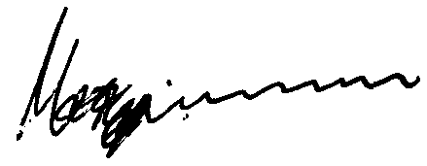

Dr Robert Trevor Anderson
President – RVIB Board

