The Light shineth in Darkness and the
Darkness comprehendeth it not
To the right worshipful the Master, Wardens and
other Officers of all regular Lodges of the ancient and
honourable Society of Free & accepted Masons
We the Master, Wardens & Secretary of the
Royal Yorkshire Lodge No. 503 held at the sign of the Lord Rodney
in Keighley in the County of York Doherty certify that Thos Hidgley
was regularly admitted a Mason & hath taken the first, Second &
third degrees of Masonry
Signed under our [unclear] seal of our Lodge at Keighley
Aforesaid the 21st Day of Nov in the year
of our Lord 1827 & in the year of Masonry 5827
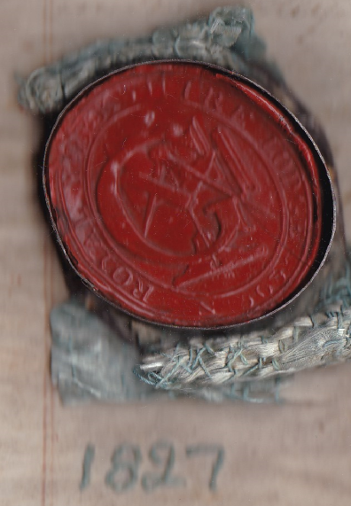
[signature unclear] Master
Hugh Keaton
Rich Still Wardens
John Murgatroy Secretary

