Old Colonists' Club
News Letter

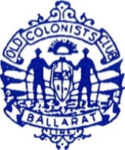
Established 1888
20 Lydiard Street Ballarat 3350
Ph. / Fax: 53 312 461

NOVEMBER 2016

Old Colonists’ Club
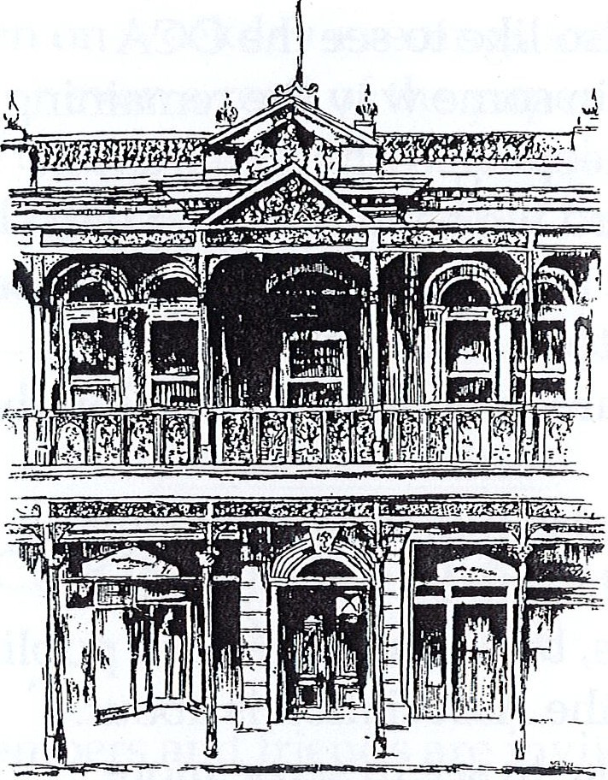

President:
Vice President: Secretary: Treasurer:
Ivan Crowley
Committee

Marg Knez, Marie Wilson,
Judy Kay, Daryl Weybury

Newsletter Editor

Sean McGaffin
PRESIDENTS REPORT

One Friday late in August after carrying the new outdoor furniture up the stairs I paused to catch my breath and in doing so began to read the marble tablets which carry the names of the Presidents of the association since its inception.

As I read through the names I thought how privileged we are to be members of such an historic club and to have as our home such a magnificent building.

The grandeur of the building creates amazement when visited by guests yet most of us take what we have for granted.

My plea to members, please make use of what we have, bring your friends, bring your family the club is open Monday to Friday with $3 Stubbies on Monday & Wednesday.

Join our educators on a Thursday night and most importantly if you don’t use it you run the risk of losing it.
John Lewis
Tim Etchells
Karl Hemphill

Dear Old Colonist Club Member

We are a small club with big facilities, and in order for us to stay viable, we need members to actively support the club. In the last few years’ membership has slipped below two hundred, and probably less than half of those use the Club on a regular basis.

There are a few simple things that Members can do to help keep our great Ballarat institution thriving and successful:
- I would encourage all members to think of a suitable person that they could nominate for Membership.
- If you’re going out for dinner in town, stop at the Club for an aperitif beforehand.
- Invite people who are not aware of the OCC to join you on a Friday night, and give them a tour of the facilities.
- If you are organising a work/family function, consider the OCC for the venue.
- And finally, if you’ve had a bad day at work; stop in at the Club for a drink on your way home and tell Bill all your troubles (he loves it!)

It’s your club – support it! Best regards, Karl Hemphill - Treasurer OCC

HERITAGE WEEKEND
A report on the 2016 event moving forward to 2017.

The Old Cols once again participated in the City of Ballarat’s Heritage weekend over the Mother’s Day weekend in May. As in previous years, the Club provided Devonshire Teas, guided tours of the building and also held the “Heritage Dinner” on the Saturday night with Judge Lance Pilgrim delivering the Don Anderson Lecture.

The Committee would like to thank everyone who helped to make the weekend event a successful one, whether by volunteering to assist with the running of any of the events or simply by attending the Dinner or dropping in for a delightful Devonshire Tea.

The City of Ballarat has very recently advised that following on from consultation with various stake holders (including the Club) a decision has been made to shift the date of the Ballarat Heritage Weekend to the last weekend in May (27 & 28 in 2017) thereby avoiding any conflict with various other “Mother’s Day” activities.

The Club welcomes this change of date and we look forward to another successful event in 2017.

Further news about next year’s event will be advised in coming newsletters and announcements.

CULINARY CORNER

A reminder to all members that on the last Friday of each month the Committee provides a lovely evening meal for a very reasonable cost. The meal on offer each month is usually announced one week prior.

Also, on the first Friday of the month a lunch of succulent roast meats and vegetables is served, again for a very reasonable cost. Attendees could also win a bottle of wine – make sure you book your place for catering purposes.

Any assistance offered with serving and cleaning up at these meal times is welcomed.

CHRISTMAS 2016
The last trading night of the club will be Friday 23rd December with the usual major Christmas raffle with all proceeds to be donated to the Fiona Elsie Cancer Research Institute.

Donations of wrapped gifts would be very welcome on the night to ensure the ongoing success of this fun filled night.

SNOOKER & BILLIARDS UPDATE

Snooker Season
The Ballarat and Billiards Snooker Association Inc, snooker season has been completed with the OCC2 side, led by John Eltingham making the finals, but unfortunately for the side couldn’t grab a spot in the Grand final
The OCC1 side, unfortunately has had a disappointing season not making the finals for the second year in a row. We are now paying for those successful premiership years, to the point our handicaps are making winning very challenging.
On a bright note, OCC1 player Jason Crocker won the Association Snooker Open Title, which was a fantastic effort to win the Grand Final 8 frames to 7, on the black ball. Doesn’t get any closer than that, congratulations Jason.
In the OCC Club Championship Jason Crocker played John Lewis for the title this year. Jason Crocker, in his first appearance, and who is currently the Ballarat Snooker Champion, defeated John Lewis in the final. This year all regular players played off scratch, so we have an open champion for the first time. It is my intention to get non playing Club Members back entering the club tournament, with a handicap start against registered players. This will encourage club members to participate, and have fun playing on our wonderful tables, in one of the best rooms in Victoria, if not Australia.
Pre match coaching also available by contacting John Lewis, for both Billiards and Snooker

Billiards Season
We are up to round 11 of 18, and OCC2 are sitting third. A strong performance, and hopefully they can sustain their form, to make the finals
OCC1 the story doesn’t get any better in Billiards, we are sitting on the bottom, with some serious work in front of us to get to the finals. We are finding most weeks, as a team, we are giving up to 400 points start.

CLUB NEWS
The Committee is organising a lunch at Warrenmang Winery on Sunday, 27 November. The cost of a 3 course menu, a wine tasting of the winery’s 5-star vintage wines, Luigi’s guided tour of the underground Barrel Hall and Wine Cellar plus tea or coffee is $41 per person. Wine (or other refreshments) can be purchased during the meal. Athalie and Luigi have kindly offered a 20% discount at cellar door off any wines which are purchased to take home. Please see Bill to book and pay for your place prior to Friday 18 November so that we can make the booking with our hosts.

