MITCHAM POST OFFICE – 1913 to 1957
By Brian Millane
Presentation to the Whitehorse Historical Society (WHS) on 7 October, 2023
- INTRODUCTION
NOTE: This document was prepared as if to be a read, or recited, presentation. As it happened, on the day, I had both hands full (one holding a microphone and the other using the controller for the screen showing the images) and, accordingly, I could only refer to this script occasionally, but I am sure that most of this material was in my talk.
- I will tell you what I know, or have discovered about Mitcham’s early postal service and the three post office premises that were used. However, the earliest years are not well recorded. To properly document that history will take someone a lot more research than I have been able to complete thus far.
- I have previously written an account covering quite a bit of what I am about to tell you. That paper has been included in the Whitehorse Historical Society’s collection. It is available on line – via the Victorian Collections web site - and for those who might be interested, it is titled The Mitcham Post Office - 1924 to 1957; the Catalogue number is ND7571.
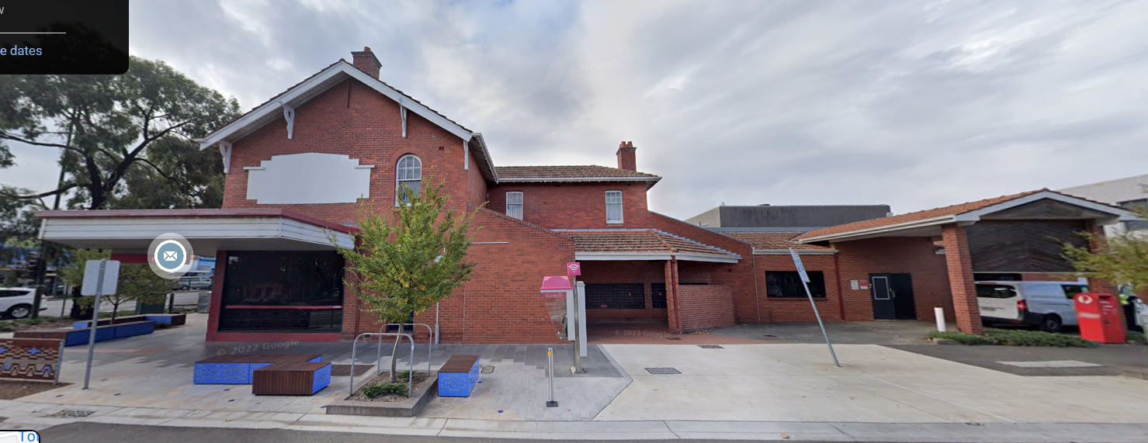
- Today, mainly, I’ll concentrate on the Post Office building that was closed recently as a post office. This is what it looked like a couple of years ago. The image is courtesy of Google Maps – Street View. The latest WHS newsletter has a photo of the building taken a month ago with a large sign: “FOR LEASE.”
- I lived in that house from birth (in 1944) to age 13; so, I have a good memory of the building and the goings on there. Our home was all of the upper storey and the rear part of the ground floor to the right of the shop; originally extending to just past where the tiled veranda ends; the kitchen was on the other side of the sloping brick wall.
- To be honest, I don’t have much personal knowledge of the history before about 1950; so, what I’ll tell you about the earlier times will be from records – mostly newspaper articles and photographs - and from family memories and mythology.
- MITCHAM’S EARLY POSTAL SERVICE
- In the early days, possibly from the 1840’s or 50’s, letters and parcels came by horse-drawn passenger coach from Melbourne – Cobb and Co . . . at times, something similar. From the early to mid-1860’s, the mail was dropped off at McGlone’s Harvest Home Hotel: locals would call in to check for mail; John McGlone was the licensee and he used to personally deliver anything marked “urgent.”
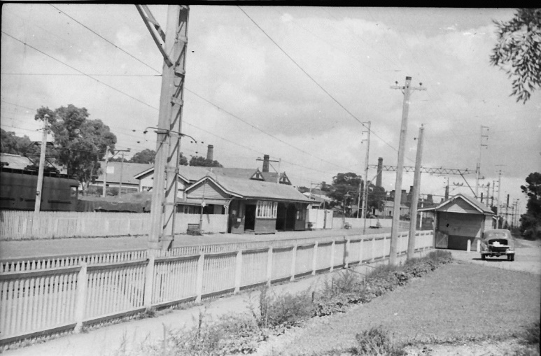
- On 25th December, 1882, train services to Mitcham commenced. The first official Post Office was located at the Mitcham Railway Station, commencing 1 June, 1884. Government Gazettes record the postmasters’ appointments and salary –it was very likely a joint role incorporated with that of Station Master. It was the habit of the Post Master General at that time – especially in non-metropolitan towns - to have the combined roles in order to save money on salary and accommodation for the postal service. Also, the small volume of postage didn’t justify a full time postmaster.
In the 20th Century, the ‘down’ platform ticket office building, on the right in this photo, was used as the post office. Certain trains had a ‘parcels’ van.’ On my way home from school as a child in the 1950s, I would collect parcels for our shop from the station assistant there . . . cartons with toys or books and rolled up magazines from Gordon and Gotch: Women’s Day, Women’s Weekly, comics and so on.

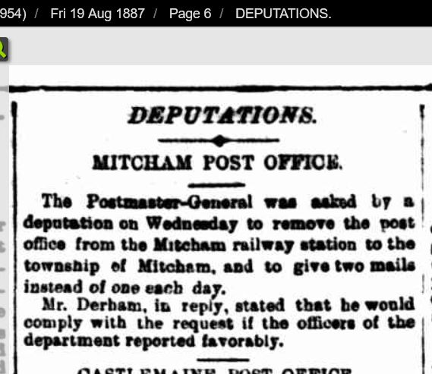
- This is a newspaper report from August, 1887, that shows the location of the post office and the request that it be shifted into the township.
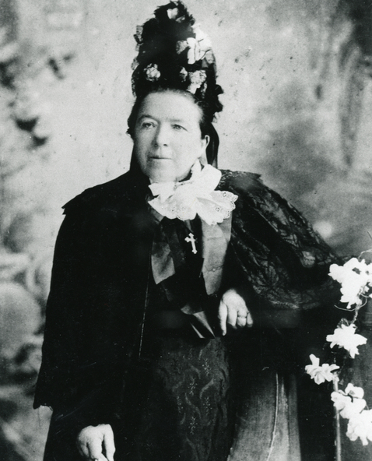
- So, at some point, after 1887 that I have not been able to discover, a new Post Office was established in a shop owned by the McGlone’s - near their Harvest Home Hotel. ..The hotel relinquished its licence in 1889; and this may have been because Eliza had been appointed Mitcham's first official Postmistress at a salary about double that of the postmaster at the Mitcham Railway Station Post Office which seems to have continued in operation for some time concurrently with the new one . . . at least well into 1890.
Eliza McGlone circa 1890
Photo from W.H.S. collection Ref: NP19
- Also, as they were operating the hotel in their front living room, the McGlones had always had problems retaining their liquor licence. Further, they had a substantial income in rents from the three shops and the police station that they owned.
- John McGlone died on 3 September, 1892, so Eliza ran the businesses from then.
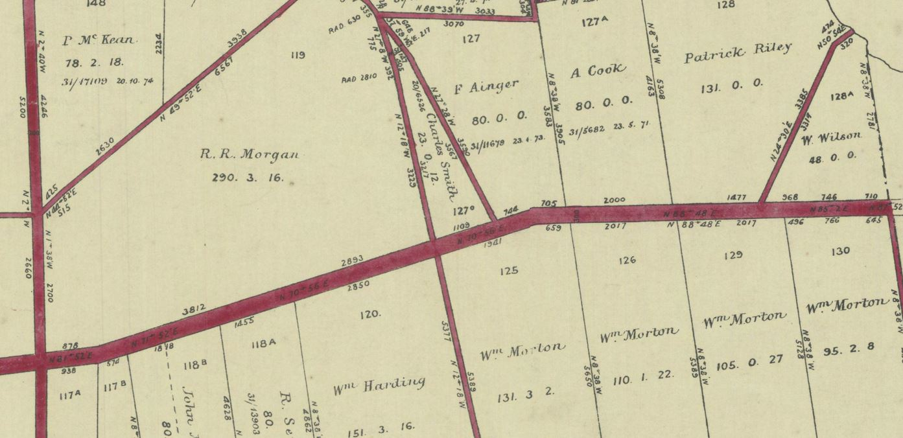
- This first map shows the area between Springvale Road and Heatherdale Road; the wide red coloured road is Whitehorse Road. The map is the official one gazetted in 1878. It was clearly out of date because the McGlones owned a portion, possibly 5 or 6 acres, of Lot 120 which had been subdivided and several lots had already been built upon: notably the Harvest Home which had opened in 1873. And the railway reserve is not shown; nor is the Catholic Church which was established in 1872. (Map source: Public Records Office, Vic.)
- Note: there are published histories of Mitcham that state that the McGlones settled here in 1862;but no mention of that name in this map.
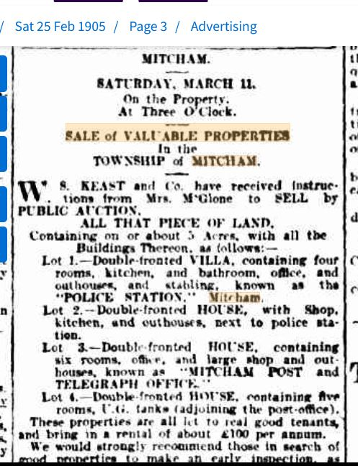
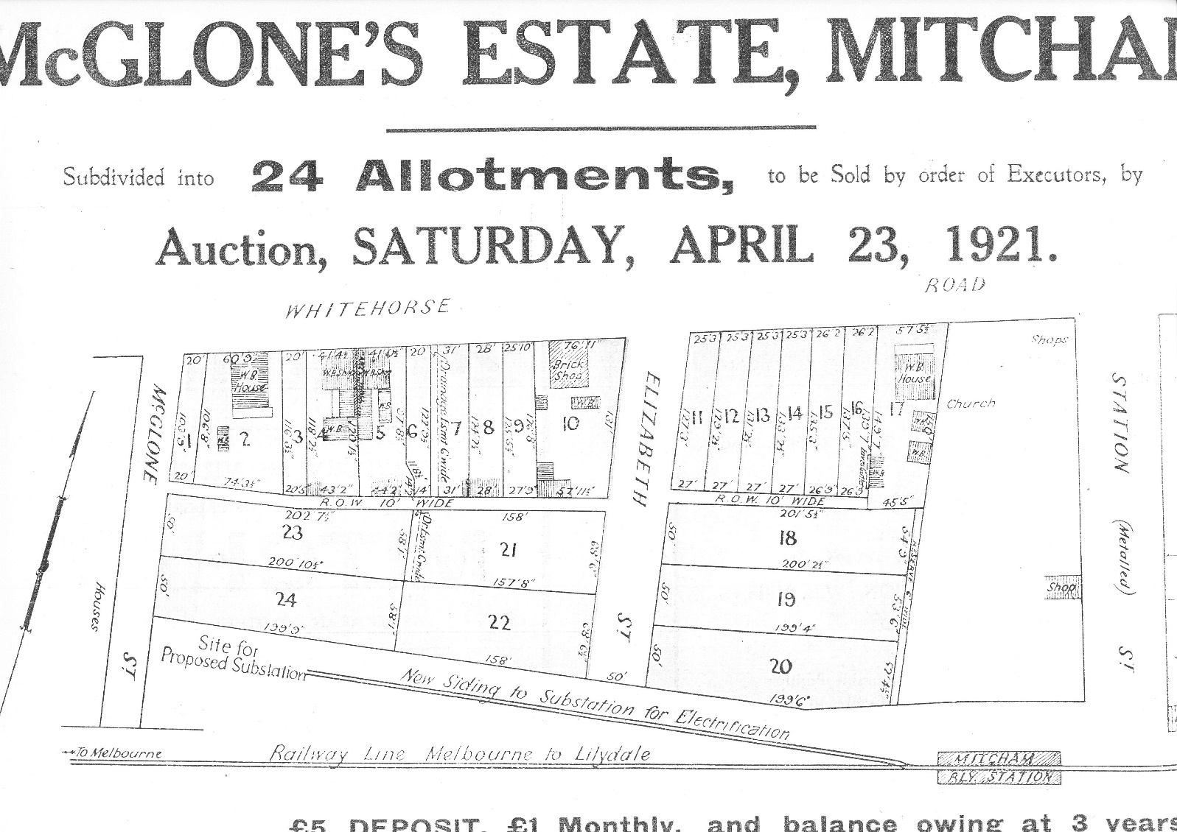
- This next map shows the location in 1921 of the post office (Lot 5). It is in one of a pair of shops owned by the McGlones. They owned all the numbered allotments. This sale followed the death of Eliza in January 1922.
- You will notice the rail siding and the proposed sub-station site for the electrification of the railway beyond Box Hill. My mother wrote about this being built and there were only paddocks between her home and the railway and the workers would come down a couple of times a day asking her mother: “Please, missus, could we have some hot water for our tea?”
- This next image, somewhat surprisingly, shows that much of this estate (5 acres with frontages to Whitehorse Road) had been offered for sale back in 1905, including the Post Office but excluding the Harvest Home (probably Lots 1, 2 and 3, in the map above).
- Telegraphic communications. As an aside, it should be noted that, as commerce and social events (think land selections, allocations and sales, Eureka Stockade and other unrest on the goldfields, shipping intelligence, market prices etc) the use of couriers and postal services were not fast enough to allow those in government and business to manage their affairs efficiently. In the 1860s, post offices and railways quickly adopted telegraphy as a means of fast, and cheap, communication. Even up to the 1960’s, telegraphists were using Morse Code to transmit telegrams across the world. Hence, we see, in the above advertisement the term “Post and Telegraph Office.”
- And the Box Hill telephone exchange did not open until 1899. Probably there was no phone connection to Mitcham until at least 1905. Even then, since all exchanges were manually operated, the cost of a call was much greater than that of a telegram.
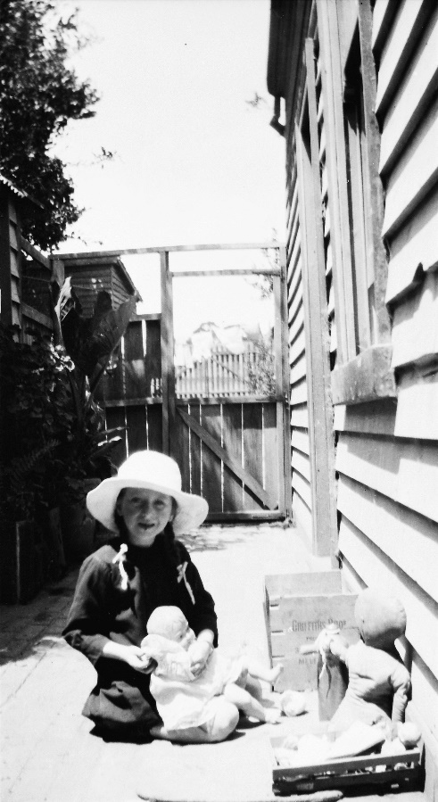
This is my mother in about 1920 in the side path at the old P. O. The adjacent wooden shop can be seen in the background to the left. The two shops had similar fenced lanes leading to the back yard.
My mother has given me lots of photos from her young days but, unfortunately, none shows the street frontage of the old wooden shops, including the post office, down near McGlone Street. But my recollection is that they were very similar in construction and appearance to the Harvest Home.

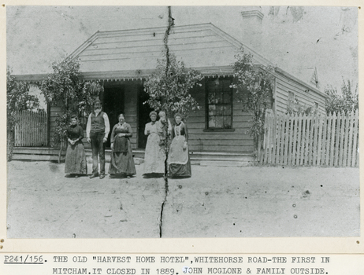
This photo is from the WHS collection. It shows the Harvest Home and it looks just how I remember the old post office shop with its raised wooden veranda and the small glass panels in the windows; and the weatherboard exterior.

Postmistresses and Postmen
With research, it will be possible to discover the correct facts. The following are my gleanings from various sources; mostly Sands and McDougall directories (Sands & Mc’s).
1884 to ? unknown Railway Postmaster(s) /Stationmaster(s)
1889 to ? Eliza McGlone who was 54 yrs. (Vict Collections Ref NP19)
1900 Mrs. Mary DeValle (Sands & Mc’s)
1905 Eliza McGlone (Sands & Mc’s)
? to 1908 Miss Thomas (newspaper report of her leaving the position)
1910 Miss A. O’Sullivan (Sands & Mc’s)
? to 1913 Eliza McGlone (Government Gazette)
1913 to 1942 Bertha Markham (Government Gazettes)
1942 to 1944 Patrick Markham (Government Gazettes)
NOTE: By the time she retired in 1913, Eliza McGlone was 78 years old.
- I can’t find out much about the various postmen or, more accurately, contractors as they were in those days. In her memoir, my mother mentions postmen by name. It’s not clear what period she’s referring to, but likely from around the mid-1920’s to the early 1940’s. She says:
After Arthur Gayleard, our postman, finished, we had a chap called Weymouth and then later still Les Miller and of course Owen Loftus.
I assume that these were all contractors. I’m pretty sure Mitcham didn’t have uniformed postmen until after my grandparents died in 1944. In the early days, the Postmaster/Postmistress would sort the mail, probably with the delivery contractor.

- PATRICK AND BERTHA MARKHAM
- Bertha Jane Cruse (28 yrs) and Patrick Joseph Markham (40 yrs) married in the Ringwood Catholic Church on 20 August, 1910. Patrick was then residing in the city and Bertha was living in Mitcham. I have been unable to ascertain her address up until the time they rented the old post office premises I mentioned a minute ago.
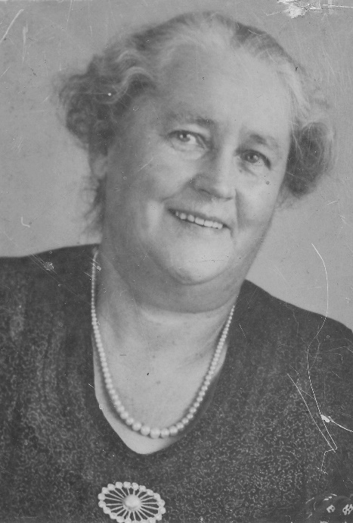
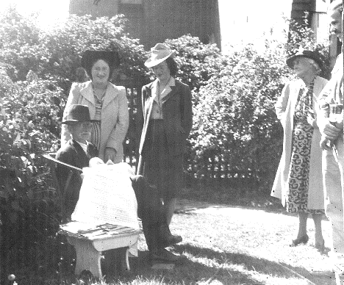
- This is a photo of Bertha from about 1938. I do not have many photos of Patrick, other than within family groups. Here, Patrick is holding my brother in March, 1943; my mother, Mary Millane (nee Markham) is standing directly behind him. (Note: the baby is wearing the christening gown that Bertha’s mother made for her baptism in 1882. This gown is now part of the W.H.S. collection.)
- By about 1920, Bertha Markham was well ensconced as the Mitcham Postmistress. And her husband, Patrick, was very keen to move their business to the heart of the village. For years he had wanted to buy the site where the post office building stands today. But it was not on the market. Well, not at a price he was able to afford . . . or, more likely, was willing to pay.

- Photos of Station Street around 1923, show houses and shops along the east side of Station Street to the south of the right of way. That portion had been sold off some years earlier, initially in the 1912 sale. However, along the Whitehorse Road frontage, there is little development: the State Bank building next door to the post office was not commenced until 1929. So, it may be assumed that the allotments along Whitehorse Road from Station Street to Mitcham Road were not sold to people wishing to build on them until around 1921 or later.
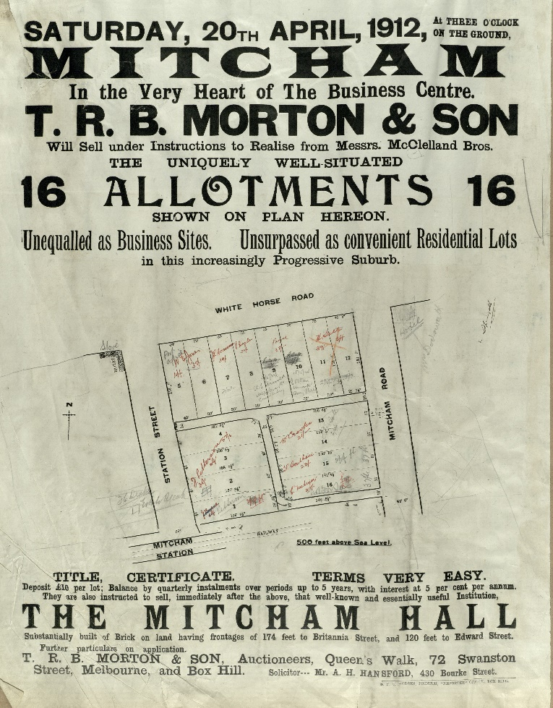
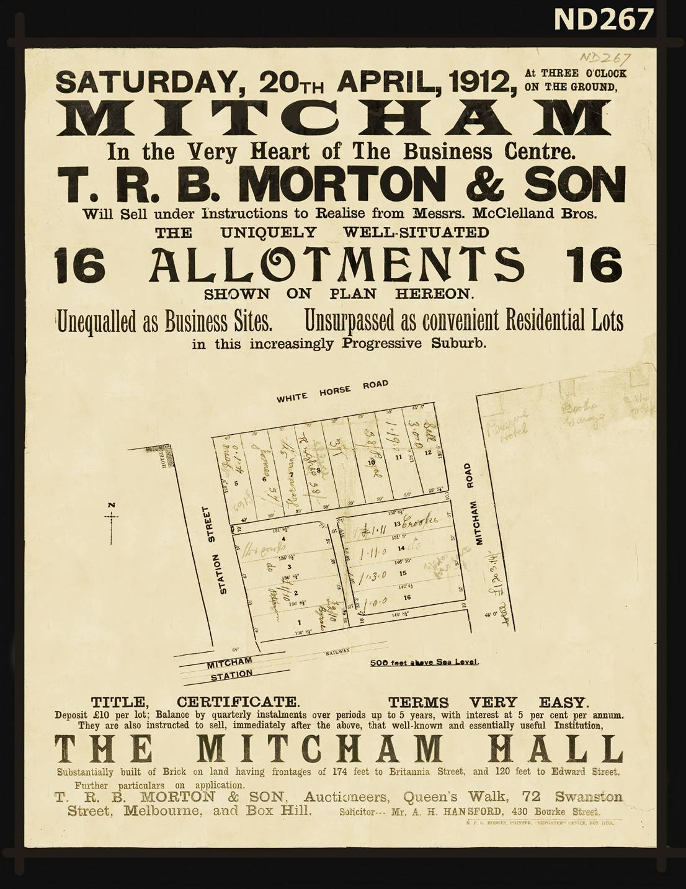
- In 1912, as can be seen from this poster (also part of W.H.S. collection) the whole block between Station Street and Mitcham Road and from Whitehorse Road to the railway line was sold off. The two copies of this poster I have seen both have records of the 1912 sale including the prices paid and the purchasers’ names for all of the lots. The more expensive lots facing Whitehorse Road were not developed: apparently, the buyers of those prime allotments had held onto them until their value gave them the profit they wanted.
- (See also S.L.V. ID 2238101; Filename -ha000334.) This is another copy of the previous poster I showed you. It is from the State Library of Victoria. It has annotations made in May, 1924, of the re-sales of Lots 9 and 10. These notes also show the existence of the new Post Office on Lot 5 and the old Hill Hotel having been replaced by a store - i.e. on the Western corner of Station St and Whitehorse Rd.
- Patrick had long operated a newsagency in West Melbourne – Spencer Street. His wish was to cease working in the city and conduct a newsagency in Mitcham. But, as there was already a newsagent in Mitcham, he was refused a licence. So, he and Bertha, had to make do with stocking the other kinds of products that newsagents sell: magazines, stationery, etc. and, as Bertha was a seamstress and tailor, haberdashery items.
- Of course, they were also the Commonwealth Bank Agency.
- So, Bertha had all the responsibilities of running a mail service, supervising mail sorting and contractors; selling and accounting for sales of stamps, postal orders and telegrams as well as servicing customers of the bank and her general goods offerings. Not to mention her household work as a wife and mother.
- Bertha was the official postmistress as well as the local Registrar of Births and Deaths; and she held those roles, other than in times when on leave, from at least January, 1913 until October, 1942, when she became too ill to continue.
- Patrick, who had been her relieving or Acting Postmaster, then took over until he, too, became ill in 1944.
- Bertha Markham died on May 31st 1944. Patrick died on July 3rd, 1944. They are buried together in the Box Hill Cemetery.
- My mother, Mary Millane, was appointed as Acting Postmistress from 1st July, 1944. However, the P.M.G. department took control of postal services from about October, 1944, and removed the Post Office to a shop several doors away.
- I’ll return, later, to discuss my mother’s shop as I remember it in the late 1940’s and 1950’s.
- THE BRICK POST OFFICE - 1923-24
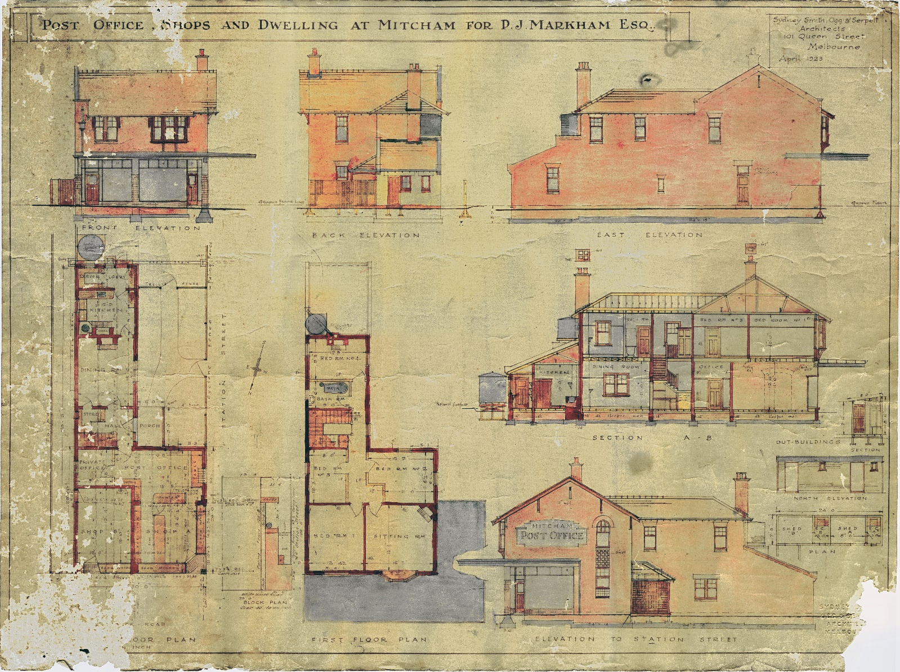
- Once he had secured his chosen site, at the corner of Station Street, Patrick retained Sydney Smith, Ogg & Serpell, Architects, 101 Queen Street, Melbourne to draw up plans and working drawings for his new post office. In April, 1923 the plans were completed. An original copy is held by W.H.S. This next image shows the whole document. It is on display over there so, you can have a look at it when we break.

- As you can see, the silverfish have caused a bit of damage over the years but most of the important details are present.
- The original is about 19 by 25 inches (48 cm x 65 cm). Because it is so big, I will use sections of the drawings now to talk about various aspects.
- You will notice throughout the drawings some technical abbreviations that I should explain:
- R.S.J. Rolled Steel Joist. These are very strong “H” section, load bearing beams.
- R.C.L. Reinforced Concrete Lintel: used to carry brickwork over windows and doorways.
- L.P. Lath and Plaster. A form of wall surface that preceded the use of plaster board. Note: all the walls coloured dark red are solid brick; the thicker ones are double brick.
- S.W. Sleeper Wall. A wall under the ground floor used to support floor joists where the spanned distance requires one.
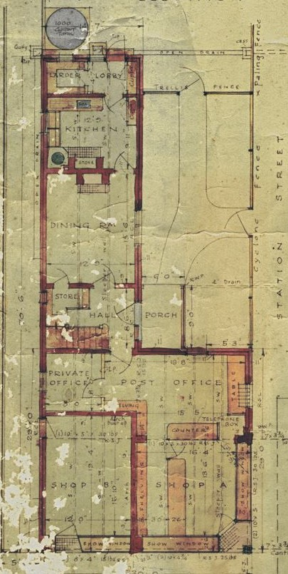
- Also, you will note the provision of large water tanks: town water reticulation didn’t reach the main part of Mitcham until late 2024 and some areas much later. So, tanks were provided at both ground and first storey levels (1,000 gallons or 4,500 litres each).
- I won’t discuss the structural engineering design features which I find really interesting. Suffice it to say that the existence of the show windows and shop doors was a major challenge as to how to carry all the brickwork above, plus the weight of the tiled roof.
- It is clear that the design of the building and its construction were of the highest quality because the post office building retains all of its original features and appears as sound today as it was almost 100 years ago.
- The Post Office section was the area behind the counter that is at right angles to Station Street; the Postmistress’s office is to the left. I assume that the G.P.O. rented this space; and Bertha Markham also received a salary.
- There was only one phone line and that was used for official purposes, including telegraphic communications, and served as the only public phone in Mitcham at the time. After much agitation by the Mitcham and Vermont Progress Association, an additional line into a public phone box outside the Post Office was installed – possibly by 1925.
- The mail was sorted on a large table in the centre of the main space and put into pigeon holes on the wall then bundled up by the contractor as per the requirements of their rounds. Mail for residents outside the delivery area was retained for collection.
- The money (and stamps, money orders, etc) relating to Post Office sales and Commonwealth Bank transactions was in a lockable drawer in the P.O. counter.
- ‘Shop A’ is the newsagency/mixed goods sales counter. This counter also had a lockable cash drawer and this money was kept separate from that in the other cash drawer.
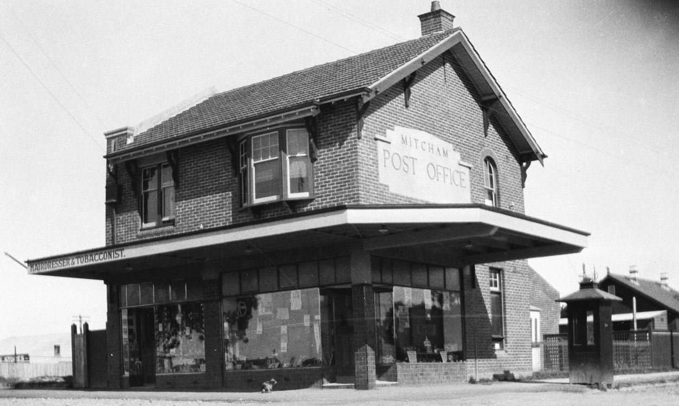
- ‘Shop B’ was rented out; it started as a hairdresser and tobacconist and, at one stage, was the Commercial Bank. After the Post Office closed in late 1944, it was used as a storeroom for the shop and a workroom for the photographic processing business. We had a system of lay-by purchases and, as Christmas approached, the volume of goods held as part of this process grew and any available space was used to store them.
- This is the earlies photo I have of the Post Office after it opened. Given that the Phone box looks well worn, it’s probably 1926 or 1927.
- The tiles shown on the steps into the shops were blue with a hint of green and these were continued on all sides of the column at the corner and on the street frontages under the show windows. I believe the tiles were locally made – probably by the Australian Tesselated Tile Company (A.T.T.C.), as Patrick Markham was a colleague of the proprietor, Mr Walker.
- I remember the shop fittings. The counters were hardwood and about 2 inches (50 mm) thick. They were truly counters as an important job at the start of each day was checking the ‘float’ and, at close of business, counting all the cash in each drawer. I used to love the feel of whipping the coins into my hand, sorting the denominations as I went, and stacking them in neat rows: Florins, shillings, sixpences, threepences, pennies and ha’pennies. We weren’t allowed to count the notes.
- The show windows were, more or less empty spaces where shelving, or whatever was needed, could be installed to carry the items on display.
- Access to these spaces was by means of sliding glass doors. The glass was obscure, similar to old style shower screens. This was an important source of light as the only windows were above the show windows and they were not very effective as they were immediately below the wide veranda roof.
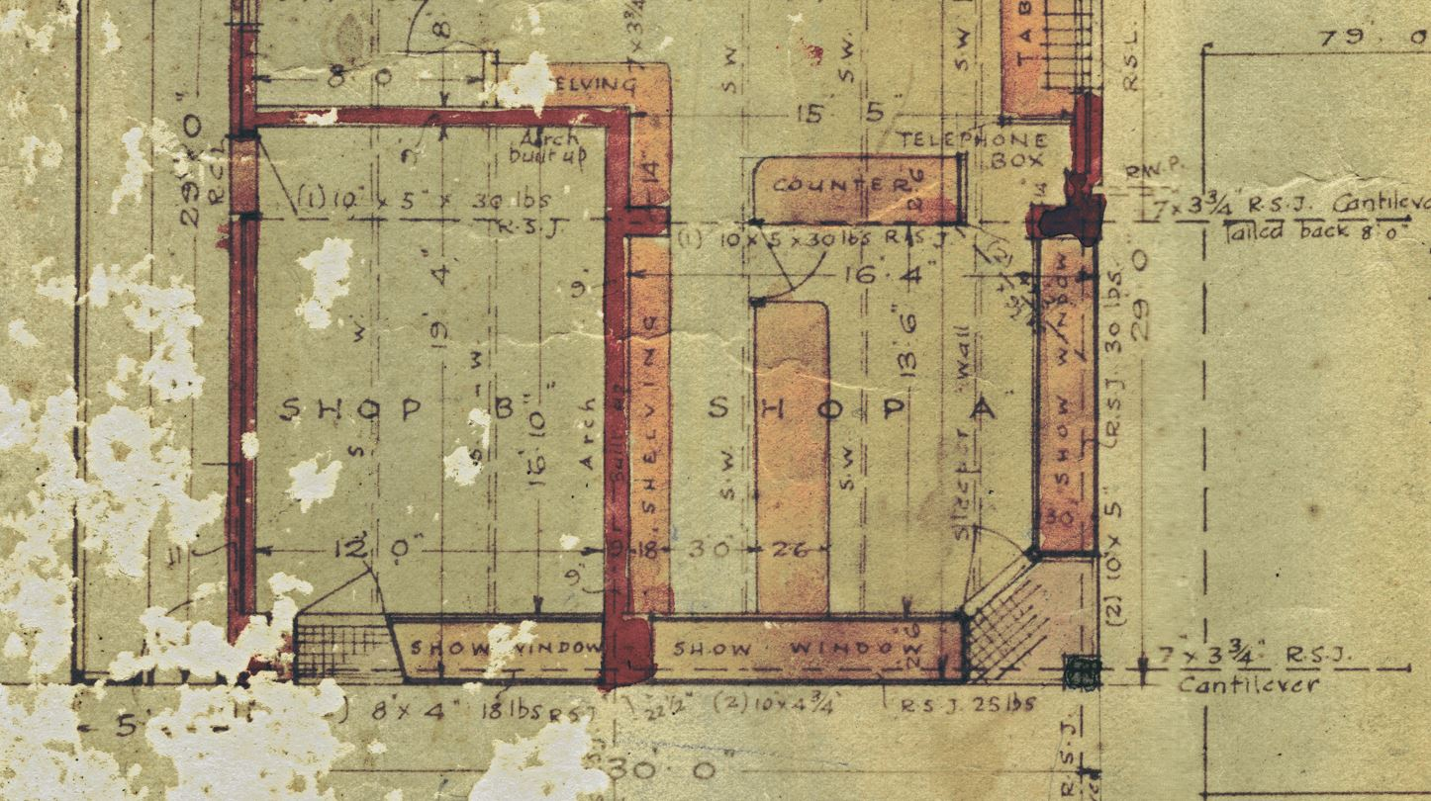
- This is a particularly damaged section of the drawings but it has enough detail for my purposes. You can see the three show windows. Also, the tiling at the doorways
- There are some of the most interesting design elements shown here as well: The RSJs, the main supporting columns and the sleeper walls.
- At the back of the ‘Shop’ section stood a row of cupboards with display shelving above.
- The rest of the ground floor was residential; the living rooms - and that’s all pretty self-explanatory from the drawing. I’ll just go back to the full plan of the ground floor.
- You will notice the store under the stairs, opening from the Dining Room: this was, more or less, the strong room . . . although it wasn’t very strong. Cash and valuables, such as stamps, postal notes and money orders were all locked in there whenever the business was closed. My sister reminded me of the smell of money whenever we were allowed to peer inside. And there was the biscuit tin full of copper coins.
- I also remember my mother showing me a bundle of, perhaps, 50 full double sheets of grey halfpenny postage stamps. She told me that her father had bought them around 1920 I think, because he believed a story about the work of a disgruntled craftsman at the printing works who had managed to replace the flag on one single stamp on one single sheet: the error was that the flag was flying upside down. Now, these were tiny stamps – perhaps half the usual stamp size. Apparently, my grandfather spent months, even years, with a magnifying glass trying to find the flawed stamp which was reputed to be worth a small fortune; it had escaped the normal checking processes. Ironically, if we had kept those unused intact sheets of stamps in good condition, each sheet would now be worth a small fortune.
- The next image is the plan of the first floor: it has the bathroom, bedrooms and sitting room. Most of that is also self-explanatory. But there are a few things I’d like to talk about
- You will notice the few internal walls tinted yellow: these are not structural; they are lath and plaster. The brick walls, marked in red, carry the weight of the tiled roof; on the interior side, these walls had plaster rendering directly onto the brickwork. Another strange memory was the ‘disaster’ when a wall got dirty: we couldn’t wash it because, except for the woodwork, the walls were covered in Kalsomine, a kind of pink-coloured whitewash. I remember my father trying to apply a fresh coating in the dining room only to see the old and the new coats slide off the plaster onto the floor.
Question: Which was your bedroom?
Answer: Well, I started off in this one (Bedroom 2); then went to this one (Bedroom 1); then into this one (Bedroom 3); then back to this one (Bedroom 1); and ended up in this one(Bedroom 4). As the numbers of children grew, we were juggled around to suit ages and genders and so on.

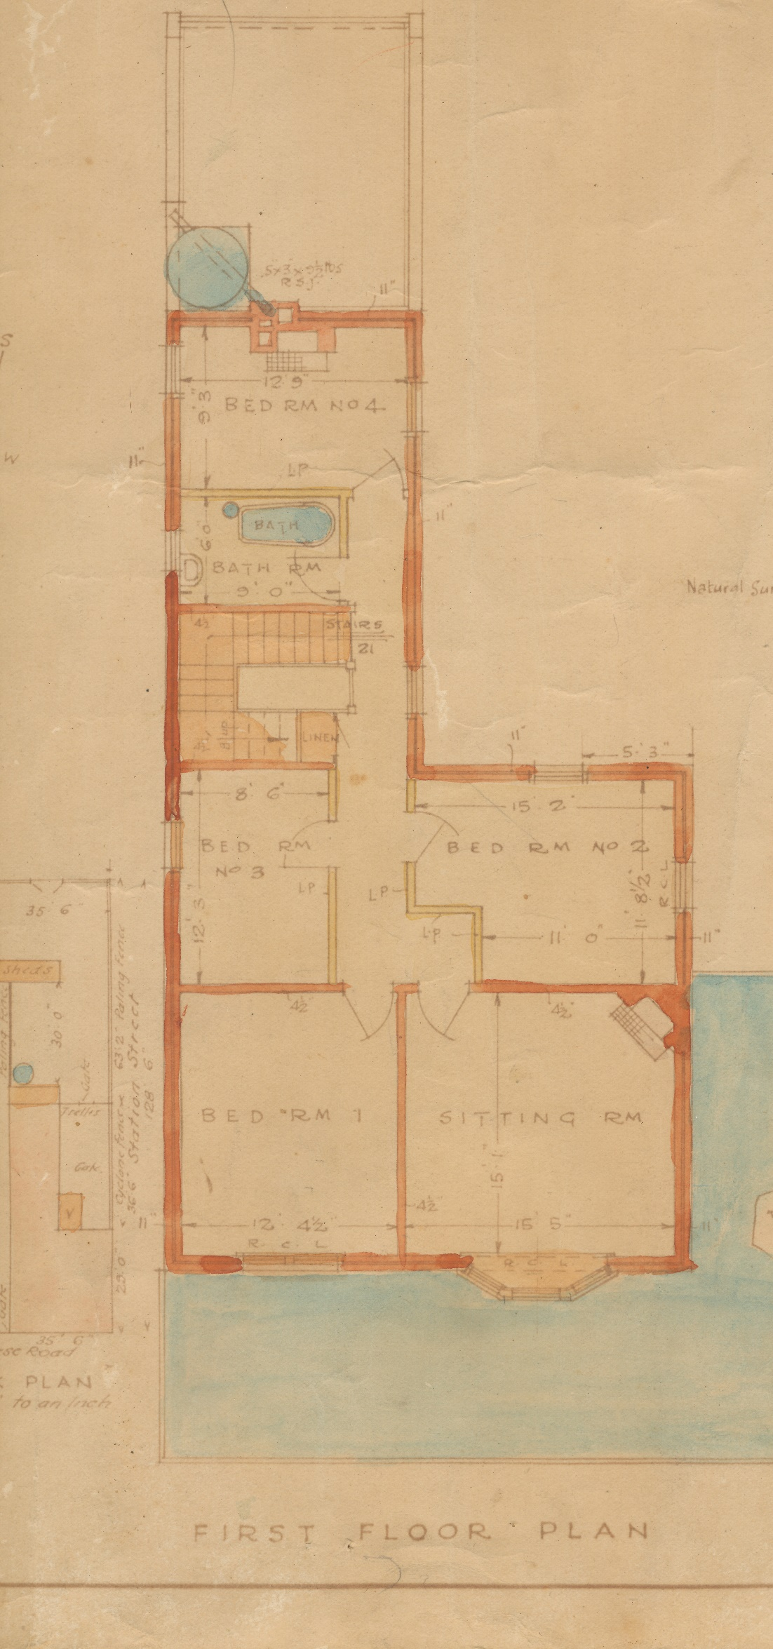
- Next, you’ll notice there is no indoor toilet . . . but more on that later.
- There is a large rainwater tank that takes the water from the roof. It is piped to the bathroom where there are only cold-water taps. There is a heater at the foot of the bath: it was probably a chip-heater in 1923 but, by the time we lived there, it was a similar appliance but run on town gas supply.
- Patrick, Bertha and their daughter, Mary, shared the upstairs sitting room (the ‘studio,’ as, later, we knew it)
- The veranda roof over the footpath (shown coloured blue in the drawings) was of corrugated iron. Bedroom 1 had a double hung sash window the sill of which was less than a metre from the floor. Our father occasionally used the veranda as a platform from which to take photos. And, as kids, we occasionally used it as a playground. We got into major trouble, if caught. I guess that the low-hanging electricity supply wires were a good reason for our parents to try and keep us inside.
- Now, here are a few photos my father took from that veranda. You can blame me for the quality – I found a roll of old negatives and scanned these shots at home.
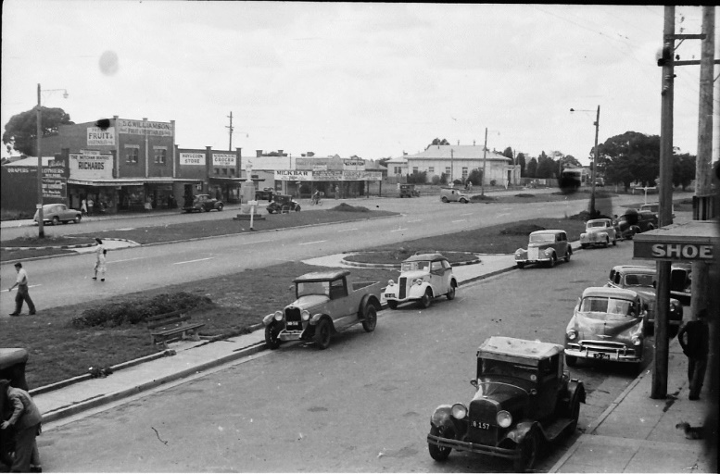
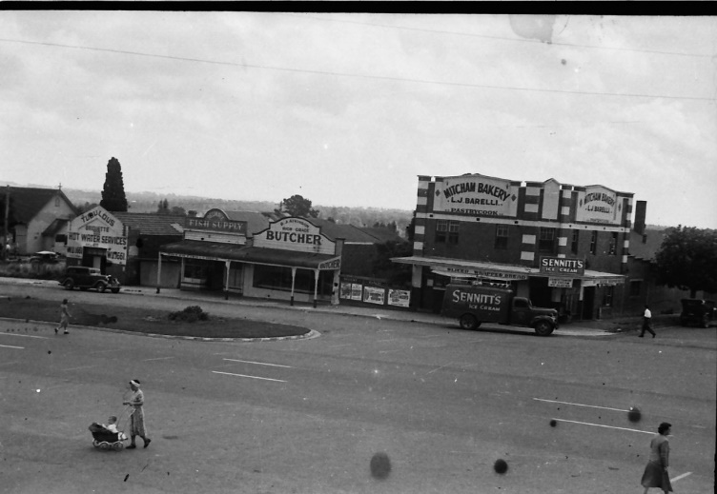
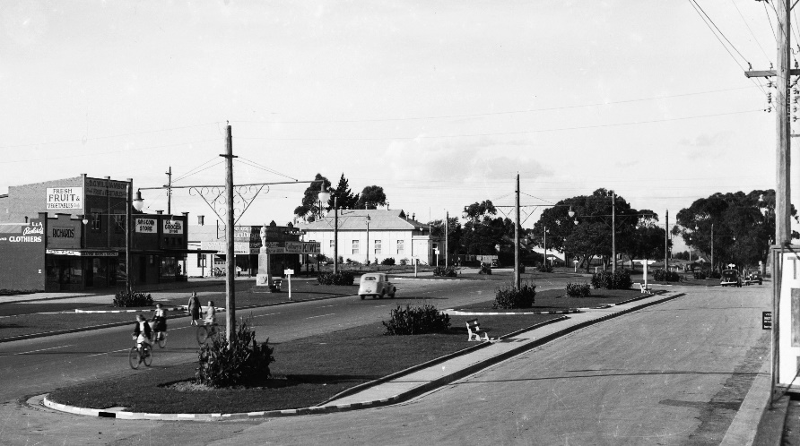

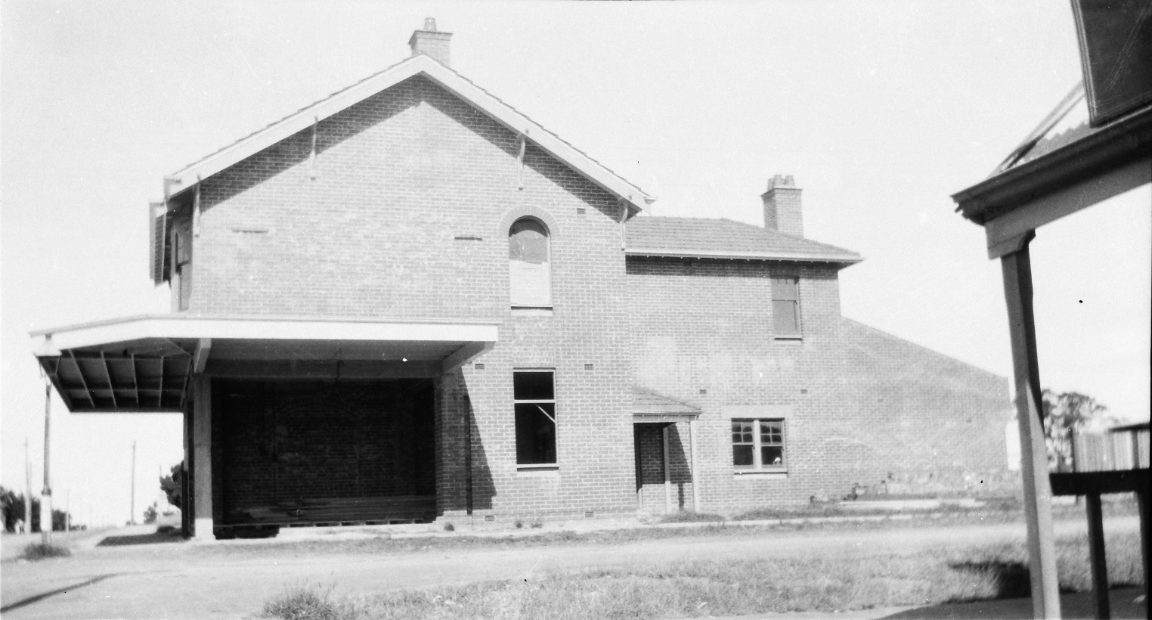
- This is the only photo I have seen of the building in the course of its construction.
- It is not even at lock-up stage; the builder must have been very trusting with all that timber just lying there: nowadays, it wouldn’t last even one night. The plaque has yet to be applied to the western wall; and the trellising and fences haven’t been started. I’d guess this was around New Year, 1923.
- You’ll notice, here in the foreground, the corner of the veranda of the O’Callaghan’s Hotel; it, was soon to be pulled down and replaced by a brick store and residence.
- Now, I’d like to talk about the new building when the Markham family had moved in.
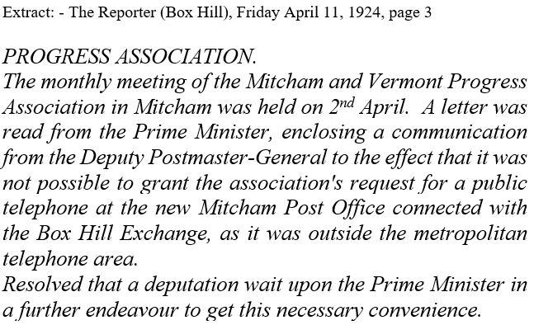
- As an aside, there was a bit of a problem getting telephone services at the beginning. Here’s a report from the local paper; I’ve transcribed it because the available image is not very readable. But note that the Progress Association was the creation of Patrick Markham and he used its influence to pursue his own business goals.
- Just as my father had used the first-floor veranda as a vantage point for photography, Bertha – and, probably Patrick – also took photos from upstairs.
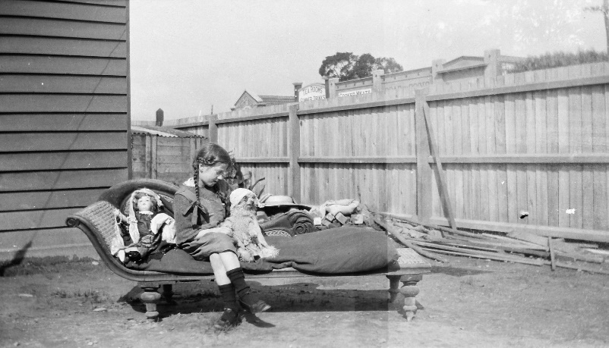
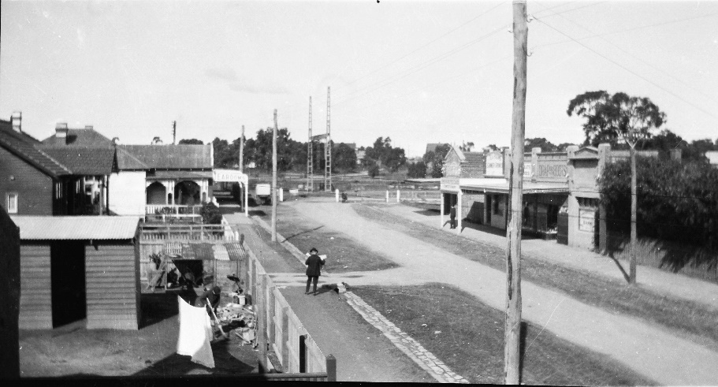
- This is taken from bedroom 2 the only room with a view south towards the railway station. Note that there’s still some builders’ rubbish in the yard; also, there is no water tower visible. The gentleman reading the paper is about to cross ‘our’ back lane . . . now called Quality Way.
- This next one was probably taken on the same day (as the rubbish stack looks pretty much the same). It’s a pic of my mother in the back yard. Lots of the photos taken in our back yard over many years had the tops of those shop fronts in them; poking over the fence.
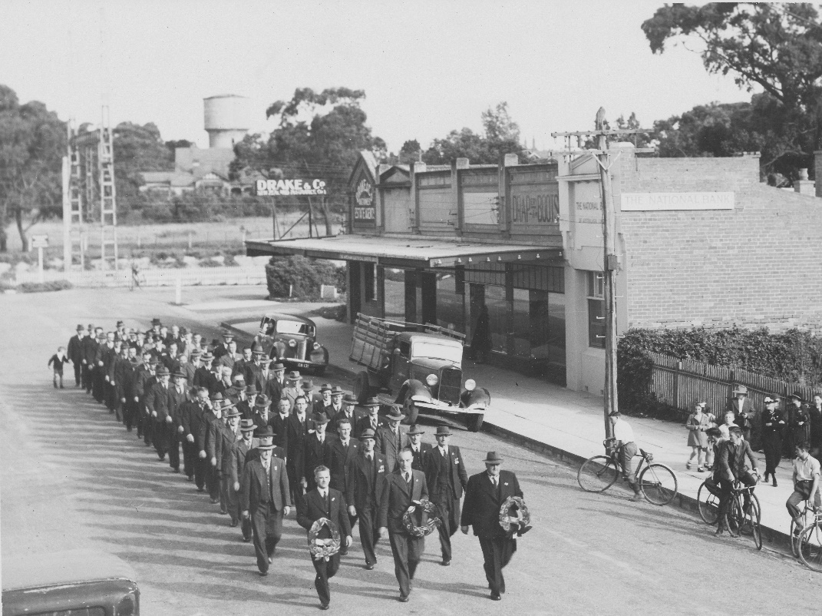
- This one is later, possibly 1950, and taken by my father. He followed these Anzac Day marches most years taking photos from this window and from the veranda overlooking Whitehorse Road as the procession moved towards its destination, the cenotaph.
NOTE: There’s the water tower in the background.
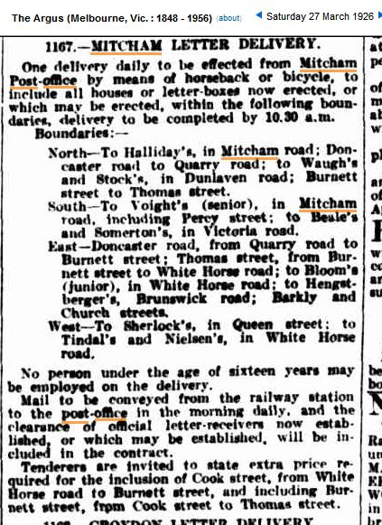

- I don’t have much information on the operations of the postal service in the 1920s . . . but I did find this advertisement that shows the range of letter delivery service to Mitcham in 1926. I believe, having seen similar advertisements over many years, that this was the standard practice for small communities that didn’t have enough work to directly employ postmen. It was not until about 1945 that Mitcham got its first ‘real’ postman.

- Now, getting back to the building itself, my next image shows one of several blueprints for a major plumbing project in 1939-40. (Again, these documents are in the WHS collection; ID ND7040)
- The major part of this work was connecting the property to the mains water supply and to the sewer main running down the lane at the rear. Previously, the waste water had been taken via pipes and open drains to a sump and that overflowed into storm water drains.
- The plumbing facilities were all upgraded. Initially, the building had been dependant on rainwater as there was no proper town supply until the late 1920s.
- The project included installing sinks and taps in the kitchen and the postmistress’s office and completely re-doing the bathroom, including adding a toilet and replacing the old bath and the hand basin. There was no provision for a hot water service.
- A set of four rooms in a new outbuilding were erected in order to provide two sewered toilets plus troughs in a new laundry. By the time I was aware of the arrangements, there was one outside toilet and a laundry with a double trough and a gas copper, plus a small storeroom.
- This building was later extended to provide a garage off the back lane. Previously, the family’s only car, my mother’s old Erskine, had been parked in the back yard behind the original toilet block.
- The large numbers marked along the sewer line seem to be distances (in red – 2321’9” and 2363’2” etc.) from a datum point; and the height above sea level (in blue – 476.41 and 477.48); If you saw the fine print in those 1912 posters I showed you before, Mitcham was said to be 500 feet above sea level. So, these numbers indicated how deep pipes were to be laid and the rate of fall to carry the liquid contents away.
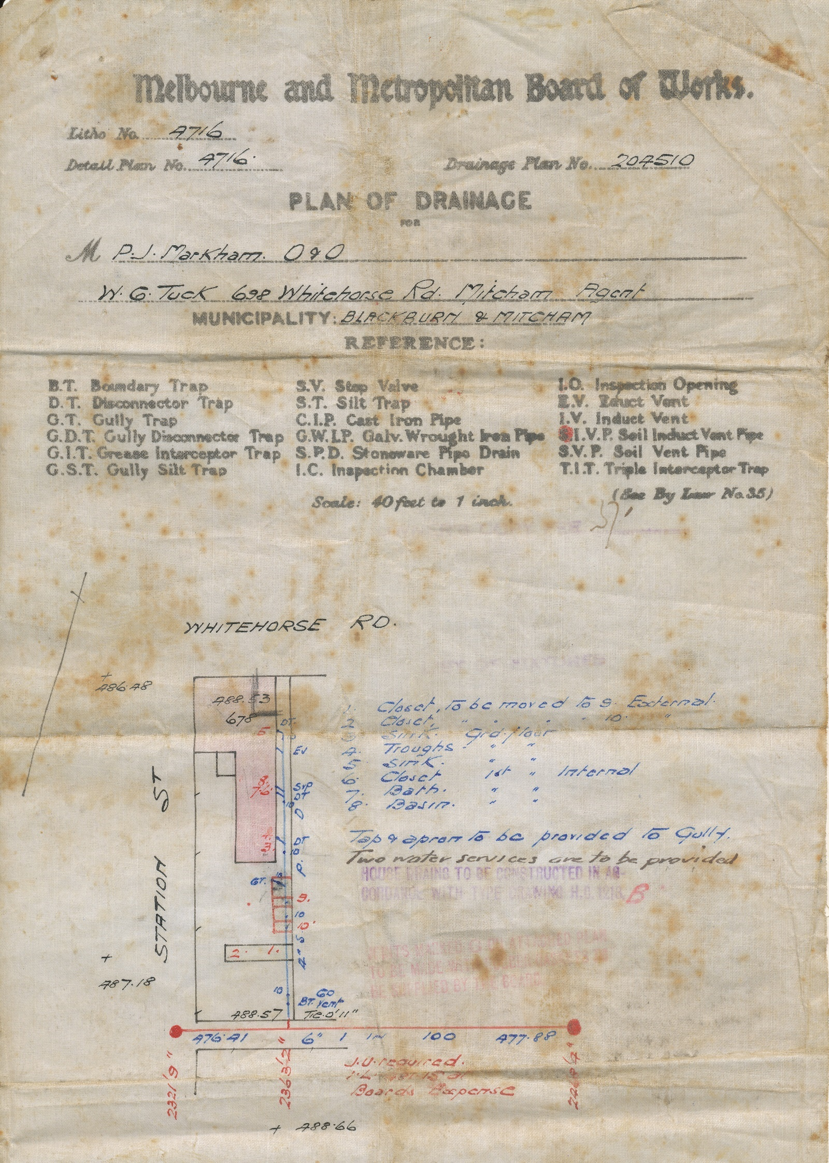
The outbuilding halfway down the back yard has the numbers 2 and 1 written in red: these were the unsewered existing toilets. : In the original architect drawings, shown in the next image, they are marked Shed A and Shed B. But they have the abbreviation E.C. annotated against what you’d expect to be W.C. today. Apparently, this stands for Earth Closet: a device for composting human waste in a bucket prior to digging it into the garden. And we had always thought there was a waste can that was taken and emptied by the bloke on the night-cart.
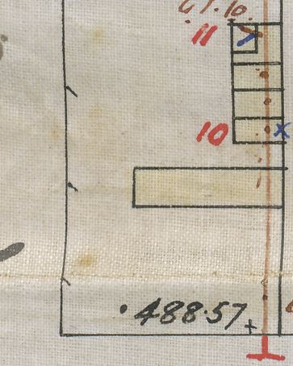
Also, I wonder about the need for two toilets . . . probably one for the family and one for the staff: the lane beside the shop was continued with a fence both sides that ended at the door to Shed ‘B.’
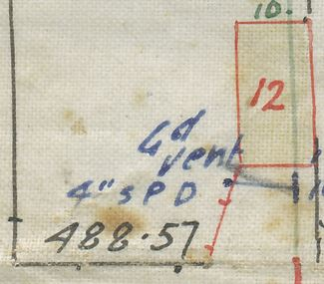
- These drawings show the changes in the back yard. The original outbuilding was replaced by the new toilet and laundry block, here. And, although it wasn’t built until some time later, the drainage plans provided for the new garage. You can see that the garage was butted up against the laundry and the back fence was altered with an angled section so that the car could more easily turn into the garage from the narrow lane. Also, there was a new gate in that section that allowed the wood truck to drive up the lane and reverse into the back yard and tip his load inside; we’d stack it all away under the cover of an old chook shed.
- You may be interested to see a couple of photos from the 1930’s. This is my mother as a teenager with her beloved collie, galah and one of her many chooks. The one on the left is in the front yard; the other is in the back yard in front of the toilet block; the door to the “staff” toilet is on the left just past the fence.
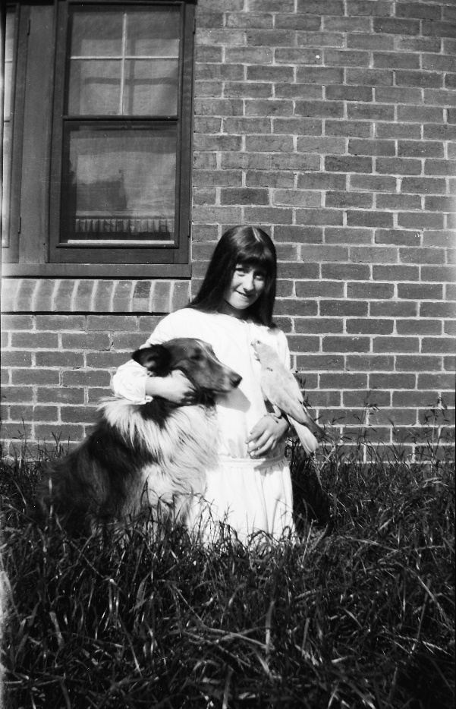
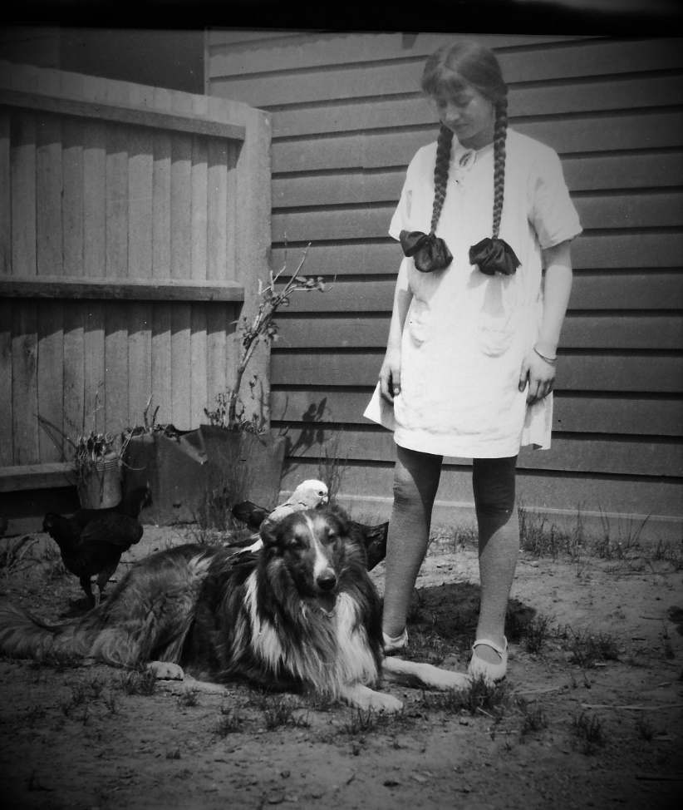

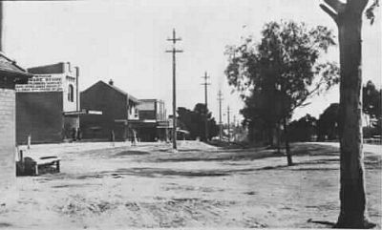
This is a photograph – I think I borrowed it from the State Library of Victoria. It was taken around 1926 and it shows the new Post Office and the new brick store on the corner where the Hill Hotel had been. Gray’s Ironmongery is the brick shop to the left. The beaten track across the foreground is Mitcham Road.
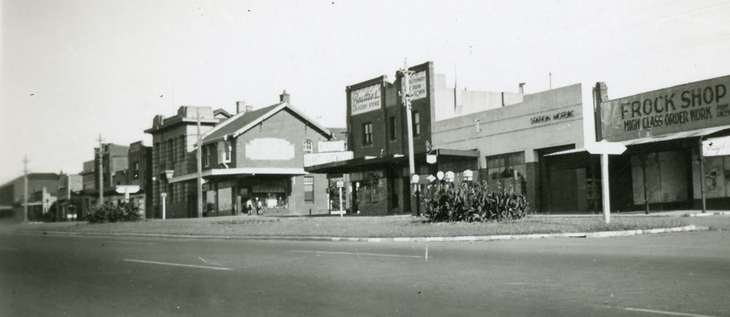
This photograph is from about 1942 and shows all the substantial buildings that reflected a prosperous and thriving town.

- THE MILLANE OCCUPATION
- As I mentioned before, both of my grandparents, Bertha and Patrick Markham, died in mid-1944. So, their only child, Mary, by then Millane, inherited the property.
- Mary Markham married Harold Millane at St. John’s Catholic Church, Mitcham, on 9th July, 1942. Mary lived in Malvern with her husband and, for extended periods from late 1942, she moved back in with the Markham’s to care for her ailing mother. This arrangement became so problematical that both she and Harold, with their infant son, took up residence permanently in the Mitcham Post Office building. I don’t know the date of the move but it was probably after October, 1943, because I was born the following March in Glen Huntly, close to Harold and Mary’s former residence. Their next seven children were all born in Ringwood or Box Hill.
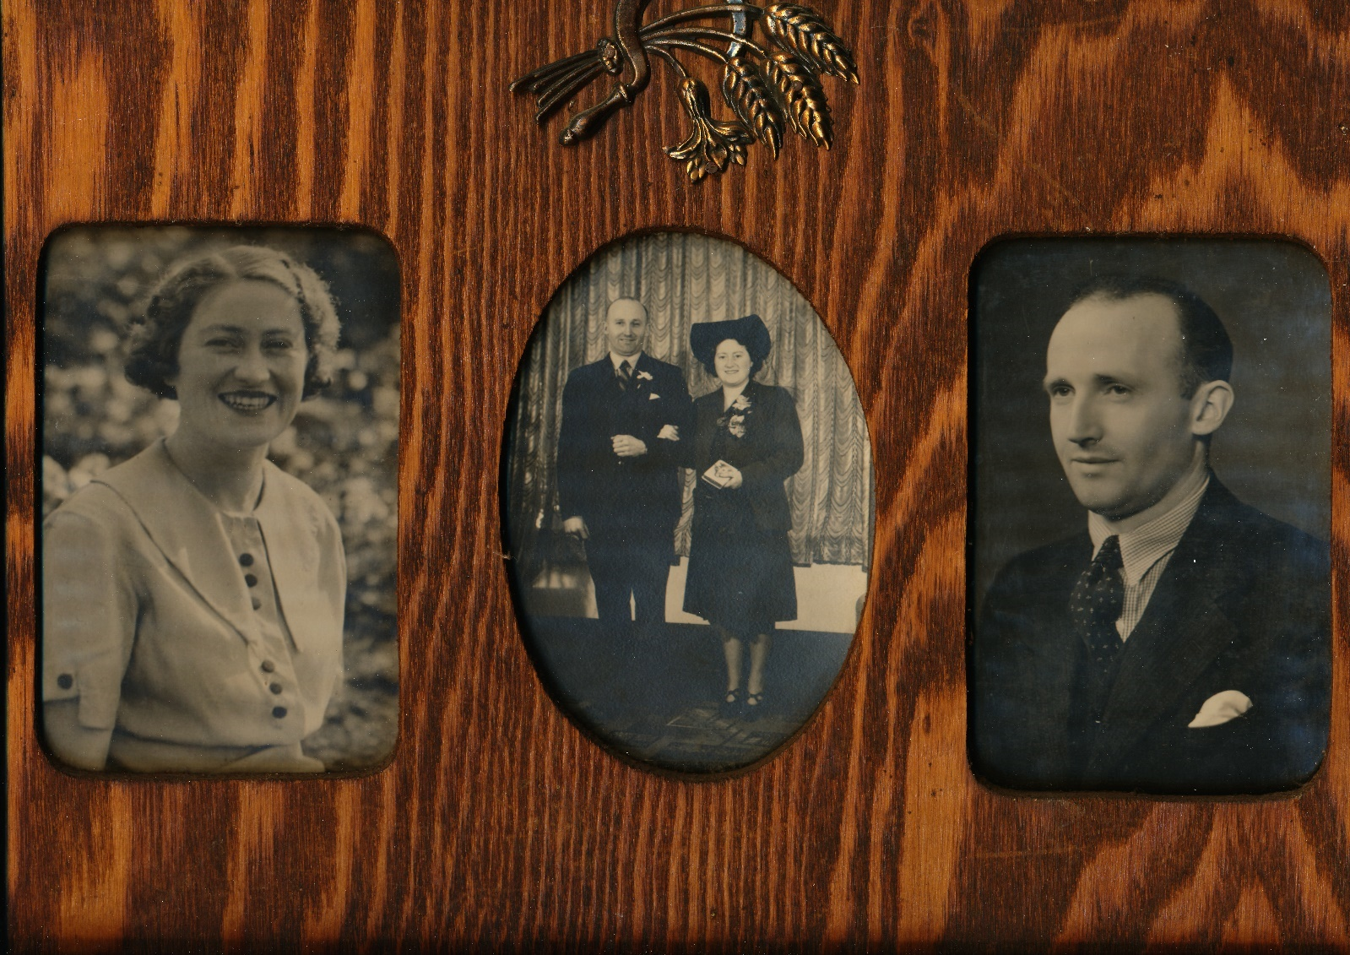
- This image shows a framed set of photographs that has been on the walls of every home I have lived in, including the Mitcham Post Office. On the left is my mother aged 21 and, on the right, my father at 25 and, in the middle, the happy couple on their wedding day in 1942.
- After her parents died, my mother was not allowed to continue to operate the Post Office. The P.M.G. Department quickly took over operations. A couple of months later, the post office was transferred to a shop several doors to the east; this had been Gray's Second-hand Furniture store; ultimately this proved to be a temporary arrangement. Mitcham’s postal services had grown with the population and the limited space at the rear of that shop had proved inadequate for mail sorting and other procedures. So, the P.M.G. and local staff were pleased to move into a larger workplace a few doors further east; it was a substantial Nissan Hut type building with access to the rear lane (now called Quality Way).
- I’d like to return to the commercial uses of the former Post Office building after my parents took it over: I’ve created this slide in a bit of a hurry so it’s not up to scratch. But it will do for the purposes of my next remarks.
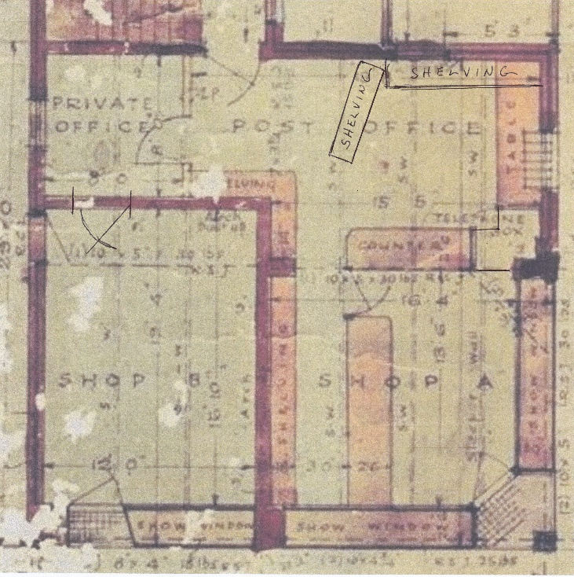
- The area that had been used for postal services was absorbed into the shop as a whole. The sorting room became a bit like a toy shop with the shelving used to display the many offerings. There was a dividing ‘wall’ consisting of a large set of shelves placed at an angle so that the contents could be seen from the customer side of the counter. And shelving was added across the rear wall.
- What had been cupboards and storage shelves under the P.O. counter now contained the tobacco products, back-up stock and, in season, fireworks. (Cracker Nights or Bonfire Nights – Guy Faulkes Day and, I seem to remember one in May . . . Empire Day, I think). Anyway, we would sell a good range of fireworks for use in the festivities, such as Sky rockets, Roman Candles, Catherine Wheels, Throwdowns, Blazing Parachutes, Penny Bungers, Tom Thumbs, Fountains and Jumping Jacks; and, our favourites, Sparklers.
- The shop section continued more or less as it had for decades: Periodicals, stationery, haberdashery, books, comics, photographic supplies and so many more miscellaneous items. A lot of the customers had standing orders for the more popular weekly and monthly magazines.
- I found out a few years ago that my mother, who would be addressed only in the proper fashion, as “Mrs Millane,” was known by the local children as “Molly” . . . presumably a reference to Molly Malone. Of course, they never called her that to her face!
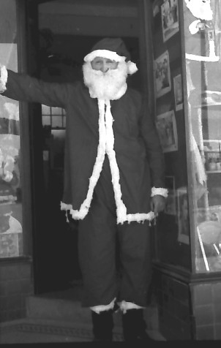
- As part of the Christmas selling period, each Saturday morning in December, my father dressed up in this Santa suit and encouraged the local children to come into the shop and select their ‘heart’s desire’ from the range of toys on display. There was a ‘Santa chimney’ letter box (made from cardboard cartons covered with red tissue paper); and this was where children could post their wish list and, later, my mother would slip the kids’ requests to the parents in an effort to secure some sales.
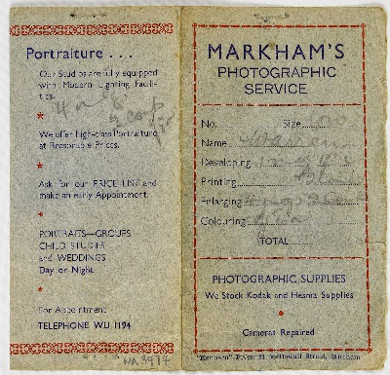
- The other expansion was of the old Markham’s Photographic Service that had been operating since the late 1930s.
- What had been the postmistress’s office was turned into a darkroom. We already were a Kodak agency. Interestingly, for years, the local dentist had his x-rays developed here; a special overnight delivery of the processed film was guaranteed. Likewise, any development and printing (D&P) of customers’ films was completed by the next day – the Kodak D&P service took 3 days. However, that policy meant that my father would get home from work, eat his dinner then take himself into the darkroom to complete all that type of work. Sometimes, one or other of the older children would assist. I liked the work; and being alone with my father was a privilege we did not get very often.
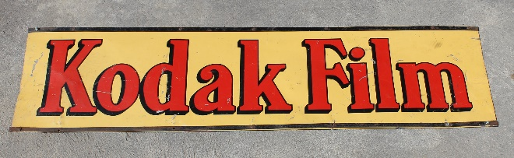
- This is a photo of the sign that was mounted under the shop veranda to attract anyone needing photographic film, paper, chemicals or D&P services; it, also, is now a part of the WHS collection and is on display in the Museum here.
- Without going into too much detail about the following photos, I present them as a record of some aspects of my family’s life there in the 1940’s and 50’s.
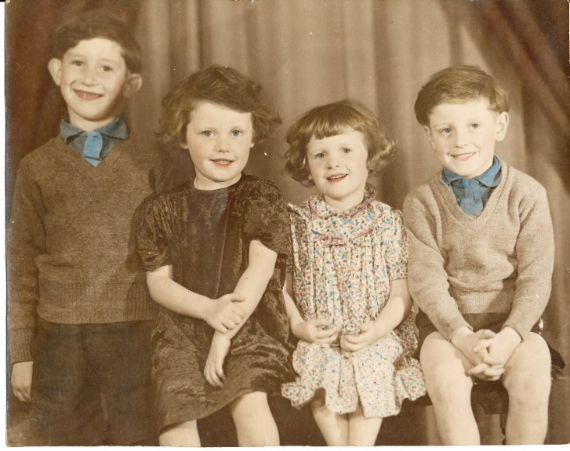
- This first one is a sepia print colourised by my mother. It is an example of the kind of photography undertaken in our ‘studio’ and the artistic value that could be added. It’s from 1948; I am on the right.

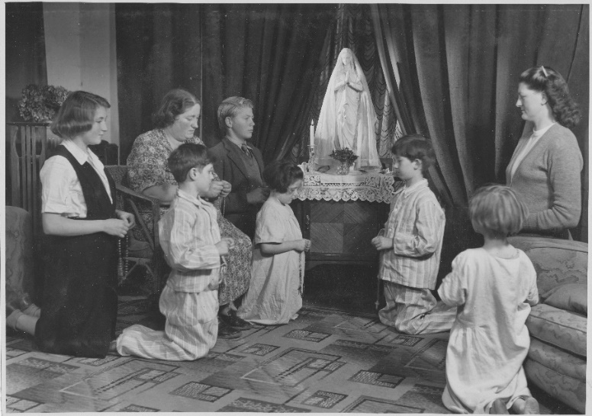
- This next one is quite interesting because it was used as the official picture of the ‘Rosary Crusade’ in 1951; it appeared in the Advocate. From left to right: Christine Darvall, Mary Millane Snr., Brian Millane, Jim Toivonen, Mary Millane, Brendan Millane, Gabrielle Millane and Eida Toivonen. Again, it’s in the ‘studio;’ and my father took the photo.
The ‘studio’ was the most presentable room in the house. It was used for many wedding and family portrait sessions. I remember lots of times we were shushed and ordered into our rooms or out into the back yard and to stay well out of sight while the studio was in action. We used to peek at the bridal parties in all their finery traipsing up the stairs along past the giggling throng.
The income from this work was an important supplement to other income streams. Of course, the Catholic Church received these services gratis.
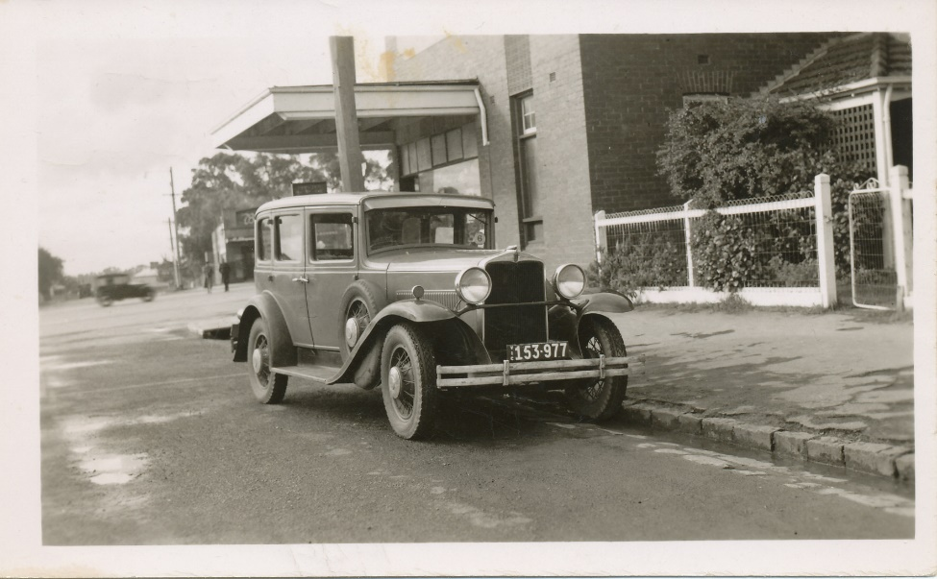
- This is our ‘new’ 1932 Hupmobile that replaced my mother’s old Erskine two-seater; it’s parked in Station Street opposite the gate to the front door of the residence. 1948.
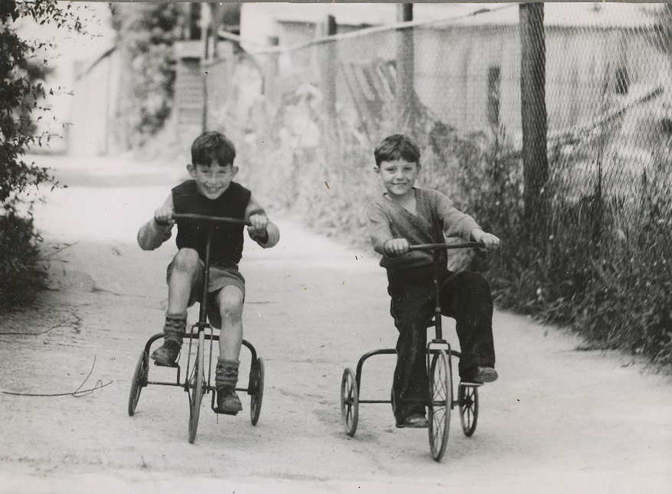

- This one’s about 1949 – demon riders burning rubber down Quality Way . . . our back lane. Yes, that’s me on the right.

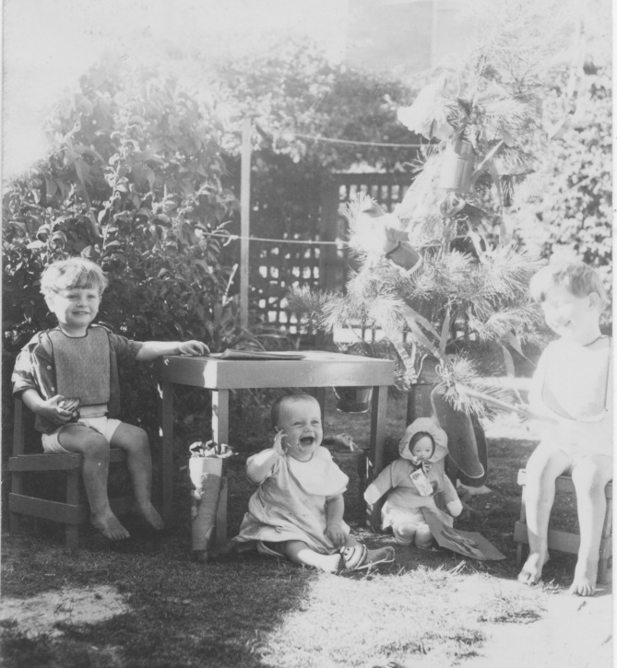

- Christmas, 1945; me on the left.

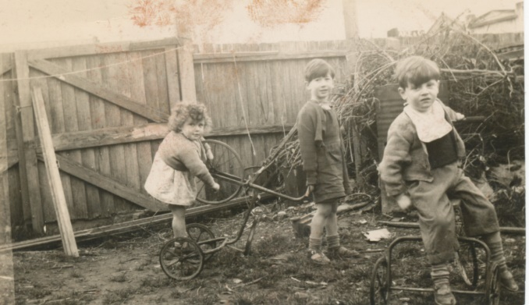
- Next, in the back yard in 1946.

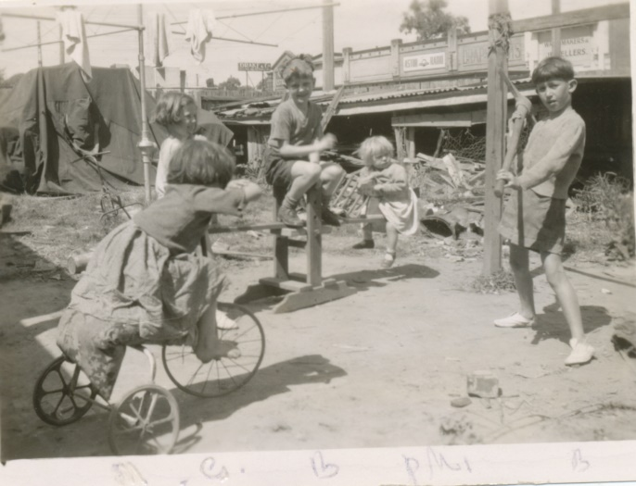

- I think this one’s from 1950; more back yard fun.

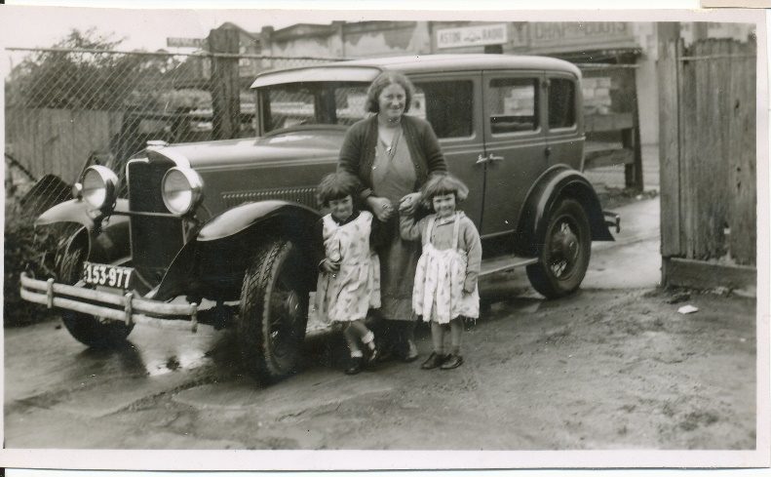
- My mother, Mary Millane, with the older girls; back lane (Quality Way) 1948. Note that the house that was on that corner has been demolished and Tuck’s plumbing business is using it as a storage and work yard.
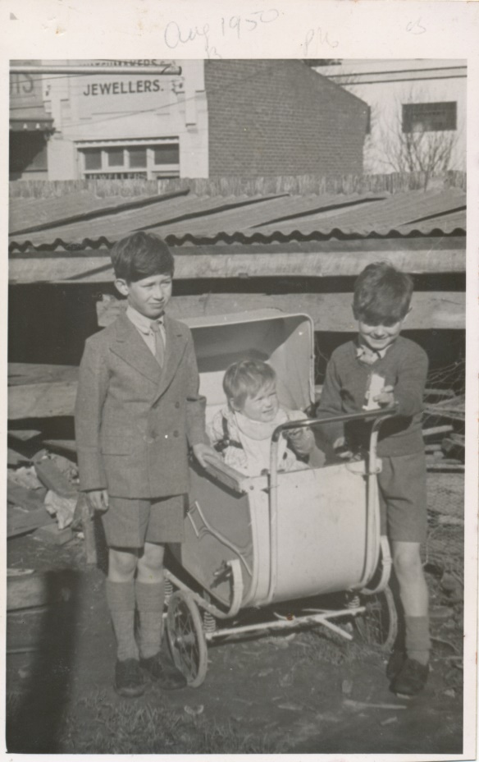

In the back yard in 1950. You can see the old chook shed where we used to store the firewood. Also, the shops across the other side of Station Street, as always, got into the picture.

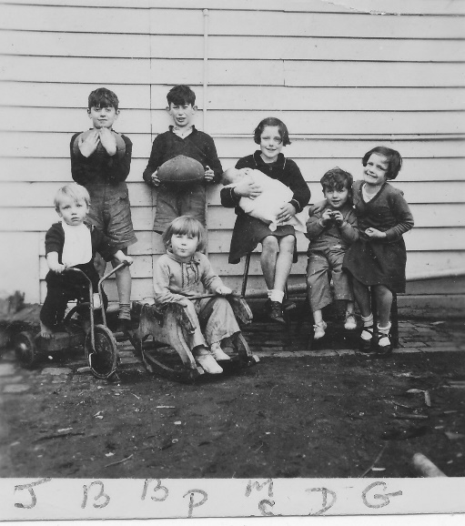

A candid photo of us all with the new baby; 1953.

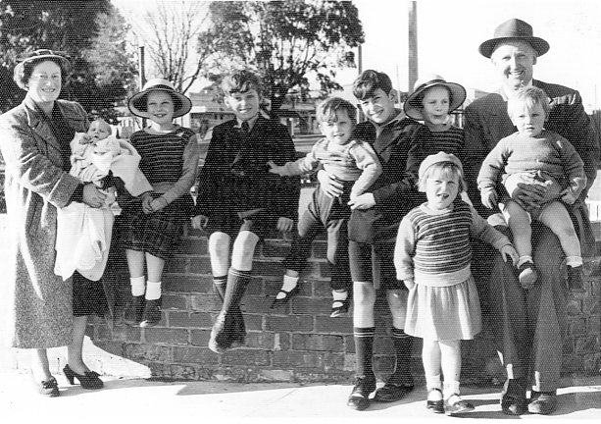
Here we all are at the new St John’s Church, Mitcham, in July 1953. The latest baby has just been baptised in the christening robe that her great grandmother had made for Bertha Markham’s baptism in 1882.

I don’t have a photo of the occasion but, two years later we were all back there again for the baptism of baby number 9. The Millane gang now totalled eleven; it was 1955.
You will remember we had a four-bedroom home. The sharing of rooms was mainly by age groupings with each new baby in the parents’ room. So, as we all grew and the babies shifted out with the rest of us, eventually, once the baby and toddlers grew up a bit, there would have to be space for ten beds. So, my parents decided that we needed to move into a bigger home: the older four were approaching puberty and there was not enough living space indoors or outdoors.
Over several years, the P.M.G. had been seeking to buy the property. (Their two temporary post offices had not been satisfactory.) So, Harold and Mary bought a bigger house in Burwood and sold the former Mitcham Post Office to the P.M.G. We moved out in June, 1957.
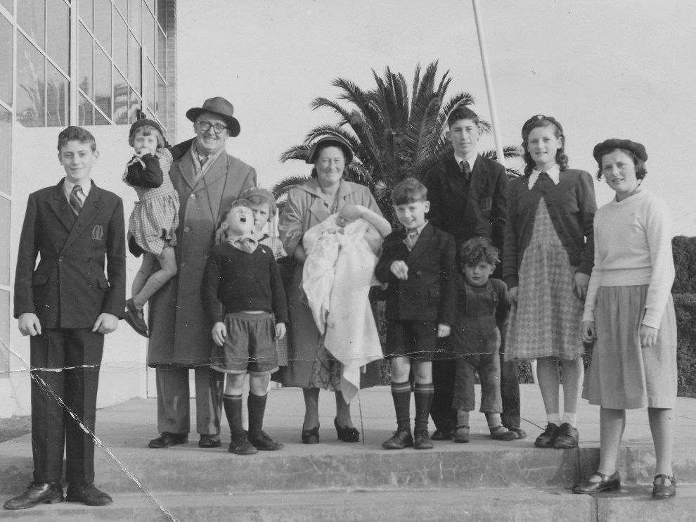
This photo is a bit of a postscript: it was taken almost exactly a year after we left Mitcham and it shows the family lined up outside St. Benedict’s Church in Burwood. Again, it’s the baptism of the latest, the tenth – and, thankfully, the last - new baby in June, 1958. And, again, as tradition dictated, he’s wearing the heirloom “Cruse” christening gown.
That’s me at the far left.

I’ll leave this last slide in place while I take any questions you may have. It shows the Post Office in late 1929. (This date is selected because contemporary reports in the Reporter, Box Hill, state that the State Savings Bank building was commenced in early 1929 and due to open in March or April, 1930.)
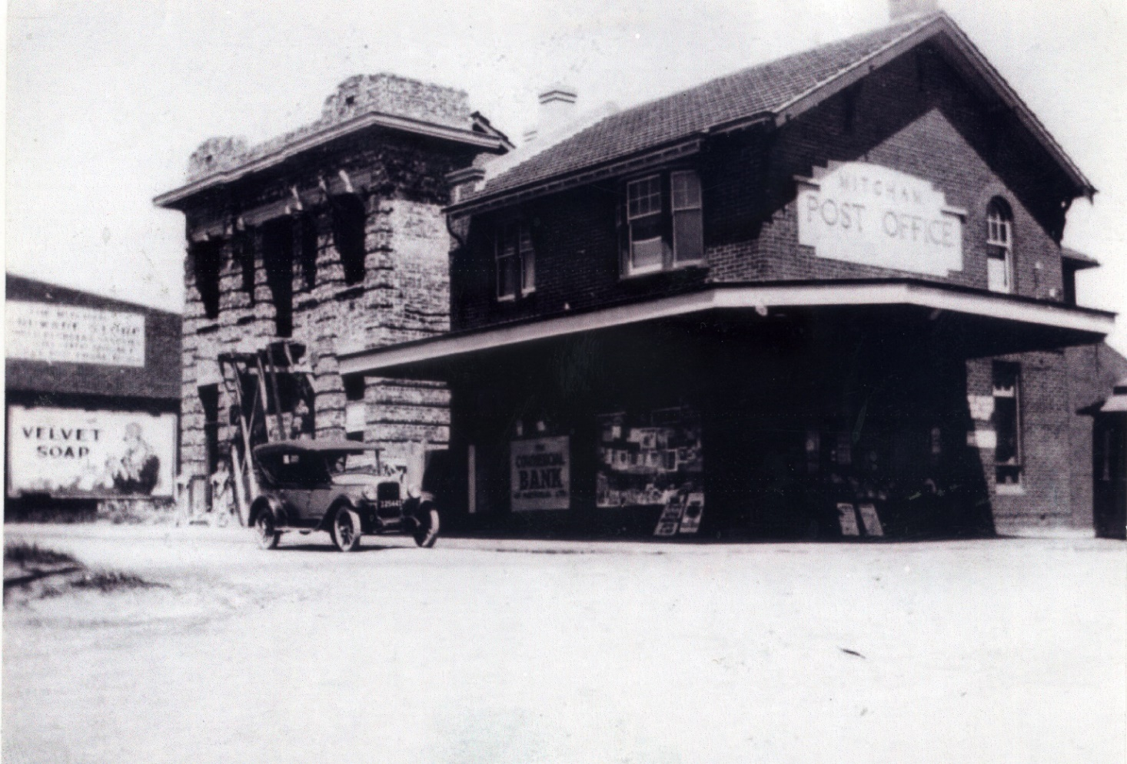
The State Savings Bank building is not finished; the balcony has scaffolding in place and windows are not glazed. Note the Commercial Bank has taken over the hairdresser’s.

