10 Gordon Crescent

Early history of Gordon Crescent

Built between1884-1888. 1888 the most likely during the ‘land boom’

Land owned by John Woods, who when railway was announced sold in 1881 to George Selth Coppin for £4834, a year later George Coppin sold it for £10,080 to Freehold Investment and Banking Company (FIBC).

FIBC owned by Sir Matthew, whose brother-in-law was Joseph B. Davies was managing director.

G.A Goodwin acted as FIBC agent for the purchase of a thousand acres including those above.

In 1887 improvements including formation of streets, drainage, footpaths, and streetlighting were undertaken. Future resident and councillor, Thomas Morton worked as the company secretary of FIBC. A number of the houses on Gordon Crescent were built by Mr Elmore or Arthur E. Clark.10 Gordon Crescent is probably built by Arthur E. Clark.

The Sections and Lots:

The Thousand acres purchased by FIBC were divided into sections and lots. As can be seen in the picture below, Gordon Street was the section #82 and Number 10 was on lot 42.

7-8 houses were built on Gordon Crescent during this time 1888-90

In 1889 the rate books show people residing at Gordon Crescent

* Lots 32-37 (2 Gordon Crescent ‘Clonmore’) and 49 - Thomas Morton

One of the houses on this street was built for Thomas Morton’s daughter, although it is unknown which

* Lots 46,47,48 (18 Gordon Crescent) – Martha Quarterman (nee Moodie)

Your House at #10

* Lot 42 (10 Gordon Crescent ‘Rheim House’)

In 1889-1890 lot 42 and the brick house on it, is owned by FIBC

Later in 1890

* Lot 44 (14 Gordon Crescent ‘The Grange’) is built, and owned by George Jose

*Whitehorse Historical Society on Victorian Collections Reference #ND13223*

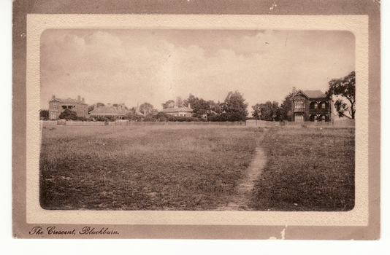

Figure 1: L-R Address #18, #16, #14, #10 Gordon Crescent <https://victoriancollections.net.au/items/60d923316e5f99545134f287>

**Summary of 10 Gordon Crescent in to the City of Whitehorse Heritage Review vol2part1 ND1220** [**https://victoriancollections.net.au/items/62e9ef428b3ae1f33f0f0e9d**](https://victoriancollections.net.au/items/62e9ef428b3ae1f33f0f0e9d)

The house is valued at £60 according to the 1889 rate book. Still owned by FIBC, a clerk of the company named J Chatfield Tyler was the living in the property. Over the next decade the house remained in the ownership of FIBC, and had numerous tenants. In the 1905 rate book, the house is first list as Rheims House

**List of homeowners on Gordon Cresent as listed in the ‘Sands and Mcdougall’s Melbourne and Suburban Directory’:**

Based on Fig2 it is reasonable to believe that in 1900 at

#2 Thomas Morton resides

#10 Thomas R. Game resides

#14 Joseph Knowles resides

#16 Charles W. Hodgson resides

#18 James Brown resides

By 1905 Fig 3 shows that Thomas R. Game has moved from #10 to #18. The house on #18 later came to be known as ‘Game House’. It is likely that Thomas Game lived as a tenant in #10, and took the opportunity to become a homeowner when #18 was on the market. Hence the move just a few houses down on the same street.

|  |  |
| --- | --- |
| Figure 2: Sands and Mcdougall’s Melbourne and Suburban Directory 1900 | A close up of a paper  Description automatically generated  Figure 3: Sands and Mcdougall’s Melbourne and Suburban Directory 1905 |
| Figure 4: Sands and Mcdougall’s Melbourne and Suburban Directory 1910 | Figure 5: Sands and Mcdougall’s Melbourne and Suburban Directory 1930 |
| Figure 6: Sands and Mcdougall’s Melbourne and Suburban Directory 1935 | Figure 7: Sands and Mcdougall’s Melbourne and Suburban Directory 1940 |
| Figure 8: Sands and Mcdougall’s Melbourne and Suburban Directory 1945 | Figure 9: Sands and Mcdougall’s Melbourne and Suburban Directory 1950 |
| Figure 10: Sands and Mcdougall’s Melbourne and Suburban Directory 1955 | Figure 11: Sands and Mcdougall’s Melbourne and Suburban Directory 1960 |
| Figure 12: Sands and Mcdougall’s Melbourne and Suburban Directory 1965 | Figure 13: Sands and Mcdougall’s Melbourne and Suburban Directory 1970 |
| Figure 14: Sands and Mcdougall’s Melbourne and Suburban Directory 1974 |  |

**Resources for further information:**

* Image of FIBC office building in 1836-1902

<https://antiqueprintmaproom.com/product/the-freehold-investment-and-banking-company-of-aus-albert-charles-cooke/>

* Robin Da Costa, Blackburn: a picturesque history, Pioneer Design Studio, 1978 <https://victoriancollections.net.au/items/5bd901fea1feee3080d08227>
* Rate books
* Title certificates
* Church records, particularly St. John’s Anglican Church whose founding meeting was held at #2 Gordon Crescent, hosted by Thomas Morton in 1889
* Public works maps, such as sewage planning
* Photo of Ms&Mrs Thomas Game <https://victoriancollections.net.au/items/60d923316e5f99545134faea>