Ballarat East High School – 1957

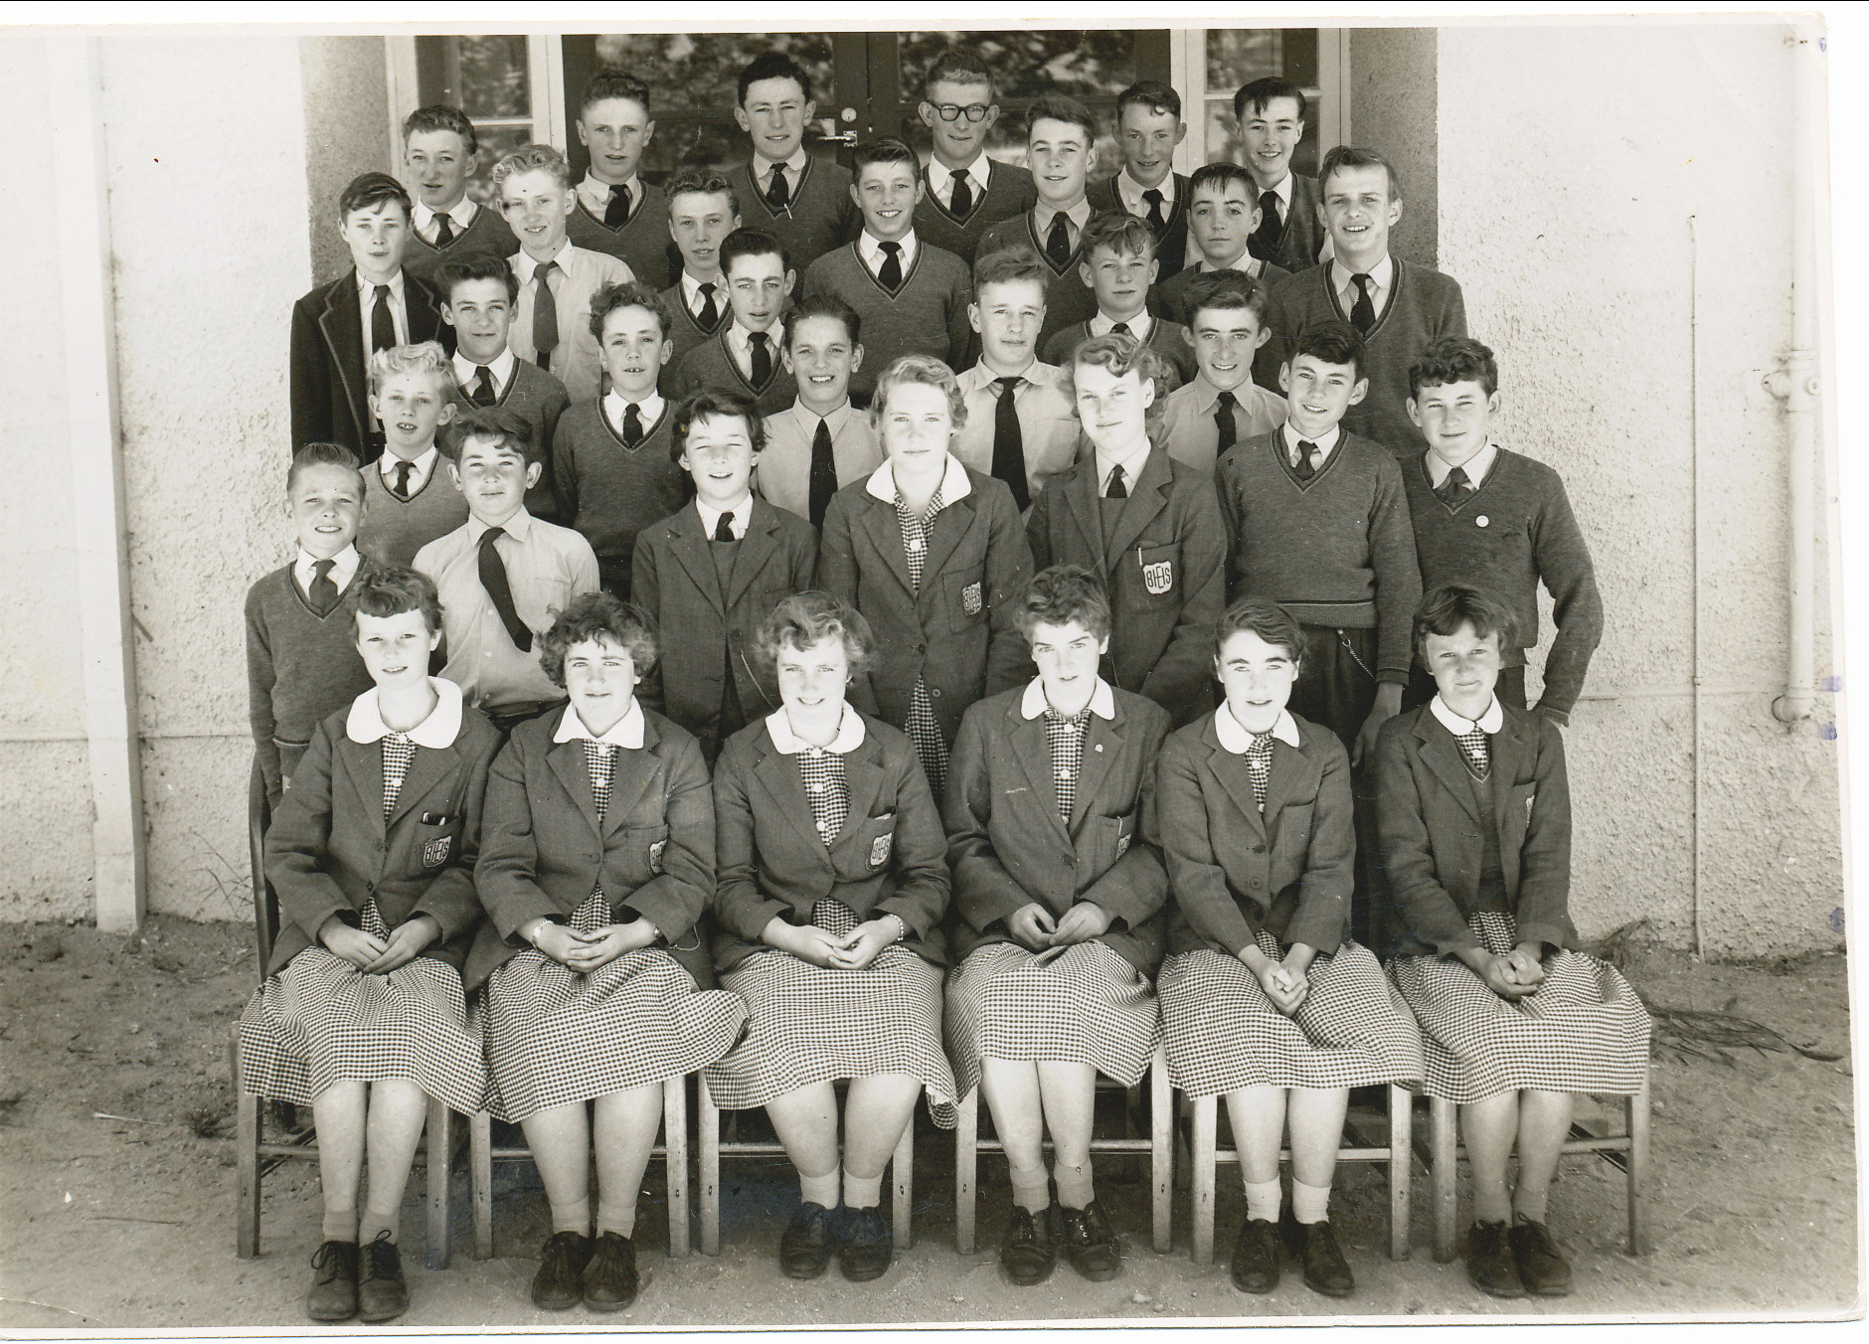

Back Row:

? Graeme Hodder? Bruce Oakman Noel Anderson Graeme? Lyndon Cocking

Row 5:

? ? Barry Mason? Peter Mayberry? ? Alan Carey? David Lindner

Row 4:

? ? Peter Ball?

Row 3:

Mervyn Nielson Charlie Hartup? John Fielder ? ?

Row 2:

? ? Lesley? Joyce Fegan Jillian Pascoe ? ?

Front Row:

Adriana Daniels Glenda Jones ? Marion Pollard Frances Gray Lynette Barron

