**Early Titles for Wonga Park**

The lands in Certificates of Title Volumes and Folios 956 / 171, 1135 / 976. 1473 / 406, 1521 / 008 & 1852 / 223 were all transferred by Transfer No. 359508 to Frederick Walter Purches on 17/6/1895 into Certificate of Title Volume 2574 Folio 725. The land in Certificate of title Volume2687 Folio 231 was old law land brought under the Act by The Mutual Assurance Society of Victoria Limited and may have been in the name of Frederick Walter Purches prior to that. The lands in Certificates of Title Volume 2574 Folio 725 and Volume 2687 Folio 231 ended up in Certificates of title Volume 2734 Folios 734 and 735.

7/6/1877 Certificate of Tite Volume 956 Folio 171, area 319 acres 2 roods and 3 perches, being Crown Allotment 11B in the name of **Mary Ann Brown** of Wellington Street Saint Kilda County of Bourke.

3/12/1880 Transfer No. 268064 from Mary Ann Brown to **William Henry Batten** of Mechanics Institute Ballarat Accountant **Henry Rawlings** of Mechanics Institute Ballarat aforesaid Gentleman and **John Milliar Coles** of Station Street Box Hill Railway Station Master.

Plan of land in C/T V. 956 F. 171 Mary Ann Brown

3/12/1885 Mortgage No. 108408 to The Mutual Assurance Society of Victoria Limited.

17/6/1895 Transfer (by Mortgagee) from The Mutual Assurance Society of Victoria Limited to **Frederick Walter Purches**. Vol 2574 Fol 725

***********************************************************************

29/4/1879 Crown Grant Vol 1127 Fol 230, area 319 acres and 3 roods, being Crown Allotment 11A, for sum of £320, issued to **Samuel Henry Cohen** and **David Elder** of Melbourne as **Trustees in the Estate of William Brown the Younger Insolvent.**

10/101879 Transfer No. 81520 from Samuel Henry Cohen and David Elder **to Mary Ann Brown**, new Certificate of Title Volume 1135 Folio976.

Plan of land in C/G V. 1127 F. 230 Insolvent Estate of William Brown the Younger

**********************************************************************

10/10/1879 Certificate of Title Volume 1135 Folio 976, area 319 acres and 3 roods, being Crown Allotment 11A in the name of **Mary Ann Brown** wife of William Brown of Melbourne Fellmonger.

10/10/1879 Mortgage No. 34157 to Samuel Henry Cohen and David Elder, discharged 1/9/1880.

Plan of land in C/T V. 1135 F. 976 Mary Ann Brown

1/9/1880 Mortgage No. 39226 to Charles James Barclay and Crawford Mayne Maxwell, discharged 15/4/1886.

19/4/1886 Mortgage to John Grice, discharged 3/12/1889.

3/12/1889 Transfer No. 268064 from Mary Ann Brown to **William Henry Batten** of Mechanics Institute Ballarat Accountant **Henry Rawlings** of Mechanics Institute Ballarat aforesaid Gentleman and **John Milliar Coles** of Station Street Box Hill Railway Station Master.

3/12/1889 Mortgage No. 108408 to The Mutual Assurance Society of Victoria Limited.

17/6/1895 Transfer (by Mortgagee) No. 359508 from The Mutual Assurance Society of Victoria Limited to **Frederick Walter Purches**. Vol 2574 Fol725

********************************************************************

Sections 5 and 6 Parish of Warrandyte County of Evelyn were granted to Peter Davis by Crown Grants on 1/10/1852, Peter Davis died on 30/7/1879 and under his Will he devised both properties to his son Alfred Davis. As the land was acquired before the Torrens Title system commence in Victoria in the 1860s the title was under the General Law until it was brought under the Act by Application No. 17032 by Alfred Davis on4/7/1883.

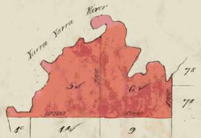4/7/1883 Certificate of Title Volume 1473 Folio 406, area 1021 acres being Crown Sections 5 and 6 in the name of **Alfred Davis** of Saint Kilda in the county of Bourke Estate Agent.

5/3/1888 Caveat No. 14982 lodged, withdrawn 3/12/1889.

3/12/1889 Transfer No. 268066 from Alfred Davis to **William Henry Batten** of Mechanics Institute Ballarat Accountant **Henry Rawlings** of Mechanics Institute Ballarat aforesaid Gentleman and **John Milliar Coles** of Station Street Box Hill Railway Station Master.

Plan of land in C/T V. 1473 F. 406 Alfred Davis (son of Peter Davis)

3/12/1889 Mortgage No. 108408 to The Mutual Assurance Society of Victoria Limited.

17/6/1895 Transfer (by Mortgagee) No. 359508 from The Mutual Assurance Society of Victoria Limited to **Frederick Walter Purches**. Vol 2574 Fol725

***********************************************************************

7/12/1883 Certificate of Title Volume 1521 Folio 008, area 312 acres 2 roods and 21 perches, being Crown Allotment 4A in the name of **Robert Lindsay Crawford** **Nicholson** of Warrandyte Grazier.

7/12/1883 Mortgage No. 57706 to Robert Durham. Does not now affect – Transfer by Mortgagee 3/12/1889.

5/1/1884 Mortgage No. 58171 to Edward Bulmer Lytton Dickens. Does not now affect –3/12/1889.

Plan of the land in C/T V. 1521 F. 008 Robert Lindsay Crawford Nicholson

23/6/1886 Caveat No. 12359 lodged, lapsed 3/12/1889.

9/3/1888 Caveat No. 15044 lodged, ???? 3/12/1889.

3/12/1889 Transfer (by Mortgagee) No. 268065 from the above-named Robert Durham to **William Henry Batten** of Mechanics Institute Ballarat Accountant **Henry Rawlings** of Mechanics Institute Ballarat aforesaid Gentleman and **John Milliar Coles** of Station Street Box Hill Railway Station Master.

3/12/1889 Mortgage No. 108408 to The Mutual Assurance Society of Melbourne Limited.

17/6/1895 Transfer (by Mortgagee) No. 359508 from The Mutual Assurance Society of Victoria Limited to **Frederick Walter Purches**. Vol 2574 Fol725

********************************************************************

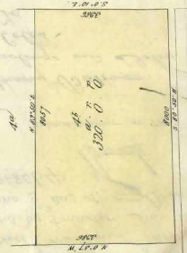21/1/1886 Crown Grant 1852 Folio 223, area 320 acres, being Crown Allotment4B in the name of Mary Ann Brown of St Arnaud.

3/12/1889 Transfer No. 268064 from the within named Mary Ann Brown to **William Henry Batten** of Mechanics Institute Ballarat Accountant **Henry Rawlings** of Mechanics Institute Ballarat aforesaid Gentleman and **John Milliar Coles** of Station Street Box Hill Railway Station Master.

Plan of the land in Crown Grant V. 1852 F. 223 Mary Ann Brown

3/12/1889 Mortgage No. 108408 to The Mutual Assurance Society of Victoria Limited.

17/6/1895 Transfer (by Mortgagee) No. 359508 from The Mutual Assurance Society of Victoria Limited to **Frederick Walter Purches**. Vol 2574 Fol725

*********************************************************************

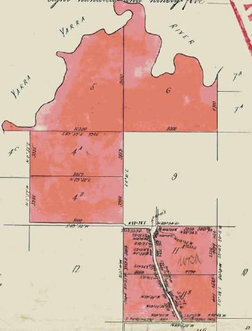17/6/1895 Certificate of Title Volume 2574 Folio 725, area 2,591 acres 3 roods and 0 perches, being Crown Allotments 4A, 4B, 11A and 11B and Crown Sections 5 and 6 Parish of Warrandyte County of Evelyn in the name of **Frederick Walter Purches** of Ascot Vale Road Ascot Vale Wholesale Butcher.

17/6/1895 Mortgage No. 165563 to The Mutual Assurance Society of Victoria Limited, discharged15/8/1896.

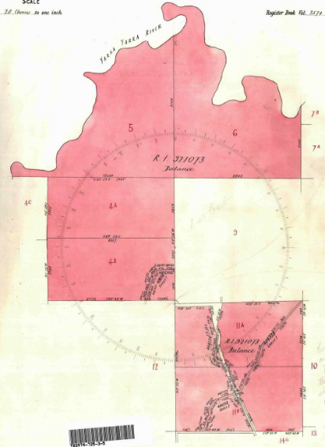15/8/1896 Transfer No. 873664 from Frederick Walter Purches to The Mutual Assurance Society of Victoria Limited of 406 Collins Street Melbourne.

Plan of lands in C/Title V. 2574 F. 725 Frederick Walter Purches

19/3/1899 Transfer No. 404328 from The Mutual Assurance Society of Victoria Limited to The President Councillors and Ratepayers of The Shire of Lilydale of 23 acres 9 roods and 18 perches, new Certificate of title Volume 2718 Folios 443 &444 which lands would appear to be Homestead Road from Yarra Road to Toppings Road, Brysons Road from Yarra Road to St Johns Road and parts of Yarra Road at the intersection with Brysons and Homestead Road and sections to the north towards Launders Avenue.

Plan of lands in C/T V. 2574 F.725 after creation of new roads in 1899

Balance of Title cancelled see Certificate of Title volume 2734 Folios 734 & 735.

**********************************************************************

11/6/1898 Certificate of Title Volume 2687 Folio 231 derived from Application to Bring Old Law Title under the Act No.30858, area1,641 acres 3 roods and 31 perches, being Crown

Sections 12 and 15 and part of Crown Section 20 Parish of Warrandyte County of Evelyn issued in the name of The Mutual Assurance Society of Victoria Limited of No. 406 Collins Street Melbourne.

13/3/1899 Transfer as to part No. 404328 from The Mutual Assurance Society of Victoria to The President Councillors and Ratepayers of the Shire of Lilydale, new Certificate of Title Volume 2718 Folio 445 which land would appear to be part of Jumping Creek Road in Crown Section 12 and Brysons Road in Crown Sections 12, 15 & 20. Also note the extension of Gatters Road into Sections 15 & 20 later removed.

******************************************************

27/7/1889 Certificate of Title Volume 2734 Folio 734, area 1,650 acres 2 roods and 11 perches, being Crown Sections 5 and 6, Crown Allotment 4A and parts of Crown Allotment 4B in the Parish of Warrandyte County of Evelyn in the name of **The Mutual Assurance Society of Victoria Limited** of Collins Street Melbourne.

Plan attached to C/T V. 2687 F. 231 showing land in Title and roads transferred out.

25/4/1912 Transfer as to part No. 682020 from The Mutual Assurance Society of Victoria Limited to James Begley of Lot 53 on Plan of Subdivision No. 4315, new Certificate of Title Volume 3594 Folio684.

Lot 53 on P/S 4315 transferred out of C/T V. 2734 F. 734 to James Begley.

Plan of lands in C/T V. 2734 F. 734

Cancelled as to part see Vol 4052 Fol 373, Red Ink No. 1824546.

25/8/1924 Caveat No. 65881 affecting part of the land herein, lapsed 1/8/1930.

5/5/1925 Transfer as to part No. 1142851 from the Mutual Assurance Society of Victoria Limited to John Ramsay the Elder, new Certificate of Title volume 5019 Folio 692.

Plan attached to C/T V. 2734 F. 734 showing lands transferred out.

Red Ink No. 3051288 Title cancelled see Certificate of Title Volume 5674 Folio 716.

**********************************************************************

27/7/1889 Certificate of Title Volume 2734 Folio 735, area 5571, being parts of Crown

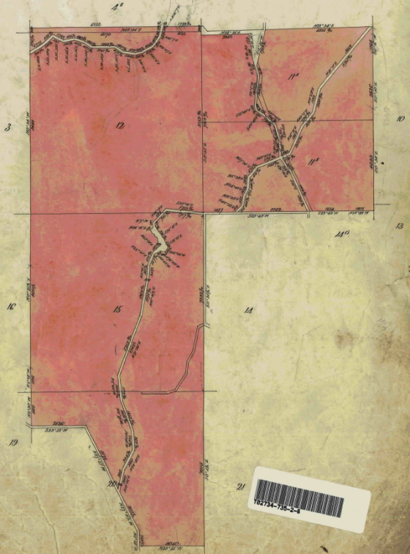

Sections 12,15 and 20 and parts of Crown Allotments 11A and 11B and land formerly parts of Government Road in the name of **The Mutual Assurance Society of Victoria Limited** of Collins Street Melbourne.

8/6/1900 Caveat No. 32949 affecting part of the land herein lodged and lapsed 20/6/1907.

10/7/1902 Transfer as to part and Creation of Easement No. 457635, area 45 acres 2 roods and 16 perches Lots 15 & 16 from The Mutual Assurance Society of Victoria to Eliza Ann Maggs, new Certificate of Title Volume 2883 Folio 492.

10/7/1902 Transfer as to part No. 457636, area 55 acres 9 roods and 19 perches, Lots 37 & 38 from The Mutual Assurance Society of Victoria to James Maggs, new Certificate of Title Volume 2883 Folio 493.

Plan of land in C/T V. 2734 F. 735

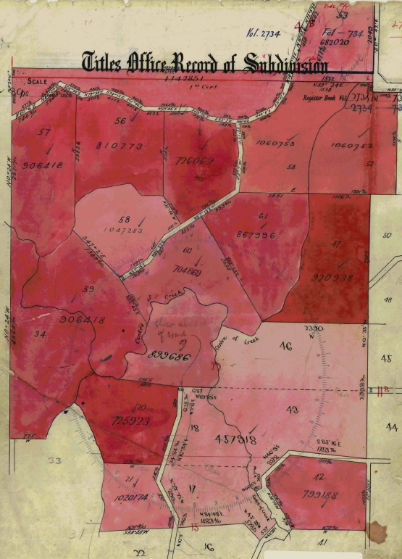10/7/1902 Transfer as to part and Creation of Easement No. 457637, area 39? Acres 3 Roods and 28 perches, Lots 35 & 36 from The Mutual Assurance Society of Victoria to Samuel Maggs, new Certificate of Title Volume 2883 Folio 495.

15/7/1902 Transfer as to part and Creation of Easement No. ??????, area ? acres ? roods and 8 perches from The Mutual Assurance Society of Victoria to Stephen Zoch, new Certificate of Title Volume ???? Folio 495.

11/12/???? Transfer as to part No. ??????, area ???? to ???? new Certificate of Title Volume ???? Folio ???.

23/2/1910 Transfer as to part and creation of easement No. 614700, area 24 acres 2 roods and 21 perches from The Mutual Assurance Society of Victoria Limited to Elizabeth Ann Walden, new Certificate of Title Volume 3400 Folio 855.

6/12/1910 Caveat No. 40889 affecting part of the land herein, caveat lapsed 7/5/1925.

Sheet 2 of Plan attached to C/T V. 2734 F. 735 showing Lots in P/S No. 4315 transferred out.

5/7/1911 Transfer as to part and creation of easement No. 658354 Lot 2 from The Mutual Assurance Society of Victoria to Mary Burchett, new Certificate of Title Volume 3520 Folio 990.

9/8/1911 Transfer as to part and creation of easement No.654990 (Lot 10) from The Mutual Assurance Society of Victoria to Kate Golding, new Certificate of Title Volume 3528 Folio 524.

24/8/1911 Transfer as to part No. 614700, area 64 acres 3 roods and 22 perches from The Mutual Assurance Society of Victoria Limited to Frederick Wedderburn Mabbot, new Certificate of Title Volume 3534 Folio 697.

5/4/1911 Transfer as to part No. 647182, area 1 acre 0 roods and 10 perches from The Mutual Assurance Society of Victoria Limited to Amelia Jane Marchesoni, new Certificate of Title Volume 3550 Folio 816.

29/9/1913 Caveat No. 43569 affecting part of the land herein, caveat lapsed 16/8/1922.

29/9/1913 Transfer as to part and creation of easement No.725923 from The Mutual Assurance Society of Victoria, area 34 acres 1 rood and 27 perches, to William Dickinson, new Certificate of Title Volume 3731 Folio 017.

Sheet 1 of Plan attached to C/T V. 2734 F. 735 showing Lots in P/S No. 4315 transferred out.

30/9/1913 Transfer as to part and creation of easement No.726062 from The Mutual Assurance Society of Victoria, area 30 acres 3 roods and 28 perches, to Robert John Hill, new Certificate of Title Volume 3731 Folio 017.

18/6/1914 Transfer as to part No. 750591, area 48 acres 3 roods and 14 perches from The Mutual Assurance Society of Victoria Limited to Isaac Thomas Coutie, new Certificate of Title Volume 3808 Folio 438.

30/11/1915 Transfer as to part No. 790525, area 31 acres 2 roods and 22 perches from The Mutual Assurance Society of Victoria Limited to William Matthew Billings, new Certificate of Title Volume 3932 Folio 334.

8/12/1915 Transfer as to part and creation of easement No.791071 from The Mutual Assurance Society of Victoria, area 31 acres 12 roods and 12 perches, to Andrew Waugh, new Certificate of Title Volume 3934 Folio 739.

12/4/1916 Transfer as to part No. 799188, area 31 acres and 20 perches, Lot42 from The Mutual Assurance Society of Victoria Limited to George Barrett, new Certificate of Title Volume 3960 Folio 821.

6/6/1916 Transfer as to part No. 803074, area 25 acres 0 roods and 6 perches from The Mutual Assurance Society of Victoria Limited to Mary Ann Speirs, new Certificate of Title Volume 3970 Folio 843.

17/7/1916 Transfer as to part No. 806315, area 24 acres 3 roods and 21 perches from The Mutual Assurance Society of Victoria Limited to Anne Wright, new Certificate of Title Volume 3981 Folio 018.

14/9/1916 Transfer as to part No. 810773, area 38 acres 2 roods and 6 perches Lot 56 906418from The Mutual Assurance Society of Victoria Limited to Agnes Ann Porter, new Certificate of Title Volume 3998 Folio 567.

16/7/1917 Transfer as to part and creation of easement No.830564, area 27 acres 2 roods and 37 perches, Lot23 from The Mutual Assurance Society of Victoria, to John Otto Von Sanch Nicolay, new Certificate of Title Volume 4059 Folio 768.

9/8/1917 Transfer as to part No.832481, area 23 acres 3 roods and 24 perches, Lot22 from The Mutual Assurance Society of Victoria to Percy Charles Smith, new Certificate of Title Volume 4063 Folio 499.

1/2/1918 Transfer as to part No.844631 from The Mutual Assurance Society of Victoria, area 27 acres 0 roods and perches, to Patrick St John, new Certificate of Title Volume 4097 Folio 230.

31/7/1918 Caveat No. 49467 affecting part of the land herein. Caveat lapsed 26/5/1922.

13/8/1918 Transfer as to part No.862044 from The Mutual Assurance Society of Victoria to James Smith, new Certificate of Title Volume 4143 Folio 599.

6/11/1918 Transfer as to part and creation of easement No.867996, area 41 acres 0 roods and 16 perches, from The Mutual Assurance Society of Victoria to Thomas Andrew Shaw and Thomas John Shaw, new Certificate of Title Volume 4164 Folio 796.

12/6/1919 Transfer as to part No. 890131, area 29 acres 3 roods and 35 perches from The Mutual Assurance Society of Victoria Limited to George Parrington and John George Wright, new Certificate of Title Volume 4214 Folio 702.

28/8/1919 Transfer as to part and creation of easement No.899686, area 52 acres 1 rood and 37 perches, Lot 19 from The Mutual Assurance Society of Victoria to David Ray, new Certificate of Title Volume 4237 Folio 317.

1/10/1919 Transfer as to part and creation of easement No.906418, Lots 34,57 & 59 area 133 acres and 37 perches, from The Mutual Assurance Society of Victoria to Matthew Wilson, new Certificate of Title Volume 4260 Folio 860.

23/1/1920 Transfer as to part and creation of easement No.920938, area 45 acres 1 rood and 36 perches, from The Mutual Assurance Society of Victoria to Wallace Fitzgerald, new Certificate of Title Volume 4283 Folio 591.

12/4/1920 Transfer as to part and creation of easement No.933926, area 26 acres 1 rood and 13 perches, from The Mutual Assurance Society of Victoria to Joseph Gregory William Taylor, new Certificate of Title Volume 4330 Folio 894.

10/11/1920 Transfer as to part No.972597, area 50 acres 1 rood and 29perches, from The Mutual Assurance Society of Victoria, to Millie Glass, new Certificate of Title Volume 4390 Folio 992.

29/6/1921 Transfer as to part No.1002881, area 26 acres 0 roods and 4 perches, Lot39 from The Mutual Assurance Society of Victoria, to William Ira Fuller, new Certificate of Title Volume 4463 Folio 520.

7/11/1921 Transfer as to part and creation of easement No.1020174, area 19 acres 0 roods and 39 perches, Lot 21from The Mutual Assurance Society of Victoria to Annie Bishop, new Certificate of Title Volume 4508 Folio 463.

26/5/1922 Transfer as to part and creation of easement No.1047283, area 30 acres 1 rood and 30 perches, Lot 58 from The Mutual Assurance Society of Victoria to John Asmus, new Certificate of Title Volume 4573 Folio 446.

16/8/1922 Transfer as to part No.1060752, area 39 acres 3 roods and 26 perches, Lot 52 from The Mutual Assurance Society of Victoria, to Peter Etchell Barton and John Barton, new Certificate of Title Volume 4608 Folio 467.

16//1922 Transfer as to part No.1060753, area 32 acres 0 roods and 1 perch, Lot 54 from The Mutual Assurance Society of Victoria, to Evelyne Radclyffe, new Certificate of Title Volume 4608 Folio 468.

5/3/1924 Transfer as to part and creation of easement No.1154299, area 26 acres 1 rood and 38 perches, Lot41 from The Mutual Assurance Society of Victoria to Grace Amelia Sedgwick, new Certificate of Title Volume 4821 Folio 069.

12/3/1925 Transfer as to part No.1206413, area 31 acres 3 roods and 22 perches, from The Mutual Assurance Society of Victoria, to Ethel Amelia Edyvane, new Certificate of Title Volume 4977 Folio 361.

5/5/1925 Transfer as to part No.1142851, area 44 acres 2 roods and 3 perches, from The Mutual Assurance Society of Victoria, to John Ramsay the Elder, new Certificate of Title Volume 5019 Folio 691.

9/7/1935 Transfer as to part and creation of easement No.11583389, area 27 acres 2 roods and 0 perches, from The Mutual Assurance Society of Victoria to Heber Newton Read, new Certificate of Title Volume 5981 Folio 039.

26/9/1947 Transfer as to part No. 2102595, area 1 acres 3 roods and 18 perches, from The Mutual Assurance Society of Victoria, to James Harvey Delaney, new Certificate of Title Volume 7055 Folio 806.