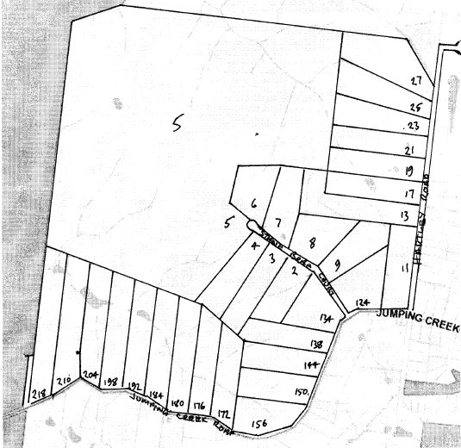 **Title History of Crown Section 4 Stane Brae**

7/12/1883 Certificate of Title Volume 1521 Folio 008, area 312 acres 2 roods and 21 perches, being Crown Allotment 4A in the name of **Robert Lindsay Crawford** **Nicholson** of Warrandyte Grazier.

7/12/1883 Mortgage No. 57706 to Robert Durham. Does not now affect – Transfer by Mortgagee 3/12/1889.

5/1/1884 Mortgage No. 58171 to Edward Bulmer Lytton Dickens. Does not now affect –3/12/1889.

23/6/1886 Caveat No. 12359 lodged, lapsed 3/12/1889.

Plan showing property boundaries and street numbers

9/3/1888 Caveat No. 15044 lodged, ???? 3/12/1889.

3/12/1889 Transfer (by Mortgagee) No. 268065 from the above-named Robert Durham to **William Henry Batten** of Mechanics Institute Ballarat Accountant **Henry Rawlings** of Mechanics Institute Ballarat aforesaid Gentleman and **John Milliar Coles** of Station Street Box Hill Railway Station Master.

3/12/1889 Mortgage No. 108408 to The Mutual Assurance Society of Melbourne Limited.

17/6/1895 Transfer (by Mortgagee) No. 359508 from The Mutual Assurance Society of Victoria Limited to **Frederick Walter Purches**. New Certificate of Title Vol 2574 Fol725

******************************************************************

21/1/1886 Crown Grant 1852 Folio 223, area 320 acres, being Crown Allotment4B for the sum of £320 in the name of Mary Ann Brown of St Arnaud.

3/12/1889 Transfer No. 268064 from the within named Mary Ann Brown to **William Henry Batten** of Mechanics Institute Ballarat Accountant **Henry Rawlings** of Mechanics Institute Ballarat aforesaid Gentleman and **John Milliar Coles** of Station Street Box Hill Railway Station Master.

3/12/1889 Mortgage No. 108408 to The Mutual Assurance Society of Victoria Limited.

17/6/1895 Transfer (by Mortgagee) No. 359508 from The Mutual Assurance Society of Victoria Limited to **Frederick Walter Purches**. New Certificate of Title Vol 2574 Fol725

********************************************************************

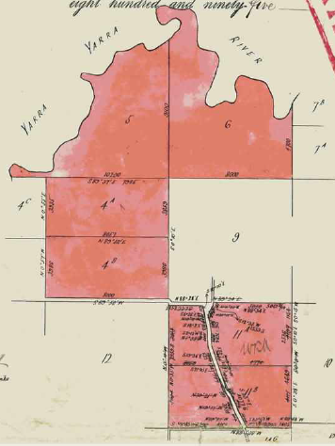17/6/1895 Certificate of Title Volume 2574 Folio 725, area 2,591 acres 3 roods and 0 perches, being Crown Allotments 4A, 4B, 11A and 11B and Crown Sections 5 and 6 Parish of Warrandyte County of Evelyn in the name of **Frederick Walter Purches** of Ascot Vale Road Ascot Vale Wholesale Butcher.

17/6/1895 Mortgage No. 165563 to The Mutual Assurance Society of Victoria Limited, discharged15/8/1896.

15/8/1896 Transfer No. 873664 from Frederick Walter Purches to The Mutual Assurance Society of Victoria Limited of 406 Collins Street Melbourne.

Plan from Certificate of Title Volume 2574 Folio 725 showing from the top down Crown Sections 5 & 6, Crown Allotments 4A & 4B and Crown Allotments 11A & 11B.

19/3/1899 Transfer No. 404328 from The Mutual Assurance Society of Victoria Limited to The President Councillors and Ratepayers of The Shire of Lilydale of 23 acres 9 roods and 18 perches, new Certificate of title Volume 2718 Folios 443 &444 which lands would appear to be Homestead Road from Yarra Road to Toppings Road, Brysons Road from Yarra Road to St Johns Road and parts of Yarra Road at the intersection with Brysons and Homestead Road and sections to the north towards Launders Avenue.

Plan of new roads transferred to The Shire of Lilydale in 1899, A realignment of Yarra Road in the centre. A new Homestead Road top right and a new Brysons Road bottom left.

Balance of Title cancelled see Certificate of Title volume 2734 Folios 734 & 735.

************************************************************

27/7/1889 Certificate of Title Volume 2734 Folio 734, area 1,650 acres 2 roods and 11 perches, being Crown Sections 5 and 6, Crown Allotment 4A and parts of Crown Allotment 4B in the Parish of Warrandyte County of Evelyn in the name of **The Mutual Assurance Society of Victoria Limited** of Collins Street Melbourne.

Lot 53 on Plan of Subdivision No. 4315 transferred out of Crown Allotment 4B to James Begley Certificate of Title Volume 3594 Folio 684

25/4/1912 Transfer as to part No. 682020 from The Mutual Assurance Society of Victoria Limited, new Certificate of Title Volume

3594 Folio 684 to James Begley of Lot 53 on Plan of Subdivision No. 4315.

Cancelled as to part see Vol 4052 Fol 373 and Red Ink No. 1824546.

25/8/1924 Caveat No. 65881 affecting part of the land herein, lapsed 1/8/1930.

5/5/1925 Transfer as to part No. 1142851 from the Mutual Assurance Society of Victoria Limited to John Ramsay the Elder, new Certificate of Title volume 5019 Folio 692.

Red Ink No. 3051288 Title cancelled see Certificate of Title Volume 5674 Folio 716

********************************************************************

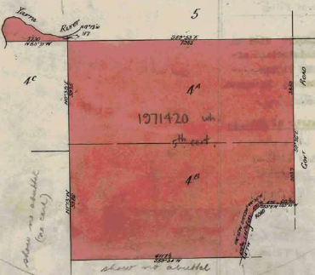5/5/1925 Certificate of Title Volume 5019 Folio 692, area 610 acres and 33 perches, being Crown Allotment 4A, part of Crown Allotment 4B and part of Section 5 Parish of Warrandyte County of Evelyn issued in the name of **John Ramsay the Elder** of “Clydebank” Vida Street Essendon Gentleman.

15/6/1925 Red ink No. 2602560: John Ramsay the Elder, in Probate called John Ramsay died on 3rd March1924. Probate has been granted to **John Ramsay** of “St Margarets” Launceston Tasmania and **William Herbert Roddick** of Monaro Road Malvern Managing Director.

10/6/1925 Transfer No. 219829? from John Ramsay and William Herbert Roddick to Laver Bros & Co. Proprietary Limited of Cambridge Street Collingwood.

Plan from Certificate of Title Volume 5019 Folio 692 transferred to John Ramsay the Elder. Note the small part of Section 5 in the top left corner attached to CAs 4A and part 4B.

9/5/1930 Mortgage No. 647144 to The Bank of Australasia, discharged 21/9/1939.

11/9/1934 Caveat No. 91438 affecting Mortgage No. 647144, does not mow affect 21/9/1939.

21/9/1939 Transfer No. 1746747 from John Ramsay and William Herbert Roddick to **Sidney James Philpotts** of Doncaster Road Balwyn Dairy Farmer.

1/11/1944 Red Ink No. 4191248: Sidney James Philpotts died on 12th November 1943. Letters of Administration of his estate have been granted to Sidney victor Philpotts of Walnut Street North Balwyn Dairyman.

17/10/1945 Transfer No. 1971420 from Sidney Victor Philpotts to **Annie Winifred Philpotts, Edward Herbert Philpotts, Albert Arthur Philpotts** and **Sidney Victor Philpotts**, Title cancelled and new Certificate of title Volume 6825 Folio 877.

*************************************************************************

17/10/1945 Certificate of Title Volume 6825 Folio 877, area 610 acres and 33 perches being Crown Allotment 4A, part of Crown allotment 4B and part of Section 5 Parish of Warrandyte County of Evelyn issued to **Annie Winifred Philpotts** of Walnut Street North Balwyn Widow as to three equal undivided ninth parts or shares and **Albert Arthur Philpotts** a Member of the Royal Australian Air Force and **Sidney Victor Philpotts** Dairyman both of Walnut Street North Balwyn and **Edward Herbert Philpotts** of Doncaster Road North Balwyn Dairyman each as to two equal undivided ninth parts or shares.

3/5/1965 Transmission Application No. C205845: As to the interest of Annie Winifred Philpotts who died on 31st May 1962 Probate of her Will has been granted to **Sidney Victor Philpotts** of 7 Almond Street North Balwyn.

20/10/1965 Transfer from Albert Arthur Philpotts, Sidney Victor Philpotts and Edward Herbert Philpotts to Albert Arthur Philpotts of 23 View Hill Road and Edward Herbert Philpotts of 226 Doncaster Road each as to two equal undivided ninth parts or shares and Sidney Victor Philpotts of 7 Almond Street as to five equal undivided ninth parts or shares all of North Balwyn Dairymen.

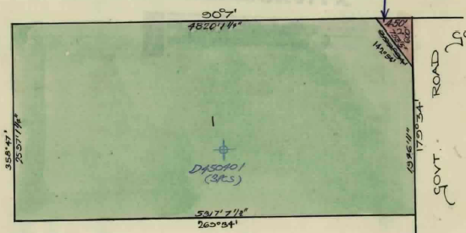??/5/1967 Transfer as to part No. C773913, Lot 2, area 3 acres 0 roods and 16 perches new Certificate of Title Volume 8675 Folio 078. Lot 2 appears to be a triangular piece of land at the north-east corner of the property.

7/6/1968 Caveat No. D99733, lapsed 12/8/1969.

Transfer as to part No. C773913 being a 3 acre triangular piece of land at the north-east corner of CA 4A

17/7/1969 Transfer as to balance No. D45040, Title cancelled see Vol 8788 Fol 369.

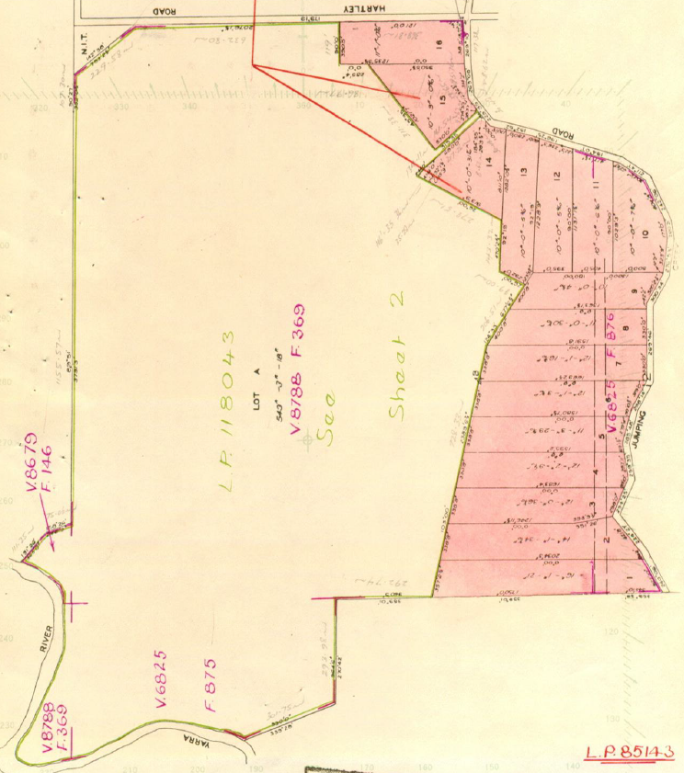 *********************************************************************

17/7/1969 Certificate of Title volume 8788 Folio 369, area 607 acres and 17 perches, being parts of Crown Allotments 4A and 4B and part of Crown Section 5 Parish of Warrandyte County of Evelyn issued in the name of **Nancy Shetland Proprietary Limited** of 7 Ultimo Court Toorak

17/7/1969 Mortgage No. D450402 to Albert Arthur Philpotts and Sidney Victor Philpotts, discharged 1/4/1982.

29/7/1969 Mortgage No. D460652 to Lensworth Finance (Vic) Pty. Limited, discharged 24/10/1975.

15/10/1969 Caveat No. D533916 affecting part of the land herein Lot 15 P/S 85413. Caveat transferred to new C/T.

Plan of Subdivision No. 85143 creating 16 approx. 10 acre blocks with frontages to Jumping Creek Road. Also note that it incorporates land from Certificate of title Volume 6825 Folio 876 along the north-west boundary of the original land.

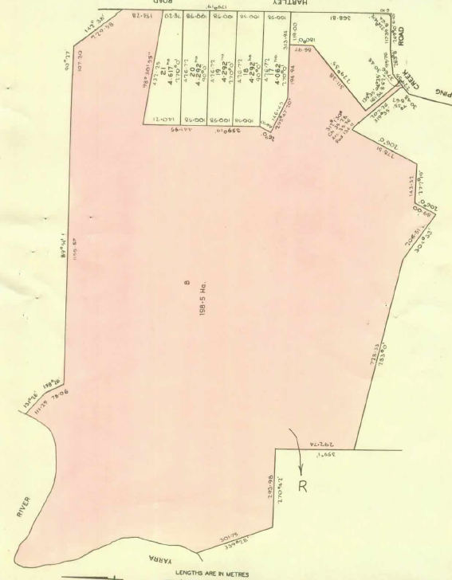19/11/1969 Transferred as to part pursuant to Regulation 12 and Titles issued as set out hereunder: Lots 1 to 16 in Vol 8801 Fol 379 to Vol 8801 Fol 394 LP 84143. **Lots 1 to 16 have Street addresses 124 to 218 Jumping Creek Road and 11 Hartley Road**.

4/8/1976 `Cancelled as to part pursuant to Regulation 12 and Titles issued as set out hereunder: Lots 17 to 21 in Vol 9152 Fol 418 to Vol 9152 Fol 422 and Lot B in Vol 9152 Fol 423. LP 118043. **Lots 17 to 21 have Street Addresses 13 to 23 Hartley Road**. (NB 20’ splay at corner of Jumping Creek and Hartley Roads remains in Certificate of Title Volume 8788 Folio 369)

Plan of Subdivision No. 140717 showing Lots 17 to 21 created in Hartley Road

**************************************************************************

16/4/1982 Certificate of Title Volume 9152 Folio 423, area 198.5 hectares, being Lot B on Plan of Subdivision No.118043 Parish of Warrandyte County of Evelyn issued in the name of Nancy Shetland Proprietary limited of 7 Ultimo Court Toorak.

4/12/1981 Instrument No. J724771: Minister of Lands has pursuant to Section 57 of Transfer of Land Act served a Notification relating to the compulsory acquisition of land comprised herein dated 23/11/1981 – Affects part of Lot B on P/s 140717.

Title cancelled. The following Titles have been issued pursuant to Regulation 12 of the Transfer of Land Act: Lots A to B in Vol 9475 Fol 999 to Vol 9477 Fol 001 (RESP.)

*************************************************************************

19/8/1982 Certificate of Title Volume 9475 Folio 999, area 4.856 hectares, being Lot A on Plan of Subdivision No. 140717 issued in the name of Nancy Shetland Proprietary Limited of 7 Ultimo Court Toorak.

3/9/1986 Title Cancelled: The following Titles have been issued pursuant to Regulation 10 of the Transfer of Land Act: Lots 22 to 23 in Vol 9697 Fol 959 and Vol 9697 Fol 961 and Lot C in Vol 9697 Fol 961. LP 200092T. It appears that Lot A which was landlocked and had no frontage to a road has been reabsorbed into the large block of land i.e. Lot C

Lot A on Plan of Subdivision No. 140717 Certificate of Title volume 9475 Folio 999 appears to have been reabsorbed into Lot C on Plan of Subdivision No. 200092T

*****************************************

19/8/1982 Certificate of Title Volume 9477 Folio 001 being Lot B on Plan of Subdivision

No. 140717 issued in the name of **Nancy Shetland Proprietary Limited** of 7 Ultimo Court Toorak.

5/11/1984 Transfer as to part No. L351949Q to **Her Majesty Queen Elizabeth II**, area 36.06 hectares. This being the river frontage land to form part of the Warrandyte State Park.

23/5/1986 Transfer as to part No. M287690B, area 2.253 hectares, new Certificate of Title Volume 9696 Folio 993. This land appears to have been attached to Lot 17 (Street No. 13) in Hartley Road.

3/9/1986 Title Cancelled as to balance: the following Titles have been issued pursuant to Regulation 10 of the Transfer of Land Act. Lots 22 to 23 in Vol 9697 Fol 959 and Vol 9697 Fol 960 and Lot C in Vol 9697 Fol 961 on LP 200092T.

Plan showing Transfers as to part out of Certificate of title Volume 9477 Folio 001 including the Transfer to her Majesty Queen Elizabeth II of the river frontage land to become part of the Warrandyte State Park

*********************************************************************

3/9/1986 Certificate of Title Volume 9697 Folio 961, area 148.4 hectares, being Lot C on Plan of Subdivision No.200092T Parish of Warrandyte County of Evelyn issued in the name of **Nancy Shetland Proprietary Limited** of 7 Ultimo Court Toorak.

13/3/1987 Title cancelled. The following Titles have been issued pursuant to Regulation 10 of the Transfer of Land Act: Lots 24 to 30 in Vol 9733 Fol 732 to Vol 9733 Fol 738 and Lot A in Fol 9733 Fol 739. Pursuant to Section 32 of the Transfer of Land Act the road in Vol 9733 Fol 740 on LP 200503Y. **Lots 22 & 23 have street addresses of 25 & 27 Hartley Road.**

Plan of Subdivision No. 200092T showing Lots 22 & 23 and Lot C.

**********************************************************************

13/3/1987 Certificate of Title Volume 9733 Folio 739, area 118.0 hectares being Lot A on Plan of Subdivision No. 200503Y in the Parish of Warrandyte County of Evelyn issued to Nancy Shetland Pty. Ltd. of 7 Ultimo Court Toorak subject to Covenant Pursuant to Sec 3A Victoria Conservation Trust Act 1972 registered 29/11/1988 N867576Y. **Street Address: 5 Stane Brae Court Wonga Park**

3/6/1967 Caveat No. M872658F lodged, withdrawn 10/5/1990.

10/5/1990 Caveat No. P791046U by B. S. Stillwell & Co Pty. Ltd. as purchaser, caveat will lapse on registration of P856031E – 29/6/1990.

19/6/1990 Transfer No. P856031E from Nancy Shetland Pty. Ltd. to **B. S. Stillwell & Co Pty. Ltd.** of 133 Cotham Rd. Kew.

Sheet 1 of Plan of Subdivision No. 200503Y showing Lot A Street No. 5 Stane Brae Court.

Sheet 2 of Plan of Subdivision No. 200503Y showing Lots 24 to 30 in Stane Brae Court with Street Nos. 2 to 4 and 6 to 9.

19/6/1990 Mortgage No. P856032B to Nancy Shetland Pty. Ltd., discharged 2/3/1993.

10/7/1990 Mortgage No. P893175H to National Australia Bank Limited, discharged 10/11/1994.

19/5/1992 Caveat No. R919125X by State Electricity commission of Victoria.

10/11/1994 Mortgage No. T407284P to BMW Australia Finance Limited, discharged 17/2/2000.

17/2/2000 Transfer No. W606491T from B. S. Stillwell & Co Pty. Ltd. to **Magic Forest Pty Ltd** of Unit 38 659 Victoria St Abbotsford 3067.

11/1/2012 Land Tax Charge No. AJ426005Q – Statutory Charge Section 96 (1) Land Tax Act 2005.

23/4/2012 Caveat No. AJ617439Q by Ewan Andrew McClue as purchaser.

7/6/2012 Discharge No. AJ712459D of Land Tax Charge No. AJ426005Q lodged.

23/10/2012 Land Tax Charge No. AJ984634Q – Statutory Charge Section 96 (1) Land Tax Act 2005.

14/1/2013 Cancelled by AK132196J.

*************************************************************************

14/1/2013 Computer Certificate of Title Volume 11398 Folio 826 for Lot A on Plan of Subdivision No. 200503Y in the name of Magic Forest Pty Ltd of 5 Stane Brae Court wonga Park Vic 3115.

6/2/2013 Discharge No. Ak171405G of Land Tax Charge No. AJ984634Q lodged.

6/2/2013 Transfer No. AK171406E from Magic Forest Pty Ltd to Ewen Andrew McLue of 5 Stane Brae Court Wonga Park Vic 3115 and lapsing of Caveat No. AJ617439Q

6/2/2013 Mortgage No. AK171407C to Commonwealth Bank of Australia.