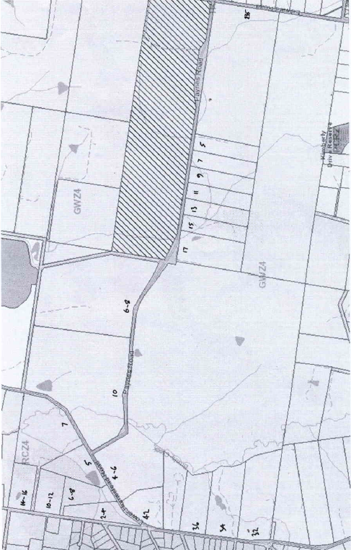
History of Crown Section 8 Parish Warrandyte – Wonga Park Cattle Station
The Wonga Park Cattle Station was centred around Section 8 Parish of Warrandyte.
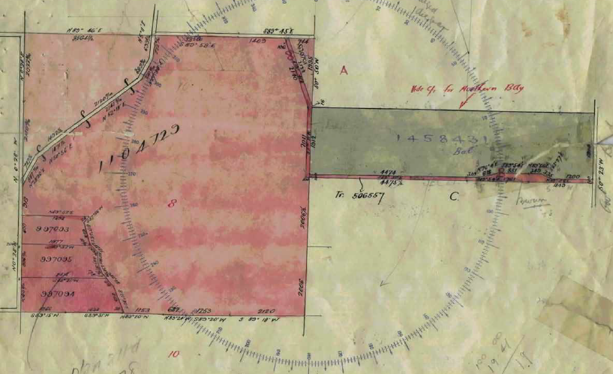
11/6/1898 Certificate of Title Volume 2687 Folio 232, area 819 acres 2 roods and 26 perches being Crown Section 8 in the Parish of Warrandyte and Crown Allotment B Section 21 Parish of Yering all in the County of Evelyn registered in the name of The Mutual Assurance Society of Victoria Limited of No. 406 Collins Street Melbourne. It appears that prior to this Certificate of Title the land was under a General Law Title, brought under the Transfer of Land Act in Application No. 3085?
Map showing Section 8 Parish of Warrandyte (on the left) and Section 21 Parish of Yering (on the right) with current street numbers
1/6/1905 Transfer as to Part No. 506557, area 14 acres 2 roods and 34 perches, from the Mutual Assurance Society of Victoria Limited to George Ernest Mather, new Certificate of Title Volume 3054 Folio 696. (Appears to be a road)
Record of Subdivision showing the land in Certificate of Title Volume 2698 Folio 232 with the coloured road transferred to Mather, the triangular piece of land at the top right of the square to Duffy, the 3 lots at the bottom left corner of the square to Beavis, Platt and Stephenson respectively, the balance of the square to Wilkinson and the large rectangular piece of land to the left of the square to Cash.
12/5/19010 Transfer as to Part No. 620761, area 7 acres 1 rood and 27 perches, from the Mutual Assurance Society of Victoria Limited to Hannah Elizabeth Duffy, new Certificate of Title Volume 3417 Folio 336. (Appears to be a triangle of land between the new road and the adjoining property)
14/5/1921 Transfer as to Part No. 997093, area 14 acres 3 roods and 18 perches, from the Mutual Assurance Society of Victoria Limited to Samuel Beavis, new Certificate of Title Volume 4469 Folio 756.
14/5/1921 Transfer as to Part No. 997094, area 27 acres 3 roods and 9 perches, from the Mutual Assurance Society of Victoria Limited to Francis Walter Stephenson, new Certificate of Title Volume 4469 Folio 757.
14/5/1921 Transfer as to Part No. 997095, area 21 acres 1 rood and 21 perches, from the Mutual Assurance Society of Victoria Limited to Samuel Hamilton Platt, new Certificate of Title Volume 4469 Folio 758.
9/6/1928 Caveat No.55656 affecting part of the land lodged and lapsed16/5/1923.
16/5/1923 Transfer as to part No. 1104729, from the Mutual Assurance Society of Victoria Limited to Archer Stalham Wilkinson, new Certificate of Title Volume 4469 Folio 758.
13/6/1926 Caveat No. 70437 lodged 3/9/1926, lapsed 13/6/1930.
13/6/1930 Transfer as to balance No. 1458431, from the Mutual Assurance Society of Victoria Limited to Albert Edward Cash and Elizabeth Cash, new Certificate of Title Volume 5663 Folio 406.
Certificate of Title Volume 4469 Folio 656 No. 36 Homestead Road
14/5/1921 Transfer as to Part No. 997093, area 14 acres 3 roods and 18 perches, from the Mutual Assurance Society of Victoria Limited to Samuel Beavis of Yarra Road near Croydon, new Certificate of Title Volume 4469 Folio 756.
23/4/1926 Transfer No.1262749 from Samuel Beavis to William Henry Wright of Wonga Park Orchardist.
21/7/1928 Mortgage No. 596659 to The English Scottish and Australian Bank Limited, discharged 23/7/1930.
23/7/1930 Mortgage No. 649758 to Annie Coxwell Forster, discharged 20/10/1941.
26/6/1946 Caveat No. 116469 lodged and lapsed 7/9/1950.
7/9/1950 Transfer No. 2339403 from William Henry Wright to Walter James Thompson Builder’s Labourer and Constance Helen Thompson his wife both of Homestead Road Wonga Park.
Housing Commission has lodged copy declaration under Section 8 of Slum Reclamation and Housing Act 1958 affecting land herein – 21/9/1964 does not now affect.
19/3/1962 Mortgage No. B384347 to Director of War Service Homes, discharged 5/10/199?
13/2/1967 Survivorship Application No. C703162. Constance Helen Thompson is now the surviving Proprietor.
31/8/1984 Transfer No. L237041A from Constance Helen Davis (formerly Thompson) to Constance Helen Davis and Arthur Edward Davis both of Homestead Road Wonga Park.
20/1/1998 Survivorship Application No. V211811B. Constance Helen Davis is now the surviving Proprietor.
10/6/2004 Transmission Application No. AC914845H. Rhonda Ewen and David Ewen both of Williams Road Lima South Vic 3673 as Legal Personal Representatives of Constance Helen Davis who died on 28/2/2004.
3/8/2004 Transfer from Rhonda Ewen and David Ewen to Anthony Graeme Hamilton and Ann Maria Hamilton both of 36 Homestead Road wonga Park Vic 3115.
7/3/2005 Transfer No. A023092R from Anthony Graeme Hamilton and Ann Maria Hamilton to Ian Russell Walker and Narelle Lisa Walker both of 247 Oban Road Ringwood North Vic 3134.
7/63/2005 Mortgage No. AD485443H to Australia and New Zealand Banking Group Limited.
17/9/2015 Discharge No. AM188895X of Mortgage No. AD485443H.
17/9/2015 Mortgage No. AM188896V to Westpac Banking Corporation.
Certificate of Title Volume 4469 Folio 757 No.32 Homestead Road
14/5/1921 Transfer as to Part No. 997094, area 27 acres 3 roods and 9 perches, from the Mutual Assurance Society of Victoria Limited to Francis Walter Stephenson of Wonga Park Farmer, new Certificate of Title Volume 4469 Folio 756.
21/1/1924 Transfer No. 1147488 from Francis Walter Stephenson to Emily Stephenson of Clyde Married Woman.
13/5/1925 Mortgage No. 51679 to Victoria Producers Co-operative Company Limited, discharged 7/9/1926.
? /9/1926 Mortgage No. 54832 to Florence Amy Keys, discharged 22/8/1928.
22/8/1928 Mortgage No. 598574 to The Commissioners of The State Savings Bank of Victoria.
17/1/1945 Transfer No. 1940583 from Emily Stephenson to Basil Leslie Willey Tramway Employee and Lillian Mary Willey Married Woman both of 39 Katawa Grove Brunswick.
17/1/1945 Mortgage No. 842149 to The Commissioners of The State Savings Bank of Victoria, discharged 12/4/1951.
10/9/1946 Transfer No. 2015187 from Basil Leslie Willey and Lillian Mary Willey to Stanley Osmond Daley Farmer and Mary Daley Married Woman both of Homestead Road Croydon.
1?/4/1951 Mortgage No. 969474 to The Commissioners of The State Savings Bank of Victoria, discharged as to part 4/11/1960, discharged 31/5/1972.
14/11/1980 Transfer as to part No. B100326, new Certificate of Title Volume 8310 Folio 248.
10/5/1967 State Electricity Commission has pursuant to section 57 of the Transfer of Land Act served notification relating to the compulsory acquisition of an easement over land herein. Dated 5/5/1967, Entered 10/5/1967, No. C768426.
22/8/1969 Creation of Easement No. D404201 registered.
31/5/1972 Transfer as to balance No. E408070, new Certificate of Title Volume 8639 Folio 748.
Certificate of Title Volume 4469 Folio 758 No. 34 Homestead Road
14/5/1921 Transfer as to Part No. 997095, area 21 acres 1 rood and 21 perches, from the Mutual Assurance Society of Victoria Limited to Samuel Hamilton Platt of Wonga Park Farmer, new Certificate of Title Volume 4469 Folio 758.
23/9/1943 Transfer No. 1895375 from Samuel Hamilton Platt to Dominico Coniglio Farmer and Caterina Coniglio Married Woman both of Wonga Park.
9/5/1958 Survivorship Application No. A525515. Caterina Coniglio the survivor of the proprietors named herein is now registered as sole proprietor of the land now comprised herein.
19/7/1985 Transmission Application No. L786724L. Caterina Coniglio died on 20/11/1984. Probate of her Will has been granted to Guiseppe Coniglio.
19/7/1985 Transfer No. L786725H from Giuseppe Coniglio to Giuseppe Coniglio of 151 Maroondah Hwy. Croydon Italia Vittoria Sciarrone of 10 Glenair St. Lower Templestowe Margarita Conforto of 37 Lanigan St. Fawkner & Nicholas John George Coniglio of 13 Stafford Crt. East Doncaster as tenants in common in equal shares.
9/4/1986 Transfer No. M216681M from Giuseppe Coniglio, Italia Vittoria Coniglio, Margarita Coniglio, and Nicholas John George Coniglio to Steven Geoffrey Ward & Carol Joy Ward of 3 Gretel Crt. Croydon.
9/4/1986 Mortgage No. M216682J to National Mutual Royal Savings Bank Limited, discharged 19/5/1988.
28/11/1986 Mortgage No. M587116S to National Mutual Royal Savings Bank Limited, discharged 19/5/1988.
11/3/1987 Mortgage No. M739027X to National Mutual Royal Savings Bank Limited, discharged 19/5/1988.
19/5/1988 Mortgage No. N463420G to The Commissioners of The State Savings Bank of Victoria.
27/5/2009 Discharge No. AG528910R of Mortgage No. N463420G lodged.
27/5/2009 Mortgage No. AG528911P lodged.
Certificates of Title Volume 4705 Folio 907, Volume 4935 Folio 805 and Volume 5101 Folio 181
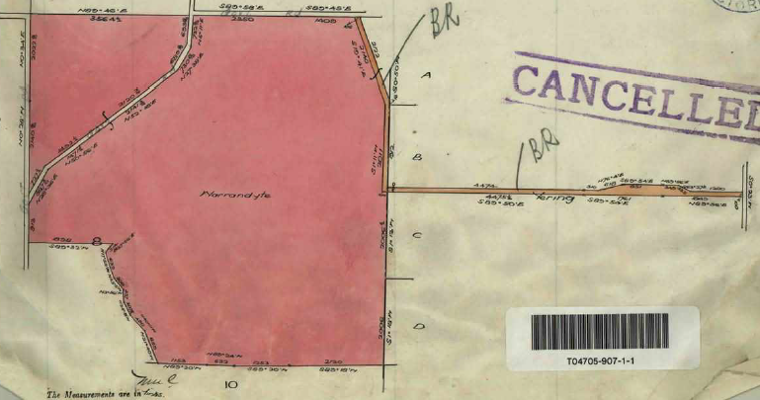
16/5/1923 Transfer as to Part No. 1104729, area 580 acres 0 roods and 12 perches, from the Mutual Assurance Society of Victoria Limited to Archer Stalham Wilkinson of 17 Simpson Street East Melbourne Grazier.
16/5/1923 Mortgage No. 467260 to The National Mutual Life Association of Australasia Limited.
The plan forming part of Certificate of Title Volume 405 Folio 907 showing the land transferred to Wilkinson and the brown coloured road over which he had a right of carriage way
18/5/1923 Mortgage No. 468435 to Joseph Allan Coxon.
11/12/1924 Transfer No. 1195074 to Henry James Furner and Ernest Joseph Addison. Title cancelled see Certificate of Title Volume 4935 Folio 805 in the names of Henry James Furner and Ernest Joseph Addison both of Gruyere Farmers subject to Mortgages Nos. 467260 and 468435.
28/8/1925 Mortgages Nos. 467260 and 468435 are discharged as to part being the land in transfer number 1231675.
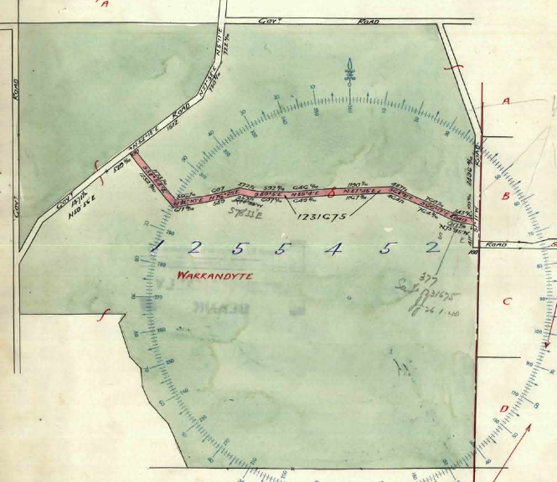
28/8/1925 Transfer as to part No. 1231675 to The President Councillors and Ratepayers of the Shire of Lillydale, new Certificate of Title Volume 5034 Folio 738. (This is the road then named Hughes Road but later renamed Paynes Road)
4/3/1926 Transfer as to balance No. 1255452 to Clara Misken. Title cancelled see Certificate of Title volume 5101 Folio 181 area 573 acres 1 rood and 23 perches in the name of Clara Misken of 0 Yarraford Avenue Alphington Married Woman subject to Mortgages Nos. 467260 and 468435.
The land coloured red on the above plan is the road transferred by Furner and Addison to the Shire of Lillydale in 1925
31/3/1928 Mortgages Nos. 467260 and 468435 are discharged.
10/8/1927 Mortgage No.571552 to Ellen Shorthorne, discharged 31/3/1928.
31/3/1928 Mortgage No. 587998 to the National Mutual Life Association of Australasia Limited, discharged 11/11/1940.
14/5/1936 Caveat No. 94534 affecting Mortgage No. 587998, lapsed 11/11/1940.
11/11/1940 Transfer No. 1793913 from Clara Misken to William Henry Stocks of High Street Ashburton.
?/7/1941? Creation of Easement No. 1818325 to State Electricity Commission of Victoria, removed 14/2/1979 (H409140).
24/3/1944 Creation of Easement No. 1911267 to State Electricity Commission of Victoria, removed 24/10/1978 (H285724).
17/5/1967 State Electricity Commission has pursuant to Section 57 of Transfer of Land Act served notification relating to the compulsory acquisition of an easement over land contained herein No. C774576
29/1/1970 Transmission Application No. D621841. William Henry Stocks died on 17th September 1968. Probate of his Will has been granted to Doris Elizabeth Stocks of Wonga Park Widow, Annie Thelma Jenkin of 37 Waverley Road East Malvern Home Duties and Elizabeth Rosina Lithgow of “Flowerfield” Coldstream Married Woman.
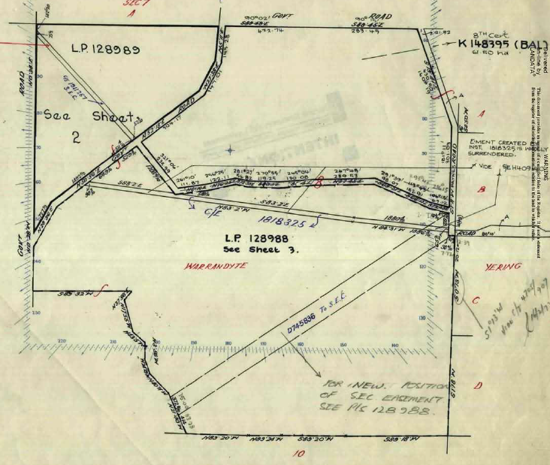
12/6/1970 Creation of Easement No. D745836.
30/8/1979 Cancelled as to part pursuant to Regulation 12 and Titles issued as set out hereunder: Lots one to 6 in Vol 9342 Fol 880 to Vol 9342 Fol 885 LP128989.
3/11/1982 Instrument No. K148394 Annie Thelma Jenkin and Elizabeth Rosina Lithgow are now the proprietors.
3/11/1982 Transfer as to balance K148395. Title cancelled See Vol 9514 Fol 295 to Vol 9514 Fol 301.
Staged Plan of Subdivision with LP 128989 in the top left corner of the plan, LP 128988 in the bottom of the plan and the balance of the land in the top right corner of the plan was later subdivided into 2 lots.

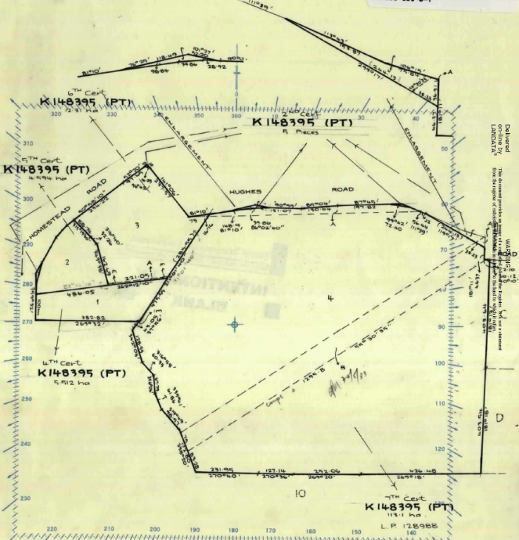
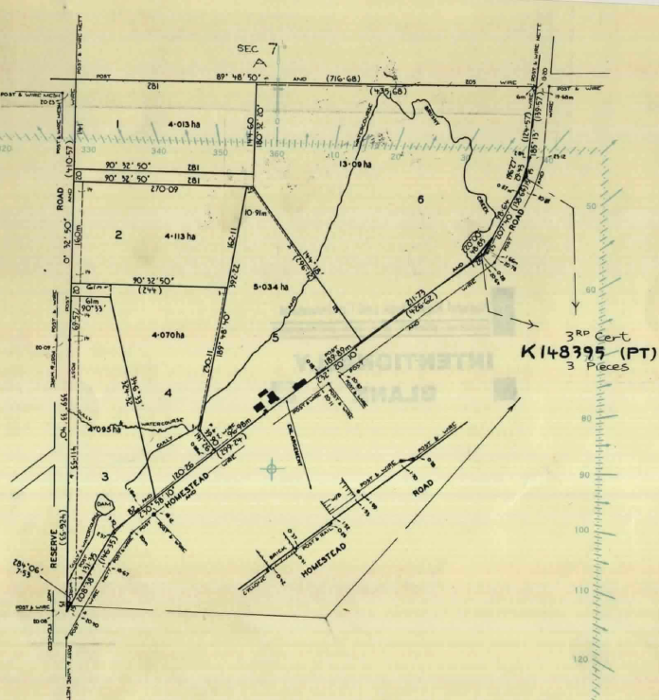
Details of Plan of Subdivision No. 128988 in the centre to south-eastern corner of Section 8.
Details of Plan of Subdivision 128985 in the north-west corner of Section 8.

Certificates of Title Volume 9514 Folios 299 & 300, Nos. 4-6 Lower Homestead Road Wonga Park
3/11/1982 Transfer as to balance K148395. Title cancelled See Vol 9514 Fol 295 to Vol 9514 Fol 301. The Certificates of Title for Lots 3 and 4 on Plan of Subdivision No. 128988 issued to Annie Thelma Jenkin of 37 Waverley Road East Malvern Home Duties and Elizabeth Rosina Lithgow Married Woman and Douglas Brown Lithgow Student both of “Flowerfield” Coldstream.
3/12/1986 Transfer No. M591828A from Annie Thelma Jenkin, and Elizabeth Rosina Lithgow and Douglas Brown Lithgow to Elizabeth Rosina Lithgow and Douglas Brown Lithgow of “Flowerfield” Coldstream.

