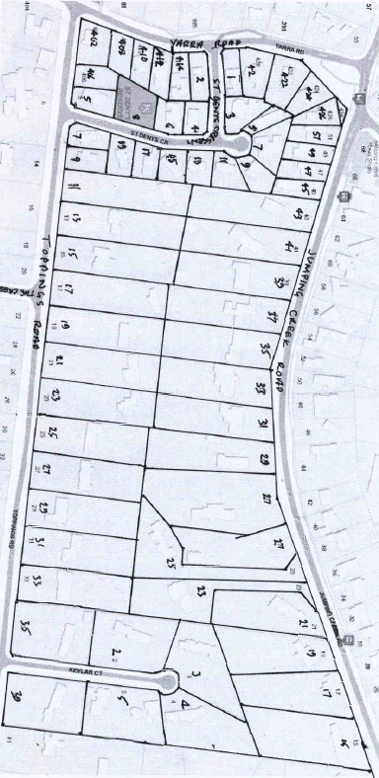
History of Crown Allotment 9G Parish Warrandyte
23/4/1914 Crown Grant Volume 3807 Folio 323, in consideration of the payment of 33 pounds15 shillings Frederick Augustus Topping of Croydon Farmer was granted 44 acres 1 rood and 19 perches being (Crown) Allotment 9 G in the Parish of Warrandyte County of Evelyn.
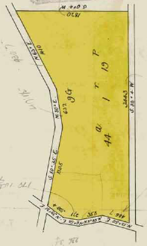
10/12/1917 Transfer as to part No. 841480 from Frederick Augustus Topping to The Church of England Trusts Corporation for the Diocese of Melbourne, new Certificate of Title Volume 4087 Folio 252.
Map of Crown Allotment 9G showing property boundaries and street numbers
30/10/1918 Transfer as to part No. 822663, area 10 acres from Frederick Augustus Topping to Albert Thomas Slater of 92 Harmsworth Street Seedly Manchester England Warehouseman, new Certificate of Title Volume 4162 Folio 363.
A plan of the land granted in Crown Grant Volume 3807 Folio 323 with Jumping Creek Road on the north, Yarra Road on the west and Toppings Road on the south.
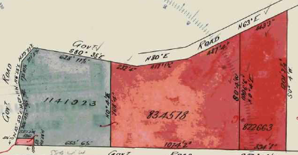
30/10/1918 Transfer as to part No. 834578, area 20 acres 0 roods 9 perches from Frederick Augustus Topping to Edward Henry Frank Burch of Wonga Park Orchardist, new Certificate of Title Volume 4162 Folio 364.
11/12/1923 Transfer as to balance No. 834578 from Frederick Augustus Topping to Albert John Harford of 93 Chapman Street North Melbourne Carpenter, new Certificate of Title Volume 4788 Folio 547.
Plan showing subdivision of Crown Grant Volume 3807 Folio 323 by transfers as to part and balance
********************************************************************
Land in Certificate of Title Volume 4162 Folio 363 being the eastern most portion of Crown Allotment 9G, area 10 acres transferred to Albert Thomas Slater on 30/10/1918.
11/11/1926 Transfer No. 1293138 from Albert Thomas Slater to Twentieth Century Building and Investment Society of 314 Collins Street Melbourne.
23/10/1931 Transfer No. 1490659 from Twentieth Century Building and Investment Company to John Peter McDonald of Point Smythe Inverloch Dairyman and Grazier.
23/10/1931 Mortgage No. 670078 to William George Morrison, discharged 4/4/1938.
22/2/1932 Mortgage No. 673949 to William George Morrison, discharged 4/4/1938.
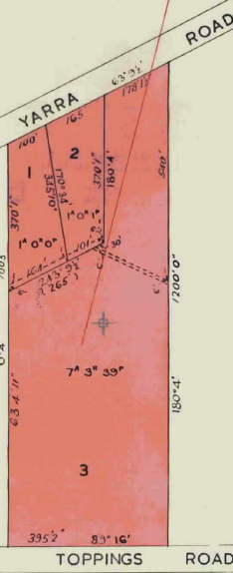
15/6/1948 Transfer No. 2147171 from John Peter McDonald to Joan O’Dwyer of 27 Coventry Street South Melbourne Married Woman.
?? /8/1950 Mortgage No. 948870 to The Bank of Australasia, discharged 18/8/1953.
14/12/1966 Mortgage No. C6??22? to The National Bank of Australasia Limited, discharged 16/10/1968.
29/10/1968 Mortgage No. D229106 to Deposit and Investment Company Limited.
23/12/1968 (Certificate of Title) Cancelled pursuant to Regulation 12 and Titles issued as set out hereunder Lots One to 3 in Vol 8755 Fol003 to Vol 8755 Fol 005, LP82534.
29/10/1970 Transfer No. D872765 of Lot 2 on Plan of Subdivision No. 82534 from Joan O’Dwyer to John Greenwood-Smith Draughtsman and Patricia Ann Greenwood-Smith Married Woman of 14 Darrup Street Carlton, new Certificate of Title Volume 8755 Folio 004.
Plan of Subdivision No. 82534
*************************************************************************
Land in Certificate of Title Volume 4162 Folio 364 being the central portion of Crown Allotment 9G, area 20 acres 0 roods and 9 perches transferred to Edward Henry Frank Burch on 30/10/1918.
8/10/1941 Caveat No. 108812 lodged and lapsed 21/6/1945.
14/5/1943 Caveat No. 111918 lodged and lapsed 14/5/1947.
21/6/1945 Transfer No. 1956754 from Edward Henry Frank Burch to Eliza Jean Robinson Moull of Whitehorse Road North Croydon Married Woman.
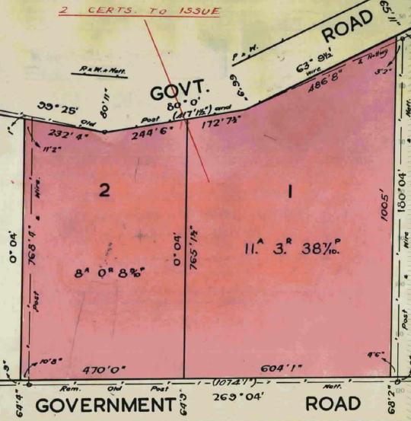
14/5/1947 Transfer No. 2076244 from Eliza Jean Robinson Moull to Henry Thomas John Curnow Hat Blocker and Amy Lucy Lousia Curnow Married Woman both of Brushy Park Road Wonga Park.
30/3/1950 Red Ink No. 485262 Amy Lucy Louise Curnow of Yarra Road Wonga Park Widow the survivor of the proprietors is by direction of the Commissioner of Titles now registered as sole proprietor of the land now comprised herein.
30/3/1950 Transfer No. 2291676 from Amy Lucy Louise Curnow to Effie Felice Grieve of
Fussell Road Kilsyth Widow.
Plan of Subdivision No. 48233 by Shirley June Brown
29/4/1952 Mortgage No. 1003881 to Charles Robert Redrobe, discharged 11/11/1960.
11/11/1960 Transfer No. B99385from Effie Felice Grieve to Shirley June Brown of 9 Lemnos Street Croydon Married Woman (believed to be the wife of Max Brown real estate agent in Croydon).
11/11/1960 Mortgage No. B99385 to Effie Felice Grieve.
7/12/1960 Mortgage No. B116562 to The English Scottish and Australian Bank Limited.
15/12/1961 (Certificate of title) Cancelled pursuant to Regulation 12 and Titles issued as set out hereunder – Lots 1,2 Vol 8328 Fol 972 (&) Fol 973. It is believed that Lot 1 was subsequently subdivided into 11 lots, 6 irregular shaped lots fronting Jumping Creek Road and 5 one acre lots fronting Toppings Road and Lot 2 was subsequently subdivided into 8 one acre lots, 4 fronting Jumping Creek Road and 4 fronting Toppings Road.
***************************************************************************
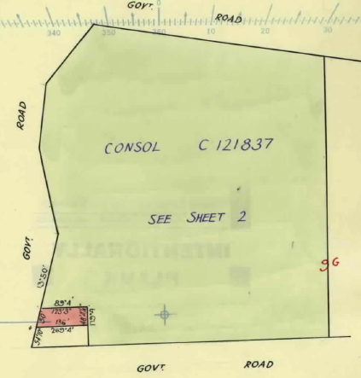
Land in Certificate of Title Volume 4788 Folio 364 being the western portion of Crown Allotment 9G, area 14 acres 0 roods and 22 perches transferred to Albert John Harford on 11/12/1923.
20/1/1955 Transfer No. 2697039 from Albert John Harford to Albert John Henry Harford of 20 Prospect Grove Black Rock Commercial Traveller.
24/2/1959 Transfer No. A692745 from Albert John Henry Harford to Arthur Tasman Walker Gentleman and Dorothy Mabel Walker Married Woman both of Yarra Road Wonga Park.
6/12/1961 Transfer as to part No. B329257, new Certificate of Title Volume 8376 Folio 963. (presumably an addition to St Marks Church of England)
Plan attached to Certificate of Title volume 4788 Folio 364 showing land transferred out ( to Church of England as an addition to St Marks)
24/12/1966 Cancelled Application No. C121837, new Certificate of Title Volume 8673 Folio 574 (Appears to be a consolidation of the land untransferred out of Volume 4788 Folio 364 into a new Certificate of Title). This land was later subdivided by Mr. and Mrs. Walker into the small blocks surrounding St Denys Crescent and possibly 6 one acre blocks to the east 3 fronting Jumping Creek Road and 3 fronting Toppings Road.

