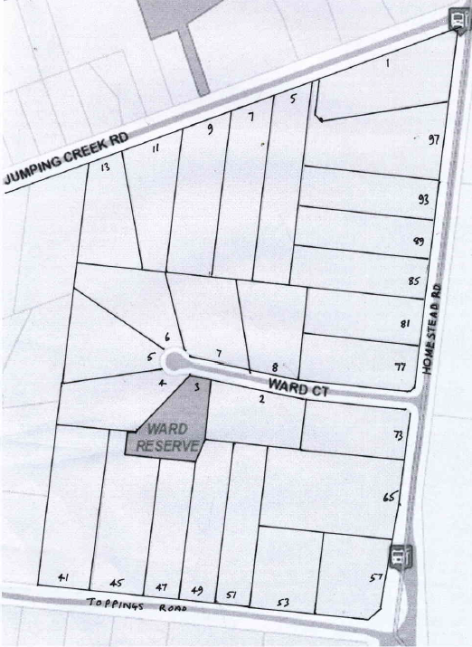
History of Crown Allotment 9H Parish Warrandyte
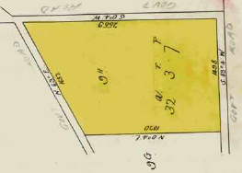
6/10/1914 Crown Grant Volume 3850 Folio 822, in consideration of the payment of 33 pounds Thompson Brooks Baishont of 59 Napier Street Fitzroy was granted 32 acres 3 roods and 7 perches being (Crown) Allotment 9 H in the Parish of Warrandyte County of Evelyn.
Plan of the land in Crown Grant No. 3850 Folio 822 for Crown Allotment 9H
4/3/1915 Mortgage No. 344591 to the Commissioners of The State Savings Bank of Victoria, discharged 31/8/1922.
Plan showing current street numbers for lands in Crown allotment 9H
6/3/1922 Mortgage No. 440?77 to Katherine Fielding, discharged 3/8/1922.
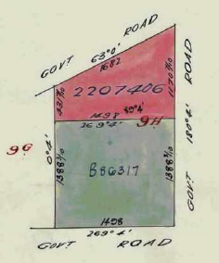
6/2/1924 Mortgage No. 483088 to The English Scottish and Australasian Bank Limited, discharged 9/1/1947.
8/11/1929 Caveat No.80984 affecting Mortgage No. 483088 lodged and lapsed 14/3/1947.
9/1/1947 Transfer No. 2059346 from Thompson Brooks Baishont to Alfred Raymond Hardidge of Croydon Road Croydon Orchardist.
7/4/1949 Transfer as to part No. 2207406 of 12 acres to Thora Victoria Clark, new Certificate of Title Volume 7258 Folio 473.
Subdivision of Crown Allotment 9H into 2 parcels of land
24/10/1960 Transfer as to balance No. B86317, area 20 acres 3 roods and 10 perches, new Certificate of Title Volume 8280 Folio488.
Certificate of Title Volume 7258 Folio 473: 1-13 Jumping Creek Road and 85-97 Homestead Road
7/4/1949 Transfer as to part No. 2207406 of 12 acres from Alfred Raymond Hardidge to Thora Victoria Clark of Alto Avenue Croydon Married Woman, being the land on the south-western corner of Jumping Creek and Homestead Roads, new Certificate of Title Volume 7258 Folio 473.
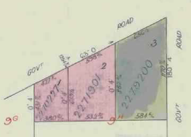
?? May 1949 Mortgage No. 917314 to William Grant Ritchie, discharged 7/11/1949.
1/12/1949 Transfer as to part No. 2270227 from Alfred Raymond Hardidge to Valston Eldridge Hancock, new Certificate of Title Volume 7613 Folio 142.
9/12/1949 Transfer as to part No. 2271901 from Alfred Raymond Hardidge to William James Bolitho, new Certificate of Title Volume 7613 Folio 901.
Subdivision of land in Certificate of Title Volume 7258 Folio 473 into 3 parcels of land. Nos. 1-13 Jumping Creek Road & 85-97 Homestead Road.
16/1/1950 Transfer as to balance No. 2279200 from Alfred Raymond Hardidge to Rex Smead, new Certificate of Title Volume 7613 folio 144.
Certificate of Title Volume 7613 Folio 142 being Lot 1 on Plan of Subdivision No. 22615: 11-13 Jumping Creek Road
1/12/1949 Transfer as to part No. 2270227 being Lot 1 on Plan of Subdivision No. 22615, area 2 acres, from Thora Victoria Clark to Valston Eldridge Hancock of Royal Australian Air force Station Point Cook Commissioned Officer of the Royal Australian Air Force, new Certificate of title Volume 7613 Folio 142.
?/12/1949 Mortgage No. 1000408 to Bank of New South Wales, discharged 8/5/1950.
8/5/1950 Mortgage No. 1003317 to Director of War Service Homes, discharged 28/8/1964.
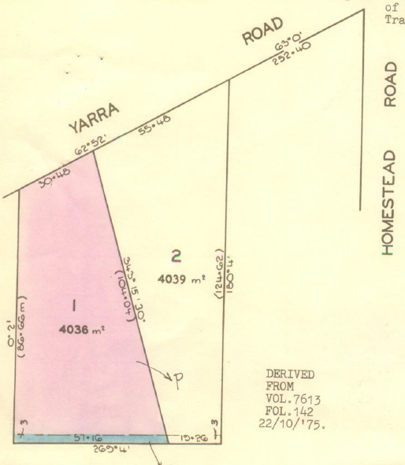
28/8/1964 Transfer No. C20315 from Valston Eldridge Hancock to John Graham Edwards Musician and Janet Patricia Christine Edwards Married Woman both of Flat 4 No. 35 Wells Street Brighton.
28/8/1964 Mortgage No. C20315 to Australia and New Zealand Savings Bank Limited, discharged 6/9/1974.
6/9/1974 Transfer No. F450130 from John Graham Edwards and Janet Patricia Christine Edwards to Graeme Williams Grazier and Janice Louise Williams Married Woman both of Moralla Avenue Croydon.
22/10/1975 Certificate of Title Volume 7613 folio 142 cancelled pursuant to Regulation 12 and Titles issued as set out hereunder – Lots One to 2 in Vol 9107 Fol 896 to Vol 9107 Fol 897. LP116162
Subdivision of Certificate of Title into 2 lots. Plan of Subdivision No. 116162 Nos. 11 &13 Jumping Creek Road.
Certificate of Title Volume 9107 Folio 896 being Lot 1 on Plan of Subdivision No. 116162: 13 Jumping Creek Road
22/10/1975 Certificate of Title Volume 9107 folio 896 for Lot 1 on Plan of Subdivision No. 116162, area 4036 square metres, issued in the names of Graeme Williams Grazier and Janice Louise Williams Married Woman both of 16 Moralla Avenue Croydon.
12/11/1975 Transfer No. F927016 from Graeme Williams and Janice Louise Williams to Charles Neville Hervey Bagot Solicitor and Catherine Ann Bagot Married Woman both of Yarra Road Wonga Park.
12/11/1975 Mortgage No. F927017 to The National Bank Savings Bank Limited, discharged 15/3/1982.
15/3/1982 Transfer No. J854328 from Charles Neville Hervey Bagot and Catherine Ann Bagot to Auspol Nominees Pty. Ltd. whose address is at the office of Jensen Kenny & Associates of 88 Whitehorse Road Ringwood.
15/3/1982 Mortgage No. J854329 to The RESI Permanent Building Society, discharged 23/5/1983.
23/5/1983 Mortgage No. K383267 to National Commercial Banking Corporation of Australia Limited, discharged 4/7/2001.
4/7/2001 Mortgage No. X577627H to National Australia Bank.
9/11/2010 Discharge No. AH603955R of Mortgage No. X577627H lodged.
9/11/2010 Transfer No. AH603955R from Auspol Nominees Pty. Ltd. to Diane Katherine Szafranski of 13 Jumping Creek Road Wonga Park Vic 3115.
9/11/2010 Mortgage No. AH603956P to Westpac Banking Corporation.
5/2/2014 Discharge No. AK880008N of Mortgage No. AH603956P lodged.
6/5/2015 Rectification of Proprietor Name / Address No. AL864917F to Diana Katherine Szafranski of 13 Jumping Creek Road Wonga Park Vic 3115.
Certificate of Title Volume 9107 Folio 897 being Lot 2 on Plan of Subdivision No. 116162: 11 Jumping Creek Road
22/10/1975 Certificate of Title Volume 9107 folio 897 for Lot 2 on Plan of Subdivision No. 116162, area 4039 square metres, issued in the names of Graeme Williams Grazier and Janice Louise Williams Married Woman both of 16 Moralla Avenue Croydon.
25/1/1980 Caveat No. H845921 lodged and lapsed 21/5/1980.
3/31980 Transfer No. H890261 from Graeme Williams and Janice Louise /Williams to Denis Patrick Tully Tiler and Patricia Ann Tully Married Woman both of 7 Balmain court Wantirna.
18/12/1980 Transfer No. J279980 from Denis Patrick Tully and Patricia Ann Tully to Laurence Arthur White Farmer and Ruth Laraine White Married Woman both of Wangandary.
4/8/1981 Mortgage No. J573671 to The Commissioners of The State Savings Bank of Victoria, discharged 17/6/1986.
15/2/1984 Mortgage No. K757122 to Australia and New Zealand Banking Group Limited, discharged 8/7/1987.
8/7/1987 Transfer No. M927798E from Laurence Arthur White and Ruth Laraine White to Peter Norman Brush & Linde Rosalind Brush of 39 Braeside Dr. Launching Place.
15/2/1984 Mortgage No. M948308T to Independent Order of Odd Fellows of Victoria Permanent Building Society, discharged 15/8/1989.
20/12/1988 Instrument (transfer or survivorship application) No. N914897U to Linde Rosalind Brush of 11 Jumping Creek Rd. Wonga Park.
15/8/1989 Transfer No. P371711L from Linde Rosalind Brush to Noel Michael Balle & Barbara Kate Hudson of 11 Jumping Creek Road Wonga Park as tenants in common in equal shares.
15/8/1989 Mortgage No. P371712H to State Bank of Victoria, discharged 24/6/1992.
24/6/1992 Transfer No. R977942X from Noel Michael Balle and Barbara Kaye Hudson to Noel Michael Balle of 11 Jumping Creek Road Wonga Park.
24/6/1992 Mortgage No. R977943U to Commonwealth Bank of Australia, discharged 12/3/1999.
15/1/1996 Transmission Application No. U43167P. Noel Michael Balle died on 6/5/1995. Probate of his Will has been granted to Michele Joy Balle of 121 Broughton Rd. Surrey Hills 3127.
12//3/1999 Transfer No. V937201X from Michele Joy Balle to Kevin Patrick Cannon & Jennifer Joan Cannon of 11 Jumping Creek Rd. Wonga Park 3115.
12/3/1999 Mortgage No. V937202U to Commonwealth Bank of Australia.
23/4/1999 Mortgage No. W5779T to commonwealth Bank of Australia.
2/8/2001 Caveat No. X641913M by Mark Joseph Gibson & Jennifer Louise Gibson as purchasers.
20/12/2001 Discharge No. X963373P of Mortgages Nos. V937202U and W005779T lodged.
20/12/2001 Transfer No. X963374L from Kevin Patrick Cannon and Jennifer Joan Cannon to Mark Joseph Gibson and Jennifer Lousie Gibson both of 11 Jumping Creek Road Wonga Park Vic 3115.
20/12/2001 Mortgage No. X963375H to National Australia Bank Limited.
Certificate of Title Volume 7613 Folio 143 being Lot 2 on Plan of Subdivision No. 22615: 5-9 Jumping Creek Road
9/12/1949 Transfer as to part No. 2271901 being Lot 2 on Plan of Subdivision No. 22615, area 4 acres, from Thora Victoria Clark to William James Bolitho of 58 Edithvale Road Edithvale Traveller, new Certificate of Title Volume 7613 Folio 901.
??/11/1952 Mortgage No. 1020340 to The Commercial Bank of Australia Limited, discharged 19/8/1954.
19/8/1954 Transfer No. 2665462 from William James Bolitho to Maxwell Leslie Swift Builder and Lorna Maria Swift Home Duties both of Main Road Kallista.
23/11/1956 Mortgage No. 255422 to Commonwealth Trading Bank of Australia.
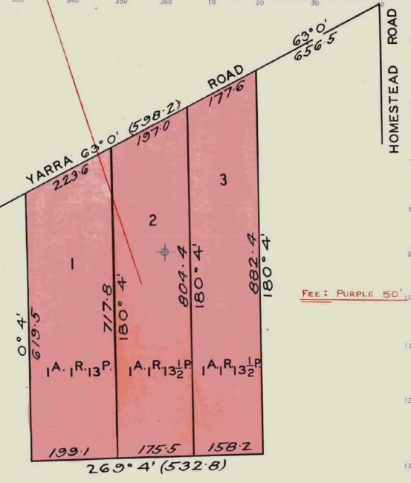
1/4/1969 Certificate of Tile Volume 7613 Folio 143 cancelled pursuant to Regulation 12 and Titles issued as set out hereunder – Lots1 to 3 in Vol 8768 Fol 190 to Vol 9768 Fol 192.
Certificate of Title Volume 8768 Folio 190 being Lot 1 on Plan of Subdivision No. 84020: 9 Jumping Creek Road
1/4/1969 Certificate of Title Volume 8768 Folio 190 for Lot 1 on Plan of Subdivision No. 84020, area 1 acre 1 rood and 13 perches, issued in the names of Maxwell Leslie Swift Builder and Lorna Maria Swift Home Duties both of Yarra Road Wonga Park.
8/7/1970 Transfer No. D768638 from Maxwell Leslie Swift and Lorna Maria Swift to Robert George Hutchings Weeks and Mary Ann Ruth Weeks both of 33 The Avenue Ferntree Gully Shop Proprietors.
Subdivision No. 80420 divided land in Certificate of Title Volume 7613 folio 143 into 3 lots, Nos. 5-9 Jumping Creek Road (then Yarra Road).
8/7/1970 Mortgage to Arthur Leslie Burton and Mary Kathleen Burton, discharged 22/7/1973.
22/6/1973 Transfer No. E868316 from Robert George Hutchings Weeks and Mary Ann Ruth Weeks to John Stanley Shinns Cleaning Contractor and Margaret Ann Shinns Married Woman both of 18 Hampshire Road Forest Hill.
22/6/1973 Mortgage No. E868317 to The RESI Permanent Building Society, discharged 8/2/1978.
8/12/1973 Caveat No. F115488 lodged and withdrawn 8/2/1978.
23/5/1974 Mortgage No. F316087 to The RESI Permanent Building Society, discharged 8/2/1978.
26/2/1976 Caveat No. G49007 lodged and withdrawn 8/2/1978.
29/1/1976 Mortgage No. G11924 to Alliance Acceptance Co. Limited, discharged 8/2/1978.
8/281978 Transfer No. G95972 from John Stanley Shinns and Margaret Anne Shinns to John Charles Stanfort Quinton Salesman and Carmel Inez Quinton Married Woman both of Holloway Road North Croydon.
26/8/1983 Transfer from John Charles Stanfort Quinton and Carmel Inez Quinton to Leendert Dekievit Trained Nurse and John Trenfield Pemberton Orderly both of 46 Jumping Creek Road Wonga Park.
5/3/1985 Mortgage No. L543904B to The Commissioners of The State Savings Bank of Victoria, discharged 8/8/1999.
26/6/1990 Survivorship Application No. P867679P. Leendert De Kievit of 9 Jumping Creek Road Wonga Park is now the surviving proprietor.
9/8/1999 Transfer No. 209563K Transfer No. W209563K from Leendert De Kievit to Michael Ralph Callaghan and Louise Mary Callaghan of 9 Jumping Creek Road Wonga Park 3115.
9/8/1999 Mortgage No. W209564G to Westpac Banking Corporation.
14/4/2004 Discharge No. AC793271B of Mortgage No. W209564G lodged.
14/4/2004 Transfer No. AC793272Y from Michael Ralph Callaghan and Louise Mary Callaghan to Louise Mary Callaghan of 9 Jumping Creek Road Wonga Park Vic 3115.
14/4/2004 Mortgage No. AC793273W to Westpac Banking Corporation.
Certificate of Title Volume 8768 Folio 191 being Lot 2 on Plan of Subdivision No. 84020: 7 Jumping Creek Road
1/4/1969 Certificate of Title Volume 8768 Folio 191 for Lot 2 on Plan of Subdivision No. 84020, area 1 acre 1 rood and 13½ perches, issued in the names of Maxwell Leslie Swift Builder and Lorna Maria Swift Home Duties both of Yarra Road Wonga Park.
9/11/1970 Mortgage No. D881269 to Irene Monica Lee Thompson, discharged 24/2/1972.
21/2/1972 Transfer from Maxwell Leslie Swift and Lorna Maria Swift to William August Kretzschmar Gentleman and Shirley Elaine Kretzschmar Married Woman both of 11 Grandview Road Box Hill.
14/11/1994 Mortgage No. T11244N to National Australia Bank Limited, discharged 20/12/1996.
3/1/2009 Transmission Application No. AG903885 to Pamela Helen Kretzschmar of 7 Jumping Creek Road Wonga Park Vic 3115 Legal Personal Representative of William August Kretzschmar who died on 20/7/1998.
3/12/2009 Transfer No. AG903886U from Pamela Helen Kretzschmar to Pamela Helen Kretzschmar of 7 Jumping Creek Road Wonga Park Vic 3115.
Certificate of Title Volume 8768 Folio 192 being Lot 3 on Plan of Subdivision No. 84020: 5 Jumping Creek Road
1/4/1969 Certificate of Title Volume 8768 Folio 192 for Lot 3 on Plan of Subdivision No. 84020, area 1 acre 1 rood and 13½ perches, issued in the names of Maxwell Leslie Swift Builder and Lorna Maria Swift Home Duties both of Yarra Road Wonga Park.
21/4/1969 Transfer No. 369337 from Maxwell Leslie Swift and Lorna Maria Swift to Riachella Proprietary Limited of 472 Bourke Street Melbourne.
28/9/1983 Transfer No. F22959 from Riachella Proprietary Limited to Alan Harry Box Solicitor and Pauline Box Married Woman both of Yarra Road Wonga Park.
13/8/1974 Mortgage No. F420100 to The Commercial Savings Bank of Australia Limited, discharged 3/4/1986.
9/4/1986 Transfer No. M215816W from Alan Harry Box and Pauline Box to Pauline Box of 5 Jumping Creek Rd. Wonga Park.
9/4/1986 Mortgage No. M215817T to National Australia Limited, discharged 27/8/17.
27/7/1987 Transfer No. M956841C from Pauline Box to Pauline Box & Allen David Crawley of 5 Jumping Creek Rd. Wonga Park as tenants in common in equal shares.
27/7/1987 Mortgage No. M956842Y to The Commissioners of The State Savings Bank of Victoria.
7/5/191 Mortgage No. 326617H to Commonwealth Bank of Australia.
22/12/2021 Discharge No. AV181017P of Mortgage No. R326617H lodged.
22/12/2021 Discharge No. AV181018M of Mortgage No. M956842Y lodged.
22/12/2021 Transfer No. AV181019K from Pauline Box and Allen David Crawley to Benjamin Paul Neagle and Nicole Louise Neagle both of 5 Jumping Creek Road Wonga Park Vic 3115.
22/12/2021 Mortgage No. AV181020B to Secure Funding Pty Ltd.
Certificate of Title Volume 7613 Folio 144 being Lot 3 on Plan of Subdivision No. 22615: 1 Jumping Creek Road and 85-97 Homestead Road
16/1/1950 Transfer as to balance No. 2279200 being Lot 3 on Plan of Subdivision No. 22615 area 6 acres, from Thora Victoria Clark to Rex Smead of 12 Yeovil Road Burwood Delicatessan Proprietor, new Certificate of Title Volume 7613 folio 144.
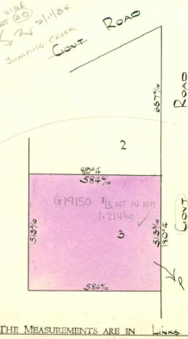
1/6/1954 Mortgage No. A170357 to The Commercial Bank of Australia Limited, discharged 16/11/1964.
14/8/1957 Transfer as to part No. A385917, area 3 acres, new Certificate of Title Volume 8163 Folio 531.
6/11/1964 Transfer as to balance No. C83973, new Certificate of Title Volume 8542 Folio 170.
Certificate of Title Volume 8163 Folio 531 being Lot 3 on Plan of Subdivision No. 33666: 85-93 Homestead Road
14/8/1957 Transfer as to part No. A385917, area 3 acres, from Rex Smead to Leonard Alfred Emselle Sign Writer and Edna Lily Emselle Home Duties both of Mitcham Road Mitcham, new Certificate of Title Volume 8163 Folio 531.
25/8/1958 Transfer No. A592148 from Leonard Alfred Emselle and Edna Lily Emselle to Payne’s Bon Marché Pty. Limited of 128 Bourke Street Melbourne.
Lot 3 on Plan of Subdivision No. 33666 Certificate of title Volume 8163 Folio 531, Nos 85-93 Homestead Road.
25/6/1959 Transfer No. A764219 from Payne’s Bon Marché Pty. Limited to Raymond Borg of 62 Bolingbroke Road Pascoe Vale Gentleman.
25/6/1959 Transfer No. A764220 from Raymond Borg to Albina Pace Married Woman, Arlette Pace Clerk and Mario Scotto Electrician all of 146 Munro Street West Coburg as tenants in common in equal shares.
4/2/1976 Transfer as to the interest of Albina Pace No. G19150 cancelled as to the said interest and as to the interest of Arlette Waitzer (formerly Pace), see Vol 9135 Fol 066.
27/3/1985 Transfer as to part No. L581054L, new Certificate of Title Vol 9608 Folio 024.
27/5/1985 Transfer as to part No. L683970, new Certificate of Title Volume 9631 Folio 281.
23/5/1985 Transfer as to balance No. L700730, new Certificate of Title Volume 9631 Folio 282.
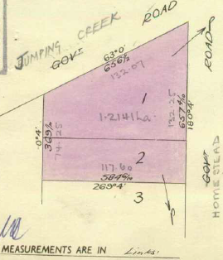
Certificate of Title Volume 8542 Folio 170 being Lots 1 & 2 on Plan of Subdivision No. 33666: 1 Jumping Creek Road and 97 Homestead Road
6/11/1964 Transfer as to balance of Certificate of Title Volume 7613 Folio 144 No. C83973 being Lots 1 & 2 Plan of Subdivision No. 33666, area 3 acres at the south-west corner of Jumping Creek Road (in 1964 called Yarra Road) and Homestead Road from Rex Smead to Riachella Proprietary Limited of 472 Bourke Street Melbourne, new Certificate of Title Volume 8542 Folio 170. (Riachella Pty Ltd was a trustee company and Henry Powell Box held the beneficial interest in the land.)
27/5/1974 Transfer No. F320191 from Riachella Proprietary Limited to Henry Powell Box of 472 Bourke Street Melbourne Solicitor.
Lots 1 & 2 on Plan of Subdivision No. 33666 Certificate of Title Volume 8542 Folio 170, No. 1 Jumping Creek Road & No. 97 Homestead Road
23/7/1980 Transfer as to part No. J82068 (Lot 2), new Certificate of Title Volume 9394 Folio 556.
6/8/1980 Creation of Easement No. J101244.
Transfer as to part and Plan of Consolidation: Transfer registered 19/12/1989 and Plan of Consolidation registered 30/4/1990. Cancelled as to part see Vol 9946 Fol 709. Nos. P579486L and CP 172360J.
12/7/1990 Cancelled as to balance – Application No. P898404S See Vol. 9998 Fol.998
Certificate of Title Volume 9998 Folio 998 being part of Lot 1 on Plan of Subdivision No. 134134: 1 Jumping Creek Road
12/7/1990 Henry Powell Box of 1 Jumping Creek Road Wonga Park is the proprietor … (of) part of Lot 1 on Plan of Subdivision No. 134134, area 5702 square metres and being on the south-western corner of Jumping Creek and Homestead Roads.
3/12/1997 Transfer from Henry Powell Box to Catherine Helen Magner & Bernard Thomas Magner of Lincoln Road Croydon 3136.
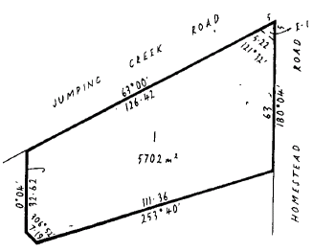
3/12/1997 Mortgage No. V126424C to Westpac Banking Corporation, discharged 19/1/2000.
19/1/2000 Mortgage No. W536792K to Rams Mortgage Corporation, discharged 8/6/2001.
8/6/2001 Transfer No. X525044S from Catherine Helen Magner and Bernard Thomas Magner to Leonard Bryson-Haynes & Aliyah Katherine Bryson-Haines of 1 Jumping
Creek Road Wonga Park 3115.
Part Lot 1 PS 134134 Certificate of Title Volume 9998 Folio 998, No. 1 Jumping Creek Road
18/3/2004 Transfer No. AC744127L from Leonard Bryson-Haines and Aliyah Katherine Bryson-Haines to Gregory Charles Petherick and Simone Lee Dimtsas-Ritchie both of 257
18/3/2004 Mortgage No. AC744128J to Australia and New Zealand Banking Group Limited.
8/2/2011 Caveat No. AH770783H by Jason Scott Plehn as purchaser.
22/3/2011 Discharge No. AH851190M of Mortgage No. AC744128J lodged.
22/3/2011 Transfer No. AH851191K from Gregory Charles Petherick and Simone Lee Dimtsas-Ritchie to Jason Scott Plehn of 1 Jumping Creek Road Wonga Park Vic 3115 and lapsing of Caveat No. AH770783H.
22/3/2011 Mortgage No. AH851129H to Australia and New Zealand Banking Group limited.
28/3/2014 Mortgage No. AK992747W to Australia and New Zealand Banking Group limited.
5/8/2015 Discharge No. AM083038F of Mortgage No. AK992747W lodged.
14/9/2016 Discharge No. AN101750H of Mortgage No. AH851129H lodged.
14/9/2016 Mortgage No. AN101753B to Commonwealth Bank of Australia.
20/10/2020 Discharge No.AT707050H of Mortgage No. AN101753B lodged.
20/20/2020 Mortgage No. AT707051F to AFSH Nominees Pty Ltd.
29/6/2021 Caveat No. AU513127U lodged by Farzeen Anwar and Matthew Thomas Harrigan as purchasers under contract dated 22/6/2021.
22/10/2021 Discharge No.AU941897C of Mortgage No. AT707051F lodged.
22/10/2021 Transfer No. AU941898A from Jason Scott Plehn to Matthew Thomas Harrigan and Farzeen Anwar both of 1 Jumping Creek Road Wonga Park Vic 3115.
22/10/2021 Mortgage No. AU941899X to Commonwealth Bank of Australia.
Certificate of Title Volume 9394 Folio 556 being Lot 2 on Plan of Subdivision No. 134134: 97-99 Homestead Road Wonga Park (Postal Address and Access from 3 Jumping Creek Road Wonga Park)
23/7/1980 Barry James Box Solicitor and Robyn Marie Box Married Woman both of Homestead Road Wonga Park are the proprietors … (of) Lot 2 on Plan of Subdivision No. 134134, area 6229 square metres.
6/8/1980 An easement of way appurtenant to the within land has been created by Instrument J101244 (to provide access to Jumping Creek Road).
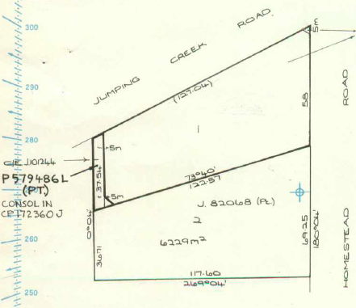
22/5/1981 Mortgage No. J473227 to The Commercial Savings Bank of Australia Limited, discharged 7/3/1986.
30/4/1990 Certificate of Title cancelled pursuant to Plan of Consolidation No. 172360J see Vol. 9946 Fol 709.
30/4/1990 In Certificate of Title Volume 9946 Folio 709 Barry James Box and Robyn Marie Box both of 3 Jumping Creek Road are joint proprietors of … the land in Plan of Consolidation No. 172360J.
14/8/1997 Mortgage No. U928127L to Westpac Banking Corporation, discharged 25/8/2000.
Lots 1&2 PS 33666 re-subdivided, easement of way created across Lot 1 benefiting Lot 2 giving access to Jumping Creek Road, then later the land in the easement of way transferred and consolidated with the new Lot 2.
Certificate of Title Volume 8280 Folio 488: 57-81 Homestead Road, 2-8 Ward Court and 41-53 Toppings Road
24/10/1960 Transfer as to balance No. B86317, area 20 acres 3 roods and 10 perches being the land on the north-eastern corner of Toppings and Homestead Roads from Alfred Raymond Hardidge to Mary Joyce Gray of 97 Broughton Road Surrey Hills Married Woman, new Certificate of Title Volume 8280 Folio488. (NB From 24/10/1960 to 30/5/1962 neither of the Hardidges were registered as owners of land in Crown Allotment 9H)
30/5/1962 Transfer as to part No. B430739, new Certificate of Title Volume 8445 Folio 444.
12/5/1969 Transfer as to the balance No. D387272, new Certificate of Title Volume 8780 Folio 243.
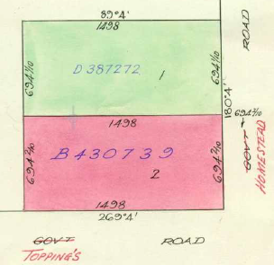
Certificate of Title Volume 8445 Folio 444: 57-65 Homestead Road and 41-53 Toppings Road
30/5/1962 Transfer as to part No. B430739 of Lot 2 on Plan of Subdivision No. 45637, area 10 acres 1 rood and 23.4 perches from Mary Joyce Gray to Alfred Raymond Hardidge of Homestead Road Croydon North Orchardist, new Certificate of Title Volume 8445 Folio 444.
15/9/1972 Caveat No. E533534 lodged.
The land in Certificate of Title Volume 8445 Folio 447 subdivided into 2 lots and Alfred Raymond Hardidge regains ownership of the southern lot.
28/6/1973 Certificate of Title Volume 8445 Folio 444 cancelled as to part pursuant to Regulation 12 and Titles issued as set out hereunder – Lots One to 2 in Vol 8979 Fol126 to Vol 8979 Fol 127 LP 97769.
Certificate of Title Volume 8780 Folio 243: 73-81 Homestead Road and 2-8 Ward Court
12/5/1969 Transfer as to the balance No. D387272 being Lot 1 on Plan of Subdivision No. 45637, area 10 acres 1 rood and 23.4 perches from Mary Joyce Gray to Mary Joyce Gray of 34 Sackville Street Kew Married Woman and Annie May Franks of 14A Wills Street Balwyn Gentlewoman as joint proprietors, new Certificate of Title Volume 8780 Folio 243.
1912/1977 By Survivorship Application No. G906867 – Mary Joyce Gray is now the Surviving Proprietor.
23/6/1978 Transfer as to part No. H126179, new Certificate of Title Volume 9297 Folio 717 being a recreation reserve.
10/4/1981 Mortgage No. J417364 to the Commercial Banking Company of Sydney Limited, discharges as to part 21/9/1982 No. K94331, discharged as to part being the land in Transfer No. K29315 10/3/1984 and discharged as to part being the land Transfer No. K363250 9/5/1983. Discharged 15/9/1983
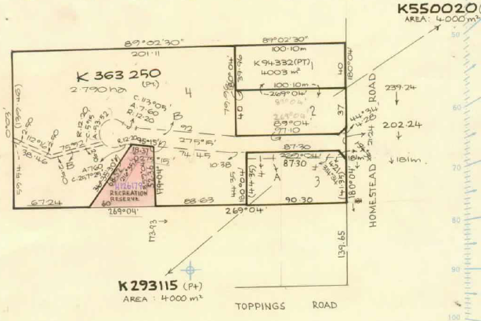
2/9/1982 Transfer as to part No. K94332 for Lot 1, new Certificate of Title Volume 9491 Folio 035.
14/1/1983 Caveat No. K230252 lodged affecting the land in Lot 3 LP 12527. Caveat will lapse on registration of K29315 - 22/4/1983.
10/3/1983 Transfer as to part No. K293115 for Lot 3, new Certificate of Title Volume 9508 Folio 636.
9/5/1983 Transfer as to part No. K363250 for Lot 4, new Certificate of Title Volume 9516 Folio 627.
Certificate of Title Volume 8780 Folio 243. LP 125277 is the 1st stage of the subdivision of the land around Ward Court
15/9/1983 Transfer as to balance No. K550020 for Lot 2, new Certificate of Title Volume 9528 Folio 699.
Certificate of Title Volume 9516 Folio 627: 2-8 Ward Court
9/5/1983 Transfer as to part No. K363250 for Lot 4, area 2.790 hectares, from Mry Joyce Gray to Mondar Pty. Ltd. of 117 Waverley Road East Malvern, new Certificate of Title Volume 9516 Folio 627.
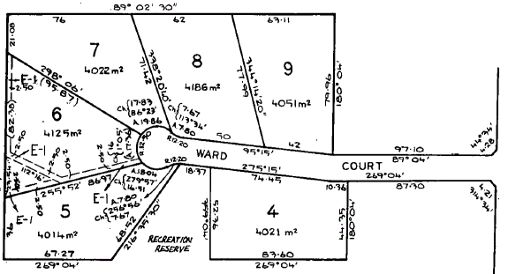
9/5/1983 Mortgage No. K363251 to National Commercial Banking Corporation of Australia Limited, discharged 16/3/1984.
16/3/1984 Transfer No. K803096 from Mondar Pty. Ltd. to Wigby Pty. Ltd. of 13 Sinclair Avenue Lower Templestowe.
2/8/1985 Certificate of Title Volume 9516 Folio 627 cancelled. The following Titles have been issued pursuant to Regulation 12 of the Transfer of Land Act: Lots 4 to 9 in Vol 9624 Fol 238 to Vol 9624 Fol 243 and pursuant to Section 32 of the Transfer of Land Act being land appropriated for easements of carriageway, drainage, sewerage, gas supply and telephone in Vol 9624 Fol 244 on LP 146611U.
Lots 4 to 9 on Plan of Subdivision No. 14661U, Nos. 2 to 8 Ward Court.
Certificate of Title Volume 9624 Folio 238: 2 Ward Court
2/8/1985 Certificate of Title Volume 9624 Folio 238 issued for Lot 4 on Plan of Subdivision No. 146611U, area 4021 square metres, in the name of Wigby Pty. Ltd. of 3 Margot Avenue Doncaster.
2/4/1986 Transfer No. M206052M from Wigby Pty. Ltd. to John Barry Castle & Anita Valda Castle of 76 Gracedale Ave. North Bayswater.
2/4/1986 Mortgage No. M206053J to Australia And New Zealand Banking Group Limited, discharged 17/11/1986.
23/5/1988 Creation of Easement No. N471311T registered.
23/8/1988 Transfer No. N656736M from John Barry Castle and Anita Valda Castle to Robert Michael Blackwell & Janet Margaret Blackwell of 6 James Milne Dr. Croydon.
23/8/1988 Mortgage No. N656737J to Westpac Savings Bank Limited.
Certificate of Title Volume 8445 Folio 444: 65 Homestead Road and 41 to 57 Toppings Road

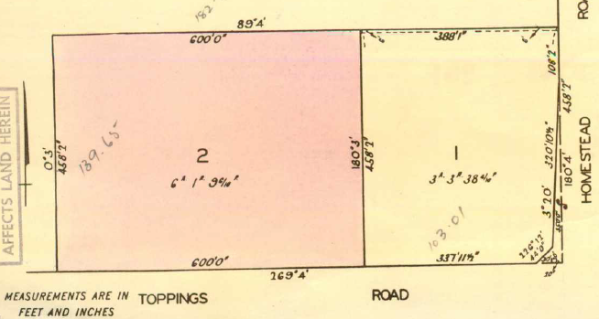
30/5/1962 Transfer as to part No. B430739 of Lot 2 on Plan of Subdivision No. 45637, area 10 acres 1 rood and 23.4 perches from Mary Joyce Gray to Alfred Raymond Hardidge of Homestead Road Croydon North Orchardist, new Certificate of Title Volume 8445 Folio 444.
15/9/1972 Caveat No. E533534 lodged.
28/6/1973 Certificate of Title Volume 8445 Folio 444 cancelled as to part pursuant to Regulation 12 and Titles issued as set out hereunder: Lots One to 2 in Vol 8979 Fol 126 to Vol 8979 Fol 127, LP 97769.
Lots 1 & 2 on Plan of Subdivision No. 97769, Certificates of Title Volume 8979 Folios 126 & 127

Certificate of Title Volume 8979 Folio 126: 65 Homestead Road and 53 to 57 Toppings Road
28/6/1973 Certificate of Title Volume 8979 Folio 126 issued for Lot 1 on Plan of Subdivision No. 97769, area 3 acres 3 roods and 38.4 perches, in the name of Alfred Raymond Hardidge of Homestead Road Croydon North Orchardist.
15/9/1972 Caveat No. E533534 lodged, withdrawn as to the within land 12/5/1975.
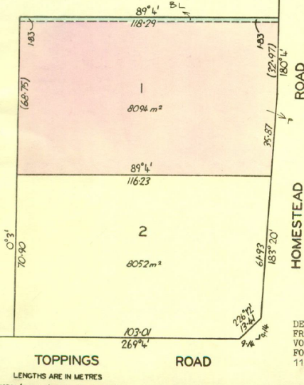
11/9/1975 Certificate of Title Volume 8979 Folio 126 cancelled pursuant to Regulation 12 and Titles issued as set out hereunder: Lots One to 2 Vol 9103 Fol 380 to Vol 9103 Fol 381, LP115442.
Certificate of Title Volume 9103 Folio 380: 65 Homestead Road
11/9/1975 Certificate of Title Volume 9103 Folio 380 issued for Lot 1 on Plan of Subdivision No. 115442, area 8094 square metres, in the name of Alfred Raymond Hardidge of Homestead Road Croydon North Retired Orchardist.
18/11/1975 Transfer No. F933091 from Alfred Raymond Hardidge to Alfred Thomas Hardidge of Homestead Road Wonga Park Cleaner.
Lot 1 on Plan of Subdivision No. 97769 subdivided into 2 lots by Plan of Subdivision No. 115442

18/11/1975 Mortgage No. F933092 to Commonwealth Trading Bank of Australia.
24/6/2004 Mortgage No. AC941202A to Commonwealth Bank of Australia.
Certificate of Title Volume 9103 Folio 381: 53 to 57 Toppings Road
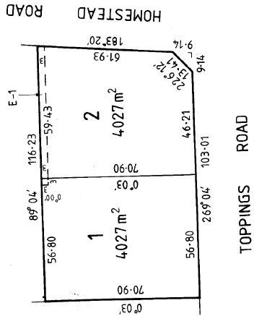
11/9/1975 Certificate of Title Volume 9103 Folio 381 issued for Lot 2 on Plan of Subdivision No. 115442, area 8052 square metres, in the name of Alfred Raymond Hardidge of Homestead Road Croydon North Retired Orchardist.
6/10/1979 Transmission Application No. H712002. Alfred Raymond Hardidge died on 3rd June 1979. Probate of his Will has been granted to Violet Gertrude Hardidge Widow and Alfred Thomas Hardidge School Cleaner both of Homestead Road North Croydon and Faye Alice Chettle of 24 Croydondale Drive Mooroolbark Home Duties.
1/9/1989 Certificate of Title Volume 9103 Folio381 cancelled. The following Titles have been issued pursuant to Regulation 10 of the Transfer of Land Act: Lots one to 2 in Vol 9899 Fol 585 to Vol 9899 Fol 586 being Lots 1 & 2 on Plan of Subdivision No. 215302B.
Lot 2 on Plan of Subdivision No. 115442 subdivided into 2 lots by Plan of Subdivision No. 215302B being Nos. 53 & 57 Toppings Road.

Certificate of Title Volume 8979 Folio 127: 41 to 51 Toppings Road
28/6/1973 Certificate of Title Volume 8979 Folio 127 issued for Lot 2 on Plan of Subdivision No. 97769, area 6 acres 1 rood and 9.6 perches, in the name of Alfred Raymond Hardidge of Homestead Road Croydon North Orchardist.
15/9/1972 Caveat No. E533534 lodged and lapsed as to the within land on 4/5/1978.
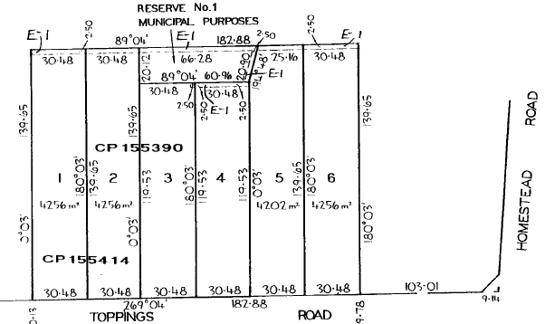
29/9/1977 Transfer No. G808854 from Alfred Raymond Hardidge to J.P. Vincent Pty. Ltd. of 38 Jocelyn Court Doncaster East and T.C. Porter Pty. Ltd. of 535 Glenhuntly Road Elsternwick.
11/1/1979 Mortgage No. H368235 to Australia And New Zealand Banking Group Limited, discharged as to part being the land in Transfer No. H873435 19/2/1980.
9/5/1980 Certificate of Title Volume 8797 Folio 127 cancelled as to part pursuant to Regulation 12 and Titles issued as set out hereunder: Lots one to 6 in Vol 9373 Fol 257 to Vol 9373 Fol 262 LP 131490. At some stage the owners of Lot 1 and 3 purchased Lot 2 and subdivided it into 2 and then they each consolidated a half of lot 3 with their lots 1 and 3.
Lot 2 on Plan of Subdivision No. 97769 was subdivided into 6 lots by Plan of Subdivision No. 131490
19/2/1980 Transfer as to balance No. H873435 new Certificate of Title Volume 9389 Folio 204 being Reserve 1 for Municipal Purposes on Plan of Subdivision No. 131490.

