History of Crown Allotment 9Q Parish Warrandyte
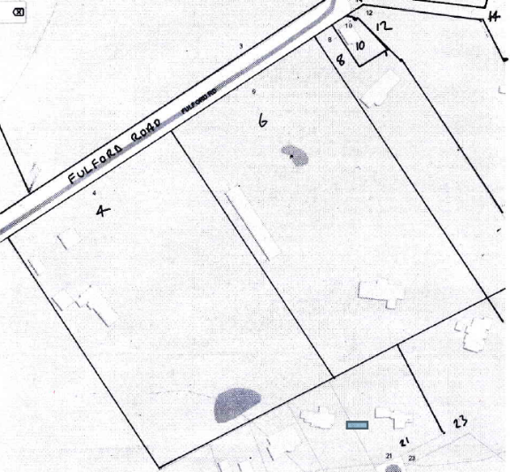
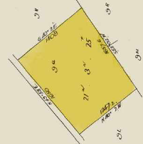
12/2/1914 Crown Grant Volume 3791 Folio 120, in consideration of the payment of 16 pounds10 shillings Edward Robert Burch of Croydon Plasterer was granted 21 acres 3 roods and 25 perches being (Crown) Allotment 9Q in the Parish of Warrandyte County of Evelyn. Street Address: 4 & 6 Fulford Road Wonga Park
Map of Crown Allotment 9Q showing property boundaries and street numbers
Title Plan from Crown Grant Volume 3791 Folio 120 showing the land in Crown allotment 9Q
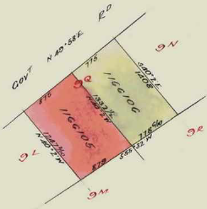
20/5/1924 Transfer as to part No. 1166105 from Edward Robert Burch to Edward Henry Frank Burch, new Certificate of Title Volume 4852 Folio 332. Street Address: 4 Fulford Road Wonga Park
20/5/1924 Transfer as to balance No. 1166106 from Edward Robert Burch to Horace Frederick George Burch, new Certificate of title Volume 4852 Folio 333. Street Address: 6 Fulford Road Wonga Park
************************************
20/5/1924 Certificate of Title Volume 4852 Folio 332, area 11 acres 1 rood and 6 perches being part of Crown Allotment 9Q issued in the name of Edward Henry Frank Burch of Wonga Park Orchardist. Street Address: 4 Fulford Road Wonga Park
Plan showing subdivision of Crown Allotment 9Q by transfer as to part and as to balance by Edward Robert Burch to his sons Edward Henry Frank Burch and Horace Frederick George Burch
30/4/1925 Mortgage No. 518558 to The Colonial Mutual Life Assurance Society Limited, discharged10/3/1929.
26/6/19?? Mortgage to The Colonial Mutual Life Assurance Society Limited, discharged 23/10/1940.
9/12/1963 Caveat No. B811488 lodged and lapsed 31/12/1968.
4/12/1968 Transfer No. D261025 from Edward Henry Frank Burch to Irene Constance Balmain Hudson of Fulford Road Wonga Park.
24/11/1992 Caveat No. S233209N by Norm Fisher, Caveat lapsed 12/10/1993.
27/8/1996 Caveat No. U376423K by James Hudson Vains, Caveat withdrawn 18/6/1997 by U828395K.
28/10/1997 Transmission Application No. Y62490P: Irene Constance Balmain Hudson died on 6/8/1996. Probate of her Will has been granted to Norman Arthur Fisher of 4 Fulford road Wonga Park 3115.
25/3/1998 Caveat No. V337735W by Michelle Sciberras as purchaser. Caveat will lapse on registration of V589659M – 19/8/1998.
17/8/1998 Transfer No. U589659M from Norman Arthur Fisher to Michelle Sciberas of 4 Fulford Rd. Wonga Park 3115.
17/8/1998 Mortgage No. V589660M to Westpac Banking Corporation.
17/8/1998 Mortgage No. V589661M to Westpac Banking Corporation.
13/10/2004 Discharge No. AD177204V of Mortgages Nos. V589660M and V589661J lodged.
13/10/2004 Transfer No. AD177205T from Norman Arthur Fisher to Lindy Whitfort of 4 Fulford Road Wonga Park Vic 3115.
13/10/2004 Mortgage No. AD177206R to Commonwealth Bank of Australia.
26/11/2015 Certificate of Title Volume 4852 Folio 332 cancelled by AM359072U and Computer Folio created as Volume 11615 Folio 713.
20/8/2021 Discharge No. AU713446M of Mortgage No. AD177206R lodged.
*************************************************************************
20/5/1924 Certificate of Title Volume 4852 Folio 333, area 10 acres 2 roods and 19 perches being part of Crown Allotment 9Q issued in the name of Horace Frederick George Burch of Wonga Park Orchardist. Street Address: 6 Fulford Road Wonga Park
30/11/1954 Transfer No. 2685903 from Horace Frederick George Burch to David Walter Fulford of Fulford Road Wonga Park.
22/4/1965 Transfer No. C198146 from David Walter Fulford to Eliasz Semenow Poultry Farmer and Stefania Semenow both of Wonga Road Ringwood.
21/10/1965 Mortgage No. C341957 to The English Scottish And Australian Bank Limited, discharged 3/10/1968.
15/2/1966 Mortgage No. C421780 to Robert Hutchinson Limited, discharged 3/10/1968.
3/10/1968 Mortgage No. D205203 to Credit House (Vic) Proprietary Limited, discharged 30/4/1973.
21/8/1969 Mortgage to The Commercial Banking Company of Sydney Limited, discharged 30/4/1973.
21/4/1971 Caveat No. E18495 lodged and withdrawn 30/4/1973.
30/4/1973 Transfer No. E791817 from Eliazs Semenow and Stefania Semenow to Svetomir Trajkovic Driver and Dracica Trajkovic Married Woman both of 12 Alexandra road East Ringwood.
30/4/1973 Mortgage No. E791818 to Network Finance Limited, discharged 6/8/1975.
6/8/1975 Transfer No. F802101 from Svetomir Trajkovic and Dracica Trajkovic to Raymond John Smith Senior Technical Officer and Valerie Merle Smith Married Woman both of 20 McKeller Street Watsonia.
6/8/1975 Mortgage No. F802102 to Network Finance Limited, discharged 29/10/1979.
8/6/1978 Mortgage No. H172148 to The National Bank of Australasia Limited, discharged 29/10/1979.
29/10/1979 Mortgage No. H741823 to The Commercial Banking Company of Sydney Limited.
9/11/1979 Mortgage No. H758317 to Commercial & General Acceptance Limited.
1/10/1980 Title Cancelled by Application J174282 registered for Second Edition Title. (Apparently second page of the Certificate of Title was full of endorsements and a second edition of the Certificate was issued.)
1/10/1980 Certificate of Title Volume 4852 Folio 333 Second Edition issued in the names of Valerie Merle Smith Secretary and Raymond John Smith Farmer both of Fulford Road Wonga Park as tenants in common in equal shares subject to Mortgage No. H741823 discharged 26/10/1982 and Mortgage No. H758317 discharged 8/12/1980. (It would appear that Application J174282 was a transfer from Raymond John Smith and Valerie Merle Smith as joint proprietors to Valerie Merle Smith and Raymond John Smith as tenants in common in equal shares.)
26/10/1982 Transmission application No.K136478: As to the interest of Raymond John Smith who died on the 23rd April 1982 Probate of his Will has been granted to Valerie Merle Smith Widow and Wayne Gregory Smith Student both of Fulford Road Wonga Park, Michell Wendy Janssen of 56 Matthews Court Launching Place Married Woman and Robert Leslie Uppen Solicitor of 400 Lonsdale Street Melbourne.
26/10/1982 Mortgage No. K136479 as to the interest of Valerie Merle Smith to The Commercial Banking Company of Sydney Limited, discharged 12/7/1983.
26/10/1982 Mortgage No. K136480 as to the interest of Raymond John Smith to the Commercial Banking Company of Sydney Limited, discharged 12/7/1983.
12/7/1983 Transfer No. K454353 from Valerie Merle Smith, Wayne Gregory Smith, Michelle Wendy Janssen and Robert Leslie Uppen to Nineteenth Nesbarb Pty. Ltd. of 210 diamond Creek Road Greensborough.
12/7/1983 Mortgage No. K454354 to Westpac Banking Corporation, discharged 3/10/1985.
3/10/1985 Transfer No. L919281N from Nineteenth Nesbarb Pty. Ltd. to Nasron Pty. Ltd. of Fulford road Wonga Park.
3/10/1985 Mortgage No. L919282K to Westpac Banking Corporation, discharged16/5/1990.
16/5/1990 Transfer No. P799980V from Nasron Pty. Ltd. to Ian Geoffrey Anderson & Dianne Lesley Anderson of Anzac Rd. Warrandyte South.
16/5/1990 Mortgage No. P799981S to Westpac Banking Corporation, discharged 5/10/1993.
5/10/1993 Transfer No. S723423C from Ian Geoffrey Anderson & Dianne Lesley Anderson to Allan John Overall & Diana June Overall “Lauriston” 6 Fulford Rd. Wonga Park.
2/10/1993 Mortgage No. S723424Y to Ringwood (No. 1) Co-operative Housing Society Limited.
4/7/2006 Transfer No. AE462726Q of Mortgage No. AE462726Q from Ringwood (No. 1) Co-operative Housing Society Limited to Crucis Pty. Ltd.
9/8/2007 Discharge No. AF261134E of Mortgage No. S723424Y lodged.
15/8/2007 Transfer No. AF275090U from Allan John Overall and Diana June Overall to Diana June Overall of 6 Fulford Road Wonga Park Vic 3115.
11/5/2009 Mortgage No. AG498291F to National Australia Bank Ltd.

