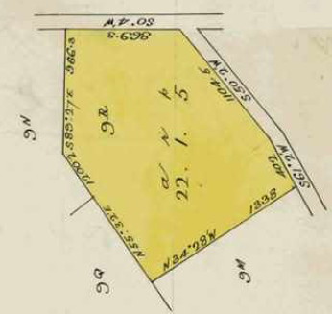**Crown Allotments 9R and 9ROne** bounded on the south by Paynters Road, on the east by Reserve Road and on the west by Crown allotment 9M and on the north by Crown Allotments 9Q and 9N. Although this was the land initially settled by Walter Fulford in 1893 he later moved to Crown Allotment 9N. He sold the western part of nearly 9 acres in 1903 and the balance of a bit over 13 acres in 1918.

Street numbers for properties in Paynters Road and Violet Court Wonga Park

Crown Allotment 9R Parish of Warrandyte County of Evelyn on the corner of Reserve and Paynters Roads Wonga Park

1/12/1899 Crown Grant No. 2892 Folio 394 for the sum of Seventeen pounds and five shillings, area 22 acres 1 rood and 5 perches being Crown Allotment 9R to Walter Fulford of Croydon Gardener.

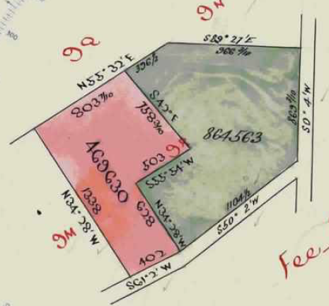 30/3/1903 Transfer as to part No. 469630 from Walter Fulford to **George Zimmermann** of No. 34 Jeffcott Street West Melbourne Jeweller the western portion of the land, area 8 acres 3 roods and 12 perches, new Certificate of Title Volume 2922 folio 268.

9/9/1918 Transfer as to the balance (of the land in Crown Grant No. 2892 Folio 394) No. 864563, area 13 acres I rood and35 perches to **His Majesty King George V**, new Certificate of Title Volume 4149 folio 794. No further dealings on this Certificate of Title but the land referred to therein was regranted by the Crown in Crown Grant Volume 6111 Folio 081 on 24/11/1936. See Crown Grant details below.

The western and eastern parts of Crown Allotment 9R. The eastern part subsequently became Crown Allotment 9ROne.

22/3/1920 Transfer No. 930159 of the land in Certificate of Title Volume 2922 Folio 268 (the western portion of Crown Allotment 9R) from George Zimmermann to **William Henry Wright** of Mooulim Park Arcadia Farmer.

25/1/1927 Caveat No. 56711 lodged, lapsed 22/10/1932.

22/10/1932 Transfer No. 1510975 from William Henry Wright to **Alphonse Reynolds** of Macclesfield Farmer.

16/11/1932 Transfer No. 1513192 from Alphonse Reynolds to **Daisy Edith Thomas** of 54 Cruickshank Street Port Melbourne Married Woman.

9/10/1942 Transfer No. 1869032 from Daisy Edith Thomas to **Edith May Ahrens** of Wonga Park Married Woman.

10/4/1946 Transfer No. 1999662 from Edith May Ahrens to **Annie May Todner Gill** Married Woman and **Raymond Oswald Gill** State School Teacher both of 21 The Avenue Balaclava.

3/12/1952 Transfer No. 2526246 from Annie May Todner Gill and Raymond Oswald Gill to **Walter Thomas Colville** Sawyer and **Elsie Edna Colville** Spinster both of Paynters Road Wonga Park.

Transfer A405768 to Certificate of Title Volume 8168 Folio 063 of 7a 3r 12.5p leaving balance of 1 acre

**Part Crown Allotment 9R, Certificate of Title Volume 8168 Folio 063, area 7 acres 3 roods and 12.5 perches, Street Address: parts of Nos. 33, 35 & 35A Paynter’s Road & 21 & 23 Barooga Drive Wonga Park**

19/9/1959 Transfer as to part and creation of easement No. A405768 from Walter Thomas Colville and Elsie Edna Colville to **George David Duncan** of 37 Kingston Road Surrey Hills Retired Military Officer, new Certificate of Title Volume 8168 Folio 063 of 7 acres 3 roods and 12 and 5/10 perches, leaving a 1acre parcel of land at the south-western corner of the land.

9/12/1971 Transfer No. E247680 of the land in Certificate of Title Volume 8168 Folio 063 from George David Duncan to **Graeme Stuart Galbraith** Research Officer and **June Marion Galbraith** Married Woman both of 3 Pound Road Warrandyte. (NB on the same date Graeme Stuart and June Marion Galbraith became registered as proprietors of the bulk of the land in Crown Grant Volume 6111 Folio 081)

9/12/1971 Mortgage No. E247682 to Nancy Marion Rogerson, discharged 8/2/1974.

17/5/1974 Mortgage No. F308677 to The Commissioners of The State Savings Bank of Victoria, discharged 29/10/1979.

27/12/1979 Transfer as to part No. H817115, new Certificate of Title Volume 9369 Folio 003, being Lot 1 on Plan of Subdivision No. 132428, being **Street Address No.** **33 Paynters Road Wonga Park.**

Plan of Subdivision No. 132428 of lands in Certificates of Title Volume 8168 Folio 063 and Volume 8912 Folio 478 being the bulk of the land in Crown Allotment 9R and some of the land in Crown Allotment 9ROne.

15/12/1982 Transfer as to part No. K198318, new Certificate of Title Volume 9503 Folio 240 being Lot 2 on Plan of Subdivision No. 132428, being **Street Address Nos**. **35 & 35A Paynters Road and 21 & 23 & Barooga Drive Wonga Park**.

7/3/1984 Transfer as to balance No. K789890, new Certificate of Title Volume 9553 Folio 398, being Reserve 1 on Plan of Subdivision No. 132428, being the Reserve now known as **Barooga Reserve**.

***********************************************************************

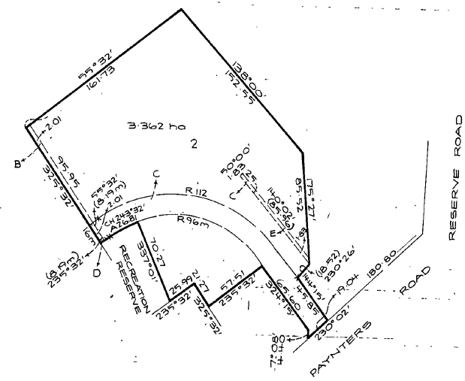Certificate of Title Volume 9503 Folio 240, area 3.362 hectares, being Lot 2 on Plan of Subdivision No. 132428 in the names of **Eamonn Anthony McDonnell** Civil Engineer and **Patricia Jean McDonnell** Married Woman both of 14 Larkspur Avenue Doncaster **Street Address: 35 & 35A Paynters Road and 21 & 23 Barooga Drive Wonga Park**

Certificate of Title Volume 9503 Folio 240 (lot 2 on Plan of Subdivision No. 132428 in the names of Eamonn Anthony McDonnell and Patricia Jean McDonnell

19/11/2001 Caveat No. X890296G by Colin Stephen Fenton lodged.

25/5/2002 Withdrawal No. AB303326A of Caveat No. X890296G lodged.

Plan of Subdivision No. 517894W. NB Lot 1 is Barooga Drive

25/5/2002 Discharge No. AB303327X of Mortgage No. L058280V lodged.

25/5/2002 Transfer No. AB303329T from Eamonn Anthony McDonnell and Patricia Jean McDonnell to **Colin Stephen Fenton** and **Susan Joy Fenton** both of 26 Kenilworth Avenue Wonga Park Vic 3115.

Plan of Subdivision No. 517902B NB Lot 4 is 35A Paynters Road

25/5/2002 Mortgage No. AB303330K to National Australia Bank Limited.

18/11/2003 Caveat No. AC481599E by Russell Allan and Christine Allan as purchasers.

11/3/2004 Withdrawal No. AC729333T of Caveat No. AC481599E lodged.

12/3/2004 Plan of Subdivision, Subdivision Act 1988 cancelled by PS 517894W.

**Certificate of Title Volume 10792 Folio 766 for Lot 2 on Plan of Subdivision no. 517894W**

13/3/2004 Certificate of Title Volume 10792 Folio 766 for Lot 2 on Plan of Subdivision issued in names of **Colin Stephen Fenton** and **Susan Joy Fenton** both of 35 Paynters Road Wonga Park.

17/8/2004 Discharge No. AD502255A of Mortgage No. AB303330K lodged.

17/8/2004 Mortgage No. AD052256X to St. George Bank Ltd lodged.

17/8/2004 Mortgage No. AD052257X to St. George Bank Ltd lodged.

Plan of Subdivision No. 517894B Sheet 3 NB Lot 5 is 23 Barooga Drive and Lot 6 is 35 Paynters Road

12/10/2004 Certificate of Title Volume 10792 Folio 766 cancelled by Plan of Subdivision No. 517902B.

**Part Crown Allotment 9R, Certificate of title Volume 8772 Folio 197, area 1 acre, No. 31 Paynters Road Wonga Park**

10/1/1960 Mortgage No. C979342 on the land in Certificate of Title Volume 2922 Folio 268 to the Commercial Bank of Australia, discharged 31/1/1989.

31/1/1989 Transfer as to balance No. D304080 of Certificate of Title Volume 2922 Folio268 from Walter Thomas Colville and Elsie Edna Colville to **Hugh Martin Duncan** of Paynters Road Wonga Park Driver, new Certificate of Title Volume 8772 Folio 197.

28/6/1972 Transfer No. E438025 of Certificate of Title Volume 8772 Folio 197 from Hugh Martin Duncan to **John Freeman Mackenzie** Service Manager and **Patricia Elsie Mackenzie** Married Woman.

28/6/1982 Mortgage No. E438026 to The National Bank of Australasia Limited, discharged 5/7/1974.

28/2/1974 Caveat No. F213731 lodged 25/2/974, lapsed 13/1/1977.

22/12/1976 Transfer No. G456578 from John Freeman Mackenzie and Patricia Elsie Mackenzie to **Ray Frank Clark** Sub-Contract Carpenter and **Gail Elizabeth Clark** Married Woman both of 35 Barrabool Street Doncaster East.

30/181979 Mortgage No. H388690 to The Commissioners of the State Savings Bank of Victoria, discharged 2/9/1994

22/11/1994 Mortgage No. T424833? To National Australia Bank Limited, discharged 10/4/1996.

10/4/1996 Mortgage No. U167607N to Citibank Limited, discharged 14/7/2010.

9/7/2021 Transfer No. AU559157B from Ray Frank Clark and Gail Elizabeth Clark to **Vanessa Leigh Gammon** of 31 Paynters road Wonga Park Vic 3115.

9/7/2021 Mortgage No. AU559158Y to first Mortgage Company Home Loans Pty Ltd.

**Crown Allotment 9R One**

It is possible that the Crown purchased this land from Walter Fulford in 1918 for the purposes of Closer Settlement/ Soldier Settlement and then let it out on leases with a right to purchase on generous terms as this land was not regranted until 1936. In the recital to the Crown Grant it states “Whereas in conformity with the laws relating to the alienation (otherwise than the same being taken up under a conditional purchase lease) of lands in Our State of Victoria acquired for Closer Settlement …” John William Wilcox Farmer Wonga Park (with Lilian Violet Wilcox Home Duties) was recorded in the Electoral Rolls for 1931,1936,1937 & 1943. Crown Allotment 9ROne includes Nos. Part 33, part 35, 37, 39, 41, 43 & 45 Paynters Road and 1, 2, 3, 4, 5 & 6 Violet Court.

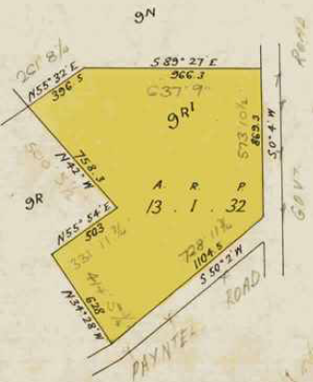24/11/1936 Crown Grant Volume 6111 Folio 081 from **George** **VI** to **John William Wilcox** of Wonga Park via Heidelberg in consideration of the sum of Sixty-Seven Pounds Five Shillings, land area 13 acres 1 rood and 32 perches, being (Crown) Allotment 9 R one.

3/8/1948 Transfer No.2157119 from John William Wilcox to **William Wilson** Market Gardener and **Elsie Pearl Wilson** his wife both of 87 Whitehorse Ringwood.

4/7/1949 Transfer No. 2157119 from William Wilson and Elsie Pearl Wilson to **Geoffrey John Duncan** Analytical Chemist and **Geraldine Duncan** married Woman both of 47 York Street Surrey Hills.

Crown Grant Volume 6111 Folio 081 for Crown Allotment 9None granted 24/11/1936 and sealed 8/6/1937

4/7/1949 Mortgage No. 917932 to The Commissioners of The State Savings Bank of Victoria, discharged 18/4/1967.

9/11/1955 Transfer as to part and creation of easement No. A66170 to **Theresa Margaret Hunter** (of a small house block of land) being Lot 1 on Plan of Subdivision No. 328964S, new Certificate of Title Volume 8101 Folio 275 **Street Address:** **No. 37 Paynters Road** (see details of dealings with this land further below).

16/11/1955 Mortgage No. A69538 to The Commissioners of The State Savings Bank of Victoria, discharged 18/4/1967.

18/4/1967 Mortgage No. C753120 to The National Bank of Australia Limited, discharged 12/1/1971.

Transfer of a 1acre lot out of Certificate of Crown Grant Volume 6111 Folio 081 to Theresa Margaret Hunter, new Certificate of Title Volume 8101 Folio 275 on 9/11/1955

9/12/1971 Transfer as to Balance No. E247681 from Geoffrey John Duncan to **Geoffrey Stuart Galbraith** Research

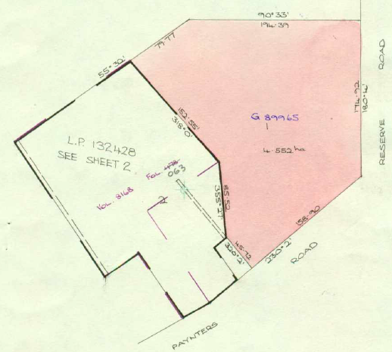Officer and **June Marion Galbraith** Married Woman both of 3 Pound Road Warrandyte, area 13 acres and 35 perches, new Certificate of Title volume 8912 Folio 478. (Part of this land was included in Plan of Subdivision No. 132428 along with the bulk of the land in Crown Allotment 9R detailed above).

9/12/1971 Mortgage No. E247682 to Nancy Marion Rogerson, discharged 8/2/1974.

8/2/1974 Mortgage No. F193414 to Nancy Marion Rogerson, discharged 31/3/1976.

29/9/1975 Mortgage No. F872930 to The Commissioners of The State Savings Bank Of Victoria, discharged 31/3/1976.

Eastern part of land above is 4.552 hectares in Transfer No. G89965 to Edward Alfons & Faye Alicia Muller, new Certificate of Title Volume 8101 Folio 048

31/3/1976 Transfer as to part No. G89965, area 4.552 hectares, from Geoffrey Stuart Galbraith and June Marion Galbraith to **Edward Alfons Muller** Plumber and **Faye Alicia Muller** Shopkeeper both of 49 Humber Road North Croydon, new Certificate of Title Volume 9138 Folio 048.

27/12/1979 Transfer as to Part No. H817115, new Certificate of Title Volume 9369 Folio 003.

18/2/1982 Caveat No. J824967 lodged, withdrawn 15/2/1982.

15/12/1982 Transfer as to balance No. K198318, new Certificate of Title Volume 9503 Folio 240.

**Lot 1 on Plan of Subdivision No. 117391**

Certificate of Title Volume 9138 Folio 048 for Lot 1 Plan of Subdivision No. 117391in the names of Edward Alfons Muller and Faye Alicia Muller

31/3/1976 Mortgage No. G89966 to The Commercial Banking Company of Sydney Limited.

12/12/1991 Cancelled – The following Titles have been issued pursuant to Regulation 10 of the Transfer of Land Act Lots 1 to 5 in Vol 10048 Fol 629 In (to) Vol 10048 Fol 633 see Lodged Plan No. 222206G.

**Lot 1 on Plan of Subdivision No. 222206G**

Certificate of Title Volume 10048 folio 629 for Lot 1 on Plan of Subdivision No. 222206G in the names of Edward Alfons Muller and Faye Alicia Muller.

17/9/1992 Lodged, 29/12/1994 Registered Mortgage No. G089966 discharged by Discharge of Mortgage No. S125981U.

28/9/1992Lodged, 29/12/1994 Registered Transfer No. S140704X from Edward Alfons Muller and Faye Alicia Muller to **Edward Alfons Muller** (This transfer may have been part of a divorce settlement.)

2/9/1994 Lodged 29/12/1994 Registered Mortgage No. T313428T to National Australia Bank Limited.

13/7/1995 Lodged 7/9/1995 Registered Discharge No. T769641K of Mortgage No. T313428T.

13/7/1995 Lodged 7/9/1995 Registered Mortgage to Gerd Raschoupf

8/11/1995 Lodged 20/11/1996 Registered Mortgage No. T949050P to Metway Bank Ltd

9/12/1996 Lodged 13/12/1996 Registered Discharge No. U544474A of Mortgage No. T769641K.

9/12/1996 Lodged 13/12/1995 Registered Discharge of Mortgage No. U544475A of Mortgage No. T949050P.

16/5/2008 Transfer No. AF847963W from Edward Alfons Muller **to Edward Alfons Muller** and **Marietta Janjua Muller** both of 39 Paynters Road Wonga Park 3115.

3/3/2011 Instrument No. AH819194L to amend proprietors’ names to Edward Alfons Muller and Marietta Muller both of 39 Paynters Road Wonga Park Vic 3115.

17/2/2017 Survivorship Application No. AN570304M from Edward Alfons Muller and Marietta Muller to **Marietta Janjua Muller** of 39 Paynters Road Wonga Park Vic 3115.

23/5/2024 Transmission Application No. AY025861A from Marietta Janjua Muller **to Janete Slaviero** of 41 Paynters Road Wonga Park Vic 3115 Executor(s) of Marieta Janjua Muller deceased.

***************************************************************************

**Certificate of Title Volume 8101 Folio 275** **Street Address:** **No. 37 Paynters Road.**

9/11/1955 Transfer as to part from Crown Grant Volume 6111 Folio 081 and creation of easement No. A66170 to **Theresa Margaret Hunter** (of a house block size parcel of land having a frontage of 71 feet 10 inches to Paynters Road by a depth of 150 feet) being Lot 1 on Plan of Subdivision No. 328964S, new Certificate of Title Volume 8101 Folio 275 for part Crown Allotment 9ROneA drawing of a road
and being No. 37 Paynters Road Wonga Park.

8/6/1967 Caveat No. C799071 lodged, lapsed 31/8/1971.

13/8/1971 Transfer No. E130692 from Theresa Margaret Hunter to **Geoffrey John Duncan** Chemist and **Geraldine Duncan** Teacher both of Paynters Road Wonga Park.

House block size parcel of land being the balance of the land in Crown Grant Volume 6111 Folio 081 transferred to Theresa Margaret Hunter on 9/11/1955, new Certificate of Title Volume 8101 Folio 275

9/12/1971 Transfer No. E247981 from Geoffrey John Duncan and Geraldine Duncan to **Graeme Stuart Galbraith** Research Officer and **June Marion Galbraith** Married Woman both of 3 Pound Road Warrandyte.

9/12/1971 Mortgage No. E247682 to Nancy Marion Rogerson, discharged 8/2/1974.

27/9/1974 Mortgage No. F473736 to The Commissioners of The State Savings Bank of Victoria, discharged 28/4/1975.

28/4/1975 Transfer No. F676076 from Graeme Stuart Galbraith and June Marion Galbraith to **Larry Robert Sluiter** Warehouse Manager and **Ann Denise Sluiter** Married Woman both of 28 Packham Street North Box Hill.

28/4/1975 Mortgage No. F676077 to Bank of New South Wales, discharged 29/3/1977.

29/3/1977 Transfer No. G570749 from Larry Robert Sluiter and Ann Denise Sluiter to **Malcolm David Jones** P.M.G. Employee and **Rosalyn Joy Jones** Married Woman both of Flat 1 No. 67 Sherlock Road Mooroolbark.

29/3/1977 Mortgage No. G570750 to The Sandhurst Mutual Permanent Investment and Building Society, discharged 25/3/1996.

18/10/1985 Mortgage No. L9480268 to Commonwealth Development Bank of Australia, discharged 1/5/1989.

1/5/1989 Transfer No. P158338N from Malcolm David Jones and Rosalyn Joy Jones to **Malcolm David Jones** of 37 Paynters Road Wonga Park.

27/10/1992 Mortgage No. S191014M to Bendigo Sandhurst Mutual Permanent Land and Building Society, discharged 25/3/1996.

1/3/1995 Mortgage No. T600710J to Bendigo Sandhurst Mutual Permanent Land and Building Society, discharged 25/3/1996.

25/3/1996 Transfer No. U143401B from Malcolm David Jones to **David Sanderson** & **Donna Marie Sanderso**n 37 Paynters Rd. Wonga Park 3115.

25/3/1996 Mortgage No. U143102X to Bank of Melbourne Limited.

17/4/2008 Caveat No. AF786872M by Alan Dudley Alpass as Chargee, date of claim 10/4/2008.

28/10/2008 Withdrawal No. AG163982V of Caveat No. AF786872M lodged.

28/10/2008 Discharge No. AG163983T of Mortgage No. U143102X lodged.

2/10/2008 Instrument No. AG163984R to amend proprietor name to **David Kenneth** **Sanderson** and **Donna Marie Sanderson** both of 37 Paynters Rd Wonga park 3115.

2/10/2008 Transfer No. AG163985P from David Kenneth Sanderson and Donna Marie Sanderson to **David Kenneth Sanderson** of 37 Paynters Road wonga Park Vic 3115.

28/10/2008 Mortgage No. AG163986M to Westpac Banking Corporation.