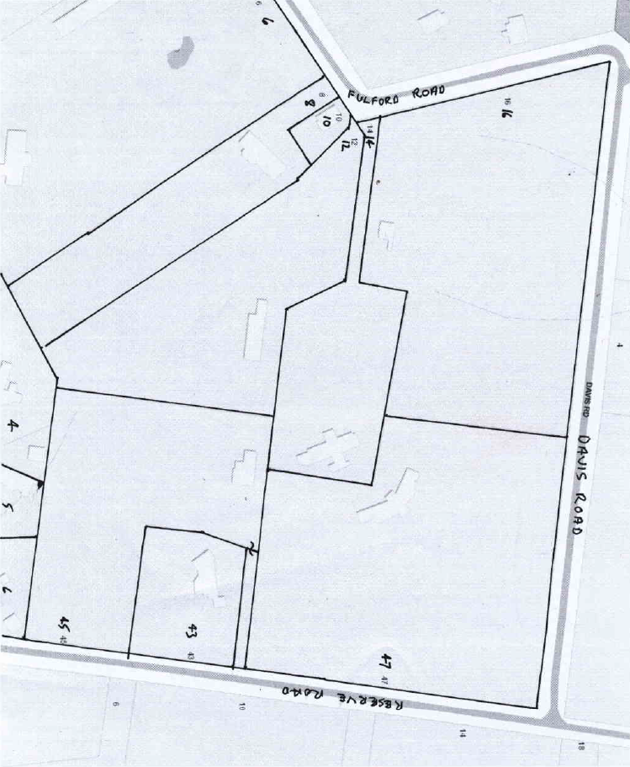
Title History of Crown Allotment 9N
12/5/1910 Crown Grant Volume 3379 Folio 685 of 39 acres 3 roods and 29 perches being (Crown) Allotment 9N, for a consideration of Thirty Pounds to Walter Fulford of Croydon Farmer.
27/5/1910 Mortgage No. 283117 to Helen Mary Dyer, discharged 24/7/1918.
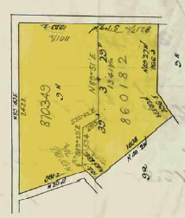
24/7/1918 Transfer as to part No. 860182 being the southern portion of the Crown Allotment with an area of 16 acres 3 roods and 35½ perches from Walter Fulford to (his son) Charles Henry Fulford, new Certificate of title Volume 4136 Folio 196.
Map of Crown Allotment 9N showing property boundaries and street numbers

8/11/1918 Transfer as to balance No. 870349 being the northern portion of the Crown Allotment with an area of 22 acres 3 roods and 33½ perches from Walter Fulford to (his wife) Ellen Betsy Fullford, new Certificate of Title Volume 4163 Folio 598.
7/11/1919 Red Ink No.1993024: Ellen Betsy Fulford died on 5/7/1919. Probate of her Will has been granted to Walter Fulford of Wonga Park Croydon Fruit Grower
A plan of the land granted in Crown Grant Volume 3379 Folio 685 with Fulford Road on the west, Davis Road on the north and Reserves Road on the west.

7/11/1919 Transfer No. 909973 from Walter Fulford (as the Executor of the Will of Ellen Betsy Fulford deceased) to Charles Henry Fulford.
21/3/1940 Transfer as to part No. 1766080 of an area of 19 acres 2 roods and 31 perches from Charles Henry Fulford to Henry Ralph Perry, new Certificate of title Volume 6387 Folio 366.
15/11/1949 Transfer as to balance from Charles Henry Fulford to Edward Henry Kroschel and Jessie Muriel Kroschel.
***************************************************************************
21/3/1940 The land in Certificate of Title Volume 6387 Folio 366 containing 19 acres 2 roods and 31 perches being part of Crown Allotment 9N in the name of Henry Ralph Perry of 44
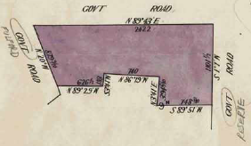
Collins Street West Brunswick Dealer registered 21/3/1940.
12/10/1955 Transfer No. A52682 from Henry Ralph Perry to Desmond James Lindsay of 21 James Street Ringwood Contractor.
12/10/1955 Mortgage No. A52683 to The Southern Cross Assurance Company Limited, discharged 5/5/1959.
Plan of the land in Certificate of Title Volume 6387 Folio 366 transferred from Charles Henry Fulford to Henry Ralph Perry on 21/3/1940
5/5/1959 Transfer No. A731682 from Desmond James Lindsay to Stanley Paul Moser Director and Lyla Muriel Jean Moser Married Woman both of 6 Field Street Caulfield.
5/5/1959 Mortgage No. A731683 to Percival Andrew Ferguson, discharged 29/12/1966.
29/12/1966 Mortgage No. C676525 to Bank of New South Wales.
19/8/1971 Cancelled pursuant to Regulation 12 and Titles issued as set out hereunder: Lots one to 2 in Vol 8893 Fol 535 to Vol 8893 Fol 536, LP 9157
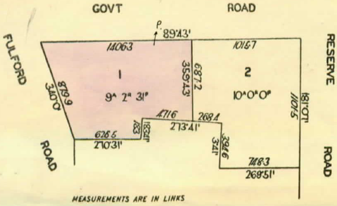
*****************************************************************************
19/8/1971 The land in Certificate of Title Volume 8893 Folio 535, area 9 acres 2 roods and 31 perches being Lot 1 on Plan of Subdivision No. 91577 in the names of Stanley Paul Moser Director and Lyla Muriel Jean Moser Married Woman both of 8 Field Street Caulfield, registered 19/8/1971. Street Address: 16 Fulford Road Wonga Park
16/1/1982 Discharge No. J784484 of Mortgage No. C676525 lodged.
Plan of Subdivision No. 91577 subdivided the land in Certificate of Title 6387 Folio 366 into 2 lots
24/12/1987 Transfer No. N212917X from Stanley Paul Moser and Lyla Muriel Jean Moser to Douglas Barry Moser & Lee-Anne Margaret Moser of “Avonleigh” Fulford Rd. Wonga Park.
24/12/1987 Mortgage No. N212918U to Zurich Australia Life Insurance Limited, discharged 16/5/1989.
16/5/1989 Transfer from Douglas Barry Moser and Lee-Anne Margaret Moser to F. W. Westmore Investments Pty. Ltd. of Davis Rd. Wonga Park.
16/5/1989 Mortgage No. P193444T to Australia and New Zealand Banking Group Limited, discharged 12/4/2001.
2/3/2001 Caveat No. X345596P by Lynda Alice Taylor as purchaser – Caveat will lapse on registration of W417361F, 23/4/2001.
12/01/2001 Transfer No. X417361F from F. W. Westmore Investments Pty. Ltd. to Lynda Alice Taylor 96 Partridge Way Mooroolbark 3138.
27/11/2017 Statutory (Land Tax) Charge No. AQ489100F lodged.
16/3/2018 Discharge No. AQ827521Y of Statutory (Land Tax) Charge No. AQ489100F lodged.
6/6/2018 Transfer No. AR097535T from Lynda Alice Taylor to Katherine Louise Elmer of 16 Fulford Road Wonga Park Vic 3115.
6/6/2018 Mortgage No. AR097536R to Australia And New Zealand Banking Group Limited.
15/11/2021 Transfer No. AV016122T from Katherine Louise Elmer to James Andrew Elmer and Katherine Louise Elmer both of 16 Fulford Road Wonga Park Vic 3115.
1/11/2022 Discharge No. AW222806C of Mortgage No. AR097536R lodged
1/11/2022 Mortgage No. AW222807A to National Australia Bank Ltd.
***************************************************************************
19/8/1971 The land in Certificate of Title Volume 8893 Folio 536, area 10 acres 0 roods and 30 perches being Lot 2 on Plan of Subdivision No. 91577 in the names of Stanley Paul Moser Director and Lyla Muriel Jean Moser Married Woman both of 8 Field Street Caulfield, registered 19/8/1971. Street Address: 47 Reserve Road Wonga Park.
16/1/1982 Discharge No. J784484 of Mortgage No. C676525 lodged.
22/11/1996 Survivorship application No. U519025J – Stanley Paul Moser of 47 Reserve Rd. Wonga Park Vic 3115 is the surviving proprietor.
10/9/2004 Transfer No. AD108121Q from Stanley Paul Moser to Elizabeth Mary Cesa of 50-52 Toppings Road Wonga Park Vic 3115.
10/9/2004 Mortgage No. AD108122N to Australia And New Zealand Banking Group Limited.
6/4/2005 Mortgage No. AD539621N to Australia And New Zealand Banking Group Limited.
9/11/2009 Discharge No. AG856079K of Mortgages No. AD108122N and No. AD539621N lodged.
9/11/2009 Mortgage No. AG856080B to Bank of Queensland Ltd lodged.
29/6/2015 Discharge No. AL992947E of Mortgage No. AG856080B lodged.
11/9/2015 Transfer No. AM172312R from Elizabeth Mary Cesa to Kevin John Wallace of 47 Reserve Road Wonga Park Vic 3115.
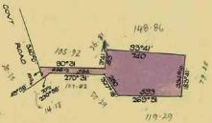
**********************************************
The land in Certificate of Title Volume 7336 Folio 139 containing 3 acres 1 rood and 2½ perches being part of Crown Allotment 9N in the name of Edward Henry Kroschel Railway Employee and Jessie Muriel Kroschel Married Woman both of 119 Asling Elsternwick registered 21/11/1949. Street Address: 14 Fulford Road Wonga Park.
Plan of the land in Certificate of Title Volume 7336 Folio 139 transferred from Charles Henry Fulford to Edward Henry & Jessie Kroschel on 21/11/1949

??/5/1950 Mortgage No. 942195 to The Bank of Australia, discharged 27/2/1953.
7/5/1953 Mortgage No. 1038873 to Australia and New Zealand Bank Limited, discharged 26/8/1955.
13/7/1955 Caveat No. 5793 lodged and lapsed 1/10/1956.
1/10/1956 Transfer No. A229108 from Edward Henry Kroschel and Jessie Muriel Kroschel to Edward Shaw Draughtsman and Bernice Placid Shaw Married Woman both of “Bimbadeen” Fulford Road Wonga Park.
29/6/1960 Caveat No. B1805 lodged and lapsed 14/4/1965.
26/3/1965 Transfer No. C179629 from Edward Shaw and Bernice Placid Shaw to William Francis Maynes Storekeeper and Marjorie Beatrice Maynes Married Woman both of Toorak Avenue Croydon.
22/6/1966 Transfer No. C520510 from William Francis Maynes and Marjorie Beatrice Maynes to Eric Alan Hall Company Secretary and Viola Lois Hall Home Duties both of Dudley Road Wonga Park.
22/6/1966 Mortgage No. C520511 to Commercial & General Acceptance Limited, discharged 12/10/1966.
12/10/1966 Transfer No. C612585 from Eric Alan Hall and Viola Lois Hall to Earl Gordon Flecknoe-Brown company Executive and Dorothy Eva Flecknoe-Brown Married Woman both of 36 Sussex Street Middle Brighton.
12/10/1966 Mortgage No. C612586 to The National Bank of Australasia Limited, discharged 6/9/1968.
6/9/1968 Mortgage No. D182089 to The National Savings Bank, discharged 21/12/1972.
21/12/1972 Transfer No. E651016 from Earl Gordon Flecknoe-Brown and Dorothy Eva Flecknoe Brown to Noel Burley and Nancy Kathryn Burley both of 332 Whitehorse Road Ringwood Company Directors.
21/12/1972 Mortgage No. E651017 to Hotham Permanent Building Society, discharged 14/12/1977.
14/12/1977 Transfer No. G901679 from Noel Burley and Nancy Kathryn Burley to Kenneth Charles Faulkner Director and Judith Treve Faulkner.
14/12/1977 Mortgage No. G901680 to The Commissioners of The State Savings Bank of Victoria, discharged 5/5/1982.
14/2/1978 Mortgage No. G967044 to Esanda Limited, discharged 5/5/1982.
5/5/1982 Transfer No. J915256 from Kenneth Charles Faulkner and Judith Treve Faulkner to Robert Stuart Robey Company Director and Beryl Ann Robey Married Woman both of 21 Kenilworth Avenue Wonga Park.
5/5/1982 Mortgage No. J915256 to Commonwealth Savings Bank of Australia, discharged 4/2/1988.
19/3/1984 Mortgage No. K80462 to Commonwealth Trading Bank of Australia, discharged 14/4/1989.
14/4/1989 Transfer No. P131320E from Robert Stuart Robey and Beryl Ann Robey to Dorothy Lorraine McLean & Kevin Melville McLean of 392-394 Ringwood-Warrandyte Road Warrandyte.
14/4/1989 Mortgage No. P131320E to Australian Mutual Provident Society, discharged 14/10/1993.
21/4/1989 Mortgage No. P146976Q to Chase AMP Bank Limited, discharged 14/10/1993.
14/10/1993 Mortgage No. S737949N to Westpac Banking Corporation.
6/3/1996 (Certificate of title) Cancelled See Vol 10273 Fol 521 which is issued pursuant to Section 32(2) Act 6399 Instrument T977388Y.
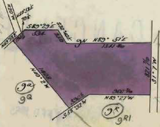
***************************************************************************
24/7/1918 The land in Certificate of Title Volume 4136 Folio 196 being the southern portion of Crown Allotment 9N with an area of 16 acres 3 roods and 35½ perches in the name of Charles Henry Fulford of Wonga Park near Croydon Orchardist, registered 24/7/1918. This land had two road frontages: one to Fulford Road in the west and the other to Reserve Road to the east.
22/12/1927 Mortgage No. 581902 to closer Settlement Board, discharged 15/5/1957.
Plan of the land in Certificate of Title Volume 4136 Folio 196 transferred from Walter Fulford to his son Charles Henry Fulford on 24/7/1918

?4/2/1941 Mortgage No. 802310 to the English Scottish and Australian Bank Ltd, discharged 6/3/1946.
20/11/1958 Caveat No. A645908 affecting part of the land, lapsed 7/7/1957.
7/7/1959 Transfer as to Part No. A774953 see Vol 8231 Fol 533, area 5 acres 1 rood and 38 perches.
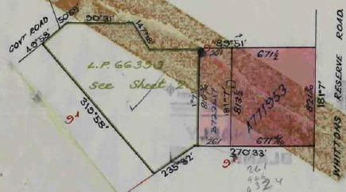
8/8/1963 Transfer as to part No. B722617 see Vol 8458 Fol 749, area 2 acres 0 roods and 19 perches.
28/1/1965 Transfer as to balance pursuant to Regulation 12 and Titles issued as set out hereunder – Lots1 and 2 in Vol 8530 Fol362 to 363, LP 66399.
**************************
27/7/1959 The land in Certificate of Title Volume 8231 Folio 533 being part of Crown Allotment 9N with an area of 5 acres 1 roods and 38 perches transferred in Transfer No. A771953 from Charles Henry Fulford to Hester Francesca Grimes of 51 Blackburn Road Blackburn Married Woman, registered 27/7/1959. Street Address: the front part of 43 & 45 Reserve Road Wonga Park.
Plan of the land in Certificate of Title Volume 4136 Folio 196 shown divided into 3 separate parcels by transfers as to part

*********************************************************************
27/7/1959 The land in Certificate of Title Volume 8458 Folio 749 being part of Crown Allotment 9N with an area of 2 acres 0 roods and 19 perches transferred in Transfer No. 7267 from Charles Henry Fulford to Hester Francesca Grimes of 51 Blackburn Road Blackburn Married Woman, registered 27/7/1959. Street Address: the rear part of 43 & 45 Reserve Road Wonga Park
Although the above two properties were transferred to Hester Francesca Grimes at different times, they adjoin each other (the 2 acre property does not have a street frontage and together they form a single 7½ acre property) and accordingly they are being treated together below.
14/3/1964 Mortgage No. B888531 to Commonwealth Development Bank of Australia, discharged 24/7/1964.
24/6/1964 Transfer No. B964672 from Hester Francesca Grimes to Albert James Aird Accountant and Edith Jean Aird both of 28 Wonga Road Ringwood.
31/8/1966 Transfer No. C581841 from Albert James Aird and Edith Jean Aird to John Lister Greenwood Contractor and Barbara Phyllis Greenwood Married Woman both of 10 Penrose Street Box Hill South.
10/1/1969 Mortgage No. D288107 to Commonwealth Trading Bank of Australia, discharged 14/11/1969.
27/11/1969 Mortgage No. D572243 to Commonwealth Savings Bank of Australia, discharged 24/8/1976.
24/8/1976 Transfer No. G291548 from John Lister Greenwood and Barbara Phyllis Greenwood to John Barson Chartered Accountant and Judith Alicia Barson Married Woman both of 194 Church Road Doncaster.
24/8/1976 Mortgage No. G291549 to The Commercial Bank of Australia Limited, discharged 28/9/1984.
24/8/1976 Mortgage No. G291520 to The Commercial Bank of Australia Limited, discharged 13/9/1983.
13/9/1983 Mortgage No. K545489 to National Commercial Banking Corporation of Australia Limited.
1/9/1987 SUBSTITUTE No. N16446G Proprietor Judith Alicia Barson of Reserve Road Wonga Park. (Certificate of Title) Cancelled See Vol 9781 Fol 914 which is issued pursuant to Section 32 (2) Act 6399 Registered 1/9/1987 No 16446G. It is unclear whether Judith Alicia Barson became sole proprietor by transfer or by survivorship.
*************************************************************************
28/1/1965 The land in Certificate of Title Volume 8530 Folio 362 being Lot 1 on Plan of Subdivision No. 66399 being a large house block size of land with a frontage of 90 feet 9 inches by a depth of 242 feet 4 inches, created by Instrument LP 066399 28/1/1965. Street Address: 8 Fulford Road Wonga Park.

The Search of Certificate of Title Volume 8530 folio 362 states that No CofT exists which implies that the paper title may be missing and there are no title searchable records between 28/1/1965 and 11/8/2004. It is most likely that the title would have issued to Charles Henry Fulford as the subdivider and then most likely have been transferred by him to his son James (Jim) Henry Fulford. At some stage the land was transferred to Cecilia Antoinette Le Duc-Spoor as evidenced by the transfer below (which was able to be searched).
11/8/2004 Transfer No. AD41741C from Cecilia Antoinette Le Duc-Spoor to Simon Vincent Mutsaers and Fiona Helen Mutsaers both of 10 Fulford Road Wonga Park Vic 3115.
11/8/2004 Mortgage No. AD041741C to Australia and New Zealand Banking Group Ltd.
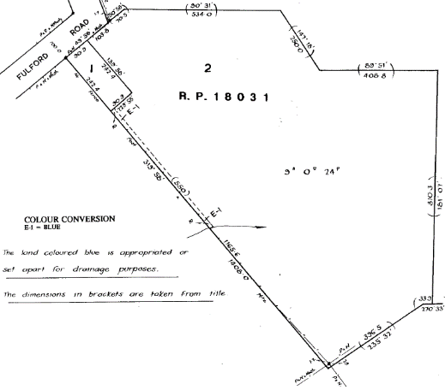
8/3/2011 Caveat No. AH829745S by Carew Counsel Pty Ltd as Chargee, date of claim 7/3/2011.
30/4/2012 Caveat No. AJ630706T by Yarra Valley Grammar as Chargee, date of claim 10/4/2012.,
20/6/2012 Caveat No. AJ739213M by Yarra Valley Grammar as Chargee, date of claim 24/4/2012.
8/2/2013 Agreement No. AK176516U Section 173 Planning and Environment Act 1987.
No Date This Folio (Certificate of Title) has been cancelled. See Folios 11438 / 467 for Lot 1 on Plan of Subdivision No. 628507N and 11438 / 468 for Lot 2 on Plan of Subdivision No. 628507N.
By Plan of Subdivision No. 66399 Charles Henry Fulford cut off from his land a large house block for his son James (Jim) Henry Fulford
******************************************************************
28/1/1965 The land in Certificate of Title Volume 8530 Folio 363 being Lot 2 on Plan of Subdivision No. 66399, having an area of 9 acres 0 roods and 24 perches registered in the name of Charles Henry Fulford of Fulford Road Wonga Park Orchardist. Certificate of Title created 28/1/1965. Street Address: Part of 8 and the whole of 10 & 12 Fulford Road Wonga Park
19/7/1967 Transmission Application No. C834777. Charles Henry Fulford died on 20th September 1966. Probate of his Will has been granted to David Walter Fulford of Tongala Farmer and James Henry Fulford of Fulford Road Wonga Park Driver.
19/7/1967 Transfer No. C834778 from David Walter Fulford and James Henry Fulford to Violet May Fulford Widow of Fulford Road Wonga Park.
29/10/1968 Transfer No. D228320 from Violet May Fulford to Malcolm John Blair Investment Adviser and Elizabeth Mary Jane Blair Married Woman both of 37 Eothen Lane Kilsyth.
27/10/1970 Mortgage No. D870380 to The Langridge Building Society, discharged 23/12/1975.
23/12/1975 Mortgage No. F979220 to Australia and New Zealand Savings Bank Limited, discharged 29/12/1977.
7/3/1977 Mortgage No. G540383 to Australia and New Zealand Banking Group Limited, discharged 29/12/1977.
29/12/1977 Transfer No. G919490 from Malcolm John Blair and Elizabeth Mary Jane Blair to Geoffrey Russell Cabena Insurance Broker and Elizabeth Gladys Cabena Married Woman both of 291-293 Springvale Road Donvale.
29/12/1977 Mortgage No. G919491 to Australia and New Zealand Banking Group Limited, discharged 22/7/1982.
7/8/1982 Title Cancelled Units One to 2 In Vol 9480 Fol 138 to Vol 9480 Fol 139 Registered Plan No. 18031, instrument K16840.
7/8/1982 Certificate of Title Volume 9480 Folio 138 for Unit 1 on Strata Plan No. 018031 in the name of David Joel Clarke and Susan Lesley Clarke of 28 Loughnan Road Ringwood 3134.
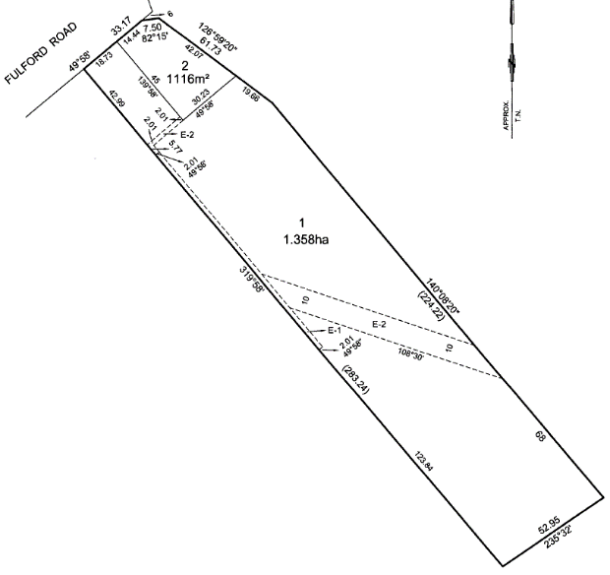
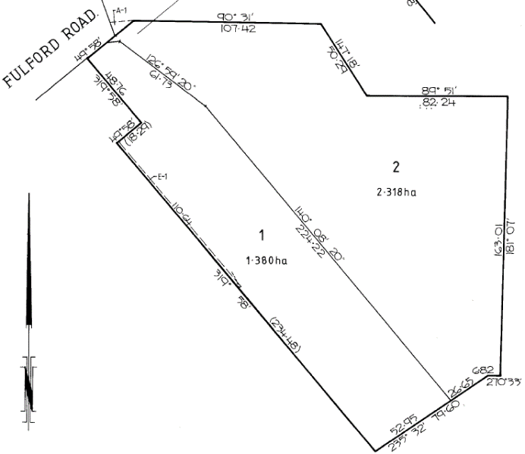
20/8/1997 Lands in Certificates of Title Volume 9480 Folio 138, Volume 9480 Folio 139 and Volume 10285 Folio 399 (effectively a subdivision of Lot 2 on Plan of Subdivision No. 66399) subdivided by Plan of Subdivision No. 347822U. The stated purpose of this plan is to consolidate Units 1 and 2 and common property on RP 18031 and dissolve the body corporate on RP 18031.)
Plan of Subdivision No. 347822U
8/8/2013 Plan of Subdivision No. 628507N was a subdivision affecting Lot 1 on Plan of Subdivision No. 34782U (Certificate of Title Volume 10343 Folio 083) and Lot 1 on Plan of Subdivision No. 66399 (Certificate of Title Volume 8530 Folio362). The new titles to issue from Plan of Subdivision No. 628507N were Certificates of Title Volume 11438 Folio 467 for Lot 1 and Volume 11438 Folio 468 for Lot 2.
Plan of Subdivision No. 628507N

8/8/2013 The land in Certificate of Title Volume 1438 Folio 467 being Lot 1 on Plan of Subdivision No. 628507N, having an area of 1.358 hectares, registered in the names of Fiona Helen Kelso, Simon Vincent Mutsaers and Fiona Helen Kelso. Certificate of Title created 8/8/2013. Street Address: 8 Fulford Road Wonga Park
29/8/2013 Withdrawal Nos. AK574603G, AK558231J, AK 558232G, AK 558233E, AK558234C, AK558235A & AK558236X of Caveats Nos. AH574603G, AH829745S, AH829757K, AJ630025U, AJ630706T & AJ739213M lodged.
29/8/2013 Discharge No. AK558236X of Mortgage No. W32759B lodged.
29/8/2013 Discharge No. AK558237V of Mortgage No. AC070575M lodged.
29/8/2013 Discharge No. AK558238T of Mortgage No. AD041742A lodged.
29/8/2013 Transfer No. AK558239R from Fiona Helen Kelso, Simon Vincent Mutsaers and Fiona Helen Kelso to Peter John McElvogue and Brenda Ellen McElvogue both of 8 Fulford Road Wonga Park 3115.
29/8/2013 Mortgage No. AK558240H to Australia And New Zealand Banking Group Ltd.
2/5/2019 Caveat No. AS131369P by Leanne Holden as Chargee.
20/11/2023 Caveat No. A469478E by Zoe Katherine Storer as purchaser.
1/2/2024 Withdrawal No. AX694982K of Caveat No. AS131369P lodged.
1/2/2024 Discharge No. AX694983H of Mortgage No. AK558240H lodged.
1/2/2024 Transfer No. AX694984F from Peter John McElvogue and Brenda Ellen McElvogue to Zoe Katherine Storer of 8 Fulford road Wonga Park Vic 3115.
1/2/2024 Mortgage No. AX694985D to National Australia Bank Ltd.
*************************************************************************
8/8/2013 The land in Certificate of Title Volume 1438 Folio 468 being Lot 2 on Plan of Subdivision No. 628507N, having an area of 1116 square metres, registered in the name of Fiona Helen Kelso. Certificate of Title created 8/8/2013. Street Address: 10 Fulford Road Wonga Park
3/9/2013 Withdrawal Nos. AK56859N, AK568595 & AK 568596J of Caveats Nos. AH574603G, AJ630025U & AH829757K lodged.
3/9/2013 Discharge No. AK568597G of Mortgage No. W327519B lodged.
3/9/2013 Discharge No. AK568598E of Mortgage No. AC070575M lodged.
3/9/2013 Transfer No. AK568599C from Fiona Helen Kelso to Benjamin John Cresswell and Amy Louise Madden both of 10 Fulford Road Wonga Park Vic 3115.
3/9/2013 Mortgage No. AK568600W to Commonwealth Bank of Australia.
16/10/2017 Discharge No. AQ350017S of Mortgage No. AK568600W lodged.
16/10/2017 Transfer No. AQ350018Q from Benjamin John Cresswell and Amy Louise Madden to Samuel Charles Cresswell of 10 Fulford Road Wonga Park 3115 as to1 of a total of 2 equal undivided shares as tenants in common and Paul Cresswell of 13 Muirfield 7 Mews Chirnside Park Vic 3116 and Jacqueline Rhiannon Cresswell of 13 Muirfield Mews Chirnside Park Vic as joint proprietors as to 1 of a total of 2 equal undivided shares as tenants in common.
16/10/20017 Mortgage No. AQ350019N to Commonwealth Bank of Australia.

