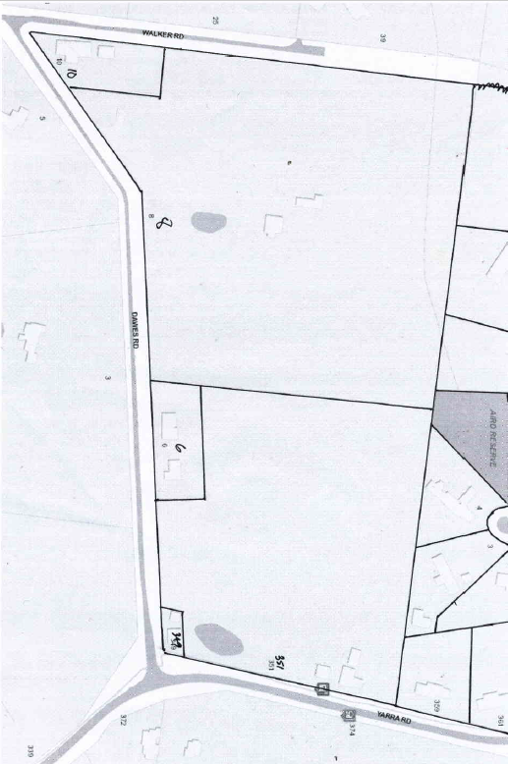
Lot 50 on Plan of Subdivision No. 4315 (bounded on three sides by Yarra Road, Dawes Road and Walker Road) and being part of the land in Certificate of title Volume 3932 Folio 334. Street Addresses: 349 & 351 Yarra Road and 6, 8 & 10 Dawes Road Wonga Park

30/11/19 Transfer No. 790525 from The Mutual Assurance Society of Victoria Limited to William Martin Billings of Croydon Farmer area 31 acres 2 roods and 22 perches, new Certificate of Title Volume 3932 Folio 334.
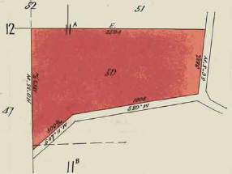
Electoral Rolls for 1916, 1918 and 1919 for subdistrict of Ringwood listed “Billings, Fanny, Coo-ee, Yarra rd., Wonga Park, home duties, F” and “Billings, William M., Coo-ee, Yarra rd., Wonga Park, farmer, M”
Plan of Lot 50 showing property boundaries and street addresses

30/11/1915 Mortgage No. 355015 from William Martin Billings to Agnes Ann Porter, discharged 10/10/1916.

6/9/1921 Mortgage No. 420917 from William Martin Billings to the English Scottish and Australasian Bank Limited, discharged 16/5/1923.
Plan from Certificate of Title Volume 3932 Folio 334 for Lot 50 on Plan of subdivision No. 4315

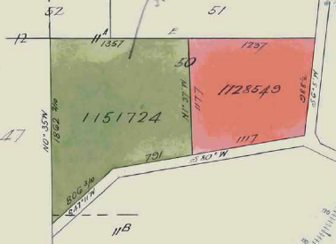
27/9/1921 Caveat No. 55980 affecting part of the land, lapsed 21/9/1921.

21/9/1923 Transfer as to part of the land (eastern part) No. 1128549 from William Martin Billings to William Mathews Rogers, area 12 acres 2 roods and 13 perches, new Certificate of Title Volume 4757 Folio 235.

19/2/1924 Transfer as to the balance of the land No. 1511724 from William Martin Billings to Dorothy May Heward of Hillside Avenue Camberwell spinster, area 19 acres 9 perches, new Certificate of Title Volume 4817 Folio 235.
Plan showing subdivision of Lot 50 by transfers as to part to William Mathews Rogers (right) and balance to Dorothy May Heward (left)

1/7/1924 Transfer No. 1172530 from William Matthew Rogers to Rupert Lionel Heward of Hillside Avenue Camberwell, fireman, area 12 acres 2 roods 13 perches.

Dorothy May Heward and Rupert Lionel Heward were sister and brother and Dorothy’s marriage to William James Dawe was registered in 1927. Hillside Avenue Camberwell was the address of Dorothy and Lionel’s widowed mother.

27/7/1949 Transfer No. 2231471 by Rupert Lionel Heward to William Thomas Lawrence of Yarra Road Wonga Park Gentleman.

19/5/1954 Transfer as to part of the land (one acre fronting Dawes Road) No. 264163 by William Thomas Lawrence to Victor William Lawrence, new Certificate of Title Volume 8045 Folio 910. Street Address: 6 Dawes Road Wonga Park

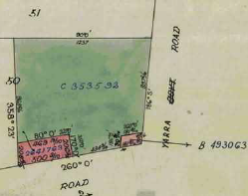
29/8/1982 Transfer as to part of the land (scout hall) No. B493063 by William Thomas Lawrence to The Boy Scouts Association Victorian Branch of 384 Elizabeth Street Melbourne, new Certificate of Title Volume 8409 Folio 342. Street Address: 349 Yarra Road Wonga Park

8/11/1965 Transfer of the balance of the land No. C353592 by William Thomas Lawrence to Edward Joseph Richmond investor and Clarice Lesley Richmond Married Woman both of Yarra Road Croydon, area 11 acres 1 rood 28 perches. New Certificate of Title Volume 8599 Folio 471. Street Address: 351 Yarra Road Wonga Park
Plan showing lands transferred as to part by William Thomas Lawrence to Victor William Lawrence and for the
Scout Hall.

23/10/1968 Transfer No. D223551 from Edward Joseph Richmond and Clarice Lesley Richmond to Raymond George Galloway Carpenter and Beverley Ann Galloway both of 10 Harrow Street Blackburn South

23/10/1968 Mortgage No. D228552 to Australia and New Zealand Bank Limited, discharged 10/12/1976

10/12/1976 Transfer No. G436831 from Raymond George Galloway and Beverley Ann Galloway to Vance Le Francke Company Director and Barbara Joan Le Francke Married Woman both of 19 Vivianne Avenue Box Hill North

10/12/1976 Mortgage No. G436832 to The Commercial Banking Company of Sydney Limited, discharged 29/5/1992.

29/10/2004 Caveat No. AD210880W by Ivan Gregorich and Gilbert Shanti Kumar Ponniah as purchaser / fee simple, lapsed 20/12/2004

20/12/2004 Transfer No. AD319387W from Vance Le Francke and Barbara Joan Le Francke to Eric Ivan Gregorich and Gilbert Shanti Kumar Ponniah both of 1042 Doncaster Road Doncaster East as tenants in common in equal shares.

20/12/2004 Mortgage No. AD319388U to Commonwealth Bank of Australia, discharged 21/8/2012

8/5/2012 Caveat No. AJ866203E by Peter Cameron Hoskins and Amanda Jane Hoskins as purchaser / fee simple, lapsed 21/8/2012.

21/8/2012 Transfer No. AJ866204C from Eric Ivan Gregorich and Gilbert Shanti Kumar Ponniah to Peter Cameron Hoskins and Amanda Jane Hoskins both of 351-357 Yarra Road Wonga Park.

21/8/2012 Mortgage No. AJ866205A to Commonwealth Bank of Australia.

4/8/1966 Transfer as to part of the land No. C557288 by Dorothy May Heward (now Dawes) of a small block at the corner of Dawes Road and Walker Road), new Certificate of Title Volume 8638 folio 725. Part of Street Address: 10 Dawes Road Wonga Park

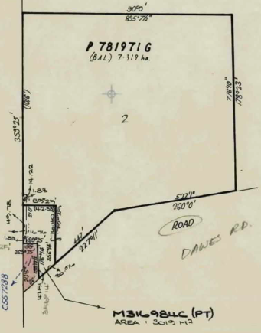
14/2/1966 Caveat No. M136626 affecting part of the within land. Will lapse on registration of M316984C, 3/7/1986

12/6/1986 Transfer as to part of the land (3019square metres surrounding previous small block transferred) No. M316984C by Dorothy May Heward (now Dawes), new Certificate of Title volume 9688 Folio 570. Balance of Street Address: 10 Dawes Road Wonga Park

8/7/1986 Dorothy May Dawe (formerly Heward) died on 24/3/1986. Probate of her Will has been granted to The Equity Trustees Executors and Agency Company Limited of 472 Bourke St. Melbourne N356103Q.
According to Margaret Fankhauser (e-mail 13/5/2024) Dorothy left a life interest in the property to her husband and on his death to the Church of which Alan Phelan was the trustee.
Transfers as to part by Dorothy May Dawes, new Certificates of Title volume 8638 Folio 725 and Volume 9688 Folio 570

15/10/1987 Transfer No. 88564H as to balance of the land to William James Dawes of “Lostwithiel”, Dawes Road, Wonga Park. Street Address: 8 Dawes Road Wonga Park

2/2/1990 William James Dawe died on 6/9/1988. Probate of his Will has been granted to Alan Phelan of 53 Taylor Road Mooroolbark. P642013H.

7/5/1990 Transfer No. P781971G as to the balance of the land, new Certificate of title Volume 9981 Folio 959. To Eric and Margaret Fankhauser according to an e-mail dated 13/5/2024 from Margaret Fankhauser.

