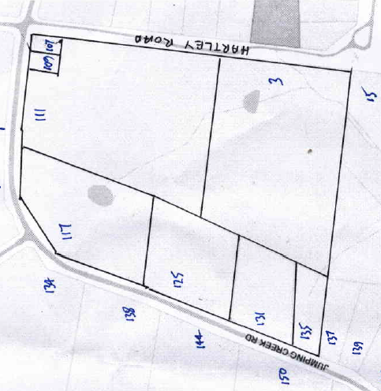
Lot 53 on Plan of Subdivision No. 4315 (bounded on the west and north by Jumping Creek Road and on the east by Hartley Road and being part of the land in Certificate of title Volume 234 Folios 734 & 735. Street Addresses: 107 to 135 Jumping Creek Road and 3 Hartley Road Wonga Park
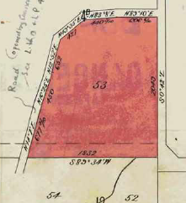
25/4/1912 Transfer No. 682020 from The Mutual Assurance Society of Victoria Limited to James Begley of Allansford Dairyman, area 31 acres and 33 perches, being Lot 53 on Plan of Subdivision No. 4315 and being part of Crown Allotment 4B and land formerly part of a Government Road, new Certificate of Title Volume 3594 Folio 684.
Plan showing property boundaries and Street Numbers
20/2/1915 Transfer No. 769307 from James Begley to George Gale of Marvel Loch Western Australia Mining Manager.
Title Plan on Certificate of Title being Lot 53 on Plan of Subdivision 4315 and part of a former Government Road
15/4/1920 Transfer No. 934422 from George Gale to Walter Slade Blacksmith and Ellen Elizabeth Slade, his wife, both of Wonga Park Croydon.
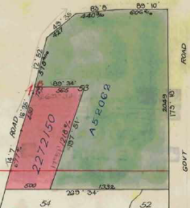
5/12/1949 Red Ink No. 480403 Walter Slade of Wonga Park Blacksmith the survivor of the proprietors named herein is by direction of the Commissioner of Titles, now registered as sole proprietor of the land now comprised herein.
9/12/1949 Transfer as part No. 2272150, area 6 acres 0 roods and 33 perches to Cecil Cook Beeston, new Certificate of Title Volume 7551 Folio 100. Street Address: 125 to 135 Jumping Creek Road Wonga Park
Red Ink No. 4993931: by Vesting Order dated 24th November 1950 Produced to me on 28th December 1950 the balance of the described land vested to Walter Embert Slade of Douglas Street Hastings, Orchardist.
Subdivision of Lot 53 & part Government Road by transfer as to part and balance
19/4/1957 Caveat No. 132529 lodged and lapsed 11/10/1951.
11/10/1955 Transfer as to balance No. 52062, new Certificate of Title Volume 8096 Folio 131. Street Address: 107 to 117 Jumping Creek Road and 3 Hartley Road Wonga Park
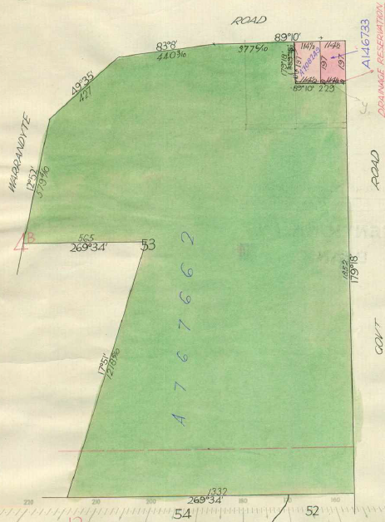
1/10/1955 Certificate of Title Volume 8096 Folio 131, area 25 acres, in the name of Ernest Alfred Arthur Janes of Warrandyte Road Wonga Park Orchardist. It is likely that E.A.A. Janes had been occupying this land on or soon after 11/10/1951 under a terms contract when the above caveat was lodged. Street Address: 107 to 117 Jumping Creek Road and 3 Hartley Road Wonga Park
26/4/1956 Transfer as to part and creation of easement No. A146733, new Certificate of Title Volume 8148 Folio 418. Street Address: 107 Jumping Creek Road Wonga Park
16/6/1959 Caveat No. A757586 lodged 16/6/1959 and (subsequently) transferred to new Certificate of Title Volume 8236 Folio 125.
24/3/1959 Transfer as to part No. A708249, new Certificate of Title Volume 8220 Folio 963. Street Address: 109 Jumping Creek Road Wonga Park
1/7/1959 Transfer as to balance No. A767662, new Certificate of Title Volume 8236 Folio 963. Street Address: 111 and 117 Jumping Creek Road and 3 Hartley Road Wonga Park
Two small parcels of land (in the north-east corner) transferred out of Certificate of Title Volume 8096 Folio 131
*************************************************************************
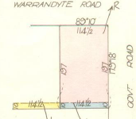
26/4/1956 Certificate of Title Volume 8148 Folio 418 having a frontage of 114½ links to Warrandyte (Jumping Creek) Road by a depth of 197 links along Hartley Road, being part of Lot 53 on Plan of Subdivision No. 4315 transferred by Ernest Alfred Arthur Janes to Vivian Valentine Weller Messenger and Hilda Weller Married Woman both of Warrandyte Road Wonga Park. Street Address: 107 Jumping Creek Road Wonga Park
29/3/1960 Survivorship Application No. A935025: Hilda Weller of 81 Hewish Road Croydon Widow the survivor of the proprietors is now registered as the sole proprietor of the land now comprised herein.
Title Plan on Certificate of Title Volume 8148 Folio 418 Street Address: 107 Jumping Creek Rd.
7/5/1963 Transfer No. B650431 from Hilda Weller to Gilbert Edward Polkinghorne Truck Driver and Margaret June Polkinghorne His Wife both of Warrandyte Road Wonga Park.
7/5/1963 Transfer No. B650432 from Gilbert Edward Polkinghorne and Margaret June Polkinghorne to Benjamin James Standish Packer and Rose Emma Standish Married Woman both of 34 Liverpool Road Kilsyth.
9/9/1969 Transfer No. D500546 from Benjamin James Standish and Rose Emma Standish to Raymond Francis Chenhall of 44 Marchant Avenue Reservoir Electro Plating Manager.
9/9/1969 Mortgage No. D500547 to Argus Permanent Building and Investment Society, discharged 7/6/1985.
23/8/1982 Caveat No. K57505 lodged, caveat will lapse on registration of V282874Q, 12/8/1996
7/6/1985 Mortgage No. L716233Q to Croydon & District Credit Co-Operative Limited, discharged 16/11/1989
4/9/1995 Caveat No. T851776B by The Official Trustee in Bankruptcy, see Caveat lodged by Lewis Hutchinson (presumably Caveat No. K57505).
27/6/96 Instrument (the nature of which is unknown) No. U282873T: Proprietor – Raymond Francis Chenhall of 2/236McCrae St. Bendigo 3850.
27/6/1996 Mortgage No. U282875M to Octet Nominees Pty. Ltd., discharged 28/8/1997.
15/5/1997 Caveat No. U773740E by Pamela Rose Chen as purchaser; caveat will lapse on registration of U956429D – 1/9/1997.
28/8/1997 Transfer No. U956429D from Raymond Francis Chenhall to Pamela Rose Chen of 75 Lee St. North Carlton 3054.
28/8/1997 Mortgage No. U956430D to RAMS Mortgage Corporation Limited, discharged, 30/6/1999.
30/6/1999 Mortgage No. W133041C.
17/6/2013 Discharge No. AK402120R of Mortgage No. W133041C lodged.
17/6/2013 Mortgage No. AK402121P to Bendigo and Adelaide Bank Ltd.
25/5/2015 Discharge No. AL909653T of Mortgage No. AK402121P lodged.
25/5/2015 Transfer No. AL909654R from Pamela Rose Chen to Kevin Michael Lang and Stephanie Anne Lang both of 107 Jumping Creek Road Wonga Park Vic 3115.
25/5/2015 Mortgage No. AL909655P to Australia And New Zealand Banking Group Ltd.
***************************************************************************
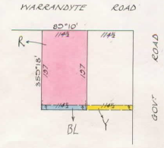
24/3/1959 Certificate of Title Volume 8220 Folio 125 having a frontage of 114½ links to Warrandyte (Jumping Creek) Road by a depth of 197 links, being part of Lot 53 on Plan of Subdivision No. 4315 transferred by Ernest Alfred Arthur Janes to Ian Geoffrey Spencer of 9A Yarra Road Wonga Park Cartage Contractor. Street Address: 109 Jumping Creek Road Wonga Park
5/2/1965 Transfer No. C142619 from Ian Geoffrey Spencer to Jaraslav Sury Painter and Jindriska Sury Married Woman both of Jumping Creek Road Wonga Park.
17/6/1965 Mortgage No. C242084 to The English Scottish and Australian Bank Limited, discharged 30/5/1975.
30/5/1975 Transfer No. F716074 from Jaraslav Sury and Jindriska Sury to Craig Stuart Mitchell Licencee and Judith Margaret Mitchell Married Woman both of “Arrochar” David Road Warrandyte.
Title Plan on Certificate of Title Volume 8220 Folio 125 Street Address: 109 Jumping Creek Road
30/5/1975 Mortgage No. F716075 to The Commissioner of The State Savings Bank of Victoria, discharged 19/11/1980
7/3/1978 Mortgage No. G992872 to The Commercial Banking Company of Sydney Limited, discharged 19/11/1980.
19/11/1990 Transfer No. J239874 from Craig Stuart Mitchell and Judith Margaret Mitchell to Ian Eric Fauconnier Sutton Accountant and Ann Burton Sutton Married Woman both of 13 Lynwood Avenue Ringwood East.
19/11/1980 Mortgage No. J239874 to The National Bank Savings Bank Limited, discharged 10/4/1991.
11/3/1992 Survivorship Application No. R815629S: Ann Burton Sutton of 109 Jumping Creek Rd. Wonga Park is now the surviving proprietor.
19/5/1992 Transfer No. R919212G from Ann Burton Sutton to Stuart David Wallace & Jane Patricia Wallace of 29 Curry Rd. Park Orchards.
19/5/1992 Mortgage No. R919213D to Commonwealth Savings Bank of Australia, discharged 28/8/1996.
26/8/1996 Transfer No. U373693N from Stuart David Wallace & Jane Patricia Wallace to Geoffrey Brian Raftery & Deborah Shirley Weiss 109 Jumping Creek Rd. Wonga Park 3115.
26/8/1996 Mortgage No. U373694K to Defence force Credit Union Limited, discharged 20/1/1998.
20/1/1998 Mortgage No. V212653G to State Bank of New South Wales Limited, discharged 24/11/1999.
24/11/1999 Mortgage No. W424935U to St George Bank Limited, discharged 31/8/2001.
31/8/2001 Mortgage No. X711304K to Australia And New Zealand Banking Group Limited, discharged 26/10/2001.
29/10/2001 Transfer No. X842804U from Stuart David Wallace & Jane Patricia Wallace to Sara Dyer & Arthur John Lewidge both of 109 Jumping Creek Rd Wonga Park 3115.
29/10/2001 Mortgage No. X842805R to Commonwealth Bank of Australia.
27/10/2008 Discharge No. AG161405X of Mortgage No. X842805R lodged.
27/10/2008 Transfer No. AG161406V from Sara Dyer and Arthur John Ledwidge to Sara Dyer of 109 Jumping Creek Road Wonga Park Vic 3115.
27/10/2008 Mortgage No. AG161407T to Commonwealth Bank of Australia.
18/6/2014 Discharge No. AL161453S of Mortgage No. AG161407T lodged.
18/6/2014 Transfer No. AL161454Q from Sara Dyer to Helen Angela Haslinghouse of 67 Scott Street Vermont Vic 3133.
18/6/2014 Mortgage No. AL161455N to Commonwealth Bank of Australia.
28/1/2022 Discharge No. AV281020T of Mortgage No. AL161455N lodged.
***************************************************************************
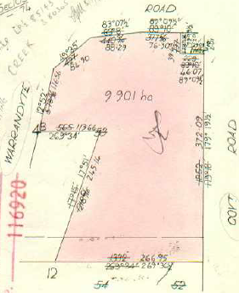
1/7/1959 Certificate of Title Volume 8236 Folio 963, area 24 acres 2 roods and 8 perches (9.901 hectares) being part of Lot 53 on Plan of Subdivision No. 4315 transferred by Ernest Alfred Arthur Janes to Albert Caborne Murcutt Gentleman and Verna Maud Murcutt Married Woman both of Warrandyte Road Wonga Park. Street Address: 111 and 117 Jumping Creek Road and 3 Hartley Road Wonga Park
16/7/1959 Caveat No. A757586 lodged and later lapsed.
1/8/1960 Transfer No. B26130 from Albert Caborne Murcutt and Verna Maud Murcutt to Charles William Lloyd of Wetherby Road Doncaster Orchardist.
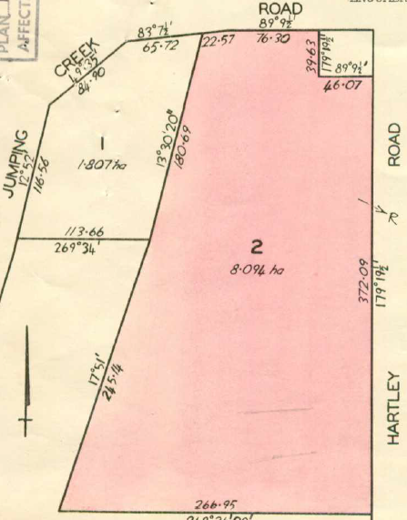
5/4/1962 Transfer No. B397474 from Charles William Lloyd to Charles William Lloyd Orchardist and Jean Elizabeth Mary Lloyd Married Woman both of Wetherby Road Doncaster.
Title plan on Certificate of Title Volume 8236 Folio 963
4/2/1976 Title Cancelled pursuant to Regulation 12 and titles issued as set out herunder: Lots One to 2 in Vol 9123 Fol 901 and Vol 9123 Fol 902. LP 116920.
4/2/1976 Certificate of Title Volume 9123 Folio 902, area 8.094 hectares, being lot 2 on Plan of Subdivision No. 116920 issued in the names of Charles William Lloyd Orchardist and Jean Elizabeth Mary Lloyd both of 69 Wetherby Road Doncaster East. Street Address: 111 Jumping Creek Road and 3 Hartley Road Wonga Park
18/5/1983 Title Cancelled and the following Titles have been issued pursuant to Regulation 12 of the Transfer of Land Act: Lots 3 to 4 in Vol 9512 Fol 818 and Vol 9512 Fol 819 LP 142622.
Title Plan on Certificate of Title Volume 9123 Folio 902 showing Lots 1 & 2 on Plan of Subdivision No. 116920
**************************************************
18/5/1983 Certificate of Title Volume 9512 Folio 818, area 4.047 hectares, being lot 3 on Plan of Subdivision No. 142622 issued in the names of Charles William Lloyd Orchardist and Jean Elizabeth Mary Lloyd both of Yarra Road Wonga Park. Street Address: 111 Jumping Creek Road Wonga Park
6/7/1983 Transfer No. K446563 from Charles William Lloyd and Jean Elizabeth Mary Lloyd to Eric Ivan Gregorich of 1042 Doncaster Road East Doncaster Travel Agent.
6/7/1983 Mortgage No. K446564 to Australia And New Zealand Savings Bank Limited, discharged 22/6/1994.

6/7/1983 Mortgage No. K446565 to Australia And New Zealand Banking Group Ltd, discharged 22/6/1994.
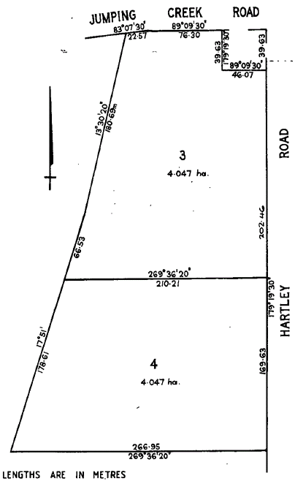
22/6/1994 Mortgage No. T153362N to Commonwealth Bank of Australia.
8/4/2009 Caveat No. AG446577E by Car And Home Finance Pty Ltd as mortgagee.
16/7/2009 Mortgage No. AG633800M to Car And Home Finance Pty Ltd and lapsing of Caveat AG446577E.
22/10/2010 Caveat No. AH573358X by Car And Home Finance Pty Ltd as mortgagee.
1/11/2012 Withdrawal No. AK001422K of Caveat No. AH573358X lodged.
10/4/2013 Caveat No. AK280953P by Needlebridge Pty Ltd as purchaser lodged.
16/7/2013 Discharge No. AK467584E of Mortgage No. T153362N lodged.
16/7/2013 Discharge No. AK467585C of Mortgage No. AG633800M lodged.
Lots 3 & 4 on Plan of Subdivision No. 14622
16/7/2013 Transfer No. AK467586A from Eric Ivan Gregorich to Needlebridge Pty Ltd of Level 3 115-119 Collins Street Melbourne Vic 3000.
16/7/2013 Mortgage No. AK467587X to Bendigo and Adelaide Bank Ltd and lapsing of caveat No. AK280953P.
15/7/2015 Discharge No. AM031004S of Mortgage No. AK467587X lodged.
15/7/2015 Transfer No. AM031005Q from Needlebridge Pty Ltd to Helen Sevastas of 111-115 Jumping Creek Road Wonga Park Vic 3115.
15/7/2015 Mortgage No. AM031006N to Westpac Banking Corporation lodged.
11/5/2021 Caveat No. AU329472C by Vassilis Sevastas as an implied, resulting or constructive trust.
**************************************************************************
18/5/1983 Certificate of Title Volume 9512 Folio 819, area 4.047 hectares, being lot 4 on Plan of Subdivision No. 142622 issued in the names of Charles William Lloyd Orchardist and Jean Elizabeth Mary Lloyd both of Yarra Road Wonga Park. Street Address: 3 Hartley Road Wonga Park
8/7/1983 Transfer No. K451630 from Charles William Lloyd and Jean Elizabeth Mary Lloyd to Matthew Henry Taine Medical Practitioner and Karin Taine Married Woman both of 10 Omeo Parade Warranwood.
12/9/1983 Mortgage No. K543374 to National Australia Savings Bank Limited, discharged 11/8/1993.
12/9/1983 Mortgage No. K543375 to National Commercial Corporation of Australia Limited, discharged 11/8/1993.
3/5/1984 Caveat No. L15592T lodged and withdrawn 11/8/1993.
11/8/1993 Mortgage No. S629401M to Citibank Savings Limited, discharged 23/9/2000.
25/9/2000 Mortgage No. X57222E to State Bank of New South Wales Limited.
9/8/2006 Discharge No. AE535365S of Mortgage No. X057222E lodged.
17/12/2009 Transfer No. AG929927M from Matthew Henry Taine and Karin Taine to Kristin Margaret Thomson of 3 Hartley Road Wonga Park Vic 3115.
17/12/2009 Mortgage No. AG929928K to Victori Teachers Credit Union Ltd.
*****************************************************************************
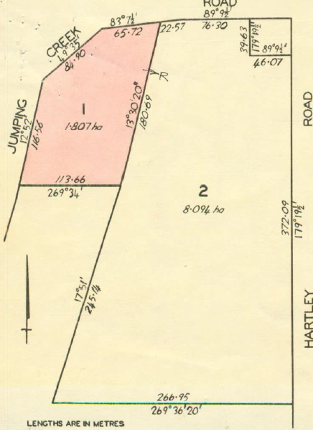
4/2/1976 Certificate of Title Volume 9123 Folio 901, area 1.807 hectares, being lot 1 on Plan of Subdivision No. 116920 issued in the names of Charles William Lloyd Orchardist and Jean Elizabeth Mary Lloyd both of 69 Wetherby Road Doncaster East. Street Address: 117 Jumping Creek Road Wonga Park
6/12/1976 Caveat No. G429371lodged and lapsed 28/11/1977.
15/11/1977 Transfer No. G863609 from Charles William Lloyd and Jean Elizabeth Mary Lloyd to Danda Nominees Pty. Ltd. of 406 Lonsdale Street Melbourne.
2/12/1982 Mortgage No. K182030 to Commonwealth Trading Bank of Australia, discharged 5/7/1983.
5/7/1983 Mortgage No. K445144 to Clients Investments Proprietary Limited, discharged 13/6/1985.
Title Plan on Certificate of Title Volume 9123 Folio 901 showing Lots 1 & 2 on Plan of Subdivision No. 116920
6/9/1984 Mortgage No. L246714P to Commonwealth Bank of Australia, discharged 13/6/1985.
28/4/1986 Caveat No. L719287L lodged and withdrawn 28/4/1986.
28/9/1984 Transfer No. L284190H from Danda Nominees Pty. Ltd. to Gunnar Knudsen of 127 Drummond St. Carlton.
28/9/1984 Mortgage No. L284191E to Combined Mortgage Services Pty. Ltd., discharged 28/4/1986.
24/1/1985 Mortgage No. L479103U to ALA Nominees Pty. Ltd., discharged 28/4/1986
28/4/1986 Transfer No. M243538N from Gunnar Knudsen to Frank Considine Investigations Pty. Ltd. of 456 St. Kilda Rd. Melbourne.
28/4/1986 Mortgage No. M243539K to Australia And New Zealand Savings Bank Limited, discharged 27/5/1987.
28/4/1986 Mortgage No. M243540K to Australia And New Zealand Banking
Group Limited, discharged 27/5/1987.
27/5/1987 Transfer No. M860932N from Frank Considine Investigations Pty. Ltd. to Norman John Cronin of 193 Tindals Rd. Donvale.
27/5/1987 Mortgage No. M860933K to Commonwealth Bank of Australia, discharged 16/8/1991.
14/3/1991 Caveat No. R257809Y by Giovanni Santamaria & Regina Mary Santamaria as purchasers. This caveat will lapse on registration of R495022W – 26/8/1991.
16/8/1991 Transfer No. R495022W from Norman John Cronin to Giovanni Santamaria & Regina Mary Santamaria both of 117 Jumping Creek Rd. Wonga Park.
16/8/1991 Mortgage No. R495023T to Australia And New Zealand Savings Bank Limited.
11/5/2001 Discharge No. X467822E of Mortgage No. R495023T lodged.
11/5/2001 Transfer No. X467823B from Giovanni Santamaria and Regina Mary Santamaria to Lachlan Shackleton-Fergus and Julia Patricia Shackleton-Fergus both of 117-123 Jumping Creek Road Wonga Park 3115.
**********************************************************************
9/12/1949 Certificate of Title Volume 7551 Folio 100, area 6 acres and 33 perches being part of Lot 53 on Plan of Subdivision No. 4315 and part of a Government Road in the name of Cecil Cook Beeston of Wonga Park Croydon Engineer (having been transferred to him by Walter Slade). Street Address: 125 to 135 Jumping Creek Road Wonga Park
22/12/1953 Transfer No. 2606222 from Cecil Cook Beeston to Herbert Clifford Howard Storeman and Mary Howard Married Woman both of Warrandyte Road Wonga Park.
14/7/1958 Transfer No. A566061 from Herbert Clifford Howard and Mary Howard to Leonie St. Clair Aytoun of 1 Vinter Avenue Croydon Gentlewoman.
14/7/1958 Mortgage No. A566062 to The Bank of Adelaide, discharged 29/9/1959.
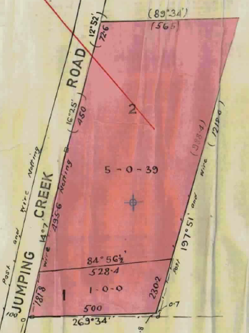
29/9/1959 Mortgage No. A824989 to Eagle Star Insurance Company Limited, dischaged14/10/1966
3/7/1968 Title cancelled pursuant to Regulation 12 and Titles issued as set out hereunder: Lots One and 2 in vol 8728 Fol 272 and Vol 8728 Fol 273, LP 80305.
3/7/1968 Certificate of Title Volume 8728 Folio 273, area 5 acres 0 roods and 39 perches, being Lot 2 on Plan of Subdivision No. 80305 issued in the name of Leonie St.Clair Aytoun of Jumping Creek Road Wonga Park Gentlewoman subject to Mortgage No. C614981, which mortgage was discharged on 17/11/1971.
17/11/1971 Mortgage No. E224 051 to George John Treleaven and Elsie Laura Treleaven, discharged 21/11/1971.
Lots 1 & 2 on Plan of Subdivision No. 80305. Certificates of Title Volume 8728 Folios 272 & 273
21/2/1973 Mortgage No. E711346 to Robert Wilfred Holt, discharged ???.
1/7/1974 Caveat No. F363904 lodged affecting part of the land herein Lot No. 2 on P/S 112004.
Title cancelled pursuant to Regulation 12 and Titles issued as set out hereunder: Lots One to 2 in Vol 9036 Fol 689 to Vol 9036 Fol 690.
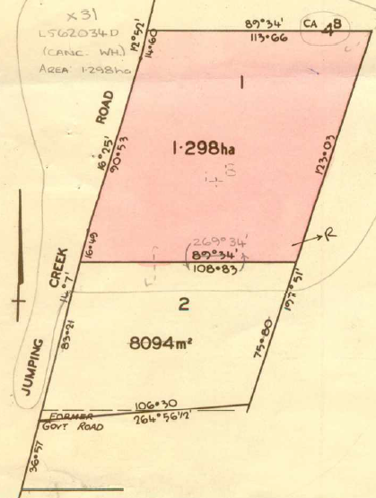
2/7/1974 Certificate of Title Volume 9036 Folio 689, area 1.298 hectares, being Lot 1 on Plan of Subdivision No. 112004 issued in the name of Leonie St.Clair Aytoun of “Somerset” Jumping Creek Road Wonga Park Gentlewoman subject to Mortgage No. E711346, which mortgage was discharged on 24/7/1974. Street Address: 125 Jumping Creek Road Wonga Park
30/10/1981 Caveat No. J661088 lodged and transferred to new C/T.
15/3/1985 Transmission Application No. L562033G: Leonie St. Clair Aytoun died on 23rd August 1984. Probate of her will has been granted to Albert Edgar Flood and June Allison Flood.
Title cancelled Application No. L562034D Registered 15 Mar 1985 See Vol 9638 Fol 307 which is issued pursuant to Section 31 Act 6399.
Plan on Certificate of Title Volume 9036 Folio 689 showing Lots 1 & 2 on Plan of Subdivision No. 112004
15/3/1985 Certificate of Title Volume 9638 Folio 307, area 1.298 hectares, being Lot 1 on Plan of Subdivision No. 112004 issued in the names of Albert Edgar Flood and June Allison Flood both of 16 Wattle Avenue Ringwood (Executors of the Will of Leonie St.Clair Aytoun) being Lot 1 on Plan of Subdivision No. 112004. Street Address: 125 Jumping Creek Road Wonga Park
30/9/1981 Caveat No. J661088 lodged, caveat will lapse on registration of B543383T – 15/10/1991
27/2/1987 Mortgage No. M722636S to Australi And New Zealand Savings Bank Limited, discharged 4/9/2000.
7/2/1989 Caveat No. N998509G by Avco Financial Services Limited as charge.
13/9/1991 Transfer No. R543383T from Albert Edgar Flood and June Allison Flood (as executors of the Will of Leonie St.Clair Aytoun) to Albert Edgar Flood & June Allison Flood of 125 Jumping Creek Rd. Wonga Park.
4/10/1991 Mortgage No. R577225G to Australia and New Zealand Banking Group Limited, discharged 4/9/2000.
2/11/1994 Transfer No. T390572U from albert Edgar Flood and June Allison Flood to June Allison Flood of 125 Jumping Creek Rd. Wonga Park 3115
2/11/2016 Transmission Application No. AN296882V to Gary John Flood of 10 McIntyre Lane Yering Vic 3770, Susan Elizabeth Flood of 17 Valencia Road Lilydale Vic 3140 and Vicki Christina Flood of Unit 4, 6 Patrick Avenue North Croydon Vic 3136 as Legal Personal Representatives of June Allison Flood deceased.
21/11/2016 Transfer No. AN296883T from Gary John Flood, Susan Elizabeth Flood and Vicki Christina Flood to Vicki Chistina flood of Unit 4, 6 Patrick Avenue North Croydon Vic 3136.
**********************************************************************
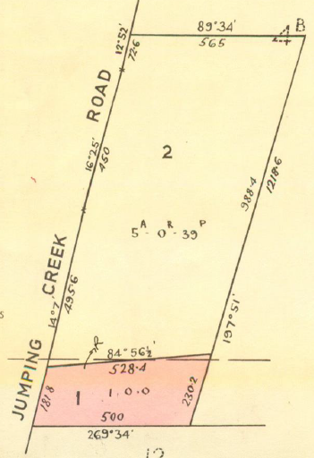
3/7/1968 Certificate of Title Volume 8728 Folio 272, area 1 acres 0 roods and 0 perches, being Lot 1 on Plan of Subdivision No. 80305 issued in the name of Leonie St.Clair Aytoun of Jumping Creek Road Wonga Park Gentlewoman subject to Mortgage No. C614981, which mortgage was discharged as to part being the within land on 2/7/1968. Street Address: 135 Jumping Creek Road Wonga Park
2/7/1968 Transfer No. D120405 from Leonie St.Clair Aytoun to Lance William Bullock Clerk and Judith Dianne Bullock Married Woman both of 15 Hume Street Bayswater.
16/7/1973 Mortgage No. E900136 to The Commissioners of The State Savings Bank of Victoria, discharged 15/7/1986.
15/7/1986 Transfer No. M367691E from Lance Willian Bullock and Judith Dianne Bullock to Bruce David Ferrall & Lynette Joy Ferrall both of 7 Klead Crt. North Ringwood.
Plan on Certificate of Title Volume 8728 folio 272 showing Lots 1 &2 on Plan of Subdivision No. 80305
15/7/1986 Mortgage No. M367692B to Australian Mutual Provident Building Society, discharged 11/11/1997.
27/10/1989 Mortgage No. P496711E to Australian Mutual Provident Society, discharged 11/11/1997.
11/11/1997 Mortgage No. V86425M to Priority One Financia Services Ltd.
11/8/1998 Transfer No. V579185W of Mortgage No. V86425M to AMP Bank Ltd.
13/7/2021 Discharge No. AU568694W of Mortgage No. V086425M lodged.
21/4/2023 Transfer No. AW755652E from Bruce David Ferrall and Lynette Joy Ferrall to Michael Peter Cullum and Lauren May Cullum both of 135 Jumping Creek Road Wonga Park Vic 3115.
21/4/2023 Mortgage No. AW755653C to Commonwealth Bank of Australia.
*********************************************************************
2/7/1974 Certificate of Title Volume 9036 Folio 690, area 8094 square metres, being Lot 2 on Plan of Subdivision No. 112004 issued in the name of Leonie St.Clair Aytoun of “Somerset” Jumping Creek Road Wonga Park Gentlewoman subject to Mortgage No. E711346, which mortgage was discharged on 24/7/1974. Street Address: 125 Jumping Creek Road Wonga Park
17/3/1975 Transfer No. F634653 from Leonie St.Clair Aytoun to Martin Hobkirk Riddell Finance Controller and Jillian Nancy Riddell Married Woman both of 38 Granard Avenue Park Orchards.
30/7/1975 Mortgage No. F792552 to The Commissioners of The State Savings Bank of Victoria, discharged 19/7/1993.
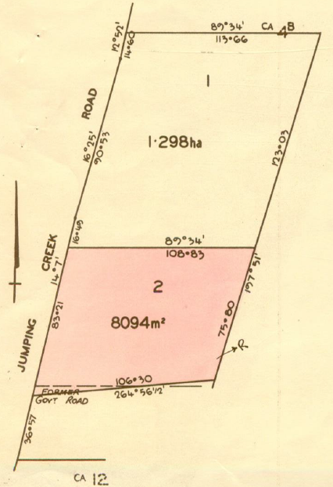
16/10/1991 Transfer No. R594331C from Martin Hobkirk Riddell and Jillian Nancy Riddell to Martin Hobkirk Riddell of 131 Jumping Creek Rd. Wonga Park.
16/10/1991 Transfer No. R594332Y from Martin Hobkirk Riddell to Martin Hobkirk Riddell & Merilyn Faye Riddell of 131 Jumping Creek Rd. Wonga Park as tenants in common in equal shares.
29/10/1991 Mortgage No. R594332Y to Commonwealth Bank of Australia.
19/11/2001 Transfer No. X889189F from Martin Hobkirk Riddell and Merilyn Faye Riddell to Annette Margaret Cherry of 9 St James Av. Mont Albert 3127.
19/11/2001 Mortgage No. X889190F to National Australia Bank Limited.
Plan on Certificate of Title Volume 9036 Folio 690 showing Lots 1 & 2 on Plan of Subdivision No. 112004
18/1/2005 Discharge No. AD374811Y of Mortgage No. X889190F lodged.
18/1/2005 Transfer No. AD374812W from Annette Margaret Cherry to Anthony Gordon Eliott of 131-133 Jumping Creek Road Wonga Park Vic 3115.
18/1/2005 Mortgage No. AD374813U to Westpac Banking Corporation.
22/7/2009 Discharge No. AG646737T of Mortgage No. AD374813U lodged.
22/7/2009 Transfer No. AG646738R from Anthony Gordon Eliott to Eva Anke Eliott of 131-133 Jumping Creek Road Wonga Park Vic 3115.
2/6/2010 Mortgage No. AH268354J to National Australia Bank Ltd.
25/10/2011 Discharge No. AJ275647K of Mortgage No. AH268354J lodged.
25/10/2011 Mortgage No. AJ275648H to Suncorp-Metway Ltd.
13/2/2014 Discharge No. AK898590E of Mortgage No. AJ275648H lodged.
13/2/2014 Transfer No. AK898591C from Eva Anke Eliott to Charles Malcolm Stewart and Carol Anne Stewart both of 131-133 Jumping Creek Road Wonga Park Vic 3115.
13/2/2014 Mortgage No. AK898592A to Commonwealth Bank of Australia.

