Title History of Lot 55 on Plan of Subdivision No. 4315
Lot 55 PS 4315 (bounded on the north by Jumping Creek (formerly Warrandyte) Road) and on the East by Hooper (formerly Mullens) Road and being part of the land in Certificate of title Volume 3932 Folio 334. (And being the lands in Nos. 157,165 & 167 Jumping Creek Road and Nos. 2, 8 &10 Hooper Road Wonga Park.)
Street numbers for properties in Jumping Creek Road between Hooper Road and Jumping Creek Reserve plus a few in Hooper Road, they being parts of Lots 55, 56 & 57 on Plan of Subdivision No. 4315
Plan showing property boundaries and street numbers for Lots 55, 56 & 57 on Plan of Subdivision No. 4315 and some surrounding properties.
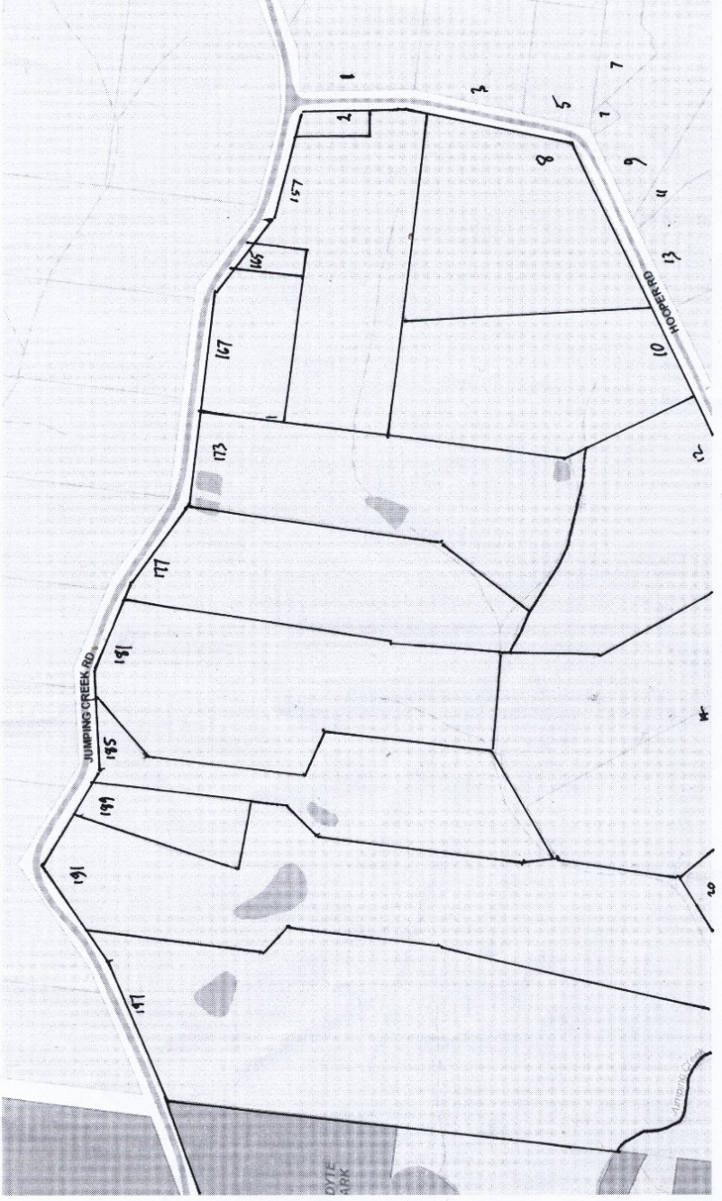
The Mutual Assurance Society of Victoria Limited owned much of the land in Wonga Park in 1897 and drew up a plan of subdivision which was not approved until 1902 but, as was allowed in those days sold lots on terms contracts before the plan was approved by the Titles Office. This Plan of Subdivision was registered as Plan of Subdivision No. 4315 and was the land in Certificate of Title Volume 2734 Folio 735.
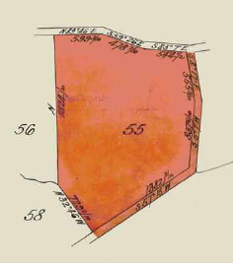
Lot 55 on Plan of Subdivision No. 4315
13/9/1913 Transfer No. 726062 from The Mutual Assurance Society of Victoria Limited to Robert John Hill of Apsley Farmer of Lot 55 on Plan of Subdivision No. 4315, area 30 acres 3 roods and 28 perches together with a right of carriage way over the roads coloured brown (Hooper Road from Jumping Creek Road to the south-eastern corner of the lot), new Certificate of Title Volume 3731 Folio 022.
13/4/1922 Transfer as to part (of Lot 55) No. 1041214 (the northern half) from Robert John Hill to Walter Armstrong of 2 South Street Footscray Carpenter, area 15 acres 1 rood and 34 perches, new Certificate of title Volume 4560 Folio 806.
Plan of land in Certificate of Title Volume 3731 Folio 022.
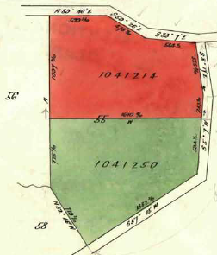
14/8/1924 Transfer No. 1179709 from Walter Armstrong to James Joseph Quinlivan of Wonga Park Orchardist.
19/4/1922 Transfer as to the balance (of Lot 55) No. 1044250 (the southern half) from Robert John Hill to James Joseph Quinlivan of Wonga Park Warrandyte Orchardist, area 15 acres 1 rood and 34 perches, new Certificate of Title Volume 4560 Folio 807.
20/3/1925 Caveat No. 65567 lodged on both Certificates of Title Volume 4560 Folio 806 and Volume 4560 Folio 807 (being the whole of Lot 55), lapsed on 20/1/1928.
Plan attached to Certificate of Title Volume 3731 Folio 022 showing lands transferred out and then later reunited in the name of Arthur Wesley Lobb
20/1/1928 Transfer No. 1352204 of the lands in Certificates of Title Volume 4560 Folio 806 and Volume 4560 Folio 807 (being the whole of Lot 55) to Arthur Wesley Lobb of 20 Mont Albert Road Mont Albert Brewer
13/11/1944 Transfer No. 1934281 from Arthur Wesley Lobb to Richard Wesley Lobb of 4 Grandview Grove Northcote Used Car Dealer.
9/10/1946 Transfer No. 2040013 from Richard Wesley Lobb to Martha Lilian Powell of 36 Blair Street Coburg Spinster.
29/8/1947 Transfer as to part No. 2098201 from Martha Lilian Powell to Andew George Reid Irwin, area 27 acres 3 roods and 28 perches new Certificate of Title Volume 7162 Folio 293 and being the lands in No. 157 & 165 Jumping Creek Road and Nos. 2, 8 & 10 Hooper Road Wonga Park.
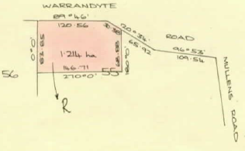
11/6/1968 Martha Lilian Woods (formerly Powell) died on 31st January 1968. Probate of her Will has been granted to Public Trustee D100637 4/9/1975
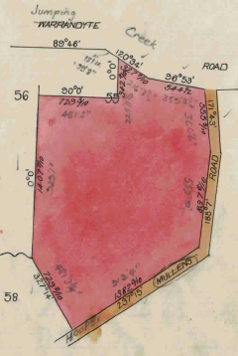
4/9/1975 Transfer No. F840313 as to Balance by Public Trustee to Ainslie Lamb of 23 Chatham Road Canterbury Solicitor area 1.214 hectares (on north-east corner of Lot 55), new Certificate of Title Volume 9108 Folio 563 and being the land at 167 Jumping Creek Road Wonga Park.
Plan of land being the balance of the land in Certificate of Title Volume 4560 Folio 806 after the transfer of over 27 acres to Andrew George Reid Irwin and then becoming the land in Certificate of Title Volume 9108 Folio 563 being167 Jumping Creek Road.
Certificate of Title Volume 7162 Folio 293
29/8/1947 Certificate of Title Volume 7162 Folio 293, area 27 acres 3 roods and 28 perches issued in the name of Andrew George Reid Irwin and being the lands at 157 & 165 Jumping Creek Road and Nos. 2, 8 & 10 Hooper Road Wonga Park.
Plan of land in Certificate of Title Volume 7162 Folio 293 in the name of Andrew George Irwin
6/9/1968 Mortgage No. D181757 to The Commissioners of the State Savings Bank of Victoria.

No. 2 Hooper Road Wonga Park
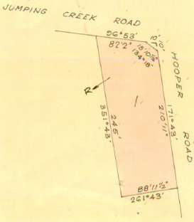
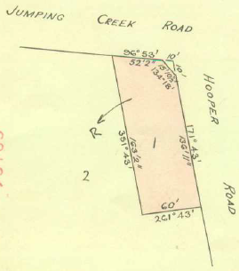
21/5/1968 Transfer as to part No. D83122 (out of the land in Certificate of Title Volume 7162 Folio 293) from Andrew George Reid Irwin to his son Denis Richard Irwin Orchardist and daughter-in-law Margaret Ann Irwin Married Woman both of Hooper Road Wonga Park of Lot 1 on Plan of Subdivision No. 80195 (dimensions approx. 60ft x 163ft on the north-east corner of Jumping Creek Road and Hooper Road and being the land at No. 2 Hooper Road Wonga Park, new Certificate of Title Volume 8730 Folio 390.
Plan of the land in Certificate of Title Volume 8730 Folio 390
24/7/1972 Transfer No. E468672 (out of the land in Certificate of Title Volume 7162 Folio 293) from Andrew George Reid Irwin to Denis Richard Irwin Orchardist and Margaret Ann Irwin Married Woman both of Hooper Road Wonga Park of an L shaped piece of land which was then consolidated with the land in Certificate of Title Volume 8730 Folio 390 to form Lot 1 on Plan of Subdivision No. 93163, new Certificate of Title Volume 8939 Folio 921.
Plan of the land in Certificate of Title Volume 8939 Folio 921
29/7/1990 Mortgage No. D181757 to The Commissioners of the State Savings Bank of Victoria discharged.
29/1/1980 Transfer No. H847193 from Denis Richard Irwin and Margaret Ann Irwin to Victor William Benton Truck Driver and Sharon Anne Benton Married Woman both of 74 Renshaw Street East Doncaster.
29/1/1980 Mortgage No. H847194 to Australia and New Zealand Savings Bank Limited, discharged 26/10/1983.
26/10/1983 Transfer No. K604051 from Victor William Benton and Sharon Anne Benton to Zentachem Pty. Ltd. Whose address is at the office of Deloitte Haskins & Sells of 461 Bourke Street Melbourne.
26/10/1983 Mortgage No. K604052 to The RESI Permanent Building Society, discharged 21/8/1987.
21/8/1987 Transfer No. N2487U from Zentachem Pty. Ltd. to Ronald Douglas Cook & Daphne Margaret Cook of 1 Sandra Crt. Donvale.
17/5/1991 Transfer No. R344985Q from Ronald Douglas Cook & Daphne Margaret Cook to Stuart Wayne Biggins & Pamela Joy Biggins of 155 Jumping Creek Rd. Wonga Park.
17/5/1991 Mortgage No. R344986M to National Bank Ltd.
30/12/2004 Caveat No. AD336649V by Alan Dudley Alpass as Chargee, date of claim 23/12/2004, Caveat removed 30/5/2005.
30/12/2004 Mortgage No. R344986M to National Bank Ltd. Discharged.
30/12/2004 Transfer No. AD650173S from Stuart Wayne Biggins and Pamela Joy Biggins to Pamela Joy Biggins of 2 Hooper Road Wonga Park Vic 3115.
30/5/2005 Mortgage No. AD650174Q to National Australia Bank Limited.
16/6/2016 Caveat No. AM860385B by Daniel John Veith as purchaser as of 14/5/2016.
2/8/2016 Discharge of Mortgage No. AM984262B of Mortgage No. AD650174Q.
2/8/2016 Transfer (and Removal of Caveat No. AM860385B) No. AM984263Y from Pamela Joy Biggins to Daniel John Veith and Celia Elizabeth Cosgriff both of 2 Hooper Road Wonga Park Vic 3115.
2/8/2016 Mortgage No. AM984264W to ING Bank (Australia) Ltd.
***************************************************************************
Certificate of Title Volume 7162 Folio 293, area 27 acres 3 roods and 28 perches in the name of Andrew George Reid Irwin and being the land at Nos.157 &165 Jumping Creek Road and 2, 8 & 10 Hooper Road Wonga Park.
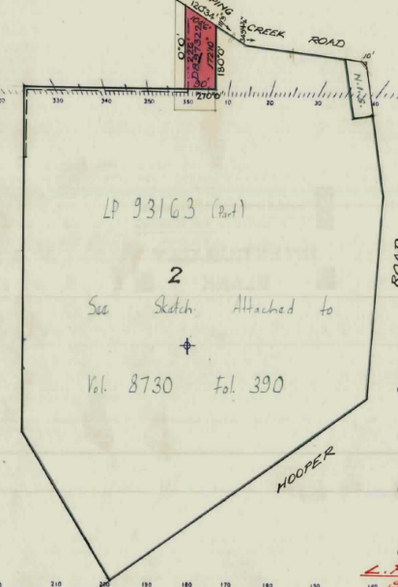
165 Jumping Creek Road Wonga Park
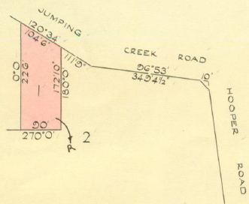
26/11/1970 Transfer as to Part No. D897322 from Andrew George Reid Irwin to Andrew George Reid Irwin Orchardist and Meta Alice Irwin Married Woman being Lot 1 on Plan of Subdivision No. 89511 being an irregular shaped piece of land with a frontage of 104’ 6” to Jumping Creek Road with a western depth of 226’ a rear of 90’ and an eastern depth of 172’ 10” and being the land at 165 Jumping Creek Road Wonga Park, new Certificate of Title Volume 8861 Folio 355.
Plan attached to certificate of Title Volume 7162 Folio 293 showing land transferred out in Transfer No. D89732.
Plan of land in Certificate of Title Volume 8861 Folio 355 in the name of Andrew George Reid Irwin and his wife Meta Alice Irwin.

15/3/1974 Meta Alice Irwin is now the surviving proprietor F237461.

11/11/1975 Transfer No. F924505 from Meta Alice Irwin to John David Potts Sales Manager and Constance Joan Potts Clerk both of 144 Bedford Road Ringwood.

11/11/1975 Mortgage No. F92450 to Bank of New South Wales Savings Bank Limited, discharged 2/3/1982.

29/5/2000 Transfer No. W810120H from John David Potts and Constance Joan Potts to Ralph Gordon Clarke & Clariss Myrtle Clarke of 13 Deep Creek Dr. East Doncaster 3109.

15/3/2010 Transfer No. AH092826V from Ralph Gordon Clarke and Clariss Myrtle Clarke to Nathan Daniel Burkett and Kristen Nicole Curtis both of 165 Jumping Creek Road Wonga Park Vic 3115.

15/3/2010 Mortgage No. AH092827T to Bendigo and Adelaide Bank Ltd.

29/8/2017 Transfer No. AQ185840G from Nathan Daniel Burkett and Kristen Nicole Curtis to Kristen Nicole Curtis of 165 Jumping Creek Road Wonga Park Vic 3115.

7/11/2019 Discharge of (Mortgage No. AH092827T) No. AS688534T.

7/11/2019 Mortgage and Change of name of registered proprietor No. AS688535Q to Commonwealth Bank of Australia, name of registered proprietor changed from Kristen Nicole Curtis to Kristen Nicole Burkett.

3/8/2023 Caveat No. AX115777V by Catherine Elizabeth Doyle as purchaser under contract dated 3/7/2023.

10/10/2023 Discharge of (Mortgage No. AS688535Q) No. AX337458Y.

10/10/2023 Transfer and Removal of Caveat No. AX337459W from Kristen Nicole Burkett to Catherine Elizabeth Doyle of 165 Jumping Creek Road Wonga Park Vic 3115.

10/10/2023 Mortgage No. AX337460N to Australia and New Zealand Banking Group Ltd.

************************************************************************
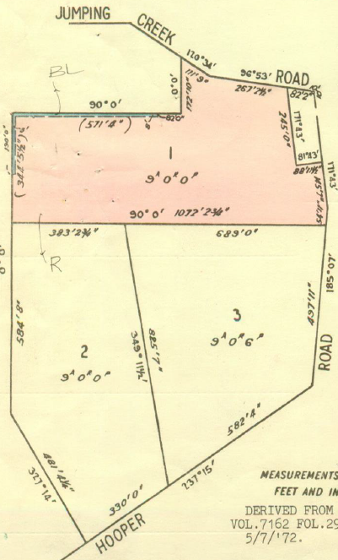
Certificate of Title Volume 7162 Folio 293, area 27 acres 3 roods and 28 perches in the name of Andrew George Reid Irwin and being the land at 157 Jumping Creek Road and Nos. 8 & 10 Hooper Road Wonga Park
5/7/1972 Cancelled as to part under Regulation 12 and Titles created as set out hereunder Lots 1 to 3 Lodged Plan No. 94748 Volume 8932 Folio 049 to Volume 8932 Folio 051
Plan of Subdivision No. 94748 subdivided the land left in the title into 3 large lots Lot one with frontages to both Jumping Creek and Hooper Roads (but not on the corner) Lot 3 immediately to the south of Lot 1 with a frontage to Hooper road and Lot 2 adjacent to and south east of Lot 3 with a frontage to Hooper Road and being the lands at 157 Jumping Creek Road and Nos. 8 & 10 Hooper Road Wonga Park.
157 Jumping Creek Road Wonga Park
Lot 1 Plan of Subdivision No. 94748 area 9 acres 0 roods and 0 perches Certificate of Title Volume 8932 Folio 049, in the name of Andrew George Reid Irwin of Jumping Creek Road Wonga Park Gentleman and being the land at 157 Jumping Creek Road Wonga Park.
Plan of land in Plan of Subdivision No. 94748 and Lot 1 is shown as coloured red. Lot 1 is the land in Certificate of Title Volume 8932 Folio 049
28/7/1972 Transfer No. E476543 from Alexander George Reid Irwin to Graham Alexander Kerr Solicitor and Jennifer
Brooke Kerr Married Woman both of 45 Orange Grove Bayswater.
18/8/1942 Mortgage No. E501041 to Adolph Martin Kleinert, discharged.
19/9/1974 Caveat No. F464759, lapsed 17/3/1975
28/2/1975 Transfer No. F618500 from Graham Alexander Kerr and Jennifer Brooke Kerr to Pierre Drijfhout Gentleman and Annie Wilhelmien Drijfhout Married Woman both of 280 Maroondah Highway Ringwood.
28/2/1975 Mortgage No. F798603 to H.S.W. Nominees Pty. Ltd., discharged 8/10/1975.
10/1/1977 Transfer No. G470082 from Pierre Drijfhout and Annie Wilhelmien Drijfhout to Harold Lionel Shield Orchardist and Valda Adeline Emily Shield Married Woman.
10/1/1977 Mortgage No. G470083 to Bank of New South Wales, discharged 8/6/1979.
8/6/1979 Valda Adeline Emily Shield of Jumping Creek Road Wonga Park Widow is now the surviving proprietor.
4/6/1980 Caveat No. J14174, lapsed 20/1/1981.
11/12/1980 Transfer No. J269819 from Valda Adeline Emily Shield to Colin Reginald Fricke Engineer and Diana Lesley Fricke Married Woman both of Bemboka Road Warranwood.
11/12/1980 Mortgage No. J269820 to C.B.C. Investment Services Limited, discharged 29/8/1983.
4/2/1981 Mortgage No. J328577 to The Commercial Banking Company of Sydney Limited, discharged 15/8/1984.
15/8/1984 Transfer No. L207321Q from Colin Reginald Fricke and Diana Lesley Fricke to Alexander Nicholas Psalti and Sigrid Maria Psalti both of 8 woodland Street Doncaster West area 3.642 hectares.
3/3/1988 Transfer No. N333416X from Alexander Nicholas Psalti and Sigrid Maria Psalti to Robert Jones & Linda Frances Langmead of 11 Pinetree Cl. Croydon South.
3/3/1988 Mortgage No. N333417U to Westpac Banking Corporation, dischaged25/3/1991
5/5/1988 Caveat No. N436551N by A.G.C. (Advances) Limited as Mortgagee claim document dated 21/3/1988, lapsed 23/8/1988.
15/8/1988 Mortgage No. N640656F to A.G. C. (Advances) Limited., discharged 22/11/1989.
2/11/1989 Mortgage No. P535663A to Custom Credit Corporation Limited, Does not now affect 25/3/1991.
8/1/1990 Caveat No. P602719F to Hacklete Nominees Pty. Ltd. as Mortgagee, claim document dated 1/12/1989, lapsed 29/4/1991.
Memo No. R37215X Served on 9/10/1990? Copy Warrant of Seizure and Sale issued out of the Supreme Court at Melbourne in an action numbered 8547 in the year 1990 Siddons Raypak Pty. Ltd. v Robert Jones and Linda Frances Jones. Ceased to Affect 18/4/1991.
25/3/1991 Transfer No. R273053B from Robert Jones & Linda Frances Jones to Ross Albert Beasley & Christine Anne Beasley of 157 Jumping Creek Rd. Wonga Park.
24/8/1993 Transfer No. S 652585G from Ross Albert Beasley and Christine Anne Beasley to Bob Exon Pty. Ltd. of 157 Jumping Creek Rd. Wonga Park 3115.
24/8/1993 Mortgage No. S652586D to Joan Exon, discharged 6/1/1999.
6/1/1999 Transfer No. V826813C from Bob Exon Pty. Ltd. to Trinity Dale Pty. Ltd. of 157 Jumping Creek Rd. Wonga Park 3115.
6/1/1999 Mortgage No. V826814Y to Westpac Banking Corporation, discharged 25/8/1999.
10/4/2013 Land Tax Charge Statutory Charge Section 96 (1) Land Tax Act 2005 No. AK282169W, removed 9/12/2019.
10/12/2019 Transfer No. AK282169W from Trinity Dale Pty. Ltd. to Johannes August Joseph Abandowitz of 157 Jumping Creek Road Wonga Park Vic 3115.
10 Hooper Road Wonga Park
5/7/1972 Certificate of Title Volume 8932 Folio 050 issued for Lot 2 Plan of Subdivision No. 94748, area 9 acres 0 roods and 0 perches, in the name of Andrew George Reid Irwin of Jumping Creek Road Wonga Park Gentleman and being the land at 10 Hooper Road Wonga Park.
28/7/1972 Transfer No. E476543 from Andrew George Reid Irwin to Graham Alexander Kerr Solicitor and Jennifer Brooke Kerr Married Woman both of 45 Orange Grove Bayswater.
18/8/1972 Mortgage No. E501042 to Adolph Martin Kleinert, discharged 29/5/1975.
25/2/1975 Creation of Easement No. F614605 being a right of Carriage Way along the rear boundary appurtenant to (for the benefit of) the adjacent Lot2.
29/5/1975 Transfer No. F713747 from Graham Alexander Kerr and Jennifer Brooke Kerr to Graham Alexander Campbell and Margaret Joyce Campbell both of Jumping Creek Road Wonga Park Thoroughbred Breeders.
6/12/1976 Transfer No. G429467 from Graham Alexander Campbell and Margaret Joyce Campbell to Ritoma Pty. Ltd. of Hooper Road Wonga Park.
8/12/1976 Mortgage No. G433846 to Thomas Stewart White and Nance Margaret White, discharged 25/7/1985.
8/11/2001 Transfer No. X868352C from Ritoma Pty. Ltd. to Debra-Anne Hill of 2 Hooper Rd Wonga Park 3115.
8/11/2001 Mortgage No. X868353Y to Westpac Banking Corporation, discharged 31/3/2005.
8/11/2001 Mortgage No. X868354V to Westpac Banking Corporation, discharged 31/3/2005.
31/3/2005 Transfer No. AD527955Y from Debra-Anne Hill to Philip David Bloom of 10 Hooper Road Wonga Park Vic 3115.
31/3/2005 Mortgage No. AD527956W to Commonwealth Bank of Australia.
8 Hooper Road Wonga Park
5/7/1972 Certificate of Title Volume 8932 Folio 051 issued for Lot 3 on Plan of Subdivision No. 94748 area 9 acres 0 roods and 0 perches, in the name of Andrew George Reid Irwin of Jumping Creek Road Wonga Park Gentleman and being the land at 8 Hooper Road Wonga Park.
28/7/1972 Transfer No. E476543 from Andrew George Reid Irwin to Graham Alesander Kerr Solicitor and Jennifer Brooke Kerr Married Woman both of 45 Orange Grove Bayswater.
28/7/1972 Mortgage No. E476544 to Andrew Geroge Reid Irwin and Meta Alice Irwin, discharged 10/10/1973.
10/10/1973 Mortgage No. F38641 to The Commercial Savings Bank of Australia Limited, discharged 25/2/1975.
10/10/1973 Mortgage No. F38642 to The Commercial Bank of Australia Limited, discharged 25/2/1975.
25/2/1975 Transfer No. F614604 from Graham Alexander Kerr and Jennifer Brooke Kerr to James Peter O’Shaughnessy Real Estate Agent and Rae Elizabeth O’Shaughnessy Married Woman both of Jumping Creek Road Wonga Park.
14/7/1997 Surviving Proprietor Rae Elizabeth O’Shaughnessy 8 Hooper Road Wonga Park 3115, U871729H.
14/03/2001 Mortgage No. X364005A to Commonwealth Bank of Australia, discharged 10/5/2001.
10/2/2001 Transfer No. X466051U from Rae Elizabeth O’Shaughnessy to Helmut Pekarek and Hilary Kathleen Pekarek 8 Hooper Rd. Wonga Park 3115.
10/5/2001 Mortgage No. X466052R to Westpac Banking Corporation.
167 Jumping Creek Road Wonga Park
4/9/1975 Certificate of Title Volume 9108 Folio 563 issued, area 1.214 hectares, in the name of Ainslie Lamb and being the land at 167 Jumping Creek Road Wonga Park.
4/9/1975 Mortgage No. F840314 to Commonwealth Savings Bank of Australia, discharged 25/7/1991.
8/12/1982 Mortgage No. K188546 to Commonwealth Trading Bank of Australia, discharged 26/9/1984.
5/8/1992 Transfer No. S50074G from Ainslie Lamb to Ainslie Lamb and Ronald Kentish Browne of 167 Jumping Creek Rd. Wonga Park.
Plan of the land in Certificate of Title Volume 9108 Folio 563
7/10/1997 Mortgage No. V24952Q to National Australia Bank Limited, discharged 22/5/1998.
22/5/1998 Transfer No. V435570L from Ainslie Lamb and Ronald Kentish Browne to Peter Robin Byron of 167 Jumping Creek Rd. Wonga Park 3115.
22/5/1998 Mortgage No. V435571H to Australia and New Zealand Banking Group Limited, discharged 20/12/2003.
20/12/2003 Transfer No. AC559085G from Peter Robin Byron to Peter Robin Byron and Joy Ann Byron both of 167-171 Jumping Creek Rd Wonga Park 3115.
20/12/2003 Mortgage No. AC559086E to Bendigo Bank Ltd, discharged 9/7/2021.
7/4/2021 Caveat No. AU212403A by Prasanna Dassanayaka as purchaser under contract dated 13/3/2021. Caveat withdrawn 8/7/2021.
9/7/2021 Transfer No. AU558089W from Peter Robin Byron and Joy Ann Byron to Delanne Marie Dezilwa and Mahagedara Gamage Chandana Prasanna Dassanayaka both of 167-171 Jumping Creek Road Wonga Park Vic 3115.
9/7/2021 Mortgage No. AU558090N to Ines Testolin and Silvano Testolin, discharged 17/2/2022.
26/4/2023 Transfer No. AW762562Q from Delanne Marie Dezilwa and Mahagedara Gamage Chandana Prasanna Dassanayaka to Mahagedara Gamage Chandana Prasanna Dassanayaka of 161-171 Jumping Creek Road Wonga Park Vic 3115.

