Summary of Title History of Lot 56 PS 4315
Lot 56 PS 4315 with a frontage to Jumping Creek (formerly Warrandyte) Road), being part of the land in Certificate of title Volume 3932 Folio 334 and being the lands in Nos. 173, 177 & part 181 Jumping Creek Road.
Street numbers for properties in Jumping Creek Road between Hooper Road and Jumping Creek Reserve plus a few in Hooper Road, they being parts of Lots 55, 56 & 57 on Plan of Subdivision No. 4315
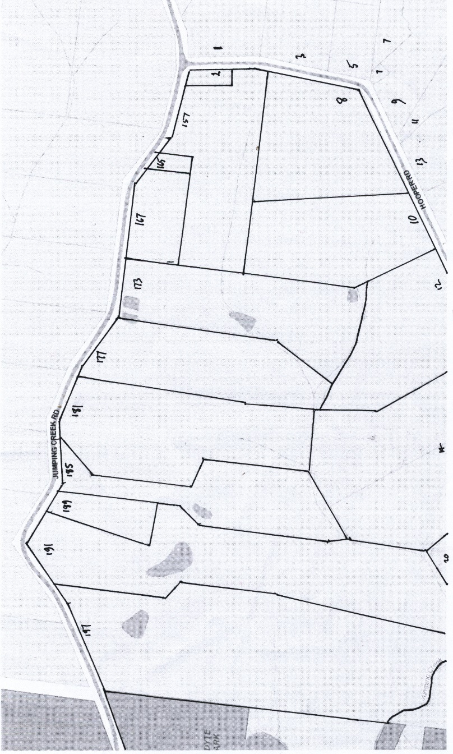
The Mutual Assurance Society of Victoria Limited owned much of the land in Wonga Park in 1897 and drew up a plan of subdivision which was not approved until 1902 but, as was allowed in those days sold lots on terms contracts before the plan was approved by the Titles Office. This Plan of Subdivision was registered as Plan of Subdivision No. 4315 and was the land in Certificate of Title Volume 2734 Folio 735
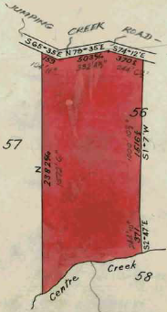
Lot 56 Plan of Subdivision No. 4315
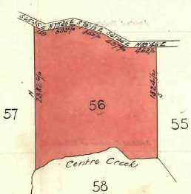
14/9/1916 Transfer No. 810773 from The Mutual Assurance Society of Victoria Limited to Agnes Ann Porter of Moorhouse Street Camberwell Married Woman, area 38 acres 2 roods and 6 perches, the western part of Lot 56, new Certificate of Title Volume 3998 Folio 567.
Western Part of Lot 56
Lot 56 on Plan of Subdivision No. 4315
9/10/1919 Transfer as to part No. 905604 from Agnes Ann Porter to Frank Wesley Sedgman, area 20 acres 1 rood and 18 perches, the western part of Lot 56, new Certificate of Title Volume 4252 Folio 347.
Western Part of Lot 56 PS 4315 transferred to F.S. Sedgman
9/10/1919 Mortgage No. 397261 to The Commissioners of the State Savings Bank of Victoria, discharged 10/8/1921.
3/11/1920 Caveat No. 53962, lapsed 26/1/1929
18/12/1928 Transfer No. 1395814 from Frank Wesley Sedgman to Jacob Vergers of Wonga Park Croydon.
18/12/1928 Mortgage to The Commissioners of the State Savings Bank of Victoria, discharged 9/4/1942.
9/2/1956 John Vergers (herein called Jacob Vergers) died on 27 April 1955. Probate of his Will has been granted to Edward Vergers of Wonga Park and Peter Vergers of Mullum Road Ringwood Orchardists – Instrument A110160.
7/9/1956 Transfer No. A168238 to Edward Vergers of Wonga Park Orchardist.
25/11/1972 Caveat No. E616308 (Lot 2) and transferred to new title.
18/4/1973 Cancelled Pursuant to Regulation 12 and Titles issued as set out hereunder – Lots one to 2 in volume 8970 Folio 944 and Volume 8970 Folio 945
NB Jacob Vergers was the owner of Lot 57 on Plan of Subdivision No. 4305 and the owner of the western portion of Lot 56. His subdivisions of land, etc. involved both portions of land and thus further dealings in his part of Lot 56 are set out in the Title History of Lot 57.
Eastern Part of Lot 56
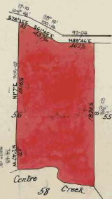
24/11/1919 Transfer as to the balance of Lot 56 Plan of Subdivision No. 912316 from Agnes Ann Porter to John Irwin of Wonga Park Croydon, area 18 acres and 28 perches, new Certificate of Title Volume 4266 Folio 124.
24/11/1919 Mortgage No. 398774 to The Commissioners of the State Savings Bank of Victoria, discharged 11/1/1928.
26/5/1933 Mortgage No. 688465 to the Commercial Banking Company of Sydney Limited, discharged 1/7/1937.
1/7/1937 John Irwin died on 4th June 1936. Letters of Administration with the Will annexed of his estate has been granted to Andrew George Reid Irwin of Wonga Park Croydon Orchardist.
Eastern part of Lot 56 on PS 4315 transferred to John Irwin
1/7/1937 Transfer No. 1655441to Andrew George Reid Irwin of Wonga Park Croydon Orchardist.
13/8/1970 Caveat No. E131435, lapsed 21/12/1977
4/6/1974 Andrew George Reid Irwin died on the 27thSeptember 1973. Probate of his Will has been granted to Meta Alice Irwin of Jumping Creek Road Wonga Park Widow.
7/12/1977 Transfer No. G893156 from Meta Alice Irwin to James Peter O’Shaughnessy Company Director and Rae Elizabeth O’Shaughnessy Married Woman both of Jumping creek Road Wonga Park.
Certificate of Title Volume 4266 Folio 124 cancelled by Plan of Subdivision No. 328749K
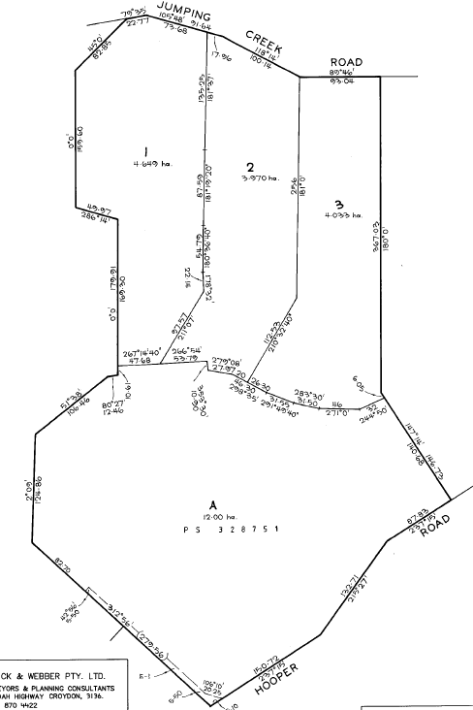
This plan affects Certificates of Title Volume 4266 Folio 124 (O’Shaughnessy), Volume 4573 Folio464 (Lot 58 on PS 4315 (Sandell) & Volume 9575 Folio 407 (Campbell)
Certificates of title Issued:
Lot 1 Live Volume 10207 Folio 951
Lot 2 Live Volume 10207 Folio 952
Lot 3 Live Volume 102071Folio 953
Cancelled Volume 10207 Folio 954 (see
PS 328751)
Lot 1 being the land at No. 181 Jumping Creek Road Wonga Park

Lot 1 Donald Brian Clark Irvine and Janet Isabel Irvine both of “Clovelly” 181 Jumping Creek Road Wonga Park are joint proprietors Certificate of Title Volume 10207 Folio 951.

26/2/2009 Mortgages Nos. P482600B and P617541P discharged.
Plan of Subdivision No. 328749K

26/2/2009 Transfer No. AG370678T from Donald Brian Clark Irvine and Janet Isabel Irvine to Eileen Bettiol of 27 Yarra Valley Boulevard Bulleen Vic 3105.

25/2/2009 Mortgage No. AG370679R to National Australia Bank Ltd, discharged 13/8/2015.

13/8/2015 Transfer No. AM105253K from Eileen Bettiol to Karina Evelyn Sherar of 181-183 Jumping Creek Road Wonga Park Vic 3115.

13/8/2015 Mortgage No. AM105254H to Westpac Banking Corporation.

Lot 2 being the land at 177 Jumping Creek Road Wonga Park

Lot 2 Donald Brian Clark Irvine and Janet Isabel Irvine both of “Clovelly” 181 Jumping Creek Road Wonga Park as joint proprietors (as to the land formerly contained in Certificate of Title Vol.9575 Fol.407) and James Peter O’Shaughnessy and Rae Elizabeth O’Shaughnessy both of 8-10 Hooper Road Wonga Park as joint proprietors (as to the land formerly contained in Certificate of Title Vol. 4266 Fol. 124 and Douglas Walter Sandell of Hooper Road Wonga Park (as to the land formerly contained in Certificate of Title Vol.4573 Fol. 464) are the proprietors Certificate of Title Volume 1027 Folio 952.

18/11/1994 As to the land formerly contained in Certificate of Title Vol. 9575 fol. 407 Mortgage No. P482600B to Westpac Savings Bank Limited, Mortgage No. P617541P to Westpac Banking Corporation and Mortgage No. K531433 to Aileen Louisa Victoria Kellaway are discharged.

18/11/1994 Transfer No. T421899K from Donald Brian Clark Irvine, Janet Isabel Irvine, James Peter O’Shaughnessy, Rae Elizabeth O’Shaughnessy and Douglas Walter Sandell to James Peter O’Shaughnessy & Rae Elizabeth O’Shaughnessy 8-10 Hooper Road Wonga Park 3136.

17/5/1995 Caveat No. T685153V by Anthony Frank Vita & Janet Le-Anne Maroney as purchaser, lapsed 15/7/1996.

8/7/1996 Transfer No. U297864E from Peter James O’Shaughnessy and Rae Elizabeth O’Shaughnessy to Anthony Frank Vita & Janet Le-Anne Maroney 173 Jumping Creek Rd. Wonga Park 3115.

30/9/1996 Mortgage No. U430923T to National Australia Bank Limited, discharged 12/3/2002.

12/3/2002 Transfer No.X934575N from Anthony Frank Vita and Janet Le-Anne Vita to Anthony Frank Vita of 173 Jumping Creek Road Wonga Park Vic 3115.

12/3/2002 Mortgage No. X934576K to National Australia Bank Limited, discharged 6/12/2005.

6/12/2005 Mortgage No. AE043112R to St. George Bank Ltd, discharged 28/10/2008.

28/10/2008 Transfer No. AG164605X from Anthony Frank Vita to Janine Maree Probst of 177 Jumping Creek Road Wonga Park Vic 3115.

18/5/2009 Mortgage No. AG510180D to St. George Bank Ltd, discharged 21/12/2016.

21/12/2016 Transfer No. AN401698J from Janine Maree Probst to Anthony Frank Vita of 177-179 Jumping Creek Road Wonga Park Vic 3115.

21/12/2016 Mortgage No. AN401700B to Westpac Banking Corporation, discharged 14/9/2021.

14/9/2021 Mortgage No. AU807336W to National Australia Bank, discharged 5/12/2022.

5/12/2022 Transfer No. AW336631B from Anthony Frank Vita to Phillip Raymond Pollock and Victoria Louise Pollock both of 177-179 Jumping Creek Road Wonga Park Vic 3115.

5/12/2022 Mortgage No. AW336632Y to Westpac Banking Corporation.

Lot 3 being the land at 173 Jumping Creek Road Wonga Park

Lot 3 James Peter O’Shaughnessy and Rae Elizabeth O’Shaughnessy both of 8-10 Hooper Road Wonga Park as joint proprietors (as to the land formerly contained in Certificate of Title Vol. 4266 Fol. 124 and Douglas Walter Sandell of Hooper Road Wonga Park (as to the land formerly contained in Certificate of Title Vol.4573 Fol. 464) are the proprietors Certificate of Title Volume 10107 Folio 953.

18/11/1994 Mortgage No. K531433 to Aileen Louisa Victori Kellaway is discharged.

18/11/1994 Transfer No. T421898N from James Peter O’Shaughnessy, Rae Elizabeth O’Shaughnessy and Douglas Walter Sandell to James Peter O’Shaughnessy and Rae Elizabeth O’Shaughnessy 8-10 Hooper Rd. Wonga Park 3136.

14/7/1997 Surviving Proprietor Rae Elizabeth O’Shaughnessy of 8 Hooper Rd. Wonga Park 3115 U871729H.

14/6/2000 Transfer No. W842492T from Rae Elizabth O’Shaughnessy to Anthony Frank Vita.

6/4/2002 Transfer No. AB198521G from Anthony Frank Vita to Nancy Sorace of 13 Sevenoaks Avenue Croydon Vic 3136.

6/9/2002 Mortgage No. AB538163Q to Victoria Teachers Credit Union Limited.

Lot A being the land at Nos. 12 & 14 Hooper Road Wonga Park

Lot A Donald Brian Clark Irvine and Janet Isabel Irvine both of “Clovelly” 181 Jumping Creek Road Wonga Park as joint proprietors (as to the land formerly contained in Certificate of Title Vol.9575 Fol.407) and Douglas Walter Sandell of Hooper Road Wonga Park (as to the land formerly contained in Certificate of Title Vol.4573 Fol. 464) are the proprietors, Certificate of Title Volume 1027 Folio 954.

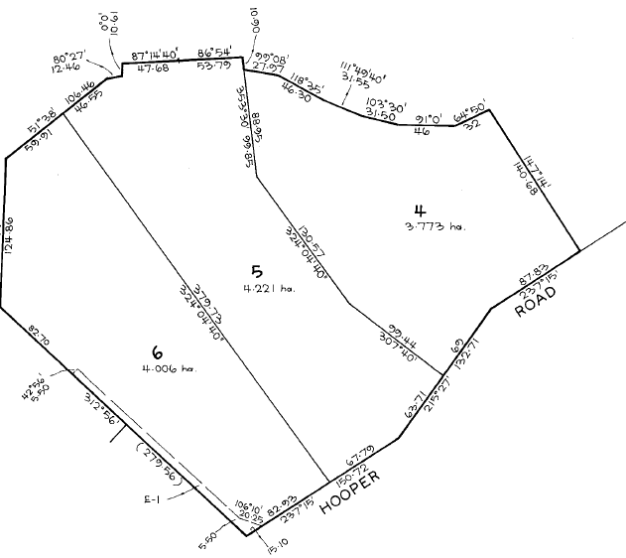
18/11/1994 As to the land formerly contained in Certificate of Title Vol. 9575 fol. 407 Mortgage No. P482600B to Westpac Savings Bank Limited, Mortgage No. P617541P to Westpac Banking Corporation and Mortgage No. K531433 to Aileen Louisa Victoria Kellaway are discharged.

18/11/1994 Transfer No. T421900X from Donald Brian Clark Irvine, Janet Isabel Irvine, James and Douglas Walter Sandell to Douglas Walter Sandell of Hooper Rd. Wonga Park 3136.

18/11/1994 Mortgage No. T421913J to Aileen Louisa Victoria Kellaway.

Certificate of Title Volume 1027 Folio 954 cancelled by Plan of Subdivision No. 328751Y.
Lot A on PS 328749K subdivided into Lots 4, 5 & 6 on Plan of Subdivision No. 328751

