Title History of Lot 66 on Plan of Subdivision No. 4315 Parish of Warrandyte
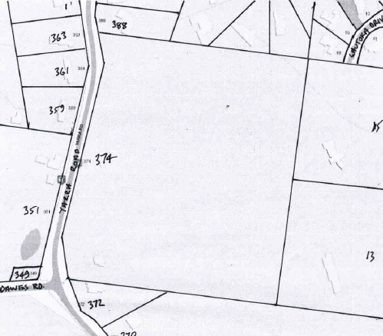
Lot 66 on Plan of Subdivision No. 4315 being part of the land in Certificate of title Volume 2734 Folio 735 and being the lands situate on the east side of Yarra Road immediately north-east of the intersection of Yarra and Dawes Roads Wonga Park, area 23 acres 0 roods and 1 perch being approx. No. 374 Yarra Road Wonga Park.
The Mutual Assurance Society of Victoria Limited owned much of the land in Wonga Park in 1897 and drew up a plan of subdivision (on which Lot 66 was part of) but was not approved until 1902 but, as was allowed in those days sold lots on terms contracts before the plan was approved by the Titles Office. This Plan of Subdivision was registered as Plan of Subdivision No. 4315 and was the land in Certificate of Title Volume 2734 Folio 735.
Plan showing property boundaries and street numbers of and around Lot 66
Lot 66 on Plan of Subdivision No. 4315
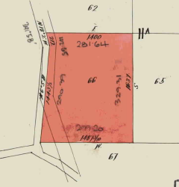
3/9/1909 Transfer No. 603407 from The Mutual Assurance Society of Victoria Limited to James Henry Hewish of Wonga Park near Ringwood Orchardist, area 23 acres and 1 perch, of Lot 66 on Plan of Subdivision No. 4315 and being part of Crown Allotment 11A and part of a former Government Road Parish of Warrandyte County of Evelyn, new Certificate of Title Volume 3365 Folio 973. Yarra road was realigned in 1897.
3/9/1909 Mortgage No. 276156 to Jane Neil, discharged 7/11/1916.
4/4/1925 Mortgage No. 515400 to The Commissioners of The State Savings Bank of Victoria, discharged 24/4/1930.
16/6/1939 Transfer No. 1734537 from James Henry Hewish to Alwin Herman Noske of Wonga Park near Ringwood Orchardist.
Title Plan on Certificate of Title Volume 3365 Folio 973 showing Lot 66 on Plan of Subdivision No. 4315 and the original (pre1897) alignment of Yarra Road
27/2/1962 Mortgage No. B372828 to Coral Maysel Guymer, discharged 28/10/1964.
28/10/1964 Mortgage No. C69209 to John Thomas Williams, discharged 2/9/1970.
24/8/1970 Caveat No. D812045 lodged and lapsed 20/10/1970.
2/9/1970 Mortgage No. D819693 to Coral Maysel Guymer, discharged 5/9/1975.
5/9/1975 Transmission Application No. F842855: Alwin Herman Noske died on 9th March 1974. Letters of Administration of his Estate have been granted to Anna Helene Noske of 36 Yarra Road Wonga Park Widow.
12/12/1975 Transfer No. F966605 from Anna Helene Noske to John Barry Mills and Warren Francis Mills both of 208 Jasper Road Bentleigh Company Directors.
14/12/1990 Instrument No. R137459X: Shire of Lillydale has pursuant to Section 10(1) of The Land Acquisition and Compensation Act 1986 notified the Services of Notice and of Intention to Acquire part of the land herein pursuant to Section 6 of the Act and has nominated the address hereunder for the services of notices pursuant to Section 12(2) of that Act. Date of Service of Notice of Intention: 14/11/90 Address for Service of Notices: Anderson St. Lilydale.
22/2/1993 Amended (Satisfied) No. R942371B.
7/5/1992 Title cancelled as to part pursuant to Section 24 Subdivision Act 1988 PS311295T. title not issued for Road(s) which are vested as shown on the plan.
Plan of Subdivision No. 311295Tcreated Lot 1 with an area of 9.26 hectares and a Lot R1 to become part of Yarra Road enabling the realignment of the intersection of Yarra and Dawes Roads.
A new Certificate of Title issued for Lot 1 on Plan of Subdivision No. 311295T being Certificate of Title Volume 12482 Folio 568 in the names of Warren Francis Mills and John Barry Mills.
16/6/2023 Survivorship Application No. AW940447Y from Warren Francis Mills and John Barry Mills to Warren Francis Mills of 208 Jasper Road Bentleigh Vic 3204.
19/6/2023 Caveat No. AW951322J by Keir Michael Smith as purchaser.
17/5/2024 Transfer (and removal of Caveat No. AW951233J) No. AY008406X from Warren Francis Mills to Keir Michael Smith and Tracey Maria Smith both of 8 Valley Road Wonga Park Vic 3115.

