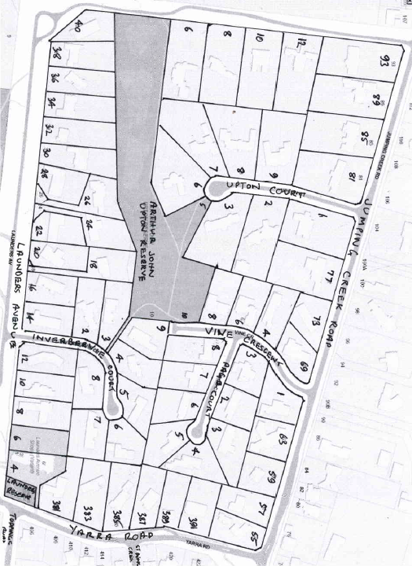
Title History of Crown Allotment 9F Parish of Warrandyte
Plan showing property boundaries and street numbers
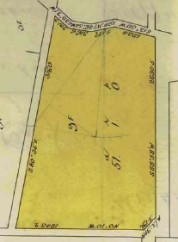
1/12/1899 Crown Grant Volume 2863 Folio 505, in consideration of the payment of £39, George Launder of Croydon Clerk of Works was granted 51 acres 1 rood and being (Crown) Allotment 9 F in the Parish of Warrandyte County of Evelyn.
8/10/1902 Transfer as to part No. 461943 from George Launder to Emma Webb, area 12 acres 2 roods and 20.4 perches, new Certificate of Title Volume 2897 Folio 304.
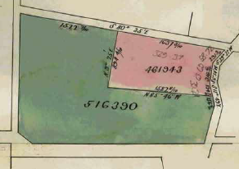
29/1/1904 Mortgage No. 224794 to Thomas Wilson lodged.
Plan of land in Crown Grant Volume 2863 Folio 505
13/5/1904 Mortgage No. 227075 to Thomas Wilson lodged.
19/10/1905 Caveat No. 36562 lodged. Caveat lapsed 5/12/1905.
Plan attached to Crown Grant Volume 2863 Folio 585 showing transfers as to part and balance
5/12/1905 Transfer as to balance No. 516390 from George Launder to James George Kipps, new Certificate of Title Volume 3096 Folio 170.
*************************************************************************
Certificates of Title Volume 2897 Folio 304 and Volume 5165 Folio 822
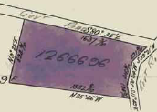
8/10/1902 Certificate of Title Volume 2897 Folio304, area 12 acres 2 roods and 20.4 perches being part of Crown Allotment 9F issued in the name of Emma Webb of Canterbury Road Canterbury Widow Administratrix of the Estate of William Webb deceased.
19/5/1926 Transfer No. 1266696 from Emma Webb to Emma Webb, Lucy Grace Webb and Herbert James Webb, new Certificate of Title Volume 5165 Folio 822.
19/5/1926 Certificate of Title Volume 5165 Folio 822, area 12 acres 2 roods and 20.4 perches being part of Crown Allotment 9F issued in the names of Emma Webb of Canterbury Road Canterbury Widow and Lucy Grace Webb Spinster and Herbert James Webb both of 12 Allenby Avenue East Malvern.
Plan of land in Certificate of Title Volume 2897 Folio 304
?/8/1926 Mortgage No. 547955 to Penelope Agnes O’Dea, Margaret Mary O’Dea and Maria Teresa O’Dea, discharged, 14/5/1929.
14/5/1929 Mortgage No. 617691 to The Commissioners of The State Savings Bank of Victoria, discharged 16/3/1945.
16/3/1945 Transfer No. 1946256 from Emma Webb, Lucy Grace Webb and Herbert James Webb to Reginald Booth and Wilfred Emil Booth both of 55 Park Street Moonee Ponds Builders.
21/5/1946 Transfer No. 2003092 from Reginald Booth and Wilfred Emil Booth to Veronica May Jacobs of 23 Grovedale Road Surrey Hills Home Duties.
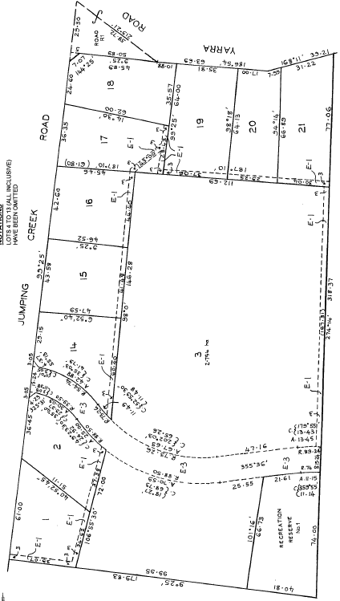
11/6/1946 Mortgage No. 857424 to Joseph Robert Wade, discharged 11/2/1948.
25/6/1946 Mortgage No. 158968 to Elsie Peppin, discharged 11/2/1948.
11/2/1948 Transfer No.2151087 from Veronica Mary Jacobs to Winifred May Roland of 262 Ascot Vale Road Ascot Vale Home Duties.
9/1/1951 Transfer No. 2373581 from Winifred May Roland to James Murray More of “White Lodge” Wonga Park Director.
10/8/1956 Transfer No. A206806 from James Murray More to Arthur Tasman Walker Master Plumber and Dorothy Mabel Walker Married Woman both of 4 Elgar Road Burwood.
Plan of Subdivision No.129074
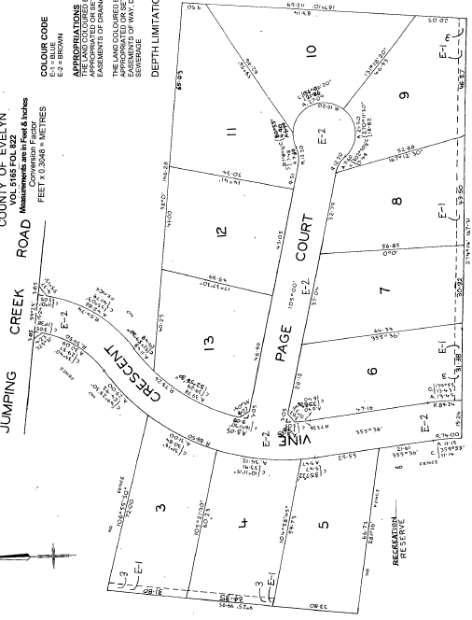
4/4/1979 Title cancelled as to part Pursuant to Regulation 12 and Titles issued as set out hereunder. Lots One to 3 in Vol 9319 Fol 012 to Vol 9319 Fol 014 and Lots 14 to 21 in Vol 9319 Fol 015 to Vol 9319 Fol 022, LP 129074.
12/1/1982 Title Cancelled and the following Titles have been issued Pursuant to Regulation 12 of the Transfer of Land Act: Lots 3 to 13 in Vol 9448 Fol 491 to Vol 9448 Fol 501 and Pursuant to Section 32 of the Transfer of Land Act: land appropriated or set apart for easements of way drainage and sewerage in Vol. 9448 Fols 502 & 503 and A Recreation Reserve in Vol 9448 Fol 504, LP 129075.
Plan of Subdivision No. 129075
**********************************************************************
Certificate of Title Volume 9319 Folio 020
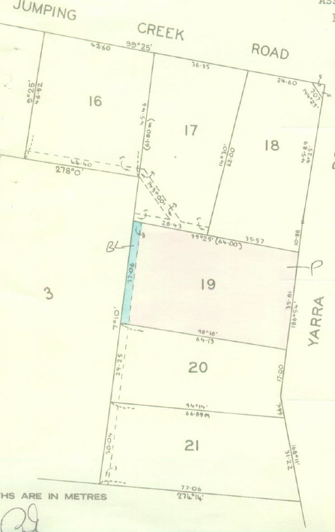
4/4/1979 Certificate of Title Volume 9319 Folio 020, frontage to Yarra Road 35.01 metres by depths of 64 and 64.3 metres, being Lot19 on Plan of Subdivision No.129074 issued in the names of Arthur Tasman Walker Master Plumber and Dorothy Mabel Walker both of St. Deny’s Crescent Wonga Park.
7/12/1979 Transfer No. H793243 from Arthur Tasman Walker and Dorothy Mabel Walker to Robert Anthony Freethy Draftsman and Carolyn Rita Freethy both of 1 Church Crescent Cockatoo.
7/12/1979 Mortgage No. H793244 to The Commissioners of The State Savings Bank of Victoria, discharged 16/7/1984.
19/12/1979 Mortgage No. H806402 to Alliance Acceptance Co. Limited, discharged 16/7/1984.
16/7/1984 Transfer No. L147715N from Robert Anthony Freethy and Carolyn Rita Freethy to Phillip George Heather and Annette Margaret Heather both of Brushy Park Road Wonga Park.
Plan of land in Certificate of Title Volume 9319 Folio 020
16/7/1984 Mortgage No. L147716K to National Australia Savings Bank Limited, discharged 31/1/1995.
31/1/1995 Transfer from Phillip George Heather and Annette Margaret Heather to Phillip George Heather of Yarra Road Wonga Park.
31/1/1995 Mortgage No. T528648R to National Australia Bank Limited, discharged 23/10/1997.
18/7/1997 Caveat No. U881834M by Susan Candace Currie as purchaser lodged: Caveat will lapse on Registration of V55021B – 24/10/1997.
23/10/1997 Transfer No. V55021B from Phillip George Heather to Susan Candace Currie of Yarra Road Wonga Park 3115.
23/10/1997 Mortgage No. V55022X to National Australia Bank Limited.
24/11/2006 Discharge No. AE747111T of Mortgage No. V055022X.
24/11/2006 Transfer No. AE747112R from Susan Candace Currie to Geoffrey Bradley Barras and Gay Suellen Barras both of 391 Yarra Road Wonga Park Vic 3115.
24/11/2006 Mortgage No. AE747113P to Westpac Banking Corporation.
30/7/2010 Discharge No. AH395729E of Mortgage No. AE747113P.
30/7/2010 Transfer No. AH395730V from Geoffrey Bradley Barras and Gay Suellen Barass to Lee Norman Ferrall and Elizabeth Blanche Ferrall both of 391 Yarra Road Wonga Park Vic 3115.
Certificate of Title Volume 3096 Folio 170
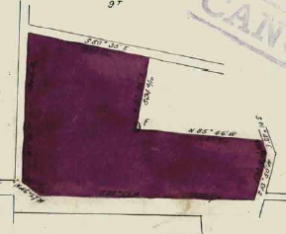
5/12/1905 Certificate of Title Volume 3096 Folio 170, area 38 acres 2 roods and 19.6 perches, being part of Crown Allotment 9F issued in the name of James George Kipps of No 244 Burnley Street Burnley Orchardist subject to Mortgages Nos. 224794 and 227075 to Thomas Wilson, both mortgages discharged on 11/6/1912.
18/6/1912 Transfer No. 687444 from James Geroge Kipps to William Sydney Rackham of May Farm of Wonga Park near Croydon Farmer.
18/6/1912 Mortgage No. 307149 to Thomas Wilson, discharged 5/9/1914.
Plan of land in Certificate of Title Volume 3096 Folio 170
18/6/1912 Mortgage No. 307150 to James George Kipps, discharged 11/6/1913.
5/9/1914 Transfer No. 759336 from William Sydney Rackham to James Duncan Couper of “Rosemont” Hartington Street Elsternwick Gentleman.
5/9/1914 Mortgage No. 338316 to Bessie Rattray Brown, discharged 25/6/1920.
24/12/1920 Caveat No. 54245 lodged. Caveat lapsed 10/10/1922.
10/10/1922 Transfer No. 1069451 from James Duncan Couper to Arthur John Upton, new Certificate of Title Volume 4627 Folio 371.
Certificate of Title Volume 4267 Folio 371
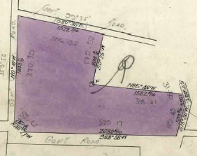
10/10/1922 Certificate of Title Volume 4267 Folio 371, area 38 acres 2 roods and 19.6 perches, being part of Crown Allotment 9F issued in the name of Arthur John Upton of Langwarrin Orchardist.
10/10/1922 Mortgage No.454033 to Margaret Roberts, discharged 12/10/1927.
10/10/1922 Mortgage No. 454034 to Daniel Robert Cowley, discharged 12/10/1927.
12/10/1927 Mortgage No. 576205 to The Commissioners of The State Savings Bank of Victoria, discharged as to the land in Transfer No. 1521777 on15/5/1933 and discharged as to the balance of the land on 5/3/1945.
Plan of the land in Certificate of Title Volume 4267 Folio 371
21/10/1928 Mortgage No. 577264 to Daniel Robert Cowley, discharged as to the land in Transfer No. 1521777 on15/5/1933 and discharged as to the balance of the land on 5/3/1945.
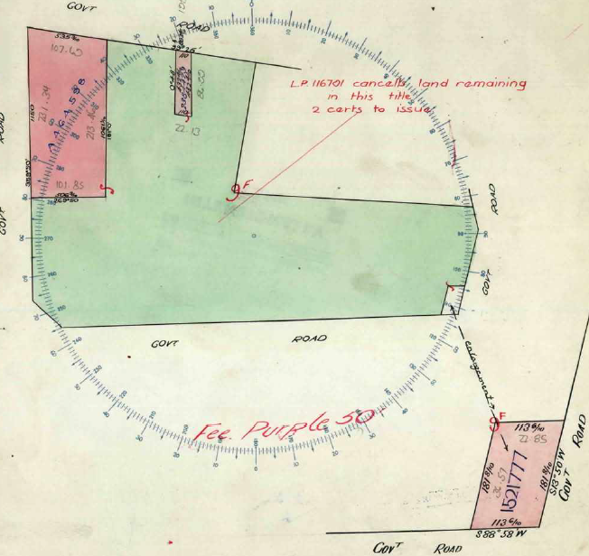
15/5/1933 Transfer as to part No. 1521777 from Arthur John Upton to Arthur John Upton, Horace Frederick George Burch and Clement Arthur Hochkins (presumably as trustees for the Methodist Church and it is believed that the church later sold it to the Shire of Lillydale as a park), new Certificate of Title Volume 5841 Folio 042.
28/2/1951 Transfer as to part No. 2384479 from Arthur John Upton (the father to his son) Arthur John Upton, new Certificate of title Volume 7545 Folio 118. (This was the block of land that Arthur John Upton (the son) built his house on.)
Plan attached to Certificate of Title Volume 4267 Folio 371 showing the three blocks of land transferred out.
14/1/1958 Transfer as to part No. A464598, area 5 acres 2 roods and 35.3 perches, new Certificate of Title Volume 8172 Folio 684.
18/10/1963 Transmission Application No. B777044: Arthur John Upton died on 18th July 1962. Probate of his Will has been granted to George Robert Upton of 39 Molonglo Street Queanbeyan New South Wales Public Personal Estimating Officer and Arthur John Upton of Warrandyte Road Wonga Park Orchardist.
26/3/1976 Title Cancelled Pursuant to Regulation 12 and Titles issued as set out hereunder: Lots One to 2 in Vol 9130 Fol 957 to Vol 9130 Fol 958 LP 116701.
*****************************************************************************
Certificate of Title Volume 8172 Folio 684
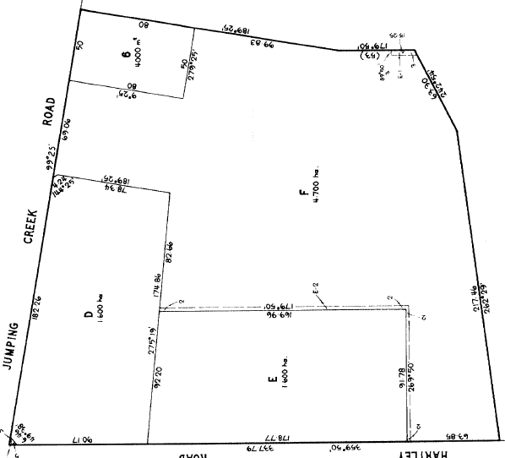
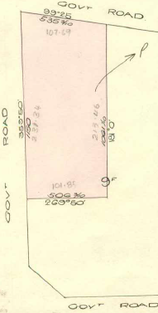
14/1/1958 Certificate of Title Volume 7545 Folio 684, area 5 acres 2 roods and 35.3 perches, being part of Crown Allotment 9F issued in the name of Arthur John Upton, the Younger of Wonga Park Orchardist.
23/5/19?8 Mortgage No. H530124 to the National Bank of Australasia Limited, discharged 2/2/1987.
2/2/1987 Mortgage No. M67810R to National Australia Bank Limited.
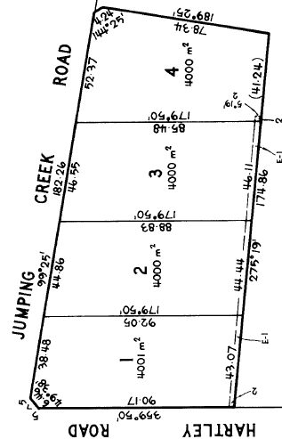
13/7/1988 Title cancelled as to part Pursuant to Regulation 10 and titles issued as set out hereunder: Lots E & F in Vol 9820 Fol 527 to Vol 9820 Fol 528 and Lot 6 in Vol 9820 Fol 526. Pursuant to Section 32 of the Transfer of Land Act being the Roads in Vol 9820 Fol 529 on LP 207146J.
Plan of Subdivision No. 207146J of lands in Certificates of Title V958olume 8172 Folio 684 and Volume 9130 Folio
13/7/1988 Title Cancelled as to balance: The following Titles have been issued Pursuant to Regulation 10 of the Transfer of Land Act – Lots One to A in Vol 9820 Fol 530 to Vol 9820 Fol 533 on LP 207147G. The above plans of subdivision affects lands in this Certificate of Title Volume 8172 Folio 684 and in Certificate of Title Volume 9130 Folio 958 both in the name of Arthur John Upton (the son).
Plan of Subdivision No. 207147G of lands in Certificates of Title V958olume 8172 Folio 684 and Volume 9130 Folio

**************************************************************************
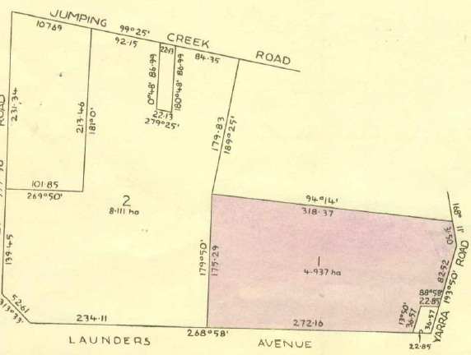
Certificate of Title Volume 9130 Folio 957
23/3/1976 Certificate of Title Volume 9130 Folio 957, area 4.937 hectares, being Lot 1 on Plan of Subdivision No. 116701 issued in the names of George Robert Upton of 39 Carinya Street Queanbeyan New South Wales Public Personal Estimating Officer and Arthur John Upton of Warrandyte Road Wonga Park Orchardist (Executors of the Will of Arthur John Upton deceased).
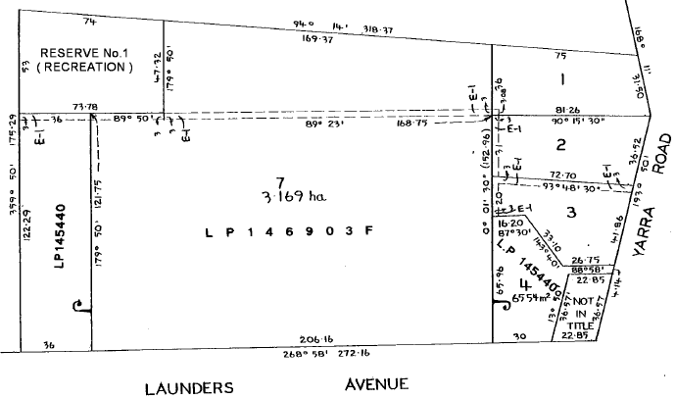
10/5/1977 Transfer No. G741610 from George Robert Upton and Arthur John Upton to George Robert Upton of 39 Carinya Street Queanbeyan New South Wales Public Servant as to Two equal undivided fifth parts or shares Lillian May Petterd of 31 Bartlett Avenue Croydon Beverley Joan Kennedy of 15 Clematis Avenue West Rosebud and Margaret Elaine Fankhauser of 8 Lindau Drive Vermont South Married Woman each as to One equal undivided fifth part or share as Tenants in Common.
Plan of land in Certificate of Title Volume 9130 Folio 957
25/9/1981 Title Cancelled. The following Titles have been issued Pursuant to Regulation 12 of the Transfer of Land Act: Lots One to 4 in Vol 9436 Fol 872 to Vol 9436 Fol 875 and Lot 7 in Vol 9436 Fol 876. Pursuant to Section 32 of the Transfer of land Act A Recreation Reserve in Vol 9436 Fol 877 LP 135108.
Plan of Subdivision No. 135108
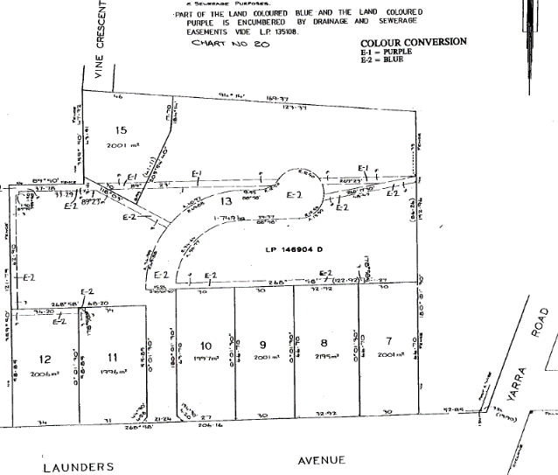
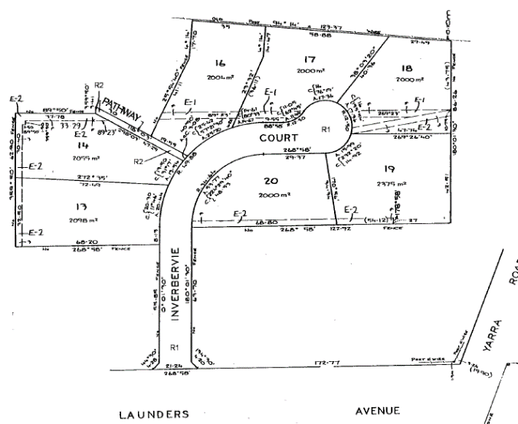
Lot 7 on Plan of Subdivision No. 135108 (being the land in Certificate of Title Volume 9436 Folio 876) was subdivided further in Plan of Subdivision No. 146903F and Lot 13 on Plan of Subdivision No. 146903F was further subdivided by Plan of Subdivision No. 146904D into Lots 13 to 2 plus the road Inverbie Court.
Plan of Subdivision No. 146904D
Plan of Subdivision No. 146903E

**************************************************************************
Certificate of Title Volume 9130 Folio 958
23/3/1976 Certificate of Title Volume 9130 Folio 958, area 8.111 hectares, being Lot 2 on Plan of Subdivision No. 116701 issued in the names of George Robert Upton of 39 Carinya Street Queanbeyan New South Wales Public Personal Estimating Officer and Arthur John Upton of Warrandyte Road Wonga Park Orchardist (Executors of the Will of Arthur John Upton deceased).
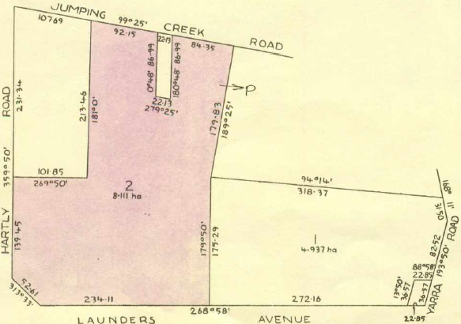
19/7/1976 Transfer No. G239842 from George Robert Upton and Arthur John Upton to Arthur John Upton of Jumping Creek Road Wonga Park Orchardist.
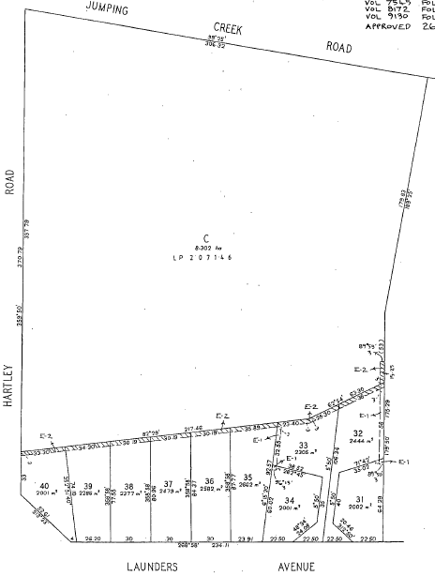
22/1986 Title Cancelled as to part Pursuant to Regulation 12 and Titles issued as set out hereunder: Lots 31 to 40 in
Plan of land being Lot 2 on Plan of Subdivision No. 116701 and being the land in Certificate of Title Volume 9130 Folio 958
Vol 9663 Fol 685 to Vol 9663 Fol 694 on LP 201848G.
Plan of Subdivision No. 201848
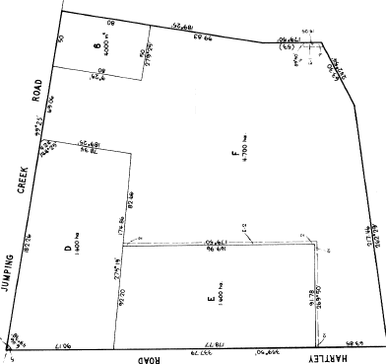
23/12/1986 Mortgage No. M626768J to National Australia Bank Limited, discharged 2/2/1987.
2/2/1987 Mortgage No. M678810R to National Australia Limited.
13/7/1988 Title Cancelled as to part Pursuant to Regulation 10 and Titles issued as set out hereunder Lots E & F in Vol 9820 Fol 527 to Vol 9820 Fol 528 and lot 6 in Vol 9820 Fol 526. Pursuant to Section 32 of the Transfer of Land Act being the Roads in Vol 9820 Fol 529 On LP 207146J.
Plan of Subdivision No. 207146J
13/7/1988 Title Cancelled as to balance. The following Titles have been issued Pursuant to Regulation 10 of the Transfer of Land Act: Lots One to 4 in Vol 9820 Fol 530 to Vol 9820 Fol 533 on LP 207147G.
**************************************************************************

Certificate of Title Volume 9820 Folio 527
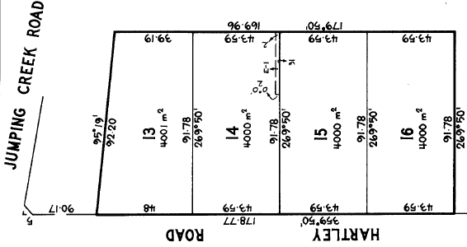
13/7/1988 Certificate of Title Volume 9820 Folio 527, area 1.600 hectares, being Lot E on Plan of Subdivision No. 207146J issued in the name of Arthur John Upton of Jumping Creek Road Wonga Park subject to Mortgage No. M678810R to the National Australia Bank Limited.
8/12/1988 Title Cancelled. The following Titles have been issued Pursuant to Regulation 10 of the Transfer of Land Act: Lots 13 to 13 in Vol 9850 Fol 868 to Vol 9850 Fol 871 on LP 207148E.
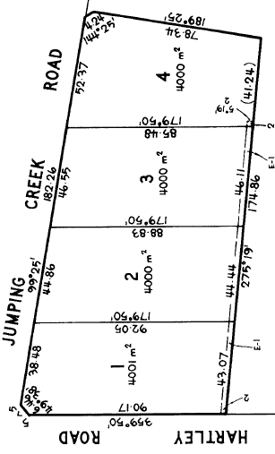
Certificate of Title Volume 9820 Folio 528
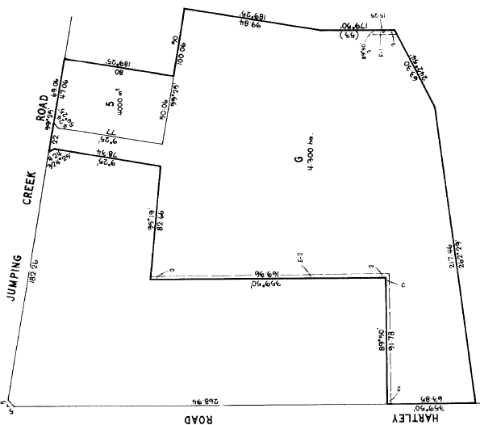
13/7/1988 Certificate of Title Volume 9820 Folio 528, area 4.700 hectares, being Lot F on Plan of Subdivision No. 207146J issued in the name of Arthur John Upton of Jumping Creek Road Wonga Park subject to Mortgage No. M678810R.
Plan of Subdivision No. 207147G
Plan of Subdivision No. 207148E
9/12/1991 Title Cancelled as to part Pursuant to Regulation 10 and Titles issued as set out hereunder: Lot 5 in Vol 10047 Fol 867 on LP 207149C. Lot 5 is the site on which (Arthur) John Upton’s house was built (now demolished).
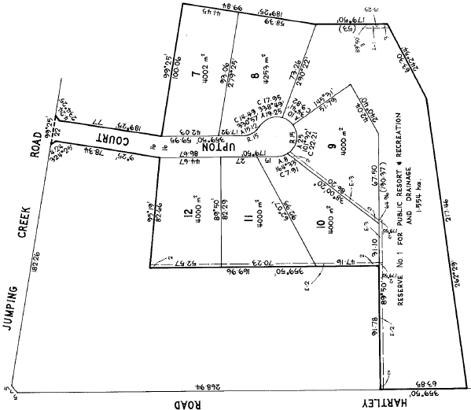
9/12/1991 Title Cancelled as to balance. The following Titles have been issued Pursuant to Regulation 10 of the Transfer of Land Act: Lots 7 to 12 in Vol 10047 Fol 870 to Vol 10047 Fol 875 and Pursuant to Section 32 of the Transfer of Land Act being for Public Resort & Recreation & Drainage Reserve in Vol. 10047 Fol. 876 and Road in Vol. 10047 Fol. 877 on LP 207150T.
Plan of Subdivision No. 207149C

Plan of Subdivision No. 207150T

