**Title History of Crown Allotment 9J**

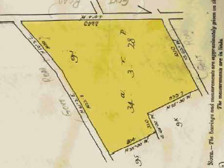24/1/1907 Crown Grant Volume 3191 Folio 044, in consideration of the payment of 26 pounds and five shillings **Arthur George Chipperfield** of Wonga Park Orchardist was granted 34 acres 3 roods and 28 perches being (Crown) Allotment 9J in the Parish of Warrandyte County of Evelyn.

25/10/1901 Mortgage No. 206816 to The Commercial Bank of Australia Limited, discharged 10/7/1908.

Plan of Land in Crown Grant Volume 3191 Folio 044

10/7/1908 Mortgage No. 263088 to Elina Cole, discharged 15/12/1909.

Plan showing property boundaries and street numbers for Crown Allotment 9J

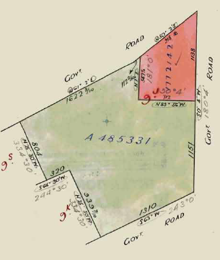18/4/1910 Transfer No. 618008 from Arthur George Chipperfield to **Mary Jane Smith** of Franklin Street West Melbourne Married Woman.

23/7/1935 Mortgage No. 711950 to Edward Lambert a’Beckett and Gilbert Michie a’Beckett, discharged 27/8/1937.

14/5/1940 Transfer as to part No. 1772142 from Mary Jane Smith to Nina May Smith, area 5 acres 3 roods and 32 perches, new Certificate of Title Volume 6384 Folio 690.

20/12/1950 Red Ink No. 4991481 Mary Jane Smith died on 5th July 1950. Probate of her Will has been granted to Francis Walter Stephenson of Croydon Road Croydon Packer and Arthur Ryland of Brushy Park Road North Croydon Orchardist.

Plan attached to Crown Grant Volume 3191 Folio 044 showing transfers as to part and balance

25/2/1958 Transfer as to balance No. A485331, new Certificate of Title Volume 8188 Folio 608.

**********************************************************************

**Certificate of Title Volume 6384 Folio 690 Street Addresses: 3, 7, 11 & 15 Reserve Road and 38 Paynters Road**

14/5/1940 Certificate of title Volume 6384 Folio 690, area 5 acres 3 roods and 32 perches, being part of Crown allotment 9J issued to **Nina Mary Smith** of Boronia Married Woman.

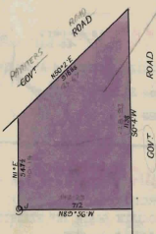16/10/1946 Transfer No. 2041031 from Nina Mary Smith to **Clifford Spurgeon Worboys** of 27 Kalimna Street Balwyn Farmer.

11/7/1949 Transfer No. 2227270 from Clifford Spurgeon Worboys to **Ernest Stewart Kent** of “Oakwood” Whitehorse Road Croydon Builder.

8/6/1950 Transfer No. 2336618 from Ernest Stewart Kent to **Geoffrey John Duncan** Analytical Chemist and **Geraldine Duncan** Married Woman both of Paynter’s Road Wonga Park.

18/4/1967 Mortgage No. C753120 to The National Bank of Australasia Limited, discharged 12/1/1971.

Plan of land in Certificate of Title Volume 6384 Folio 690

9/12/1971 Transfer No. E247679 from Geoffrey John Duncan and Geraldine Duncan to **Robert Graham Treseder** Lecturer and **Sonia Deirdre Treseder** Married Woman both of 77 Wilson Street North Carlton.

29/11/1973 Transfer No. F108476 from Robert Grahan Treseder and Sonia Deirdre Treseder to **Jack Nickolaou** Plasterer and **Maree Gwynneth Nickolaou** Married Woman both of 5 River Reserve Road Wonga Park.

29/11/1973 Mortgage No. F108477 to Bank of New South Wales, discharged 22/7/1975.

22/7/1975 Mortgage No. F 781015? to The Commercial Banking Company of Sydney Limited, discharged as to part being lots 3, 4 & 5 on P/S 127476 21/6/1979 and discharged 25/1/1982.

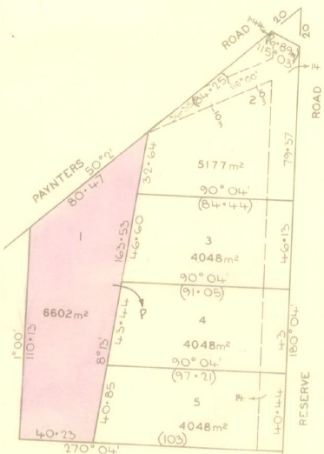22/6/1976 Mortgage No. ????? to Leo Dimos, discharged as to part being Lots 3,4 & 5 on P/S 127476, 21/6/1979, discharged 25/1/1982.

3/11/1976 Caveat No. G889878 lodged and later withdrawn as to parts of the land at several times.

28/5/1979 Caveat No. H536112 affecting part of the land herein being Lot 1 P/S 127476 lodged and lapsed 21/5/1980.

21/6/1979 Mortgage as to part No. H569280 to Trustees for The Time Being Of The Uniting Church In Australia Beneficiary Fund Trust Registered Folium 666 In The Register Of Successory Trusts Lots 3,4,5 on LP 127476.

28/5/1980 Title cancelled as to part No. H858491 See Vol 9379 Fol 451 to Vol 9373 Fol 455.

6/12/2019 Disposition of Land No. AS781953B from Jack Nickolaou and Maree Gwynneth Nickolaou to **Manningham City Council** of 699 Doncaster Road Doncaster Vic 3115. (Road R1 on Plan of Subdivision No. 127476 created by Instrument No. 1772142 14/5/1940.

Plan of land in Certificate of Title Volume 9373 Folio 451. It also shows Lots 1 to 5 on Plan of Subdivision No. 127476

**************************************************************************

**Certificate of Title Volume 9373 Folio 451 Street Address 38 Paynters Road**

31/7/1979 Certificate of Title Volume 9373 Folio 451, area 6602 m2, being Lot 1 on Plan of Subdivision No. 127476 issued to **Jack Nickolaou** Plasterer and **Maree Gwynneth Nickolaou** Married Woman both of 5 River Reserve Road Wonga Park subject to Mortgages F781615 and G202935.

22/8/1979 Mortgages F781615 and G202735 discharged as to part being the within land.

22/8/1979 Transfer No. H652886 from Jack Nickolaou and Maree Gwennyth Nickolaou to **Edmund Geoffrey Taylor** Civil Engineer and **Lesley Taylor** Married Woman both of 69 Patterson Street East Ringwood.

22/8/1979 Mortgage o. H652887 to The Commissioners of The State Savings Bank of Victoria.

16/6/1993 Caveat No. S537487 by Metro Credit Co-Operative Limited as Chargee. Caveat withdrawn 13/4/1994.

****************************************************************************

**Certificate of Title Volume 8188 Folio 608**

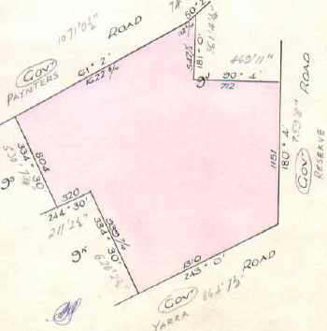25/2/1958 Certificate of Title Volume 8188 Folio 608, area 28 acres 3 roods and 36 perches, being part of Crown Allotment 9J issued to **Horace Albert Evington Smith** of Homestead Road Wonga Park Orchardist.

18/9/1959 Mortgage No. A819487 to Commonwealth Savings Bank of Australia, discharged 2/12/1965.

29/10/1965 Caveat No. C 348785, affecting part of the land herein, lodged, caveat lapsed 16/1/1970.

29/4/1968 Caveat No. D375428 affecting part of the land herein, Lot 1, lodged, caveat lapsed 23/7/1969.

Plan of Land in Certificate of Title Volume 8188 Folio 608. Note that at that time Jumping Creek Road east of Yarra Road was also called Yarra Road.

10/6/1969 Transfer as to part No. D415234 being Lot 1, new Certificate of Title Volume 8785 Folio 224.

Plan attached to Certificate of Title Volume 8188 Folio 608 showing land transferred as to part.

14/11/1969 Transfer as to balance No. D561186, new Certificate of Title Volume 8812 Folio 396.

********************************************************************

**Certificate of Title Volume 8785 Folio 224 Street Address: 12 Jumping Creek Road**

10/16/1969 Certificate of Title Volume 8785 Folio 224, size 80 feet by 200 feet, being Lot 1 on Plan of Subdivision No. 82300 issued to **Francis John Thomas** Painter and Decorator and **Flossie May Thomas** both of 37 Devon Drive Blackburn (after Transfer as to part No. D415234 from Horace Albert Evington Smith).

9/6/1970 Transfer No. D741266 from Francis John Thomas and Flossie May Thomas to **Flossie May Thomas** of 37 Devon Drive Blackburn Married Woman.

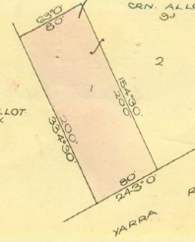4/2/1972 Mortgage No. E298456 to The Commissioners of The State Savings Bank of Victoria, discharged 27/12/1973.

27/12/1973 Transfer No. F146875 from Flossie May Thomas to **John Denis Heffernan** Company Director and **Angela Rachel May Heffernan** Married Woman both of 74 Lyons Road Croydon North.

27/12/1973 Mortgage No. F146876 to Bank of New South Wales Savings Bank Limited, discharged 18/6/1976.

16/6/1976 Transfer No. G193113 from John Denis Heffernan and Angela Rachel Mary Heffernan to **John Anthony Steele** Manager and **Frances Mary Steele** Married Woman both of 4 Netherby Avenue Mulgrave.

Plan of land in Certificate of Title Volume 8785 Folio 224.Again note Jumping Creek Road is shown as Yarra Road

16/6/1976 Mortgage No. G193114 to Australia And New Zealand Savings Bank Limited, discharged 18/6/198.

16/6/1976 Mortgage No. G193114 to Australia And New Zealand Savings Bank Limited, discharged 18/6/1981.

18/6/1981 Transfer No. J507748 from John Anthony Steele and Frances Mary Steele to **James Turner Linton** Company Director and **Ann McDougall Linton** Married Woman both of 58 Esther Crescent.

18/6/1981 Mortgage No. J507749 to Bank of New South Wales Savings Bank Limited, discharged 10/7/1989.

7/6/1982 Mortgage No. J957963 to Bank of New South Wales, discharged 10/7/1989.

24/1/1985 Mortgage No. L477366L to National Australia Bank Limited, discharged 10/4/1985.

10/7/1989 Transfer No. P301500H from James Turner Linton and Ann McDougall Linton to **Liam Francis Gavin** & **Geraldine Mary Gavin** of 12 Jumping Creek Road Wonga Park.

10/7/1989 Mortgage No. P31501E to Ivandale No. 19 Co-Operative Housing Society Limited, discharged 19/3/1993.

19/3/1993 Mortgage No. S404410B to National Australia Bank Limited, discharged 2/6/1995.

2/6/1995 Mortgage No. T709687T to Westpac Banking Corporation, discharged 9/3/1999.

9/3/1999 Transfer from Liam Francis Gavin and Geraldine Mary Gavin to **Carol Anne Stewart** and **Charles Malcolm Stewart** of 12 Jumping Creek Road Wonga Park.

3/3/1999 Mortgage No. V930127V to Commonwealth Bank of Australia.

**************************************************************************

**Certificate of Title Volume 8812 Folio 396**

14/11/1969 Certificate of Title Volume 8812 Folio 396, area 28 acres 2 roods and 18 perches, being Lot 2 on Plan of Subdivision No. 82300 issued to **Thelma McIntosh** of Homestead Road 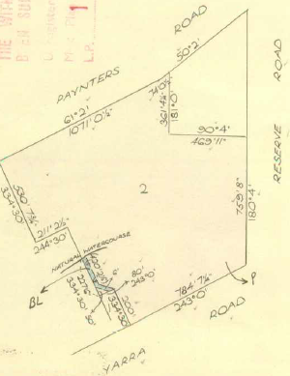Wonga Park Widow (after Transfer as to balance No. D561186 from Horace Albert Evington Smith).

13/5/1970 Transfer No. D715604 from Thelma McIntosh to **Progress Pty. Ltd.** of 53 Main Street Croydon.

29/12/1975 Title cancelled as to part Pursuant to Regulation 12 and Titles issued as set out hereunder Lots One to 6, LP 116246 in Vol 9120 Fol 469 to Vol 9120 Fol474**. Lot 1 is 24 & 26 Paynters Road, Lot 2 is subdivided into 3 lots, all 28 Paynters Road and lot 3 is 34 Paynters Road**

Plan of land in Certificate of Title Volume 8812 Folio 396

7/4/1977 Transfer as to balance No. G583918, new Certificate of Title Volume 9208 Folio 584.

*************************************************************************

**Certificate of Title Volume 9120 Folio 472**

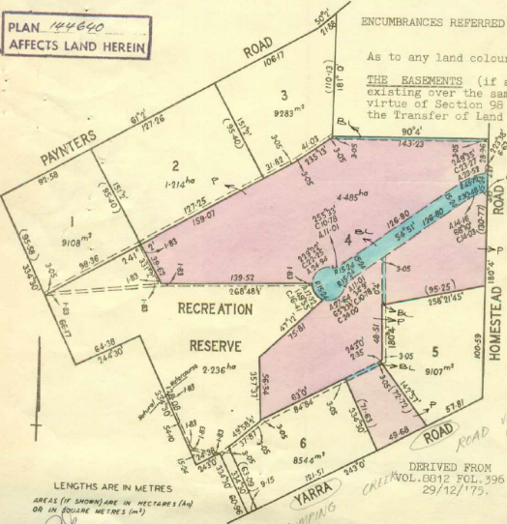29/12/1975 Certificate of Title Volume 9120 Folio 472, area 4.485 hectares, being Lot 4 on Plan of Subdivision No. 116246 issued to **Progress Pty. Ltd.** of 53 Main Street Croydon.

1/3/1977 Transfer No. G554871 from Progress Pty. Ltd. to **Maxwell Ewart Stringer** Builder and **Elwyn Viola Stringer** Married Woman both of 19 St. Denys Crescent Wonga Park.

26/5/1977 Mortgage No. G64179 to The Commissioners of The State Savings Bank of Victoria, discharged 16/9/1980.

16/9/1980 Mortgage No. J155491 to Norman Keith Barr, Mary Jane Alston, Lesley Mary Turner, Jillian Thelma Christie, Thelma Blanche Humphreys, Olive Joyce Augustini, George Augustini, Keith Eldred Albert Best, Emily Jean Best and Pivot Swingler and Olive Swingler, Gerard Wallace / Transport Pty. Ltd.

Plan of land (shaded red) in Certificate of Title Volume 9120 Folio 472. Note the plan also shows Lots 1 to 6 pus recreation Reserve on Plan of Subdivision No. 116246

15/4/1982 Caveat No. J890059 lodged and Caveat Withdrawn 5/12/1983.

24/1/1984 Title Cancelled. The following Titles have been issued Pursuant to Regulation 12

of the Transfer of Land Act: Lots 7 to 8 in Vol 9540 Fol 798 to Vol 9540 Fol 799 LP 144640.

*************************************************************************

**Certificate of Title Volume 9540 Folio 798 Street Address: 4 Jumping Creek Road**

24/1/1984 Certificate of Title Volume 9540 Folio 798, frontage 49.68 metres, depths 171.63 and 72.72 metres and rear 35.11 metres, being Lot 7 on Plan of Subdivision No. 144640 issued to **Maxwell Ewart Stringer** Builder and **Elwyn Viola Stringer** Married Woman both of Homestead Road Wonga Park subject to Mortgage No. J155491.

6/3/1984 Caveat No. K787911 lodged and will lapse on Registration of K850491 – 10/5/1984.

17/4/1984 Mortgage No. J155497 discharged.

17/4/1984 Transfer No. K850491 from Maxwell Ewart Stringer and Elwyn Viola Stringer to **Dennis William Caudery** Manager and **Eileen Caudery** both of 17 Montalto Road Ringwood.

28/1/1988 Transfer from Dennis William Caudery and Eileen Caudery to **Michael Christopher Guthrie** of 43 Garden Rd. Donvale.

Plan of land in Certificate of Title, showing the details of Plan of Subdivision No. 144640 and the land in the Title marked as (Lot) 7

28/1/1988 Mortgage No. N259568T to Australia and New Zealand Banking Group Limited, discharged 19/9/1988.

19/9/1988 Transfer from Michael Christopher Guthrie to **George Emmett Burton** & **Suzanne Burton** of 37 Hamilton Dr. North Ringwood.

19/9/1988 Mortgage No. N715193G to Westpac Savings Bank Limited, discharged 22/6/1995.

1/11/199? Mortgage No. S2208331 to Australia and New Zealand Banking Group Limited, discharged 11/6/1993.

22/12/1993 Caveat No. S855429N by Brian Geoffrey Bell & Corinne Patricia Bell as Mortgagee lodged, and Caveat withdrawn 22/6/1995.

22/6/1995 Mortgage No. T738138X to Adelaide Bank Limited, discharged 24/7/1996.

22/6/1995 Mortgage No. T738139U to Adelaide Bank Limited, discharged 24/7/1996.

24/7/1996 Mortgage No. U323959H to Australia and New Zealand Banking Group Limited.

24/6/2010 Caveat No. AH314507G by Bendigo and Adelaide Bank Ltd as Mortgagee lodged.

28/2/2013 Withdrawal No. AK212998G of Caveat No. AH314507G lodged.

28/2/2013 Discharge No. AK212996E of Mortgage No. 323959H lodged.

28/2/2013 Transfer No. AK212997C from George Emmett Burton and Suzanne Burton to **Geoffrey Thomas Ross Bradley** and **Fiona Margaret Bradley** both of 4 Jumping Creek Road Wonga Park Vic 3115.

24/6/2021 Transfer No. AU494706C from Geoffrey Thomas Ross Bradley and Fiona Margaret Bradley to **Elizabeth Michelle Distefano** of 4 Jumping Creek Road Wonga Park Vic 3115.

24/6/2021 Mortgage No. AU494707A to Secure Funding Pty Ltd.

19/11/2021 Discharge No. AV040026C of Mortgage No. AU494707A lodged.

19/11/2021 Mortgage No. AV040027A to AMP Bank Ltd.

************************************************************************

**Certificate of Title Volume 9540 Folio 799 Street Addresses: 1, 2, 3, 4, 6, 7, 8, 9, 10 & 11 Penderel Court**

24/1/1984 Certificate of Title Volume 9540 Folio 799, area 4.181 hectares, being Lot 8 on Plan of Subdivision No. 144640 issued to **Maxwell Ewart Stringer** Builder and **Elwyn Viola Stringer** Married Woman both of Homestead Road Wonga Park subject to Mortgage No. J155491.

11/1/1985 Mortgage No. J155491 is discharged.

11/1/1985 Mortgage No. L457243A to The Commissioners of The State Savings Bank of Victoria.

28/8/1986 Title Cancelled. The following Titles have been issued Pursuant to Regulation 10 of the Transfer of Land Act. Lots 1 to 10 in Vol. 9697 Fol. 188 to Vol. 9697 Fol. 197 and Pursuant to Section 32 of the Transfer of Land Act Being the land appropriated or set apart for easements of Way Drainage Sewerage and Supply of Water, Gas Telephone and Electricity in Vol. 9697 Fol. 198 on LP 148641Y.

Plan of Subdivision No. 148641Y being a subdivision into 10 lots of Lot 8 on Plan of Subdivision No. 144640 being the land in Certificate of Title Volume 9540 Folio 799

**************************************************

**Certificate of Title Volume 9120 Folio 473 Street Addresses: 2 Jumping Creek Road and 109 Homestead Road**

Land in Certificate of Title Volume 9120 Folio 473 shown as shaded red and numbered 5 on the plan. The whole plan shows Plan of Subdivision No. 116246. Note Jumping Creek Road is shown with its old name of Yarra Road

29/12/1975 Certificate of Title Volume 9120 Folio 473, area 9107 m2, being Lot 5 on Plan of Subdivision No. 116246 issued to **Progress Pty. Ltd.** of 53 Main Street Croydon.

7/9/1976 Transfer No. G309454 from Progress Pty. Ltd.

to **Charles Bruce Carver** Bus Driver and **Theodora Carver** Married Woman both of 319 Mount Dandenong Road Croydon.

24/12/2012 Agreement No. AJ621295P Section 173 Planning and Environment Act 1987.

27/6/2013 Title Cancelled by Plan of Subdivision No. 707303R.

***************************************************

**Certificate of Title Volume 11430 Folio 889 Street Address: 2 Jumping Creek Road**

29/12/1975 Certificate of Title Volume 11430 Folio 889, area 9107 m2, being Lot 1 on Plan of Subdivision No. 707303R issued to **Charles Bruce Carver** and **Theodora Carver** both of 2 Jumping Creek Road Wonga Park Vic 3115.

30/7/2013 Caveat No. AK492677E by Claudio Salvatore Berghella and Kelly Ann Berghella as purchasers was lodged.

24/9/2013 Transfer No. AK610383V from Charles Bruce Carver and Theadora Carver to **Claudio Salvatore Berghella** and **Kelly Ann Berghella** both of 156 Templestowe Road Templestowe Vic 3106 and the lapsing of Caveat No. AK492677E.

Plan of Subdivision No. 707303R

24/9/2013 Mortgage No. AK610384T to Commonwealth Bank of Australia.

5/5/2022 Priority Notice No. AV610384T, expiring 5/7/2022 by Sharon Lynette Young and Nathan Paul Young both of 49 Wray Crescent Mount Evelyn Vic 3796 – Transaction Instruments: Discharge of Mortgage, Transfer of land and Mortgage or Annuity.

22/6/2022 Withdrawal No. AV767439V of Priority Notice No. AV594656Y lodged.

22/6/2022 Discharge No. AV767441K of Mortgage No. AK610384T lodged.

22/6/2022 Transfer No. AV767441K from Claudio Salvatore Berghella and Kelly Ann Berghella to **Sharon Lynette Young** and **Nathan Paul Young** both of 2 Jumping Creek Road Wonga Park Vic 3115.

22/6/2022 Mortgage No. AV767442H to Commonwealth Bank of Australia.

*********************************************************************

**Certificate of Title Volume 9120 Folio 474 Street Address: 6 and 8 Jumping Creek Road**

29/12/1975 Certificate of Title Volume 9120 Folio 474, area 8544 m2, being Lot 6 on Plan of Subdivision No. 116246 issued to **Progress Pty. Ltd.** of 53 Main Street Croydon.

19/4/1978 Mortgage No.H42268 to Commonwealth Trading Bank of Australia, discharged 24/1/1980.

8/7/1980 Transfer No. J58772 from Progress Pty. Ltd. to **Christopher Michael Gleeson** Company Director and **Bronwen Gleeson** Company Director both of 27 Cass Avenue Croydon.

8/7/1980 Mortgage No. J58773 to Esanda Limited, discharged ?/3/198?.

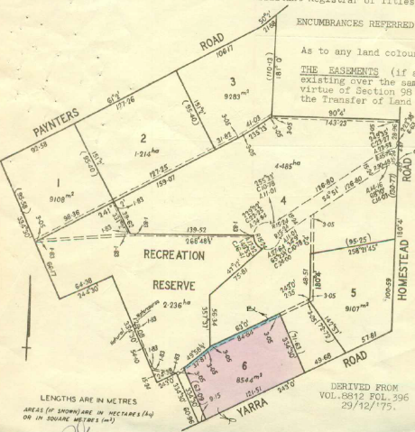3/3/1982 Mortgage No. J840593 to The Commercial Bank of Australia Limited, discharged 3/3/1982.

10/1/1983 Mortgage No. K223964 to Commonwealth Development Bank of Australia, discharged 14/3/1988.

19/7/1984 Caveat No. L158012 lodged. Caveat withdrawn 30/6/1986.

30/6/1986 Mortgage No. M343809X to Westpac Banking Corporation, discharged 13/10/1988.

14/3/1988 Mortgage No. P71620R to Equity Trustees Executors And Agency Company Limited, discharged 9/10/1992.

The land coloured red and numbered (lot) 7 on this Plan is the land in Certificate of Title Volume 9120 Folio 474 The whole plan is Plan of Subdivision No. 116246

5/6/1991 Mortgage No. R374234F to Australia And New Zealand Banking Group Limited, discharged 9/1/1992.

9/10/1992 Mortgage No. S161751P to National Australia Bank Limited.

31/10/1994 Caveat No. T387814K by Didel Pty. Ltd. as purchaser (Caveat transferred to new C/T.

Title Cancelled Plan of Subdivision No. 336802N.

*********************************************************************

**Certificate of Title Volume 10271 Folio 052 Street Address: 6 Jumping Creek Road**

19/2/1996 Certificate of Title Volume 10271 Folio 052, area 3000 m2, being Lot 1 on Plan of Subdivision No. 336802N issued to **Christopher Michael Gleeson** and **Bronwen Gleeson** both of 1 Chestnut Street Wellesley MA 02181 USA.

13/6/1996 Withdrawal No. U262740M of Caveat No. T387814K.

14/4/1997 Discharge No. U721676D of Mortgage No. S161751P.

4/8/1997 Transfer No. U906375N from Christopher Michael Gleeson and Bronwen Gleeson **to Paul Frank Ferris** and **Jennifer Ferris** both of 74 Narr-Maen Dr. Croydon Hills 3136.

4/8/1997 Mortgage No. U906376K to Bank of Melbourne Ltd.

Plan of Subdivision No. 336802N and Lot 1 is the land in Certificate of Title Volume 10271 Folio 052

15/10/2008 Discharge No. AG141554S of Mortgage No. U906376K.

12/10/2016 Caveat No. AN173191M by Mariana Weber and Martin Weber as purchasers lodged.

3/3/2017 Withdrawal No. AN615637M of Caveat No. AN173191M lodged.

3/3/2017 Transfer No. AN615638K from Paul Frank Ferris and Jennifer Ferris to **Martin Weber** and **Mariana Weber** both of 6 Jumping Creek Road Wonga Park Vic 3115.

3/3/2017 Mortgage No. AN615639H to National Australia Bank Ltd.

15/12/2022 Discharge No. AW378288A of Mortgage No. AN615639H.

15/2/2022 Transfer No. AW378289X from Martin Weber and Mariana Weber to Jian Tang and Chengyong Wu both of 6 Jumping Creek Road Wonga Park Vic 3115.

15/12/2022 Mortgage No. AW378290P to National Australia Bank Ltd.

18/4/2024 Discharge No. AX915808B of Mortgage No. AW378290P.

18/4/2024 Mortgage No. AX915809Y to Australia And New Zealand Banking Group Ltd.

*************************************************************************

**Certificate of Title Volume 10271 Folio 053 Street Address: 8 Jumping Creek Road**

19/2/1996 Certificate of Title Volume 10271 Folio 053, area 5544 m2, being Lot 2 on Plan of Subdivision No. 336802N issued to **Christopher Michael Gleeson** and **Bronwen Gleeson** both of 1 Chestnut Street Wellesley MA 02181 USA.

7/5/1996 Discharge No. U205407Y of Mortgage No. S161751P lodged.

7/5/1996 Transfer No. U205408V from Christophe Michael Gleeson and Bronwen Gleeson to **Didel Pty Ltd** of 35 Cleveland Av. Lower Plenty 3093 and lapsing of caveat.

13/8/1996 Mortgage No. U355196H to Barbfam Pty Ltd.

6/7/1999 Discharge No. W143412H of Mortgage No. U355196H lodged.

Plan of Subdivision No. 336802N and Lot 2 is the land in Certificate of Title Volume 10271 Folio 053

1/6/2004 Transfer No. AC894049P from Didel Pty Ltd to **Steven James Richards** and **Angela Jane Richards** both of 602 Warrandyte Road Park Orchards Vic 3114.

1/6/2004 Mortgage No. AC894050F to Permanent Custodians Ltd.

11/5/2009 Discharge No. AG497693P of Mortgage No. AC894050F lodged.

11/5/2009 Transfer No. AG497693P from Steven James Richards and Angela Jane Richards to Ellen Ingrid Mitchell of 20 Wandsworth Street Surrey Hills Vic 3127.8785