**Title History of Crown Allotment 9 A Parish of Warrandyte**

17/9/1906 Crown Grant Volume 3161 Folio 174 of 46 acres and 6 perches being (Crown) Allotment 9A, for a consideration of Thirty-Six Pounds Five Shillings to **Thomas Shaw** of 34 Wellington Street Collingwood Iron Worker.

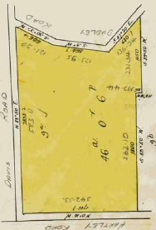29/6/1920 Transfer No. 948508 from Thomas Shaw to **Charles James Phair** of Wonga Park Orchardist.

Plan of land in Crown Grant Volume 3161 Folio 174

Plan showing property boundaries and street numbers

9/6/1920 Mortgage No. 407323 to Charles William Wood, discharged 20/8/1926.

20/8/1926 Transfer No. 1281473 from Charles James Phair to **Victor Sydney Hollow** of 120 Queen Street Melbourne Solicitor.

20/8/1926 Transfer No. 1281474 from Victor Sydney Hollow to **Ellen Nora Taubman** of Ipswich Road Kilsyth Married Woman.

20/3/1929 Caveat No. 79002 affecting part of the land herein lodged. Caveat lapsed 22/2/1944.

19/11/1943 Transfer No. 1960518 from Ellen Nora Taubman to **Norman Edward Taubman** Orchardist and **Ethel Clara Taubman** his wife both of Wonga Park.

24/8/1960 Transfer No. B43840 from Norman Edward Taubman and Ethel Clara Taubman to **Norman Hugo Semmler** Orchardist and **Dulcie Margaret Semmler** Married Woman both of Dudley Road Wonga Park.

21/5/1968 Mortgage No. ???? to The English Scottish and Australian Bank Limited, discharged 6/11/1968.

21/8/1968 Caveat No. D167350 lodged. Caveat lapsed 10/8/1976.

Plan attached to Crown Grant showing subdivision into 2 lots (Plan of Subdivision No. 121558) Lot 2 re-subdivided and lot 1 remaining in the Crown Grant

29/12/1968 Caveat No. D280906 lodged.

Caveat lapsed 27/9/1976.

28/7/1976 Transfer No. G253776 from Norman Hugo Semmler and Dulcie Margaret Semmler to **Wesley Charles Robinson** Airline Pilot and **Margaret Joyce Robinson** both of Dudley Road Wonga Park.

20/7/1976 Mortgage No. G253777 to The National Bank of Australasia Limited, discharged 29/4/1978.

8/5/1978 Caveat No. H64367 affecting part of the land herein 2 P/S 124315. Caveat Transferred to new C/T.

Plan attached to Crown Grant showing subdivision of Lot 2 on Plan of Subdivision No. 11558 into 3 lots (Plan of Subdivision No. 14315)

13/7/1978 Title Cancelled as to part Pursuant to Regulation 12. Titles issued as set out hereunder Lots One to 3 in Vol 9274 Fol 298 to Vol 9274 Fol 300.

7/12/1983 Transfer as to balance No. K662960, new Certificate of Title Volume 9538 Folio 560.

****************************************************************************

**Certificate of Title Volume 9274 Folio 298**

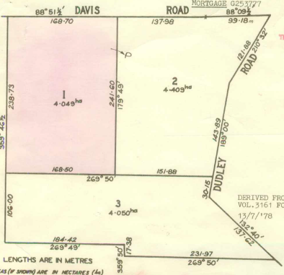 13/7/1978 Certificate of Title Volume 9274 Folio 298 being Lot 1 on Plan of Subdivision No.

124315 issued to **Wesley Charles Robinson** Airline Pilot and **Margaret Joyce Robinson** both of

Dudley Road Wonga Park subject to Mortgage No. G253777, discharged 28/4/1978.

19/6/1978 Caveat No. H563882 lodged. Caveat lapsed ?? 1979.

11/9/1979 Transfer No. H677581 from Wesley Charles Robinson and Margaret Joyce Robinson to **Roslan Pty. Ltd.** of Corner Hull Road and Charles Street Mooroolbark.

Plan of land in Certificate of Title Volume 9274 Folio 298

7/12/1979 Mortgage No. H793352 to Commonwealth Savings Bank of Australia, discharged 31/7/1985.

26/2/1980 Mortgage to Commonwealth Trading Bank of Australia, discharged 31/7/1980.

16/1/1981 Creation of Easement No. F308499 registered.

31/7/1985 Mortgage No. J80834K to National Mutual Permanent Building Society, discharged 17/2/1987.

31/7/1985 Mortgage No. J805835G to National Mutual Permanent Building Society, discharged 17/2/1987.

17/2/1987 Transfer No. M703098B from Roslan Pty. Ltd. to **Ian Michael Dunn** & **Jennifer Beryl Dunn** of 4 Tugan Pl. North Ringwood.

17/2/1987 Mortgage No.M703099X C discharged 5/8/1982.

17/2/1987 Mortgage No. M703100W National Mutual Permanent Building Society, discharged 20/3/1992.

5/7/1994 Title Cancelled Pursuant to Section 24 Subdivision Act 1988 – PC 354507C.

***********************************************************************

**Certificate of Title Volume 9274 Folio 299**

1 3/7/1978 Certificate of Title Volume 9274 Folio 299 being Lot 2 on Plan of Subdivision No. 124315 issued to **Wesley Charles Robinson** Airline Pilot and **Margaret Joyce Robinson** both of Dudley Road Wonga Park subject to Mortgage No. G253777, discharged 28/4/1978.

8/5/1978 Caveat No. H64367 lodged. Caveat lapsed 11/4/1979.

27/3/1979 Transfer No. H460389 from Wesley Charles Robinson and Margaret Joyce Robinson to **Aktip** Pty. Ltd. of 16 Byways Drive East Ringwood.

Plan of land in Certificate of Title Volume 9274 Folio 299

27/3/1979 Mortgage No. H460390 to Corbun Nominees Pty. Ltd., discharged 5/5/1982.

13/12/1979 Creation of Easement No. H801610 registered.

20/10/1981 Mortgage No. J682875 to Commonwealth Trading Bank of Australia, discharged 26/10/1983

5/5/1982 Mortgage No. J915241 to commonwealth Savings Bank of Australia, discharged 26/10/1983.

25/10/1983 Mortgage No. K603893 to Commonwealth Trading Bank of Australia, discharged 27/9/1989.

22/5/1989 Caveat No. P205755R by Hendricus Martinus Versteegen & Marie Therese Versteegen as purchaser. Caveat will lapse on registration of P448210K – 9/10/1989.

25/5/1989 Caveat No. P214594 lodged 25/5/1989. Caveat will lapse on registration of P448210K – 9/10/1989.

27/9/1989 Transfer No. P448210K from Aktip Pty. Ltd. to **Hendricus Martinus Versteegen** & **Marie Therese Versteegen** of 1 Tandarook Cr. Donvale.

27/9/1989 Mortgage No. P448211G to Australia and New Zealand Banking Group Limited.

10/2/1994 Title Cancelled Pursuant to Section 24 Subdivision Act 1988 PS 331410J.

***********************************************************************

**Certificate of Title Volume 10155 Folio 452 Street Nos. 61 & 61A Dudley Road Wonga Park**

10/2/1994 Certificate of Title Volume 10155 Folio 452 being Lot 1 on Plan of Subdivision No. 331410J issued to **Hendricus Martinus Versteegen** & **Marie Therese Versteegen** both of 59-61 Dudley Road Wonga Park subject to Mortgage No. P448211G.

8/6/1995 Discharge No. T717970K of Mortgage No. P448211G lodged.

8/6/1995 Mortgage No. T717971G to commonwealth Bank of Australia lodged.

29/5/2002 Discharge No. AB309901J of Mortgage No. T717971G lodged.

Plan of Subdivision No. 331410J

29/5/2002 Transfer No. AB309902G from Hendricus Martinus Versteegen and Marie Therese Versteegen to **Andrew Alexander Hansen** and **Tanya Jacinta Hansen** both of 2 Frederick Street Doncaster Vic 3108.

29/5/2002 Mortgage No. AB309903E to Westpac Banking Corporation.

23/10/2002 Discharge No. AB649333W of Mortgage No. AB309903E lodged.

23/10/2002 Transfer No. AB649334U from Andrew Alexander Hansen and Tanya Jacinta Hansen to **Andrew Ernest Schnell** and **Doone Lee McDougall** both of 61 Dudley Road Wonga Park.

23/10/2002 Mortgage No. AB649335S to Westpac Banking Corporation lodged.

12/8/2010 Discharge No. AH426913U of Mortgage No. AB649335S lodged

12/8/2010 Transfer No. AH426914S from Andrew Ernest Schnell and Doone Lee McDougall to **Andrew Ernest Schnell** of 61 Dudley Street Wonga Park.

12/8/2010 Mortgage No. AH426915Q to Westpac Banking Corporation lodged.

23/4/2021 Caveat No. AU265837Q by Blaire Vanessa Redgrove and Matthew John Redgrove as purchasers lodged.

14/5/2021 Discharge No. AU343333M of Mortgage No. AH426915Q lodged.

14/5/2012 Transfer No. AU34334K from Andrew Ernest Schnell to **Blaire Vanessa Redgrove** and **Matthew John Redgrove** both of 61 Dudley Road Wonga Park Vic 3115.

14/5/2021 Mortgage No. AU343335H to Perpetual Trustee Company Ltd lodged.

19/5/2023 Discharge No. AW847034V of Mortgage No. AU343335H lodged.

19/5/2023 Mortgage No. AW847035T to Westpac Banking Corporation lodged.

***********************************************************************

**Certificate of Title Volume 10155 Folio 453**

10/2/1994 Certificate of Title Volume 10155 Folio 453 being Lot 2 on Plan of Subdivision No. 331410J issued to **Ian Michael Dunn** and **Jennifer Beryl Dunn** both of Davis Road Wonga Park (after transfer No. T010258M on 29/3/1994 from Hendricus Martinus Versteegen & Marie Therese Versteegen).

19/7/1994 Title Cancelled by Plan of Consolidation No. 354507C, see new Certificate of Title Volume 10177 Folio 343.

******************************

**Certificate of Title Volume 10177 Folio 343 Street No. 17 Davis Road Wonga Park**

19/7/1994 Certificate of Title Volume 10177 Folio 343 being the land in Plan of Consolidation No. 354507C, parent titles Volume 9274 Folio 298 and Volume 10155 Folio 453 issued in the names of **Ian Michael Dunn** and **Jennifer Beryl Dunn** both of Davis Road Wonga Park.

Plan of Consolidation No.354507 consolidating the lands in Certificates of Tile Volume 9274 Folio 298 and Volume 10155 Folio 453 and then becoming the land in Certificate of Title Volume 10177 Folio 343

**********************************************************************

**Certificate of Title Volume 9274 Folio 300 Street No. 55 Dudley Road Wonga Park**

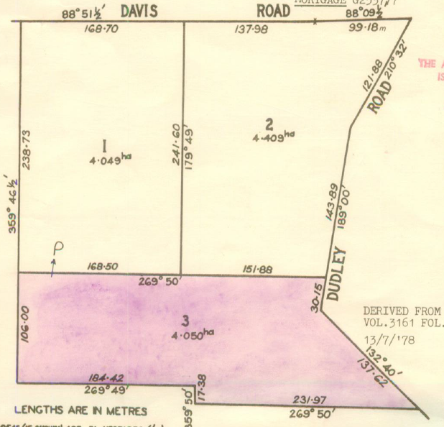13/7/1978 Certificate of Title Volume 9274 Folio 300 being Lot 3 on Plan of Subdivision No. 124315, area 4.050 hectares, issued to **Wesley Charles Robinson** Airline Pilot and **Margaret Joyce Robinson** both of Dudley Road Wonga Park subject to Mortgage No. G253777, discharged 28/4/1978.

23/11/1979 Transfer No. H775779 from Wesley Charles Robinson and Margaret Joyce Robinson to **Gary Grey Hutchins** Company Director and **Annette Louise Hutchins** Company Director both of Whistlewood Close Bulleen.

3/7/1980 Mortgage No. J52534 to The Commissioners of The State Savings Bank of Victoria, discharged 29/1/1985.

28/4/1981 Mortgage No. J436300 to The National Bank of Australasia Limited, discharged 18/5/1988.

Plan of land in Certificate of Title Volume 9274 Folio 300

18/5/1988 Transfer No. N462750J from Gary Grey Hutchins and Annette Louise Hutchins to **Frederick Allen Lang** & **Beverley Elizabeth Lang** of 6 Merimbula Rd. Ferny Creek.

18/5/1988 Mortgage No. N462751F to Australia and New Zealand Banking Group Limited, discharged 18/8/1993.

18/8/1993 Transfer No. S640361K from Frederick Allen Lang and Beverley Elizabeth Lang to **Gary John Cole** & **Kay Jean Cole** 25 Currajong Rd. East Hawthorn 3123.

28/8/1993 Mortgage No. S640362G to Australia and New Zealand Banking Group Limited, discharged 3/5/1999.

3/5/1999 Transfer No. W24692E from Gary John Cole and Kay Jean Cole to **Second Chance Investments Pty Ltd** 11 Paxton St. East Malvern 3145.

25/7/2016 Caveat No. AM964253Q by Jade Victoria Giovanetti lodged.

30/11/2016 Transfer No. AN326607H from Second Chance Investments Pty Ltd to **Jade Victoria Giovannetti** of 55-57 Dudley Road Wonga Park Vic 3115.

30/11/2016 Mortgage No. AN326608F to National Australia Bank Ltd lodged.

28/6/2021 Discharge No. AU508037A of Mortgage No. AN326608F lodged.

28/6/2021 Mortgage No. AU508037A to Perpetual Corporate Trust Ltd lodged.

13/5/2022 Discharge No. AV626316C of Mortgage No. AU508037A lodged.

13/5/2022 Mortgage No. AV626317A to National Australia Bank Ltd lodged.

6/8/2024 Caveat No. AY285962P by David Cowen Investments Pty Ltd as Mortgagee.

********************************************************************

**Certificate of Title Volume 9538 Folio 560 Street No. 70 Hartley Road Wonga Park**

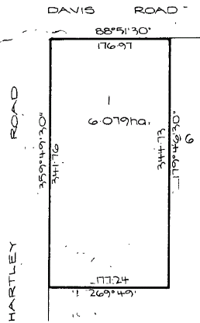 7/12/1983 Certificate of Title Volume 9538 Folio 560, aea 6.079 hectares, being Lot 1 on Plan of Subdivision No. 121558 issued to **Trevor James Lethlean** Manager and **Rosalie Dawn Lethlean** Married Woman both of 3 Duxson Drive Templestowe (after Transfer as to balance No. K662960 fromWesley Charles Robinson and Margaret Joyce Robinson).

26/7/1988 Transfer No. K597560B from Trevor James Lethlean and Rosalie Dawn Lethlean to **John Peter Farnham** & **Jillian Kaye Farnham** of 11 Paddys Lane Park Orchards.

21/11/1990 Mortgage No. R100706G to State Bank of Victoria lodged.

Plan of land in Certificate of Title Volume 9538 Folio 560