Arno Neuparth is a son of Fritz Neuparth, orchardist and poultry farmer of Exeter Road North Croydon presumably where Neuparth Road now is.

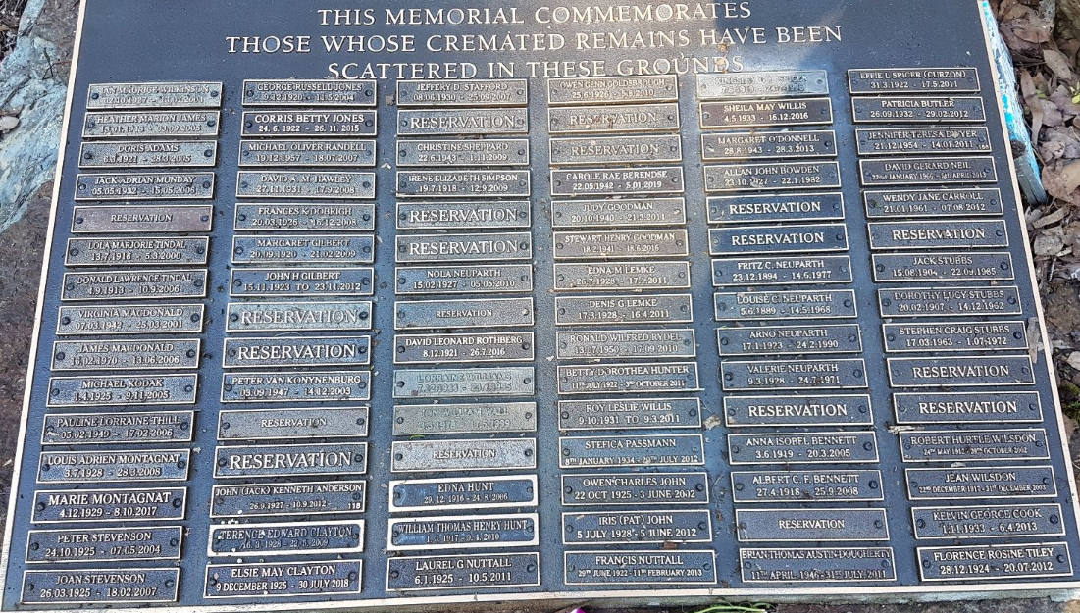

Nola Neuparth 15/2/1927 – 5/5/2010 Fritz C. Neuparth 23/12/1894 – 14/6/1977 Louise C. Neuparth 5/6/1889 – 14/5/1968 Arno Neuparth 17/1/1923 – 24/2/1990 Valerie Neuparth 9/3/1928 – 24/7/1971

**Electoral Roll**

Electoral Roll 

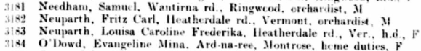



Electoral Roll

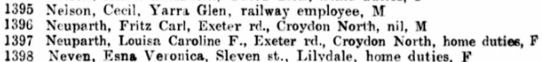

Electoral Roll

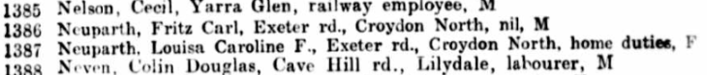

Electoral Roll

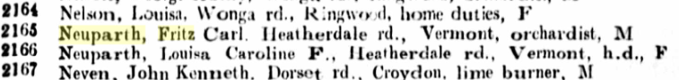

Electoral Roll



Electoral Roll

