**Title History of Crown Allotment 9 C Parish of Warrandyte**

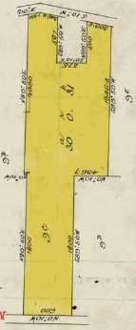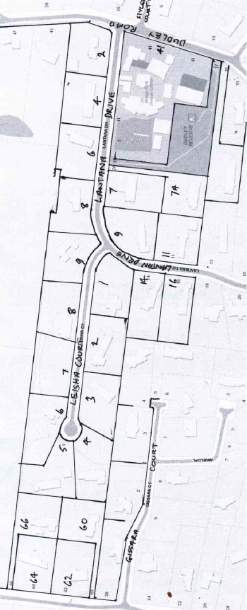16/5/1906 Crown Grant Volume 3142 Folio 262 of 30 acres and 31 perches being (Crown) Allotment 9C, for a consideration of Twenty three Pounds and Five Shillings to **George Pickup** of 472 Napier Street North Fitzroy Gentleman.

Plan showing property boundaries and street numbers

15/2/1912 Memo No. 50181: George Pickup died the 27th day of July 1905. On the 15th day of January 1906 probate of the will of the said George Pickup was granted to **Mary Ann Pickup** of 472 Napier Street Fitzroy Widow.

Plan showing land in Crown Grant Volume 3142 Folio 262. NB the unusual shape is due to the State School being excised from the original Allotment while the holding was still leasehold and before the Crown Grant was made.

15/2/1912 Transfer No. 675215 from Mary Ann Pickup to **Agnes Mitchelson** of Yarra Road Croydon Widow.

15/2/1912 Mortgage No. 302273 to Robert Beckett and Vincent Alfred Yardley, discharged 8/11/1919.

6/5/1920 Transfer No. 938726 from Agnes Mitchelson to **Margaret Winifred Browning** of Wonga Park Croydon Married Woman.

3/10/1920 Caveat No. 53787 lodged. Caveat lapsed 22/1/1924.

22/1/1924 Transfer No. 1147636 from Margaret Winifred Browning to **Alfred John Allingham** of 22 Kangerong Road Box Hill Orchardist.

19/4/1926 Transfer as to part to Sidney John Oakes, new Certificate of Title Volume 5131 Folio 178.

30/7/1926 Mortgage No. 545654 to Mary Ellen Parish, discharged ?/9/1929.

23/10/1929 Mortgage No. 628106 ?? Marshino, discharged 8/7/194?.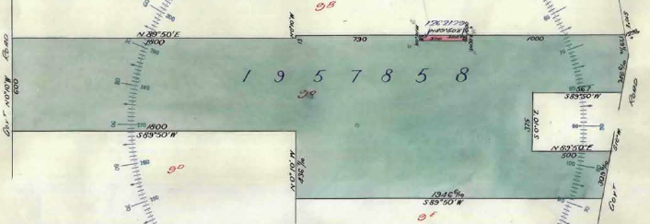

Plan attached to Crown Grant Volume 3142 Folio 262 showing a small rectangular piece of land transferred out to Sidney John Oakes to be attached to Crown Allotment 9B.

2/6/1945 Transfer as to balance No. 1957858 to William Richard Lonie, new Certificate of Title Volume 6781 Folio 107.

An enlargement of the piece of land transferred out to Sidney John Oakes.

************************************************************************

**Certificate of Title Volume 5131 Folio 178**

19//1926 Certificate of Title Volume 5131 Folio 178, being a strip of land 53 links wide by 300 links long on the northern boundary of the land without a road frontage, being part of Crown allotment 9C issued in the name of **Sidney John Oakes** of Windmere Crescent Brighton Commercial Traveller.

Plan of the land in Certificate of Title Volume 5131 Folio 178

29/10/1945 Transfer No. 1969892 from Sidney John Oakes to **David Johnston Gawith** of Greville Street Prahran Baker.

10/11/1949 Transfer No. 2256243 from David Johnston Gawith to **Joseph Henry Hartley** of Warrandyte Road Wonga Park Dry Cleaner.

10/12/1959 Mortgage No. A872935 to The Commercial Banking Company of Sydney Limited, discharged 31/1963.

3/1/1963 Mortgage No. B574715 to The Commercial Banking Company of Sydney Limited, discharged 13/7/1969.

13/7/1967 Mortgage No. C828738 to The Commercial Banking Company of Sydney Limited, discharged 3/8/1971.

26/9/1967 Mortgage No. C895273 to Leopold Walter Adolph Hunt and Ronald Kenneth Dickson, discharged 5/8/1971.

5/8/1971 Mortgage No. E122510 to Burwood Discounts Pty. Ltd., discharged 6/7/1972.

6/7/1972 Mortgage No. E447508 to Edward Francis Flanagan and Catherine Mary Flanagan, discharged 27/6/1975.

27/6/1975 Mortgage No. F750897 to The Commercial Bank of Australia Limited, discharged 9/9/1976.

27/2/1976 Mortgage No. G49418 to The Commercial Bank of Australia Limited, discharged 9/9/1976.

9/9/1976 Mortgage No. G313863 to The Commercial Bank of Australia Limited, discharged 19/1/1977.

7/10/1976 Caveat No. G353668 lodged. Caveat lapsed 14/2/1977.

19/1/1977 Mortgage No. G480838 to The Commercial Bank of Australia Limited, discharged.

15/5/1984 Title Cancelled The following Titles have been issued Pursuant Regulation 12 of the Transfer of Land Act: Lot One to 3 in Vol 9553 Fol 568 to Vol 9553 Fol 570 LP 144205.

****************************************************************************

**Certificate of Title Volume 6781 Folio 107**

28/6/1945 Certificate of Title Volume 6781 Folio 107, a30 acres and 15 perches, being part of Crown Allotment 9C issued in the name of **William Richard Lonie** of Warrandyte Farmer.

12/9/1945 Mortgage No. 851225 to Jane Ethel Fordyce, discharged 18/9/1947.

?/2/1946 Mortgage No. 853500 to Jane Ethel Fordyce, discharged 18/9/1947.

Plan of land in Certificate of Title Volume 6781 Folio 107

18/2/1947 Transfer No. 2055683 from William Richard Lonie to **Alan Thomas Knee** of Donvale Carrier.

18/2/1947 Mortgage No. 872736 to Francis Burton Goodrich, discharged 31/71951.

21/8/1947 Mortgage No. 877888 to Soldier Settlement Commission, discharged 31/7/1951.

31/7/1951 Mortgage No. 993011 to Soldier Settlement Commission, discharged 24/11/1954.

31/7/1951 Mortgage No. 993011 to Soldier Settlement Commission, discharged 24/11/1954.

31/7/1951 Mortgage No. 993012 to Soldier Settlement Commission, discharged 24/11/1954.

24/11/1954? Mortgage No. to Soldier Settlement Commission, discharged 17/3/1956?.

24?/11/1954 Mortgage No. 1103488 to Soldier Settlement Commission, discharged 17/3/1956.

17/5/1956 Mortgage No. 158237 to George Frederick Goodrich, discharged 7/6/1960.

29/2/1958 Mortgage No. A484502 to George Frederick Goodrich, discharged 7/6/1960.

7/6/1960 Mortgage No. A985827 to George Frederick Goodrich, discharged ??.

?/6/1962 Mortgage No. B?54096 to George Frederick Goodrich, discharged 5/7/1973.

3/3/1964 Mortgage No. B972852 to George Frederick Goodrich, discharged 5/7/1973.

23/8/1967 Mortgage No. C865495 to George Frederick Goodrich, discharged 5/7/1973.

21/8/1969 Mortgage No. D483425 to George Frederick Goodrich, discharged 20/1/1970.

5/6/1970 Caveat No. D739344 lodged. Caveat lapsed 30/7/1973.

5/7/1975 Transfer No. E886243 from Alan Thomas Knee to **Edwin Baumgartner** Pastry Cook and **Irma Baumgartner** Married Woman both of 259 Thompson Road Lower Templestowe.

10/3/1977 Transfer No. G547244 from Edwin Baumgartner and Irma Baumgartner to **Eros Zamagni** Company Director and **June Nesta Esma Zamagni** Married Woman both of 22Farquharson Street Mount Waverley as joint proprietors as to one equal undivided half part or share **Jeffrey Stewart Cox** Solicitor and **Margaret Elizabeth Cox** Married Woman both of 3/1 Monaro Road Kooyong as joint proprietors as to the other one equal undivided half part or share as tenants in common.

10/3/1977 Mortgage No. G547245 to Edwin Baumgartner and Irma Baumgartner, discharged 29/9/1980.

30/8/1978 Mortgage No. H215160 to The Commercial Bank of Australia Limited.

26/1/1982 Title Cancelled. The following Titles have been issued Pursuant to Regulation 12 of the Transfer of Land Act: Lot A in Vol 9450 Fol 209 and Lot B in Vol 9450 Fol 210. Pursuant to Section 32 of the Transfer of Land Act: Reserve for public resort & recreation in Vol 9450 Fol 211 LP 138445.

****************************************************************************

**Certificate of Title Volume 9450 Folio 209**

26/1/1982 Certificate of Title Volume 9450 Folio 209, area 9.712 hectares, being Lot A on Plan of Subdivision No. 138445 issued to **Eros Zamagni** Company Director and **June Nesta Esma Zamagni** Married Woman both of 22 Farquharson Street Mount Waverley as joint proprietors as to one equal undivided half part or share **Jeffrey Stewart Cox** Solicitor and **Margaret Elizabeth Cox** Married Woman both of 3/1 Monaro Road Kooyong as joint proprietors as to the other one equal undivided half part or share A blueprint of a building
as tenants in common subject to Mortgage No. H215160, discharged 19/3/1982.

Plan in which the land in Certificate of Title Volume 9450 Folio 209 is marked Lot A

19/3/1982 Caveat No. J861068 lodged 19/3/1982. Caveat withdrawn 29/2/1984.

7/8/1984 Title Cancelled as to part Pursuant to Regulation 12 and Titles issued as set out hereunder: Lots 1 to 5 in Vol 9564 Fol 941 to Vol 9564 Fol 945 and Lot 17 in Vol 9564 Fol 946 and Lots 21 to25 in Vol 9564 Fol 947 to Vol 9564 Fol 951 and Pursuant to Section 32 of the Transfer of Land Act Being a Reserve for Public Resort and Recreation See Vol 9564 Fol 952 Supply of water, electricity, telephone & gas on LP144585

Plan of Subdivision No. 144585

7/8/1984 Title Cancelled. The following Titles have been issued Pursuant to Regulation 12 of the Transfer of Land Act: Lots 6 to 9 in Vol 9564 Fol 954 to Vol 9564 Fol 957 and Lots 14 to 16 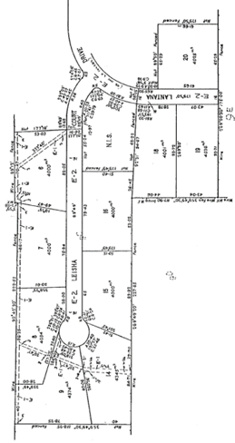in Vol 9564 Fol 958 to Vol 9564 Fol 960 and Lots 18 to 20 in Vol 9564 Fol 961 to Vol 9564 Fol 963 and Pursuant to Section 32 of the Transfer of Land Act Land appropriated and set apart for easements of way drainage and sewerage in Vol 9564 Fol 964 Supply of water, electricity, telephone & gas on LP 144586.

Plan of Subdivision No. 144586

*********************************************************************

**Certificate of Title Volume 9564 Folio 952**

7/8/1984 Certificate of Title Volume 9564 Folio 95 being a Reserve for Public Resort and Recreation on Plan of Subdivision No. 144585 issued in the names of **Jeffrey Stewart Cox** 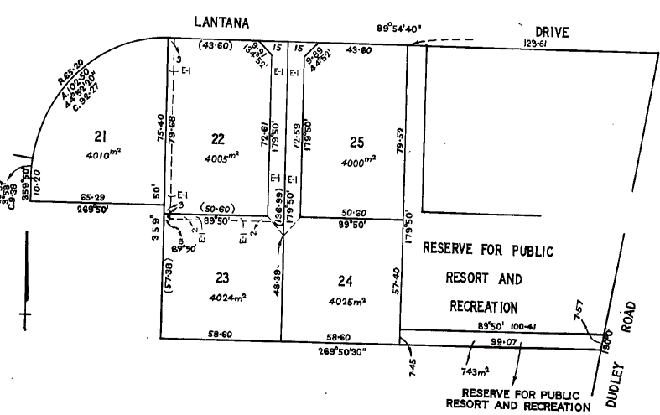Solicitor and **Margaret Elizabeth Cox** Married Woman both of 12 Fordholm Road Hawthorn as joint proprietors as to one equal undivided half part or share to **Eros Zamagni** Company Director and **June Nesta Esma Zamagni** Married Woman both of 22 Farquharson Street Mount Waverley as joint proprietors as to the other one equal undivided half part or share as tenants in common.

29/2/1984 Mortgage No. K779937J to Elders Lensworth Finance Limited, discharged 23/1/1986.

Plan on Certificate of Title Volume 9564 Folio 952

30/7/1984 Mortgage No. L176785R to Australia and New Zealand Banking Group Limited.

14/12/2017 Title cancelled by Instrument No. AQ552151M.

It is understood that this land was transferred to the Wonga Park Primary School in exchange for Lot 24 which had previously been acquired for the school by the Education Department.

**Certificate of Title Volume 9564 Folio 959 Street Number: 3 Leisha Court Wonga Park**

7/8/1984 Certificate of Title Volume 9564 Folio 959, area 4000 m2 being Lot 15 on Plan of Subdivision No. 144586 issued in the names of **Jeffrey Stewart Cox** Solicitor and **Margaret A black and white drawing of a land
Elizabeth Cox** Married Woman both of 12 Fordholm Road Hawthorn as joint proprietors as to one equal undivided half part or share to **Eros Zamagni** Company Director and **June Nesta Esma Zamagni** Married Woman both of 22 Farquharson Street Mount Waverley as joint proprietors as to the other one equal undivided half part or share as tenants in common subject to The Covenant contained in Transfer 541991K registered 4/3/1985.

Plan on Certificate of Title Volume 9564 Folio 959 on which the land in the title is numbered 15.

29/2/1984 Mortgage No. K779937 to Edder Lensworth Finance Limited, discharged as to part being the within land 4/3/1985.

30/7/1984 Mortgage No. L176785R to Australia and New Zealand Banking Group Limited, discharged 4/3/1985.

4/3/1985 Transfer No. L541991K from Jeffrey Stewart Cox, Margaret Elizabeth Cox, Eros Zamagni and June Nesta Esma Zamagni to **Philip Glenister** & **Patricia Dawn Glenister** of 25 Arkarra Crt. Mooroolbark.

25/7/1985 Mortgage No. L796034M to Australia and New Zealand Banking Group Limited, discharged 28/5/1986.

28/5/1986 Mortgage No. M292619G to National Australia Bank Limited.

28/5/1986 Mortgage No. M292620G to National Australia Savings Bank Limited.

******************************************************************************

**Certificate of Title Volume 9450 Folio 210 Street Nos. 60, 62, 64 & 66 Hartley Road Wonga Park**

26/1/1982 Certificate of Title Volume 9450 Folio 210, area 1.601 hectares, being Lot B on Plan of Subdivision No. 138445 issued to **Eros Zamagni** Company Director and **June Nesta Esma Zamagni** Married Woman both of 22 Farquharson Street Mount Waverley as joint proprietors as to one equal undivided half part or share **Jeffrey Stewart Cox** Solicitor and **Margaret Elizabeth Cox** Married Woman both of 12 Fordholm Road Hawthorn as joint proprietors as to the other one equal undivided half part or share as tenants in common subject to Mortgage No. H215160, discharged 18/1/1982.

Plan in which the land in Certificate of Title Volume 9450 Folio 210 is marked Lot B

18/1/1982 Transfer No. J785408 from Eros Zamagni, June Nesta Esma Zamagni Jeffrey Stewart Cox and Margaret Elizabeth Cox to Rolf Bernard Mulligan Director and Margaret Frances Mulligan Married Woman both of Jumping Creek Road Wonga Park.

17/5/1983 Title Cancelled. The following Titles have been issued Pursuant to Regulation 12 of the Transfer of Land Act: Lots One to 2 in Vol 9510 Fol 812 to Vol 9510 Fol 813 - LP 141010.