**Title History of Crown Allotment 9 L**

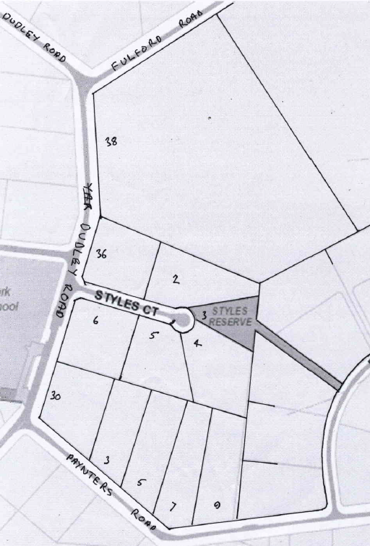3/3/1909 Crown Grant Volume 3344 Folio 691, in consideration of the payment of 21 pounds **Edgar 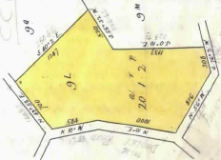Richard Collyer** of 146 boundary Road North Melbourne Engraver was granted 321 acres 1 rood and 2 perches being (Crown) Allotment 9 L in the Parish of Warrandyte County of Evelyn.

5/12/1930 Red Ink No. 3171358: Edgar Richard Collyer died on 20th May 1930. Probate of his Will has been granted to **Alice Collyer** of 146 Boundary Road Norh Melbourne Widow and **William Richard Collyer** of 9 Ashburton Road Glen Iris Bank Official.

Plan showing property boundaries and Street Addresses.

Plan of land in Crown Grant Volume 3344 Folio 691

3/9/1936 Red Ink No. 3521019: **Alice Collyer** the survivor of the proprietors named herein by Direction of the Commissioner of Titles, now registered as the sole proprietor of the land now comprised herein.

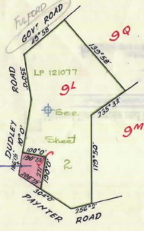3/9/1936 Transfer No. 1623886 from Alice Collyer to **Alice Collyer** of 146 Boundary Road North Melbourne Widow and **Edgar Arthur Collyer** of Macquarie Street Windsor New South Wales Bank Official.

Alice Collyer died on 10th April 1944.

12/2/1948 Red Ink No. 4547238: **Edgar Arthur Collyer** of Railway Parade Hurstville New South Wales Bank Official the survivor of the proprietors named herein is by Direction of the Commissioner of Titles now registered as sole proprietor of the land now comprised herein.

12/4/1948 Transfer No. 2124782 from Edgar Arthur Collyer to **Horace Frederick George Burch** of Wonga Park Orchardist.

1/6/1956 Transfer No. A166455 from Horace Frederick George Burch to **Gordon Graham Styles** Carpenter and **Myrna Louise Styles** Married Woman both of Croydon.

27/1/1961 Transfer as to part No. B144815, area 1 acre 0 roods 0 perches, new Certificate of Title Volume 8311 Folio 236.

Plan attached to Crown Grant Volume 3344 Folio 691 showing land transferred out in transfer as to part No. B144815

21/10/1977 Title Cancelled as to part Pursuant to Regulation 12 and Titles issued as set out hereunder: Lots One to 4 in

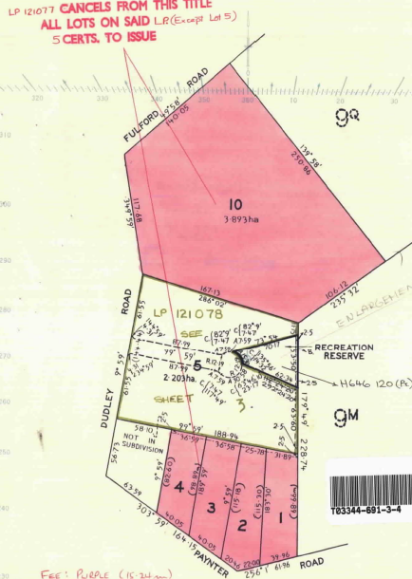 Vol 9232 Fol 443 to Vol 9232 Fol 446 and Lot 10 in Vol 9232 Fol 447 – LP 121077.

29/11/1978 Transfer as to part No. H323245, (Lot 8) new Certificate of Title Volume 9313 Fol 391.

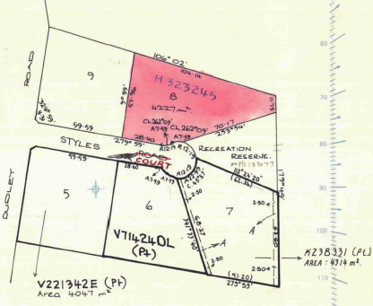16/8/1979 Transfer as to part No. H646120, Reserve, new Certificate of Title Volume 9352 Fol 417.

Plan attached to Crown Grant Volume 3344 Folio 691 showing Lots 1 to 4, 5 & 10 in Plan of Subdivision No. 121077. All lots except Lot 5 cancelled from the Crown Grant by this plan of subdivision

Plan attached to Crown Grant Volume 3344 Folio 691 showing Lots 5 to 9 in Plan of Subdivision No. 121078

24/1/1985 Transfer as to part No. K288331, Lot 7, new Certificate of Title Volume 9503 Fol 966.

17/1/1997 Survivorship Application No. U598072S by Myra Louise Styles of Dudley Rd. Wonga Park 3115.

10/12/1997 Caveat No. V144524U by Roy Holden & Patricia Ann Holden as purchaser. Caveat will lapse on registration of V221342E – 16/3/1998.

23/1/1998 Transfer as to part No. V221342E, Lot 5, new Certificate of Title Vol 10370 Fol 121.

27/10/1998 Transfer as to part No. V714240L, Lot 6, new Certificate of Title Vol 10411 Fol 173.

10/12/1998 Transfer as to balance No. V791244G (Lot 9) from Myra Louise Styles to Barry Medley & Noelene Leanne Medley of 36 Dudley Rd. Wonga Park.

10/12/1998 Mortgage No. V791245D to Permanent Custodians Ltd.

7/8/2006 Discharge No. AE527276M of Mortgage No. V791245D lodged.

7/8/2006 Mortgage No. AE527277K to Permanent Custodians Limited.

************************************************************************

**Certificate of Title Volume 8311 Folio 236 Street: Address 30 Dudley Road Wonga Park**

271/1961 Certificate of Title Volume 8311 Folio 236, area 1 acre, being part of Crown Allotment 9L issued to **Queenie Tomkin** of 184 Whitehorse Road Croydon Married Woman (by 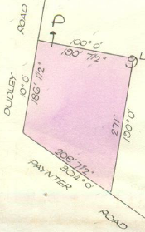transfer No. B144815 from Gordon Graham Styles and Myrna Louise Styles).

31/7/1972 Caveat No. D994102 lodged. Caveat lapsed 31/7/1972.

11/7/1972 Transfer No. E453239 from Queenie Tomkin to **Wayne Athol Ford** Engineer and **Judith Margaret Ford** Married Woman both of 19 Clarice Road Box Hill.

20/12/1972 Mortgage No. E574280 to Hotham Permanent Building Society, discharged 30/6/1976.

30/6/1976 Mortgage No. G213991 to Albert John Thompson, discharged 25/9/1991.

Plan of land in Certificate of Title Volume 8311 Folio 236

8/9/1977 Mortgage No. G779027 to Bank of New Zealand, discharged 20/1/1995.

25/9/1991 Mortgage No. R564119T to Yuncken Nominees Pty. Ltd., discharged 20/1/1993.

11/10/1991 By Instrument No. R589213K the registered mortgages affecting the within land now rank in the following order of priority:- 1. Mortgage R564119T and 2. Mortgage G779027.

20/1/1993 Mortgage No. S316437H to National Australia Bank Limited.

12/7/2002 Discharge No. AB409383W of Mortgage No. S316437H lodged.

12/7/2002 Transfer No. AB409384U from Wayne Athol Ford and Judith Margaret Ford to **Jennifer Ellen McGarry** of 30 Dudley Road Wonga Park Vic 3115.

12/7/2002 Mortgage No. AB409385S to National Australia Bank Limited.

28/3/2003 Discharge No. AC295796P of Mortgage No. AB409385S.

28/8/2003 Mortgage No. AC295797M to Bank of Western Australia Ltd.

1/8/2005 Discharge No. AD781940R of Mortgage No. AC295797M.

19/11/2010 Caveat No. AH62447 by Laurice Elizabeth Temple and Anthony Robert Duff as purchaser.

18/3/2011 Transfer No. AH847095E from Jennifer Ellen Magarry to **Anthony Robert Duff** and **Laurice Elizabeth Temple** both of 2 Bemm Court Croydon Hills Vic 3136.

18/3/2011 Mortgage No. AH847096C to Commonwealth Bank of Australia.

3/11/2022 Discharge No. AW230398U of Mortgage No. AH847096C.

3/11/2022 Transfer No. AW230399S from Anthony Robert Duff and Laurice Elizabeth Temple to **Kirsty Nicole Turner** and **John Daves** both of 30 Dudley Road Wonga ark Vic 3115.

3/11/2022 Mortgage No. AW230400M to Commonwealth Bank of Australia.

***********************************************************************

**Certificate of Title Volume 9232 Folio 447: Street Address 38 Dudley Road Wonga Park**

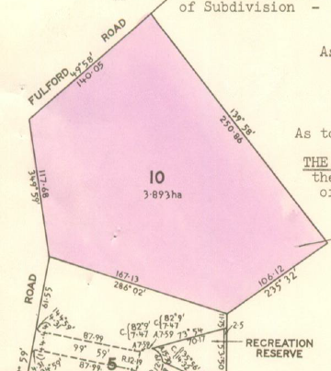2/10/1977 Certificate of Title Volume 9232 Folio 447.area 3.893 hectares, being Lot 10 on Plan of Subdivision No. 121077 issued to **Gordon Graham Styles** Carpenter and **Myra Louise Styles** both of Dudley Road Wonga Park.

20/7/1979 Transfer No. H611410 from Gordon Graham Styles and Myra Louise Styles to **George John Kepper** Company Director and **Eva-Brigitte Kepper** Married Woman both of 11 Gairns Court Croydon.

20/2/1987 Transfer No. M709812X from George John Kepper and Eva-Brigitte Kepper to **George John Kepper** of 10 Dudley Rd. Wonga Park.

Plan of Land in Certificate of Title Volume 9232 Folio 447

2/9/2003 Transfer No. 30319V from George John Keper to George John Kepper and Sharon Joyce Kepper both of 38 Dudley Road Wonga Park Vic 3115.

***********************************************************************

**Certificate of Title Volume 9313 Folio 391: Street Address 2 Styles Court Wonga Park**

29/11/1978 Certificate of Title Volume 9313 Folio 391, area 4227 m2, being Lot 8 on Plan of Subdivision No. 121078 issued to **Adiel John Anderson** Co-Director and **Florence Edith 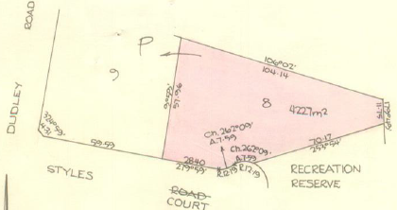Anderson** Married Woman both of 12 Churchill Way Kilsyth (after Transfer No. H323245 from Gordon Graham Styles and Myra Louise Styles).

25/9/1979 Mortgage No. H6960 to Bank of New South Wales, discharged 4/8/1980.

4/8/1980 Mortgage No. J97035 to RESI Permanent Building Society, discharged 5/9/1984.

Plan of land in Certificate of Title Volume 9313 Folio 391

28/10/1986 Survivorship Application No. M537717U by **Florence Edith Anderson** of Styles Crt. Wonga Park.

13/1/2004 Transfer No. AC598749K from Florence Edith Anderson to **Jonathan Patrick O’Donnell-Young** and **Charlotte O’Donnell-Young** both of 2 Styles Court Wonga Park Vic 3115.

13/1/2004 Mortgage No. AC59870B to Australia and New Zealand Banking Group Limited.

25/8/2008 Discharge No. AG045043F of Mortgage No. AC598750B.

26/8/2011 Caveat No. AJ157673T by Murray Chapman and Marie-Claude Chapman as purchaser.

5/10/2011 Withdrawal No. AJ237336T of Caveat No. AJ157673T.

5/10/2011 Discharge No. AJ237337R of Mortgage No. AG045043F.

5/10/2011 Transfer No. AJ237338P from Jonathan Patrick O’Donnell-Young and Charlotte O’Donnell-Young to Murray Grant Chapman and Marie-Claude Chapman both of 2 Styles Court Wonga Park Vic 3115.

5/10/2011 Mortgage No. AJ237339M to Westpac Banking Corporation.