**Title History of Crown Allotment 7B Mount Lofty**

Plan of Crown Allotment 7B showing property boundaries and Street Numbers. Most of the subdivided land having been transferred to the Crown to form par of the Warrandyte State Park

A composite plan of Plan of Subdivision No. 59020 into approximately 10 acre blocks most of which wer later acquired by the M7MBW for the proposed Yarra Brae Dam and when that did not go ahead was transferred to the Crown to add to Warrandyte State Park. Not the joining of the 2 halves of the plan was not perfect – see the boundary between Lots 12 & 13.

**Crown Grant Volume 1477 Folio 222**

10/5/1883 Crown Grant Volume 1477 Folio 222 of 274 acres 2 roods and being (Crown) Allotment 7B, for a consideration of Two hundred and seventy five Pounds to **Annie Bruce** of Warrandyte Widow as Administratrix of the Estate and Effects of David Bruce late of Warrandyte Farmer.

6/8/1885 Transfer No. 152405 from Annie Bruce to Edward Alfred Paterson.

**Certificate of Title Volume 1726 Folio 037**

6/8/1885 Certificate of Title Volume 1726 Folio 037, area 274 acres and 2 roods, being Crown Allotment Seven B issued to **Edward Alfred Paterson** of Collins Street East Melbourne Agent.

Plan of land in Crown Grant Volume 1477 Folio 222

13/8/1985 Mortgage No. 67245 to The Australian Deposit and Mortgage Bank Limited.

30/1/1886 Mortgage No. 70185 to The Federal Bank of Australia Limited

27/4/1887 Memo No.13523 Copy Writ of Fieri Facias issued out of the Supreme Court on an action No. 4700 in the year 1896 Thomas Murphy? Derham against Edward Alfred Paterson served on the 27thApril 1887 at 10.50 am.

26/3/1888 Transfer of Mortgage No. 70785 from The Federal Bank of Australia Limited to The Mercantile Finance Guarantee and Agency Company Limited.

26/3/1988 Transfer of Mortgage No. 67248 from The Australian Deposit and Mortgage Bank Limited to The Mercantile Finance Guarantee and Agency Company Limited.

31/10/1888 Caveat No. 17658 lodged against Mortgage No. 67245. Caveat lapsed 1/7/1890.

31/10/1888 Caveat No. 17658 lodged against Mortgage No. 70185. Caveat lapsed 1/7/1890.

31/10/1888 Caveat No. 17658 lodged. Caveat lapsed 1/7/1890.

30/4/1895 Transfer No. 278450 from The Mercantile finance Trustee and Agency Company of Australia Limited to Alfred Rawlings, Albert Wiseman and Frederick Walter Purches.

************************************************************************

**Certificate of Title Volume 2274 Folio 614**

30/4/1890 Certificate of Title Volume 2274 Folio 614, area 274 acres and 2 roods, being Crown Allotment 7B issued to **Alfred Rawlings** of Box Hill Gentleman **Albert Wiseman** of Flinders Lane Melbourne Warehouseman and **Frederick Walter Purches** of Elizabeth Street Melbourne Butcher.

30/4/1890 Mortgage No. 113947 to Eliza Butterworth.

24/10/1895 Transfer No. 361799 from Alfred Rawlings, Albert Wiseman and Frederick Walter Purches to **Albert Wiseman** and **Frederick Walter Purches**, new Certificate of Title Vol 2589 Fol 737.

***********************************************************************

**Certificate of Title Volume 2589 Folio 737**

24/10/1895 Certificate of Title Volume 2589 Folio 737, area 274 acres and 2 roods, being Crown Allotment 7B issued to **Albert Wiseman** of Flinders Lane Warehouseman and **Frederick Walter Purches** of Elizabeth Street Butcher both of Melbourne subject to Mortgage Registered 30/4/1890 and numbered 113947. The above mortgage is discharged 5/8/1903.

5/8/1903 Transfer No. 45665 from Albert Wiseman and Frederick Walter Purches to **George Ernest Mather** of Strathalbyn South Australia Gentleman.

27/6/1905 Transfer No. 507884 from George Ernest Mather to **Arthur Ernest Tyndall Payne** new Certificate of Title Vol 3060 Fol 953.

**************************************************************************

**Certificate of Title Volume 3060 Folio 953**

27/6/1905 Certificate of Title Volume 3060 Folio 953, area 289 acres and 34 roods, being Crown Allotment 7B and part of Crown Section 8 Parish of Warrandyte and part of Crown 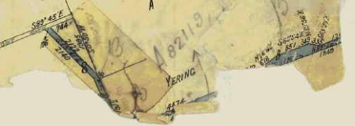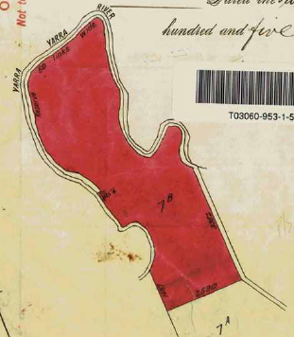Allotment 21B Parish of Yering issued to Arthur Ernest Tyndall Payne of “Scotsburn” Toorak Road Toorak Gentleman subject as to the land coloured blue The easement created by Instrument No. 506558. The additional land would appear to be a small triangle of land previously owned by George Mather from Section 8 and parts of Yarraview Road and Paynes Road (the part of Paynes Road being in the Parish of Yering, the rest in the Parish of Warrandyte.

Part of the plan of the land in Certificate of title Volume 3060 Folio 953

Balance of the plan of the land in Certificate of Title Volume 3060 Folio 953 showing the parts that are in Section 8 Parish of Warrandyte and Crown Allotment 21B Parish of Yering being a triangular piece of land plus Yarraview Road and part of Paynes Road.

24/8/1955 Red ink? No. A28448. Arthur Tyndall Payne died on 8th September 1954. Probate of his Will has been granted to Thomas Edward Neville Payne of “Woodburn” Kilmore Farmer and Grazier for his life.

8/12/1955 Transfer as to Part No. A82119, area 14 acres 2 roods and 34 perches to The President Councillors and Ratepayers of the Shire of Lilydale, see Certificate of Title Volume 8105 Folio 751. This was presumably for roads.

????? Caveat No. A66 4186 vide C/T 8255/454

Caveat No. A850344 vide C/T 8255/454

Caveat No. B22298 vide C/T 8255/454

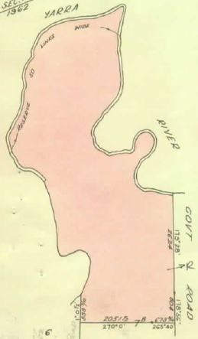22/3/1962 Title Cancelled. Application No. B607311 (16695/103). See Vol. 8563 Fol. 387 & 388.

****************************************************

**Certificate of Title Volume 8563 Folio 387**

22/3/1962 Certificate of Title Volume 8563 Folio 387, area 233 acres and 15 perches, being part of Crown Allotment 7B issued in the name of **Thomas Edward Neville Payne** of Woodburn Kilmore Farmer (to whom Probate of the Will of Arthur Ernest Tyndall Payne deceased has been granted for his life).

Caveat C250045 Lot 20 PS 59020. Caveat transferred to new C/T.

21/6/1962 Transfer No. B445805 from Thomas Edward Neville Payne to **Harold Thomas Junghenn** of 35 Melcombe Road Ivanhoe Retailer as to two equal undivided fourth parts or shares and **Trinity Holdings Proprietary Limited** of 406 Lonsdale Street Melbourne and **Mary Forbes Adeney** of “Evergreen” Rosedale Married Woman each as to one equal undivided fourth part or share as Tenants in Common.

Plan of land in Certificate of Title Volume 8563 Folio 387

16/8/1965 Title Cancelled as to Part. Pursuant to Regulation 12 and Titles issued as set out hereunder: Lots 1 to 21 in Vol 8571 Fol 919 to Fol 939 - LP 59020.

Plan of Subdivision No. 59020

*****************************************************************************

**Certificate of Title Volume 8571 Folio 936**

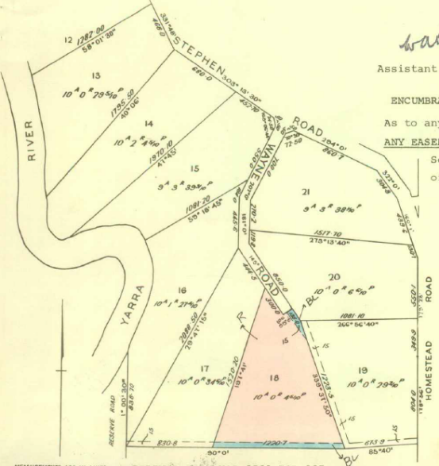16/8/1965 Certificate of Title Volume 8571 Folio 936, area 10 acres 0 roods and 4.5 perches, being Lot 18 on Plan of Subdivision No. 59020 issued to **Harold Thomas Junghenn** of 35 Melcombe Road Ivanhoe Retailer as to two equal undivided fourth parts or shares and **Trinity Holdings Proprietary Limited** of 406 Lonsdale Street Melbourne and **Mary Forbes Adeney** of “Evergreen” Rosedale Married Woman each as to one equal undivided fourth part or share as Tenants in Common.

5/11/1964 Creation of Easement No. C75282 – See Vol 8599 Fol 817.

18/11/1970 Caveat No. D88860 lodged. Caveat lapsed 28/8/1974.

Plan of land on Certificate of Title Volume 8571 Folio 936. The land in the Title being numbered 18.

29/7/1974 Transfer No. F400931 to Melbourne and Metropolitan Board of Works.

28/7/1997 Transfer No. U895223T from Melbourne and Metropolitan Board of Works to Her Majesty Queen Elizabeth II. Title Cancelled.

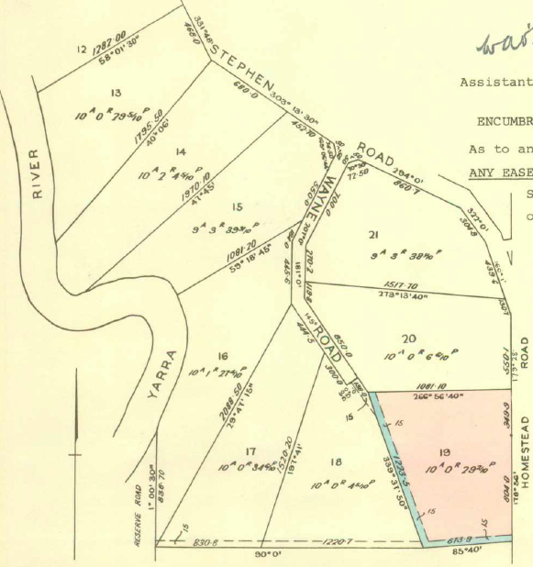 *************************************************************************

**Certificate of Title Volume 8571 Folio 937**

16/8/1965 Certificate of Title Volume 8571 Folio 937, area 10 acres 0 roods and 23.2 perches, being Lot 19 on Plan of Subdivision No. 59020 issued to **Harold Thomas Junghenn** of 35 Melcombe Road Ivanhoe Retailer as to two equal undivided fourth parts or shares and **Trinity Holdings Proprietary Limited** of 406 Lonsdale Street Melbourne and **Mary Forbes Adeney** of “Evergreen” Rosedale Married Woman each as to one equal undivided fourth part or share as Tenants in Common. Title Cancelled See Vol 8599 Fol 847.

5/11/1964 Transfer No. C75282 from Harold Thomas Junghenn, Trinity Holdings Proprietary Limited and Mary Forbes Adeney to **John Sinnott Mills** Dental Surgeon and **Lorna Mills** Married Woman both of Lower Heidelberg Road Together with a right of carriageway over the road coloured brown on the said map.

Plan of land on Certificate of Title Volume 8571 Folio 937. The land in the Title being numbered 19.

7/1/1982 Transfer No. J7765 from John Sinnott Mills and Lorna Mills to **Douglas William Marchbank** Primary Producer and **Beryl Annie Marchbank** both of 24 Rubicon Street Reservoir.

7/1/1982 Mortgage No. J776596 to Australia and New Zealand Banking Group Limited, discharged 21/5/1991.

30/1/1998 Survivorship Application No. V232581Q by Beryl Annie Marchbank 25 Lower Homestead Rd. Wonga Park.

30/1/1998 Title Cancelled Application No. V232580T See Vol 10377 Fol 530 Which is issued pursuant to Section 31 Act 6399.

**************************************************************************

**Certificate of Title Volume 10377 Folio 530**

3/1/1998 Certificate of Title Volume 10377 Folio 530 being Lot 19 on Plan of Subdivision No. 59020 issued to **Beryl Annie Marchbank** of 25 Lower Homestead Road Wonga Park.

25/2/1998 Caveat No. V284905P by Karen Therese Vogl.

16/3/2001 Transfer and Lapsing of Caveat No. X369377P from Beryl Annie Marchbank to **Karen Therese Vogl** of 25 Lower Homestead Road Wonga Park.

20/3/2002 Mortgage No. AB164464H to Commonwealth Bank of Australia lodged.

23/1/2003 Discharge No. AB828179H of Mortgage No. AB164464H lodged.

23/1/2003 Mortgage No. AB828180Y to CSN Mortgages Limited lodged.

29/3/2008 Discharge No. AF743793A of Mortgage No. AB828180Y lodged.

29/3/2008 Mortgage No. AF743794X to St. George Bank Ltd lodged.

29/5/2010 Discharge No. AH260625W of Mortgage No. AF743794X lodged.

29/5/2010 Mortgage No. AH260626U to National Australia Bank Ltd lodged.

24/3/2017 Caveat No. AN680949X by Anita Kim Wagg as purchaser lodged.

26/7/2017 Discharge No. AQ080919C of Mortgage No. AH260626U lodged.

26/2/2017 Transfer No. AQ080920T from Karen Therese Vogl to **Anita Kim Wagg** of 356 Reynolds Road Research Vic 3095 lodged.

19/12/2017 Mortgage No. AQ570154D to Perpetual Corporate Trust Ltd. lodged.

29/4/2020 Discharge No. AT198698H of Mortgage No. AQ570154D lodged.

*********************************************************************

**Certificate of Title Volume 8563 Folio 388**

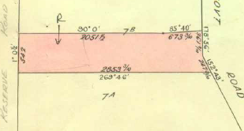22/3/1962 Certificate of Title Volume 8563 Folio 388, area 14 acres 3 roods and 33 perches, being part of Crown Allotment 7B issued to **Thomas Edward Neville** **Payne** of Woodburn Kilmore Farmer (to whom Probate of the Will of Arthur Ernest Tyndall Payne deceased has been granted for life).

22/3/1962 Transfer as to part No. B387638, Lot 1 area 6 acres 1 rood and 36 perches, new Certificate of title Volume 8563 Folio 389.

21/6/1962 Transfer as to balance No. B445805, new Certificate of Title Volume 8563 Folio 390

Plan of land in Certificate of Title Volume 8563 Folio 388

********************************************************************

**Certificate of Title Volume 8563 Folio 389**

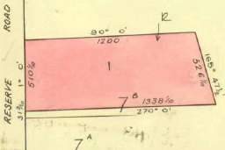22/3/1962 Certificate of Title Volume 8563 Folio 389, area 6 acres 1 rood and 32 perches, being Lot 1 on Plan of Subdivision No. 58880 issued to **Harold Thomas Junghenn** of 35 Melcombe Road Ivanhoe Retailer as to two equal undivided fourth parts or shares and **Trinity Holdings Proprietary Limited** of 406 Lonsdale Street Melbourne and **Mary Forbes Adeney** of “Evergreen” Rosedale Married Woman each as to one equal undivided fourth part or share as Tenants in Common.

22/3/1962 Transfer No. B387639 from Harold Thomas Junghenn, Trinity Holdings Proprietary Limited and Mary Forbes Adeney to Hans Weiler of 17 Woorigoleen Drive East Keilor Toolmaker.

Plan of land in Certificate of Title Volume 8563 Folio 389

6/8/1973 Transfer No. E932041 from Hans Weiler to **Melbourne and Metropolitan Board of Works**.

28/7/1987 Transfer No. U895223T from Melbourne and Metropolitan Board of Works to **Her Majesty Queen Elizabeth II**.

**********************************************************************

**Certificate of Title Volume 8563 Folio 390**

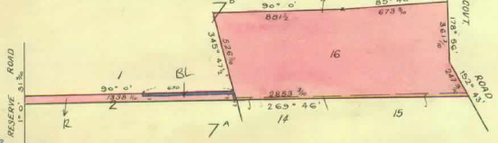21/6/1962 Certificate of Title Volume 8563 Folio 390, area 8 acres 1 rood and 37 perches, being Lot 16 and parts of Lots 2, 14 and 15 on Plan of Subdivision No. 58880 issued to **Harold Thomas Junghenn** of 35 Melcombe Road Ivanhoe Retailer as to two equal undivided fourth parts or shares and **Trinity Holdings Proprietary Limited** of 406 Lonsdale Street Melbourne and **Mary Forbes Adeney** of “Evergreen” Rosedale Married Woman each as to one equal undivided fourth part or share as Tenants in Common.

Plan of land in Certificate of Title Volume 8563 Folio 390

Caveat No. 930344 Lot 15 PS 58880 lapsed.

Caveat No. B22298 Lot 2 PS 58880 lapsed.

Caveat No. 700175 Lot 14 PS 58880 lapsed.

16/1/1964 Transfer as to part No. B839212, new Certificate of Title Volume 8610 Folio 016.

10/6/1965 Transfer as to part No. C238198, area 7 acres 3 roods and 32.5 perches, Lot 16, new Certificate of Title Volume 8610 Folio 022.

1/3/1967 Transfer as to part No. C716542, new Certificate of Title Volume 8675 Folio 566.

3/7/1969 Transfer as to balance No. D436765, new Certificate of Title Volume 8792 Folio 872.

**************************************************************************

**Certificate of Title Volume 8610 Folio 022**

10/6/1965 Certificate of Title Volume 8610 Folio 022, area 7 acres 3 roods and 32.5 perches, being Lot 16 on Plan of Subdivision No. 58880 issued to **Thomas Edward Thompson** Builder and **Jean Thompson** Married Woman both of 9 Norwood Street Ringwood.

10/6/1965 Transfer No. C238199 from

Plan of land in Certificate of Title Volume 8610 Folio 022

Thomas Edward Thompson and Jean Thompson to **John Sinnott Mills** Dental Surgeon and **Lorna Mills** Married Woman both of 352 Lower Heidelberg Road East Ivanhoe.

7/6/1979 Transfer No. H550906 from John Sinnott Mills and Lorna Mills to **Hilary Kaye Patterson** of 74 Nixon Crescent Wagga New South Wales Married Woman.

6/4/1982 Transfer No. J881806 from Hilary Kaye Patterson to **Mary Carme**l **Allen** of 9 Tadstan Place Donvale Home Duties.

6/4/1982 Mortgage No. J881807 to Douglas William Marchbank and Beryl Annie Marchbank, discharged 11/12/1991.

5/8/1984 Mortgage No. L207343 to Commonwealth Bank of Australia, discharged 11/12/1991.

9/11/1987 Mortgage No. N1198171L to Commonwealth Development Bank of Australia, discharged 11/12/1991.

24/6/1991 Caveat No. R401049K by Angelo Basilone & Cal Basilone as purchaser lodged. Caveat will lapse on registration of R683226B – 30/12/1991.

11/12/1991 Transfer No. R683226B from Mary Carmel Allen to **Angelo Basilone** **& Carol Basilone** of 9 Airlie Crt. East Doncaster.

12/7/2019 Caveat No. AS346463Y by Carol Susan Bright as purchaser.

6/7/2020 Transfer and Removal of Caveat No. AT403518B from Angelo Basilone and Carol Basilone to **Carol Susan Bright** of 23 Lower Homestead Road Wonga Park Vic 3115.

6/7/2020 Mortgage No. AT403519Y to Suncorp-Metway Ltd. lodged.