**Title History of Crown Allotment 14 H Parish of Warrandyte**

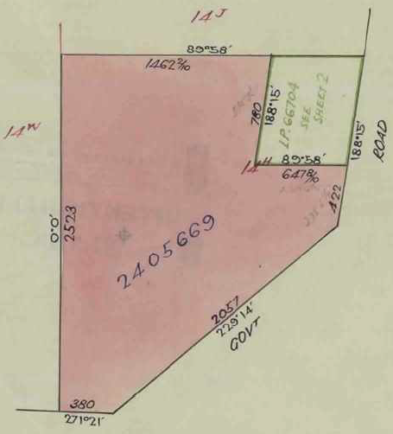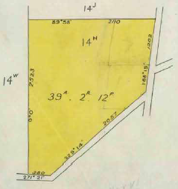24/7/1928 Crown Grant Volume 6971 Folio 048, in consideration of the payment of 976 pounds **Cyril Edward Rice** of Yarra Road Croydon Orchardist was granted 39 acres 2 roods and 12 perches being (Crown) Allotment 14 H in the Parish of Warrandyte County of Evelyn. From early Parish Plans it would appear that originally a Crown Grant for CA 14H was issued to a J. Power in 1883 but the Crown acquired the land under one of the Closer Settlement Acts, possibly after WWI, and then in 1928 granted it to Cyril Edward Rice

Plan of land in Crown Grant Volume 6971 Folio 048

Plan showing property boundaries and street numbers.

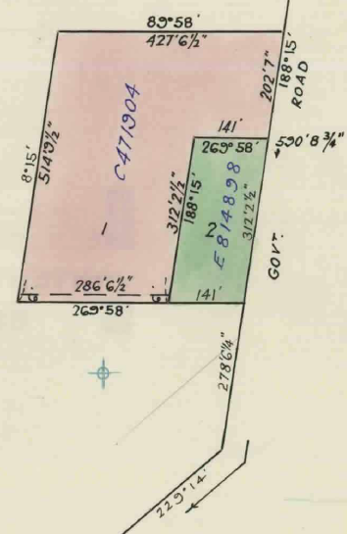6/10/1947 Transfer No. 2102028 from Cyril Edward Rice to (possibly James) **Urquhart** of Bacchus Farmer.

23/5/1951 Transfer as to part No. 2405669 to **Frederick Boyce Geale**, area 34 acres 2 roods and 12 perches, new Certificate of Title Volume 8104 Folio 534.

9/12/1954 Caveat No. C104745 affecting part of the land herein Lot No. 1. Caveat lapsed 31/5/1966.

Plan attached to Crown Grant Volume 6971 Folio 048 showing land transferred out in Transfer No. 2405669.

22/4/1966 Transfer as to part No. C471904, area 4 acres 0 roods and 0 perches, Lot 1 P/S 66704, new Certificate of Title Volume 8621 Folio 049.

Plan attached to Crown Grant Volume 6971 Folio 048 showing lands transferred out in Transfer No. C471904 and transferred as to balance in Transfer No. E814898.

16/5/1973 Transfer as to balance No. E814898, new Certificate of Title Volume 8981 Folio 077.

************************************************************************

**Certificate of Title Volume 8104 Folio 534**

23/5/1951 Certificate of Title Volume 8104 Folio 534, area 34 acres 2 roods and 12 perches

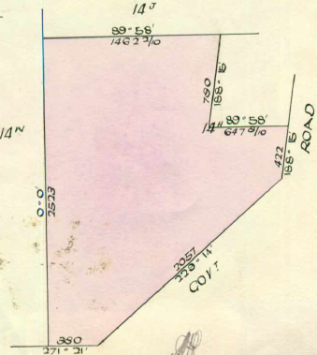 being part of Crown Allotment 14H issued to **Frederick Boyce Geale** of Kitchener Road Croydon Farmer (after Transfer No. 2405669 from Cyril Edward Rice).

23/5/1951 Transfer as to part No. 2405670 from Frederick Boyce Geale to **James Brittingham**, new Certificate of Title Volume 8104 Folio 535.

Plan of land in Certificate of Title Volume 8104 Folio 534

Plan attached to Certificate of Title Volume 8104 Folio 534 showing lands transferred out in Transfer as to part No. 2405670 and Transfer as to balance No. 2454738.

30/11/1951 Transfer as to balance No. 2454738 from Frederick Boyce Geale to **Jack Docking**, new Certificate of Title Volume 8104 Folio 536.

*************************************************************************

**Certificate of Title Volume 8104 Folio 535**

being part of Crown Allotment 14H issued to **James Brittingham** (after Transfer No. 2405670 from Frederick Boyce Geale).

23/5/1951 Transfer No. 2405671 from James Brittingham to **Thomas James Cook** Gentleman and **Florence Winifred Cook** Married Woman both of Hillcrest Road Ringwood.

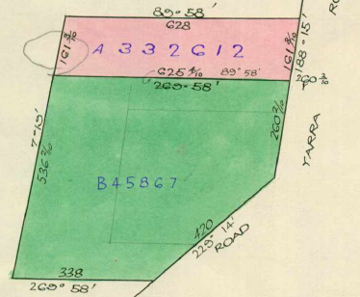12/11/1953 Mortgage No. 1131338 to Croydon District (No. 4) Co-Operative Housing Society Limited, discharged 7/5/1957.

Plan of land in Certificate of Title Volume 8104 Folio 535.

15/5/1957 Caveat No. A334677 lodged. Caveat lapsed.

7/5/1957 Survivorship application No.329608 by Florence Winifred Cook of 191 Yarra Road Widow.

10/5/1957 Transfer as to part No. A332612, area 1 acre 0 roods 0.4 perches, new Certificate of Title Volume 8166 Folio 242.

Plan attached to Certificate of Title Volume 8104 Folio 535 showing lands transferred out in Transfer as to part No. A332612 and Transfer as to balance No. B45867.

26/8/1960 Transfer as to balance No. B45867, new Certificate of Title Volume 8270 Folio 584.

**********************************************************************

**Certificate of Title Volume 8166 Folio 242**

Certificate of Title Volume 8166 Folio 242 has been cancelled and it appears that it has been consolidated with land transferred out of Certificate of Title Volume 8104 Folio 536 (PC 430478) to eventually become Lot 1 on Plan of Subdivision No. 39734 and being the land in Certificate of Title Volume 8611 Folio 404.

**********************************************************************

**Certificate of Title Volume 8270 Folio 584 Street Address: 251 Yarra Road Wonga Park**

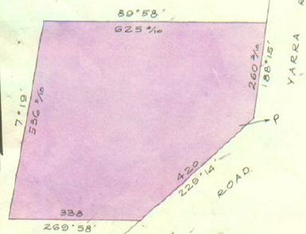26/8/1960 Certificate of Title Volume 8270 Folio 584, area 2 acres 3 roods and 27.6 perches, being part of Crown Allotment 14H issued to **Wladyslaw Nadolski** Cleaner and **Janina Nadolski** Married Woman both of 21 Dunbar Avenue Sunshine and **Viktor Emil Trigarszky** Storeman and **Janina Trigarszky** Married Woman both of corner Yarra and Gatters Roads Croydon as tenants in common in equal shares.

22/12/1965 Caveat No. C391239 as to the ¼ shares of W. Nadolski and J. Nadolski lodged. Caveat lapsed 24/4/1967.

14/4/1967 Transfer No. C751123 from Wladyslaw Nadolski, Janina Nadolski, Viktor Emil Trigarszky and Janina Trigarszky to **Wladyslaw Nadolski** and **Janina Nadolski**.

Plan of land in Certificate of Title Volume 8270 Folio 584.

7/6/1967 Mortgage No. C797111 to The English Scottish and Australasian Bank Limited, discharged 16/3/1981.

16/3/1981 Transfer No. J381019 from Viktor Emil Trigarszky and Janina Trigarszky to **Donald Richard Carter** of 54 Surrey Road Blackburn Manager.

16/3/1981 Mortgage No. J381020 to Commonwealth Bank of Australia, discharged 3/3/1982.

Caveat No. N481111 lodged. Caveat withdrawn 18/4/1991.

20/10/1988 Transmission Application No. N785360Q: Donald Richard Carter died on 18/1/1988. Letters of Administration of his Estate have been granted to **Joanne Carter** of Corner of Gatters & Yarra Rds. Wonga Park.

16/8/1990 Caveat No. P 953965Q lodged. Finally disposed of under Sec.??? Returned under Sec. 105 Act 6399 16/8/1991.

1/11/199? Caveat No. R74775W lodged. Caveat will lapse on Registration of R303456P – 16/8/1991.

18/4/1991 Transfer No. R303456P from Joanne Carter to **William Vels**, **Jan Louis Haartsen** & **Roderic Terrance Basil Crozier** all of 85 Edinburgh Rd. Lilydale as tenants in common in equal shares.

11/11/1996 Transfer No. U498548S from William Vels, Jan Louis Haartsen and Roderic Terrance Basik Crozier to **Reformed Church of Wonga Park Inc** of Corner Yarra Rd. & Gatters Rd. Wonga Park 3115 (pursuant to Act 9713).

***********************************************************************

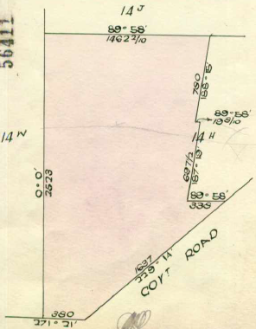**Certificate of Title Volume 8104 Folio 536**

30/11/1951 Certificate of Title Volume 8104 Folio 536, area 30 acres 2 roods and 24 perches, being part of Crown Allotment 14H issued to **Jack Docking** of Alexandra Farmer.

30/7/1956 Transfer No. A193011 from Jack Docking to **William Yorke Richardson** Farmer and **Phyllis May Richardson** Married Woman both of Toolamba Road Mooroopna.

15/7/1978 Caveat No. A566665 affecting part of the land herein (Plan on Caveat Lot1). Caveat lapsed 5/4/1966.

8/6/1960 Caveat No. A987172 affecting part of the land herein Lot No. 1. Caveat withdrawn 3/7/1963.

Plan of land in Certificate of Title Volume 8104 Folio 536

15/10/1962 Title Cancelled as to part Pursuant to Regulation 12 and Titles issued as set out hereunder: Lots 1,2 Vol. 8376 Fol. 454 & 455.

Plan attached to Certificate of Title Volume 8104 Folio 536 showing land subdivided into 2 lots on LP 39734 and Lot 1 transferred out as to balance and consolidated with land in Certificate of Title Volume 8166 Folio 942 by Plan of consolidation No. C430478

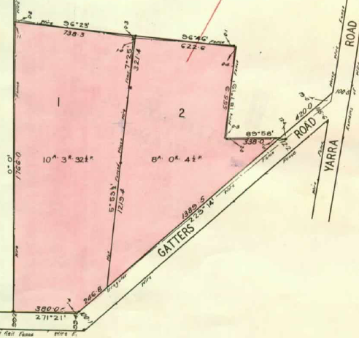25/2/1966 Transfer as to balance No. C430478, new Certificate of Title Volume 8611 Folio 404.

Plan attached to Certificate of Title Volume 8104 Folio 536 showing Lot 2 on Plan of Subdivision No. 39734 and Title cancelled as to part and Lots 1 & 2 created on LP 56411

***************************************************************************

**Certificate of Title Volume 8376 Folio 454 Street Address 6 Gatters Road Wonga Park**

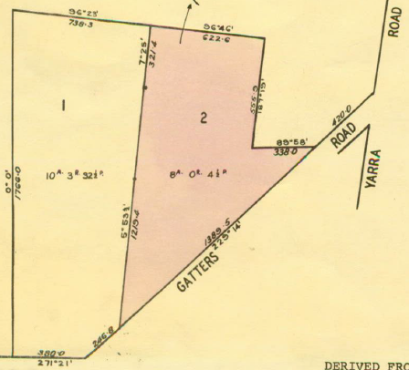15/10/1962 Certificate of Title Volume 8376 Folio 454, area 10 acres 3 roods and 32½ perches, being Lot 1 on Plan of Subdivision No. 56411 issued to **William Yorke Richardson** Farmer and **Phyllis May Richardson** Married Woman both of Yarra Road Croydon.

21/11/1972 Transfer No. E607776 from William Yorke Richardson and Phyllis May Richardson to **Nino Colaneri** Concretor and **Lina Colaneri** Married Woman both of 263 Stud Road Wantirna South.

10/10/1973 Mortgage No. F37203 to Bank of New South Wales, discharged 27/10/1989.

27/10/1989 Mortgage No. P495551E to Westpac Savings Bank Limited, discharged 4/1/1991.

Plan of Land on in which the land in Certificate of Title Volume 8376 Folio 455 is numbered 1.

4/1/1991 Mortgage No. R160420N to Westpac Banking Corporation.

***************************************************************************

**Certificate of Title Volume 8376 Folio 455 Street Address 4 Gatters Road Wonga Park**

15/10/1962 Certificate of Title Volume 8376 Folio 455, area 8 acres 0 roods and 4½ perches, being part of Lot 2 on Plan of Subdivision No. 56411 issued to **William Yorke Richardson** Farmer and **Phyllis May Richardson** Married Woman bothof Yarra Road Croydon.

13/5/1965 Transfer No. C214532 from William Yorke Richardson and Phyllis May Richardson to **Kenneth Ross Pearce** Storeman and **Gwenda Joyce Pearce** Married Woman both of 3 Hartington Street Glenroy.

13/5/1965 Mortgage No. C214529 to Robert Hutchinson Limited, discharged 23/11/1966.

22/2/2002 Instrument No. AB094900C creating Computer folio Volume 10650 Folio 309 as a replacement for Certificate of title Volume 8376 Folio 455.

Plan of Land on Certificate of Title Volume 8376 Folio 455 in which the land in the Title is numbered 2.

22/4/2009 Transmission Application No. AG466630Q: Resulting Proprietorship: Tenants in Common as to 1 of 2 equal undivided shares **Gwenda Joyce Pearce** of 3 Hartington Street Glenroy Vic 3046 and as to 1 of a total of 2 equal undivided shares **Gwenda Joyce Pearce** of 4 Gatters Road Wonga Park Vic 3115 legal personal representative of Kenneth Ross Pearce who died on 26/6/2008.

22/4/2009 Transfer No. AG466631N from Gwenda Joyce Pearce to as to 1 of a total of 2 equal undivided shares **Gwenda Joyce Pearce** of 3 Hartington Street Glenroy Vic 3046 ad as to a total of 2 equal undivided shares as joint proprietors **Susan Elizabeth Minetti** of 31 Ainslie Park Avenue Croydon Vic 3136, **Kerry Eva Pearce** of 4 Gatters Road Wonga Park Vic 3115 and **Robert John Pearce** of 265 Sanders Road North Garfield Vic 3814.

20/7/2009 Mortgage No. AG640781X to Westpac Banking Corporation.

26/9/2022 Transfer No. AW093933J from Susan Elizabeth Minetti, Kerry Eva Pearce and Robert John Pearce to Susan Elizabeth Minetti, Robert John Pearce and Kerry Eva Pearce with resulting proprietorship: Tenants in Common as to 3 of a total of 6 equal undivided shares **Gwenda Joyce Pearce** of 3 Hartington Street Glenroy Vic 3046. As to 1 of a total of 6 equal undivided shares **Susan Elizabeth Minetti** of 31 Ainslie Park Avenue Croydon Vic 3136, as to 1 of a total of 6 equal undivided shares **Robert John Pearce** of 232-236 Cardigan Road Montrose Vic 3765 and as to 1 of a total of 6 equal undivided shares **Kerry Eva Pearce** of 4 Gatters Road Wonga Park Vic 3115.

7/10/2022 Transmission Application from Gwenda Pearce to Robert John Pearce, Kerry Eva Pearce and Susan Elizabeth Minetti with resulting proprietorship: Tenants in Common as to1 of a total of 6 equal undivided shares **Susan Elizabeth Minetti** of 31 Ainslie Park Avenue Croydon Vic 3136, as to 1 of a total of 6 equal undivided shares **Robert John Pearce** of 232-236 Cardigan Road Montrose Vic 3765 and as to 1 of a total of 6 equal undivided shares **Kerry Eva Pearce** of 4 Gatters Road Wonga Park Vic 3115 and as to 3 of a total of 6 equal undivided shares as joint proprietors shares **Robert John Pearce** of 232-236 Cardigan Road Montrose Vic 3765, **Kerry Eva Pearce** of 4 Gatters Road Wonga Park Vic 3115 and **Susan Elizabeth Minetti** of 31 Ainslie Park Avenue Croydon Vic 3136 Administrators of Gwenda Joyce Pearce deceased.

29/11/2022 Discharge No. AW318016A of Mortgage No. AG640781X lodged.

7/12/2022 Caveat No. AW344952J by Brianna Marie Chivers and James John Chivers.

18/5/2023 Transfer No. AW840894E from Susan Elizabeth Minetti, Robert John Pearce and Kerry Eva Pearce to **James John Chivers** and **Brianna Marie Chivers** both of 4 Gatters Road Wonga Park Vic 3115.

18/5/2023 Mortgage No. AW840895C to Bank of Queensland Ltd.

**Certificate of Title Volume 8611 Folio 404 Street Address: 255 Yarra Road Wonga Park**

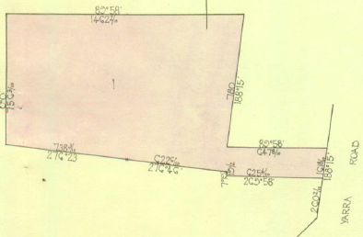 25/2/1966 Certificate of Title Volume 8611 Folio 404, being Lot 1 on Plan of Subdivision No. 3734 issued to **Bruce Thomas Hartley** Butcher and **Gwenda Isobel Hartley** Married Woman both of Yarra Road Croydon (after Transfer No. C430478 from William Yorke Richardson and Phyllis May Richardson).

25/2/1966 Mortgage No. C430479 to The Commercial Banking Company of Sydney Limited.

28/9/1976 Mortgage No. G338764 to C.B.C. Savings Bank Limited.

11/4/2002 Discharge No. AB20916R of Mortgage No. C430479 lodged.

Plan of land in Certificate of Title Volume 8611 Folio 404.

11/4/2002 Discharge No. AB20917P of Mortgage No. G338764 lodged.

1/4/2002 Transfer No. AB209018M from Bruce Thomas Hartley and Gwenda Isobel Hartley to as Tenants in Common as to 154 of a total of 287 equal undivided shares **Paul Eric Williams** of 172 Wonga Road Ringwood 3134 and as to 133 of a total of 287 equal undivided **shares Noeni Maree Williams** of 172 Wonga Road Ringwood 3134.

11/4/2002 Mortgage No. AB209019K to Commonwealth Bank of Australia.

10/4/2003 Caveat No. AC00068B by Anthony Michae Williams as purchaser.

6/9/2003 Discharge No. C316257L of Mortgage No. AB209019K lodged.

6/9/2003 Transfer No. AC316258J from Paul Eric Williams and Noeni Maree Williams to **Anthony Michael Williams** of 255 Yarra Road Wonga Park Vic 3115.

6/9/2003 Mortgage No. AC3162G to Commonwealth Bank of Australia lodged.

15/10/2021 Discharge No. AU917649K of Mortgage No. C316259G lodged.

15/10/2021 Transfer No. AU914650B from Anthony Michael Williams to **Michael Craig Oliver** of 255 Yarra Road Wonga Park Vic 3115.

15/10/2021 Mortgage No. AU917651Y to Bendigo and Adelaide Bank Ltd.

*****************************************************************************

**Certificate of Title Volume 8261 Folio 049 Street Address: 259 Yarra Road Wonga Park**

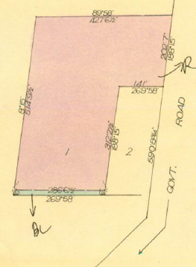22/4/1966 Certificate of Title Volume 8261 Folio 049, area 4 acres, being Lot 1 on Plan of Subdivision No. 66704 (after Transfer as to part No. C471904 from (possibly James) Urquhart) issued to **Leslie Walter Ingram** of 6 Great Ryrie Street Ringwood Drainage Contractor.

24/11/1977 Transmission Application No. G875876. Leslie Walter Ingram died on 2nd September has been granted to **Winifred Margaret Ingram** of 22A Yarra Road Croydon Widow.

26/6/1980 Transfer No. J43284 from Winifred Margaret Ingram to **Kenneth James Evans** Sales Manager and **Lorraine Grace Evans** Married Woman both of 10 Geles Crescent Vermont South.

5/8/1986 Transfer No. M404870M from Kenneth James Evans and Lorraine Grace Evans to **Grant Alexander Newton** & **Heather May Newton** of 83 Kalinda Rd. Ringwood North.

Plan of land in Certificate of Title Volume 8261 Folio 049.

25/6/1997 Transfer No. U838830S from Grant Alexander Newton and Heather May Newton to **Mark Rohan Duguid** & **Denise Ann Duguid** (both of) “Balcara” Yarra Rd. Wonga Park 3115.

25/6/1997 Mortgage No. U838831P to Australia and New Zealand Banking Group Limited.

4/7/2017 Mortgage No. AQ007412D to Australia and New Zealand Banking Group Ltd lodged.

**************************************************************************

**Certificate of Title Volume 8981 Folio 077 Street Address: 257 Yarra Road Wonga Park**

16/5/1973 Certificate of Title Volume 8981 Folio 077, area 1 acre, being Lot 2 on Plan of 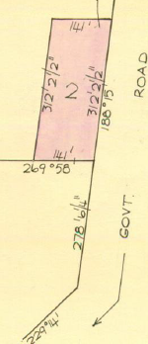Subdivision No.66704 issued to **Donald Leslie Nelson** Brick Layer and **Sharon Frances Nelson** Married Woman both of 63 Balmoral Avenue Springvale.

16/5/1973 Mortgage No. E814899 to The RESI Permanent Building Society, discharged 9/1/1979.

31/10/1978 Caveat No. H288356 lodged. Caveat lapsed 2/2/1979.

9/1/1979 Transfer No. H365281 from Donald Leslie Nelson and Sharon Frances Nelson to **Keith William Ritchie** Shop Proprietor and **Fotina Ritchie** Married Woman both of Flat 21 No 86 Graham Road Rosanna.

9/1/1979 Mortgage No. H365282 to The Commissioners of The State Savings Bank of Victoria, discharged 15/2/1980.

31/3/1982 Mortgage No. J874326 to Australia and New Zealand Banking Group Limited, discharged 9/3/1994.

9/3/1994 Mortgage No. S976184P to National Australia Bank Limited.

Plan of land in Certificate of Title Volume 8981 Folio 077.

2/3/2007 Discharge No. AE930017P of Mortgage No. S976184P lodged.

2/3/2007 Mortgage No. AE930018M to Australia and New Zealand Banking Group Limited lodged.

29/4/2010 Mortgage No. AH190350Y to Australia and New Zealand Banking Group Ltd lodged.

3/3/2014 Discharge No. AK940720M of Mortgage No. AH190350Y lodged.

3/2/2014 Discharge No. AK920721K of Mortgage No. AE930018M lodged.

3/3/2014 Mortgage No. AK940722H to National Australia Bank Ltd lodged.

19/9/2018 Discharge No. AR467774N of Mortgage No. AK940722H lodged.