**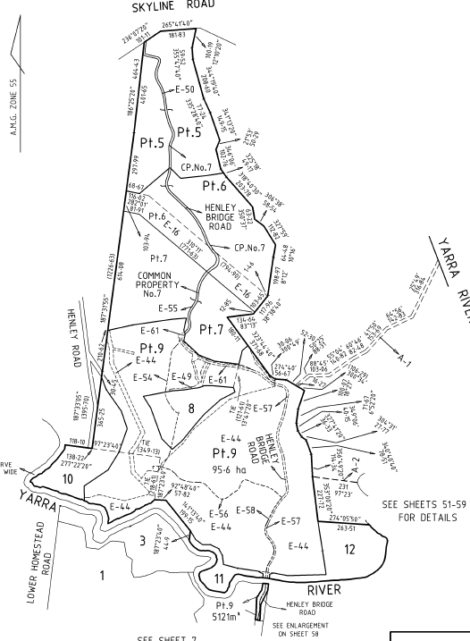Title History of Crown Allotments 7C and 7D Parish of Warrandyte and parts of Section A (Yarra Glen Pre-emptive Right) Parish of Sutton**

Plan of Subdivision No. 415064K is a 65 page document and above are Sheets 7 and 8 giving a partial overview of the subdivision. This Plan of Subdivision forms the basis of the Heritage Golf and Country Club both south and north of the Yarra River.

**Certificate of Title Volume 9797 Folio 902**

25/2/1988 Certificate of title Volume 9797 Folio 902, area 136.9 hectares, being Crown Allotments 7C and &D Parish of Warrandyte, derived from Application No. 61815G to bring Old Law land under the Transfer of Land Act issued to **The Trustees of The Hospitaller Brothers of St. John of God** of 13 Granthon Street Burwood New South Wales.

31/1/1996 Caveat No. T958845H by Heritage Golf and Country Club Pty. Ltd. as purchaser. Caveat will lapse on registration of T975470M – 31/1/1996.

27/11/1995 Transfer No. T975470M from The Trustees of The Hospitaller Brothers of St. John of God to Heritage Golf and Country Club Pty. Ltd. Level 3 302-308 Russell St. Melbourne 3000.

27/11/1995 Mortgage No. T975471J to Challenge Bank Limited, discharged 27/8/1998.

Plan of land in Certificate of Title Volume 9797 Folio 902.

22/7/1997 Mortgage No. U885954W from **Yarra Valley Golf Pty. Ltd**. (formerly Heritage Golf and Country Club Pty. Ltd.) to Judy Michelle Tauber,

27/8/1998 Mortgage No. V610826X to D.N.B. Nominees Pty Ltd & Somersview Nominees Pty Ltd, discharged 22/3/1999.

27/8/1998 Instrument No. V610863U. The registered mortgages affection the within land now rank in the following order of priority: Mortgage V610862X (then) Mortgage U885954W.

22/3/1999 Mortgage No. V953318B to St. George Bank Limited.

25/3/1999 Instrument No. V960108D. The registered mortgages affection the within land now rank in the following order of priority: Mortgage V953318B (then) Mortgage U885954W.

??? Instrument No. W287882Q [PS 415064 Stage H (or 4)] Title Cancelled.

**Certificate of Title Volume 8056 Folio 742**

6/4/1951 Certificate of Title Volume 8056 Folio 742, area 316 acres 2 roods and 32 perches, being part of Crown Section A known as Yarra Glen Pre-emptive Right Parish of Sutton 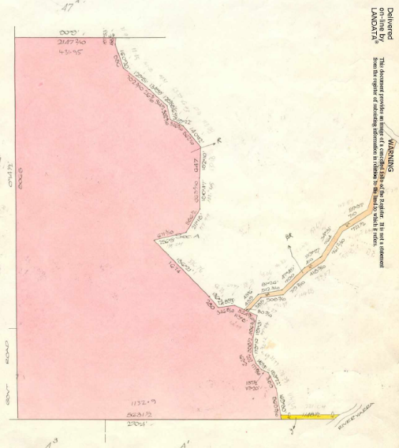County of Evelyn subject to Charge (under the Wire Netting Act 1928) No. 773969 issued to **Clive Olaf Hill** of Henley Estate Lilydale Farmer.

22/3/1965 Corres. No.: State Electricity Commission has pursuant to Section 57 of the Transfer of Land Act served a Notification relating to the compulsory acquisition of an easement over part of the land comprised herein.

23/2/1968 Creation of Easement No. D11539.

15/1/1981 Transfer No. J307174 from Clive Olaf Hill to **Bethal Nominees Pty. Limited** of 3rd Floor 44 Market Street Melbourne.

26/4/1988 Mortgage No. N416830Y to National Australia Bank Limited, discharged 8/5/1989.

Plan of land in Certificate of Title Volume 8056 Folio 742.

8/5/1989 Mortgage No. P173910H to State Bank of Victoria, discharged 15/5/1997.

17/1/1996 Caveat No. U46111L by Yarra Valley Golf Pty. Ltd. Caveat will lapse on registration of U885952D – 16/9/1997.

12/12/1996 Caveat No. U551934F by Yarra Valley Golf Pty. Ltd. as purchaser. Caveat will lapse on registration of U885952D – 16/9/1997.

22/7/1997 Transfer No. U885952D from Bethal Nominees Pty. Limited to **Yarra Valley Golf Pty. Ltd.** Level 3/410 Collins Street Melbourne 3000.

22/7/1997 Mortgage No. U885953A to Judy Michelle Tauber.

24/7/1997 Mortgage No. U891407E to Bethal Nominees Pty Ltd, discharged 30/1/1998.

?? Title Cancelled No. PS 415064K.

**Certificate of Title Volume 8056 Folio 743**

6/4/1951 Certificate of Title Volume 8056 Folio 743, area 151 acres 2 roods and 24 perches, being Crown Allotment A3 and part of Crown Allotments AOne and A2 Parish of Sutton County of Evelyn subject to Charge (under the Wire Netting Act 1928) No. 773969 issued to **Clive Olaf Hill** of Henley Estate Lilydale Farmer.

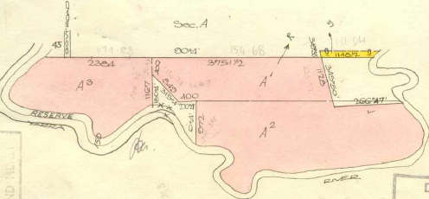15/1/1981 Transfer No. J307174 from Clive Olaf Hill to **Bethal Nominees Pty. Limited** of 3rd Floor 44 Market Street Melbourne.

26/4/1988 Mortgage No. N416830Y to National Australia Bank Limited, discharged 8/5/1989.

Plan of land in Certificate of Title Volume 8056 Folio 743.

8/5/1989 Mortgage No. P173910H to State Bank of Victoria, discharged 15/5/1997.

17/1/1996 Caveat No. U46111L by Yarra Valley Golf Pty. Ltd. Caveat will lapse on registration of U885952D – 16/9/1997.

12/12/1996 Caveat No. U551934F by Yarra Valley Golf Pty. Ltd. as purchaser. Caveat will lapse on registration of U885952D – 16/9/1997.

22/7/1997 Transfer No. U885949K from Bethal Nominees Pty. Limited to **Yarra Valley Golf Pty. Ltd.** Level 3/410 Collins Street Melbourne 3000.

22/7/1997 Mortgage No. U885953A to Judy Michelle Tauber.

24/7/1997 Mortgage No. U891407E to Bethal Nominees Pty Ltd, discharged 30/1/1998.

?? Title Cancelled No. PS 415064K.

**Crown Grant Volume 8560 Folio 103**

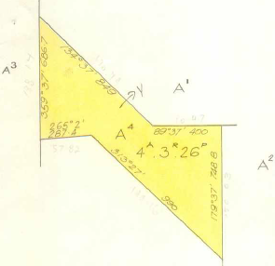17/11/1964 Crown Grant Volume 8560 Folio 103 in consideration of the sum of £200, area 4 acres 3 roods and 26 perches, being Allotment A 4 in the Parish of Sutton county of Evelyn issued to **Clive Olaf Hill** of Victoria Road Lilydale Farmer.

15/1/1981 Transfer No. J307174 from Clive Olaf Hill to **Bethal Nominees Pty. Limited** of 3rd Floor 44 Market Street Melbourne.

26/4/1988 Mortgage No. N416830Y to National Australia Bank Limited, discharged 8/5/1989.

8/5/1989 Mortgage No. P173910H to State Bank of Victoria, discharged 15/5/1997.

17/1/1996 Caveat No. U46111L by Yarra Valley Golf Pty. Ltd. Caveat will lapse on registration of U885951G – 16/9/1997.

Plan of land in Crown Grant Volume 8560 Folio 103

12/12/1996 Caveat No. U551934F by Yarra Valley Golf Pty. Ltd. as purchaser. Caveat will lapse on registration of U885951G – 16/9/1997.

22/7/1997 Transfer No. U885951G from Bethal Nominees Pty. Limited to **Yarra Valley Golf Pty. Ltd.** Level 3/410 Collins Street Melbourne 3000.

22/7/1997 Mortgage No. U885953A to Judy Michelle Tauber.

24/7/1997 Mortgage No. U891407E to Bethal Nominees Pty Ltd, discharged 30/1/1998.

?? Title Cancelled No. PS 415064K.

**Certificate of Title Volume 9415 Folio 630**

21/10/1980 Certificate of Title Volume 9415 Folio 630, area 17.39 hectares, being Lot 1 on Plan of Subdivision No. 130843 and being part of Crown Allotments 47A and 47C Parish of Sutton County of Evelyn issued to **Clive Olaf Hill** of Henley Victoria Road Lilydale Farmer.

25/8/1977 No. 742563: State Electricity Commission has pursuant to Section 57 of the Transfer of Land Act served a Notification relating to the compulsory acquisition of an easement over part of the land comprised herein. 5/1/1985 by J250892 does not now affect.

15/1/1981 Transfer No. J307174 from Clive Olaf Hill to **Bethal Nominees Pty. Limited** of 3rd Floor 44 Market Street Melbourne.

26/4/1988 Mortgage No. N416830Y to National Australia Bank Limited, discharged 8/5/1989.

Plan of land in Certificate of Title Volume 9415 Folio 630.

8/5/1989 Mortgage No. P173910H to State Bank of Victoria, discharged 15/5/1997.

17/1/1996 Caveat No. U46111L by Yarra Valley Golf Pty. Ltd. Caveat will lapse on registration of U885950K – 16/9/1997.

12/12/1996 Caveat No. U551934F by Yarra Valley Golf Pty. Ltd. as purchaser. Caveat will lapse on registration of U885950K – 16/9/1997.

22/7/1997 Transfer No. U885950K from Bethal Nominees Pty. Limited to **Yarra Valley Golf Pty. Ltd.** Level 3/410 Collins Street Melbourne 3000.

22/7/1997 Mortgage No. U885953A to Judy Michelle Tauber.

24/7/1997 Mortgage No. U891407E to Bethal Nominees Pty Ltd, discharged 30/1/1998.

?? Title Cancelled No. PS 415064K.

**Certificate of Title Volume 10469 Folio 805**

22/9/1999 Certificate of Title Volume 10469 Folio 805 derived from Vol 8056 Fol742, Vol 8056 Fol 743, Vol 8560 Fol 103, vol 9415 Fol 630 and Vol 9797 Fol 902, being Lot S11 on Plan of Subdivision No. 415064K Parish of Warrandyte issued to **Yarra Valley Golf Pty. Ltd.** subject to Mortgages Nos. U885954W 22/7/97 Judy Michelle Tauber and V953318B 22/3/99 St. George Bank Limited. The above Mortgages now rank in the following order of priority 1. Mortgage V953318B and 2. Mortgage U885954W Vide V960108F.

8/8/2006 Discharge No. AE532544J of Mortgage No. U885954W lodged.

8/8/2006 Discharge No. AE532545G of Mortgage No. V953318B lodged.

12/9/2006 Mortgage No. AE602197Q to Westpac Banking Corporation lodged.

18/3/2011 Caveat No. AH847489G by Yarra Valley Pty Ltd. lodged.

29/3/2011 Rectification Modify Caveat No. AH865669C lodged.

29/3/2011 Withdrawal No. AH866060S of Caveat No. AH847489G lodged.

29/3/2011 Caveat No. AH866061Q by Golden Heritage Golf Pty Ltd lodged.

14/4/2011 Land Tax Charge No. AH897234K lodged.

15/7/2011 Caveat No. AJ072926M by Lezak Nominees Pty Ltd, Binsted Pty Ltd, Ollson Pty Ltd & Brownbee Pty Ltd as Mortgagee lodged.

21/3/2012 Caveat No. AJ557285X by Glenbelle Pty Ltd lodged.

17/4/2012 Discharge No. AJ604154F of Land Tax Charge AH897234K lodged.

17/4/2012 Discharge No. AJ604156B of Mortgage No. AE602197Q lodged.

17/4/2012 Transfer No. AJ604159U from Yarra Valley Golf Pty. Ltd. to **Golden Heritage Golf Pty Ltd** of “Falcoln Corporate Advisory” Level 3 600 Bourke Street Melbourne Vic 3000.

17/4/2012 Mortgage No. AJ604161J to by Lezak Nominees Pty Ltd, Binsted Pty Ltd, Ollson Pty Ltd & Brownbee Pty Ltd.

17/8/2012 Transfer No. AJ861215Y of Mortgage No. AJ604161J lodged.

30/11/2012 Mortgage No. AK055921L to Glenbelle Pty Ltd lodged.

10/7/2013 Caveat No. AK456418K by Hua Wang as Mortgagee lodged.

30/7/2013 Transfer No. AK492166G of Mortgage No. AJ604161J to Morlend Finance Corporation (Vic) Pty Ltd lodged.

1/8/2013 Transfer No. AK499000F of Mortgage No. AK055921L to Morlend finance Corporation (Vic) Pty Ltd lodged.

29/11/2013 Caveat No. AK746256T by Falcon Corporate Advisory Pty Ltd lodged.

23/12/2013 Withdrawal No. AK803527X of Caveat No. AK746256T lodged.

5/2/2014 Caveat No. AK878701L by Falcone Corporate Advisory Pty Ltd as Mortgagee lodged.

4/3/2014 Withdrawal No. AK944773S of Caveat No. AK456418K lodged.

15/4/2014 Caveat No. AL027009P by Well Link Holdings Pty Ltd lodged.

17/4/2014 Caveat No. AL033253S by HGC Properties Pty Ltd as purchaser lodged.

23/4/2014 Transfer by Mortgagee No. AL038262P from Golden Heritage Golf Pty Ltd to **HGC Properties Pty Ltd** of Level 2 428 Little Bourke Street Melbourne Vic 3000 and removal of Mortgages AJ604161J and AK055921L and lapsing of Caveats AK878101L, AL027009P and AL033253S.

24/4/2014 Caveat No. AL039439U by Z4 Capital Pty Ltd as Mortgagee lodged.

24/4/2014 Mortgage No. AL040640U to Z4 Capital Pty Ltd lodged.

12/5/2014 Caveat No. AL072527K affecting Mortgage No. AL040640U by Galaxy Securities Pty Ltd lodged.

14/5/2014 Caveat No. AL081175P by Cosmic Properties Pty Ltd lodged.

29/5/2014 Caveat No. AL117545M by Galaxy Securities Pty Ltd as Mortgagee lodged.

2/6/2014 Caveat No. AL123094K by Kylie Bao lodged.

6/11/2014 Withdrawal No. AL469964Y of Caveat No. AL081175P lodged.

10/11/2014 Withdrawal No. AL475447L of Caveat No. AL072527K lodged.

12/11/2014 Withdrawal No. AL482605E of Caveat No. AL117545M lodged.

26/11/2018 Rectification Modify No. AR691525J of Caveat No. AL123094K by Kylie Bao lodged.

16/4/2021 Withdrawal No. AU243681U of Caveat No. AL123094K lodged.

16/4/2021 Discharge No. AU243682S of Mortgage No. AL040640U lodged.

21/5/2021 Transfer No. AU370434C from HGC Properties Pty Ltd to **Dominicus International Pty Ltd** of 21 Heritage Avenue Chirnside Park Vic 3116.

22/2/2024 Change of Address for Notice Section 34 Subdivision Act 1988 No. AX753778H lodged.

22/2/2024 Owners Corporation Act Rules Owners Corporation Altered No. AX753986A lodged.

7/3/2024 Rectification Address of Owners Corporation Owners Corporations Altered No. AX795556Q lodged.