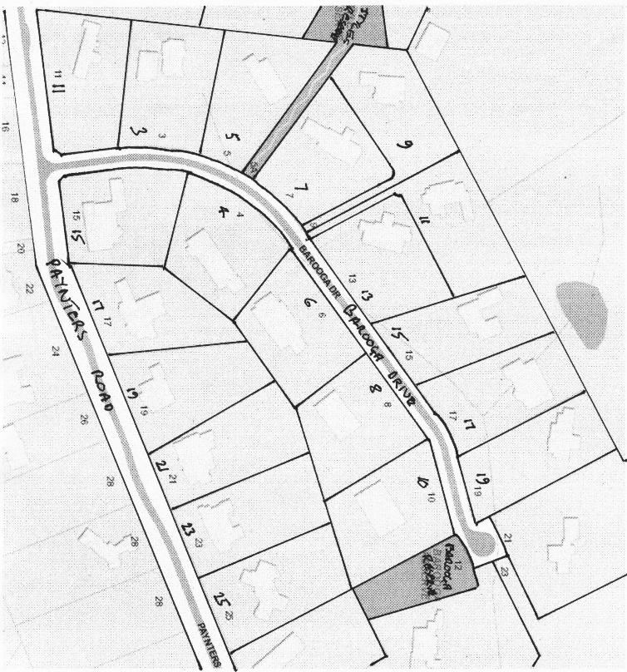**Title History of Crown Allotment 9M Parish of Warrandyte**

12/9/1910 Crown Grant Volume 3379 Folio 773 of 21 acres 1 rood and 21 perches being (Crown) Allotment 9M, for a consideration of Twenty two Pounds to **Samuel Painter** of Wonga Park Croydon Orchardist.

Plan of land in Crown Grant Volume 3068 Folio 574

3110/1910 Mortgage No. 288008 to William Wicks, Charles Alexander Berglund and William Henry Tucker, discharged 19/2/1918.

Plan showing property boundaries and street numbers for Crown Allotment 9M Parish of Warrandyte

25/6/191923 Red Ink No. 2379715. Samuel Painter died on 21st May 1914. Probate has been granted to **Edith Eleanor Painter** of 11 Garden Avenue Glenhuntly Widow.

13/8/1923 Transfer No. 1121573 from Edith Eleanor Painter to Ethel Fisher of Wonga Park via Croydon Married Woman.

13/8/1923 Mortgage No.471231 to Reginald Stanley Porter, does not now affect 13/5/1943.

13/5/1947 Transfer No. 207337 from Ethel Fisher to Enoch Bedson of Painters Road Wonga Park Farmer.

20/9/1948 Mortgage No.900245 to The Bank of Australasia, discharged 5/6/1953.

5/6/1953 Mortgage No. 40251 to Australia and New Zealand Bank Limited, discharged 26/2/1958.

3/2/1959 Mortgage No. A681530 to Edward Read Bartlett and Margaret Christian Phillipa Bartlett, discharged 9/11/19??.

16/7/1963 Transmission Application No. B704122. Enoch Bedson died on 20th September 1962. Probate of his Will has been granted to **Albert Mervyn Bedson** of Painters Road Wonga Park Farmer.

10/11/1970 Mortgage No. D691389 to Mita Simons and David Kiers, discharged 2/12/1971.

26/4/1971? Mortgage No. E23287 to Mita Simons and David Kiers, discharged 2/12/1971.

2/12/1971 Mortgage No. E239337 to Mita Simons and David Kiers, discharged 2/10/1975.

6/4/172 Memo No. ?50487 Copy Writ of Fieri Facias issued out of the Supreme Court at Melbourne I an action numbered 746 in the year 1972 Victorian Producers Co Operative Co. Ltd. v. A. M. Bedson Served on 7th July 1972. Has ceased to affect 7/9/1973?.

9/6/1972 Mortgage No. E419213 to Industrial Acceptance Corporation Limited, discharged 24/6/1979.

7/7/1972 Memo No. E450246 Copy Writ of Fieri Facias issued out of the Supreme Court at Melbourne I an action numbered 746 in the year 1972 Victorian Producers Co Operative Co. Ltd. v. A. M. Bedson Served on 7th July 1972. Satisfied 11/7/1975.

1/7/1973 Mortgage No. E894292 to Australia and New Zealand Banking Group Limited, discharged 17/10/1975.

17/10/1975 Mortgage No. F908309 to Charles John Closter, discharged 21/12/1977.

5/12/1973 Mortgage No. F956194 to Australia and New Zealand Banking Group Limited, discharged 21/12/1977.

21/12/1977 Mortgage No. G911471 to Charles John Closter, Gladys Ruby Closter, Leonard John Closter and Ann Sparks, discharged 5/12/1979.

5/12/1979 Mortgage No. H789715 to Charles John Closter and Gladys Ruby Closter, discharged 1982?.

4/1/1982 Transmission Application No. 773532. Albert Mervyn Bedson died on 15/5/1981. Probate of his Will has been granted to **Leigh Francis Bedson** and **Peter Weir Bedson**.

4/1/1982 Transfer No. J773533 registered. Certificate of Title Cancelled. See Vol 9457 Fol 306.

****************************************************************************

**Certificate of Title Volume 9457 Folio 306**

4/1/1982 Certificate of Title Volume 9457 Folio 306, area 8.653 hectares, being Crown Allotment 9M issued to **Leigh Francis Bedson** Driver as to eleven equal undivided twenty first

Plan attached to Certificate of Title Volume 9457 Folio 306 showing Creation of Easement

Plan of land in Certificate of Title Volume 9457 Folio 306

parts of shares and **Peter Weir Bedson** Driver as to Ten equal undivided twenty first parts or shares both of Paynters Road Wonga Park as proprietors as tenants in common.

4/1/1982 Mortgage to Charles John Closter and Gladys Ruby Closter, discharged 15/12/1983.

3/2/1989 Mortgage No. N991162V to Commonwealth Savings Bank of Australia, discharged ???.

19/7/1994 Creation of Easement No. T201617U ([to Shire of Lillydale).

1/2/1999 Caveat No. V869228P by Pendant Properties Pty Ltd as purchaser.

**Certificate of Title Cancelled by Plan of Subdivision No. 423065M.

Plan of Subdivision No. 423065 M

*********************************************************************************

**Certificate of Title Volume 10453 Folio 565 Street Address: 15 Paynters Road Wonga Park**

30/6/1999 Certificate of Title Volume 10453 Folio 565, parent title Volume 10438 Folio 677. Created by Instrument PS423065M Stage 2. Being Lot 7 on Plan of Subdivision No. 423065M and issued to **Pendant Properties Pty Ltd** of 24A Liddiard St. Hawthorn 3122

2/9/1999 Transfer No. W264333V from Pendant Properties Pty Ltd to **Hamish Nicoll Angus Strachan** and **Irene Lynette Strachan** both of 24 Campaspe Dr. Croydon Hills 3136.

9/6/2000 Mortgage No. W837707A to Adelaide Bank Ltd. lodged.

15/8/2005 Discharge No. AD810462V of Mortgage No. W837707A lodged.

5/6/2007 Caveat No. AF111938B by James Albert Tolley and Kim Roslyn Tolley as purchasers lodged.

18/12/2007 Transfer No. AF541534C from Hamish Nicoll Angus Strachan and Irene Lynette Strachan to **James Albert Tolley** and **Kim Roslyn Tolley** both of 15 Paynters Road Wonga Park.

18/12/2007 Mortgage No. AF541535A to Commonwealth Bank of Australia lodged.