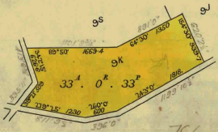**

Plan showing property boundaries and street numbers for Crown Allotment 9K Parish of Warrandyte

21/3/1936 Crown Grant Volume 6714 Folio 624 of 33 acres and 33 perches being (Crown) Allotment 9K, for a consideration of Four hundred and seventy-five Pounds to **Arthur Edward Hedgman Davis** of 3 Balloan Street Coburg Storeman. Note: According to the Crown Grant A.E.H. Davis was entitled to the Crown grant on 21/3/1936 it was not sealed until 23/10/1944.

Plan of land in Crown Grant Volume 6714 Folio 624

The land in Crown Grant Volume 6714 Folio 624 was subdivided by Plan of Subdivision No. 32864.

Plan of Subdivision No. 32864

1610/1950 Transfer as to part No. 2351529 being Lots 3 & 4 to Phyllis May Wood, new Certificate of Title Volume 8108 Folio 203.

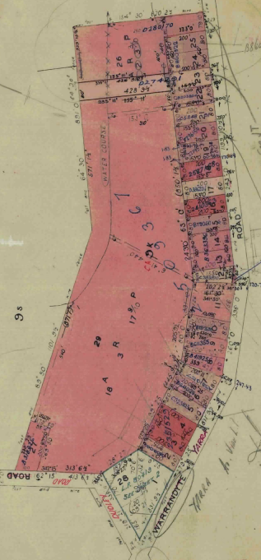14/6/1951 Transfer as to part No. 2410363 being Lot 16 to Alice Kate Monks, new Certificate of Title Volume 8108 Folio 204.

20/7/1952 Transfer as to part No. 2509367 being Lots 11 & 29, area 19 acres 2 roods and 1.5 perches, to Nellie Joan Raby, new Certificate of Title Volume 8108 Folio 205.

9/9/1953 Transfer as to part No. 2587168 being Lot 18 to Lillian Gilmore Millard, new Certificate of Title Volume 8108 Folio206.

30/7/1956 Caveat No. A199986 affecting part of the land herein (Lots 24, 25). Caveat lapsed 11/3/1964.

20/9/1957 Caveat No. A406554 affecting part of the land herein Lot 26. Caveat withdrawn 26/9/1967.

7/6/1957 Mortgage as to part No. A??8449 to ??? Company Limited, discharged as to part being the land in A931057 22/3/1960, discharged as to part B283404 19/9/1961, discharged as to part being the land in Transfer No B3580?79 24/11/1961, discharged as to part being the land in Transfer No. B363396 ? February 1962 and discharged 13/4/1962.

4/10/1957 Caveat No. A418611 affecting part of the lands herein Lots 6 and 8. Caveat lapsed 12/8/1983

Plan attached to Crown Grant Volume 6714 Folio 624 showing lots transferred out.

21/1/1959 Caveat No. A675897 affecting part of the land herein Lots 7,9. Caveat lapsed 27/8/1963?

8/3/1959 Caveat No. A699637 affecting part of the land herein Lot 15. Caveat lapsed 11/3/1964.

11/6/1959 Caveat No. A755856 affecting part of the land herein Lot 19. Caveat lapsed 17/9/1976.

13/7/1960 Caveat No. B12361 affecting part of the land herein Lot 12. Caveat lapsed 14/10/1965

22/3/1960 Transfer as to part No. A931057, Lot 7, new Certificate of Title Volume 8256 Folio 847.

10/4/161 Caveat No. B1850209 affecting part of the land herein Lot 10. Caveat lapsed 11/3/1964.

25/1/1962 Caveat No. B354014 affecting part of the land herein Lot 6. Caveat lapsed 11/3/1964.

20/11/1961 Transfer as to part No. B318626 being Lot 27, new Certificate of Title Volume 8395 Folio 168.

2/2/1962 Transfer as to part No. B358079 being Lot 12, new Certificate of Title Volume 8395 Folio 169

12/2/1962 Transfer as to part No. B363396 being Lots 13, 14, new Certificate of Title Volume 8395 Folio 170.

14/5/1962 Transfer as to part No. B419256 being Lot 8, new Certificate of Title Volume 8395 Folio 171.

6/3/1963 Transfer as to part No. B611355 being Lot 9, new Certificate of Title Volume 8430 Folio 186.

22/4/1963 Transfer as to part No. B641028 being Lot 6, new Certificate of Title Volume 8469 Folio 559.

18/9/1963 Transfer as to part No. B752690 being Lot 10, new Certificate of title Volume 8469 Folio 560.

8/11/1963 Transfer as to part No. B792606 being Lot 15, new Certificate of Title Volume 8469 Folio 561.

17/2/1964 Transfer as to part No. B860322 being Lots 24, 25, new Certificate of Title Volume 8469 Folio 562.

39/8/1965 Transfer as to part No. C283970 being Lot 12, new Certificate of Title Volume 8585 Folio 302.

29/9/1965 Transfer as to part No. C323803 being Lot 5, new Certificate of Title Volume 8596 Folio 932.

8/7/1966 Transfer as to part No. C534891 being Lot 21, new Certificate of Title Volume 8632 Folio 547.

3021/6/1967 Transfer as to part No. C809000 being Lot 2, new Certificate of Title Volume 8679 Folio 800.

29/9/1967 Caveat No. C897691 affecting part of the land herein See Plan. Caveat lapsed 31/3/1969.

1968 Lots 1 and 28 on Plan of Subdivision No. 32864 re-subdivided by Plan of Subdivision No. 80419 into five lots.

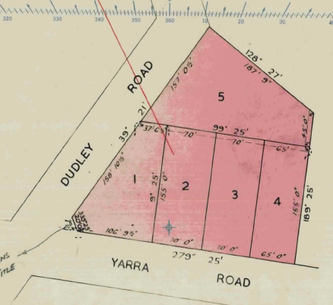29/4/1968 Certificate of Title Cancelled as to part Pursuant to Regulation 12 and Titles issued as set out hereunder: Lots One to 5 in Vol 8717 Fol 805 to Vol 8717 Fol 809. LP 80419.

3/7/1968 Caveat No. D121430 affecting part of the land herein Lot17. Caveat lapsed 2/7/1969.

2/10/1968 Transfer as to part No. D203954 being Lot 22, new Certificate of Title Volume 8753 Folio 385.

18/12/1968 Transfer as to part No. D274291 being Lot 23, area 1 acre 0 roods and 24 perches, new Certificate of Title Volume 8769 Folio 318.

Plan of Subdivision No. 80419

23/12/1968 Transfer as to part No. D280170 being Lot 26, area 2 acres 2 roods and 37 perches, new Certificate of Title Volume 8769 Folio 319.

9/5/1969 Transfer as to part No. D386201 being Lot 17, new Certificate of Title Volume 8780 Folio 829.

8/5/1974 Transfer as to part No. F296154 being Lot 20, new Certificate of Title Volume 9039 Folio 699.

10/8/1976 Transfer as to part No. G271957 being Lot 19, new Certificate of Title Volume 9164 Folio 051.

18/11/2019 Disposition of Land No. AS717748Q from Arthur Edward Hedgman Davis to **Manningham City Council** of 699 Doncaster Road Doncaster Vic 3108being Road R1 on Plan of Subdivision No. 80419 being the land remaining in Crown Grant Volume 6714 Folio 624.

****************************************************************************

**Certificate of Title Volume 8108 Folio 205**

29/7/1952 Certificate of Title Volume 8108 Folio 205, area 19 acres 2 roods and 1 perch, 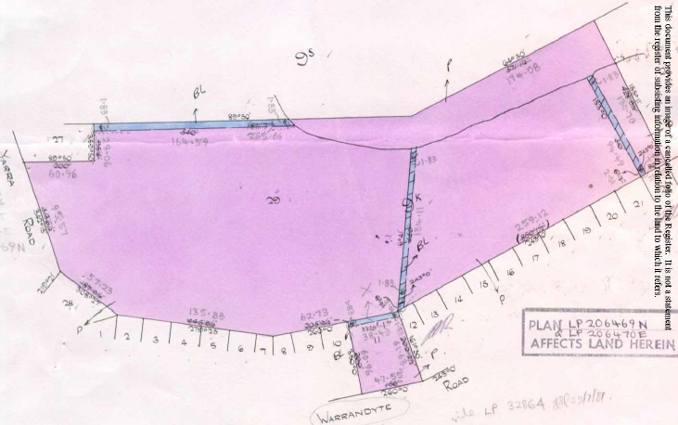being Lots 11 and 29 on Plan of Subdivision No. 32864 issued to **Nellie Joan Raby** of 16 Maple Crescent Camberwell Married Woman.

Plan of land in Certificate of Title Volume 8108 Folio 205

6/4/1955 Caveat No. 135493. Caveat lapsed (presumably in 1960).

15/2/1960 Transfer No. A908336 from Nellie Joan Raby to **Frederick James Knee** of Yarra Road Croydon.

17/8/1960 Transfer as to part No. B37590, new Certificate of Title Volume 8326 Folio 468 (a small triangular parcel of land for road widening out of Lot 11).

10/4/1981 Transfer as to part No. J417339 being the balance of Lot 11, new Certificate of Title Volume 9435 Folio 795.

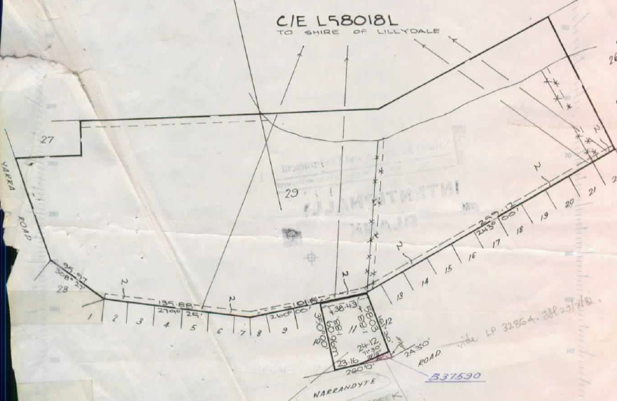28/5/1984 Creation of Easement No. L58018L (to Shire of Lillydale).

Plan attached to Certificate of Title Volume 8108 Folio 205 showing Creation of Easement to the Shire of Lillydale (and the removal of 2 near north-south easements) and the transfers out of a small triangular piece of land for road widening or straightening and Lot 11. NB On this plan Dudley Road is incorrectly shown as Yarra Road and what is now Jumping Creek Road and formerly Yarra Road) as Warrandyte Road.

9/7/1986 Caveat No. M359802Y affecting part of the land herein (Plan). Caveat withdrawn 19/1/1987.

4/8/1986 Caveat No. M402650U affecting part of the land herein Plan. Caveat transferred to new C/T

20/2/1987 Certificate of Title Cancelled as to balance. The following Titles have been issued Pursuant to Regulation 10 of the Transfer of Land Act. Lots A to B in Vol 9727 Fol 899 to Vol 9727 Fol 900 on LP206469N.

**Certificate of Title Volume 9727 Folio 899**

20/2/1987 Certificate of Title Volume 9727 Folio 899, area 1.237hectares, being Lot A on Plan of Subdivision No. 206469N issued to **Frederick James Knee** of (10) Dudley Road wonga Park.

Plan of Subdivision No. 206469 as appears on plans attached to Certificates of Title Volume 9729 Folios 899 and 900 for Lots A and B respectively.

9/5/1991 Certificate of Title Cancelled as to part. The following Titles have been issued Pursuant to Regulation 10 of the Transfer of Land Act. Lots One to 3 in Vol 10016 Folio 508 to Vol 10016 Fol 510 on LP 209554G.

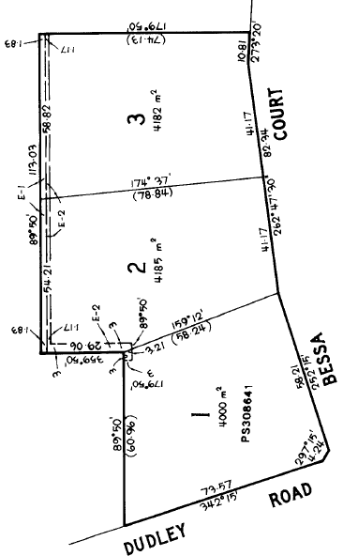30/7/1993 Certificate of Title Cancelled Amended (Cancelled) No. S396593D.

****************************

**Certificate of Title Volume 10016 Folio 508**

9/5/1991 Certificate of Title Volume 10016 Folio 508, area 4000 m2) being Lot 1 on Plan of Subdivision No. 209554G issued **to Frederick James Knee** of 10 Dudley Road Wonga Park.

Plan of Subdivision No. 209554G

19/11/1992 Certificate of Title Cancelled Pursuant to Section 24 Subdivision Act 1899 and Titles issued as set out hereunder. Registered 19/11/1992 Plan of Subdivision No. 308641U. Lots One to 2 in Vol 10072 Fol 228 and Vol 10072 Fol 229.

****************************************

**Certificate of Title Volume 10072 Folio 228 Street Address: 8 Dudley Road Wonga Park**

9/5/1991 Certificate of Title Volume 10072 Folio 228, area 1774 m2, being Lot 1 on Plan of Subdivision No. 308641U issued to **Frederick James Knee** of 10 Dudley Road Wonga Park.

Plan of Subdivision No. 308641U

27/6/2016 Transmission Application No. AM888014H from Frederick James Knee to **Hilda Rene Knee** of 10 Dudley Road Wonga Park Vic 3115 as Legal Personal Representative of Frederick James Knee deceased.

27/6/2016 Transfer No. AM888015P from Hida Rene Knee (as legal personal representative) to **Hilda Rene Knee** of 10 Dudley Road Wonga Park Vic 3115.

31/7/2020 Transmission Application No. AT479612G from Hilda Rene Knee to **Judith Lynnette Knee** of 8 Dudley Road Wonga Park Vic 3115 as Executor of Hilda Rene Knee deceased.

16/6/2022 Transfer No. AV747836X from Judith Lynnette Knee (as Executor) to **Judith Lynnette Kne**e of 8 Dudley Road Wonga Park Vic 3115.

*********************************************************************

**Certificate of Title Volume 10072 Folio 229 Street Address: 10 Dudley Road Wonga Park**

9/5/1991 Certificate of Title Volume 10072 Folio 229, area 2226 m2, being Lot 2 on Plan of Subdivision No. 308641U issued to **Frederick James Knee** of 10 Dudley Road Wonga Park.

27/6/2016 Transmission Application No. AM888014H from Frederick James Knee to **Hilda Rene Knee** of 10 Dudley Road Wonga Park Vic 3115 as Legal Personal Representative of Frederick James Knee deceased.

27/6/2016 Transfer No. AM888015P from Hida Rene Knee (as legal personal representative) to **Hilda Rene Knee** of 10 Dudley Road Wonga Park Vic 3115.

31/7/2020 Transmission Application No. AT479612G from Hilda Rene Knee to **Judith Lynnette Knee** of 8 Dudley Road Wonga Park Vic 3115 as Executor of Hilda Rene Knee deceased.

2/12/2024 Transfer No. AY653973J from Judith Lynnette Knee to **Alison Marie Kahn** of 10 Dudley Road Wonga Park Vic 3115.

2/12/2024 Mortgage No. AY653947G to Westpac Banking Corporation lodged.

**\*\*\*\*\*\*\*\*\*\*\*\*\*\*\*\*\*\*\*\*\*\*\*\*\*\*\*\*\*\*\*\*\*\*\*\*\*\*\*\*\*\*\*\*\*\*\*\*\*\*\*\*\*\*\*\*\*\*\*\*\*\*\*\*\*\*\*\***

**Certificate of Title Volume 9727 Folio 900**

20/2/1987 Certificate of Title Volume 9727 Folio 900, area 6.992 hectares, being Lot B on Plan of Subdivision No. 206469N issued to **Frederick James Knee** of Dudley Road wonga Park.

4/8/1986 Caveat No. M402650U. Caveat transferred to new Certificate of Title.

23/6/1987 Certificate of Title Cancelled

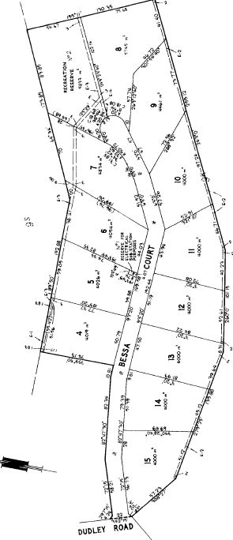The following Titles have been issued Pursuant to Regulation 10 of the Transfer of Land Act. Lots 4 to 15 in Vol 9753 Fol 446 to Vol 9753 Fol 457.

Plan of Subdivision No. 206469 as appears on plans attached to Certificates of Title Volume 9729 Folios 899 and 900 for Lots A and B respectively.

Pursuant to Section 32 of the Transfer of Land Act Being Reserve No. 1 (Reserve for Electrical Sub-station purposes) in Vol 9753 Fol 458.

Pursuant to Section 32 of the Transfer of Land Act Being Reserve No. 2 (Recreation) in Vol 9753 Fol 459.

Pursuant to Section 32 of the Transfer of Land Act Being the Roads in Vol 9753 Fol 460. All on LP 206470E.

Plan of Subdivision No. 206470E

******************************************************************************

**Certificate of Title Volume 9753 Folio 446 Street Address: 4 Bessa Court Wonga Park**

23/6/1987 Certificate of Title Volume 9753 Folio 446, area 4019m2, being Lot 4 on Plan of Subdivision No. 206470E issued to **Frederick James Knee** of Dudley Road Wonga Park.

4/8/1986 Caveat No. M402650U. Caveat withdrawn 21/7/1987.

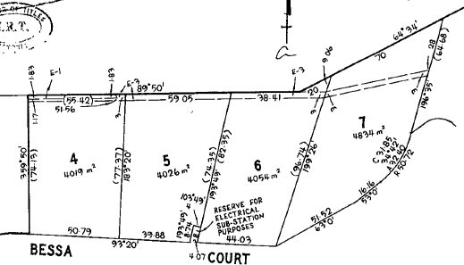21/7/1987 Caveat No. M949356W. Caveat will lapse on registration of M972221E – 10/8/1987.

4/8/1987 Transfer No. M972221E from Frederick James Knee to **Dorset Gardens Nominees Pty. Ltd.** of 177 York Rd. Mount Evelyn.

4/8/1987 Mortgage No. M972222B to Frederick James Knee, discharged as to part being the within land 8/2/1988.

Plan of land in Certificate of Title Volume 9753 Folio 446 in which the land in the Title is marked “4”.

18/9/1987 Caveat No. N46848F. Caveat will lapse on registration of N2768055.

8/2/1988 Transfer No. N276805S from Dorset Gardens Nominees Pty. Ltd. **to Norman Leslie Long** & **Tina Long** both of 9 Dudley Rd. Wonga Park.

8/2/1988 Mortgage No. N276806P to The Commissioners of The State Bank of Victoria, discharged 11/9/1990.

27/2/1995 Mortgage No. T573226X to Westpac Banking Corporation.

17/2/2015 Discharge No. AL691582X of Mortgage No. T573226X lodged.

17/2/2015 Mortgage No. AL691583V to Commonwealth Bank of Australia lodged.

7/11/2021 Caveat No. AU992151V by Connie Sorace and Travis Michael Lambe as purchasers lodged.

22/1/2022 Discharge No. AV258044K of Mortgage No. AL691583V lodged.

1/4/2022 Transfer No. AV489419B from Norman Leslie Long and Tina Long to Connie Sorace and Travis Michael Lambe both of 4 Bessa Court Wonga Park Vic 3115.

1/4/2022 Mortgage No. AV489420S to Macquarie Bank Ltd lodged.

*************************************************

**Certificate of Title Volume 8395 Folio 168 Street Address: 12 Dudley Road Wonga Park**

20/1/1961 Certificate of Title Volume 8395 Folio 168 being Lot 27 on Plan of Subdivision No. 32864 issued to **Frederick James Knee** of Yarra Road Croydon Orchardist (after Transfer No. B318626 from Arthur Edward Hedgman Davis).

27/6/2016 Transmission Application No. AM888014H from Frederick James Knee to **Hilda Rene Knee** of 10 Dudley Road Wonga Park Vic 3115 as Legal Personal Representative of Frederick James Knee deceased.

27/6/2016 Transfer No. AM888015F from Hilda Rene Knee (as legal personal representative of Frederick James Knee deceased) to Hilda Rene Knee of 10 Dudley Road Wonga Park.

31/7/2020 Transmission Application No. A479612G from Hilda Rene Knee to **Judith Lynnette Knee** of 8 Dudley Road Wonga Park Vic 3115 Executor of Hilda Rene Knee deceased.

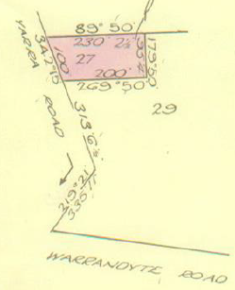8/6/2022 Transfer No. AV719601L from Judith Lynnette Knee to **Dean Anthony Kennedy** and **Sharelle Maree** **Beckworth** both of Unit 4, Oban Road Ringwood Certificate of Title Volume 8717 Folio 809 Vic 3134.

21/12/2022 Mortgage No. AW404214 to National Australia Bank Ltd lodged.

31/7/2023 Discharge No. AX103809C of Mortgage No. AW404214R lodged.

31/7/2023 Transfer No. AX103810T from Dean Anthony Kennedy and Sharelle Maree Beckworth to **Paul William Cannon** and **Nicole** **Maree Cannon** both of 5 Portsmouth Place Portsea Vic 3944.

Plan of land in Certificate of Title Volume 8395 Folio 168 NB On the plan Dudley Road is incorrectly named Yarra Road and Jumping Creek Road (formerly Yarra Road) is incorrectly named Warrandyte Road

************************************************

**Certificate of Title Volume 8717 Folio 805 Street Address: 68 Jumping Creek Road Wonga Park**

29/4/1968 Certificate of Title Volume 871 Folio 805 being Lot 1 on Plan of Subdivision No. 80419 issued to Arthur **Edward Hedgman Davis** of Wonga Park Post Office Storekeeper.

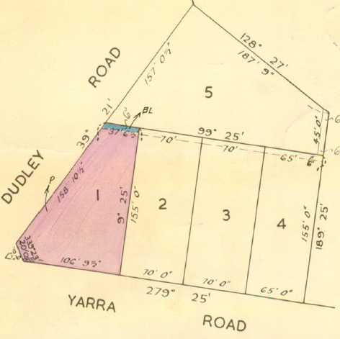1/11/1972 Transfer No. E600915 from Arthur Edward Hedgman Davis to **Arthur Tasman Walker** Gentleman and **Dorothy Mabel Walker** Married Woman both of “Yarra Crest” St. Denys Crescent Wonga Park.

20/10/1983 Caveat No. K596315. Caveat will lapse on registration of K671081 – 8/12/1983.

13/12/1983 Transfer No. K671081 from Arthur Tasman Walker and Dorothy Mabel Walker to **Deeside Investments Pty. Ltd.** of 460 Bourke Street Melbourne.

13/12/1983 Mortgage No. K671081 to National Commercial Banking Corporation of Australia Limited, discharged 2/5/1985.

Plan of land in Certificate of Title Volume 8717 Folio 805 in which the land in the Title is marked “1”.

2/5/1985 Mortgage No. L644560U to Leo Dimos, discharged 7/12/1992.

6/5/1986 Caveat No. M258467T lodged. Caveat will lapse on registration of M462163M.

5/9/1986 Mortgage No. M462163M to Leo Dimos, discharged 7/12/1992.

29/1/1987 Instrument No. M772028K. an Agreement dated 29 Jan 1987 with The President Councillors and Ratepayers of the Shire of Lillydale under Section 52A of Act 6849 affects the land herein.

27/10/1988 Mortgage No. N800037G to National Australia Bank Limited, discharged 7/12/1992.

20/12/1989 Caveat No. P583149R by Leo Dimos as charge. Caveat withdrawn 7/12/1992.

6/5/1992 Caveat No. R898269R by Sansford Pty. Ltd. as purchaser. Caveat withdrawn 7/12/1992.

7/12/1992 Transfer No. S254607B from Deeside Investments Pty. Ltd. to **Calavorno Pty. Ltd.** of Davis Rd. Wonga Park 3195 (sic).

7/12/1992 Mortgage No. S254610U to Bank of Melbourne Limited.

18/9/2002 Discharge No. AB566792X of Mortgage S254610U lodged.

4/10/2002 Caveat No. AB605227T by Rory Fleming and James Thomas Hughes as purchasers lodged.

13/3/2003 Transfer No. AB939336Y from Calvorno Pty. Ltd. to as tenants in common **Rory William Fleming** of 4 Anderson Street Clifton Hill Vic 3068 as to 3 of a total of 4 equal undivided shares and **James Thomas Hughes** of 4 Anderson Street Clifton Hill Vic 3068 as to 1 of a total of 4 equal undivided shares.

13/3/2003 Mortgage No. AB939337W to La Trobe Capital & Mortgage Corporation Limited lodged.

13/3/2003 Mortgage No. AB939338U to Jell (Vic) Pty Ltd lodged.

13/3/2003 Mortgage No. AB939339S to Calvorno Pty Ltd and lapsing of Caveat No. AB60527T lodged.

12/8/2004 Discharge No. AD043859R of Mortgage No. AB939337W lodged.

12/8/2004 Discharge No. AD043860H of Mortgage No. AB93938U lodged.

12/8/2004 Discharge No. AD043861F of Mortgage No. AB939339S lodged.

12/8/2004 Transfer No. AD043862D from James Thomas Hughes to Jane Elizabeth Daniels resulting in proprietorship as tenants in Common **Rory William Fleming** of 4 Anderson Street Clifton Hill Vic 3068 as to 3 of a total of 4 equal undivided shares and **Jane Elizabeth Daniels** of 134A Eglington Street Kew Vic 3101 as to 1 of a total of 4 equal undivided shares.

12/8/2004 Mortgage No. AD043863B to La Trobe Capital & Mortgage corporation Limited lodged.

27/9/2005 Caveat No. AD899854B by Peter Kevin Earnshaw and Norma Lesley Earnshaw as purchasers.

2/2/2006 Withdrawal No. AE153816N of Caveat No. A89985B lodged.

2/2/2006 Discharge No. AE153817L of Mortgage AD043863B lodged.

2/2/2006 Mortgage No. AE1818J to Bank of Queensland Limited lodged.

23/11/2007 Discharge No. F487813W of Mortgage No. 153818J lodged.

23/11/2007 Transfer No. AF487814U from Rory William Fleming and Jane Elizabeth Daniels to **Peter Kevin Earnshaw** and **Norma Lesley Earnshaw** both of 2/12 Juniper Road Wantirna Vic 3152.

23/11/2007 Mortgage No. AF487815S to Bank of Queensland Limited.

4/5/2011 Discharge No. AH92893H of Mortgage No. AF487815S lodged.

4/5/2011 Transfer No. AH92895F from Peter Kevin Earnshaw and Norma Lesley Earnshaw to Eagle Crest Pty Ltd of 44 Alexander Road Warrandyte Vic 3113.

18/5/2012 Caveat No. AJ675502H by Mary Gedye, capacity see Caveat, lodged

20/9/202 Caveat No. AJ921704B by Jason   
William Luxon, capacity see Caveat, lodged.

17/12/2012 Withdrawal No. AK08358T of Caveat No. AJ675502H lodged.

7/3/2013 Withdrawal No. AK228165M of Caveat No. AJ921704B lodged.

***********************************************************************

**Certificate of Title Volume 8717 Folio 808 Street Address: 64 Jumping Creek Road Wonga Park**

29/4/1968 Certificate of Title Volume 8717 Folio 808 being Lot 4 on Plan of Subdivision No. 80419 issued to **Arthur Edward Hedgman Davis** of Wonga Park Post Office Storekeeper.

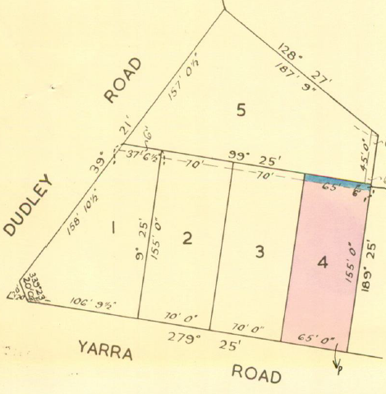21/8/1984 Transfer No. L216561L from Arthur Edward Hedgman Davis to **Michael John Tapper** and **Dawne Marie Tapper** both of 64 Jumping Creek Road Wonga Park.

21/8/1984 Mortgage No. L216562H to Australia and New Zealand Savings Bank Limited.

13/9/2007 Mortgage No. AF340259T to Australia and New Zealand Banking Group Ltd lodged.

20/7/2010 Discharge No. AH374702U of Mortgage No. L216562H lodged.

20/7/2010 Discharge No. AH374703H of Mortgage No. AF340259T lodged.

Plan of land in Certificate of Title Volume 8717 Folio 808 in which the land in the Title is marked “4”.

20/7/2010 Mortgage No. AH374704Q to National Australia Bank Ltd lodged.

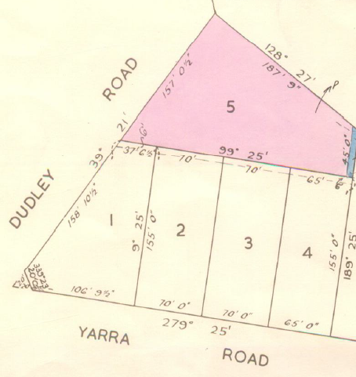 **************************************************************************

**Certificate of Title Volume 8717 Folio 809 Street Address: 4 Dudley Road Wonga Park**

29/4/1968 Certificate of Title Volume 8717 Folio 809 being Lot 5 on Plan of Subdivision No. 80419 issued to **Arthur Edward Hedgman Davis** of Wonga Park Post Office Storeman.

25/1/1971 Transfer No. E52235 from Arthur Edward Hedgman Davis to **Peter William Kear** Orchard Employee and **Doreen Norma Kear** Married Woman both of Jumping Creek Road Wonga Park.

Plan of land in Certificate of Title Volume 8717 Folio 809 in which the land in the Title is marked “5”.

29/9/1972 Transfer No. E547158 from Peter William Kear and Doreen Norma Kear to **Francis Denis Kennedy** Policeman and **Carmel Kathleen Kennedy** both of 70 Croydon Road Croydon.

29/2/1973 Mortgage No. E716863 to Bank of New South Wales Savings Bank Limited, discharged 17/10/1984.

17/10/1984 Transfer No. L317267S from Francis Denis Kennedy and Carmel Norma Kennedy to **Helmut Brauer** and **Pamela Joy Brauer** both of 8 Arkarra Court Mooroolbark.

17/10/1984 Mortgage No. L317268P to The Commissioners of The State Bank of Victoria, discharged 27/10/1988.

7/7/1988 Caveat No. N559257R by Deeside Investments Pty. Ltd. as purchaser.

27/10/1988 Transfer No. N800044M from Helmut Brauer and Pamela Joy Brauer to **Deeside Investments Pty. Ltd.** of 6 Reserve Rd. Wonga Park.

27/10/1988 Mortgage No. N800045J to National Australia Bank Limited, discharged 5/7/1991.

5/7/1991 Transfer No. R421156U from Deeside Investments Pty. Ltd. to **Mark Brian Gills** & **Lorraine Kaye Gills** of 2 Yea Crt. Croydon Hills.

5/7/1991 Mortgage No. R421157R to National Australia Bank Limited, discharged 3/10/1995.

3/7/1995 Caveat No. T752864J by Trevor John Sharpe & Julie Elizabeth Sharpe as purchasers. Caveat will lapse on registration of T893813N – 5/10/1985.

3/10/1995 Transfer No. T893813N from Mark Brian Gills and Lorraine Kaye Gills to **Trevor John Sharpe** & **Julie Elizabeth Sharpe** of 4 Dudley Rd. Wonga Park 3115.

3/10/1995 Mortgage No. T893814K to Arnott’s Biscuits Limited, discharged 13/8/1998.

29/11/1995 Mortgage No. T978275M to Australia and New Zealand Banking Group Limited, discharged 13/8/1998.

13/8/1998 Mortgage No. V584398W to NRMA Building Society Ltd, discharged 13/6/2001.

13/6/2001 Transfer No. X530995T from Trevor John Sharpe and Julie Elizabeth Sharpe to **Lisa Jane De Cler** of 4 Dudley Rd. Wonga Park 3115.

13/6/2001 Mortgage No. X530996Q to National Australia Bank Limited.

27/3/2003 Discharge No. AB972402A of Mortgage No. X530996Q lodged.

27/3/2003 Transfer No. AB972403X from Lisa Jane De Cler to **Graeme Neil Brewster** and **Lyndall Gaye Brewster** both of 4 Dudley Road Wonga Park Vic 3115.

27/3/2003 Mortgage No. AB972404V to Commonwealth Bank of Australia lodged.

28/6/2019 Discharge No. AS307571R of Mortgage No. AB972404V lodged.

26/6/2019 Transfer No. AS307572P from Graeme Neil Brewster and Lyndall Gaye Brewster to **Christopher Andrew Gallop** and Rebecca Jule Gallop both of 4 Dudley Road Wonga Park Vic 3115.

28/6/2019 Mortgage No. AS307573 to “Westpac Banking Corporation lodged.