**Title History of Crown Allotment 9T Parish of Warrandyte**

Plan showing property boundaries and street numbers for Crown Allotment 9T Parish of Warrandyte

3/1/1912 Crown Grant Volume 3580 Folio 984 of 26 acres 2 roods and 28 perches being (Crown) Allotment 9T, for a consideration of Twenty Pounds and five shillings to **Elizabeth Hughes** of Waltham Street Richmond Widow.

20/5/1914 Transfer as to part No. 747443, area 7 acres, to Thomas Bell Hughes, new Certificate of Title Volume 3797 Folio 279.

20/5/1914 Transfer as to part No. 747444, area 6 acres and 39 perches, to Ethel Dinah Hughes, new Certificate of Title Volume 3797 Folio 280.

Plan of land in Crown Grant Volume 3580 Folio 984

20/5/1914 Transfer as to part No. 747445, area 6 acres and 39 perches, to Walter Sargeant Hughes, new Certificate of Title Volume 3797 Folio 281.

3/5/1923 Red Ink No. 2361171. Elizabeth Hughes died on 4th May 1920. Probate has been granted to **Florence Sharp** of Wonga Park Croydon Married Woman.

Plan attached to Crown Grant Volume 3580 Folio 984 showing parcels of land transferred out.

3/5/1923 Transfer as to balance No. 1102076 to Florence Sharp, new Certificate of Title Volume 4755 Folio 911. Certificate of Title Cancelled.

*************************************************************************

**Certificate of Title Volume 3797 Folio 279**

Crown Allotment 9T issued to **Thomas Bell Hughes** of Ivanhoe Monumental Mason (after transfer No.747445 from his mother Elizabeth Hughes).

9/11/1926 Mortgage No. 552877 Alexander Guila, discharged 2/11/1929.

2/11/1929 Mortgage No. 628786 to William Henry Flood, discharged 9/1/1933.

Plan of land in Certificate of Title Volume 3797 Folio 279

9/1/1933 Transfer as to part No. 1515994, area 5 acres, to Edith May Ahrens, new Certificate of Title Volume 5827 Folio 300.

11/10/1952 Red Ink No. 5640068. Thomas Bell Hughes died on 30 December 1953. Probate of his Will has been granted to Paris Hughes of 34 Burran Avenue Balmoral New South Wales Storeman.

19/12/1973 Transmission Application No. F140843. Paris Hughes died on 4th November 1971. Probate of his Will has been granted to **Julie Ann** **McLeod** Married Woman and **Raymond Leslie McLeod** Clicker both of 6 Brazilia Drive Glen Waverley.

Plan attached to Certificate of Title Volume 3797 Folio 279 showing lands transferred out as to part and balance.

3/12/1974 Transfer as to balance No. F542118 new Certificate of Title Volume 9069 Folio 413. Certificate of Title Cancelled.

***************************************************************************

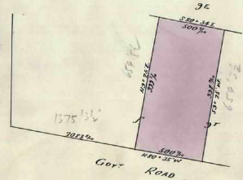**Certificate of Title Volume 5827 Folio 300**

9/1/1933 Certificate of Title Volume 5827 Folio 300, area 5 acres, being part of Crown Allotment 9T issued to **Edith May Ahrens** of Wonga Park Married Woman.

24/5/1946 Transfer No. 2008340 from Edith May Ahrens to **Vera Reimers** of Sheffield Road Montrose Widow.

18/2/1953 Red Ink No. 5419560. Vera Hussey (formerly Vera Reimers) died on 18th February 1953. Probate of her Will has been granted to **Public Trustee**.

Plan of land in Certificate of Title Volume 5827 Folio 300

15/5/1964 Transfer No. B931639 from Public Trustee to **Kenneth Albert Jones** Clothier and **Pamela Anne Jones** Married Woman both of 15 Wridgeway avenue Bennetswood.

15/4/1965 Transfer No. C196117 from Kenneth Albert Jones and Pamela Anne Jones to **Donald Earle Tinkler** School Teacher and **Norma Lorraine Tinkler** both of Dudley Road Wonga Park.

15/4/1965 Mortgage No. C196118 to Lensworth Finance (vic.) Limited, discharged????

22/11/1967 Mortgage No. C943236 to The English Scottish and Australian Bank Limited, discharged????

11/81971 Mortgage No. E128719 to Geoffrey Charles Penfold and Ralph   
Watson.

9/11/1972 Certificate of title Cancelled. Pursuant to   
Regulation 12 and Titles issued as set out hereunder: Lots One to 2 in Vol 8951 Fol 090 to Vol 8951 Fol 091 LP 96279.

***************************************************************************

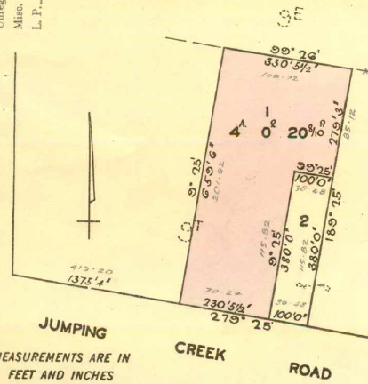**Certificate of Title Volume 8951 Folio 090**

9/11/1972 Certificate of Title Volume 8951 Folio 090, area 4 acres 0 roods and 20.8 perches, being Lot 1 on Plan of Subdivision No. 96279 issued to **Donald Earle Tinkler** School Teacher and **Norma Lorraine Tinkler** Married Woman both of Jumping Creek Road Wonga Park subject to Mortgage No. E128719, discharged 8/11/1973.

9/11/1973 Mortgage No. F79017 to Bank of New South Wales Savings Bank Limited.

24/12/1974 Certificate of Title Cancelled. Pursuant to Regulation 12 and titles issued as set out hereunder: Lots One to 2 in Vol 9063 Fol 616 to Vol 9063 Fol 617 LP 113414.

Plan of land in Certificate of Title Volume 8951 Folio 090

***************************************************************************

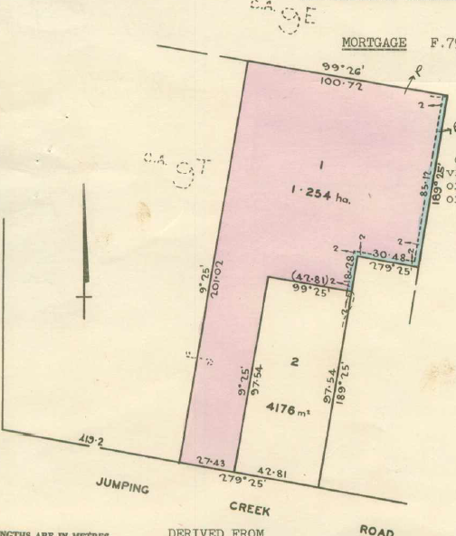**Certificate of Title Volume 9063 Folio 616**

24/12/1974 Certificate of Title Volume 9063 Folio 616, area 1.254 hectares, being Lot 1 on Plan of Subdivision No. 11314 issued to **Donald Earle Tinkler** School Teacher and **Norma Lorraine Tinkler** Married Woman both of “Strathmuir” Jumping Creek Road Wonga Park subject to Mortgage No. F79017, discharged 24/11/1976.

25/10/1976 Caveat No. G375937 lodged. Caveat withdrawn before entry 16/12/1976.

16/7/1976 Caveat No. G445830 lodged. Caveat withdrawn 15/3/1977.

26/11/1976 Transfer No. G412255 from Donald Earle Tinkler and Norma Lorraine Tinkler to **Donald Earle Tinkler** of “Strathmuir” Jumping Creek Road Wonga Park School Teacher.

Plan of land in Certificate of Title Volume 9063 Folio 616

24/11/1976 Mortgage No. G412257 to Bank of New South Wales Savings Bank Limited, discharged 15/3/1977.

1/5/1984 Caveat No. L12293B lodged. Caveat will lapse on registration of M318207C - 18/6/1986.

13/6/1986 Transfer No.M318207C from Donald Earle Tinkler to **Owen Jervoise Cruickshank** & **Thelma Joyce Cruickshank** of 92 Jumping Creek Rd. Wonga Park.

8/5/1991 Mortgage No. R329991G to Commonwealth Bank of Australia, discharged 19/4/1997.

15/4/1997 Transfer No. U722364Y from Owen Jervoise Cruickshank and Thelma Joyce Cruickshank to **Sky Property Developments Pty. Ltd.** Delaneys Road Warranwood.

Plan of Subdivision No. 406909F

Plan of Subdivision No. 405617A

6/6/1997 Certificate of Title Cancelled as to part No. PS 405617A.

???? Certificate of Title Cancelled as to balance No. PS 406909F.

***********************************************************************

**Certificate of Title Volume 10332 Folio 117 Street Address: 90B Jumping Creek Road Wonga Park**

6/6/1997 Certificate of Title Volume 10332 Folio 117, area 4018 m2, being Lot 1 on Plan of Subdivision No. 405617A issued to **Sky Property Developments Pty. Ltd.**; Delaneys Road Warranwood 3134 subject to Mortgage No. U731802D and Covenant No. PS405617A.

28/7/1997 Discharge No. U894682F of Mortgage No. U731802D lodged.

28/7/1997 Transfer No. U894683C from Sky Property Developments Pty Ltd. to **Neil Rory Macdonald** and **Julie Macdonald** both of 3 Songbird Av. Chirnside Park 3116.

28/7/1997 Mortgage No. U894684Y to National Australia Bank Limited lodged.

16/3/2002 Discharge No. AV430733B of Mortgage No. U894684Y lodged.

16/3/2022 Transfer No. AV430734Y from Neil Rory Macdonald and Julie Macdonald to David Patrick Cox and Caitlin Jane Cox both of 90B Jumping Creek Road Wonga Park Vic 3115.

16/3/2022 Mortgage No. AV430735W to National Australia Bank Ltd lodged.

****************************************************************************

**Certificate of Title Volume 10332 Folio 118 Street Address: 90A Jumping Creek Road Wonga Park**

Lot 1 on Plan of Subdivision No. 406909F

**************************************************************************

**Certificate of Title Volume 10332 Folio 119 Street Address: 90 Jumping Creek Road Wonga Park**

Lot 2 on Plan of Subdivision No. 406909F

*************************************************************************

**Certificate of Title Volume 9063 Folio 617 Street Address: 86 Jumping Creek Road Wonga Park**

Lot 2 on Plan of Subdivision No. 113414

Plan of Subdivision No. 113414 and land in Certificate of Title Volume 9063 Folio is marked “2”

*************************************************************************

**Certificate of Title Volume 8951 Folio 091 Street Address: 84 Jumping Creek Road Wonga Park**

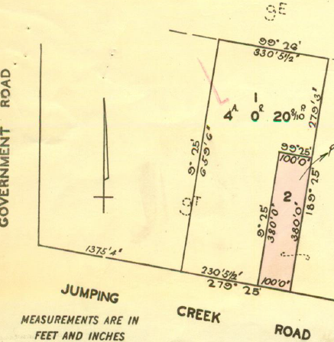9/11/1972 Certificate of Title Volume 8951 Folio 091 being Lot 2 on Plan of Subdivision No. 96279 issued to **Donald Earle Tinkler** School Teacher and **Norma Lorraine Tinkler** Married Woman both of Jumping Creek Road Wonga Park subject to Mortgage No. E128719, discharged 15/11/1972.

15/11/1972 Transfer No. E602582 from Donald Earle Tinkler and norma Lorraine Tinkler to **John William Mitchel**l Butterfield Manager and **Dianne Elizabeth Butterfield** Married Woman both of 23 Clauscen Street Lower Templestowe.

7/3/1973 Transfer No. E729492 from John William Mitchell Butterfield and Dianne Elizabeth Butterfield to **Robert Flowers** of “Johnswood” Eastfield Road Ringwood East School Teacher.

Plan of land on Certificate of Title Volume 8951 Folio 091 in which the land in the Title is marked “2”

12/3/1976 Transfer No. G65728 from Robert Flowers to **Robert Peter Holdsworth** and **Elaine Ruth Holdsworth** both of The Mall South Croydon Newsagents.

12/3/1976 Mortgage No. G65729 to The Commissioners of The State Savings Bank of Victoria, discharged 1/4/1985.

4/11/1982 Mortgage No. K14927 to The Commercial Banking Company of Sydney Limited, discharged 12/2/1985.

18/7/1985 Mortgage No. L781908D to National Australia Bank Limited, discharged 11/7/1988.

11/7/1996 Mortgage No. U303538G to Bank of Melbourne Limited.

14/10/1998 Mortgage No. V691038S to Westpac Banking Corporation.

13/6/2008 Discharge No. AF904472C of Mortgage No. U303538G lodged.

13/6/2008 Discharge No. AF904473A of Mortgage No. V691038S lodged.

13/6/2008 Transfer No. AF904474X from Robert peter Holdsworth and Elaine Ruth Holdsworth to **Peta Kerryn Nash** of 84 Jumping Creek Road Wonga Park Vic 3115.

13/6/2008 Mortgage No. AF904475V to Perpetual Ltd lodged.

10/10/2016 Transfer No. AN163060K of Mortgage No. AF904475V to Members Equity Bank Ltd.

30/10/2023 Discharge No. AX402680M of Mortgage No. AF904475V lodged.

*************************************************************************

**Certificate of Title Volume 9069 Folio 413 Street Address: 92 Jumping Creek Road Wonga Park**

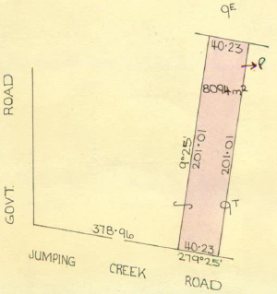3/12/1974 Certificate of Title Volume 9069 Folio 413 being part of Crown Allotment 9T issued to **Kenneth Samuel John Jamison** of Jamieson Road Wonga Park Plumber (after Transfer No. F542118 from Julie Ann McLeod and Raymond Leslie McLeod as executors of the Will of Paris Hughes Deceased).

30/1/1976 Transfer from Kenneth Samuel Jamieson to **Kenneth Samuel Jamison** of Jamieson Road Wonga Park Plumber and **Robin Gale Blunn** of Walker Road Wonga Park Nursing Aide.

28/2/1979 Transfer No. H426884 from Kenneth Samuel Jamieson and Robin Gale Blunn to **Berjud Nominees Pty. Ltd**. of 35 Sinclair Road Bayswater.

4/2/1979 Mortgage No. H471421 to The National Bank of Australasia Limited, discharged 5/6/1984.

Plan of land in Certificate of Title Volume 9069 Folio 413

5/6/1984 Transfer No. L74999K from Berjud Nominees Pty. Ltd. to **Owen Jervoise Cruickshank** and **Thelma Joyce Cruickshank** both of 246 Andersons Creek Road East Doncaster.

31/1/1985 Mortgage No. L488299E to Commonwealth Savings Bank of Australia, discharged 29/12/1986.

13/3/1987 Mortgage No. M744225T to Commonwealth Savings Bank of Australia, discharged 3/2/1989.

24/1/1992 Mortgage No. R747558L to Commonwealth Bank of Australia, discharged 1/5/1997.

1/5/1997 Mortgage No. U748589J to National Mutual Life Association of Australasia Ltd, discharged 30/9/1997.

30/9/1997 Transfer No. V12932U from Owen Jervoise Cruickshank and Thelma Joyce Cruickshank to **Roxanne Chipman** & **Nicholas John Chipman** of 92 Jumping Creek Road Wonga Park 3115.

30/9/1997 Mortgage No. V12933R to Westpac Banking Corporation, discharged 12/11/1999.

12/11/1999 Mortgage No. W403239R to Commonwealth Bank of Australia.

12/8/2019 Discharge No.AS432835H of Mortgage No. W403239R lodged.

17/1/2020 Transfer No. AS903290B from Roxanne Chipman and Nicholas John Chipman to Adam John Pargeter and Michelle Julie Carlton both of 92 Jumping Creek Road Wonga Park Vic 3115.

17/1/2020 Mortgage No. AS903291Y to HSBC Bank Australia Ltd lodged.

23/8/2023 Discharge No. AX181769V of Mortgage No. AS903291Y lodged.

21/8/2023 Mortgage No. AX181769V to Australia and New Zealand Banking Group Ltd lodged.

*************************************************************************

**Certificate of Title Volume 3797 Folio 280**

Crown Allotment 9T issued to Ethel a Hughes of Wonga Park Spinster (after Transfer No. 747444 from her mother Elizabeth Hughes).

11/8/1936 Transfer No. ?21375 from Ethel Dinah Hughes to **Peter Vergers** of Mullum Road Ringwood Orchardist.

10/9/1936 Mortgage No. 3708304 to Emily Elizabeth Cock, discharged 14/7/1941.

11/5/1961 Transfer No. B204429 from Peter Vergers to (his sons) **Peter Vergers the Younger** and **John Meredith Vergers** both of Warrandyte Road Ringwood Orchardists.

Plan of land in Certificate of Title Volume 3797 Folio 280

23/3/1972 Transfer No. E338227 from Peter Vergers the Younger and John Meredith Vergers to **John Meredith Vergers** of Warrandyte Road Ringwood Orchardist.

23/5/1977 Certificate of Title Cancelled. Pursuant to Regulation 12 and Titles issued as set out hereunder: Lots One to 2 in Vol 9204 Fol 391 to Vol 9204 Fol 392.

************************************************************************

**Certificate of Title Volume 9204 Folio 391**

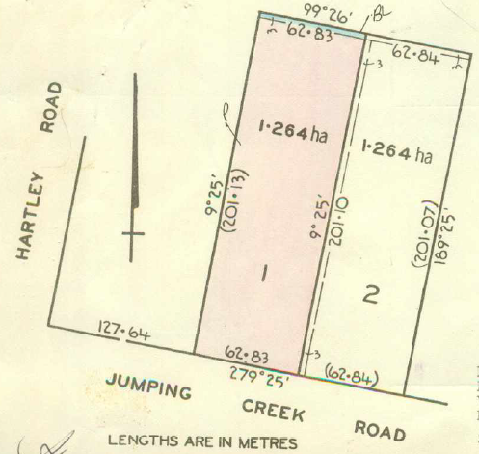23/5/1977 Certificate of Title Volume 9204 Folio 391, area 1.264 hectares, being Lot 1 on Plan of Subdivision No. 121461 issued to **John Meredith Vergers** of Warrandyte Road   
Ringwood Orchardist.

3/7/1980 Transfer No. J51952 from John Meredith Vergers to **Charles Edward Clarke** Builder and **Elizabeth Joy Clarke** Married Woman both of 4 Cairns Court Croydon.

3/7/1980 Mortgage No. J51953 to The Commercial Bank of Australia Limited, discharged 21/10/1980.

21/10/1980 Mortgage No. J200565 to The Commercial Savings Bank of Australia Limited.

Plan on Certificate of Title Volume 9204 Folio 391 in which the land in the Title is marked “1”

21/10/1980 Mortgage No. J200566 to The Commercial Bank of Australia Limited.

27/1/1981 Caveat No. J319550 lodged. Caveat withdrawn 30/6/1980.

6/7/1984 Mortgage No. J532844 to George John Kepper and Eva Brigitte Kepper, discharged 30/6/1982.

19/7/1982 Caveat No. K11672 lodged. Caveat will lapse on registration of K147529 – 13/12/1982.

3/11/1982 Mortgage No. K147529 to Clarke and Kepper Pty. Ltd., discharged13/3/198?.

19/9/1983 Caveat No. K55354 lodged. Caveat finally disposed of under Sec 105 Act 899 – 5/3/1984?

1/2/1984 Memo No. K737423. Copy Writ of Fieri Facias issued out of the Supreme Court at Melbourne in an action numbered M17009 Roma Hannah Elizabeth Clausen v. C. E. & E. J. Clarke served on 1st Feb 1984.

1/5/1984 Memo No. L12255. Copy Writ of Fieri Facias issued out of the Supreme Court at Melbourne in an action numbered M17009 Roma Hannah Elizabeth Clausen v. C. E. & E. J. Clarke served on 1st May 1984.

12/3/1986 Certificate of Title Cancelled. The following Titles have been issued Pursuant to

Regulation 12 of the Transfer of and Act: Lots One to 2 in Vol 9666 Fol 202 to Vol 9666 Fol 203.

***************************************************************************

**Certificate of Title Volume 9666 Folio 202 Street Address: 106 Jumping Creek Road Wonga Park**

12/3/1986 Certificate of Title Volume 9666 Folio 202, area 7673 m2, being Lot 1 on Plan of

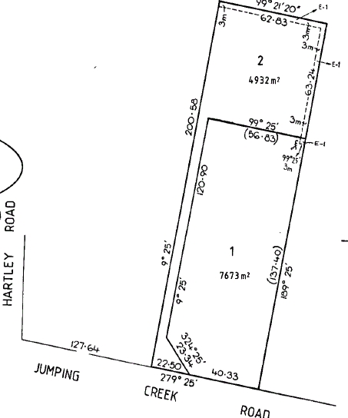Subdivision No. 202454Y issued to **Charles Edward Clarke** and **Elizabeth Joy Clarke** both of Jumping Creek Road Wonga Park subject to Mortgages Nos. J200565 and J200566 and The Covenant contained in Transfer P203767T registered 19/5/1989. The above mortgages are discharged 19/5/1989.

19/5/1989 Transfer No. P263767T from Charles Edward Clarke and Elizabeth Joy Clarke to **John Alan Morriss** & **Sheryl Ann Morriss** of Lynwood Pl. Castle Hill New South Wales.

19/5/1989 Mortgage No. P203768Q to Republic National Bank of New York (Singapore) Limited, discharged 14/5/1991.

14/5/1991 Mortgage No. R339830L to Commonwealth Savings Bank of Australia, discharged 4/5/1994.

4/5/1994 Mortgage No. T65571P to National Australia Bank Limited.

Plan on Certificate of Title Volume 9666 Folio 202 showing Plan of Subdivision No. 202454Y on which the land in this Title is marked “1”

5/6/1997 Discharge No. U808127K of Mortgage No. T065571P lodged.

5/6/1997 Transfer No. U808128G from John Alan Morriss and Sheryl Ann Morris to **Pauline Margaret Frolley** of 106 Jumping Creek Rd. Wonga Park 3115.

5/6/1997 Mortgage No. U808129D to National Australia Bank Limited lodged.

27/7/2011 Discharge No. AJ095335H of Mortgage No. U808129D lodged.

27/7/2011 Variation No. AJ095336F of Covenant in Instrument No. P203767T lodged.

************************************************************************

**Certificate of Title Volume 9666 Folio 203 Street Address: 108 Jumping Creek Road Wonga Park**

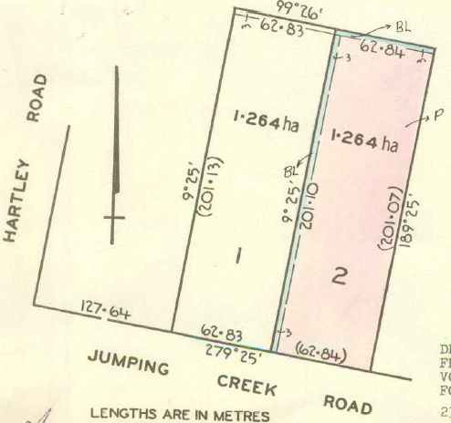Lot 2 on Plan of Subdivision No. 202454Y

*********************************************

**Certificate of Title Volume 9204 Folio 392**

23/5/1977 Certificate of Title Volume 9204 Folio 392, area 1.264 hectares, being Lot 2 on Plan of Subdivision No. 121461 issued to **John Meredith Vergers** of Warrandyte Road Ringwood Orchardist.

11/7/1979 Transfer No. H597189 from John Meredith Vergers to **Peter John Beck** Experimental Officer and **Carole May Beck** Married Woman both of 3 Eucalypt Avenue Lower Templestowe.

Plan on Certificate of Title Volume 9204 Folio 392 in which the land in the Title is marked “2”

2?/911979 Mortgage No. H691392 The Commercial Savings Bank of Australia Limited.

31/10/1979 Mortgage No. H749306to C.S.I.R.O. Co-Operative Credit Society Limited, discharged 7/2/1983.

27/1/1981 Mortgage No. J318329 to The Commercial Bank of Australia Limited, discharged 15/8/1984.

21/6/1985 Certificate of Title Cancelled. The following Titles have been issued Pursuant to Regulation 12 of the Transfer of Land Act: Lots One to 2 in Vol 9616 Fol 486 to Vol 9616 Fol 487 on LP 149567D.

************************************************************************

**Certificate of Title Volume 9616 Folio 486 Street Address: 104 Jumping Creek Road Wonga Park**

21/6/1985 Certificate of Title Volume 9616 Folio 486, area 7748 m2, being Lot 1 on Plan of Subdivision No. 149567D issued to **Peter John Beck** and **Carole May Beck** both of 102 Jumping Creek Road Wonga Park subject to Mortgage H691392 which mortgage was discharged on 31/1/1986.

31/1/1986 Transfer No. M112323H from Peter John Beck and Carole May Beck to **Alexander George Ellenford** & **Faye Denise Ellenford** of Faneco Rd. Plenty.

31/6/1986 Mortgage No. M112324E to Commonwealth Savings Bank of Australia, discharged 24/8/2000.

24/5/2000 Caveat No. W801210H by William John McNeil, Nicola-Jane McNeil & Peter Allan Cawsey as purchasers. Caveat withdrawn.

24/8/2000 Transfer No. W998400D from Alexander George Ellenford and Faye Denise Ellenford to William John McNeil of 2 Pescara Pl. Donvale 3111 as two equal undivided fourth parts, Nicola-Jane Alexandra McNeil & Peter Alan Cawsey each as to one equal undivided fourth part or share both of 102 Jumping Creek Road Wonga Park 3115 as tenants in common.

Plan on Certificate of Title Volume 9616 Folio 486 showing Plan of Subdivision No. 149567D and the land in the Title is marked “1”

24/8/2000 Mortgage No. W998401A.

15/11/2011 Discharge No. AJ313343Y of Mortgage No. W998401A lodged.

15/11/2011 Transfer No. AJ313344W from William John McNeil, Nicola-Jane Alexandra McNeil and Peter Alan Cawsey to **Nicola-Jane McNeil** and **Peter Alan Cawsey** both of 104 Jumping Creek Road Wonga Pak Vic 3115.

15/11/2011 Mortgage No. AJ313345U lodged.

5/8/2013 Caveat No. AK503235K by Shane William MacFarlane as purchaser.

15/8/2013 Discharge No. AK528989P of Mortgage No. AJ313345U lodged.

15/8/2013 Transfer No. AK528990F from Nicola-Jane McNeil and Peter Alan Cawsey to **Shane William MacFarlane** of 104 Jumping Creek Road Wonga Park Vic 3115.

15/8/2013 Mortgage No. AK528991D to Westpac Banking Corporation lodged.

6/5/2014 Discharge No. AL061648J of Mortgage No. AK528991D lodged.

6/5/2014 Mortgage No. AL061649G to HSBC Bank Australia Ltd lodged.

18/5/2017 Discharge No. AN845647Y of Mortgage No. AL061649G lodged.

18/5/2017 Caveat No. AN845648W by Commonwealth Bank of Australia as Mortgagee lodged.

7/2/2020 Withdrawal No. AS971342Y of Caveat No. AN845648W lodged.

7/2/2020 Transfer No. AS971343W from Shane William MacFarlane to Joanne Rahmani of 104 Jumping Creek Road Wonga Park Vic 3115.

7/2/2020 Mortgage No. AS971344U to Perpetual Corporate Trust Ltd lodged.

************************************************************************

**Certificate of Title Volume 9616 Folio 487 Street Address: 102 Jumping Creek Road Wonga Park**

Lot 2 on Plan of Subdivision No. 149567D.

************************************************************************

**Certificate of Title Volume 3797 Folio 281**

20/5/1914 Certificate of Title Volume 3797 Folio 281, area 6 acres and 39 perches, being 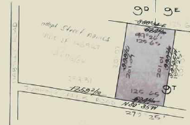part of Crown Allotment 9T issued to **Walter Sargeant Hughes** of Bosisto Street Richmond Mason after transfer No. 747445 from his mother Elizabeth Hughes.

9/11/1937 Red Ink No. 3618267. Walter Sargeant Hughes died on 17th June 1937. Letters of Administration with the Will Annexed of his estate have been granted to (his niece) Florence Annie Sharp of Wonga Park Married Woman.

Plan of land in Certificate of Title Volume 3797 Folio 281

27/9/1938 Transfer No. 1705753 from Florence Annie Sharp to (her daughter) **Elizabeth Lilian Vergers** of Mullum Road Ringwood Married Woman.

5/5/1961 Transmission Application No. B200405 Elizabeth Lilian Vergers died on 18th October 1960. Probate of her Will has been granted to **Peter Vergers** of Mullem (sic) Road Ringwood Orchardist.

5/5/1961 Transfer No. B200406 from Peter Vergers (as executor) to **Peter Vergers** of Mullum road Ringwood Orchardist.

11/5/1961 Transfer No. B204429 from Peter Vergers to **Peter Vergers the Younger** and **John Meredith Vergers** both of Warrandyte Road Ringwood Orchardists.

22/3/1972 Transfer No. E338226 from Peter Vergers the Younger and John Meredith Vergers to **Peter Vergers the Younger** of Bengworden Road Perry Bridge Farmer.

26/1/1973 Mortgage No. E693274 to Kathleen Jessie Longmire, discharged 24/31976.

5/8/1976 Transfer No. G266894 from Peter Vergers the Younger to Susan Le Fevre of 6 Yarra Road Wonga Park Married Woman.

26/9/1978 Caveat No.H247210 lodged. Caveat withdrawn24/101984

27/9/1978 Mortgage No. H248242 to The Commercial Bank of Australia Limited, discharged 14/8/1986.

2/7/1986 Caveat No. M348030A lodged. Caveat transferred to new C/T

17/2/1987 Certificate of Title Cancelled. The following Titles have been issued Pursuant to Regulation 10 of the Transfer of Land Act: Lots One to 4 in Vol 9726 Fol 957 to Vol 9726 Fol 960 all on L0205891J.

*************************************************************************

**Certificate of Title Volume 9726 Folio 957**

17/2/1987 Certificate of Title Volume 9726 Folio 957, area 1.462 hectares, being Lot 1 on Plan of Subdivision No. 205891J issued to Susan Ann Le Fevre of Jumping Creek Road Wonga Park.

2/7/1980 Caveat No. M348030A lodged. Caveat withdrawn 5/7/1988.

Certificate of Title Cancelled. The following Titles have been issued Pursuant to Regulation 10 of the Transfer of Land Act: Lots One to 2 in Vol 9841 Fol 594 to Vol 9841 Fol 595 and Lot 5 in Vol 9841 Fol 596 LP 212773A.

Plan of land on Certificate of Title Volume 9726 Folio 957 showing Plan of Subdivision No. 205891J and the land in the Title is marked “1”.

**************************************************************************

**Certificate of Title Volume 9841 Folio 594 Street Address: 94 Jumping Creek Road Wonga Park**

27/10/1988 Certificate of Title Volume 9841 Folio 594 area 1.051 hectare, being Lot 1 on Plan of Subdivision No.212773A issued to **Susan Ann Le Fevre** of 92 Jumping Creek Road Wonga Park.

23/1/1989 Caveat No. N968982V by Geoffrey Ronald Pearce & Beverley Joan Pearce. Caveat will lapse upon registration of P143066D – 11/5/1989.

20/4/1989 Transfer No. P140366N from Susan Ann Le Fevre to **Geoffrey Ronald Pearce** & **Beverley Joan Pearce** of 94 Jumping Creek Rd. Wonga Park.

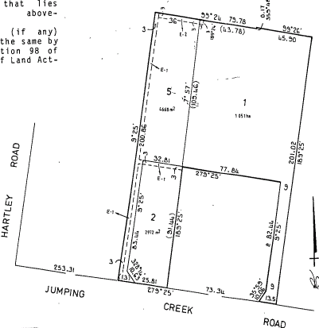20/4/1989 Mortgage No. P143067K to Australia and New Zealand Savings Bank Limited.

7/12/1989 Mortgage No. P560746 D to Australia and New Zealand Banking Group Ltd.

1/8/1996 Discharge No. U338515U of Mortgage No. P143067K lodged.

9/7/1998 Discharge No. V516897N of Mortgage No. P560746D lodged.

9/10/1998 Transfer No. V685134G from Geoffrey Ronald Pearce and Beverley Joan Pearce to **Beverley Joan Pearce** of 94 Jumping Creek Rd. Wonga Park 3115.

Plan on Certificate of Title Volume 9841 Folio 594 showing Plan of Subdivision No. 212773A and the land in the Title is marked “1”.

1/2/1999 Mortgage No. V867935U to Australia and New Zealand Banking Group Limited lodged.

9/12/1999 Caveat No. W456161C by Rodney Peter Hands and Lisa Jane Hands as purchasers lodged.

24/2/2000 Discharge No. W620575H of Mortgage No. V867935U lodged.

24/2/2000 Transfer No. W620576E from Beverley Joan Pearce to **Rodney Peter Hands** and **Lisa Jane Hands** both of 94 Jumping Creek Road Wonga Park 3115.

24/2/2000 Mortgage No. W620577B to National Australia Bank Limited lodged.

2/3/2006 Discharge No. AE217012D of Mortgage No. W620577B lodged.

2/3/2006 Transfer No. AE217013B from Rodney Peter Hands and Lisa Jane Hands to Chantal Marie Denise Davidson of 94 Jumping Creek Road Wonga Park Vic 3115.

14/6/2011 Mortgage No. AJ004302N to Commonwealth Bank of Australia lodged.

*************************************************************************

**Certificate of Title Volume 9841 Folio 595 Street Address: 100 Jumping Creek Road Wonga Park**

Lot 2 on Plan of Subdivision No. 212773A

************************************************************************

**Certificate of Title Volume 9841 Folio 596 Street Address: 100A Jumping Creek Road Wonga Park**

27/10/1988 Certificate of Title Volume 9841 Folio 596, area 4668 m2, being Lot 5 on Plan of Subdivision No. 212773A issued to **Mark Frederick Pullyblank** and **Kathryn Elizabeth Mary Sands** both of 100A Jumping Creek Rd. Wonga Park 3115.

Certificate of Title Cancelled. See Certificate of Title Volume 10678 Folio 655.

*************************************************************************

**Certificate of Title Volume 9726 Folio 958**

Certificate of Title Volume 9726 Folio 958 being Lot 2 on Plan of Subdivision 205891J has been re-subdivided by Plan of Subdivision No. 212773A and now forms Lot 2 on that plan of subdivision plus access to lot 5 on that plan of subdivision.

*************************************************************************

**Certificate of Title Volume 9726 Folio 959 Street Address: 98 Jumping Creek Road Wonga Park**

17/2/1987 Certificate of Title Volume 9726 Folio 959 being Lot 3 on Plan of Subdivision No. 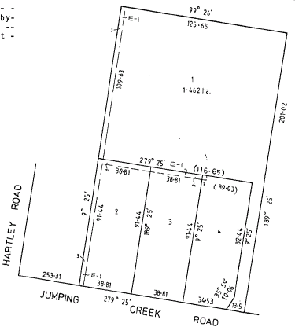 205891J issued to **Susan Le Fevre** of Jumping Creek Road Wonga Park.

2/7/1986 Caveat No.M348030A lodged. Caveat withdrawn 5/7/1988.

21/6/1988 Caveat No. N526695B by D. A. Stonehouse Pty. Ltd. as purchaser. Caveat will lapse on registration of N720809N.

20/9/1988 Caveat No. N719195Y by Graham Alan Pollock & Julie Gaye Pollock as purchasers. Caveat will lapse on registration of P98896U.

21/9/1988 Transfer No. N720809N from Susan Le Fevre to **D. A. Stonehouse Pty. Ltd.** of Hartley Rd. Wonga Park.

Plan of land on Certificate of Title Volume 9726 Folio 959 showing Plan of Subdivision No. 205891J and the land in the Title is marked ‘3”.

21/9/1988 Mortgage No. N720810N to National Australia Bank Limited, discharged 29/3/1989.

29/3/1989 Transfer No. P98896U from D. A. Stonehouse Pty. Ltd. to **Graham Alan Pollock** & **Julie Gaye Pollock** of 9 Glamis Crt. Croydon.

20/8/1990 Transfer No. P963106Y from Graham Alan Pollock & Julie Gaye Pollock to **Graham Alan Pollock** of 98 Jumping Creek Road Wonga Park.

8/7/1991 Mortgage No. R423746D to Perpetual Trustees Victoria Limited, discharged 3/7/1993.

3/6/1993 Mortgage No. S517399Q to Westpac Banking Corporation.

4/7/1996 Discharge No. U292396U of Mortgage No. S517699Q lodged.

4/7/1996 Mortgage No. U293397R to Australia and New Zealand Banking Group Limited.

6/2/1998 Discharge No. V243798N of Mortgage No. U293397R lodged.

6/2/1998 Transfer No. V243799K from Graham Pollock to **Paul Jeffrey Keenan** and **Marcia Therese Keenan** both of 98 Jumping Creek Road Wonga Park 3115.

6/2/1998 Mortgage No. V243800X to Australia and New Zealand Banking Group Limited lodged.

4/12/2006 Discharge No. AE763745H of Mortgage No. V243800X lodged.

4/12/2006 Transfer No. AE763746F from Paul Jeffrey Keenan and Marcia Therese Keenan to **Grace D’Annibale** and **Frank D’Annibale** both of 98 Jumping Creek Road Wonga Park Vic 3115.

28/5/2012 Survivorship Application No. AJ690453H by **Grace D’Annibale** of 98 Jumping Creek Road Wonga Park Vic 3115.

5/7/2016 Transfer No. AM913911Q from Grace D’Annibale to **Jamie Daniel Kupinic** and **Emma Jane McDougall** both of 98 Jumping Creek Road Wonga Park Vic 3115.

5/7/2016 Mortgage No. AM913912N to Pepper Finance Corporation Ltd lodged.

26/10/2017 Discharge No. AQ388769D of Mortgage No. AM913912N lodged.

26/10/2017 Mortgage No. AQ388772Q to National Australia Bank Ltd lodged.

***************************************************************************

**Certificate of Title Volume 9726 Folio 960 Street Address: 96 Jumping Creek Road Wonga Park**

Being Lot 4 on Plan of Subdivision No. 205891J.

***************************************************************************

**Certificate of Title Volume 4755 Folio 911**

3/5/1923 Certificate of Title Volume 4755 Folio 911, area 7 acres and 30 perches, being part of Crown Allotment 9T issued to **Florence Sharp** of Wonga Park Croydon Married Woman.

21/11/1923 Mortgage No. 478168 to Emma Sarah Atkyns, discharged 13/5/1924.

5/6/1924? Mortgage No. 492765 to Carolina Eliza Kitchen, discharged 5/9/1934.

Plan of land in Certificate of Title Volume 4755 Folio 911

5/9/1934 Mortgage No. 701748 to Beatrice May Gibbings, discharged 23/8/1935.

Plan attached to Certificate of Title Volume 4755 Folio 911 showing lands transferred out as to part and balance

23/8/1935 Transfer as to part No. 1587866, area 4 acres 0 roods and 2 perches, to Florence Ina Gambetta, new Certificate of Title Volume 5986 Folio 025.

26/3/1954 Red ink No. 5538470. Certificate of Title Cancelled. See Certificate of Title Volume 8054 Folio 201.

**************************************************************************

**Certificate of Title Volume 5986 Folio 025**

23/8/1935 Certificate of Title Volume 5986 Folio 025, area 4 acres and 2 perches, being part of Crown Allotment 9T issued to **Florence Ina Gambetta** of 4 Westbury Grove East St. Kilda Married Woman (after transfer No.1587866 from her aunt Florence Sharp).

28/5/1945 Mortgage No. 844921 to Minnie Polley, discharged 16/5/1947.

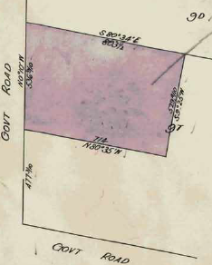31/3/1949 Transfer as to part No. 2205453 **to George Henry Goff**, new Certificate of Title Volume 7963 Folio 199.

17/3/1976 Transmission Application No. G71547. Florence Ina Gambetta died on 9th September 1974. Probate of her will has been sealed with the seal of the Supreme Court of Victoria upon the application of **Noel Margaret Pamphilon**.

Plan attached to Certificate of Title Volume 5986 Folio 025 showing Transfers out as to part and balance.

Plan of land in Certificate of Title Volume 5986 Folio 025

17/36/1976 Transfer as to balance No. G71548, new Certificate of Title Volume 9135 Folio 920.

**********************************************************************

**Certificate of Title Volume 7963 Folio 199**

31/3/1949 Certificate of Title Volume 7963 Folio 199, area 2 acres and 22 perches, being part of Crown Allotment 9T issued to George Henry Goff of 49 Moonee Street Ascot Vale Traveller (after Transfer No. 2205453 from Florence Ina Gambetta).

3/3/1954 Transfer No. 2625096 from George Henry Goff to **George Henry Goff** Traveller and **Ida Sturgess Goff** Married Woman both of Hartley Road Wonga Park.

Plan attached to Certificate of Title Volume 7963 Folio 199 showing transfers out as to part and balance.

Plan of land in Certificate of Title Volume 7963 Folio 199

3/3/1954 Transfer as to part No. 2625097 from George Henry Goff and Ida Sturgess Goff to Florence Sharp, new Certificate of Title Volume 8038 Folio 895.

22/12/1954 Caveat No. C117104 lodged. Caveat lapsed 22/11/1965.

2/4/1965 Survivorship Application No. C185124 by **Ida Sturgess Goff**.

17/9/1965 Transfer as to balance No. C316281, new Certificate of Title Volume 8592 Folio 330.

**********************************************************************

**Certificate of Title Volume 8038 Folio 895**

3/3/1954 Certificate of title Volume 8038 Folio 895 being part of Crown Allotment 9T issued to Florence Sharp of Wonga Park Croydon Married Woman,

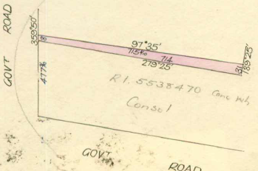26/3/1954 Red ink No. 5538470. Certificate of Title Cancelled. See Certificate of Title Volume 8054 Folio 261(this land was presumably consolidated with the land in Certificate of Title Volume 8054 Folio 025 also owned by Florence Sharp).

*************************************

**Certificate of Title Volume 8592 Folio 330**

17/9//1965 Certificate of Title Volume 8592 Folio 330, area 2 acres, being part of Crown Allotment 9T issued to **Beryl Therese Chivers** of Hartley Road Wonga Park (after Transfer as to balance No. C316281 from Ida Sturgess Goff).

Plan of land in Certificate of Title Volume8038 Folio 895

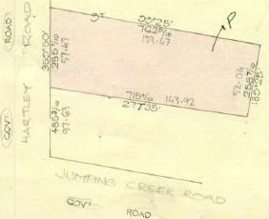 17/9/1965 Mortgage No. C316282 to Ida Sturgess Goff, discharged 7/1/1966.

7/1/1966 Transfer No. C398745 from Beryl Therese Chivers to **Clive Leonard Aikman** of Flat 4 No. 176 Glen Eira Road Elsternwick.

7/1/1966 Mortgage No. C398746 to Bank of New South Wales Savings Bank Limited, discharged 13/Jun 19?6.

26/7/1973 Mortgage No. E917305 to Bank of Adelaide Savings Bank Limited, discharged 4/10/1985.

Plan of the land in Certificate of Title Volume 8592 Folio 330

31/1/1979 Mortgage No. H390816 to Finance Corporation of Australia Limited, discharged 4/10/1985.

30/3/1979 Mortgage No. H466035 to The Bank of Adelaide, discharged 4/10/1985.

28/6/1984 Caveat No. L118575P lodged. Caveat Withdrawn 4/10/1985.

4/10/1985 Mortgage No. L920765H to The Commissioners of The State Bank of Victoria.

23/12/1987 Certificate of Title Cancelled. The following Titles have been issued Pursuant to Regulation 10 of the Transfer of Land Act: Lots One to 2 in Vol 9786 Fol 394 to Vol 9786 Fol 395 on LP 209756T.

****************************************************************************

**Certificate of Title Volume 9786 Folio 394 Street Address: 18 Hartley Road Wonga Park**

23/12/1987 Certificate of Title Volume 9786 Folio 394, area 4023 m2, being Lot 1 on Plan of Subdivision No. 209756T issued to **Clive Leonard Aickman** of Hartley Road Wonga Park subject to Mortgage No. L920465H.

23/10/1991 Mortgage No. R604162G to Commonwealth   
Bank of Australia.

17/7/1992 Caveat No. S19607R by Suzanne Lynette Aikman lodged. Caveat will lapse on registration of T50433V.

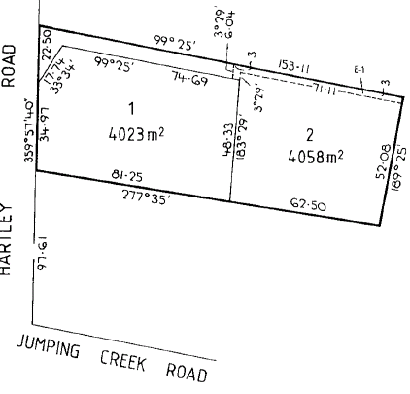26/4/1994 Transfer No. T050433V from Clive Leonard Aickman to **Clive Leonard Aickman** and **Suzanne Lynette Aikman** both of Hartley Road Wonga Park 3115.

21/4/2004 Discharge No. AC808560S of Mortgages Nos. L920465H and R604162G lodged.

21/4/2004 Transfer No. AC808561Q from Clive Leonard Aickman and Suzanne Lynette Aickman to **Shane Raymond Freeman** and **Leanne Margaret Freeman** both of Hartley Road Wonga Park Vic 3115.

21/4/2004 Mortgage No. AC808562N to GE Mortgage Solutions Limited lodged.

Plan on Certificate of Title showing Plan of Subdivision No. 209756T and the land in the Title is marked “1”

22/2/2006 Transfer No. AE199057Y of Mortgage No. AC808562N to Perpetual Trustee Company Ltd lodged.

15/5/2006 Discharge No. AE353469S of Mortgage No. AC808562N lodged.

15/5/2006 Transfer No. AE353470J from Shane Raymond Freeman and Leanne Margaret Freeman to **Leanne Margaret Freeman** of 18 Hartley Road Wonga Park Vic 3115.

15/5/2006 Mortgage No. AE353471G to Australia and New Zealand Banking Group Limited lodged.

29/10/2012 Discharge No. AJ993787M of Mortgage No. AE353471G lodged.

28/4/2014 Transfer No. AL040808G from Leanne Margaret Freeman as to 1 of a total of 2 equal undivided shares **Angelo John Lombardo** of 18 Hartley Road Wonga Park Vic 3115 and as to 1 of a total of 2 equal undivided shares **Leanne Margaret Atwood** of 18 Hartley Road Wonga Park Vic 3115.

****************************************************************************

**Certificate of Title Volume 9786 Folio 395 Street Address: 20 Hartley Road Wonga Park**

Lot 2 on Plan of Subdivision No. 209756T

****************************************************************************

**Certificate of Title Volume 9135 Folio 920 Street Address: 22 Hartley Road Wonga Park**

17/3/1976 Certificate of Title Volume 9135 Folio 920, area 7588 m2, being part of Crown Allotment 9T issued to **John Charles Pamphilon** of 11 Stanley Street Chatswood New South Wales Sales Representative and **Susan Noel Healy** of 11 Stanley Street Chatswood New South Wales as tenants in common in equal shares (After transfer No. G71548 from Noel Margaret Pamphilon presumably the legal personal representative of George Henry Goff).

???? Caveat No.H689795 lodged. Caveat will lapse on registration of K195646.

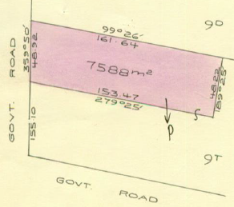11/11/1982 Caveat No. K157559 lodged. Caveat will lapse on registration of K235747.

14/12/1982 Caveat No. K195647 lodged. Caveat Withdrawn 20/1/1983.

20/1/1983 Transfer No. K235747 from John Charles Pamphilon and Susan Noel Healy to **Susan Noel Healy** of 4 Garnett Street Killara New South Wales Married Woman.

20/1/1983 Transfer No. K235747 from Susan Noel Healy to **Robert William Oliver** Cartage Contractor and **Pauline Ann Oliver** Married Woman both of “Pineview” Yarra Road Croydon.

Plan of the land in Certificate of Title Volume 9135 Folio 920

6/1/1984 Mortgage No. K710693 to The Commissioners of The State Savings Bank of Victoria, discharged 4/3/1996.

4/3/1996 Transfer No. U115045L from Robert William Oliver and Pauline Ann Oliver to Rodney Nelson Maruff & Margaret Anne Maruff of 12 Homestead Road Wonga Park.

************************************************************************

**Certificate of Title Volume 8054 Folio 201**

26/5/1954 Certificate of Title Volume 8054 Folio 201, area 3 acres 1 rood and 10 perches, 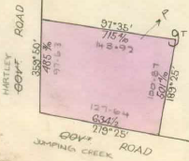being part of Crown allotment 9D and being the consolidation of the lands in the balance of the land in Certificate of Title Volume 4755 Folio 911 and the land in Certificate of Title Volume 8038 Folio895) issued to **Florence Sharp** of Wonga Park Croydon Married Woman.

1/11/1962 Transfer No. B536834 from Florence Sharp to **Peter Vergers** of Warrandyte Road Ringwood Orchardist.

20/9/1972 Transfer No. E537623 from Peter Vergers to **John Meredith Vergers** Orchardist and **Elizabeth Anne Vergers** Married Woman both of Wonga Road Ringwood.

Plan of the land in Certificate of Title Volume 8054 Folio 201.

1/3/1974 Mortgage No. F219684 to Australia and New Zealand Savings Bank Limited.

23/7/1984 Mortgage No. L163482U to Australia and New Zealand Banking Group Limited.

30/10/1984 Certificate of Title Cancelled. The following Titles have been issued Pursuant to Regulation 12 of the Transfer of Land Ac t: Lots One to 3 in Vol 9577 Fol 551 to Vol 9577 Fol 553. Pursuant to Section 32 of the Transfer of Land Act being a road in Vol 9577 Fol 554 on LP 146745W.

*************************************************************************

**Certificate of Title Volume 9577 Folio 551 Street Address: 16 Hartley Road Wonga Park**

30/10/1984 Certificate of Title Volume 9577 Folio 551, area 5386 m2, being Lot 1 on Plan of

Subdivision No. 146745W issued to **John Meredith Vergers** and **Elizabeth Ann Vergers** both of

Hartley Road Wonga Park subject to Mortgages Nos. F219684 and L163482U which mortgages

were discharged as to part being the within land on 4/12/1985.

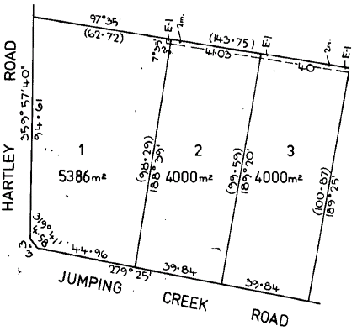4/12/1985 Transfer No. M24969B from John Meredith Vergers and Elizabeth Ann Vergers to **Une Joseph Parkinson** & **Carol May Parkinson** of Sheep Station Creek Rd. Yellingbo.

4/12/1985 Mortgage No. M24970B to National Australia Bank Limited, discharged 8/12/1997.

8/12/1997 Transfer No. V138185T from Une Joseph Parkinson and Carol May Parkinson to **David Grant Anderson** & **Wendy Elizabeth Anderson** of 114 Jumping Creek Rd. Wonga Park 3115.

8/12/1997 Mortgage No. V138186Q to Perpetual Trustees Australia Limited.

Plan on Certificate of Title showing Plan of Subdivision No. 146745W and on which the land in the Title is marked “1”

16/8/2007 Discharge No. AF276814W of Mortgage No. V138186Q lodged.

16/8/2007 Mortgage No. AF276815U to Pepper Finance Corporation Limited lodged.

3/5/2016 Discharge No. AM742040X of Mortgage No. AF276815U lodged.

21/7/2022 Caveat No. AV878804E by Jasmine May Turner and Joshua Stephen Turner as purchasers lodged.

14/10/2022 Transfer No. AW162743G from David Grant Anderson and Wendy Elizabeth Anderson to **Jasmine May Turner** and **Joshua Stephen Turner** both of 16 Hartley Road Wonga Park Vic 3115.

14/10/2022 Mortgage No. AW162744E to National Australia Bank Ltd lodged.

*************************************************************************

**Certificate of Title Volume 9577 Folio 552 Street Address 112 Jumping Creek Road Wonga Park**

Lot 2 on Plan of Subdivision No. 146745W

************************************************************************

**Certificate of Title Volume 9577 Folio 553 Street Address: 110 Jumping Creek Road Wonga Park**

Lot 3 on Plan of Subdivision No. 146745W