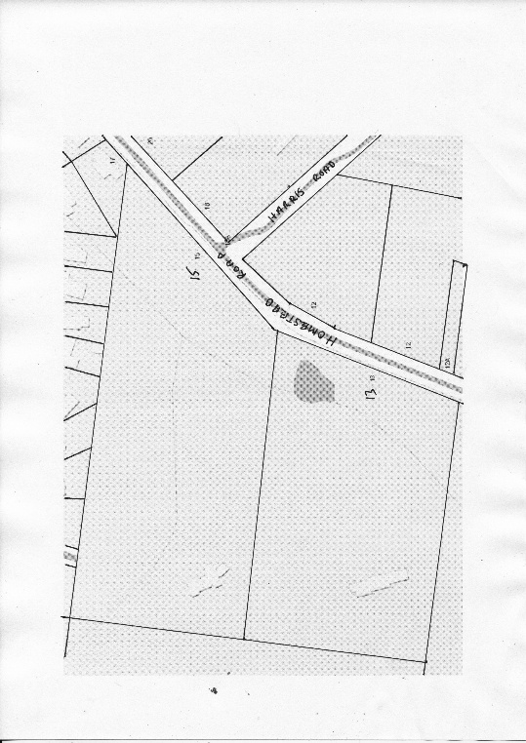
Title History of Lot 65 Plan of Subdivision No. 4315
Lot 65 on Plan of Subdivision No. 4315 being part of the land in Certificate of Title Volume 2734 Folio 735, area 24 acres 3 roods and 21 perches being Nos. 13 & 15Homestead Road Wonga Park.
The Mutual Assurance Society of Victoria Limited owned much of the land in Wonga Park in 1897 and drew up a plan of subdivision which Lot 52 was on but not approved until 1902 but, as was allowed in those days, sold lots on terms contracts before the plan was approved by the Titles Office. This Plan of Subdivision was registered as Plan of Subdivision No. 4315 and was the land in Certificate of Title Volume 2734 Folio 735.
A Street Map in which the land in Lot 65 Plan of Subdivision No. 4315 is shown with the Street Nos. 13 & 15.
Lot 65 on Plan of Subdivision No. 4315 Certificate of Title Volume 3981 Folio 018
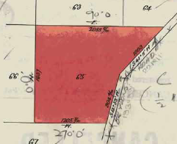
17/7/1916 Transfer No. 806315 from The Mutual Assurance Society of Victoria Limited to Anne Wright of Grove Road Box Hill Married Woman, area 24 acres 3 roods and 21 perches, of Lot 65, new Certificate of Title Volume 3981 Folio 018.
3/7/1920 Red Ink No. 2075109. Anne Wright died on 1st December 1919. Probate of her will has been granted to Fitzwalter George Read of William Street Melbourne Gentleman.
15/9/1922 Transfer No. 1065730 from Fitzwalter George Read to Harold Cornelius Kemp of corner of Prospect Hill Road and Spencer Street East Camberwell.
Plan of the land in Certificate of Title Volume 3981 Folio 018 being Lot 65 on Plan of Subdivision No. 4315
15/9/1922 Mortgage No. 451299 to Agnes Ann Porter, discharged 22/5/1957.
13/9/1926 Mortgage No. 548465 to Agnes Ann Porter, discharged 22/5/1957.
22/5/1957 Transfer No. A338546 from Harold Cornelius Kemp to Ernest Frederick Bloom of Firth Street Doncaster Builder and Albert Norris Bloom of Warrandyte Orchardist as tenants in common in equal shares.
19/1/1960 Transfer No. A893139 from Ernest Frederick Bloom and Albert Norris Bloom to Albert Norris Bloom of Warrandyte Orchardist.
19/1/1960 Mortgage No. A893140 to James Aloysius Kennedy, discharged 6/7/19??.
11/5/1965 Transfer as to one equal undivided half part or share No. C21567, new Certificate of Title Volume 8570 Folios 828.
23/8/1966 Mortgage No. C572284 to Bank of New South Wales, discharged 11/2/1970.
12/11/1970 Caveat No. D884432 lodged. Caveat lapsed 4/4/1973.
19/2/1973 Transfer as to balance No. E707540, new Certificate of Title Volume 8967 Folio 270.
*************************************************************************
Certificate of Title Volume 8570 Folio 828
13/5/1965 Certificate of Title Volume 8570 Folio 828 for One equal undivided part or share of, area 24 acres 3 roods and 21 perches, being Lot 65 on Plan of Subdivision No. 4315 issued to Albert Arthur Bloom of Homestead Road Wonga Park Orchardist.
23/8/1966 Mortgage No. C572284 to Bank of New South Wales, discharged 11/2/1970.
12/11/1970 Caveat No. D884432 lodged. Caveat lapsed 4/4/1973.
19/2/1973 Transfer No. E707540, new Certificate of Title Volume 8967 Folio 270.
************************************************************************
Certificate of Title Volume 8967 Folio 270
19/2/1973 Certificate of Title Volume 8967 Folio 270, area 24 acres 3 roods and 21 perches, being Lot 65 on Plan of Subdivision No. 4315 (after transfer from Albert Norris Boom and Albert Arthur Bloom) to Kevin Heffernan Company Director and Irene June Heffernan Married Woman both of “Greenways Stud” Homestead Road Wonga Park.
19/8/1985 Certificate of Title Cancelled. The following Titles have been issued Pursuant to Regulation 12 of the Transfer of Land Act. Lots One to 2 in Vol 9627 Fol 196 to Vol 9627 Fol 127.
**********************************************************************
Certificate of Title Volume 9627 Folio 196 Street Address 15 Homestead Road Wonga Park
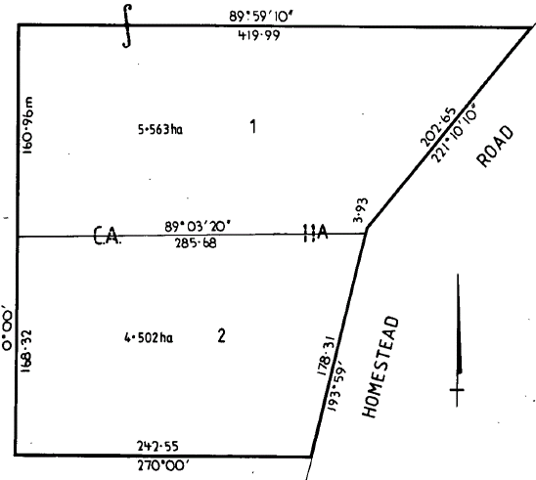
19/8/1985 Certificate of Title Volume 9627 Folio 196, area 5.563 hectares, being Lot 1 on Plan of Subdivision No. 200576U issued to Kevin Heffernan and Irene June Heffernan both of “Greenways Stud” Homestead Road Wonga Park.
27/1/1988 Caveat No. N258257Y by Taylor Logging Co. Pty. Ltd. as purchaser. Caveat will lapse on registration of N443350P 20/5/1988.
9/5/1988 Transfer No. N443350P from Kevin Heffernan and Irene June Heffernan to Taylor Logging Co. Pty. Ltd. of 463 Mt. Dandenong Rd. Kilsyth.
Plan attached to Certificate of Title Volume 9627 Folio 196 showing Lots 1 & 2 on Plan of Subdivision No. 200576U, Lot 1 being the land in the Title and Lot 2 being the land in Certificate of Title Volume 9627 Folio 197.
9/5/1988 Mortgage No. N443351L to Commonwealth Bank of Australia, discharged 2/8/1989.
2/8/1989 Transfer No. P348361N from Taylor Logging Co. Pty. Ltd. to Gordon Forbes Strachan & Lorraine Lesley Strachan of Black Springs Rd. Chirnside Park.
2/8/1989 Mortgage No. P348362K to Commonwealth Bank of Australia.
20/10/1998 Discharge No. V700858G of Mortgage No. P348362K lodged.
26/6/2000 Transfer No. W866461T from Gordon Forbes Strachan and Lorraine Lesley Strachan as joint proprietors to as tenants in common as to 1 of a total of 2 equal undivided shares as sole proprietor Gordon Forbes Strachan of 15 Homestead Rd. Wonga Park and as to 1 of a total of 2 equal undivided shares as sole proprietor Lorraine Lesley Strachan of 15 Homestead Rd. Wonga Park.
1/2/2003 Mortgage No. AB846724G to Commonwealth Bank of Australia lodged.
5/7/2021 Discharge No. AU536949U of Mortgage No. AB846724G lodged.
****************************************************************************
Certificate of Title Volume 9627 Folio 197 Street Address: 13 Homestead Road Wonga Park
19/8/1985 Certificate of Title Volume 9627 Folio 197, area 4.502 hectares, being Lot 2 on Plan of Subdivision No. 200576U issued to Kevin Heffernan and Irene June Heffernan both of “Greenways Stud” Homestead Road Wonga Park.
18/9/1985 Transfer No. L894443T from Kevin Heffernan and Irene June Heffernan to Gerard Van Ommen & Johanna Van Ommen both of 3 Nelson Road Warrandyte.
18/9/1985 Mortgage No. L894444G to Australia and New Zealand Savings Bank Limited, discharged 15/6/1988.
22/11/1985 Mortgage No. M6861K to Kevin Heffernan an Irene June Heffernan, discharged 15/10/1986.
20/1/1988 Caveat No. N250203L by Roger Eric Kirsten & Joan Irene Kirsten as purchasers. Caveat will lapse on registration of N516094U.
15/6/1988 Transfer No. N516094U from Gerard Van Ommen and Johanna Van Ommen to Roger Eric Kirsten & Joan Irene Kirsten both of Hillcrest Rd. Warranwood.
9/6/1999 Caveat No. W095870Y by Peter John Trewin as purchaser lodged.
8/10/1999 Withdrawal No. W377468F of Caveat No. W095870Y lodged.
8/10/1999 Transfer No. W337469C from Roger Eric Kirsten and Joan Irene Kirsten to Peter John Trewin and Beverley Anne Trewin both of 13 Homestead Rd Wonga Park 3115.
8/10/1999 Mortgage No. W337470C to Westpac Banking Corporation lodged.
2/6/2011 Discharge No. AH988091Y of Mortgage No. W337470C lodged.
2/6/2011 Transfer No. AH988092W from Peter John Trewin and Beverley Anne Trewin to Yong Lian of 13 Homestead Road Wonga Park Vic 3115.
2/6/2011 Mortgage No. AH988093U to HSBC Bank Australia Ltd lodged.
11/2/2016 Discharge No. AM554837Y of Mortgage No. AH988093U lodged.
11/2/2016 Mortgage No. AM554838W to Westpac Banking Corporation lodged.
12/10/2012 Caveat No. AU903515L by Nicky Vorenas as purchaser lodged.
5/11/2021 Discharge No. AU988801F of Mortgage No. AM554838W lodged.
5/11/2021 Transfer No. AU988802D from Yong Lian to Nicky Vorenas of 13 Homestead Road Wonga Park Vic 3115.
5/11/2021 Mortgage No. AU988803B to Australia and New Zealand Banking Group Ltd lodged.

