**Title History of Crown Allotment 14 A and 14 A1 Parish of Warrandyte**

18/6/1883 Crown Grant Volume 1483 Folio 409, area 179 acres and 20 perches, being (Crown) Allotment 14 A for the consideration of One hundred and eighty pounds issued to **George Prowlin Gatter** of Box Hill Farmer.

**10/8/1886 Memo No. 6292. **Joseph Clemens** **Matthews** of Kew Bank Manager and **Edward Dickason** of Lennox Street Richmond Law Clerk are registered as proprietors of the within described land as executors to whom Probate of the Will of George Prowlin Gatter who died 2 April 1886 was granted 22 April 1886.

Plan of land in Crown Grant Volume 1483 Folio 409

Street Plan of the Western part of Crown Allotment 14 A and Crown Allotment 14 A1

10/8/1886 Transfer as to part No. 174444, area 84 acres 3 roods and 22 perches, from Joseph Clemens Matthews and Edward Dickason to (a son of George Prowlin Gatter) **James George Gatter**, new Certificate of Title Volume 1846 Folio 125.

Plan of Land on Crown Grant volume 1483 Folio 509showing lands transferred out.

Street Plan of the Eastern Part of Crown Allotment 14 A

8/7/1903 Transfer as to balance No. 474327 from Joseph Clemens Matthews and Edward Dickason to **Catherine Amelia Charlesworth**, new Certificate of Title Volume 2938 Folio 518.

**\*\*\*\*\*\*\*\*\*\*\*\*\*\*\*\*\*\*\*\*\*\*\*\*\*\*\*\*\*\*\*\*\*\*\*\*\*\*\*\*\*\*\*\*\*\*\*\*\*\*\*\*\*\*\*\*\*\*\*\*\*\*\*\*\*\*\*\*\*\*\*\*\*\***

**Certificate of Title Volume 1846 Folio 125**

10/8/1886 Certificate of Title Volume 1846 Folio 125, area 84 acres 3 roods and 22 perches, being part of Crown Allotment 14 A issued to **James George Gatter** of Box Hill Nurseryman.

15/8/1892 Mortgage No. 138545 to The English Scottish and Australian Chartered Bank.

9/11/1901 Transfer as to part No. 446278 from The English Scottish and Australian Bank Limited to Thomas Henry Power, area 45 acres 0 roods and 7½ perches, new Certificate of Title Volume 2850 Folio 900.

Plan of the land in Certificate of Title Volume 1849 Folio 125

Plan attached to Certificate of Title Volume 1846 Folio 125 showing lands transferred out.

11/12/1907 Transfer as to balance No. 562265 from The English Scottish and Australian Bank Limited to Joseph Hutchinson the Elder, new Certificate of Title Volume 3243 Folio 524.

*************************************************************************

**Certificate of Title Volume 2850 Folio 900**

9/11/1901 Certificate of Title Volume 2850 Folio 900, area 45 acres and 7½ perches, being 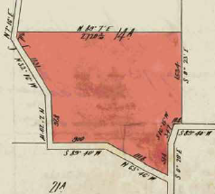part of Crown allotment 14 A issued to **Thomas Henry Power** of Yarra Road Croydon Farmer.

9/11/1901 Mortgage No. 207951 to the English Scottish and Australian Bank Limited, discharged 22/10/1908.

22/10/1908 Mortgage No. 266085 to The Commissioners of Savings Banks in the Colony of Victoria, discharged as to part being the land in Transfer No. 997949 20/5/1921 and discharged (in full) ?/10/1921.

Plan of land in Certificate of Title Volume 2850 Folio 900

20/8/1915 Mortgage No. 351109 to The Commissioners of the State Savings Bank of Victoria, discharged 20/5/1921.

20/5/1921 Transfer as to part No. 997949, area 4 acres 2 roods and 25 perches, to Michael Duggan, new Certificate of Title Volume 4468 Folio 404.

24/5/1922 Mortgage No. 444578 to Cornelia Ann Henry.

22/1/1923 Mortgage No. 458102 to (his sister) Mary Jane Power.

14/1/1924 Red Ink No. 2447076 Certificate of Title Cancelled. See Certificate of Title Volume 4894 Folio 626.

********************************

**Certificate of Title Volume 4894 Folio 626**

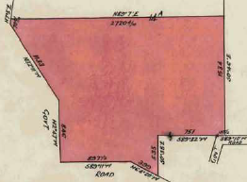14/1/1924 Certificate of Title Volume 4894 Folio 626, area 40 acres 3 roods and 3 perches, being Part of Crown allotment 14 A issued to **Thomas Henry Power** of Yarra Road Croydon subject to Mortgages Nos. 444578 and 458102 which mortgages were discharged on 25/8/1924.

Plan attached to Certificate of Title Volume 2850 Folio 900 showing lands transferred out.

18/9/1924 Transfer as to part No. 1184715 to The Minister of the Crown administering the Education Acts, area 4 acres 1 rood and 2 perches, new Certificate of Title Volume 4907 Folio 291 (presumably the site of Yarra Road Primary School).

Plan of land in Certificate of Title Volume 4894 Folio 626

13/10/1924 Transfer as to part No. 1187961, 3 acres 0 roods and 2 perches, to George Charles Rose, new Certificate of Title Volume 4919 Folio 731.

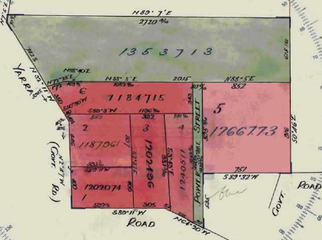9/2/1925 Transfer as to part No. 1202074. Area 2 acres 1 rood and 19 perches, to Clara Catherine Wilson, new Certificate of Title Volume 4954 Folio 650.

10/2/1925 Transfer as to part No. 1202496, area 3 acres 0 roods and 15 perches, to (his sister) Mary Jane Power, new Certificate of Title Volume 4954 Folio 651.

11/11/1925 Transfer as to Part No. 1240541, area 2 acres 2 roods and 3 perches, to (his sister) Mary Jane Power, new Certificate of Title Volume 5061 Folio 047.

Plan attached to Certificate of Title Volume 4894 Folio 626 showing the lands transferred out

20/5/1926 Transfer as to part No. 1266773, area 7 acres 2 roods and 36 perches, to Alfred Victor Collings, new Certificate of Title Volume 5130 Folio 868.

27/8/1926 Mortgage as to part ??? No. 547185 to The Commissioners of The State Savings Bank of Victoria.

7/2/1928 Transfer as to balance No. 1353713 to (his sister) Mary Jane Power, new Certificate of Title Volume 5367 Folio 378.

************************************************************************

**Certificate of Title Volume 5130 Folio 868**

20/5/1926 Certificate of Title Volume 5130 Folio 868, area 7 acres 2 roods and 36 perches, being Lot 5 on Plan of Subdivision No. 10273 and being part of Crown Allotment 14A (after Transfer as to part No. 1266773 from Thomas Henry Power) issued to **Alfred Victor Collings** of Exeter Road Croydon Laborer.

14/6/1950 Transfer as to part No. 2311539 to (his son) Raymond Victor Collings, area 1 acre 0 roods 0 perches, new Certificate of Title Volume 7422 Folio 359.

Plan attached to Certificate of Title Volume 513 Folio 868 showing lands transferred out.

Plan of land in Certificate of Title Volume 5130 Folio 868.

3/8/1954 Transfer as to balance No. 2662069 to Raymond Victor Collings, new Certificate of Title Volume 8056 Folio 220.

**************************************************************************

**Certificate of Title Volume 7422 Folio 359**

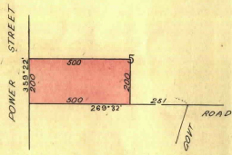14/6/1950 Certificate of Title Volume 7422 Folio 359, a large house block 200 links x 500 links) being part of Lot 5 on Plan of Subdivision No. 10273 (after Transfer as to part No. 2311539 from Alfred Victor Collings) issued to (his son) **Raymond Victor Collings** of 14 Wilana Street Ringwood Sheetmetal Worker.

9/11/1959 Mortgage No. A851511 to the Commercial Bank of Australia, discharged 8/3/1962.

8/3/1962 Transfer No. B378718 from Raymond Victor Collings to **Raymond Hector Smith** Gentleman and **Esther Smith** Married Woman both of 36 Croydon Road Croydon.

Plan of land in Certificate of Title Volume 7422 Folio 359.

1/2/1963 Transfer No. 589606 from Raymond Hector Smith to **John Harold Roberts** of 21 Holloway Road Croydon Electrician.

28/3/1963 Mortgage No. B625878 to Australia and New Zealand Savings Bank Limited, discharged 5/11/1980.

5/11/1980 Transfer No. J222447 from John Harold Roberts to **Raymond Douglas Downes** School Teacher and **Denise Lorraine Downes** both of 1 Darook Street Blackburn.

29/3/2000 Mortgage No. W691289W to Education Credit Union Co-Operative Ltd.

5130.

***************************************************************************

**Certificate of Title Volume 8056 Folio 220**

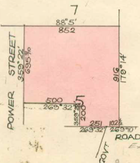3/8/1954 Certificate of Title Volume 8056 Folio 220, area 6 acres 2 roods and 36 perches, being part of Lot 5 on Plan of Subdivision No. 10273 (after Transfer as to balance No. 266069 from Alfred Victor Collings) issued to (his son) **Raymond Victor Collings** of 14 Yarra Road Croydon Primary Producer.

9/11/1959 Mortgage No. A851511 to the Commercial Bank of Australia, discharged 8/3/1962.

13/4/1962 Transfer No. B403609 from Raymond Victor Collings to **Cecil Herbert Chorley** Horticulturist and **Iris Chorley** Married Woman both of 62 Tynong Street Croydon.

Plan of land in Certificate of Title Volume 8056 Folio 220.

30/6/1965 Caveat No. C252338 lodged. Caveat transferred to new C/T.

Plan of land on Certificate of Title showing the Lots 1 and 2 on Plan of Subdivision No. 71716

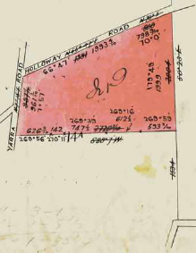7/3/1966 Certificate of Title Cancelled Pursuant to Regulation 12 and Titles issued as set out hereunder: Lots One and 2 in Vol 8604 Fol 960 and Vol 8604 Fol 961 – LP 71716.

****************************************

**Certificate of Title Volume 3243 Folio 524**

11/12/1907 Certificate of Title Volume 3243 Folio 524, area 39 acres 1 rood and 3 perches, being part of Crown Allotment 14 A issued to **Joseph David Hutchinson the Elder** of Henry Street Blackburn Fruit Grower.

2/6/1911 Transfer No. 652173 from Joseph David Hutchinson the Elder to **Mary Jane Brunner Watkins** of Cambridge Street Box Hill Married Woman.

18/6/1914 Transfer No. 750543 from Mary Jane Brunner Watkins to **Charles Ernest Wright** of Manningtree Road Hawthorn Architect.

7/7/1916 Mortgage No. 361131 to Cecelia Eddy,

Plan of land in Certificate of Title Volume 3243 Folio 524.

discharged 1/7/1919.

15/1/1945 Red Ink No. 4206030. Charles Ernest Wright died on 2nd September 1944. Probate of his Will has been granted to **The Equity Trustees Executors and Agency Company Limited** of 472 Bourke Street Melbourne.

17/1/1945 Transfer No. 1940522 from The Equity Trustees and Agency Company Limited to **Frank Cecil Edyvane** of Wonga Park Farmer.

27/3/1950 Transfer as to part No. 2291066 to Douglas Ernest Godden, new Certificate of Title Volume 7379 Folio 773.

27/3/1950 Transfer as to part No. 2094730 to Douglas Ernest Godden, new Certificate of Title Volume 7379 Folio 773. (apart from the transfer No. this appears to be a duplicate of the previous transfer – also the later entry appears to have an earlier Transfer No.)

Plan attached to Certificate of Title Volume 3243 Folio 524 showing the lands transferred out.

15/6/1953 Transfer as to balance No. 2565398 to Sydney Cain, new Certificate of title Volume 7897 Folio 073.

*************************************************************************

**Certificate of Title Volume 7379 Folio 773**

27/3/1950 Certificate of Title Volume 7379 Folio 773, area 11 acres 3 roods and 1 perch being part of Crown Allotment 14 A (this Certificate of Title was derived from two transfers as to part Nos. 2094730 and 2291066 both from Frank Cecil Edyvane and both from Certificate of Title Volume 3243 Folio 524) issued to **Douglas Ernest Godden** of Holloway Road Croydon Bricklayer.

1/12/1971 Transfer No. E238897 from Douglas Ernest Godden to **Douglas Ernest Godden** and **Harrie Blaikie Godden** Married Woman both of Holloway Road Croydon.

13/8/1980 Survivorship Application No. J110333 by **Harrie Blaikie Godden**.

14/10/1980 Caveat No. 516180R lodged. Caveat will lapse on registration of M755385X – 22/4/1987.

Plan of the land in Certificate of Title Volume 7379 Folio 773.

20/3/1987 Transfer No. M755386U from Harrie Blaikie Godden to **Yarra Views Estate Pty. Ltd.** of 170 Warrandyte Rd. North Ringwood.

20/3/1987 Mortgage No. M755386U to Mercantile Credits Limited.

20/1/1988 Certificate of Title Cancelled. The following Titles have been issued Pursuant to Regulation 10 of the Transfer of Land Act: Lots One to 3 in Vol 9791 Fol 441 to Vol 9791 Fol 443, Pursuant to Section 32 of the Transfer of Land Act being a Reserve for Drainage Sewerage & Recreation Purposes in Vol 9791 Fol 444 and Pursuant to Section 32 of the Transfer of Land Act being the Roads in Vol 9793 Fol 772 all on LP 210145S.

**\*\*\*\*\*\*\*\*\*\*\*\*\*\*\*\*\*\*\*\*\*\*\*\*\*\*\*\***

**Certificate of Title Volume 9791 Folio 443**

20/1/1988 Certificate of Title Volume 9791 Folio 443, area 1.721 hectares, being Lot 3 on Plan of Subdivision No. 210145S issued to **Yarra View Estate Pty. Ltd.** of 9 Schaffer Drive Doncaster East subject to Mortgage No. M755386U.

28/4/1988 Certificate of Title Cancelled. The following Titles have been issued Pursuant to Regulation 10 of the Transfer of Land Act: Lots 26 to 38 in Vol 9806 Fol 800 to Vol 9806 Fol 812 and Pursuant to Section 32 of the Transfer of Land Act being the Road in Vol. 9806 Fol. 813.

Plan on Certificate of Title Volume 9791 Folio 443 on which the land in the Title is marked “3”

**Certificate of Title Volume 2938 Folio 518**

8/7/1903 Certificate of Title Volume 2938 Folio 518, area 92 acres, being part of Crown Allotment14 A (after Transfer No. 474321 from Joseph Clemens Matthews and Edward Dickason the Legal Personal Representatives of George Prowlin Gatter deceased) issued to **Catherine Amelia Charlesworth** of Croydon Married Woman.

27/8/1913 Transfer as to part No.723109, area 9 acres and 12 perches, to William George Francis Pritchard, new Certificate of Title Volume 3719 Folio 758.

Plan of Subdivision No. 210147N being a subdivision of Lot 3 on Plan of Subdivision No. 210145S

22/3/1916 Transfer as to part No. 797622, area 9 acres and 29 perches, to William James Smith, new Certificate of Title Volume 3960 Folio 892.

16/7/1919 Transfer as to part No. 894406, area 9 acres 0 roods and 23 perches, to William

George Francis Pritchard, new Certificate of Title Volume 4223 Folio 562.

Plan of land in Certificate of Title volume 2938 Folio 518

24/9/1920 Transfer as to part No. 964427, area 9 acres 3 roods and 26 perches, to William James Smith, new Certificate of Title Volume 4374 Folio 719.

4/9/1922 Transfer as to part No. 1063585, area 24 acres 3 roods and 30 perches, to William Henry Burke, new Certificate of Title Volume 4669 Folio 732.

15/9/1922 Transfer as to part No. 1065896. Area 9 acres 3 roods and 17 perches, to Walter John Bishop, new Certificate of Title Volume 4669 Folio 733.

Plan attached to Certificate of Title Volume 2938 Folio 518 showing the lands transferred out.

27/3/1947 Transfer as to balance No. 2064513 to Leonard David Smith, new Certificate of Title Volume 6978 Folio 420.

***************************************************************************

**Certificate of title Volume 3719 Folio 758**

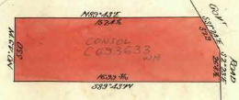27/8/1913 Certificate of title Volume 3719 Folio 758, area 9 acres and 12 perches, being part of Crown Allotment 14A (after Transfer No. 723109 from Catherine Amelia Charlesworth) issued to **William George Francis Pritchard** of No. 4 Beach Road St. Kilda Farmer.

9/2/1923 Transfer No. 1088043 from William George Francis Pritchard to **William James Smith** of Yarra Road Croydon Orchardist.

Plan of land in Certificate of Title Volume 3719 Folio 758

6/7/1923 Mortgage No. 570713 to The English Scottish and Australian Bank limited, discharged 24/9/1948.

13/8/1927 Caveat No. 73522 lodged. Caveat lapsed 18/2/1949.

24/9/1948 Transfer No. 216776 from William James Smith to **Wilbur Raymond Wright** Orchardist and **Lois May Wright** Married Woman both of Yarra Road Croydon.

19/12/1955 Transfer No. A88454 from Wilbur Raymond Wright and Lois May Wright to **Roy August Aumann** of 25 Kerrimuir Street Box Hill Orchardist.

31/1/1967 Certificate of Title Cancelled by Application No. C693633, new Certificate of Title Volume 8659 Folio 920.

**************************************************************************

**Certificate of Title Volume 3960 Folio 892**

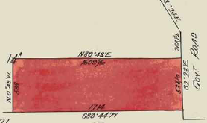22/3/1916 Certificate of Title Volume 3960 Folio 892, area 9 acres and 29 perches, being part of Crown Allotment 14 A (after Transfer No. 297622 from Catherine Amelia Charlesworth) issued to **William James Smith** of Yarra Road Croydon Orchardist.

9/10/1923 Transfer No. 1139269 from William James Smith to **His Majesty King George V**. Certificate of Title Cancelled.

Presumably this land was acquired by the Crown for the purposes of Soldier Settlement after World War I.

Plan of the land in Certificate of Title Volume 3960 Folio 892.

*****************************************************************************

**Certificate of Title Volume 4374 Folio 719**

24/9/1920 Certificate of Title Volume 4374 Folio 719, area 9 acres 3 roods and 26 perches, being part of Crown Allotment 14 A (after Transfer No. 964427 from Catherine Amelia Charlesworth) issued to **William James Smith** of “The Pines” Yarra Road Croydon Foreman Packer.

9/10/1923 Transfer No. 1139269 from William James Smith to **His Majesty King George V**. Certificate of Title Cancelled.

Plan of the land in Certificate of Title Volume 4374 Folio 719

***************************************************************************

**Certificate of Title Volume 4669 Folio 732**

4/9/1922 Certificate of Title Volume 4669 Folio 732, area 24 acres 3 roods and 30 perches, being part of Crown Allotment 14 A (after Transfer No. 1063585 from Catherine Amelia Charlesworth) issued to **William Henry Burke** of Gatters Road Croydon.

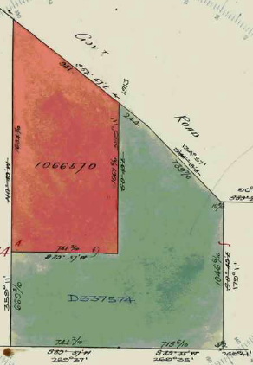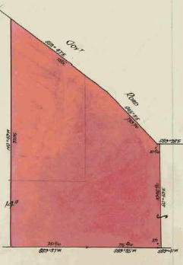20/9/1922 Transfer as to part No.1066570, area 10 acres 0 roods and 0 perches, to John Richard Heys, new Certificate of Title Volume 4669 Folio 734.

21/12/1949 Red Ink No. 4812906. William Henry Burke died on16th August 1949. Probate of his Will has been granted

to William Abraham Burke of Gatters Road Croydon Orchardist.

19/8/1968 Notice No. D159283. State Electricity Commission has pursuant to Section 57 of Transfer of Land Act served a notification relating to the compulsorily acquisition of an easement over land herein. Dated 13/8/1968.

Plan attached to Certificate of Title Volume 4669 Folio 732 showing lands transferred out.

Plan of land in Certificate of Title Volume 4669 Folio 732.

13/3/1969 Transfer as to balance No. D337574, new Certificate of Title Volume 8777 Folio 371.

*****************************************************8

**Certificate of Title Volume 4669 Folio 734**

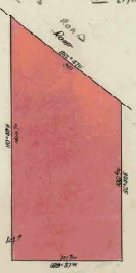20/9/1922 Certificate of Title Volume 4669 Folio 734, area 10 acres, being part of Crown allotment 14 A issued (after Transfer No. 1066570 from William Henry Burke) to John **Richard Heys** of Gatters Road Croydon Orchardist.

22/10/1948 Transfer No. 2172911 from John Richard Heys to **Edwin Ivor Sargant** Plasterer and **Mabel Sargant** Married Woman both of 16 Sydney Road Murrumbeena.

11/4/1951 Transfer No. 2394143 from Edwin Ivor Sargant and Mabel Sargant to **Peter Virtue** of 71 Anderson Street North Richmond.

13/6/1951 Mortgage No. 981227 to John Gregory Mackenzie, discharged 22/4/1955.

27/4/1953 Caveat No. 134569 lodged. Caveat lapsed 29/11/1956.

29/11/1956 Transfer No. A258003 from Peter Virtue to **Francis Harry Barr** Painter and **Esma Joan Bar**r Married Woman both of Gaters (sic) Road Croydon.

Plan of land in Certificate of Title Volume 4669 Folio 734

27/4/1983 Mortgage No. E 346941 to Rural Finance Commission, discharged 29/8/1988.

Plan attached to Certificate of Title Volume 4669 Folio 734 showing land cancelled as to part

5/10/1988 Application No. N749825T. Certificate of Title Cancelled as to part, see Certificate of Title Volume 9851 Folio 903

.

24/2/1989 Title Cancelled. The following titles have been issued Pursuant to Regulation 10 of the Transfer of Land Act: Lots 1 to 4 in Vol. 9863 Fol. 236 to Vol. 9865 Fol. 239 all in LP 213308Y.

*****************************************************

**Certificate of Title Volume 9851 Folio 903**

5/10/1988 Certificate of Title Volume 9851 Folio 903, area 5833m2, being part of Crown Allotment 14 A issued to **Francis Harry Barr** and **Esma Joan Barr** both of Gatters Road Wonga Park (presumably a separate title was created for this land in anticipation of it being compulsorily acquired as part of the Northern Arterial Route that was proposed to connect

Reynolds Road Donvale and the Maroondah Highway Croydon near Officeworks).

25/6/2018 Survivorship Application No. AR169125Q by **Esma Joan Barr** of 29 Gatters Road Wonga Park Vic 3115.

******************************

**Certificate of Title Volume 9863 Folio 239**

24/2/1989 Certificate of Title Volume 9863 Folio 239, area 2.135 hectares, being Lot 4 on Plan of Subdivision No. 213308Y issued to **Francis Harry Barr** and **Esma Joan Barr** both of Gatters Road Wonga Park.

Plan of land in Certificate of title Volume 9851 Folio 903.

25/6/2018 Survivorship Application No. AR169076B by **Esma Joan Barr** of 29 Gatters Road Wonga Park.

**\*\*\*\*\*\*\*\*\*\*\*\*\*\*\*\*\*\*\*\*\*\*\*\*\*\*\*\*\*\*\*\*\*\*\*\*\*\*\*\*\*\*\*\*\*\*\*\*\*\*\*\*\***

**Crown Grant Volume 7924 Folio 640**

Plan on Certificate of Title Volume 9863 Folio 239 whereon the land in the Title is marked “4”.

20/1/1949 Crown Grant Volume 7924 Folio 640, area 19 acres and 15 perches, in consideration of the sum of £801/1/5 granted the land being Crown allotment 14 A1 parish of Warrandyte to **William James Smith** and **Charles Hector Smith** both of Yarra Road Croydon Orchardists as tenants in common in equal shares.

16/11/1949 Transfer No.2276762 as to the interest of William James Smith to **Charles Hector Smith**, new Certificate of Title Volume 7495 Folio 017.

Plan of land in Crown Grant Volume 7924 Folio 640

***************************************************************************

**Certificate of Title Volume 7495 Folio 017**

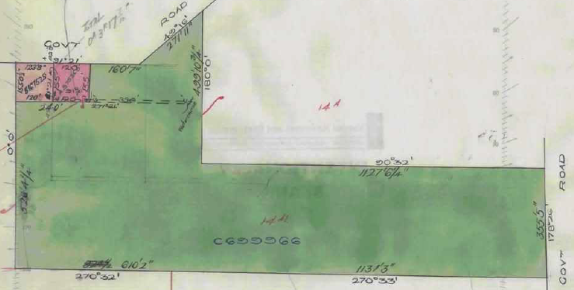16/11/1949 Certificate of Title Volume 7495 Folio 017, area 19 acres and 15 perches, being Crown Allotment 14 A1 issued to

Plan attached to Certificate of Title Volume 7495 Folio 017 showing lands transferred out.

Plan of land in Certificate of Title Volume 7495 Folio 017.

**Charles Hector Smith** of Yarra Road

Croydon Orchardist.

29/7/1958 Transfer as to part and Creation of Easement No. A575365, new Certificate of Title Volume 8198 Folio 725.

7/3/1961 Transfer as to part and Creation of Easement No. B167525, new Certificate of Title Volume 8661 Folio 331.

8/1/1967 Transfer as to balance No. B699966, new Certificate of Title Volume 8661 Folio

158.

*****************************************************************************

**Certificate of Title Volume 8661 Folio 158**

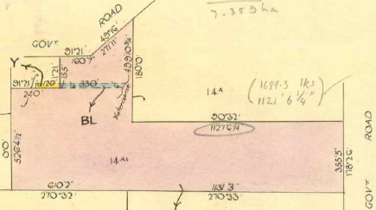8/2/1967 Certificate of Title Volume 8661 Folio 158, area 19 acres and 37.3 perches, being part of Crown Allotment 14 A1after Transfer No. C699966 from their father Charles Hector Smith) issued to **Roger Charles Smith** and **Neil Stanley Smith** both of Yarra Road Croydon Orchardists.

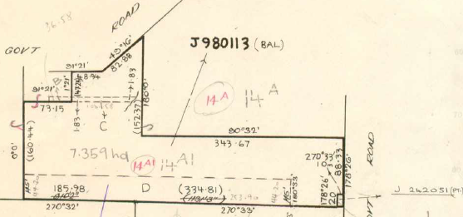8/2/1967 Mortgage No. C699967 to Charles Hector Smtih, discharged 27/7/1969.

Olan of land in Certificate of Title Volume 8661 Folio 158

19/8/1968 Notice No. D159287. State Electricity Commission has pursuant to Section 57 of Transfer of Land Act served a notification relating to the compulsorily acquisition of an easement over land herein. Dated 13/8/1968.

Plan attached to Certificate of Title Volume 8661 Folio 158 showing lands transferred out and creation of easement.

12/8/1969 Creation of Easement No. D473453.

11/9/1975 Mortgage No. F849843 to National Bank of Australasia Limited, discharged 15/9/1978.

20/11/1980 Transfer as to part No. J242051, new Certificate of Title Volume9409 Folio 324.

23/6/1982 Transfer as to balance No. J980113, new Certificate of Title Volume 9478 Folio 219.

********************************

**Certificate of Title Volume 9478 Folio 219**

23/6/1982 Certificate of Title Volume 9478 Folio 219 being part of Crown Allotment 14 A1 (after Transfer No. J980113 from Roger Charles Smith and Neil Stanley Smith) issued to **Neil Stanley Smith** of Yarra Road Croydon Orchardist.

Plan of the land in Certificate of Title Volume 9478 Folio 219.

6/5/1983 Certificate of Title Cancelled. The following Titles have been issued Pursuant to Regulation 11 of the Transfer of Land Act: Lots One to A in Vol. 9510 Fol. 347 and Vol. 9510 Fol. 348.

*************************************************************************

**Certificate of Title Volume 9510 Folio 348**

6/5/1983 Certificate of Title Volume 9510 Folio 348, area 6.942 hectares, being Lot A on Plan of Subdivision No. 141703 issued to **Neil Stanley Smith** of Yarra Road Croydon Orchardist.

6/7/1983 Caveat No. K446892 lodged. Caveat withdrawn 19/7/1989.

18/5/1989 Caveat No. P200357P by Analed Pty. Ltd. lodged. Caveat will lapse on registration of P424248M.

13/9/1989 Transfer No. P424248M from Neil Stanley Smith to Analed Pty Ltd of 4th Floor 95   
Spring St. Melbourne.

19/3/1990 Certificate of Title Cancelled. The following Titles have been issued Pursuant to Regulation 10 of the Transfer of Land Act: Lots A to B in Vol. 9937 Fol. 657 and in Vol 9937 Fol. 658 LP 219261R.

Plan on Certificate of Title Volume 9510 Folio on which the land in the Title is marked “A”.

**************************************************************************

**Certificate of Title Volume 9937 Folio 658**

19/3/1990 Certificate of Title Volume 9937 Folio 658, being Lot B on Plan of Subdivision No.

219261R issued to **Analed Pty. Ltd.** of 85 Spring Street Melbourne.

8/4/1993 No. B319002M Certificate of Title Cancelled Pursuant to Section 24 Subdivision Act 1988.

**************************************************************************

**Certificate of Title Volume 10109 Folio 213**

11/7/1995? Certificate of Title Volume 10109 Folio 213 derived from Certificates of Title Volume9937 Folio 658 and 660

7/1/1994 Surrender No. S875680Q of Easement No. D473453 lodged.

11/7/1995 Title Cancelled by Plan of Subdivision No. 333527A.

*****************************************************************************

**Certificate of Title Volume 10239 Folio 667**

11/7/1995 Certificate of Title Volume 10239 Folio 667 being Lot 108 on Plan of Subdivision No. 333527A issued to **Analed Pty. Ltd**. of 85 Spring Street Melbourne.

20/8/1996 Transfer No. U365249G from Analed Pty. Ltd. to **William Gerard Hulm** and **Katrina Margaret Hulm** both of Charles Smith Drive Wonga Park 3115.

20/8/1996 Mortgage No. U365250G to Australia and New Zealand Banking Group Limited lodged.

Plan of Subdivision No. 333527A (Outline)

20/3/2007 Discharge No. AE961711W of Mortgage No. U365250G lodged

20/3/2007 Transfer No. AE961712U from William Gerard Hulm and Katrina Margaret Hulm to **Todd Andrew Knight** and **Naomi Louise Knight** both of 15 Charles Smith Drive Wonga Park Vic 3115.

20/3/2007 Mortgage No. AE961713S to ING Bank (Australia) Ltd lodged.

11/9/2011 Discharge No. AJ192202M of Mortgage No. AE961713S lodged.

11/9/2011 Mortgage No. AJ192203K to AFSH Nominees Pty Ltd lodged.

3/7/2014 Discharge No. AL202533V of Mortgage No. AJ192203K lodged.

3/7/2014 Mortgage No. AL202534T to [WWW.Loans.Com.Au](http://WWW.Loans.Com.Au) Pty Ltd lodged.

Plan of Subdivision No. 333527A (Detail 1)

Plan of Subdivision No. 333527A (Detail 2)

7/1/2017 Discharge No. AN434031J of Mortgage No. AL202534T lodged.

7/1/2017 Mortgage No. AN434032G to AFSH Nominees Pty Ltd lodged.

5/7/2019 Discharge No. AS329376Q of Mortgage No. AN434032G lodged.

5/7/2019 Mortgage No. AS329377N to [WWW.Loans.Com.Au](http://WWW.Loans.Com.Au) lodged.

17/3/2020 Discharge No. AT081748 W of Mortgage No. AS329377N lodged.

17/3/2020 Mortgage No. AT081749U to Westpac Banking Corporation lodged.

16/12/2022 Discharge No. AW388259B of Mortgage No. AT 081749U lodged.

16/12/2022 Mortgage No. AW388260S to ING Bank (Australia) Ltd lodged.