**Title History of Lot 63 Plan of Subdivision No. 4315**

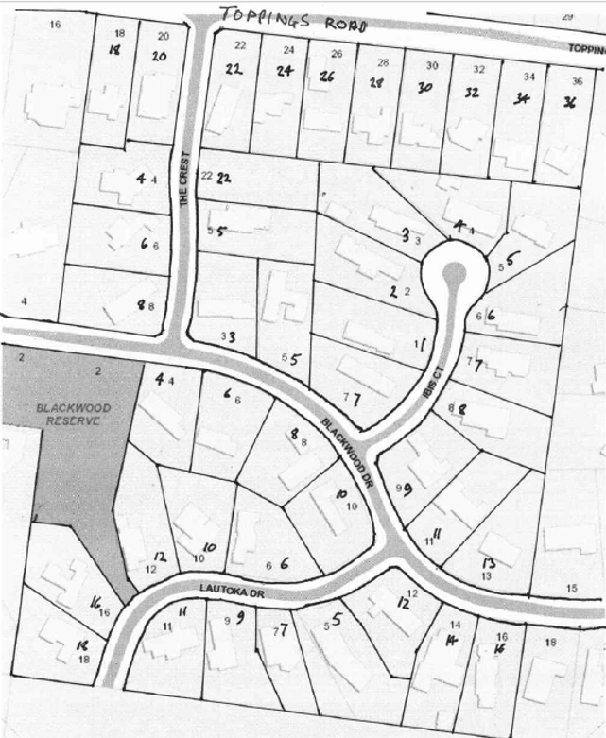Lot 63 on Plan of Subdivision No. 4315 being part of the land in Certificate of Title Volume 2734 Folio 735, area 27 acres and 2 situate on the south side of Toppings Road Wonga Park (about halfway between Yarra and Homestead Roads.

The **Mutual Assurance Society of Victoria Limited** owned much of the land in Wonga Park in 1897 and drew up a plan of subdivision which Lot 63 was on but not approved until 1902 but, as was allowed in those days, sold some lots on terms contracts before the plan was approved by the Titles Office. This Plan of Subdivision was registered as Plan of Subdivision No. 4315 and was the land in Certificate of Title Volume 2734 Folio 735.

***********************

A Street Map in which the land in Lot 63 Plan of Subdivision No. 4315 is shown

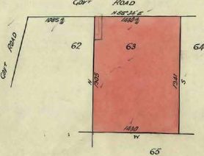**Lot 63 on Plan of Subdivision No. 4315 Certificate of Title Volume 5981 Folio 039**

Plan of the land in Certificate of Title Volume 5981 Folio 039 being Lot 63 on Plan of Subdivision No. 4315

9/7/1935 Transfer No. 1583389 from The Mutual Assurance Society of Victoria Limited to **Heber Newton Read** of Wonga ParkOrchardist, area 27 acres and 2 roods of Lot 63 on Plan of Subdivision No. 4315, new Certificate of Title Volume 5981 Folio 039.

Plan attached to Certificate of Title Volume 5981 Folio showing land transferred out.

21/19/1953 Transfer as to part No. 2590341, from Heber Newton Read to **Herbert Newton Read**, new Certificate of Title Volume 8048 Folio 824.

22/5/1956 Transmission Application No. A160146. Heber Newton Read died on 28th Aug 1953. Probate of his Will has been granted to **Leslie Walter Read** and **Herbert Newton Read** both of Wonga Park Orchardists.

10/7/1956 Transfer as to balance No. A1864515, new Certificate of Title Volume8134 Folio 504.

*********************************************************************

**Certificate of Title Volume 8134 Folio 504**

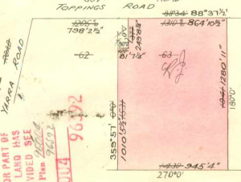10/7/1956 Certificate of Title Volume 8134 Folio 504, area 27 acres and 15 perches, being (part of lot 63 on Plan of Subdivision No. 4315 and) part of Crown Allotment 11A parish of Warrandyte (after Transfer No. A186415 from Leslie Walter Read and Herbert Newton Read) issued to **Jackson Arthur Warren** of 128 Garden Street East Geelong Contractor.

Plan of land attached to Certificate of Title Volume 8134 Folio 504 showing lands transferred out pursuant to Plan of Subdivision No. 96004

Plan of land in Certificate of Title Volume 8134 Folio 504

8/6/1957 Transfer No. C798904 from Jackson Arthur Warren to Herbert Newton Read of Toppings Road Wonga Park Orchardist.

Plan of land attached to Certificate of Title Volume 8134 Folio 504 showing lands transferred out pursuant to Plan of Subdivision No. 96392

28/1/1969 Caveat No. D300230 lodged. Caveat lapsed 14/10/1971.

30/9/1971 Transfer No. E175882 from Herbert Newton Read to **Donald Stewart McKee** Technical Representative and **Jean Margaret McKee** Married Woman both of 7 Angle Road Balwyn.

30/9/1971 Mortgage No. E175882 to Herbert Newton Read.

20/12/1972 Certificate of Title Cancelled as to Part. Pursuant to Regulation 12 and titles issued as set out hereunder: Lots One to 4 in Vol 8956 Fol 465 to Vol 8956 Fol 468 LP 96004.

20/12/1972 Certificate of Title Cancelled. Pursuant to Regulation 12 and titles issued as set out hereunder: Lots One to 2 in Vol 8956 Fol 469 to Vol 8956 Fol 470 LP 96392.

**Street Addresses for Lots on Plan of Subdivision No. 96004**

Lot 1 20 Toppings Road Wonga Park Lot 2 22 Toppings Road Wonga Park

Lot 3 24 Toppings Road Wonga Park Lot 4 26 Toppings Road Wonga Park

**************************************************************************

**Certificate of Title Volume 8956 Folio 469**

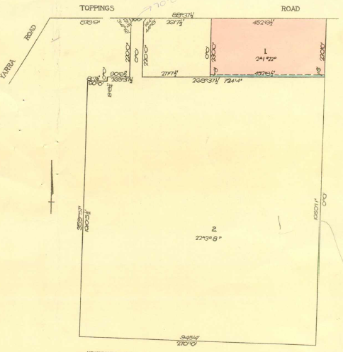20/12/1972 Certificate of Title Volume 8956 Folio 469, area 2 acres 1 rood and 22 perches, being Lot 1 on Plan of Subdivision No. 96392 issued to **Donald Stewart McKee** Technical Representative and **Jean Margaret McKee** Married Woman both of 7 Angle Road Balwyn subject to Mortgage No. E175883 which mortgage was discharged 1/12/1974.

Plan of Subdivision No. 11448

Plan on Certificate of Title Volume 8956 Folio 469 whereon the land in the Title is marked “1”

15/5/1975 Certificate of Title cancelled and Pursuant to Regulation 12and Titles issued as set out hereunder: Lots 5 to 9 in Vol 9084 Fol 813 to Vol 9084 Fol 817 – LP 11448.

**Street Addresses for Lots on Plan of Subdivision No. 96004**

Lot 5 20 Toppings Road Wonga Park Lot 6 22 Toppings Road Wonga Park

Lot 7 24 Toppings Road Wonga Park Lot 8 26 Toppings Road Wonga Park

Lot 9 36 Toppings Road Wonga Park

**Certificate of Title Volume 8956 Folio 470**

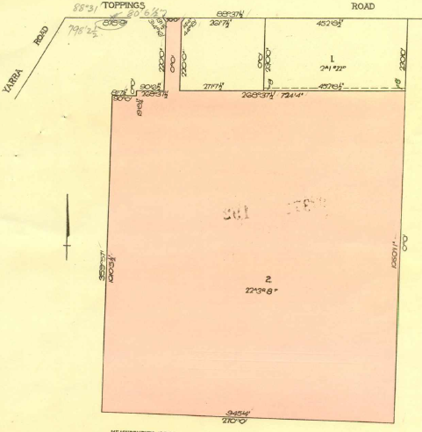20/12/1972 Certificate of Title Volume 8956 Folio 470, area 22 acres 3 roods and 8 perches,

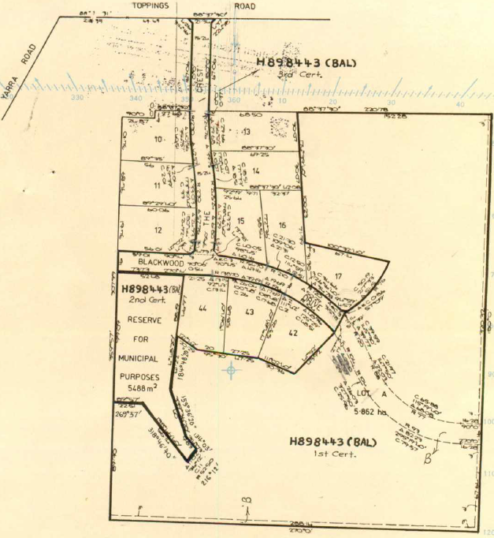being Lot 2 on Plan of Subdivision No. 96392 issued to **Donald Stewart McKee** Technical Representative and **Jean Margaret McKee** Married Woman both of 7 Angle Road Balwyn subject to Mortgage No. E175883 which mortgage was discharged 6/6/1977.

8/10/1979 Certificate of Title Cancelled as to Part Pursuant to Regulation 12 and titles issued as set out hereunder: Lots 10 to 17 on Vol 9349 Fol 260 to Vol 9349 Fol 267 and Lots 42 to 44 in Vol 9349 Fol 268 to Vol 9349 Fol 270 – LP 124963.

11/3/1980 Transfer as to Balance No. H898443 and Title Cancelled See Vol. 9371 Fols. 192 to 194.

Plan attached to Certificate of Title Volume 8965 Folio 470 showing the lots in Plan of subdivision No. 124963

**Street Addresses for Lots on Plan of Subdivision No. 96004**

Lot 10 4 The Crest Wonga Park Lot 11 6 The Crest Wonga Park

Lot 12 8 The Crest Wonga Park Lot 13 part 22 Toppings Road Wonga Park

Lot 14 5 The Crest Wonga Park Lot 15 3 Blackwood Drive Wonga Park

Lot 16 5 Blackwood Drive Wonga Park Lot 17 7 Blackwood Drive Wonga Park

Lot 42 8 Blackwood Drive Wonga park Lot 43 6 Blackwood Drive Wonga Park

Lot 44 4 Blackwood Drive Wonga Park

***************************************************************************

**Certificate of Title Volume 9349 Folio 263**

8/10/1979 Certificate of Title Volume 9349 Folio 263 being Lot 13 on Plan of Subdivision No.124963 issued to **Donald Stewart McKee** Technical Representative and **Jean Margaret McKee** Married Woman both of 7 Angle Road Balwyn subject to The Covenant contained in Transfer No. H898445 registered 11/3/1980.

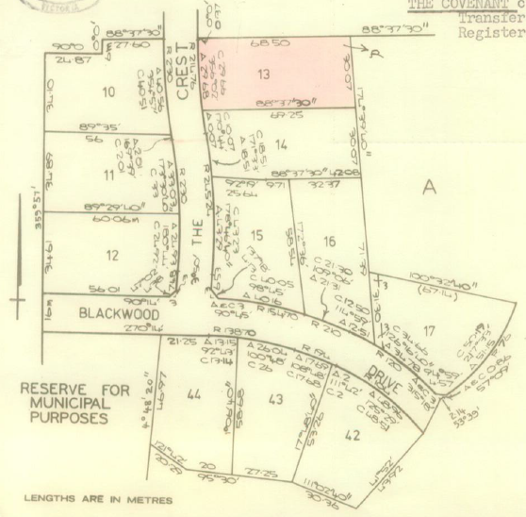11/3/1980 Transfer No. H898443 from Donald Stewart McKee and Jean Margaret McKee to **J. & D. Mckee Pty. Ltd.** of 34 Maitland Avenue East Kew.

11/3/1980 Transfer No. H898445 from J. & D. McKee Pty. Ltd. to **Gavin Frederick Hickling** School Teacher and **Lynda Florence Hickling** Married Woman both of Toppings Road Wonga Park.

9/8/2006 Survivorship Application No. AE533437E by **Lynda Florence Hickling** of 22 Toppings Road Wonga Park 3115.

Plan on Certificate of Title Volume 9349 folio 263 on which the land in the Title is coloured red and marked “13”

*************************************************************************

**Certificate of Title Volume 9371 Folio 192**

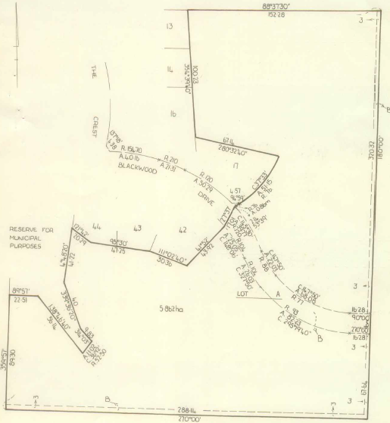11/3/1980 Certificate of Title Volume 9371 Folio 192, area 5.82 hectares, being Lot A on Plan of Subdivision No. 124963 issued to **J. & D. Mckee Pty. Ltd.** of 34 Maitland Avenue East Kew.

Plan of Subdivision No. 124964

Plan of land in Certificate of Title Volume 9371 Folio 192

15/3/1983 Transfer No. K296907 from J. & D. McKee to **John Adrian Darwin Wallace** of 26 Laing Street Mont Albert Valuer.

15/3/1983 Mortgage No. K296098B to Carlo Anthony Massola and John Frederick Henry.

19/4/1984 Certificate of title Cancelled. The following Titles have been issued Pursuant to Regulation 12 of the Transfer of Land Act: Lots 18 to 26 in Vol. 9551 Fol. 232 to Vol. 9551 Fol. 240, Lot 41 in Vol 9551 Fol 241 and Lot A in Vol 9551 Fol 242 and Pursuant to Section 32 of the Transfer of Land Act A Reserve of electrical substation purposes in Vol 9551 Fol 243 and Pursuant to Section 32 of the Transfer of Land Act Land appropriated or set apart for easements of way drainage and sewerage on Vol 9551 Fol 244 – LP 124964.

**Street Addresses for Lots on Plan of Subdivision No. 96004**

Lot 18 1 Ibis Court Wonga Park Lot 19 2 Ibis Court Wonga Park

Lot 20 3 Ibis Court Wonga Park Lot 21 4 Ibis Court Wonga Park

Lot 22 5 Ibis Court Wonga Park Lot 23 6 Ibis Court Wonga Park

Lot 24 7 Ibis Court Wonga Park Lot 25 8 Ibis Court Wonga Park

Lot 26 9 Blackwood Drive Wonga park Lot 41 10 Blackwood Drive Wonga Park

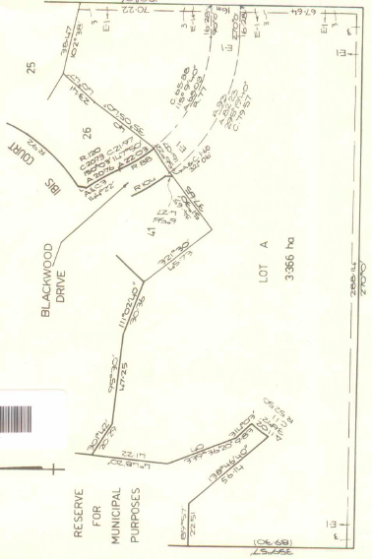 *********************************************************************

**Certificate of Title Volume 9551 Folio 242**

19/4/1984 Certificate of Title Volume 9551 Folio 242, area 3.66 hectares, being Lot A on Plan of Subdivision No. 124964 issued to **John Adrian Darwin Wallace** of 26 Laing Street Mont Albert Valuer subject to Mortgage No. K296908.

18/9/1984 Certificate of Title Cancelled and the following Titles have been issued Pursuant to Regulation 12 of the Transfer of Land Act: Lots27 to 40 in Vol. 9571 Fol. 612 to Vol 9571 Fol. 625 and Pursuant to Section 32 of the Transfer of Land Act being roads in Vol. 9571 Fol. 626 – LP 124965.

Plan of land on Certificate of title volume 9551 Folio 242 on which the land in the Title is marked “A”

**Street Addresses for Lots on Plan of Subdivision No. 96004**

Lot 18 1 Ibis Court Wonga Park

Lot 19 2 Ibis Court Wonga Park

Lot 20 3 Ibis Court Wonga Park

Lot 21 4 Ibis Court Wonga Park

Lot 22 5 Ibis Court Wonga Park

Lot 23 6 Ibis Court Wonga Park

Lot 24 7 Ibis Court Wonga Park

Lot 25 8 Ibis Court Wonga Park

Lot 26 9 Blackwood Drive Wonga park Lot 41 10 Blackwood Drive Wonga Park