**Title History of Lot 62 Plan of Subdivision No. 4315**

Lot 62 on Plan of Subdivision No. 4315 being part of the land in Certificate of Title Volume 2734 Folio 735, area 24 acres and 1 rood and 17 perches, situate at the south-eastern corner of Toppings and Yarra Roads Wonga Park

The **Mutual Assurance Society of Victoria Limited** owned much of the land in Wonga Park in 1897 and drew up a plan of subdivision which Lot 62 was on but not approved until 1902 but, as was allowed in those days, sold some lots on terms contracts before the plan was approved by the Titles Office. This Plan of Subdivision was registered as Plan of Subdivision No. 4315 and was the land in Certificate of Title Volume 2734 Folio 735.

******************************

**Lot 62 on Plan of Subdivision No. 4315 Certificate of Title Volume 3190 Folio 824**

A Street Map in which the land in Lot 63 Plan of Subdivision No. 4315 is shown

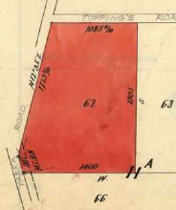20/3/1907 Transfer No. 546735 from The Mutual Assurance Society of Victoria Limited to **Heber Newton Read** of Wonga Park CroydonOrchardist, area 24 acres and 1 rood and 17 perches of Lot 65 (sic – in fact 62) on Plan of Subdivision No. 4315 being part of Crown Allotment 11A and land part of a Government Road Parish of Warrandyte County of Evelyn, new Certificate of Title Volume 3190 Folio 824.

Plan of the land in Certificate of Title Volume 3190 Folio 824 being Lot 62 on Plan of Subdivision No. 4315

20/3/1907 Mortgage No. 249953 to The Commissioners of Savings Banks in the Colony of Victoria, discharged 1/6/1915.

3/3/1911 Mortgage No. 290928 to The Commissioners of Savings Banks in the Colony of Victoria, discharged 1/6/1915.

Plan attached to Certificate of Title Volume 3190 Folio 824 showing lots on Plan of Subdivision No. 74133

22/5/1956 Transmission Application No. A160146. Heber Newton Read died on 28th Aug 1953. Probate of his Will has been granted to **Leslie Walter Read** and **Herbert Newton Read** both of Wonga Park Orchardists.

13/3/1957 Transfer No. A303204 from Leslie Walter Read and Herbert Newton Read to **Jackson Arthur Warren** of 128 Garden Street East Geelong Contractor.

28/9/1966 Certificate of title Cancelled Pursuant to Regulation 12 and titles issued as set out hereunder: Lots one and 2 in Vol 8637 Fol 620 and Vol 8637 Fol 621 – LP 74123.

***************************************************************************

**Certificate of Title Volume 8637 Folio 620** **Street Address: 16 Toppings Road Wonga Park**

28/9/1966 Certificate of Title Volume 8637 Folio 620 being Lot 1 on Plan of Subdivision No. 74133 issued to **Jackson Arthur Warren** of 128 Garden Street East Geelong Contractor.

7/2/1967 Transfer No. C69817 from Jackson Arthur Warren to **Herbert Newton Read** of Toppings Road Wonga Park Orchardist.

9/4/1981 Transfer No. J659200 from Herbert Newton Read to **Berjud Nominees Pty. Ltd.** of Jumping Creek Road Wonga Park.

9/4/1981 Mortgage No. K837489 to National Commercial Banking Corporation of Australia Limited, discharged 19/7/1984.

19/7/1984 Transfer No. L159329W from Berjud Nominees Pty. Ltd. to **Aage Herman Olsen** and **Joan Beverley Olsen** both of 111 McGowans road Donvale.

10/9/1998 Transfer No. V633084R from Aage Herman Olsen and Joan Beverley Olsen to **Robert Alan Cathie & Sandra Mary Cathie** of 16 Toppings Rd Wonga Park.

28/7/1999 Mortgage No. W186247P to Australia and New Zealand Banking Group Limited, discharged 5/2/2001.

Plan of land on Certificate of Title Volume 8637 Folio 620 the land in the Title being coloured red and marked”1”

5/2/2001 Transfer No. X297327K from Robert Alan Cathie and Sandra Mary Cathie to **Gary Robert Millard** of 191 Jumping Creek Rd Wonga Park 3115.

5/2/2001 Mortgage No. X297328G to Australia and New Zealand Banking Group Limited.

4/3/2003 Discharge No. AB920076E of Mortgage No. X297328G lodged.

4/3/2003 Transfer No. AB920077C from Gary Robert Millard to as to 1 of a total of 2 equal undivided shares **Ross Christopher Holt** and as to 1 of a total of 2 equal undivided shares **Lynette Jean Penman** both of 17-19 Cecil Circuit Croydon Vic 3115 as tenants in common.

4/3/2003 Mortgage No. AB920078A to National Australia Bank Limited.

19/10/2004 Discharge No. AD187290T of Mortgage No. AB920078A lodged.

19/10/2004 Mortgage No. AD187291R to Australia and New Zealand banking Group Limited lodged.

7/11/2016 Discharge No. AN246525E of Mortgage No. AD187291R lodged.

7/11/2016 Mortgage No. AN246525E to Bank of Queensland Ltd lodged.

**Certificate of Title Volume 8637 Folio 621**

perches, being Lot 2 on Plan of Subdivision No. 74133 issued to **Jackson Arthur Warren** of 128 Garden Street East Geelong Contractor.

8/6/1967 Transfer No. C798905 from Jackson Arthur Warren to **Herbert Newton Read** of Toppings Road Wonga Park Orchardist.

27/6/1968 Certificate of Title Cancelled Pursuant to Regulation 12 and Titles issued as set out hereunder: Lots One and 2 in Vol 8726 Fol 549 and Vol 8726 Fol 550 – LP 81132.

Plan of land attached to Certificate of Title Volume 8637 Folio 621 Plan of Subdivision No. 81132

Plan of land on Certificate of Title Volume 8637 Folio 621 the land in the Title being coloured red and marked”2”

****************************************************************

**Certificate of Title Volume 8726 Folio 549**

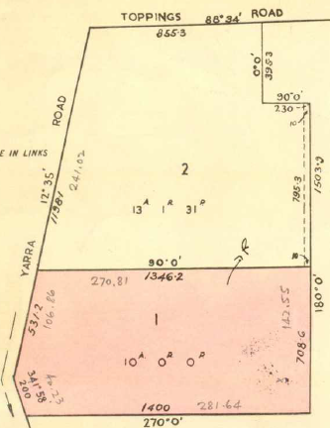27/6/1968 Certificate of Title Volume 8726 Folio 549, area 10 acres 0 roods and 0 perches, being Lot 1 on Plan of Subdivision No. 81132 issued to **Herbert Newton Read** of Toppings Road Wonga Park Orchardist.

9/10/1968 Caveat No. D210140 lodged. Caveat lapsed 2/5/1969.

16/4/1969 Transfer No. D365380 from Herbert Newton Read to **Lloyd George Wilson** Retired and **Mavis Valma Jean Wilson** Married Woman both of 8 Ferdinand Avenue North Balwyn.

18/8/1994 Transfer No. T253982N from Lloyd George Wilson and Mavis Valma Jean Wilson to **Taylor Logging Co. Pty. Ltd.** of 463 Mt. Dandenong Rd. Kilsyth.

12/4/1995 Certificate of Title Cancelled as to Part by PS 335511F Stage 1 – Amended (Cancelled) T449666N 5/3/98) – Stage 2.

Plan of land on Certificate of Title Volume 8726 Folio 549 the land in the Title being coloured red and marked”1”

**Street Addresses** for Plan of subdivision No. 335511F:

Lot 1 394 Yarra Road Wonga Park

Lot 2 392 Yarra Road Wonga Park

Lot 3 390 Yarra Road wonga Park

Lot 4 388 Yarra Road Wonga Park

Lot 5 1A Blackwood Drive Wonga Park

Lot 6 1B Blackwood Drive Wonga Park

Lot 7 1C Blackwood Drive Wonga Park

Plan of Subdivision No. 335511F Sheet 2

Lot 8 2B Blackwood Drive Wonga Park

Lot 9 2A Blackwood Drive Wonga Park

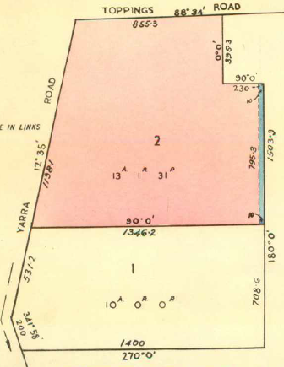**Certificate of Title Volume 8726 Folio 550**

Plan of Subdivision No. 335511F Sheet 3

27/6/1968 Certificate of Title Volume 8726 Folio 550, area 13 acres 1 rood and 31 perches, being Lot 2 on Plan of Subdivision No. 81132 issued to **Herbert Newton Read** of Toppings Road Wonga Park.

3/12/1973 Certificate of Title Cancelled Pursuant to Regulation 12 and Titles issued as set out hereunder: Lots 2 to 3 in Vol 9001 Fol 073 to Vol 9001 Fol 074 – LP 99557

**********************************************************

**Certificate of Title Volume 9001 Folio 073**

Plan of land on Certificate of Title Volume 8726 Folio 550 the land in the Title being coloured red and marked”2”

Certificate of Title Volume 9001 Folio 073, area 3 acres1 rood and

31 perches, being Lot 2 on Plan of Subdivision No. 99557 issued to

**Herbert Newton Read** of Toppings Road Wonga Park Orchardist.

3/9/1996 Certificate of Title Cancelled PS 348281X

**Street Address** for Lot 2 on Plan of Subdivision No. 348281X is 14 Toppings Road Wonga Park

Plan of land on Certificate of Title Volume 9001Folio 073 the land in the Title being coloured red and marked”2”

Plan of subdivision No. 348281X

**************************************************************************

**Certificate of Title Volume 10297 Folio 073**

Certificate of Title Volume 10297 Folio 073 (being Lot 1 on Plan of Subdivision No. 348281X)

8/4/1998 Certificate of Title Cancelled by PS 407851F.

Plan of land on Certificate of Title Volume 9001Folio 073 the land in the Title being marked”2”

**Street Addresses** for Plan of Subdivision No. 407851F

Lot 1 404 Yarra Road Wonga Park

Lot 2 6 Toppings Road Wonga Park

Plan of Subdivision No. 407851F

***************************************************************************

**Certificate of Title Volume 10377 Folio 367 Street Address 404 Yarra Road Wonga Park**

8/4/1998 Certificate of Title Volume 10377 Folio 367, area 3584 m2, being Lot 1 on Plan of Subdivision No. 407851F issued to **Herbert Newton Read** of Toppings Road Wonga Park 3115.

12/10/1998 Caveat No. V686159A by Gregory Sean Conlan as purchaser.

12/8/1999 Transmission application No. W216487F by **Jillian Ruth Tainton**

Plan of land on Certificate of Title Volume 10377Folio 367 the land in the Title being marked”1”

12/8/1999 Transfer No. W216488C from Jill Tainton to **Gregory Sean Conlon** and **Kylie Jane Conlan** both of 404 Yarra Road Wonga Park 3115.

12/8/1999 Mortgage No. W216489Y to Commonwealth Bank of Australia lodged.

10/6/2006 Discharge No. AE408131F of Mortgage No. W216489Y lodged.

10/6/2006 Transfer No. AE408132D from Gregory Sean Conlan and Kylie Jane Conlan to **Justin Gioffre** and **Caterina Pileggi** both of 30 Bartlett Avenue Croydon Vic 3116.

10/6/2006 Mortgage No. AE408133B to Commonwealth Bank of Australia lodged.

4/5/2010 Discharge No. AH198200B of Mortgage No. AE408133B lodged.

4/5/2010 Transfer No. AH198201Y from Justin Gioffre and Caterina Pileggi to **Caterina Gioffre** of 160 Yarra Road Croydon North Vic 3136.

4/5/2010 Transfer No. AH198202W from Caterina Gioffre to **James Stuart Wilson Young** and **Trudy Michelle Young** both of 7 St Denys Crescent Wonga Park Vic 3115

4/5/2010 Mortgage No. AH198203U to Commonwealth Bank of Australia lodged.

23/5/2012 Discharge No. AJ682788U of Mortgage No. AH198203U lodged.

23/5/2012 Transfer No. AJ682789S from James Stuart Wilson Young and Trudy Michelle Young to **Stewart Grant McKenzie** of 404 Yarra Road Wonga Park Vic 3115.

23/5/2012 Mortgage No. AJ682790J to Perpetual Trustee Company Ltd lodged.

17/3/2015 Discharge No. AL759122K of Mortgage No. AJ682790J lodged.

17/3/2015 Mortgage No. AL759123H to Australia and New Zealand Banking Group Ltd lodged.

18/12/2018 Discharge No. AR780511A of Mortgage No. AL759123H lodged.

18/12/2018 Mortgage No. AR780512X to Perpetual Trustee Company Ltd lodged.

22/2/2022 Discharge No. AV360466L of Mortgage No. AR780512X lodged.

22/2/2022 Mortgage No. AV360467J to Commonwealth Bank of Australia lodged.

4/4/2024 Caveat No. AX874712P by Amanda Gemmell and Craig Norman Gemmell as purchasers.

24/6/2024 Discharge No. AY131618S of Mortgage No. AV360467J lodged.

24/6/2024 Transfer No. AY131618S from Stewart Grant McKenzie to **Amanda Gemmell** and **Craig Norman Gemmell** both of 404 Yarra Road Wonga Park Vic 3115.

***************************************************************************

**Certificate of Title Volume 9001 Folio 074**

3/12/1973 Certificate of Title Volume 9001 Folio 074, area 10 acres 0 roods and 0 perches, being Lot 3 on Plan of subdivision No. 99557 issued to **Herbert Newton Read** of toppings Road Wonga Park Orchardist.

4/9/1984 Transfer No. L241653N from Herbert Newton Read to **Delta Enterprises Pty. Ltd.** of 2 Woodland Avenue Croydon.

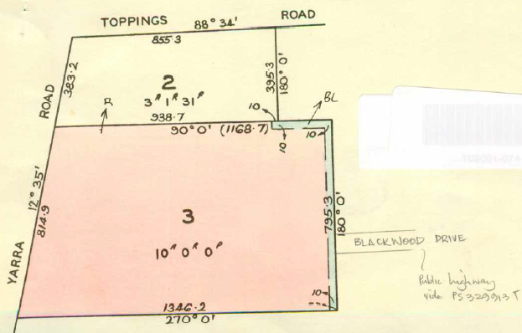21/12/1987 Mortgage No. N202967J to Australia and New Zealand Banking Group Limited, discharged 18/5/1990.

25/9/1990 Mortgage No. R17899H to Commonwealth Bank of Australia, discharged 18/1/1994.

30/7/1992 Mortgage to Australia and New Zealand Banking Group Limited, disharged18/1/1994.

Plan of land on Certificate of Title Volume 9001Folio 074 the land in the Title being coloured red and marked”3”

18/1/1994 Transfer from Delta Enterprises Pty. Ltd. to **Souffi Pty. Ltd.** of 398-424 Hammond Rd. Dandenong 3175.

20/7/1994 Certificate of Title Cancelled as to Part Pursuant to Section 24 Subdivision Act 1988. Lots one to 4 in Vol 10179 Fol 729 to Vol 10179 Fol 732 – PS 329912V.

21/7/1994 Certificate of Title Cancelled as to Balance Pursuant to Section 24 Subdivision Act 1988 – PS 329913T.

**Street Addresses** for lots on Plan of Subdivision No. 329912V

Lot 1 402 Yarra Road Wonga Park

Lot 2 400 Yarra Road Wonga Park

Lot 3 398 Yarra Road Wonga Park

Lot 4 396 Yarra Road Wonga Park

Plan of Subdivision No.32991V

**Street Addresses** for lots on Plan of Subdivision No. 329913V

Lot 5 1 Blackwood Drive Wonga Park

Lot 6 1 Barry court Wonga Park

Lot 7 2 Barry court Wonga Park

Lot 8 3 Barry court Wonga Park

Lot 9 4 Barry Court Wonga Park

Plan of Subdivision No. 329913T