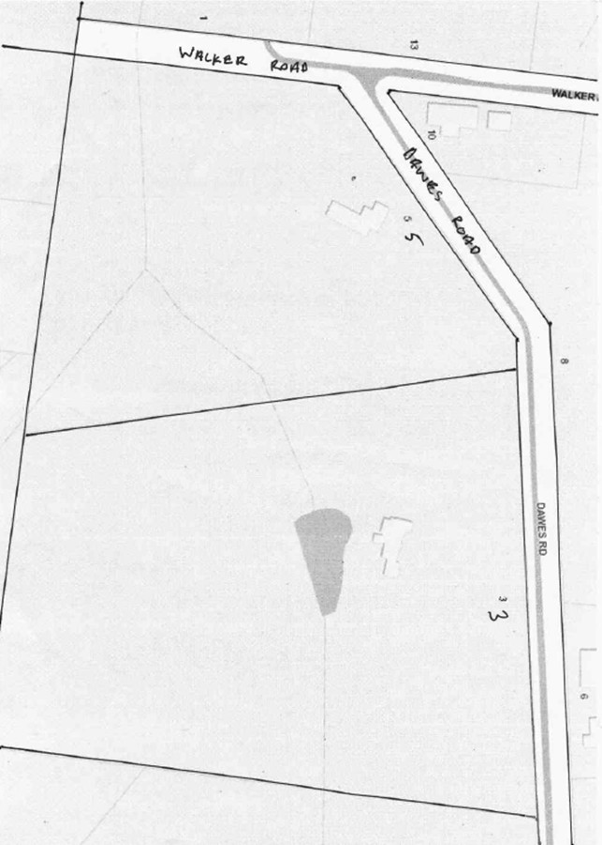
Title History of Lot 48 Plan of Subdivision No. 4315
Lot 48 on Plan of Subdivision No. 4315 being part of the land in Certificate of Title Volume 2734 Folio 735, area 26 acres 1 rood and 13 perches, situate on the southern side of Dawes Road Wonga Park.
The Mutual Assurance Society of Victoria Limited owned much of the land in Wonga Park in 1897 and drew up a plan of subdivision which Lot 48 was on but not approved until 1902 but, as was allowed in those days, sold some lots on terms contracts before the plan was approved by the Titles Office. This Plan of Subdivision was registered as Plan of Subdivision No. 4315 and was the land in Certificate of Title Volume 2734 Folio 735.
*********************************
Lot 48 on Plan of Subdivision No. 4315 Certificate of Title Volume 4330 Folio 894
12/4/1920 Transfer No. 933926 from The Mutual Assurance Society of Victoria Limited to Joseph Gregory William Taylor of 29 Little Collins Street Melbourne Investor, area 26 acres 1 rood and 13 perches of Lot 48 on Plan of Subdivision No. 4315 being parts of Crown Allotment 11A and 11B Parish of Warrandyte County of Evelyn, new Certificate of Title Volume 4330 Folio 894.
A Street Map in which the land in Lot 48 Plan of Subdivision No. 4315 is shown.
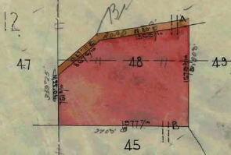
12/4/1920 Mortgage No. 406860 to Ellen Thomas, discharged 29/3/1923.
10/7/1925 Mortgage No. 520736 to Agnes Ann Porter, discharged 12/2/1926.

12/2/1926 Transfer No. 1252835 from Joseph Gregory William Taylor to Agnes Ann Porter of Moorhouse Street Camberwell Married Woman.
24/10/1930 Transfer No.1469024 from Agnes Ann Porter to Bridget Molloy of 4 Pilley Street East St. Kilda Widow.
Plan of the land in Certificate of Title Volume 4330Folio 894
20/7/1945 Red Ink No. 4260139. Bridget Molloy died on 30th January 1945. Probate of her Will has been granted to Teresa Smith of Kyneton Married Woman.

20/9/1945 Transfer No. 1967874 from Teresa Smith (as the executrix of the Will of Bridget Molloy Deceased) to Teresa Smith of Kyneton Married Woman.
30/5/1950 Transfer No. 2305982 from Teresa Smith to Blanche Short Read, Herbert Newton Read and Dorothy Nell Read, new Certificate of title Volume 7401 Folio 014.
************************************************************************
Certificate of title Volume 7401 Folio 014
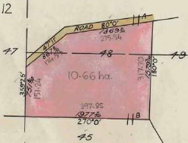
30/5/1950 Certificate of title Volume 7401 Folio 014, area 26 acres 1 rood and 13 perches, being Lot 48 on Plan of Subdivision No. 4315 issued to Blanche Short Read Married Woman, Herbert Newton Read Orchardist and Dorothy Nell Read Spinster all of Wonga Park.
133/1968 Transmission Application No. D24175. As to the interest of Blanche Short Read who died on 9th July 1967 Probate of her Will has been granted to Dorothy Nellie Read of Dudley Road Wonga Park Spinster and George Reginald Edyvane of 25 Lomond Avenue Kilsyth Retired.
20/1/1970 Transfer No. D300999 from Dorothy Nellie Read, George Reginald Edyvane and Herbert Newton Read to Edwin Baumgartner Pastry Cook and Irma Baumgartner Married Woman both of 259 Thompsons Road Lower Templestowe.
Plan of the land in Certificate of Title Volume 7401Folio 014

20/1/1970 Transfer No. D615015 from Edwin Baumgartner and Irma Baumgartner to Bernard McBride of 6 Lime Avenue North Balwyn Geologist.
29/1/1971 Mortgage to Bank of New South Wales Savings Bank Limited, discharged 25/8/19
1/11/1984 Mortgage No. L347733K to Westpac Banking Corporation.
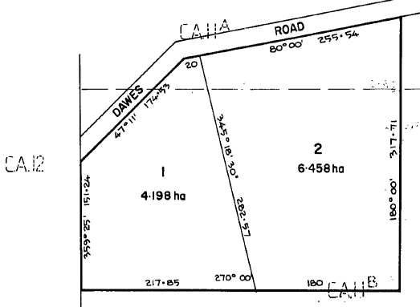
29/10/1985 Certificate of Title Cancelled. The following Titles have been issued Pursuant to Regulation 12 of the Transfer of Land Act: Lots One to 2 in Vol 9640 Fol 456 and Vol 9640 Fol 457 – LP 201239J
***********************************
Certificate of Title Volume 9640 Folio 456
29/10/1985 Certificate of Title Volume 9640 Folio 456, area 4.198 hectares, being Lot 1 on Plan of Subdivision No.201239J issued to Bernard McBride of Dawes Road Wonga Park subject to Mortgage No. L347433K which mortgage was discharged 20/12/1985.
Plan on Certificate of Title Volume 9640 Folio 456 on which the land in the Title is marked “1”
28/6/1988 Transfer No. N540003D from Bernard McBide to David George Paterson Buist & Jean Elizabeth Buist of Walker Rd. Wonga Park.
28/6/1998 Mortgage No. N540004A to The Commissioners of The State Bank of Victoria, discharged 29/4/1991.
29/4/1991 Transfer No. R 314062F from David George Paterson Buist and Jean Elizabeth Buist to Bruce Norman McBroom & Janice Margaret McBroom of 61-63 Knees Rd. Park Orchards.
9/4/1991 Mortgage No. R314063C to Australia and New Zealand Banking Group Limited.
7/10/1991 Mortgage No. R578990L to Australia and New Zealand Savings Bank Limited.
5/5/2000 Discharge No. W762173J of Mortgage No. R578990L lodged.
5/5/2000 Discharge No. W762174F of Mortgage No. R314063C lodged.
5/5/2000 Transfer No. W762176Y from Bruce Norman McBroom and Janice Margaret McBroom as tenants in common as to 1 of a total of 2 equal undivided shares to David Alfonso Gangoiti and as to 1 of 2 equal undivided shares to Maria Strangis both of 5 Dawes Road Wonga Park.
5/5/2000 Mortgage No. W762176Y to National Australia Bank Limited lodged.
**************************************************************************
Certificate of Title Volume 9640 Folio 457
29/10/1985 Certificate of Title Volume 9640 Folio 457, area 6.458 hectares, being Lot 2 on Plan of Subdivision No. 201239J issued to Bernard McBride of Dawes Road Wonga Park subject to Mortgage No. L347433K which mortgage was discharged 20/12/1985.
20/12/1985 Transfer No. M55305T from Bernard McBride to David Gregor Paterson Buist & Jean Elizabeth Buist of 4 Walker Rd. Wonga Park.
20/12/1985 Mortgage No. 55306Q to The Commissioners of The State Bank of Victoria, discharged 23/2/1986.
28/6/1989 Mortgage No. N54005W to The Commissioners of The State Bank of Victoria, discharged 26/3/199?.
Plan on Certificate of Title Volume 9640 Folio 457 on which the land in the Title is marked “2”

5/12/1991 Transfer No. R672910B from David Gregor Paterson Buist and Jean Elizabeth Buist to Bruce Alexander Craig and Janice Christine Craig of Yarra Rd. Wonga Park.
22/5/1992 Mortgage No. R925385E to Westpac Banking Corporation, discharged 11/9/1992.
11/9/1992 Mortgage No. S117167W to National Australia Bank Limited, discharged 15/9/1993.
15/9/1993 Mortgage No. S688569Q to Australia and New Zealand Banking Group Limited.
22/11/1994 Transfer No. T425999D from Bruce Alexander Craig and Janice Christine Craig to Janice Christine Craig of 2-3 Dawes Road Wonga Park.
20/1/1995 Caveat No. T517035C by Morco Holdings Pty Ltd, Morco Investments Pty Ltd and Raymond Frank Moore lodged.
27/5/1995 Withdrawal No. T744502C of Caveat No. T517035C lodged.
26/9/1997 Caveat No. V007359V by Bruce Alexander Craig lodged.
4/5/1998 Caveat No. V400847Q by Albert William Austen lodged.
16/7/1998 Withdrawal No. V531015Q of Caveat No. V400847Q lodged.
11/9/1998 Discharge No. V635291X of Mortgage No. S688569Q lodged.
11/9/1998 Transfer No. V635292U from Janice Christine Craig to Peter James Richard O’Brien and Debra Ann O’Brien both of 3 Dawes Rd. Wonga Park 3115.
11/9/1998 Mortgage No. V635293R to National Australia Bank Limited lodged.
17/6/2013 Withdrawal No. AK401920M of Caveat No. V007359V lodged.
26/2/2014 Discharge No. AL186805W of Mortgage No. V635293R lodged.
26/6/2014 Transfer No. AL186806U from Peter James Richard O’Brien and Debra Ann O’Brien as tenants in common as to 33 of a total of 50 equal undivided shares to Fiorino Bortolotto and as to 17 of a total of 50 equal undivided shares to Sharon Nixon both of 3 Dawes Road Wonga Park Vic 3115.
15/1/2019 Transfer No. AR840228N from Fiorino Bortolotto and Sharon Nixon to Fiorino Bortolotto of 3 Dawes Road Wonga Park Vic 3115.

