**Title History of Lots 43 and 46 Plan of Subdivision No. 4315**

Lot 43 and 46 on Plan of Subdivision No. 4315 being part of the land in Certificate of Title Volume 2734 Folio 735, area 95 acres 2 roods and 32 perches, situate on the northern side of Brysons Road and containing Freyne Street Wonga Park

The **Mutual Assurance Society of Victoria Limited** owned much of the land in Wonga Park in 1897 and drew up a plan of subdivision which Lots 43 and 46 were on but not approved until 1902 but, as was allowed in those days, sold some lots on terms contracts before the plan was approved by the Titles Office. This Plan of Subdivision was registered as Plan of Subdivision No. 4315 and was the land in Certificate of Title Volume 2734 Folio 735.

A Street Map in which the land in Lot 48 Plan of Subdivision No. 4315 is shown.

*********************************

**Certificate of Title Volume 2883 Folio 495**

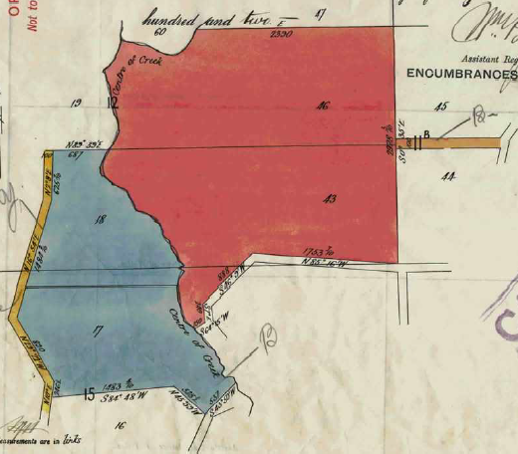10/7/1902 Transfer No. 457918 from The Mutual Assurance Society of Victoria Limited to **Stephen Goch** of Warrandyte Farmer, area 143 acres 1 rood and 8 perches of Lots 17, 18, 43 and 46 on Plan of Subdivision No. 4315 being parts of Crown Sections 12 and 15 Parish of Warrandyte County of Evelyn, new Certificate of Title Volume 2883 Folio 89495.

121/11/1904 Memo No 33283. **National Trustees Executors and Agency Company of Australasia Limited** of 113 Queen Street Melbourne is registered proprietor of the within described land as executor to whom Probate of the will of Stephen Goch who died on the 30th July 1904 was granted on the 7th September 1904.

Plan of the land in Certificate of Title Volume 2883 Folio 495

22/11/1905 Transfer as to part No. 515714 to **James Bennett Cutts**, area 95 acres 2 roods and 32 perches, new Certificate of Title Volume 3094 Folio 762.

18/9/19212 Transfer as to balance No. 695685 to **Arthur Blood**, new Certificate of Title Volume 3639 Folio 789.

************************************************************************

**Certificate of Title Volume 3094 Folio 762**

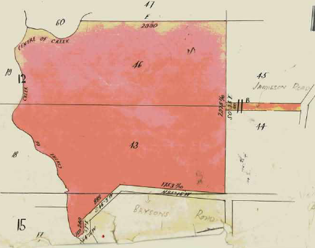22/11/1905 Certificate of Title Volume 3094 Folio 762, area 954 acres 2 roods and 32 perches, being Lots 43 and 46 on Plan of Subdivision No. 4315 and being parts of Crown Sections 12 and 15 Parish of Warrandyte County of Evelyn Together with right of carriage-way over the land delineated and colored brown on the map (after Transfer No. 515714 from National Trustees Executors and Agency Company of Australasia Limited) issued to **James Bennett Cutts** of Ringwood Laborer.

22/11/1905 Mortgage No. 289119 to Eliza Ann Elliott, discharged 9/12/1908.

9/12/1908 Mortgage No. 267513 to The Australasian Temperence and General Mutual Life Assurance Society Limited, discharged 19/4/1911.

Plan of land in Certificate of Title Volume 3094 Folio 762

13/11909 Mortgage No. 269135 to The Australasian Temperence and General Mutual Life Assurance Society Limited, discharged 19/4/1911.

19/4/1911 Transfer No. 648112 from James Bennett Cutts to **John Brown Poyett** of Croydon Farmer.

19/4/1911 Mortgage No. 292445 to Denis Carthy Evans, William Hisloff and Albert Chapple, discharged 5/3/1945.

5/3/1948 Transfer No. 2051362 from John Brown Poylett to **Leslie Walter Horace Read** of Wonga Park Orchardist.

30/7/1976 Caveat No. D789860 affecting part of the land herein Lot 2 on 88667. Caveat lapsed 22/7/1974.

Plan attached to Certificate of title Volume 3094 Folio 762 showing Lot 1 on Plan of Subdivision No 88667.

11/4/1973 Certificate of Title Cancelled as to Part Pursuant to Regulation 12 and Titles issued as set out hereunder: Lot One in Vol 8969 Fol 129 – LP92953.

11/4/1973 Certificate of Title Cancelled as to Part Pursuant to Regulation 12 and Titles issued as set out hereunder: Lots 2 to 5 in Vol 8969 Fol 130 to Vol 8969 Fol 133 – LP92954.

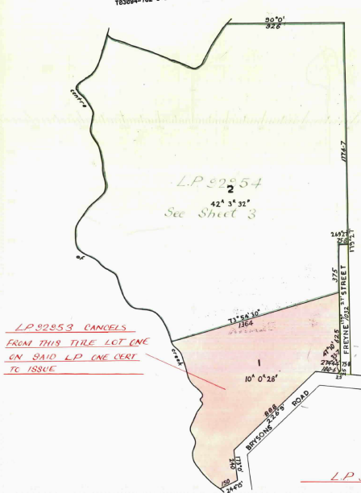4/2/1974 Caveat No. F186402 lodged affecting part of the land herein Lot 1 PS 88667. Caveat withdrawn 20/1/1976.

Plan attached to Certificate of title Volume 3094 Folio 762 showing Lot 1 on Plan of Subdivision No 92954.

Plan attached to Certificate of title Volume 3094 Folio 762 showing Lot 1 on Plan of Subdivision No 92953.

6/2/1974 Caveat No. F189865 lodged affecting part of the land herein Lot 1 PS 88667. Caveat withdrawn before entry 12/4/1974.

21/2/1973 Transfer as to Part No. E710618 and (Title) Cancelled as to Part See Vol. 9039 Fol. 536.

3/2/1976 Caveat No. G17239 lodged affecting part of the land herein Lot 1 PS 88667. Caveat lapsed 17/6/1977.

3/5/1977 Transfer as to Balance No. G609178 (Title) Cancelled See Vol. 9210 Fol. 213.

***************************************************************************

**Certificate of Title Volume 9210 Folio 213**

3/5/1977 Certificate of Title Volume 9210 Folio 213, area 17.00 hectares, being Lot 1 on Plan of Subdivision No. 88667 issued to **Cathella Proprietary Limited** of Jamieson Road Wonga Park (presumably a company connected with the Murray and Sue Couper family).

30/4/2019 Caveat No. AS122793B by James Coupar (sic – should be Couper) Grounds of Claim – Declaration of Trust with The Registered Proprietor dated 23/4/2019 lodged by J Couper with notices to J Couper of 7 Jamieson Road Wonga Park Vic 3115.

28/8/2020 Application to Remove Caveat No. AS480525C lodged, registered 8/10/2019 and Caveat Removed.

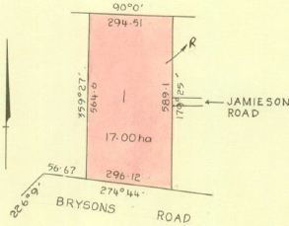6/3/2020 Caveat No. AT056500D by C & J Harvey Holdings Pty Ltd as Purchaser.

22/12/2020 Transfer No. AT900062X from Cathella Proprietary Limited to C & J Harvey Holdings Pty Ltd of 12 Fulford Drive (sic) Wonga Park Vic 3115.

22/12/2020 Mortgage No. AT900063V to RMBL Investments Ltd lodged.

25/10/2021 Discharge No. AU945091D of Mortgage No. AT900063V lodged.

Plan of land in Certificate of Title Volume 9210 Folio 213.

25/10/2021 Mortgage No. AU945062B to Commonwealth Bank of Australia lodged.