**Title History of Lot 45 Plan of Subdivision No. 4315**

Lot 45 on Plan of Subdivision No. 4315 being part of the land in Certificate of Title Volume 2734 Folio 735, area 31 acres 3 roods and 22 perches, situate on the north-west corner of Brysons and Jamiesons Roads Wonga Park.

The **Mutual Assurance Society of Victoria Limited** owned much of the land in Wonga Park in 1897 and drew up a plan of subdivision which Lot 48 was on but not approved until 1902 but, as was allowed in those days, sold some lots on terms contracts before the plan was approved by the Titles Office. This Plan of Subdivision was registered as Plan of Subdivision No. 4315 and was the land in Certificate of Title Volume 2734 Folio 735.

A Street Map in which the land in Lot 45 Plan of Subdivision No. 4315 is shown.

***********************************************************************

**Lot 45 on Plan of Subdivision No. 4315 Certificate of Title Volume 4977 Folio 361**

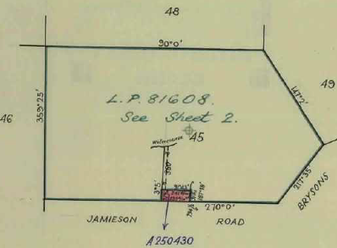12/3/1925 Transfer No. 12063 from The Mutual Assurance Society of Victoria Limited to **Ethel Amelia Edyvane** (wife of Joseph John Edyvane) of Yarra Road Croydon Married Woman, area 31 acres 3 roods and 22 perches, of Lot 45 on Plan of Subdivision No. 4315 being part of Crown Allotment 11B Parish of Warrandyte County of Evelyn, new Certificate of Title Volume 4977 Folio 361.

2610/1926 Mortgage No. 55138 to Charles Reynolds, discharged 15/11/1927.

Plan of the land in Certificate of Title Volume 4977 Folio 361.

1?/4/1930 Mortgage No. 643605 to The Commercial Bank of Australia Limited, discharged 11/8/1944.

11/8/1944 Transfer No. 1923955 from Ethel amelia Edyvane to **Samuel Norman John Jamison** of 64 Cooper Street Preston Traveller.

Plan attached to Certificate of Title Volume 4977 Folio 361 showing the land transferred out in Transfer No. A250430.

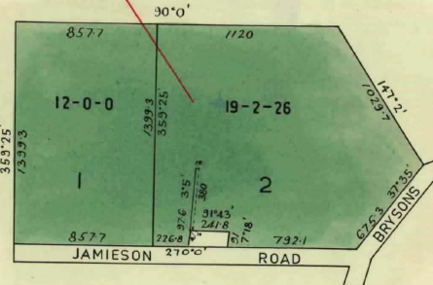13/11/1956 Transfer as to Part and Creation of Easement No. A25043. Cancelled as to Part. See Vol. 8133 Fol. 948.

5/8/1968 Certificate of title Cancelled Pursuant to Regulation 12 and titles issued as set out hereunder: Lots 1 and 2 in Vol 8734 Fol 126 and Vol 8734 Fol 127 – LP 81608.

************************************

**Certificate of Title Volume 8133 Folio 948**

Plan attached to Certificate of Title Volume 4977 Folio 361 showing the lots in Plan of Subdivision No. 81608.

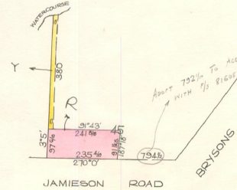13/11/1956 Certificate of Title Volume 8133 Folio 948 being part of Lot 45 on Plan of Subdivision No. 4315 Together with a right to use the land coloured yellow on the said map for drainage purposes.

9/6/1987 Transfer No. M880063F from Samuel Norman John Jamison to **Kenneth Samuel John Jamison** of 23 Paynters Rd. Wonga Park.

29/7/1988 Mortgage No. N608181 to Commonwealth Bank of Australia, discharged 11/12/1989.

14/9/1989 Caveat No. P427401W by John Edward Snowden & Ivy Mary Snowden as purchasers. Caveat lapsed on registration of P566524Q.

11/12/1989 Transfer No. P566524Q from Kenneth Samuel John Jamison to **John Edward Snowden** & **Ivy Mary Snowden** of Jamieson Road Wonga Park.

Land in Certificate of Title Volume 8133 Folio 948

31/7/1995 Mortgage No. T797327F to Commonwealth Bank of Australia, discharged 29/9/1995.

29/9/1995 Transfer No. T889394U from John Edward Snowden and Ivy Mary Snowden to **Phillip Scott Arrowsmith** & **Janelle Kristen Arrowsmith** of 8 Venetian Ct. Croydon 3136.

29/9/1995 Mortgage No. T889395S to National Australia Bank Limited.

19/12/2003 Certificate of Title Cancelled by Plan of Subdivision No. 518021F.

**************************************************************************

**Certificate of Title Volume 8734 Folio 126**

5/8/1968 Certificate of Title Volume 8734 Folio 126, area 12 acres 0 roods and 0 perches, being Lot 1 on Plan of Subdivision No. 81608 issued to **Samuel Norman John Jamison** of Brysons Road Wonga Park Farmer.

5/9/1968 Caveat No. D180914 lodged. Caveat lapsed 12/5/1970.

11/3/1970 Transfer No. D657832 from Samuel Norman John Jamison to **John William Key** of Centre Road Berwick Salesman and **George Leslie Hodgson** of 46 Liberty Parade West Ivanhoe Carpenter as Tenants in Common in Equal Shares.

11/3/1970 Mortgage No. D657833 to Samuel Norman John Jamison, discharged 3/5/1974.

6/5/1970 Transfer No. D708396 as to the interest of John William Key. Title cancelled as to the said interest. See Vol. 8833 Fol. 408.

Plan on Certificate of Title Volume 8734 Folio 126 on which the land in the Title is coloured red and marked”1”

26/9/1975 Mortgage No. F819817 to The Commissioners of the State Savings Bank of Victoria, discharged 4/7/1978.

14/7/1978 Mortgage No. H153357 as to Part – Lot 1 vide Mortgage H153357 to Alliance Acceptance Co. Limited.

14/7/1978 Mortgage No. H153358 as to Part – Lot 2 vide Mortgage H153358 to Alliance Acceptance.

2/11/1978 Mortgage as to part No. H291647 to Alliance Acceptance Co. Limited. Lot 2.

21/11/1978 Mortgage as to part No. H312248 to Alliance Acceptance Co. Limited. Lot 1.

13/3/1979 Transfer as to Part No. H441638. Certificate of Title Cancelled as to Part. See Vol. 9332 Fol. 789.

13/3/1979 Transfer as to Balance No. H441639. Certificate of Title Cancelled as to Part. See Vol. 9332 Fol. 790.

*************************************************************************

**Certificate of Title Volume 9332 Folio 789 Street Address: 6 Jamieson Road Wonga Park**

13/3/1979 Certificate of Title Volume 9332 Folio 789, area 2.428 hectares, being Lot 2 on Plan of Subdivision No. 120452 (after Transfer No. H441638 from George Leslie Hodgson) issued to **Leslie Charles George Hodgson** of Knees Road Park Orchards Builder subject to Mortgages Nos. H153358 and H291647 which mortgages were discharged 12/5/1982.

12/5/1982 Transfer No. J924807 from Leslie Charles George Hodgson to **Geoffrey Albert White** Sales Manager and **Carol Ann White** Married Woman both of 6 Pambara Court Donvale.

Plan of land in Certificate of Title Volume 9332 Folio 789

18/1/1989 Transfer No. N960802N from Geoffrey Albert White and Carol Ann White to **Neil Michael Gow** & **Joy Christine Gow** Certificate of Title Volume 9332 Folio 789 of 10 Arunga Dr. Wonga Park,

18/1/1989 Mortgage No. N960803K to National Australia Bank Limited.

31/8/2007 Discharge No. AF309176A of Mortgage No. N960803K lodged.

31/8/2007 Transfer No. AF309177X from Neil Michael Gow and Joy Christine Gow to **Hugh MacLean Harrison** and **Wendy Michelle Harrison** both of 6 Jamieson Road Wonga Park Vic 3115.

31/8/2007 Mortgage No. AF309178V to National Australia Bank Ltd lodged.

**************************************************************************

**Certificate of Title Volume 9332 Folio 790 Street Address: 8 Jamieson Road Wonga Park**

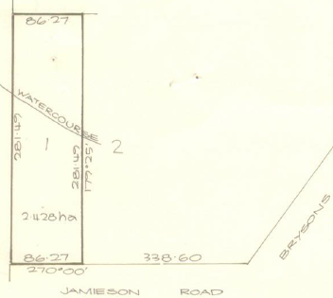13/3/1979 Certificate of Title Volume 9332 Folio 790, area 2.428 hectares, being Lot 1 on Plan of Subdivision No. 120452 (after Transfer No. H441639 from George Leslie Hodgson) issued to **George Leslie Hodgson** of 46 Liberty Parade West Ivanhoe Carpenter subject to Mortgages Nos. H153357 and H312248 which mortgages were discharged 11/12/1981.

3/8/2011 Transmission Application No. AJ108267H to **Leslie Charles George Hodgson** of 86 Marine Parade Newell Qld 4873 and **Lois Eileen Harris** of 6 Ayr Street Macleod Vic 3085 Legal Personal Representatives of George Leslie Hodgson deceased.

21/12/2011 Transfer No. AJ390013L from Leslie Charles George Hodgson and Lois Eileen Harris to **Farnwood Pty Ltd** of 339 Whitehorse Road Balwyn Vic 3103.

Plan of land in Certificate of Title Volume 9332 Folio 790.

21/12/2011 Mortgage No. AJ390025D to Australian Securities Ltd lodged.

22/8/2013 Mortgage No. AK546312B to Australian Housing Association Pty Ltd lodged.

2/12/2014 Discharge No. AL397221X of Mortgage No. AK 546312B lodged.

29/1/2015 Mortgage No. AL650469A to The Commonwealth of Australia lodged.

8/4/2015 Rectification Modify No. AL800903D of name of Mortgage No. AL650469A from The Commonwealth of Australia to Commonwealth of Australia lodged.

28/5/2015 Discharge No. AL919296K of Mortgage No. AL650469A lodged.

24/7/2015 Caveat No. AM055070T by Mingxi Liang as purchaser lodged.

18/12/2015 Withdrawal No. AM417410F of Caveat No. AM055070T lodged.

9/1/2016 Discharge No. AM462275D of Mortgage No. AJ390025D lodged.

9/1/2016 Transfer No. AM462276B from Fernwood Pty Ltd to **Haiying Liang** of 8 Jamieson Road Wonga Park Vic 3115.

9/1/2016 Mortgage No. AM462277Y to National Australia Bank Ltd lodged.

************************************************************************

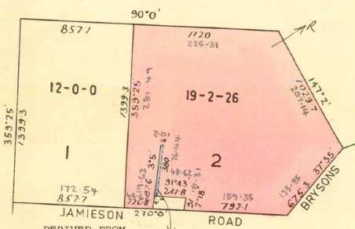**Certificate of Title Volume 8734 Folio 127**

5/8/1968 Certificate of Title Volume 8734 Folio 127, area 19 acres 2 roods and 26 perches, being Lot 2 on Plan of Subdivision No. 81608 issued to **Samuel Norman John Jamison** of Brysons Road Wonga Park Farmer.

26/8/1985 Certificate of Title Cancelled. The following Titles have been issued Pursuant to Regulation 12 of the Transfer of Land Act: Lots One to 2 in Vol. 9628 Fol. 601 to Vol. 9628 Fol. 602 on LP 200389T.

Plan on Certificate of Title Volume 8734 Folio 127 on which the land in the Title is coloured red and marked”2”

**************************************************************************

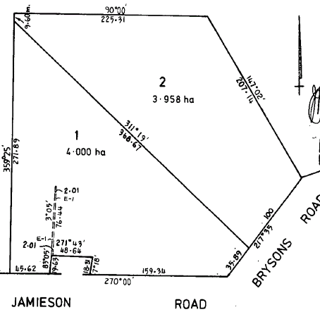**Certificate of Title Volume 9628 Folio 601**

26/8/1985 Certificate of Title Volume 9628 Folio 601, area 4.000 hectares, being Lot 1 on Plan of Subdivision No. 200389T issued to **Samuel Norman John Jamison** of Brysons Road Wonga Park subject to The Drainage Easement created by Transfer No. A250430.

2/5/1995 Transfer No. T661902T from Samuel Norman John Jamison to **Samuel Norman John Jamison** & **Clara Jamison** of 153 Brysons Road Wonga Park3115.

3/2/1998 Survivorship Application No. V236085D by **Clara Jamison** lodged.

Plan on Certificate of Title Volume 9628 Folio 601 on which the land in the Title is marked”1”

23/3/2001 Transmission Application No.X380229D by **Norman Samuel Jamison** lodged.

23/3/2001 Transfer No. X380233A from Norman Samuel Jamison to **Norman Samuel Jamison** and **Dorothy Jean Jamison** both of 153 Brysons Rd. Wonga Park 3115.

19/12/2003 Certificate of Title Cancelled by Plan of Subdivision No. 518021F.

********************************************************************

**Certificate of Title Volume 10775 Folio 951 Street Address: 4 Jamieson Road Wonga Park**

6/1/2004 Certificate of Title Volume 10775 Folio 951, area 4000 m2, being Lot 1 on Plan of Subdivision No. 518021F (Parent titles: volume 8133 Folio 948 and Volume 9628 Folio 601) issued 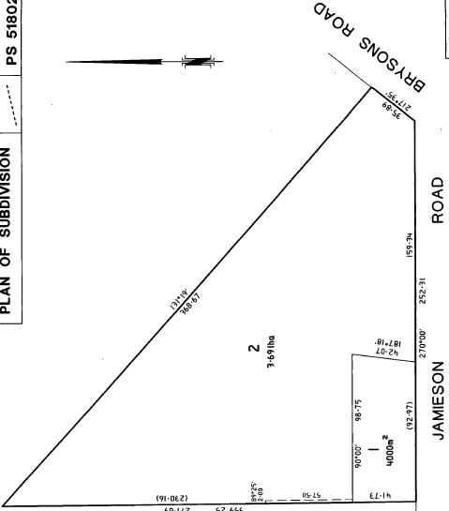as to the land formerly contained in Volume 8133 Folio 948 to **Phillip Scott Arrowsmith** and **Janelle Kristen Arrowsmith** both of 4 Jamieson Road Wonga Park Vic 3115 and as to the land formerly contained in Volume 9628 Folio 601 to **Norman Samuel Jamieson** and **Dorothy Jean Jamison** both of 153 Brysons Rd. Wonga Park 3115.

19/12/2003 Transfer No. AC557235A from Phillip Scott Arrowsmith, Janelle Kristen Arrowsmith, Norman Samuel Jamison and Dorothy Jean Jamison to **Phillip Scott Arrowsmith** and **Janelle Kristen Arrowsmith** both of 4 Jamison Road Wonga Park Vic 3115.

Plan of Subdivision No. 518021 on which the land in Certificate of Title Volume 10775 Folio 951 is marked”1”

7/5/2004 Discharge No. AC845059N of Mortgage No. T889395S lodged.

7/5/2004 Transfer No. AC845060E from Phillip Scott Arrowsmith and Janelle Kristen Arrowsmith to **Janelle Kristen Arrowsmith** of 4 Jamieson Road Wonga Park Vic 3115.

7/5/2004 Mortgage No. AC845061C to National Australia Bank Limited lodged.

2/5/2012 Caveat No. AJ635210X by Raymond Henry Arrowsmith.

8/4/2022 Withdrawal No. AV511173P of Caveat No. AJ635210X lodged.

10/3/2023 Discharge No. AW626559Q of Mortgage No. AC845061C lodged.

******************************

**Certificate of Title Volume 10775 Folio 952 Street Address: 2 Jamieson Road Wonga Park**

6/1/2004 Certificate of Title Volume 10775 Folio 952, area 3.691 hectares, being Lot 2 on Plan of Subdivision No. 518021F issued to **Norman Samuel Jamison** and **Dorothy Jean Jamison** both of 153 Brysons Road Wonga Park 3115.

Plan of Subdivision No. 518021 on which the land in Certificate of Title Volume 10775 Folio 952 is marked”2”

1/9/2005 Survivorship Application No. AD848672V from Norman Samuel Jamison and Dorothy Jean Jamison to **Dorothy Jean Jamison** of 153 Brysons Road Wonga Park 3115.

14/12/2007 Transfer No. AF533453X from Dorothy Jean Jamison as Tenants in Common as to 3 of a total of 4 equal undivided shares to **Gay Judith Ward** of 153 Brysons Road Wonga Park Vic 3115 and as to 1 of a total of 4 equal undivided shares to **Brehay Investments Pty Ltd** of 3/103 Albert Street Blackburn Vic 3130.

14/12/2007 Mortgage No. AF533454V to Westpac Banking Corporation lodged.

28/2/2017 Discharge No. AN60150D of Mortgage No. AF533454V lodged.

25/11/2021 Transfer No. AV057542N from Gay Judith Ward and Brehay Investments Pty Ltd to **Courtenay Peter Charles Baker** and **Simone Kirsten Baker** both of 153 Brysons Road Wonga Park.

25/11/2021 Mortgage No. AV057543L to Commonwealth Bank of Australia lodged.

********************************************************************

**Certificate of Title Volume 9628 Folio 602 Street Address: 155 Brysons Road Wonga Park**

26/8/1985 Certificate of Title Volume 9628 Folio 602, area 3.958 hectares, being Lot 2 on Plan of Subdivision No. 200389T issued to **Samuel Norman John Jamison** of Brysons Road Wonga Park.

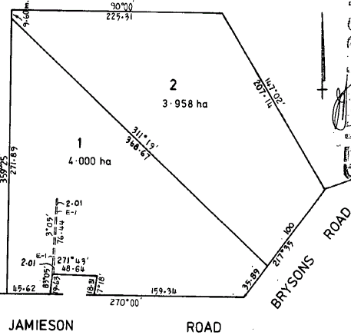24/9/1985 Transfer No. L905562L from Samuel Norman John Jamison to **K. A. & P. M. Nominees Pty. Ltd.** of Brysons Rd. Wonga Park.

4/9/1997 Caveat No. U968721S by Myhaven Pty. Ltd. as purchaser lodged.

18/3/1999 Transfer No. V949536G from K. A. & P. M. Nominees Pty. Ltd. to **Myhaven Pty Ltd** of 208 Canterbury Rd. Bayswater3153.

23/5/2014 Caveat No. AL103417A by Sarina D’ Amico.

28/11/2016 Discharge No. AN318831X of Mortgage No. X603386W lodged.

Plan on Certificate of Title Volume 9628 Folio 602 on which the land in the Title is marked”2”

1/2/2017 Withdrawal No. AN511954D of Caveat No. AL103417A lodged.

1/2/2017 Transfer No. AN511955B from Myhaven Pty Ltd to **Mina Sarina D’ Amico** of 155 Brysons Road Wonga Park Vic 3115.

18/9/2018 Mortgage and Change of Registered Proprietor Name No. AR463576P to Westpac Banking Corporation and name corrected to **Mina-Sarina D’ Amico** of 155 Brysons Road Wonga Park Vic 3115.

31/10/2018 Discharge No. AR61035Q of Mortgage No. AR463576P lodged.

31/10/2018 Transfer No. AR610356N from Mina-Sarina D’ Amico to as Tenants in Common as to 99 of a total of 100 equal undivided shares to Fon **Choorat Masci** and as to 1 of a total of 100 equal undivided shares to **Marc Graham Masci** both of 155 Brysons Road Wonga Park Vic 3115.

31/10/2018 Mortgage No. AR610357L to National Australia Bank Ltd lodged.

10/8/2021 Discharge No. AU675282Y of Mortgage No. AR610357L lodged.

10/8/2021 Transfer No. AU675283W from Fon Choorat Masci and Marc Graham Masci to **Chaohua Tang** of 45 Chatsworth Quadrant Templestowe Lower Vic 3107.

10/8/2021 Mortgage No. AU675284U to Commonwealth Bank of Australia lodged.

14/8/2024 Discharge No. AY304540S of Mortgage No. AU675284U lodged.

14/8/2024 Transfer No. AY304541Q from Chaohua Tang to **Warren Hattwich** and **Jane Louise Hattwich** both of 155 Brysons Road Wonga Park Vic 3115.

14/8/2021 Mortgage No. AY304542N to Commonwealth Bank of Australia lodged.